Effective Team Work & Communication

Contents
Introduction 3
Inter-personal communication 3
Written communication 4
Models of communication 5
Shannon Weaver model of communication 5
Berlo’s model of communication 7
Schramm’s model of communication 9
Model of communication used at my workplace 10
Conclusion 11
References 12

Introduction
Communication is the procedure by which any individual shares his own ideas, opinions and thoughts. It is a very mandated skill for any employee working at any organization. Without effective communication, it is not possible for any employee to be efficient enough and to carry out all the assigned tasks at their respective workplaces. This assignment has been prepared in order to discuss about the significance of effective communication at the workplaces and also about team building and team works at the organizations. I have been working as a manager at KFC restaurant for quite some time and this assignment will narrate my experiences in the organization regarding communication and team works.

Inter-personal communication
Inter-personal communication is that kind of communication which is done between two individuals or more. This kind of communication system is the most common one which is used by me and other professionals at KFC. The inter-personal communication can be of two types-
- Verbal: This is the communication which is done with the help of words.
- Non-verbal: This is the communication done with the help of body language or in written form (Cartwright, 2002).
Both these forms of communication are very much essential while working at any kind of workplace. Sometimes some situations are such that only talking does not help me to communicate effectively with my colleagues or the customers. That time the non-verbal communication helps in delivering my ideas. There are certain etiquettes which should be followed in the body languages as well. However, it is not always possible to express everything by body language (Barker, et al 2002). The verbal communication helps in that regard. I always tend to listen actively to whatever I am being said in return I also expect that people will listen to me carefully. This is because it is the most basic learning of communication.

Written communication
The written communication is another very popular form of communication which is also used at KFC. It is the form of communication which is frequently used at my workplace. The written communication is more of a formal type of communication which is done within the management of the organization (Graham, 2009). The different ways by which communication can be done in a written form are-
- Memos
- Letters
- Reports
- Contracts
- Handbooks
- Emails and so on.
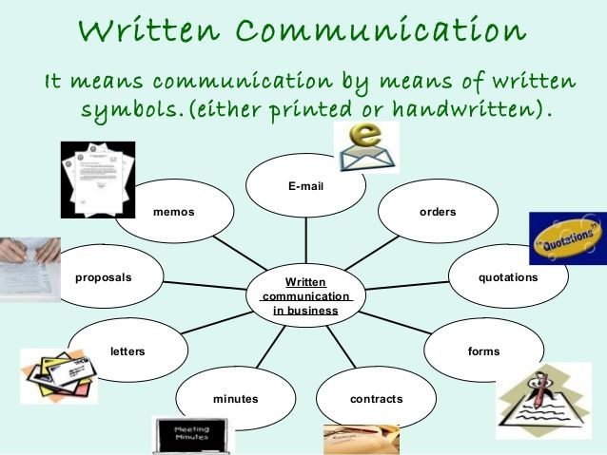
Fig: Forms of Written Communication (Greene, 2008).
This type of communication bears much significance at my workplace, because many important documents and paperwork are done by the help of this. The messages which are expressed through the forms of written communication are generally very clear and it helps me and the other officials of KFC to understand about the writer’s point of views in the process of written communication. At the same time, the written form of communication also helps in documenting and keeping proof of certain activities and actions (Barker, et al 2002). Whenever I feel the need to remind myself or any other employee about something, these written documents, handbooks and others help me a lot.
There are some certain rules and regulations which should be maintained very carefully while communicating in a written way. Some of those are narrated below-
- The idea or thoughts which are being written should be very clear and meaningful.
- A certain way of writing should be maintained which is generally devoid of extra ornamentation (Graham, 2009).
- The ideas should be positive and the message should be specific.
- Lengthy paragraphs and unnecessary words should be avoided.
- Typical tone and figure of speeches should not be used (Greene, 2008).
I have learned about this entire criterion which I should follow in order to communicate effectively in a written form with the authority of KFC and also with the employees who are under my charge. The effectiveness which I have seen is very much significant.

Models of communication
There are a number of models regarding communication which can be used at my workplace at KFC for bringing effectiveness in the whole process and which can help the employees and me as well to be able to communicate with others appropriately and to express our thoughts and concerns (Smith, et al 2008). Some of those models which have proved to be fruitful for the communication process done at KFC are described below-

Shannon Weaver model of communication
The Shannon Weaver model of communication is basically the most important model in regard of effective communication. It was first proposed by the mathematicians Claude Elwood Shannon and Warren Weaver in the year of 1948 (Holden, 2006). The significance of this model was so much that it was termed as the “mother of all the models” (Cartwright, 2002).
The model describes that any idea or concept to be shared or communicated effectively has to go through the following stages-
Sender (Source of information): A sender is basically the person who is presenting the expression of words or who sends the message.
Encoder (Transmitter): The encoder or the transmitter is the stage where the messages are transformed into signals. Sometimes the message can be turned into binary data as well.
Channel: A medium is always needed for the message being delivered from one person to another and a channel is that medium.
Decoder: This is another stage in which the encoded message is further changed into messages from the signals for the receiver of the message to understand (Muyeen, 2017).
Destination (Receiver): Finally a receiver is the person to whom the message is then delivered.
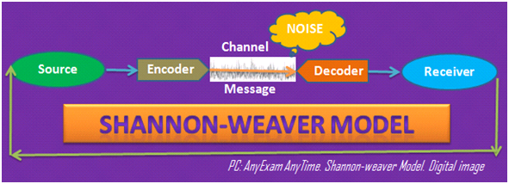
Fig: Shannon-Weaver Model of Communication (Barker, et al 2002).
This is a much used model for any kind of communication which happens at my workplace every day. Any kind of message which is intended by me or the other professionals are ought to reach the receiver of the message by the help of the stages given by the Shannon-Weaver model.

Berlo’s model of communication
This is another model of communication widely used at my workplace at KFC. This model was given by David Berlo in the year 1960 which is actually another version of the Shannon-Weaver model (Greene, 2008). This model of communication is also known as the SMCR model based upon the concepts it discusses about effective communication which are-
- Source
- Message
- Channel
- Receiver
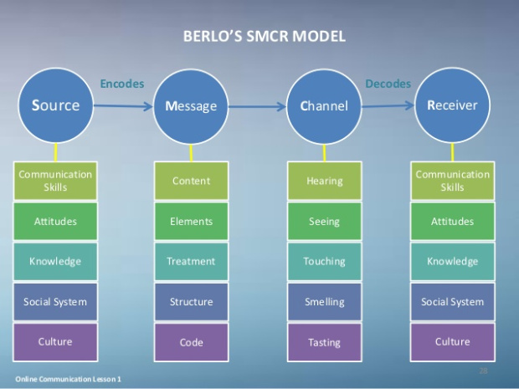
Fig: Berlo’s Model of Communication (Graham, 2009).
Sender: A sender is the component of the model where the message or idea or concept originates at the first place. It is needed that the sender has certain skills and competencies. Some of that are-
- Ample knowledge about the subject matter
- Skills of communication
- Good behavior
- Social abilities
- Cultural norms and values (Smith, et al 2008).
Message: The next component which can be discussed is the message itself. It is the actual idea, concept, thought or view of the sender of the message which he is willing to share with the other person (Belbin, 2012). The message can be of any form, let it be a written message, or voice. Message can be shared with the help of body language as well.
There are some major factors which influence on a message on being a good or effective one. Those factors are-
- Content: The content is the gist of the whole message.
- Elements: The elements of the message are generally the non-verbal signs which are accompanied with the message which includes body language, handshakes and so on (Holden, 2006).
- Treatment: The process by which the message is sent from the receiver to the sender is known as the treatment.
- Structure: Structure is one of the most basic elements of any kind of message. It is the ways by which the message is being arranged for the receiver of the message to understand it properly (Graham, 2009).
- Code: The basic form of the message by which it is sent is called as the code and it is also an important element of the process of communication. The code of a message can be audio, video, text and so on (Dalley, et al., 2010).
Channel: The medium by which the message is send to the receiver is called as channel. Generally, the inborn five senses which an individual possess are collectively known as the channel for communication. Those five senses are-
- Hearing
- Seeing
- Touching
- Smelling
- Tasting

Receiver: The receiver is basically the person to whom the message is being sent. Like the sender, the receiver should have to bear some certain skills as well. Some of that are-
- Active listening
- Communication skills
- Cultural norms and behavior
- Social abilities (Smith, et al 2008).

Schramm’s model of communication
There is yet another model of communication which is also very much important and is used vastly in my workplace of KFC. That model is the Schramm’s model of communication proposed by Wilber Schramm in the year 1954. This model is also known as the circular model of communication.
This model states that there are three components related to effective communication and that the process of communication which is performed by these three components are circular, which means, the process goes back to the backward direction (Muyeen, 2017). The three components of this model are-
- Sender: The sender is the source from which the message has been originated.
- Message: The message is the piece of information or view which is intended to be shared by the sender (Holden, 2006).
- Receiver: The receiver is the person or a group of people to which the ides or views are reached. After the message reaches them, they also provide their feedbacks on the basis of that message which is again send to the sender of the message of the first place (Smith, et al 2008).
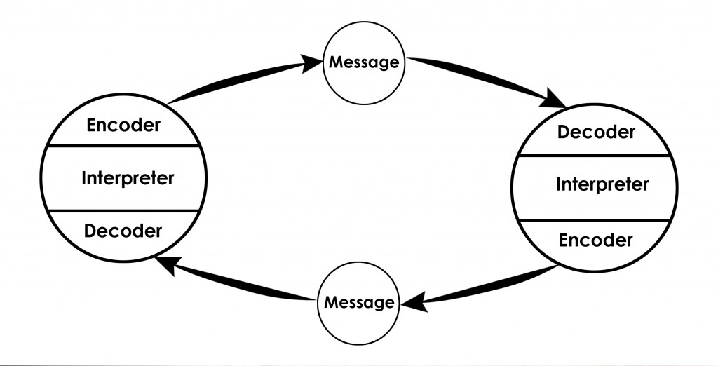
Fig: Schramm’s Model of Communication (Cartwright, 2002).

Model of communication used at my workplace
Although, there are a huge number of models of communications which are available and every one of them is more or less used in any kind of workplace, the communication model which is being used most vastly at my workplace is the Shannon-Weaver model of communication. However there are certain facts which I take into account while maintaining my communication with the help of this model. Some of those facts are discussed below-
- I remain very careful about the source of the message when I am receiving one and at the same time, try to assess about the authenticity of that source.
- When I get any message, I become sincere about the body language as well as selection of words which are chosen by the sender of the message as it can tell a lot about the message itself and also about the sender. The same thing is done by me whenever I am sending anyone a message. I choose my words carefully and maintain an effective body language (Holden, 2006).
- I always try to check about the authenticity of any news or idea which I am sharing. It help me to build a relationship of faith and bond with my colleagues and as well as the customers.
- Different sorts of channels are used when I am sending a message to anyone or receiving one. The verbal messages are sent by face to face conversations, telephone and so on. And on the other hand, the non-verbal messages are sent by body languages, expressions and so on (Cartwright, 2002). I remain very careful whenever the medium is non-verbal as it is hard to interpret someone’s’ intentions from the body language and thus it should be done very sensitively.
- One of the most important concepts of the model of communication is the feedback. Without a feedback, it is impossible to know if the message has been rightly placed for the receiver (Adair, 2009).

Conclusion
Communication is a very crucial concept for any organization as it is an everyday activity in any kind of workplace. The communication process which I have been experiencing at my workplace is quite effective. However, there is always room for improvement. There are some places which are needed to be looked over and the models of communication should be extensively studied by all the employees so that they could learn about the process in a more in-depth way. The performances of the employees will get developed automatically if their communication skills are improved.

References
Adair, J.E. (2009) Effective Teambuilding: How to make a winning team. London: Pan Books
Barker, L. and Gaut, D. (2002). Communication. Boston, MA: Allyn and Bacon.
Belbin, M.R. (2012) Team roles at work. 2nd edn. Oxford: Butterworth-Heineman
Cartwright, R. (2002). Communication. Oxford, U.K.: Capstone Pub.
Dalley, D., and Burton, L. (2010) Developing your Influencing Skills: How to influence people by increasing your credibility, trustworthiness and communication skills Universe of Learning Ltd.
Graham, I. (2009). Communication. Mankato, Minn.: QEB Pub.
Greene, J. (2008). Handbook of communication and social interaction skills. Mahwah, NJ: Erlbaum.
Holden, S. (2006). Communication. Oxford: Macmillan Education.
Muyeen, S. (2017). Communication. Stevenage, Herfordshire, UNKNOWN: The Institution of Engineering and Technology.
Smith, L. and Mounter, P. (2008). Effective internal communication. London: Kogan Page.

