An analysis of the socio-economic needs and issues in Swansea
This report is a compilation of various social and economic problems facing Swansea today. This will include statistical analysis surrounding each issue mentioned as well as the inclusion of some anecdotal evidence where applicable. This report will seek to highlight the major issues within Swansea and its various communities and will seek to highlight any issues which may be linked to one another.
The first issue to be examined will be the economic status of Swansea and the people and families within it. This will include a detailed look at levels of poverty and employment within the area to ascertain the severity of the issue.
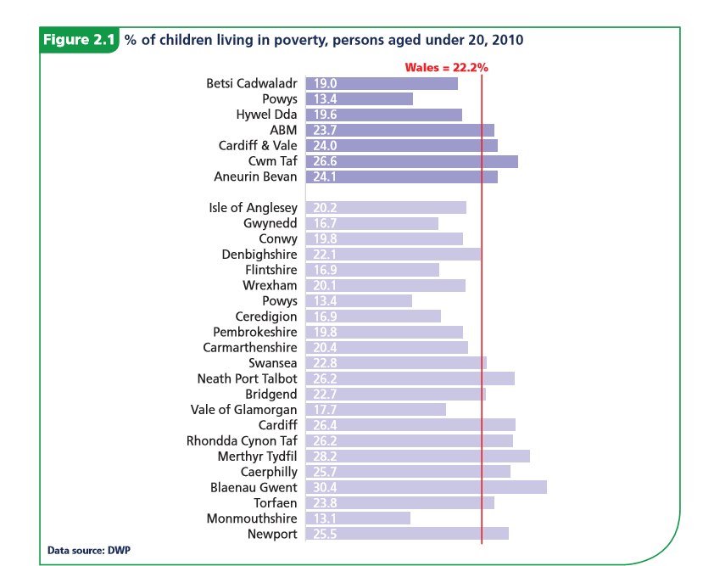(Public Health Wales Observatory, 2012)
‘Relative poverty is deﬁned with reference to the society being studied and can differ over time. It is deﬁned as when an individual’s resources are so seriously below those commanded by the average individual or family that they are, in effect, excluded from ordinary living patterns, customs and activities. (Public Health Wales Observatory, 2012)’
At 22.8% the graph clearly depicts Swansea as ranking higher in levels of poverty for children as seen in the rest of Wales. Whilst Swansea is not significantly higher than the national average in this case it should be noted that this is in one of the most modern, industrialised and affluent area of Wales with better job prospects for the local people when compared with other areas of Wales. Despite the small difference, it is perhaps most alarming that even with a relatively strong local economy comparatively speaking we still see these elevated levels of childhood poverty. This could be down to a number of factors; however, this is also reflected in the relative levels of deprivation as seen below.
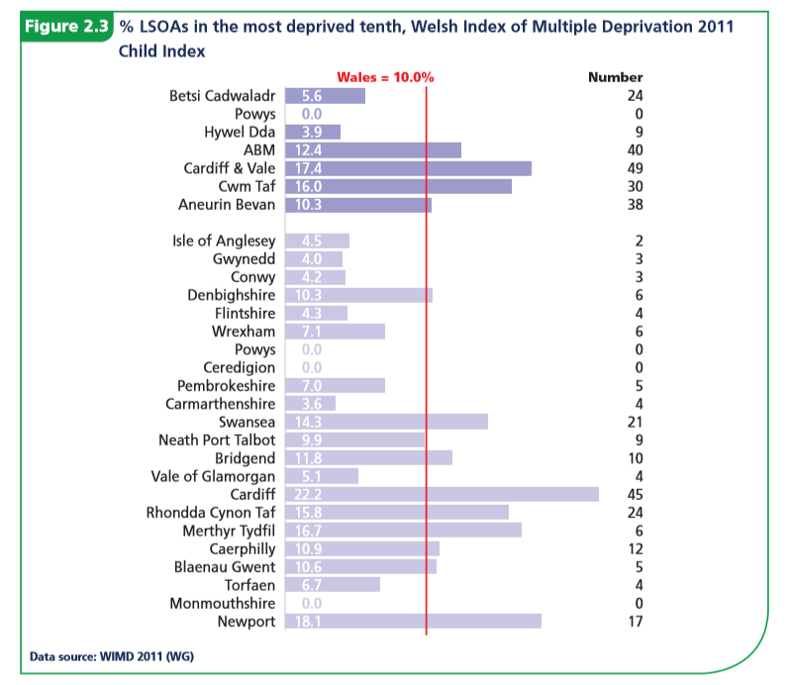 (Public Health Wales Observatory, 2012)
The data above shows relative levels of deprivation in Wales providing a broader picture than income related poverty alone. This is split into things such as income, health, education, access to services, safety and housing. It is here we see a significant elevation in levels of deprivation in the major cities including Swansea. Once again this is perhaps most alarming given that geographical location should grant the highest levels of access to services in the country yet deprivation stands at just under 50% above the national average. This would indicate that issues within Swansea are far greater than being purely economic. The above data would imply, at the very least, the income alone is not responsible for levels of poverty and deprivation.
Employment and academic achievement are intrinsically linked to an areas affluency and could give a broader perspective as to Swansea’s problems particularly in low income areas such as Townhill.
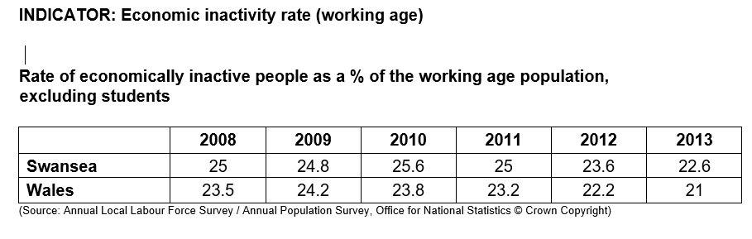(Swansea Council, 2014)
The above graph shows that even without student population Swansea faces above average levels of unemployment amongst the working class. Moreover, this issue is further exacerbated by the type of employment seen in Swansea as recognised by Swansea Council (2014) as they state:
‘Part-Employment
In Swansea, nearly a quarter (24.7%) of children currently live in households with “mixed” employment, where some people aged 16-64 are working and others are not. Part employment is a problem: The Joseph Rowntree Foundation points out that part-timers earn less per hour (£7.60 average) than full-timers (£11.55 average), and that increases in both hours and pay rates are needed to tackle poverty.’
With higher levels of unemployment and those within employment either not being paid a living wage or getting enough working hours, it becomes clearer to see why Swansea faces high levels of poverty and deprivation.
Despite all the above, what is the factor causing so many to be jobless and or part time employed? In a major city where jobs should be easier to come by in less developed areas of Wales why do we see such levels of deprivation. The key could be within the education sector and the relative skill of a workforce. This is recognised by Swansea council particularly in areas of low affluency for example according to Swansea Council 2014,
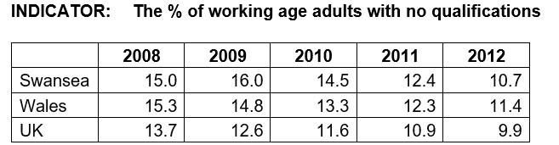
‘Qualifications are visible evidence of the cycle of poverty, with children from low-income families, where parents are less likely to have qualifications, being in turn less likely to get any themselves, and thus more likely to remain in unskilled employment. Employers have been found to be more likely to invest in increasing the qualifications of employees who already have some to begin with, thus they can be an important springboard to better financial well-being.’
Whilst Swansea does fall just below the national average for Wales, it is still above the UK average. Moreover, this does not in the case paint the whole picture as according to the very same report by Swansea Council 2014 ‘42.6%of all residents aged 16 and over in Penderry Ward have no qualifications’ and ‘52.41% of adults aged 25 – 59/65 in Townhill have no qualifications’. This quite frankly incredible jump in a lack of qualifications in some of Swansea’s poorest areas suggest that there is high level of inequity within Swansea most notably regarding education and access to services. The key to resolving many of Swansea’s social and particularly economic issues perhaps lies with education and improving education opportunity in areas such as Townhill, Penderry Ward and others in order to ensure equity amongst the populus. It is likely that areas such as these where extreme levels of poverty, unemployment, poor education etc are driving figures up as opposed to a more generalised problem for everyone in Swansea. By investing in education services and taking a more proactive approach many of these problems will at the very least be mitigated. In my own experience of working in schools in deprived areas it is apparent the children within these schools are given fewer opportunities to further their education and often face poorer standards of education. Furthermore, often in these areas of low affluency and by extension low qualification rate parents are often disengaged with their children’s education as they feel they couldn’t offer much help. Removal of this stigma and encouraging parental involvement would be tremendously helpful in the schools I’ve worked in as well as the potential attainment of children from these areas.
Issues such as deprivation and poverty are often the leading causes for other social issues, this is apparent also in Swansea as the types of crimes are reflective of the socio-economic issues stated above.
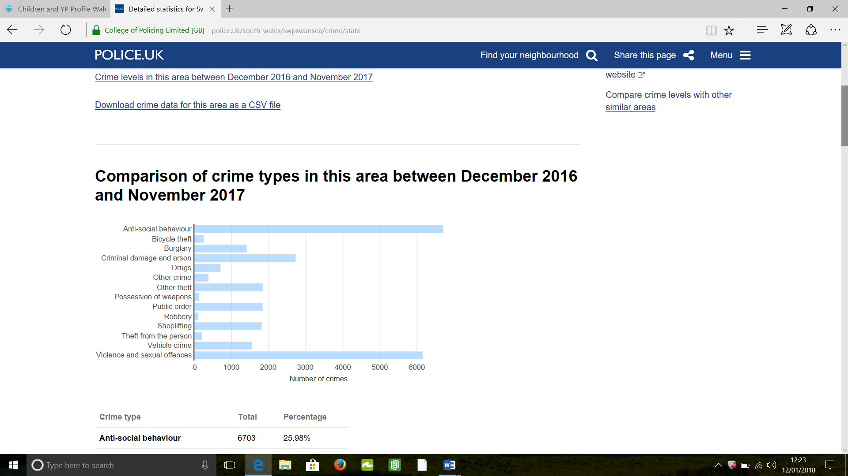
(UK police force, 2017)
We see high levels of anti-social behaviour and violent offences as well as high levels of various thefts. Whilst much of the violent offences and anti-social offences can be in part attributed to Swansea’s infamous nightlife much of the theft and anti-social behaviours can be strongly attributed to the aforementioned issues. This ideology is recognised by world health and crime organisations. For example, according to CAN 2017 ‘Anti-social behaviour can stem from a variety of factors such as: poor education, worklessness, ill health, poverty, child development and family problems.’ According to the above statistics anti-behaviour accounts for approximately 25% of all crime in Swansea. In turn this implies that 25% of all crime in Swansea, perhaps more, can be directly attributable to the previously mentioned issues of poverty, deprivation and most importantly a lack of qualifications/ quality education. It becomes apparently that the type of crimes being committed are intrinsically linked to other issues in these communities.
The data provided above regarding all issues not only provides heavy correlation and links to each other but strongly matches both my own experience but also that of my peers and colleagues.
To conclude, Swansea’s largest issues lay strongly in its divided communities where inequity of income and finances provide the driving force for many of Swansea’s social and economic problems particularly seen in low affluence areas. This is further compounded by the disparity in quality of education and academic attainment across Swansea. It is without question a proactive approach towards education and improving quality of life would prove immeasurably beneficial to all of Swansea. Everything from, qualification rate, unemployment, wages and even crime can be traced back to education within Swansea and by extension the deprivation this has built over time. The evidence both factual and anecdotal show heavy correlation between education and the socio-economic issues in Swansea’s communities especially in areas of low affluence.

References:
CAN 2017 https://can-online.org.uk/about-can/news-and-blog/what-causes-anti-social-behaviour-and-what-can-we-do-to-help (Accessed 12/01/18)
Public Health Wales Observatory 2012 http://www2.nphs.wales.nhs.uk:8080/PubHObservatoryProjDocs.nsf/3653c00e7bb6259d80256f27004900db/7b6c4b38fb85ff1880257c2700585ca6/$FILE/Children%20and%20YP%20Profile%20Wales%20Socioeconomic%20and%20Environmental%20(Eng).pdf (Accessed 11/01/18)
Swansea Council, 2014 Poverty profile pdf http://swansea.gov.uk/povertystrategy (Accessed 11/01/18)
UK Police Force, 2017 https://www.police.uk/south-wales/swpswansea/crime/stats/ (Accessed 12/01/18)

