Creative writing is a relatively new subject taught in universities, first introduced by Malcolm Bradbury at the University of East Anglia over 50 years ago. It is classed as one of the humanities disciplines, as in a subject that studies human society and culture, along with others that it has strong links to such as history, philosophy and archaeology. Creative Writing is a complex umbrella term that is difficult to define as it encompasses a myriad of various methods of human expression. It is the preservation of humanity’s existence through artistic communication with ties to the wider humanities subjects.
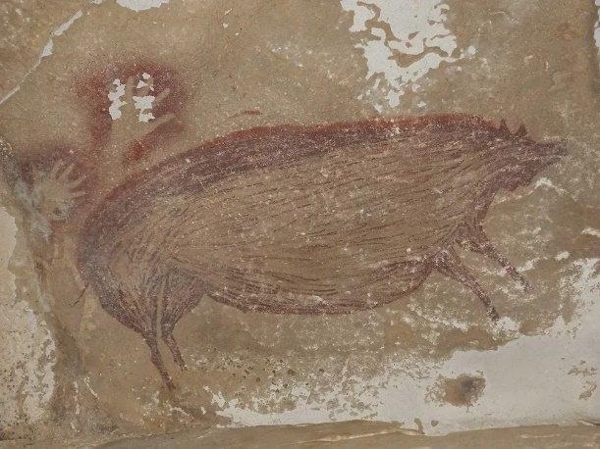
The origin of creative writing in humanity can be traced back to what is believed to be one of the oldest cave paintings created by Homo sapiens in the world, located on the island of Sulawesi off the coast of Indonesia. The simple depiction of this hog might not at first appear in our minds as a story, but it is in every sense so. An ancient human left their permanent mark in this world around 45,500 years ago when they decided to capture the likeness of a pig on a cave wall. This image, despite the lack of any accompanying written text, tells a story of its own. Scientists can analyse the contents of the paint to determine how it was made, showing insight into what the ancient person or people would harvest and what kind of wildlife surrounded the area they inhabited thousands of years ago. The way each stroke of paint has been applied to the stone can tell analysts what kind of methods and instruments were used to create the artwork. We can stand back and admire the picture, wondering what purpose its creator intended it to hold. We may never know the first true purpose of this image, but we can make our own analysis, draw our own conclusions, and is that not where the heart of literature lies?
Figure 1 Aubert. M, 45,000-Year-Old Pig Painting in Indonesia May Be Oldest Known Animal Art [Internet]. Sulawesi: Smithsonian Magazine; 13/01/2021 [cited 23/09/2024]. Available at: https://www.smithsonianmag.com/science-nature/45000-year-old-pig-painting-indonesia-may-be-oldest-known-animal-art-180976748/ Photograph, cave painting of a pig-deer.
Literature of the past gives us great insight into how our ancestors thought and what their morals and beliefs were, so it is crucial that we are able to preserve these parts of history. We can learn so much about our history by reading things such as diary entries, poems and theatrical scripts. The works of William Shakespeare are highly celebrated on a global scale, centuries after their creator’s passing, but when we read the scripts of his plays from our position in the future, we can see the amount of antisemitism written into his work. In The Merchant of Venice for example, the character of Shylock is the personification of several negative stereotypes of Jewish people. This is not to say that Shakespeare’s work should not be celebrated, we have to look at the past from the perspective of the people who lived there. The Merchant of Venice is a product of its time and plays its part in demonstrating how poorly Jews were thought of in 17th century Britain. Shakespeare wrote with the opinions and beliefs of the British public in mind. Another instance of him doing so is in the play Richard III where Shakespeare writes the character of Richard as a power-hungry villain who kills everyone who could have challenged his title, including his nephews and brothers. Queen Elizabeth’s grandfather, Henry VII, fought Richard III in the Battle of Bosworth Field where Richard III was killed. Therefore, the only way Shakespeare could portray Richard III without backlash was in this negative light due to the opinions of British people at the time.
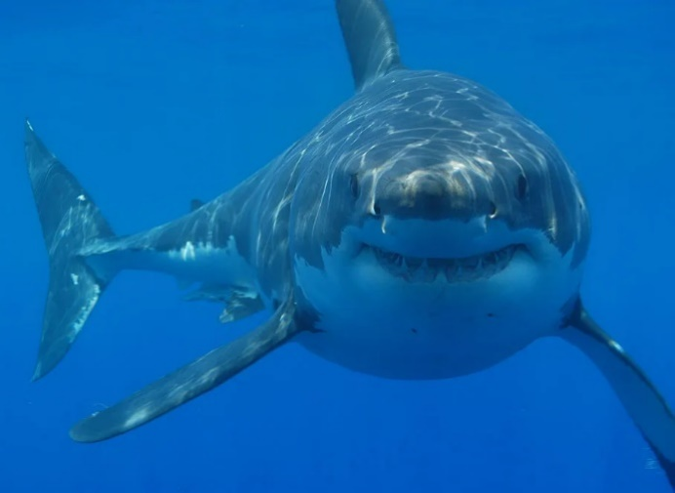
Stories shape how we perceive reality. Despite Shakespeare’s Richard III not being historically factual, many parts of the play are remembered as such. Richard III was not a vicious murderer, yet this is how he is remembered today because Shakespeare’s version of him is so famous. Another example of a story that has had such an effect on this scale is the movie Jaws which had a devastating impact on the shark population. The general public began to view sharks as mindless killers that attacked humans without reason and so, people began their own assault on sharks with no remorse. The entire population of great white sharks across the western coast of North America were nearly wiped out due to groups of people hunting them down. It is only within recent years that their numbers have begun increasing to a healthy amount once more. Stephen Spielberg, the director behind the film, has admitted he regrets how his film negatively contributed towards the perception of sharks. Stories have such a strong grip on our reality, they can completely alter how we remember history or view an innocent animal.
Figure 2 Hermanus Backpackers via Wikicommons under Creative Commons Attribution 2.0 Generic. Did Great White Sharks Drive Megalodon to Extinction? [Internet]. Smithsonian Magazine; 15/02/2019 [Cited 19/10/2024]. Available at: https://libguides.st-andrews.ac.uk/ Photograph, great white shark
One of the most culturally significant roles of creative writing was the part it played in ancient mythology and religion. It is believed that ancient Greek mythology first stemmed from centuries of orally shared stories that evolved over time into the myths as we know them. Humans came up with these ideas of how the universe began because instinctively we seek to understand the world around us. The legends of the Iliad and the Odyssey still echo in the stories we read today. Stories of heroes and monsters, good and evil, they are reflected throughout modern literature in both a literal sense and a metaphorical one. Superheroes in comics and films are not unlike Achillies and Odysseus, they follow the same core path of the Hero’s Journey. We can apply this format to almost any story, irrespective of whether or not there are any “heroes” involved. In a modern story, the protagonist may be a normal person and the obstacles and trials they must face may be being fired from their job, going through a divorce or being unable to achieve a goal. We are constantly retelling the same skeleton of a story but from a different perspective.
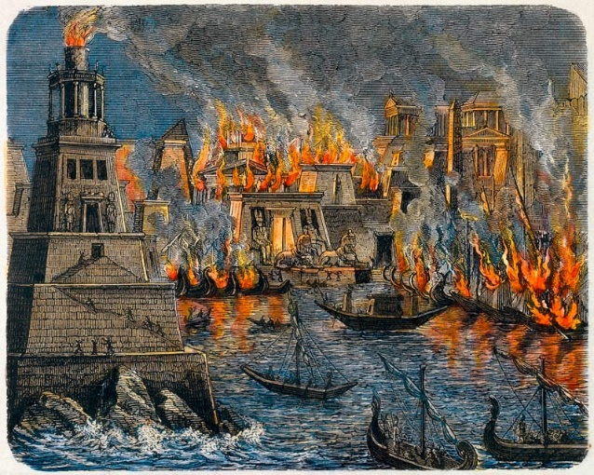
A great tragedy in the world of the humanities was the loss of the Library of Alexandria. Named for the Egyptian city founded by Alexander the Great in which it was built, the library was an esteemed and vast collection of research and writing. As the collection grew, so too did the library and so a second library was constructed in order to house the gargantuan assortment of scrolls. The archives were home to the works of some of history’s greatest minds. Philosophers, mathematicians, scientists, poets and writers alike had their work stored within the great walls. This included medical research texts written by Hippocrates, perhaps the most famous person in the history of medicine. There were also poems written by Sappho, one of the few female poets from ancient Greece whose work has survived history. The loss of her work through the destruction of the library is so tragic as many of her surviving poems that we know of today are only fragments of the entire pieces. Plato and Aristotle both also contributed to the mammoth collection of texts with their knowledge of philosophy.
Figure 3 Künstler. U. The Burning of the Library of Alexandria [Internet]. My Art Prints; n.d. [Cited 19/20/2024] Available at: https://www.myartprints.co.uk/a/unbekannter-kuenstler/derbrandderbibliothekvonalexandria.html. Photograph, print of a painting imagining the burning of the Library of Alexandria.
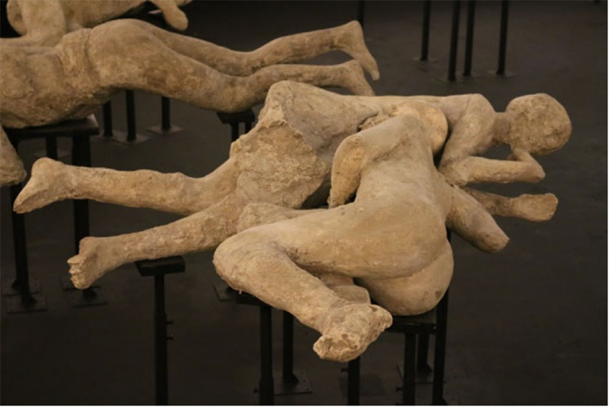
The destruction of the great library’s first building is believed to have been caused by Julius Caesar when he used fire to attempt to deter a fleet of enemy soldiers amidst a battle. The fire spread to the library and caused significant and devastating damage to both the structure and the scrolls. However, this timeline of events is debated and some historians and archaeologists have suggested that the library survived this initial burning and was actually destroyed at a later point. The second building was lost to the Emperor Theophilus I of Rome in attempt to abolish Paganism in Alexandria and spread Christianity. This devastating loss of centuries of knowledge impacts not only the world of literature and creative writing, but every single discipline across the humanities. Historians, archaeologists, philosophers, theologians and anthropologists alike must face the reality that this is a part of our past that we cannot and will probably never be able to fully understand. Poetry that will never again be read, accounts of people’s lives lost to history, advancements in science and mathematics forever forgotten. Such a wealth of knowledge left to smoulder in the ashes of time.
On the other hand, there is an infamous instance of tragedy that has opened up a fountain of historical information for us to research and understand and that is Pompeii. When Mount Vesuvius erupted in 79 AD, devastating the Roman city of Pompeii, the thick ash fell over the corpses of trapped civilians and almost perfectly preserved the position of their bodies as they died. When this was discovered during the excavation of Pompeii in the 19th century, a man called Giuseppe Fiorell developed a method of preserving these calcified moulds of people. Liquid plaster was poured into the holes to create casts of not only the bodies of people, but also animals and several artifacts. Every cast tells its own story, there are several which show people embracing in their last moments. It is unknown whether many of these pairings were family, lovers or friends, but what we can see is the most important part of what makes us human: our ability to love. These victims of a monumental catastrophe, aware of what was to come but powerless to stop it, chose to spend their precious last moments together as the end drew near. Is there anything more human than that?
Figure 4 Lazer. E, Pompeii Casts. Victims 20, 21, 22 and 23 found in the Casa del Criptoportico in July 1914 in the garden area [Internet]. PompeiiinPictures; 2015 [Cited 19/10/2024]. Photograph, casts of victims 21 and 22 who were killed in the disaster of Pompeii.
Through paintings, diaries, architecture, gravestones, bomb craters, plastic bottles, photographs, statues, skeletons and memories we have engraved ourselves into the face of the Earth to say that we were here, creative writing is just one of the many ways we have done so. Cave paintings were our first conscious mark and we have come so far since then. Thanks to the creation of the written word, we can look back on the writing of our ancestors and understand their minds. The stories that they wrote, and that we write today, can shape our view of the world into something else entirely. We can see the impact of creative writing on religion and how people of the past imagined how we came into existence before there was the science to explain it to them. There has a been significant loss of knowledge over millennia due to the careless and thoughtless actions of past humans that did not understand the importance of what they were destroying. Yet, in great loss there is also discovery like that of the remains of Pompeii. One crucial point remains as we gaze into the history of our species: though our individual lives may be short, forever we live on through history in the essence of the creations we leave behind.

BIBLIOGRAPHY
Murray. J. (May 2011) Can you teach creative writing? The Guardian, Education, online. Available at: https://www.theguardian.com/education/2011/may/10/creative-writing-courses#:~:text=The%20notion%20that%20decent%20writing,the%20first%20of%20its%20kind. (Accessed 01/10/2024)
American Academy of Arts and Sciences. (n.d.) The Scope of the “Humanities” for Purposes of the Humanities Indicators. American Academy of Arts and Sciences, online. Available at: https://www.amacad.org/humanities-indicators/scope-of-humanities (Accessed 10/10/2024)
Handwerk. B. (January 2021) 45,000-Year-Old Pig Painting in Indonesia May Be Oldest Known Animal Art. Smithsonian Magazine, Science, online. Available at: https://www.smithsonianmag.com/science-nature/45000-year-old-pig-painting-indonesia-may-be-oldest-known-animal-art-180976748/ (Accessed 23/09/2024)
Roth. E. (n.d.) The Merchant of Venice: The Play and the Jews. My Jewish Learning, online. Available at: https://www.myjewishlearning.com/article/the-merchant-of-venice/ (Accessed 18/10/2024)
Shakespeare Birthplace Trust. (n.d.) Richard III: Synopsis and plot overview of Shakespeare's Richard III. Shakespeare Birthplace Trust, online. Available at: https://www.shakespeare.org.uk/explore-shakespeare/shakespedia/shakespeares-plays/richard-iii/ (Accessed 18/10/2024)
University of Leicester. (n.d.) How Richard III Died. University of Leicester, Richard III, online. https://le.ac.uk/richard-iii/identification/osteology/injuries/how-richard-iii-died (Accessed 18/10/2024)
Land. G. (March 2023) 5 Myths About King Richard III. History Hit, online. Available at: https://www.historyhit.com/myths-about-richard-iii/ (Accessed 19/10/2024)
McGuire. D. (2023) HOW JAWS INFLUENCED SHARK PERCEPTION. Shark Stewards, online. Available at: https://sharkstewards.org/how-jaws-influenced-shark-perception/ (Accessed 17/10/2024)
Pappas. S. (May 2021) Great white shark population off California's coast is growing. Live Science, online. https://www.livescience.com/healthy-california-shark-population.html (Accessed 17/10/2024)
Germain. J. (December 2022) Steven Spielberg Regrets How ‘Jaws’ Impacted Real-World Sharks. https://www.smithsonianmag.com/smart-news/steven-spielberg-regrets-how-jaws-impacted-real-world-sharks-180981335/ (Accessed 17/10/2024)
Pollard. J. R. T. (September 2024) Greek Mythology. Britanica, Philosophy & Religion, Ancient Religions & Mythology, online. Available at: https://www.britannica.com/topic/Greek-mythology (Accessed 27/09/2024)
Master Class. (September 2021) Writing 101: What Is the Hero’s Journey? 2 Hero’s Journey Examples in Film. Master Class, Articles, online. Available at: https://www.masterclass.com/articles/writing-101-what-is-the-heros-journey (Accessed 27/09/2024)
Chesser. P. (2023) The Burning of the Library of Alexandria. eHistory, Articles, online. Available at: https://ehistory.osu.edu/articles/burning-library-alexandria (Accessed 15/10/2024)
Garlinghouse. T. (March 2022) The rise and fall of the Great Library of Alexandria. Live Science, online. Available at: https://www.livescience.com/rise-and-fall-of-the-great-alexandria-library (Accessed 15/10/2024)
Poets.org. (n.d.) Sappho. Poets.org, online. Available at: https://poets.org/poet/sappho (Accessed 15/10/2024)
Padman. R. (August 2023) The Collector, online. Available at: https://www.thecollector.com/who-was-sappho-of-lesbos/ (Accessed 15/10/2024)
El-Abbadi. M. (n.d.) The fate of the Library of Alexandria. Britannica, Literature, Libraries & Reference Works, online. Available at: https://www.britannica.com/topic/Library-of-Alexandria/The-fate-of-the-Library-of-Alexandria (Accessed 15/10/2024)
Brinkhof. T. (n.d.) The Hunt: Did Julius Caesar Really Destroy the Great Library of Alexandria? Art Net, Archaeology & History, online. https://news.artnet.com/art-world/the-hunt-library-of-alexandria-julius-caesar-2529132 (Accessed 15/10/2024)
Pompeii Sites. (n.d.) The Casts. Pompeii Sites, online. Available at: https://pompeiisites.org/en/pompeii-map/analysis/the-casts/#:~:text=The%20bodies%20of%20these%20victims,after%20the%20biological%20material%20decomposed. (Accessed 19/10/2024)
Pompeiiin (n.d.) Plaster Casts. Pompeiiin, online. Avaliable at: http://www.pompeiin.com/en/Pompeii_plaster_casts.html#:~:text=In%201870%20the%20archaeologist%20Giuseppe,cast%20was%20brought%20to%20light. (Accessed 19/10/2024)

Janet Murray. (10/05/2011) Can you teach creative writing? https://www.theguardian.com/education/2011/may/10/creative-writing-courses#:~:text=The%20notion%20that%20decent%20writing,the%20first%20of%20its%20kind (Accessed 01/10/2024)
American Academy of Arts and Sciences. (n.d.) The Scope of the “Humanities” for Purposes of the Humanities Indicators. https://www.amacad.org/humanities-indicators/scope-of-humanities (Accessed 10/10/2024)
Brian Handwerk. (13/01/2021) 45,000-Year-Old Pig Painting in Indonesia May Be Oldest Known Animal Art. https://www.smithsonianmag.com/science-nature/45000-year-old-pig-painting-indonesia-may-be-oldest-known-animal-art-180976748/ (Accessed 23/09/2024)
Elana Roth. (n.d.) The Merchant of Venice: The Play and the Jews. https://www.myjewishlearning.com/article/the-merchant-of-venice/ (Accessed 18/10/2024)
Shakespeare Birthplace Trust. (n.d.) Richard III: Synopsis and plot overview of Shakespeare's Richard III. https://www.shakespeare.org.uk/explore-shakespeare/shakespedia/shakespeares-plays/richard-iii/ (Accessed 18/10/2024)
University of Leicester. (n.d.) How Richard III Died. https://le.ac.uk/richard-iii/identification/osteology/injuries/how-richard-iii-died (Accessed 18/10/2024)
Turi King. (02/11/2016) How close was Shakespeare's portrayal of Richard III? https://www.britishcouncil.org/voices-magazine/how-close-was-shakespeares-portrayal-richard (Accessed 18/10/2024)
Graham Land. (19/03/2023) 5 Myths About King Richard III. https://www.historyhit.com/myths-about-richard-iii/ [Accessed 19/10/2024]
ibid
David McGuire. (2023) HOW JAWS INFLUENCED SHARK PERCEPTION. https://sharkstewards.org/how-jaws-influenced-shark-perception/ [Accessed 17/10/2024]
ibid
ibid
Stephanie Pappas. (26/05/2021) Great white shark population off California's coast is growing. https://www.livescience.com/healthy-california-shark-population.html [Accessed 17/10/2024]
Jacquelyne Germain. (20/12/2022) Steven Spielberg Regrets How ‘Jaws’ Impacted Real-World Sharks. https://www.smithsonianmag.com/smart-news/steven-spielberg-regrets-how-jaws-impacted-real-world-sharks-180981335/ (Accessed 17/10/2024)
John Richard Thornhill Pollard. (10/09/2024) Greek Mythology. https://www.britannica.com/topic/Greek-mythology (Accessed 27/09/2024)
Master Class. (03/09/2021) Writing 101: What Is the Hero’s Journey? 2 Hero’s Journey Examples in Film. https://www.masterclass.com/articles/writing-101-what-is-the-heros-journey (Accessed 27/09/2024)
Preston Chesser (2023) The Burning of the Library of Alexandria https://ehistory.osu.edu/articles/burning-library-alexandria (Accessed 15/10/2024)
ibid
Tom Garlinghouse. (14/03/2022) The rise and fall of the Great Library of Alexandria. https://www.livescience.com/rise-and-fall-of-the-great-alexandria-library (Accessed 15/10/2024)
ibid
ibid
Poets.org. (n.d.) Sappho. https://poets.org/poet/sappho (Accessed 15/10/2024)
Rhianna Padman. (10/08/2023) https://www.thecollector.com/who-was-sappho-of-lesbos/ (Accessed 15/10/2024)
Tom Garlinghouse. (14/03/2022) The rise and fall of the Great Library of Alexandria. https://www.livescience.com/rise-and-fall-of-the-great-alexandria-library (Accessed 15/10/2024)
Mostafa El-Abbadi (n.d.) The fate of the Library of Alexandria. https://www.britannica.com/topic/Library-of-Alexandria/The-fate-of-the-Library-of-Alexandria (Accessed 15/10/2024)
ibid
Tim Brinkhof. (n.d.) The Hunt: Did Julius Caesar Really Destroy the Great Library of Alexandria? https://news.artnet.com/art-world/the-hunt-library-of-alexandria-julius-caesar-2529132 (Accessed 15/10/2024)
Mostafa El-Abbadi (n.d.) The fate of the Library of Alexandria. https://www.britannica.com/topic/Library-of-Alexandria/The-fate-of-the-Library-of-Alexandria (Accessed 15/10/2024)
Pompeii Sites. (n.d.) The Casts. https://pompeiisites.org/en/pompeii-map/analysis/the-casts/#:~:text=The%20bodies%20of%20these%20victims,after%20the%20biological%20material%20decomposed. (Accessed 19/10/2024)
ibid
Pompeiiin.com (n.d.) Plaster Casts. http://www.pompeiin.com/en/Pompeii_plaster_casts.html#:~:text=In%201870%20the%20archaeologist%20Giuseppe,cast%20was%20brought%20to%20light. (Accessed 19/10/2024)

