The rationale
According to Webfinance (2018, para 1) an entrepreneur is
‘someone who exercises initiative by organizing a venture to take benefit of an opportunity and, as the decision maker, decides what, how, and how much of a good or service will be produced.’
In order for entrepreneurs to be successful within society they need to have two specific characteristics, these are desirability and feasibility. (chen et al., 2012) An entrepreneur must view their new venture or business as desirable and realistic for the future with specific goals in mind, in order to succeed and progress in their business. ‘Feasibility factors include human capital such as education, prior knowledge, and experience. (chen et al., 2012, pg. 2) Entrepreneurs must have previous skills, knowledge and about the field they are about to enter, so that they are aware of different opportunities that are available to them.
Furthermore, according to the Welsh Assembly Government (2010-15) The Youth Entrepreneurship Strategy (YES Plan) states that more young people in Wales are now wanting to start their own business and the YES Plan Strategy ‘aims to boost young people’s entrepreneurial confidence so they can play a full and effective part in the economy and community.’ (Welsh Assembly Government., 2010-15, pg. 3) The YES Plan provides various opportunities and entrepreneurial resources and material to classrooms to help support entrepreneurial curriculum. Opportunities include various workshops that are funded and provided by the Welsh Assembly Government. The YES Strategy believe and promote in 3 different themes, these include engaging young people which focuses on endorsing entrepreneurial values and creating opportunities for young people. The next key theme is empowering young people which focuses on providing young people with different entrepreneurial prospects. The final key theme which the YES Plan are strongly for is equipping young people, which focuses on preparing young people with the basic skills to develop and grow their very own business.
The YES Strategy is a key document which supports the Bake Sale opportunity, as it allows students to develop key networks and relationships with organisations and businesses. Building a strong connection with business and education to make the most of the benefits this may bring. Also empowering young people to become more business minded and develop key transferable and entrepreneurial skills. The Bake Sale opportunity will allow students to develop these key skills, which will be further discussed below.

A brief of the Entrepreneurial Education Opportunity.
The bake sale will be a stall held in school summer fete within school grounds. The opportunity will allow students to develop negotiation skills, communication skills and money handling/ management skills (Chang et al., 2013). Students will be required to buy, prepare, organise products and ingredients and sell their bakes at a reasonable price in order to gain a rational profit. The opportunity will involve both male and female students in years 5 and 6, as they are more aware of their surrounding and can grasp a basic understanding of the targets and goals of the opportunity.
Students who are participating within the bake sale will be required to take some time out after school at least once a week, so that lessons and learning are not disrupted. Also, canteen facilities may be used to prepare the products and a supervisor will manage and delegate their team members and give them specific roles and responsibilities each week. A manager will also be delegated to ensure the smooth running of the bake sale, also to confirm that specific goals and profit margins are met. The target group will students within the school, parents and the local community.
Curriculum Links.
There will also be various sale assistants who will oversee the preparation of the bakes and will also money handling, which will support key numeracy and mathematic skills. The business opportunity will allow students to develop many skills which link directly to the curriculum. Curriculum links include literacy skills, as students will be communicating with customers also writing signs to promote the business and develop the ability to read and follow various cupcake and cookie recipes. Numeracy skills will also be developed as students will be working out percentages of profit and loss, counting money and giving appropriate change, also other numeracy skills include weighing and measuring ingredients. Science skills can also be developed, as students will be learning raising agents and different mixtures and textures. Furthermore, health and safety skills are advanced by students as they will be getting first hand experience in a kitchen setting. Where they will be able to practice food hygiene and food safety whilst using kitchen tools, such as knives and cookers. (TheSchoolRun.com., 2018)
Entrepreneurial and Transferable Skills
Moreover, the opportunity will enhance many entrepreneurial and transferable skills, which students can use beyond school. Key skills which will be developed are creativity and critical thinking skills. From participating in this opportunity students will gain various creativity skills, which include problem solving skills, for instance when if ingredients run out or if there is not enough change available. Students need to be able to use initiative and find solutions to the problem. Lateral thinking and innovation skills also come under the creativity bracket, as students need to be able to think outside the box and looks at aspects of their business from an unexpected perspective, also be prepared for the unexpected and unplanned situations. Other entrepreneurial skills that will gained from the opportunity are self-knowledge, belief and confidence, motivation, aspiration, determination and competitiveness. (Business Wales., 2018) Students will need to have these skills prior to the opportunity and they should be able to enhance these skills alongside the process of the opportunity, these skills will also enable the opportunity to become a success.
Moreover, the opportunity will equip students with vital transferable skills which they will be able to use outside of school and in the future. These transferable skills include working with others, managing difficult situations, negotiation, persuasion and influence, presentation and effective communication skills. Within the opportunity students will have first-hand experience with dealing with various people and customers, therefore it is vital to have impeccable communication skills in order to sell the cakes and cookies. Also, presentation skills will be developed within the opportunity. Presentation can come under how students present themselves to how the stall is set up, it can make or break the success of the business opportunity. students need to be presented well in order for customers to come and approach them and thee cake and cookie stall must be presented well and aesthetically pleasing to see, as this is what will attract customers to the stall. (Business Wales., 2018)
Resources
This next section will look at what resources will be needed in order to run the bake sale business. First of all, in order to run a cake sale or any business funding is key. For this business opportunity a large amount of funding will be coming from the school budget and a voluntary contribution from student’s family and friends and the community will be admired. The school budget for this opportunity will be £100, and some resources from the school will be used such as paper and pens to make the posters and school furniture such as tables and chairs to hold the stall. This will be done to try and keep the budget down and to make use of resources that is already available, and which are easily accessible. A full price list of all resources has been made which shows exactly what resources and ingredients will be needed, where they can be sourced from and how much they will cost. (Appendix 1)
Resources and ingredients will include; 1 or 2 tables depending on how much space will be available, this will be sourced from the school. 2 cake stands, to present the cupcakes which will be sourced from eBay or Amazon, 2 packs of 50 cupcake cases which will be sourced from the pound shop, 2 baking trays which will be sourced from the pound store. Also, aprons which will sourced from the school if available or bought from eBay or Amazon, 2 large mixing bowls and 3 wooden spoons which will be sourced from the pound shop, a sieve and measuring spoons which will also be sourced from the pound shop and finally measuring scales which will be sourced from the school if available. Baking ingredients will include flour, eggs, milk, butter, chocolate Chips, Icing Sugar, sugar and vanilla extract. All ingredients will be bought in accordance to how much cupcakes and cookies will be made. Furthermore, all pricing will be calculated in the price list. (Appendix 1)
Content
There will be various lesson plans and schemes of work within the 5-week period and each week there will be a running theme up until the day of the bake sale. This will be done, so that students are aware of what they are expected to do, as during each week different aims and objectives will be discussed. The key theme for the first week of the opportunity will relate to health and safety in a kitchen environment and food safety. Aims and objectives of the session will be to identify and explain why food safety and food hygiene is important and to identify key risks and problems that can occur in a kitchen setting. During the session students will be required to list key rules and procedures that they think will be used within any catering business or kitchen setting, this may last around 10mins. Students will then be given different scenarios and incidents which have taken place in a kitchen setting, which they will then have to rank in terms of severity of risks and they will be asked to come up with solutions to problems and be asked what they will do if they are in they were in that position.
The following week will focus on a planning the opportunity, where students will plan and decide what they will be baking to the bake sale. Also, the main aim for this session is to focus of profit margins and working out what products will sell better are realistic to make with the limited time frame. Students will also be looking for simple cupcake and cookie recipes online and figuring out how they will decorate their bakes to make them look aesthetically pleasing, also considering different flavour options. The final aim of the session will be to consider allergies and dietary requirements of consumers, students will have to come up with ways of how they will meet the majority of their consumer’s needs, in order to gain the maximum profit of their business. This can be done through maybe considering some dairy free and nut free options.
The third week will focus on the creative side of the opportunity, where the main aims and objectives of the session will be to create poster and signs for the bake sale. Students will be required to design and create various posters and signs to promote their business. During this session students will develop key skills, such as creativity skills and ICT and computer skills. Students can promote their business on the school website, where they will be able to put up key information such as date, time and the location of the opportunity and also what they will be selling in the bake sale. Students will also develop digital literacy skills during this session. Digital literacy skills are vital within 21st century, as more and more schools are adopting digital devices to enhance learning in the classroom. Digital learning is simply ideas, knowledge, skills and the ability to use digital devices to support learning. There are six essential digital literacy skills, these include; digital responsibility, which focuses on how to stay safe online, digital productivity, which focuses on different skills on how to access information online. Digital information literacy is another digital literacy skill which focuses on sourcing relevant and appropriate information and being able to critically evaluate that information. Digital collaboration focuses on sharing and collaborating and sharing information with others, digital creativity focuses on accessing different software and programmes and various digital media to generate different prospects. Finally, digital learning which focuses on the overall concept of digital literacy and is can create various learning opportunities for young people and students. (Cymru, 2018)
The fourth week of the opportunity, will require student to calculate the costs and further enhance their mathematic skills. The main aims and objectives of this session will be to calculate costs of resources. Students will have to work out exactly how much they are going to spend on ingredients and resources and how they will keep within the budget. Also, during this session students will be required to go out and buy the ingredients for their cupcakes and cookies and other resources they may need. Students will be required to source their ingredients and resources and work out the quantity of their ingredients and exactly how much they will need for their bakes. Students will need to budget appropriately in order to make the most out of their money and to avoid wasting money.
The fifth and final week of the opportunity will be on the day of the bake sale. The main aims and objectives of this session will be to set up their bake sale stall in the school summer fair. Students will be required to set up the stall and prepare their bakes. Students will need to allocate specific roles amongst themselves, this is to allow each student to get involved with the business process and for the smooth running of the business. Key skills that students will develop within this session of the opportunity will be money handling, communication skills, people skills and presentation skills.
Recognized skills that are developed by students within the opportunity.
There will be many skills developed by students within the opportunity. Therefore, in order to recognise and acknowledge these skills a combination of summative and formative assessments will be used to monitor and review students’ progress and be used as a form of feedback. The main form of assessment which will used to asses and monitor student’s performance will be the use of formative assessments. Formative assessment refers to a wide variation of methods that teachers and education professionals use to conduct student evaluations, learning requirements of students, and academic progress during different lessons. Formative assessments help teachers identify ideas that students are struggling to understand, skills they are having difficulty obtaining, or learning standards they have not yet achieved or reached, this so that adjustments can be made to lessons, different techniques and approaches can be used, and academic support given. Formative assessment has been shown to be highly effective in raising the level of student achievement, increasing student outcomes and performance, and improving students’ ability to learn. Both peer assessments and student self-assessments are a form of formative assessments. (Black et al., 2003/ 2004)
This will be done at the end of each week of the business opportunity and after the opportunity is completed. Each student will be required to fill out a self-assessment feedback sheet, which will include aspects that they felt went well, aspects which they felt that they needed to improve and things that they could do better in the next session. Self-assessment is an imperative skill to have as it allows students to monitor their progress and evaluate their strengths and weaknesses. (Papa., 2017) Furthermore, at the end of the opportunity each student who played a role within the bake sale will be given a certificate (Appendix 2). This will be done to acknowledge student’s efforts and to certify that they have taken part in the opportunity. Certificates encourage students to take charge of their learning and become self-directed in their eagerness to learn things that are not directly part of the curriculum. Also, allowing them to develop a positive attitude in learning. Certificates and record of achievements are important as they help boost student’s self esteem and to make sure that they do not feel like that their efforts have gone to waste, and overall creating a positive learning environment. (Andy., 2014)
Assessment and Evaluation
Students will be assessed, evaluated and rewarded for their efforts in various ways. Within the bake sale their will be a competition amongst students, where they will be able to compete against each other and showcase their skills. This will be done as often during business opportunities and cake sales within schools, students can feel left out and feel like they are not playing a vital role within the opportunity. Therefore, allowing them to create their own bakes and showcase them in the bake sale will empower them and give them a sense of responsibility and a sense of pride. This will also give the opportunity for staff members and teachers to asses each student, giving them feedback and praise as when needed, also to recognize various strengths and weaknesses of each student.
Conclusion
In conclusion, it is clear to say that business opportunities like bake sales are essential and should be incorporated within schools more often. Many benefits of opportunities like this include gaining vital entrepreneurial and transferable skills. As stated above entrepreneurial and transferable skills are imperative for young people to acquire and develop as these skills will see them through the future amongst higher education and future job prospects. Just to reiterate the skills that can be developed within opportunities like the bake sale are communication skills, people skills, money handling skills, digital literacy skills and essential maths and literacy skills can be further enhanced. Furthermore, taking part in entrepreneurial, education opportunities like these can benefit society as well as individuals. These businesses are benefiting the economy and societal needs, society needs individuals who are able to take risks and are self-determined and self-reliant, who also to benefit and prosper from their own finical goals and merits. Entrepreneurs add great value to society as they have desirable skills that every employer seeks out for in an individual.

APPENDIX 1

APPENDIX 1 – PRICE LIST/ OVERVIEW
Product | Source | Price | Quantity | Image
Table | School property/ furniture | £0.00 | 2x tables | 
Cake stand | Amazon/ eBay | £4.50 | 2x cake stands = £9.00 | 
Cupcake cases | Amazon/ eBay | £0.90 | 2x packs of 50 cupcake cakes cases = £1.80 | 
Baking tray | Amazon/ eBay | £2.00  £2.00 | 2x cupcake trays = £4.00  2x baking trays = £4.00 | 
Apron | Amazon/ eBay  School | £5.00  £0.00 | 10x aprons = £5.00 | 
Ingredients  - Flour  - Eggs  - Milk  - Butter  - Chocolate Chips  - Icing Sugar  - Sugar  - Vanilla extract | Tesco | - Flour – £1.00  - Eggs - £1.00  - Milk - £1.00  - Butter - £0.80  - Chocolate Chips - £0.70  - Icing Sugar - £1.00  - Sugar - £1.00  - Vanilla extract - £1.50 | Flour x4 = £4.00  Eggs x4 packs of 12 = £4.00  Milk x2 = £2.00  Butter x4 = £3.20  Choclate chips x2 =£1.40  Icing Sugar x4 = £4.00  Sugar x4 = £4.00  Vanilla extract x1 = £1.50 | 
Large Mixing Bowl | Pound shop | £2.00 | 2x plastic large mixing bowls = £4.00 | 
Wooden Spoon | Pound shop | £1.00 | 3x wooden spoons = £3.00 | 
Measuring spoons | Pound shop | £1.50 | 2x sets of measuring spoons = £3.00 | 
Sieve | Pound shop | £2.00 | 2x Seives = £4.00 | 
Scales | Amazon/ eBay  School | £5.00  £0.00 | 2x scales =£10.00 | 

APPENDIX 2
APPENDIX 2 - CERTIFICATE OF APPRECIATION FOR STUDENTS

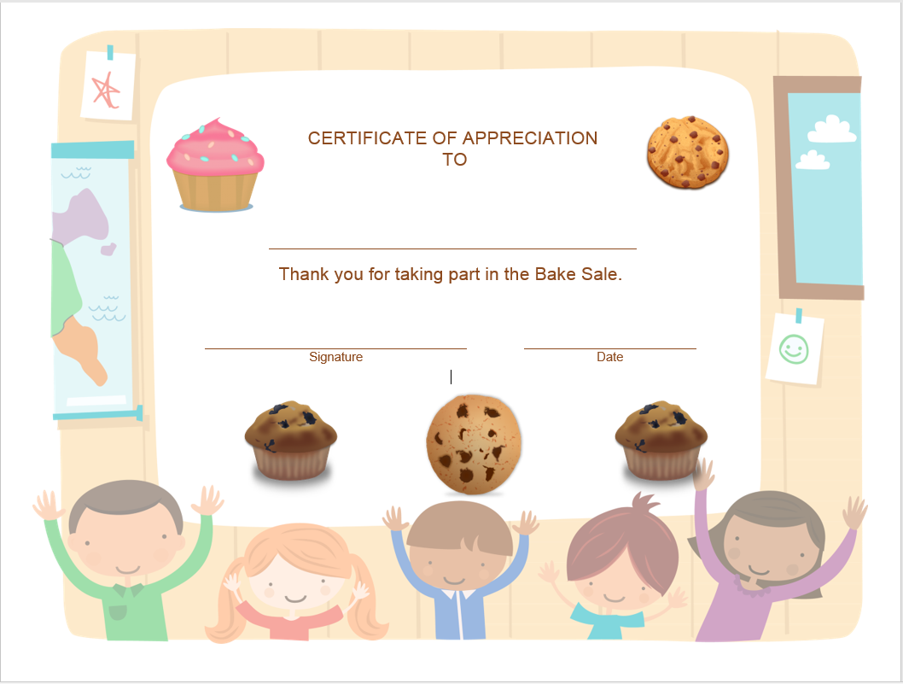

References
Andy, (2014). Motivate Pupils with Certificates for Achievement.[Online] Available at: http://www.schoolstickers.com/en-gb/blog/2014/03/28/motivate-pupils-with-certificates-for-achievement/ [Accessed 28 March 2014].
Black, P., Harrison, C., Lee, C., Marshall, B., Wiliam, D., (2003) Assessment for Learning: Putting it into Practice.
Black, P., Harrison, C., Lee, C., Marshall, B., Wiliam, D., (2004) Working inside the Black Box: Assessment for Learning in the Classroom.
Business wales. Welsh Government., (2018) Understanding Entrepreneurship - The ACRO Model. [online] available at: https://businesswales.gov.wales/bigideas/understanding-entrepreneurship-acro-model
Chen, S., Su, X. & Wu, S., (2012). NEED FOR ACHIEVEMENT, EDUCATION, AND ENTREPRENEURIAL RISK-TAKING BEHAVIOR. Social Behavior and Personality, 40(8), pp.1311–1318.
Chang, J. & Rieple, A., (2013). Assessing students' entrepreneurial skills development in live projects. Journal of Small Business and Enterprise Development, 20(1), pp.225–241.
Cymru, A., (2018). Essential Digital Literacy Skills. [Online] Available at: http://www.agored.cymru/Units-and-Qualifications/Essential-Skills-Wales/Essential-Skills-for-Learners/Essential-Digital-Literacy-Skills [Accessed 2018].
Jones, C. & Hegarty, C., (2011). Exploring the Role of Entrepreneurial Marketing in Entrepreneurship Education. Journal of Small Business and Entrepreneurship, 24(1), pp.125–137,151–152.
Papa, N., (2017). Advantages & Disadvantages of Self-Assessment. [Online] Available at: https://bizfluent.com/list-6718905-advantages-disadvantages-self-assessment.html [Accessed 26 September 2017].
TheSchoolRun.com., (2018). Bake and Learn. [Online] Available at: https://www.theschoolrun.com/cooking-kids-educational-benefits [Accessed 2018].
Welsh Assembly GOVERNEMENT., (2010-15) Youth Entrepreneurship Strategy [Online]Available at: https://businesswales.gov.wales/bigideas/sites/bigideas/files/documents/pdf/YES-%20An%20Action%20Plan%20for%20Wales%202010-15%20_Eng_1.pdf
Webfinance., (2018). Entrepreneur. [Online]
Available at: http://www.businessdictionary.com/definition/entrepreneur.html
[Accessed 2018 ].

