

Name: Hajar Takidine
Student number: 2312530
Module Code: LCBB5013
Module Title: Entrepreneurship
Assignment Title: Task 1: Business Plan Development (Elements 1–4)
University of Wales Trinity Saint David, Birmingham
Program of study: BA Business Management

Contents
Introduction 4
1: Company Overview, Products/Services, Objectives and USP 4
1.1 Company Overview 4
1.2 Products and Services 5
1.3 Objectives 5
Short-Term Objectives 5
Long-Term Objectives 6
1.4 Unique Selling Proposition (USP) 6
2: Business Environment and Competitor Analysis 7
2.1 SWOT Analysis 7
2.2 Competitor Analysis 8
3: 4Ps, Market Segmentation and Marketing Strategies 8
3.1 Market Segmentation 8
3.2 Marketing Mix (4Ps) 9
3.3 Online Marketing Strategy 11
4: Financial Planning 12
4.1 Growth from Start-Up to Global Brand 12
4.2 Investment and Growth Milestones 12
Conclusion 13
References 14

Introduction
Entrepreneurship is widely recognised as a critical driver of economic growth, enabling new ideas to generate employment and respond to evolving consumer needs (Burns, 2022). We are Gymshark, a British fitness apparel and lifestyle brand founded in 2012 by Ben Francis and Lewis Morgan in Birmingham. Starting from a garage with minimal resources, we have grown into one of the world's most recognised fitness brands, serving customers across more than 180 countries (Gymshark, 2024). This business plan critically analyses our products and services, strategic objectives, business environment, marketing strategy and financial development, applying relevant entrepreneurial and marketing theories throughout to evaluate both our achievements and the challenges we must navigate to sustain long-term competitive advantage.

1: Company Overview, Products/Services, Objectives and USP

1.1 Company Overview
Gymshark was founded when Ben Francis identified a significant gap in the fitness clothing market for products that combined performance, modern aesthetics and affordability, targeting dedicated gym enthusiasts who were largely underserved by the major sportswear brands of the time (Gymshark, 2024). We began with a dropshipping model before transitioning to designing and manufacturing our own products, giving us far greater control over quality, branding and the overall customer experience. This strategic shift proved decisive in establishing the authentic brand identity we are known for today.
Our origins closely align with Schumpeter's (1934) theory of innovation, which argues that entrepreneurs create economic value by introducing new combinations of products, processes and market approaches. Rather than competing through traditional advertising alongside established giants, we leveraged emerging social media platforms and fitness influencer partnerships to build a genuinely loyal customer base from the ground up. Burns (2022) similarly identifies this pattern as characteristic of successful entrepreneurs who recognise underserved opportunities before competitors do. Today, we operate as a global direct-to-consumer brand and are increasingly investing in physical retail to deepen our community engagement and broaden our reach.

1.2 Products and Services
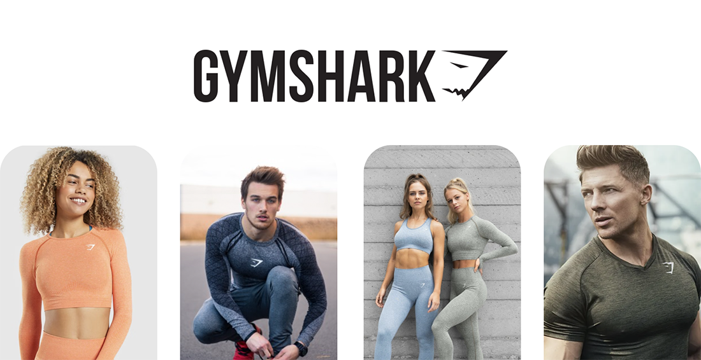
Figure 1: Gymshark brand and product
Our product portfolio primarily consists of fitness apparel, athleisure wear and related accessories. Critically, we do not simply sell clothing; we sell an identity. Our products are designed to support both athletic performance and personal expression, reflecting the growing convergence between sportswear and everyday fashion that is commonly referred to as the athleisure market (Euromonitor International, 2024).
Our fitness apparel includes leggings, sports bras, shorts, joggers, compression garments, and training tops. These items are designed to improve comfort, flexibility, and performance during exercise, with a focus on seamless construction, technical fabric innovation and ergonomic design. Our lifestyle and athleisure range appeals to consumers who wear sportswear beyond the gym, a category that has grown significantly in strategic importance as demand for versatile, everyday-appropriate clothing has accelerated. Accessories such as backpacks, water bottles and headwear extend the Gymshark ecosystem and contribute to brand visibility and customer loyalty. Our product strategy reflects Kotler, Keller and Chernev's (2022) concept of value creation, Businesses compete not only based on product features but also on the emotional and symbolic benefits they offer. This idea helps explain why our growth isn't just about product quality. Consumers choose Gymshark because they want to connect with a fitness-oriented community, and this understanding guides everything we design and create. Critically, however, this reliance on brand-driven demand means we must invest continuously in product innovation to avoid over-dependence on image at the expense of substantive development.

1.3 Objectives

Short-Term Objectives
In the short term, we are focused on increasing revenue growth, strengthening customer retention and expanding our international presence through a growing omnichannel strategy. Research consistently identifies customer retention as more cost-effective than new customer acquisition (Kotler, Keller and Chernev, 2022), and we invest heavily in social media engagement, our Gymshark Athlete ambassador programme and community events to strengthen loyalty and drive repeat purchases. Sustainability has also emerged as a meaningful short-term priority. We have introduced initiatives to reduce packaging waste and improve supply chain transparency (Gymshark, 2024), though we acknowledge that stakeholders increasingly expect measurable, independently verified progress in this area, and further commitment is required.

Long-Term Objectives
Our long-term focus is global expansion and brand leadership. We aim to establish Gymshark as a leading international fitness and lifestyle brand, capable of competing directly with Nike, Adidas and Lululemon across key global markets. We are also working to diversify revenue beyond apparel, exploring broader fitness experiences, digital engagement platforms and community-based initiatives. This aligns with Ansoff's (1957) Market Development and Product Development frameworks, which identify new market entry and new product creation as effective routes to sustained growth. Building long-term brand equity through customer loyalty, perceived quality and strong brand associations (Aaker, 1996) underpins both our short and long-term ambitions. However, global expansion carries the risk of diluting the authentic community identity that fuelled our early growth. Balancing commercial scale with cultural integrity remains one of our most important strategic challenges.

1.4 Unique Selling Proposition (USP)

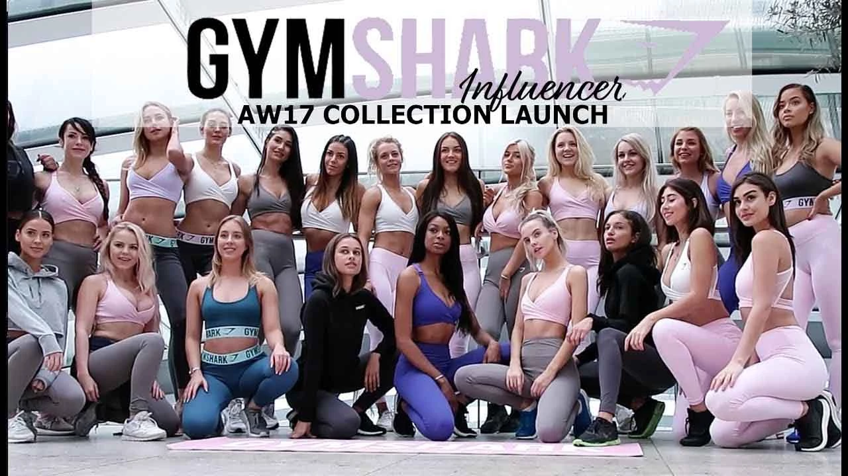
Our primary USP is the combination of high-quality fitness apparel with a strong, authentic sense of community and digital engagement. Unlike traditional sportswear brands that relied on celebrity athletes and mass broadcast advertising, we pioneered a social media-driven approach centred on fitness influencers and genuine everyday consumers. This reflects Keller's (2013) Customer-Based Brand Equity Model, which argues that the strongest brands build lasting emotional connections through meaningful experiences and powerful associations. Our influencer partnerships, fitness pop-up events and online communities create a genuine sense of belonging that extends well beyond product ownership.
Applying Barney's (1991) Resource-Based View, our community represents a strategically valuable and difficult-to-imitate asset. While competitors can replicate our clothing designs relatively easily, replicating the loyalty and emotional connection of our global community is considerably more challenging. However, it is important to evaluate this USP critically: influencer marketing has become widespread across the fitness industry, reducing its novelty as a competitive differentiator. We must therefore continue innovating our customer experience and brand positioning to maintain genuine differentiation. Our USP lies not merely in our products, but in our ability to foster emotional engagement, community participation and lifestyle identification, a combination that has enabled us to build a powerful brand within one of the world's most competitive consumer markets.

2: Business Environment and Competitor Analysis

2.1 SWOT Analysis
The SWOT framework, which evaluates strengths, weaknesses, opportunities, and threats, is one of the most commonly used tools for assessing an organisation's strategic position (Kotler, Keller, and Chernev, 2022). An effective SWOT analysis requires not only a clear understanding of each factor but also an awareness of how these factors interact and create strategic tension. Table 1 presents our SWOT analysis.
Table 1: Gymshark SWOT Analysis
Strengths | Weaknesses
• Strong brand identity and loyal global fitness community  • Direct-to-consumer model — full control over pricing, data and customer experience (Chaffey and Ellis-Chadwick, 2022)  • Dominant social media presence across Instagram, TikTok and YouTube  • Revenue growth: £176m (2019) to £607m (2024) (Gymshark, 2025)  • Gymshark Athlete ambassador programme driving authentic promotion | • Concentrated in fitness apparel — vulnerable to trend shifts  • Limited financial scale vs. Nike ($51bn) and Adidas (€23.7bn) (Nike, 2024; Adidas, 2024)  • Overseas manufacturing creates supply chain risk  • Sustainability credentials require further measurable development  • Dependence on social media platforms we do not control
Opportunities | Threats
• International expansion into Asia, Middle East and Latin America  • Growing athleisure and lifestyle apparel market (Euromonitor International, 2024)  • Digital fitness technology — wearables and personalised shopping (Chaffey and Ellis-Chadwick, 2022)  • Sustainability investment appeals to eco-conscious consumers (McKinsey, 2024)  • Physical retail expansion as community experience destinations | • Intense competition from Nike, Adidas, Lululemon and Under Armour  • Market saturation and rising new entrants (Porter, 1985)  • Economic uncertainty reducing discretionary consumer spending  • Social media algorithm changes threatening organic reach  • Rising production and logistics costs compressing margins

Our SWOT reveals a pattern common to high-growth entrepreneurial businesses: our greatest strengths and most significant vulnerabilities are frequently two sides of the same coin. Social media has enabled low-cost global growth but creates structural dependence on platforms we do not control. Our fitness-community focus creates exceptional brand clarity but simultaneously limits diversification. From a PESTEL perspective, technological developments in digital fitness and wearables present genuine growth opportunities, while macroeconomic uncertainty affecting consumer discretionary spending and algorithm changes across social media platforms represent meaningful external threats. Our future success requires actively leveraging our community, digital expertise and brand equity while investing in the operational resilience, sustainability credentials and geographic diversity needed to manage our vulnerabilities effectively.

2.2 Competitor Analysis
Understanding our competitive landscape is essential for strategic positioning (Johnson et al., 2020). Nike is the undisputed global market leader with revenues exceeding $50 billion (Nike, 2024) and possesses enormous resources for product innovation and high-profile sponsorships. However, its broad appeal across multiple sports means that it may lack the specialised connection with dedicated gym communities that Gymshark has developed through its niche positioning, enabling stronger emotional resonance with fitness-focused consumers. Lululemon competes more directly, particularly in women's activewear, with a premium pricing strategy and strong customer loyalty. Its higher price points create an accessibility gap that works in our favour, allowing us to attract quality-conscious younger consumers who find Lululemon prohibitively expensive while still maintaining a genuinely premium brand image.
ASOS acts as an indirect competitor by offering fitness and athleisure ranges within a convenient multi-brand platform. Younger consumers may choose to purchase gym clothing through ASOS for the convenience of bundled shopping, but ASOS fundamentally lacks the product specialisation, performance credentials and community identity that define our offering. Zara's fast-fashion model enables rapid adaptation to athleisure trends at competitive price points, yet it cannot credibly replicate our fitness heritage or technical product expertise. Consumers seeking genuine performance apparel are unlikely to view it as a meaningful substitute. Overall, we occupy a distinctive position: more community-focused than Nike, more accessible than Lululemon, and more credible in fitness than ASOS or Zara. Sustaining this requires continuous innovation in customer experience and product development as competitors increasingly invest in digital community strategies.

3: 4Ps, Market Segmentation and Marketing Strategies

3.1 Market Segmentation
Market segmentation involves dividing a broad consumer market into groups with shared characteristics to enable more focused and effective strategies (Kotler, Keller and Chernev, 2022). Our rapid growth since 2012 is largely attributable to the precision with which we identified and served a specific, underserved segment of consumers that established sportswear brands consistently failed to connect with authentically.
Demographically, we primarily target consumers aged 18–35, particularly Generation Z and Millennials who are fitness-conscious, digitally native and highly influenced by social media content. The women's activewear segment represents a significant growth opportunity given rising female participation in fitness (Euromonitor International, 2024), and our income positioning targets middle-income consumers seeking quality products without luxury-brand price tags. Geographically, our strongest markets are the UK, US, Canada and key European territories, with physical retail concentrated in urban centres where fitness culture exerts the strongest influence. From a psychological perspective, our most distinctive and strategically important dimension is targeting individuals who view fitness as a core component of their personal identity, not merely a hobby. Wedel and Kamakura (2000) identify values and lifestyle as powerful segmentation criteria when brands seek deep emotional engagement, and this is precisely what we have built. Behaviourally, we focus on regular gym-goers who actively engage with fitness content online and participate in our community, generating the organic word-of-mouth that no advertising budget can fully replicate. While our focused approach has led to impressive growth, depending too heavily on a narrow audience poses long-term risks. As we develop, it will be crucial to expand our appeal to a broader range of wellness and lifestyle consumers. However, achieving this without compromising the authentic fitness identity that established our community presents a significant strategic challenge for us moving forward.

3.2 Marketing Mix (4Ps)
The marketing mix provides a framework for understanding how organisations create and communicate value to their target customers through Product, Price, Place and Promotion (McCarthy, 1964). Table 2 applies the 4Ps to Gymshark, with a critical evaluation of each dimension.
Table 2: Gymshark 4Ps Marketing Mix
Product | Performance apparel combining athletic function with modern aesthetics  Our portfolio of activewear, athleisure clothing and accessories is developed with a focus on performance fabrics, seamless technology and ergonomic fit. Aaker (1996) argues that branding creates significant value by differentiating products and reducing consumers' perceived purchase risk — our minimalist logo and consistent association with fitness culture contribute meaningfully to our appeal. Fast delivery, responsive support and straightforward returns are integral components of the overall brand experience, not afterthoughts. Critically, however, increasing competition means product innovation must remain relentless; failing to invest continuously in new materials and technologies would erode our differentiation over time.
Price | Value-based pricing positioned between budget brands and premium competitors  We adopt a value-based pricing strategy, focusing on customers' perceptions of value rather than production costs alone (Kotler, Keller and Chernev, 2022). Positioned between budget fitness brands and Lululemon, we offer accessible quality without sacrificing aspirational appeal — aligning with our core demographic of younger, middle-income consumers who care deeply about brand identity but have finite budgets. Looking ahead, rising production costs and inflationary pressures may necessitate price increases that risk alienating price-sensitive customers, while excessive discounting risks eroding brand equity by weakening perceptions of exclusivity. Navigating this tension is one of our most important ongoing commercial challenges.
Place | Direct-to-consumer e-commerce expanding into omnichannel flagship retail  Our distribution is built around direct-to-consumer e-commerce, enabling rapid international growth across 180+ countries without traditional retail infrastructure costs. Chaffey and Ellis-Chadwick (2022) note that direct digital channels provide valuable customer insights while reducing dependence on intermediaries — both central to our competitive model. We are now expanding into flagship physical stores in cities such as London and New York, moving towards an omnichannel approach that integrates online and offline experiences. Physical stores increase brand visibility, enable community engagement and allow product interaction. However, they introduce high fixed costs, and we are managing this expansion carefully to ensure stores function as experiential brand destinations rather than purely transactional sales points.
Promotion | Pioneering influencer marketing, community-building and social media engagement  From our earliest days, we rejected expensive television campaigns and elite athlete sponsorships in favour of authentic social media engagement and fitness influencer partnerships. Brown and Hayes (2008) note that consumers trust recommendations from individuals they admire more than conventional advertising — an insight that has underpinned our entire promotional philosophy. Our strategy spans Instagram, TikTok, YouTube, Facebook and X; our Gymshark Athlete ambassador programme; community events and pop-up activations; user-generated content campaigns; email marketing; and public relations activity. This reflects Grönroos's (1994) relationship marketing principles — building long-term consumer relationships rather than short-term transactional sales. Critically, as influencer marketing has proliferated across the industry, we must continue innovating through deeper personalisation and richer digital experiences to sustain our promotional edge.

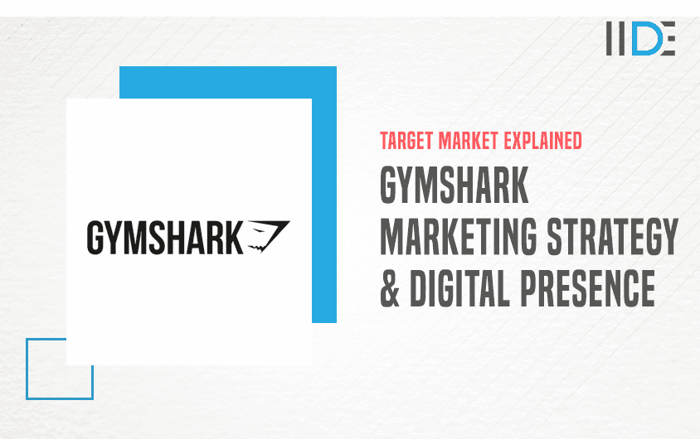
3.3 Online Marketing Strategy
Our digital-first approach has been fundamental to our success from the beginning. It allows us to compete effectively against larger, better-resourced organisations by focusing on authenticity, creativity, and community engagement. We maintain active presences on Instagram, TikTok, YouTube, Facebook, and X, platforms that research shows significantly influence purchasing decisions among younger consumers (Tiago and Veríssimo, 2014). Our content marketing strategy includes workout guides, motivational stories, and behind-the-scenes material that provides genuine value beyond just promoting products, establishing us as a credible and trusted voice in the fitness sector.
SEO investment strengthens our organic search visibility, reducing long-term dependence on paid advertising and building a more cost-efficient customer acquisition model. However, growing competition for digital attention, algorithmic volatility on major platforms and rising advertising costs all represent increasing strategic risks. Our dependence on third-party social media platforms we do not control is a structural vulnerability, and we are therefore actively investing in our owned media assets, our website, mobile application, customer database and loyalty programme to reduce this exposure and strengthen long-term customer retention. This reflects Chaffey and Ellis-Chadwick's (2022) argument that owned media provides the most durable foundation for digital marketing strategy, complementing earned and paid channels rather than relying on them exclusively.

4: Financial Planning

4.1 Growth from Start-Up to Global Brand
Gymshark was founded in 2012 with minimal resources. Ben Francis funded the business through personal savings and income from part-time work while studying at university, and early operations were run from a garage in Birmingham (Gymshark, 2024). Burns (2022) describes this as bootstrapping funding growth through personal capital and reinvested profits rather than external investment. While bootstrapping constrains early resources, it allowed us to retain full ownership and strategic flexibility. Crucially, our financial constraints pushed us towards creative, low-cost routes to market: the influencer marketing strategy we developed proved to be one of the most powerful and cost-efficient customer acquisition approaches in the industry, generating global brand awareness at a fraction of what traditional advertising would have cost.
Our revenue growth has been outstanding, as illustrated in Table 3. Revenue increased from approximately £176 million in 2019 to over £437 million by 2021, and reached £607.3 million by 2024. This demonstrates strong and sustained expansion, even amidst the economic disruptions caused by the COVID-19 pandemic (Gymshark, 2025; Burney, 2025)).

Table 3: Gymshark Revenue Growth (2019–2024)
Year | Revenue
2019 | £176 million
2020 | £260 million
2021 | £437 million
2024 | £607.3 million
Source: Gymshark Annual Reports
This trajectory reflects the effectiveness of our entrepreneurial strategy, digital marketing capabilities and ability to build deep customer relationships. However, revenue growth alone does not constitute business health. Recent financial results indicate that profitability has come under pressure as we invest in physical retail infrastructure, technology development and international expansion (Burney, 2025). This is a well-documented challenge for high-growth businesses: expansion frequently requires substantial investment ahead of the returns it is expected to generate. From a strategic perspective, these investments are best understood as consistent with Ansoff's (1957) market development framework, accepting lower short-term profitability in exchange for the capabilities needed to sustain long-term competitive advantage.

4.2 Investment and Growth Milestones
A transformative milestone came in 2020 when global investment firm General Atlantic acquired a minority stake in Gymshark, valuing us at over £1 billion and making us one of the United Kingdom's fastest-growing unicorn businesses (General Atlantic, 2020). This investment provided access to significantly greater financial resources and specialist expertise in scaling consumer businesses internationally. Capital was directed towards international market expansion, the development of flagship retail stores, technology and digital infrastructure investment, supply chain improvements and the recruitment of senior management talent to professionalise our operations.
Hisrich, Peters and Shepherd (2020) describe this transition as the shift from a founder-led start-up to a professionally managed growth organisation, a critical and often challenging evolution for businesses built around the energy and vision of their founders. For us, preserving the authentic, community-driven culture that built Gymshark while simultaneously professionalising our operations and scaling globally remains an ongoing and important strategic challenge. Looking ahead, rising operating costs, intensifying competition and the potential for consumer spending to soften in key markets all represent genuine financial risks. Balancing growth ambition with financial discipline, investing consistently in innovation and customer experience while maintaining operational efficiency, is central to sustaining our success in the years ahead.

Conclusion
This business plan has critically analysed Gymshark's entrepreneurial development across four interconnected elements. From a Birmingham garage in 2012, we have grown into a globally recognised fitness brand through innovative digital marketing, authentic community building and disciplined financial management. Applying Barney's (1991) Resource-Based View, our loyal global community is valuable, rare, and difficult to imitate, representing our most durable competitive advantage.
Our SWOT analysis highlighted significant vulnerabilities alongside our strengths. We need to address challenges such as our dependence on social media, our limited financial scale compared to industry giants, and the evolving expectations of stakeholders regarding sustainability. Additionally, our competitor analysis confirmed that we hold a truly unique market position. We are more community-focused than Nike, more accessible than Lululemon, and more credible in fitness than ASOS or Zara. However, maintaining this position will require continuous innovation in our products and marketing, especially as competition intensifies.
Our analysis of the 4Ps and segmentation reveals that a digital-first, community-driven strategy can effectively compete with much larger and better-funded organisations, as long as it is grounded in genuine consumer insights and continuous creativity. Financially, our revenue growth has increased from £176 million in 2019 to over £607 million in 2024, illustrating the strength of entrepreneurial vision paired with disciplined execution. The investment decisions we are making now—focusing on retail infrastructure, international expansion, and technology—will serve as the foundation for our next phase of growth. To maintain the trajectory we have established, we must balance our global ambitions with the authenticity, community spirit, and innovative culture that have defined Gymshark.

References
Aaker, D.A. (1996) Building strong brands. New York: Free Press.
Adidas AG (2024) Annual report 2024. Herzogenaurach: Adidas AG. Available at: https://report.adidas-group.com/2024/en/ (Accessed: 10 June 2026).
Ansoff, H.I. (1957) ‘Strategies for diversification’, Harvard Business Review, 35(5), pp. 113–124.
Barney, J.B. (1991) ‘Firm resources and sustained competitive advantage’, Journal of Management, 17(1), pp. 99–120. doi: 10.1177/014920639101700108.
Brown, D. and Hayes, N. (2008) Influencer marketing: Who really influences your customers? Oxford: Butterworth-Heinemann.
Burney, C. (2025) ‘Gymshark achieves record revenue, surpassing £600m for first time’, TheIndustry.fashion, 29 April. Available at: https://www.theindustry.fashion/gymshark-achieves-record-revenue-surpassing-600m-for-first-time/ (Accessed: 10 June 2026).
Burns, P. (2022) Entrepreneurship and small business: Start-up, growth and maturity. 6th edn. London: Bloomsbury Publishing.
Chaffey, D. and Ellis-Chadwick, F. (2022) Digital marketing: Strategy, implementation and practice. 8th edn. Harlow: Pearson.
Euromonitor International (2024) Sportswear in the United Kingdom. London: Euromonitor International. Available through: Euromonitor Passport database (Accessed: 10 June 2026).
General Atlantic (2020) ‘Gymshark secures investment from General Atlantic valuing company at over £1 billion’, 14 August. Available at: https://www.generalatlantic.com/media-article/gymshark-secures-investment-from-general-atlantic-valuing-company-at-over-1-billion/ (Accessed: 10 June 2026).
Grönroos, C. (1994) ‘From marketing mix to relationship marketing: Towards a paradigm shift in marketing’, Management Decision, 32(2), pp. 4–20. doi: 10.1108/00251749410054774.
Gymshark (n.d.) ‘About us’. Available at: https://www.gymshark.com/pages/about-us (Accessed: 10 June 2026).
Gymshark Ltd (2025) Full accounts made up to 31 July 2024. Companies House, company number 08130873. Available at: https://find-and-update.company-information.service.gov.uk/company/08130873/filing-history (Accessed: 10 June 2026).
Gymshark (2026) Gym clothes and workout clothes. Available at: https://uk.gymshark.com/ (Accessed: 20 June 2026).

Hisrich, R.D., Peters, M.P. and Shepherd, D.A. (2020) Entrepreneurship. 11th edn. New York: McGraw-Hill Education.
Keller, K.L. (2013) Strategic brand management: Building, measuring, and managing brand equity. 4th edn. Harlow: Pearson.
Kotler, P., Keller, K.L. and Chernev, A. (2022) Marketing management. 16th edn. Harlow: Pearson.
McCarthy, E.J. (1964) Basic marketing: A managerial approach. Homewood, IL: Richard D. Irwin.
Nike, Inc. (2024) Annual report 2024. Beaverton, OR: Nike, Inc. Available at: https://investors.nike.com/investors/news-events-and-reports/ (Accessed: 10 June 2026).
Porter, M.E. (1985) Competitive advantage: Creating and sustaining superior performance. New York: Free Press.
Retail Week has been replaced with the named-author reference below:
Bhoora, R. (2024) ‘Gymshark expands with second store in London’, Retail Week, 11 January. Available at: https://www.retail-week.com/sports-and-leisure/gymshark-to-open-second-store-in-london/7045328.article (Accessed: 10 June 2026).
Schumpeter, J.A. (1934) The theory of economic development: An inquiry into profits, capital, credit, interest and the business cycle. Cambridge, MA: Harvard University Press.
The Business of Fashion and McKinsey & Company (2023) The state of fashion 2024: Finding pockets of growth as uncertainty reigns. Available at: https://www.mckinsey.com/industries/retail/our-insights/state-of-fashion-2024 (Accessed: 10 June 2026).
Tiago, M.T.P.M.B. and Veríssimo, J.M.C. (2014) ‘Digital marketing and social media: Why bother?’, Business Horizons, 57(6), pp. 703–708. doi: 10.1016/j.bushor.2014.07.002.
Wedel, M. and Kamakura, W.A. (2000) Market segmentation: Conceptual and methodological foundations. 2nd edn. Boston, MA: Kluwer Academic Publishers.
Whittington, R., Regnér, P., Angwin, D., Johnson, G. and Scholes, K. (2020) Exploring strategy. 12th edn. Harlow: Pearson.

