

Student Name: | Sheila Choudhury
Student Number: | 1714030
Module No: | BMSK5004
Module Title: | Managing Projects in the Organisation
Lecturer: | Dr Gulnar Ali

Table of Contents

Introduction Pg. 5
The Project
Project Objectives
Project Deliverables
Project Time-Scale
Project Manager
Project Team-Members

Project Processes:

Project Selection/Approval Pg. 8

Sponsors and Stakeholders Pg. 8
Sponsors
Shareholders
Stakeholders
Customers
Suppliers
Competitors
Community

Project Scope Management Pg.11
Six Scope Management Factors
Project Scope Management Structure

Stakeholder Analysis Pg.13
Stakeholder Analysis Engagement Strategy
Stakeholder Analysis Approaches
Stakeholders within Medina Events

Project Methodologies Pg.16
PMBOK
PRINCE2
Extreme Project Management (XPM)

Project Lifecycle Pg.18
Diagram: Project Lifecycle

Project Planning Pg.19
Project Managers Responsibilities

Project Planning & Executing Phase Pg.20
Project Action Plan

Project Management Pg.23
Project Management Tools Gantts Charts

Project Communication Methods: Pg.23
Interactive Communication
Push Communication
Pull Communication

Nikah Event Project Communication Structure Pg.25

Project Risk Management Pg.25
Threats/Obstacles/Risks

Event Risk Management Pg.27

Project Budget and Resource Control Pg.28
Cost Benefit Analysis (CBA)
Cost Benefit Analysis Chart

Project Controlling & Monitoring Phase Pg.29

Project Closure & Exit Phase Pg.32

Reflection Pg.33
SWOT Plan
Self-Development Plan

Conclusion Pg.36

References Pg.37-38

Introduction

This Assignment is based on Project Management in the Organisation. The objective is to identify a specific task where one can demonstrate the importance of managing projects within the Organisation.

A Project defined in the PMBOK Guide as a temporary assignment undertaken to establish a Product, Service, or Result. Therefore, all Projects must take the following components into consideration such as:
- Goal
- Timeline
- Budget
- Stakeholders
- Project Manager

We must ensure that we do not confuse a Project with day-day- activities/operations or something that it is routine as it does not have a start and end.
Project Management is the appliance of skills, knowledge, tools, and techniques that is required to finalise a Project within a set time.
In this Report I will discuss a Project that I managed in a Family run Event Planning Business, that specialises in Wedding Planning for Indian, Pakistani and Bengali Bride & Groom.
The Services that is provided by ‘Medina Events’ are:
- Venues
- Wedding Favours
- Decorations
- Wedding Co-ordinator
- Caterers

‘Medina Events’ specialises in all types of Event Management ranging from: Venue Sourcing, Wedding Planning, Dawah, Conferences and Halal Catering.
The size of Wedding/Event organised ranges from:

- 50-100 Guests
- 100-300 Guests
- 300-500 Guests
- 500 Plus Guests

The Project:
The Project I will discuss is a Nikah (Engagement) Ceremony Event. I will evaluate and share knowledge of the process of how that Project was handled. Thereby, giving evidence of different tools and methods that are utilised during the management of the project and all the risk factors that are involved in the tasks, and share tools/ideas of how to overcome these obstacles so that in future same mistakes are not repeated and find solutions to the problems that are faced.
I will Self-Reflect through a SWOT & Self-Development Plan of how I will develop myself as a good Project Manager.

Project Objectives:
The main objective is to provide a High-Quality Service by Creating and Delivering a Customised Engagement Event with High-Standards and Quality Décor choices put together for an unforgettable Experience.

Project Deliverables
To deliver a Nikah/Engagement Event successfully, I will have a Team that I will work with throughout this Project that will help assist me to; Plan, Schedule, Book, Arrange, Hire with; Consultations, Appointments, Meetings with; Stakeholders/Vendors thus we are able to deliver within Budget and Timeframe to reach our Goal.

Project Time Scale: 24 Weeks (6 Months)
The timescale for Wedding/Engagement Planning varies. In the event of anything going wrong a lead time of Six Months is required in advance for purpose of availability for; Hiring/Sourcing Venues, Props, Nikah/Engagement Attire, Videographers, Photographers, Entertainment, Food & Beverage Caterers, Make-up and Henna Artist.

Project Manager (PM): Sheila (Myself)
Project Team-Members:
The Team consists of Eight Members that are split into two separate groups.
Team 1:
- Project Manager
- Assistant No.1
- Assistant No.2
- Assistant No.3

Team 2:
- Sub-Team Leader
- Assistant No.1
- Assistant No.2
- Assistant No.3

Project Processes:

Project Selection/Approval

In an organisation Projects are decided by upper management. After meetings and discussions with stakeholders, the upper management will come to a decision regarding the Project that is suitable for their organisation. The Project Managers can be chosen by the Upper-Management or by colleagues that work together as a Team within the same Department. The PM may be chosen because of the experience and skills they demonstrated by showcasing their knowledge within the task requirement of the given Project.
However, as this is a Family Business and the Bride in question is known within the family therefore, it becomes more personal. That was the reason why I put myself forward for this Project as a Wedding Co-ordinator; to help assist the Bride achieve her dream of having a fantastic, memorable, beautiful day that meets her expectations and more.

Sponsors and Stakeholders

According to ‘The School of Business Management,’ the Sponsors & Stakeholders are all the people that are involved or have an interest/influence in the Business, (2008, pg. 51). They are all the people that play a vital role in the Business. Therefore, it is necessary for Project Managers to always communicate and collaborate on the Project so that they can complete it within the Time Frame and Budget Requirement.

Sponsors

The Owners Interest in the Project relates to Profit.
In this Project there are four Sponsors and all of them are the Business Owners.

Shareholders

The Shareholders Interest in the Project relates to Dividend Payments & Business Performance as this could affect Share Prices.
As mentioned by ‘The Association of Business Executives’, Big organisations will have Shareholders and some of these Shareholders are the Institutional Investors within the Company such as Pension and Insurance Fund and Investment Trusts. These Shareholders will hold Shares which gives them more involvement in the interest of the Business than the usual Private Shareholder (pg. 52. 2008).
However, Smaller Businesses may have Business Partners that are Equal Investors in the Business and have equal shares in everything also to the point of important decision making. There could be more than one partner. ‘Medina Events’ is a family Business that is run by Two Brothers and Two Friends that are the Owners/Shareholders.

Stakeholders

The Workforce Interest in the Project is related to Jobs & Pay. Therefore, the Managing Directors are Chosen by the ‘Owners/Shareholders’ that are given the responsibilities of formulating the Company’s Objectives and Strategies for the Business. The Managers are responsible for working to a specific Target and successfully achieving them. Then we have the General Workforce: Admin Operators, Finance, Sales, Marketing and HR. (TABM,2008).
In the Project I was assigned with a Team of Assistants from Different Departments whose Roles changed as the Project Progressed.

Customers

The Customers Interest in the Project is related to Price, Product, Quality, Customer Service. The Customers are the Heart of the Project. This whole Project revolves around the Customers. My job is to provide the Bride & Groom and family with the best of all the above.

Suppliers

The Suppliers Interest in the Project relates to Fair Treatment & Lasting Business Relationship. Suppliers play an integral role in every Business/Organisation Project, as the continuation of future survival of the Business relies on future orders. The relationship between the Business and Suppliers must be of Trust, Loyalty & Honesty for repeated Business and Success.
For this Project the Suppliers ‘Medina Events’ work with are the Caterers, Decorators, Videographers and Photographers. At ‘Medina Events’ it is vital to maintain a close relationship with the Suppliers and to keep in constant communication regarding changes, timing, quality, budgeting, choices and crucial decision making.

Competitors

The Competitors interest in the Project relates to Sales, Profitability, Innovation and Growth.

Community

The Communities Interest in the Project relates Local Employment and Prosperity.

Project Scope Management

Khan mentioned, the importance of Managing the Scope of the Project ensures its success. Project Managers and Team are required to maintain a strong focus on the Scope of the Project because it projects and forecasts the entire Portfolio. Therefore, it is necessary to Plan and Manage the Scope from the start as it ensures success at end of the Project (Khan, 2011).
Six Factors of Project Scope Management: Scope Planning, Scope Definition, Scope Verification, Scope Change Control, and Create WBS.

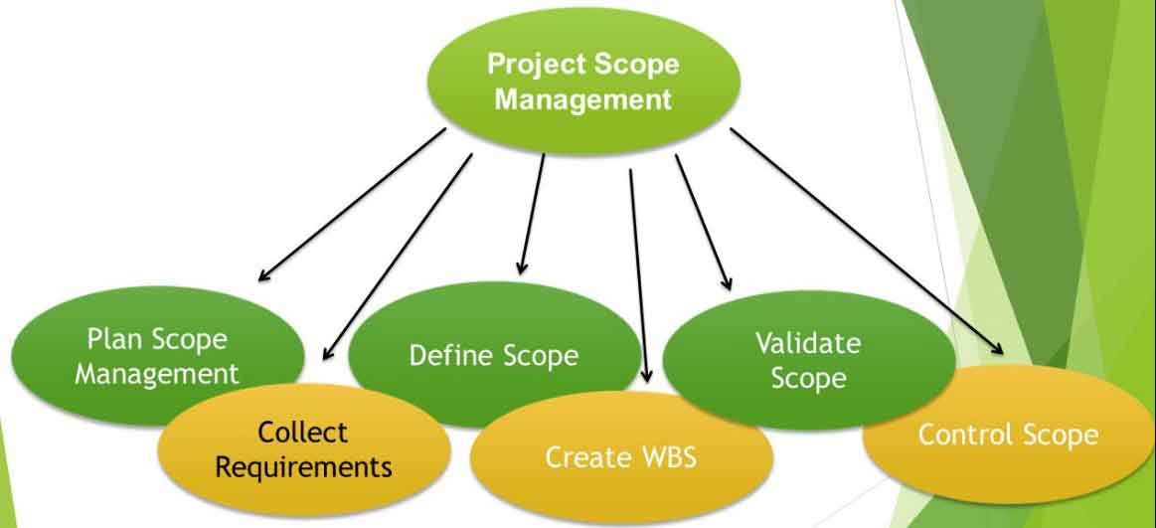

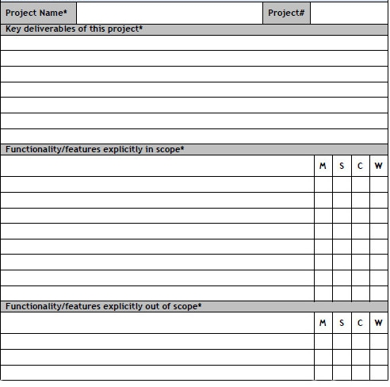

The Project Scope Structure above (Lean Project Management Framework, fig. 1) shows how each Tasks could be managed by “MoSCoW Prioritisation, Categorising, Functionality/Features. (Clegg, 2019).
- Must Have – Essential

- Should Have – Important

- Could Have – Adds value

- Won’t Have – Adds limited value

During the Project Management Task, I used a similar method to make a note of what is a Must Have, Should Have, Could Have and Won’t Have. That was discussed during/after the Consultation Meeting with Bride & Groom and Team-Members. It gives a clearer definition to what is important and what could be worked with.

Stakeholder Analysis:

A Stakeholder Analysis is a procedure of methodological collection of analysed qualitative information that is used to decide between the Stakeholders Interests and who should be given the top priority when Creating or Implementing a Program or Policy (Schmeer, 2000).

Stakeholder Engagement Strategy

The Diagram above shows the Engagement Strategy based on the Interest/Influence.
Stakeholder Engagement is the process that is used by organisations to engage its stakeholders for the purpose of achieving acceptable outcomes (OGC, 2011).
The OGC have linked stakeholder engagement to success. They explained the Support from Stakeholders for the Project is developed through maintaining constant involvement and effective consultation for the delivery of the Project Plans (2011).
The Aim of Stakeholder Analysis is to get everyone to focus on a specific goal and start a conversation method. Therefore, to engage the Stakeholders, a Stakeholder Analysis would be required for efficiency, cost effective approaches to be taken.

Stakeholder Engagement Approaches

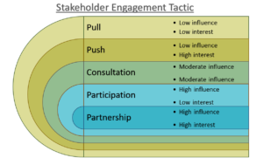

In this Project the Key Stakeholders has been identified as:

Client/Customers
The Bride & Groom/Family are the direct user of the Product & Service
↓ ↑
Project Manager
The Project’s Leader Sheila (Myself)
↓ ↑
Project Team Members
The Group executing the Project under PM’S Leadership
↓ ↑
Project Sponsor
The Projects Financier are the Owners
↓ ↑
Top Management
Executioner of Project objectives and Strategies
↓ ↑
Resource Manager
↓ ↑
Suppliers
- Food & Beverage Caterers – ‘Green Leaf Group’
- Video/Photography – ‘Sentiments Digital’
- Décor – ‘Eventist Group’

Project Methodologies:

There are different types of Methodologies that can be used in Business/Project Management. Therefore, there are the Traditional and Modern Hybrid Methods, each has its own process and workflow (PMI, 2013). I will discuss three modern methods:

PMBOK

Project Management Body of Knowledge (PMBOK), this method breaks down a Project into Five Process Group which is agreed by the Project Management Institute (PMI) and documented in the Guide to the PMBOK. The five stages are:
- Initiating
- Planning
- Executing
- Controlling
- Closing

It is like Project Life Cycle; it is appreciated by the Project Management Community.

PRINCE2

PRINCE2 is one of the most common way Projects are handled and widely practiced in Project Management. PRINCE2 focuses its approach on Organisation and Control. PRINCE2 acronym for; Project in Controlled Environment (OGC, 2019). 7 method is as follows:
- Starting Project
- Initiating Project
- Directing Project
- Controlling Stage
- Managing Product/Service Delivery
- Managing Stage Boundaries
- Closing Project

Extreme Project Managing (XPM)

I have identified the Method used by ‘Medina Events, is like Extreme Project Management (XPM). XPM allows to change and alter the Project Plan, Budget, and Final Outcome to fit the changes and requirements at any stage of the Project. Unlike the Traditional Project Management (TPM) that follows step-by-step flow, with strict requirements, it puts constraints which results to Projects going over budget, and past deadlines. Therefore, using this method, it allows for the Project Requirement to be more flexible, as Stakeholders want more involvement in the Project while in Process, therefore means they can alter choices and create more work at any given time (DeCarlo, 2013).

Common Characteristic of XPM:

- Complex Project Needs and Outcomes
- Frequent Requirement Changes (During Project Progression)
- Trial and Error Approach (What Works, What Does Not)
- Self-Correcting Process (Get Back on Track when Things Go Wrong)
- No need for Hierarchy (During Decision-Making)
- People Driven Project (Adapted to fit the Project and not the Model)
(DeCarlo, 2013).

Project Lifecycle

Projects goes through the same stages; some follow different set of Processes and Tasks. However, the Framework is similar, a Beginning, a Middle, and an End. It is called a Project Lifecycle. It allows to foresee approaching problems so that it can be resolved (Burke & Barron, 2014).

There are Five Phases:
- Initiation Phase
- Planning Phase
- Implementation/Execution Phase
- Monitoring & Controlling
- Closure/Exit Phase

The Diagram (fig.2) below shows the Project Lifecycle for Nikah/Engagement Project.

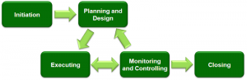

Project Planning

A Business Plan is a key to your success. It helps to secure your finance, maintain focus, communicate, and prepare yourself for the unexpected events. (Maund, 2019).
Every Project Manager must have a plan. By planning it helps the Project Manager to understand the scope of the project and to delegate Job Roles that fit the Team Members and get them to operate successfully by the tasks assigned to them. The Project Managers job is to ensure that the Project is communicated effectively to everyone taking part in the Project so that they understand the objectives and goals of the Project.
Therefore, as a PM I explained the communication process thoroughly to each Team Members and discussed the nature of the Business Proposal and briefed them on the Project.

Project Managers Responsibilities:

- Build the Plan – Project Scope, Timeline, and Budget.

- Assemble the Team – Identify the right Team Members e.g. Specialists/Experts for necessary Tasks.

- Assign Tasks – Give clear explanation of the specific Task and Timeline.

- Leading the Team – Continuous Checks, Updates, Collaboration to identify and clear Obstacles, Negotiating, Disagreements, keeping Team Morale High and Providing Training and Mentoring.

- Managing Budget – Estimates and Adjusting if necessary

- Managing Timelines – Maintaining Schedules and Setting Realistic Deadline through Lifecycle of the Project
- Engaging Stakeholders – Keep Communication Network open all time, clear obstacles and maintain healthy relations with Vendors.

- Handover the Project – Once Project is completed handover is necessary, so Project continues.

- Document the Process – Identifying and Documenting. Reflecting on experience so that in future mistakes can be avoided.

Project Managers must plan strategically, this part of the planning determines the Organisations strategy, goals and objectives. This can be achieved through Brainstorming together and figuring out the Risk Factors that are involved within the Project and how to overcome these Obstacles.

Project Planning & Executing Phase

- As a PM I was given a Budget between £20,000 - £25,000 Max with an estimated Guest List of Between 300-500. The Bride & Groom are my focus. Objectives are to arrange consultation Meeting to discuss the Requirements for the ‘Nikah/Engagement Day’.

Project Action Plan:
- Budget Planning
- Sourcing Nikah Venue
- Create and Design Stage (Bride Recommendation)
- Guest List
- Nikah Party Décor Requirements/Hire (Plan on Theme/Colour/Floral Arrangement/Props etc.
- Curate Playlist - Brides choice of Songs
- Makeup-Artist
- Bridal Nikah Clothing Choice/Colour
- Bridal Jewellery/Ring
- Nikah Engagement Party Invitations
- Entertainment
- Food & Beverage Caterers
- Photographers/Videographers

- Informing Team-Members and Discuss the Project Plan.

- Assign Task to all Team-Members with their Roles.

Assignment for Team 1:

- Locate and Hire venue
- Create the Stage Design
- Arrange/Book Mehndi Décor and Props (Venue Décor, Seating and Floral Arrangement)
- Arrange/Book Food & Beverage and Mehndi Cake
- Arrange/Book Photographers/Videographers

Assignment for Team 2:

- Make a Guest List
- Pick and Choose Mehndi Invitation Cards
- Send out Invitation Cards
- Curate Playlist for Bride
- Arrange Entertainment (Music- Singers/Drummers/DJ’s
- Bridal Mehndi Dress and Order
- Bridal Mehndi Jewellery and Order
- Arrange Henna & Makeup Artist

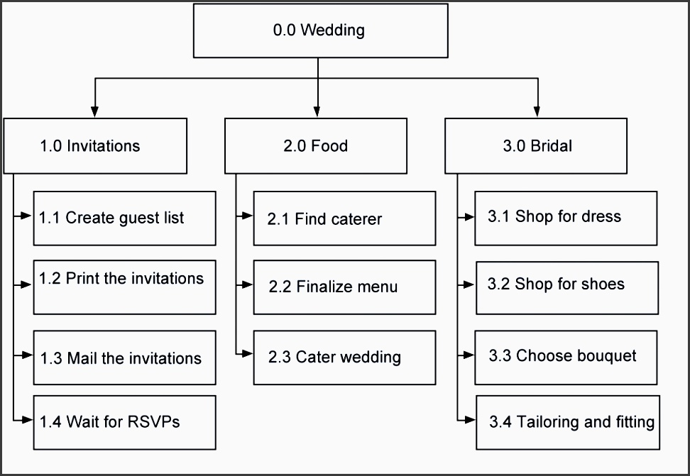

- Every Team-Member is required to work in their roles and achieve their set targets.

- My job was to manage daily activities and oversee the process of the Project and to Monitor and Control; Time, Cost, Risk and Scope. If there are any problems to manage/deal and get it sorted as soon as possible.

- Keep Focus on Quality and Service. To continuously check on Deliverables for Requirements using Quality Register.

- To ensure that the oversight and planning fit the tailor-made approach of the Project to reach the Objectives.

Project Management

Project Management: Gantts Chart for Nikah Event

The Gantts Chart above shows how I managed my Project and kept a track of everything and everyone. It is very important for PM’s to keep a track of the project as this this will help with Time-Management and allowing to forecast any problems with Time/ Date and Budget.

Project Communication Method:

The important key skill for Project Managers is Effective Communication. The Project Manager should have the ability to communicate well in written and verbal form. Communication is crucial to effective project leadership that determines the Projects Efficiency, Productivity, Quality and Customer Satisfaction.
Communication is a process of sending, receiving messages and information. It is vital for Project Managers to be able to communicate in every way from written to non-verbal gestures which make up for 50% of Communication. Therefore, skills such as listening play an important part of Project Leadership. Burke and Baron mentioned that good communication requires a balance between value of information supplied against cost and time it takes to process it (Burke, 2004).
There are various ways of Communication in a Business Organisation. Here are some of the ways that were communicated during the Project Management.

Interactive Communication: Interactive Communication is the most effective type of communication between people because it is face to face communication. Therefore, this type of communication is the appropriate for high interest/high influence stakeholders as they influence and have most interest/involvement in the Project.
Push Communication: Push Communication is not face-face but Interactive Communication. The Project Manager sends Information with no expectation of receiving immediate feedback or Response. Therefore, this type of communication is appropriate for low interest/low influence stakeholders.
Pull Communication: The PM places Information at a general database such as a SharePoint or Shared Drive and the Recipients are responsible to use the Information. Therefore, this type of communication gives shared accountability, decision making, joint learning and actions (Burke & Barron, 2014).

Nikah Planning Project Communication Structure:

The Diagram above shows the Communication Method used during the time of Managing the Engagement Project. This Communication Structure shows how everyone that is involved in the Project has full access to communication with each other if problems arise. There are no formal Communication Hierarchy and during this Project it was not necessarily required. Furthermore, the Stakeholders are involved within the Project and they influence the outcome of the Project, therefore their involvement requires constant communication/collaboration with the Suppliers and Vendors.

Project Risk Management

To prevent things from going wrong it is very important for Project Managers to have insight into the progress of the Project so that they can forecast what precautions and measurements to take, and to keep a keen eye on the Cost, Budget and Timeline at all times.
Therefore, it is necessary for Project Mangers to always examine risk areas, analyse the root causes and take precautionary measures to reduce risk factors. This however occurs throughout the lifecycle of the Project (Schmeer, 2000).
As a Project Manager I examined Five Risk Areas:

- Financial – it was important that I kept a constant Track on the Actual Cost/Budgeted or Forecasted Spend for Total Project.

- Schedule – Variances to Monitor and Focus on Project or Lifecycle Phase.

- Quality – Errors, Outstanding Issues and Time to Resolve Issues, Scope Changes or Changes in Orders. Productivity Hours and Function Point or Execution Rate.

- Alignment of Expectations and Outcomes – Customer Satisfaction Level, Enhancements or Outages.

- Project Soft Issues – To consider and evaluate Project Team Morale and Co-Operation and Team Behaviour and Attitude. Supplier Management and integration including internal/external concerns. Language and Cultural Barriers.

Threats/Obstacles/Risks

‘Medina Events’ is in the Service Industry therefore the focus is on Quality and Service.
The Threats and Risk Factors that I face are questions to whether I would be able to Deliver everything that I had promised on Day of the Event from Service, Quality, Time and Budget such as:

- Timing of the Transportation – whether the Transport (Car/Horse & Carriage/Helicopter) would arrive on Time.

- Deliverance of Hot Food and Beverage - that depends on the; Quality/Taste and whether Dinner Service would be served on Time, enough food and drinks to go around the Service Quality from the Catering Service.

- Stage and Venue Décor – last minute changes can happen, whether this will affect the Clients Choice and Timing of the Stage setting such as delays with the Equipment’s.

- Videographer & Photographer – Quality, Service and Timing of Deliverance Promise.

- Entertainment – Quality, Service and Timing, whether the Entertainers make last minute changes/plans or underperform, which may lead to disappointment which effects the Service Quality.

The objectives cannot be realised or forecasted until the actual Event and that all depends on Time, Actual Service, Actual Budget and Deliverables on the Day. However, as A PM my main priority and focus are to deliver everything on Time. That can be achieved by daily consultations with Stakeholder and Vendors and keeping a Track of every movement.

Event Risk Management: Engagement Day

The Health and Safety Measures I took on the day were:
- Risk Management

- Health and Wellness

- General Liability

- Product Safety

- Security

- Disaster Recovery

- Emergency Preparation

- Disorderly Conduct

- Fire and Life Safety

- Health and Hazard.

On the day of the Event, before the arrival of the Bride & Groom and entourage, I held a meeting with all my Team-Members and Stakeholders involved about the Health and Safety Measures and if necessary to put out safety barriers and warning/caution signs in places where entry is not permitted. The Kitchen Staff were briefed about all the Fire Regulations and Exits in the case of an Emergency.

Budget & Resource Control

Cost Benefit Analysis (CBA):
CBA is crucial to economic decision-making approach used in Government and Businesses. Therefore, this is a formal technique used in making critical decisions of the use of Society’s Scarce Resources.
CBA is used mainly in Projects that are; worthwhile, the optimal scale and the relevant constraints of a proposed project such as: Transportation Projects (HS2 Project), Environmental & Agricultural, Educational Programmes, Land-use, Health Economics & Social Welfare.
Cost Benefit Analysis is essential in deciding which Projects to avoid or pursue. It is an important aspect in Business Management as Business owners use the tool to compare the Costs & Benefits of Potential Projects that offer the most Net Benefit. Therefore, if the Benefit is Higher than the Cost the Project is Good Investment.
The Chart below shows how this can be used in Businesses to Project and Control Budget and help Businesses from potential Risk Factors from overspending such as Budget Control/Time-constraints because it accurately estimates all Benefits and Costs. RATIO: Benefits/Costs

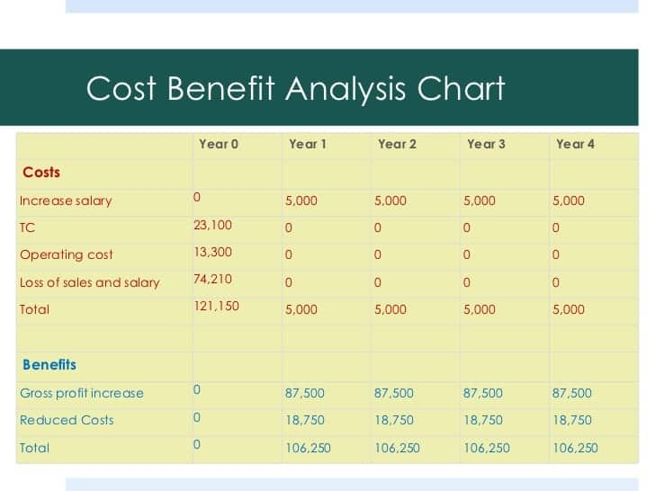

Controlling & Monitoring Phase

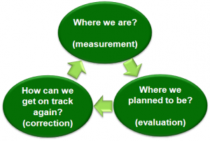

The Controlling & Monitoring Phase is very crucial. It is required that Project Managers at this stage makes sure the Resources are managed well and properly. As a PM I had to check the Budget whether it is being spent in the correct departments and to control of over-spending. It is also a time to monitor the Project Performance & Risk Management as time is very crucial. Therefore, the need to perform Status Meetings and Reports on what is going on and what is being spent where/ how and why and work on Deliverables. If there are any lags or obstacles with delivery with Products, to find solutions to how to overcome the time delays of orders e.g. look for other alternatives.
After I discussed the underlying issues with my Team-Members about what needs fixing/correcting, it was essential that I updated on the Project Schedule and Modify the Project Plans.
Through Monitoring as a Project Manager, I was will be able to see variances therefore, I was able to analyse the situation in order to source the root causes such as: inaccurate estimates, overestimated benefits, unexpected costs, under-funding, contractual changes, timing differences, or scope creep. Through understanding the problems, I was able to take remedial actions and those that were beyond my control was taken as a lesson learned.
The Budget list below shows the estimated copy of the Nikah Ceremony Event.

Nikah (Engagement) Event Budget List

Description | Estimated  Cost £ | Actual  Cost £ | Bride & Groom Expenses | Other Expenses
Ceremony
Site Fees | 2000
Choreographer | 150
Imam Fees (Wedding Registrars) | 200
Other:
Reception
Site Fees
Coffee/Juice/Mocktail Bar | 500-1000
Food/Beverage Caterers | 1500
Engagement Cake | 500
Accessories
Other:
Attire
Bride & Groom Accessories | 3000 |  | Jewellery/Rings/Shoes
Brides Hair/Nail/Makeup | 500
Bride & Groom Attire | 3000
Brides Attendants
Grooms Attendants
Flower Girl
Ring Bearer
Equipment’s
Décor | 2-3000
Entertainment | 1000
Flowers | 800-1000
Photography | 500
Videography | 600
Music/DJ | 300
Stationery
Transportation | 800-1000
Other:
Total: | 19,250

Project Closure & Exit Phase

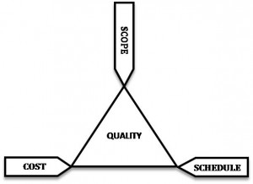

The last stage is Project Closure, that is when the Project Manager takes Inventory of all the Deliverables of the Project. As the Project Manager for this Nikah Event, I had to make sure all the demands were met such as:
Key Deliverables:
- Service – Venue, Décor Style/Design, Stage, Cake, Food, Drinks, Entertainment/Music, Videographer/Photographer,
- Products – Décor Props, Equipment’s, Attire, Accessories
- Budget – £22,300
- Time - 6 Months – On Time.

The next step was to tie up any loose ends, make sure everything was in working order so that the Project can be handed over and continue when the next person takes over.
However, before this I had a brief discussion with the Team-Members about all the learnings of the Project and the outcomes which was documented in a Centralised Location. Thereafter, the Project was communicated to Executives and Stakeholders about the outcome of the Project. A successful Project will be celebrated, and I was lucky enough to let my hair down for the after Party.

Reflection

By doing this Assignment on Project Managing I learnt a lot through my Researches and Gathering Information on how to: Initiate a Project, Plan a Project, Execute a Project, Monitor & Control a Project and finally Closing a Project. I have come across a lot of Theories/Methods/Tools that can help to Manage a Successful Project. I have understood how to deal with difficult situations, and how I can always prevent plans going wrong through focusing on Scope Management/Risk Management and Controlling and Monitoring the Budget making sure that the Team sticks to the Plan as much as they can.

SWOT Plan: This SWOT Plan shows the current Strength/Weaknesses I have and wish to Develop to be a Good Project Manager. The Opportunities show how I can achieve my goals to develop my Skills. The Threats are Obstacles that I may face which may hinder my Plan to Developing my Skills as a Project Leader/Manager.

Strengths  Communication Skill – written/verbal/non-verbal  Listening Skill  Negotiation Skills  Critical thinking Skills  Good decision-making Skills  Good Interpersonal Skills  Problem Solving Skills  Creative Skills | Weaknesses  Leadership & Managerial  Verbal Communication  Time-Management  People Management
Opportunities  Work/Experience  Academic/Education  Resource and Tools  Help and Support  Finance | Threats  Unable to complete Education  Not finding appropriate Work  Unavailability of Resource  Lack of Help and Support

Self-Development Plan for becoming a better Project Managing:

As a Project Manager there are many things to take into consideration, but my main objectives are to:

- Complete Projects on Time

As a Project Manager I would like to deliver my Project on Time because it is the core value of any Project Management Role and to be able to accomplish that is a huge Achievement.
Obstacles, threats, Risks may exist that may play a factor for Time-Delays which may be out of my control. However, I will strive to do my best to get things done on time and get the best results possible, through the help of my Team Members/Stakeholders.
Furthermore, with all the Theories/Methods/Tools and Technologies available on Project Management & Time Management will make it easier to Forecast and Time Track. E.g. Gantts Chart Timeline enables individuals to keep a Track on the Project Time and Deliverance and Identify and Address Project Delays by keeping a Track on the Project Progress.

- Effective Communication

I believe Communication is most crucial to be a good Project Manager. My communication skills are on a good level. However, I would like to improve on that so that my speech is Clearer and more Concise. I plan to improve my Communication Skills by doing more Class Presentations at University, Teamwork, Group Discussions and Leading/Managing Teams/Tasks. By developing my Communication Skills, I will be able to:

- Daily Communicate and Collaborate
- Delegate Tasks Appropriately
- Speak Efficiently and Effectively to everyone involved within the Project
- Make Status Reports Easier to Follow and Digest
- Hold Meetings that are Short and Actionable

- Budget Control and Scope

Another very important matter to all Project Managers is keeping within the Budget of the Project which is another Core Value of Project Management Role. I understand to Control Budget can be challenging. However, I will make sure that I have a good understanding of the Project Scope and its Budget. Hence, I would be able to control the impacts the outside factors could have on the Scope Creep Issues. Therefore, by utilising Tools and Technologies I could better observe the problems before it arises so that I can deal with such issues through Communication and Negotiation with everyone involved in the Task.

- Quality and Service

I believe it is very necessary for Project Managers to ensure Quality and Service. Therefore, I would make it top priority to keep an eye on the Quality Control of all the Products and Services that I offer as a Project Manager. I understand sometimes there might be Faults and Delays with the Quality or Service. However, I would want everyone to know that I expect High Quality and through my commitment it will ensure that my Team, Clients and Stakeholders are happy with the work being produced.

Conclusion

To take on the Role and Responsibility of a Project Manager, one must realise all the pressure that comes with it. Therefore, to be a very good and successful one it requires a person that has multiple Skills, Knowledge, Talents, Experience and Expertise.
However, through this assignment on Project Management I have come to conclude that Managing Projects can be diverse, and the Managers are required to have a good knowledge about the limitations and factors that surrounds the whole Project. Problems will occur and changes may slow down the course of the Project Progression. However, with good Leadership and Management Skills it can be completed within the Set Budget and Time.
There are many possible ways to prevent and resolve problems through all the latest tools, methods, theories and technologies available for Project Managers in the 21st Century, hence the future is looking better for Project Managers to accomplish their Goals Successfully within Time and Budget.

References

- Burke, R. & Barron S. (2014) Project Management Leadership. Hoboken, NJ: Wiley.

- D, DeCarlo. (2013). Extreme Project Management. San Francisco, California: Jossey-Bass.

- International Project Management Association, (2006). ICB-IPMA Competence Baseline, 3rd Edition, International Project Management Association.

- Khan, S. A. (2011). Organisational Career Development Practices: Learning from an Oman Company. International Journal of Business and Management, 10(9) 88-98.

- D, Clegg. (2019). Lean Project Management Moscow.

- Lewis, R. (2006). Project Management. McGraw-Hill Professional, New York.

- Mantel, S. J., Meredith, J. R., Shafer, S.M., Sutton, M. M. (2004). Core Concepts: Project Management in Practice. John Wiley & Sons, Inc., New York, NY.

- Maund, A., S, M., & Tinker, P. (2019). BA in Leadership and Management Skills for the Workplace, 1st Edition, SAGE Publications, Los Angeles, London and India.

- Pinegar, G. (2019). What is PRINCE2 Project Management Methodology. [ONLINE] https://learn.g2.com/prince2?hs_amp=true

- Project Management Institute, (2013). Project Management Body of Knowledge (PMBOK) Guide, 5th Edition, Project Management Institute.

- R, Joslin. & R, Muller. (2016), international Journal of Project Management, 34, pp 613-626.

- Schmeer, K. (2000). Stakeholder Analysis Guidelines. Washington DC: Partners for Health Reform.

- Sebastian, N. (2007). The Definitive guide to Project Management. Prentice Hall, London.

- The Association of Business Executives (ABE), Business Management Study Manuals, Surrey: UK.

- The office of Government Commerce, OGC. (2011), Guidance, Best Management Practice Portfolio. [ONLINE] https://www.gov.uk/government/publications/best-management-practice/about-the-office-ofgovernment-commerce Accessed: 5 Dec 2019.

- Wellman, J. (2006). Book Review: Successful Project Management: A Step-By-Step Approach with Practical Examples, Fourth Edition. Project Management Journal, 37(4), pp.75-75.

