ECAD6007C TAR Cynradd gyda SAC
The learner: who am I teaching?
Student number – 2100925
Title - A critical evaluation and the identification of next teaching and learning steps focusing on a case study of an individual learner or a group of learners, based on an observed critical incident (equivalent to 5000 words).
Date – 29/10/21
Word count –

Essay is written in English however critical incident notes are written in Welsh.

Table of Contents

Introduction | 3
The role of critical reflection | 3
School and class context | 5
Critical incident linked to Donaldson’s four purposes | 5
Literature review | 6
Reflection/evaluation and next steps | 10
Conclusion | 11
Bibliography | 13
Appendices | 16

Introduction

This essay will look at behaviour and explanations behind certain behaviour by concentrating on a particular case study that was observed. It is evident that focusing on a critical incident is useful in gaining a deeper understanding of what exactly can affect a person’s behaviour. This is a particularly beneficial way of understanding what exactly led to a specific behaviour since a full range of background information is available to draw from. In this case, a critical incident is best described as a situation that occurs, which may be easily overlooked, but when analysed further provides an opportunity to learn and develop.

Further research from a range of literature is required to understand what has been witnessed and to come up with strategies on how to deal with similar situations moving forward. Research also stresses the importance of evaluating, analysing, and reflecting on a situation in order to learn from it and to improve our skills (Kolb, 1984, pp. 20-38 and Gibbs, 1988, pp. 27-29). The new 2022 curriculum for Wales, and as an extension of this, Donaldson’s four purposes (2015, p. 31) also colour the way we view such case studies and inform us on what our next steps should be (see Appendix 1). In an attempt to better understand the critical incident in question, the main elements that will be explored moving forward are behaviour and well-being.

The role of critical reflection

In this case, critical reflection allows us to improve our way of teaching and informs us on how best to handle a similar situation in the future. Researching multiple theories and a range of educational studies informs our teaching style and ensures education is a field that is constantly developing and is able to move with time. Critical reflection has been a topic that has seen plenty of contributions over the past fifty years, much of it revolving specifically around education and learning.

Despite the number of works produced in relation to critical reflection, the works of Kolb (1984) and Gibbs (1988) stand out initially because their research has a firm theoretical base (Healey and Jenkins, 2007, p. 185-187). Kolb developed an experiential learning cycle that was highly influenced by the earlier works of Lewin (1933) and Dewey (1946). Kolb’s work suggests effective learning is conducted when a person progresses through a cycle of four stages in the hope that their experiences will be transformed into knowledge (see Appendix 2). It is during what Kolb calls abstract conceptualisation or learning from the experience that the research element comes in. A person should then partake in active experimentation where they plan and try out what they have learned (Kolb, 1984, pp. 21-22). Whereas Kolb’s cycle is based on four stages, Gibbs’ reflective cycle is based on six stages and is arguably a more practical approach to reflection (see Appendix 5).

In 1991, Schön concluded a trilogy of books devoted to reflective practice and presented the concept of ‘reflection in action’ and ‘reflection on action’ which suggests the significance of reflection both during and after an experience or event. Arguably, this is something most of us do naturally following a negative experience yet, it is also beneficial to do so following positive experiences since there is always room for improvement. Brookfield’s (1995) model puts the most emphasis on looking beyond ourselves in the process of reflection and suggests four lenses by which to look through. Besides our own view, he suggests the value of the students’ views, our colleagues’ views, and theoretical perspectives when reflecting. Most recently, Zwozdiak-Myers (2012) has published a handbook for teachers on reflective practice that respectfully encompasses previous work in the field. By carefully examining works on reflective practice and experimental learning, Zwozdiak-Myers (2012) has come up with a set of strategies to improve teaching called the nine dimensions of reflective practice (see Appendix 6). This is a detailed yet comprehendible process of reflection that educators can easily put into practice. What all of these processes have in common is the intended outcome; to improve one’s teaching abilities.

These examples and the research behind them are evidence that critical reflection is at the heart of teaching and education and ensures we are constantly developing and improving. Critical reflection is essential because it allows educators to meet targets relating to the five professional standards for teaching and leadership in Wales (see Appendix 7). Developing these standards also aids our understanding and ability to teach the new curriculum since they often go hand in hand. Critical reflection has proven to be an extremely useful tool during the process of evaluating the critical incident and the experience has shown how vital these types of experiences can be to educators, particularly early on. Although practical experience is useful and allows us to build confidence and learn from other educators and our own mistakes, arguably, it is only when we begin to reflect and evaluate using the processes suggested by scholars such as Zwozdiak-Myers (2012) that we are able to effectively improve our teaching abilities. During this process, research and theory are able to support or contradict our opinions and way of teaching which in turn allow us to adapt how we teach and help us to progress.

Observation
School and class context

The school in which the observation and critical incident took place is a Welsh-medium primary school situated in the county of Bridgend in South Wales. The most recent ESTYN (2017) report notes there were 428 pupils aged between three and eleven years old enrolled in the school. Approximately five percent of pupils come from Welsh-speaking homes and very few come from ethnic minority backgrounds. It was also noted that around eighteen percent of pupils were eligible for free school meals and that eleven percent of pupils have additional learning needs (ALN). It is important to note that the individual school budget per pupil for 2016-2017 was £2,952 out of a possible £4,484 meaning the school is placed in forty-sixth place out of forty-eight in terms of school budget per pupil. This provides good context when considering the distribution of resources within the school.

Year four is made up of fifty pupils aged eight to nine and is divided into two classes of twenty-five, which is just below the Welsh average of 25.4 recorded in 2019 (Welsh Government, 2019, p. 13). The year four class in observation has one pupil with a known ALN. The COVID-19 pandemic has affected the school because a great deal of the learning in the previous academic year was conducted online. This has meant that the pupils have been developing at a less consistent rate, resulting in a wider range of abilities. The critical incident also took place at the beginning of the academic year, meaning the teacher was still getting to know the pupils, their needs, and their abilities.

Critical incident linked to Donaldson’s Four Purposes

The purpose of this section is to explain and provide contextual information on the critical incident which was observed. By investigating the incident, we are able to use the critical reflection models discussed previously to improve the way we teach. Detailed observation and reflection also allow us to consider, use and develop the professional teaching standards moving forward and as a result, ensure we are better equipped to teach the new curriculum (Welsh Government, 2018, p. 2). Additionally, when reflecting on such incidents, we must begin to consider how they connect to Donaldson’s four purposes (2015, p. 31). These purposes provide an aim for what the curriculum should achieve and what children and young people in Wales should be. Reflecting on experiences and incidents allows us to consider whether or not we are doing enough to ensure that we are meeting the purposes and allows us to consider what more we could do to meet each purpose when planning and teaching.

The critical incident took place after lunchtime during a literacy lesson. The teacher explained the task to the class which was to write out The Lord’s Prayer in their books. The pupils began the task, but Pupil A refused to start. To begin with, the teacher ignored the pupil hoping that he would see the other pupils doing their work and want to do the same. After a few minutes, the teacher calmly asked him why he was not completing the task to which she received no reply. She gave him two options; he could either complete half of the task or lose a part of his playtime. He agreed to complete half of the task, but the teacher noticed after five minutes that he had not written anything. The teacher asked him to do what was asked of him one final time, however, he ran out of the classroom and out of the building.

Following a discussion with the teacher, I came to realise that Pupil A runs out of the classroom frequently and that the school had a policy in place to deal with this. Rather than chase the pupil, the teacher calls reception and asks them to watch the pupil on the CCTV to ensure he is safe and cannot leave school grounds. The pupil did not return to the classroom until the very end of the lesson. During this time, the teacher considered the idea that the physical education lesson that had taken place that morning may have triggered his behaviour since his morning was less structured than usual. In an attempt to prevent the situation from happening again, the teacher rearranged next week’s physical education lesson so that it was in the afternoon after the pupils had already completed some written work. Pupil A enjoys sports, so by doing this, the teacher hoped that he would have something to look forward to during the day. After discussing with the teacher, it became clear that the pupil is usually described as ambitious and capable however, during this time, the four purposes were not met.

Literature review

The areas which provide the best base for our research in relation to this particular critical incident are behaviour and well-being. Upon first glance, it may seem as though the behaviour is the only field worth focusing on however, it is evident as we look deeper that emotional well-being has a large impact on behaviour. By researching behaviour and well-being in relation to the critical incident, it is possible to reflect and begin to think about what to do next and how to approach a similar situation in the future.

Recent research suggests that ‘bad’ behaviour does not happen because a child is ‘bad’. Alternatively, it suggests that there is usually a specific reason or set of reasons which trigger undesirable behaviour (Williams, 2018, p.26). This research suggests contemplating the desires and emotions behind the behaviour as opposed to the behaviour itself. Providing an immediate punishment in an attempt to counteract the behaviour devalues this process (Rose, Gilbert, and Richards, 2016, p. 99). A great deal of work has been done on the relationship between behaviour and emotional intelligence, most notably by John Gottman (1997, pp. 20-32) and the Gottman institute. Emotional intelligence is considered an important element of emotional well-being and has been defined and developed in the work of John Mayer and Peter Salovey (1990). This research suggests that by introducing the five steps of ‘Emotion Coaching’ to children, they will have a higher level of emotional intelligence and as a result, better self-regulation and social functioning (Gottman, 1997, p. 21). Children who can understand and regulate their emotions tend to enjoy learning and go on to achieve higher academic success than those who lack impulse control (Gottman, 1997; Rose, Gilbert and Richards, 2016, pp. 98-99).

Considering the emotion behind the behaviour forces the educator to consider what other factors might be at play. Often, if something negative has impacted the learner, it usually affects their motivation, attitude, and behaviour for the rest of the day (Brownhill and Shelton, 2008, p.12). Many situations such as a difficult home life, a difficult transition, or a falling out with friends can impact a learner during the school day (Brownhill and Shelton, 2008, pp. 56-68). The critical incident took place at the beginning of the school year following a series of lockdowns due to the COVID-19 pandemic. For the learners, this meant adjusting to a new classroom, a new teacher, and a different way of learning after completing much of their education online and at home.

Many of the examples considered have shown the extent to which health and well-being are linked to behaviour. Maslow’s hierarchy of needs (1943, pp. 372-394) supports the idea that when a learner’s emotional well-being is compromised, their motivation is bound to suffer as a result. This is because a learner’s basic needs or ‘deficiency needs’ must be met before being able to focus on ‘growth needs’ (see Appendix 8; Slavin, 2018, pp. 250-254). Debatably, if a learner does not have the motivation to develop their growth needs since their basic needs are not being met, they may act out in defiance. Although Maslow’s hierarchy has received criticism for being too rigid, when considered more loosely, it remains highly useful and is the basis for a great deal of work on human needs and motivation. By creating meaningful connections with learners and getting to know their interests, we fulfil basic needs such as security and belonging and can begin to build their growth needs such as respect, self-esteem, and achievement (Lewis, 2009, p. 37; Maslow, 1943, pp. 372-389).

Perhaps it could be argued that when a learner lacks the motivation to learn but does not have the emotional intelligence required to convey this appropriately, they usually react in a way that may be deemed unacceptable (Brownhill and Shelton, 2008, pp. 71-72). Emotion coaching aids the development of emotional intelligence and is certainly a useful tool in the long run however, consistency, ideally at home and in school is key. Educators can incorporate Gottman’s (1997) approach to emotion coaching into their way of teaching however, this alone is arguably not sufficient. In these cases, other strategies and techniques could be used to both prevent and address behaviours. Nevertheless, many of the theories and strategies presented to prevent undesirable behaviour, do in fact consider the feelings and emotions of the learner and also connect them to motivation. It could be argued then, that emotion coaching and Maslow’s hierarchy of needs (1943, pp. 372-94) form the base of many behaviour management strategies (Gottman, 1997, p. 21).

One example of a strategy that could be incorporated by teachers is the freedom of choice. Brownhill and Shelton (2008, p.30) argue that learners should be given as much control of the classroom as possible. By allowing learners, particularly those in Key Stage Two, to decide what they want to learn and how they want to learn it, they can choose topics and ways of teaching that interest and benefit them. As a result, they should feel more motivated to learn and less motivated to partake in undesirable behaviour (Arthur and Peterson, 2012, pp. 136-138; Slavin, 2018, p. 248). This is especially true when the behaviour is a direct result of not wanting to complete a task due to a lack of interest or understanding.

In these instances, classroom management is vital to ensuring that a lack of interest or understanding from a handful of learners does not disrupt the entire class. Scholars have suggested that by monitoring all students throughout the lesson and keeping the lesson moving appropriately from one activity to the next, learners will have less opportunity to disrupt the lesson (Lewis, 2009, pp. 34-36). Managing the classroom also means controlling the type of learning environment and making it suitable for the lesson or task being taught. A calm and quiet environment is ideal when learners need to focus and teaches the kind of behaviour expected in quiet and formal situations. However, a noisy and busy environment has its uses since it allows a more practical approach to learning and allows children to burn energy and communicate with each other. This busier sort of environment is arguably not utilized enough by educators (Williams, 2017, pp. 29-34). Learners often prefer an active environment so providing this often provides a more productive environment. Moreover, by achieving a balance between the two, learners are able to recognise and appreciate why a particular environment has been chosen and will tend to work more productively as a result (Lawrence, 2017, p. 12).

Preventative strategies benefit all learners and can be considered a way of instilling Donaldson’s four purposes (see Appendix 1; 2015, p. 31). Inspiring and motivating using these techniques ensures learners are ambitious, capable, and enterprising. Additionally, developing their emotional literacy provides them with what they need to be healthy, ethical, and informed citizens (Donaldson, 2015, p 31). Arguably, providing learners with choices and using preventative measures to deal with behaviour should not be viewed as lenient. In reality, the simplest way of controlling behavioural problems is preventing them from happening in the first place (Arthur and Peterson, 2012, p. 80). Alternatively, it could be argued that teaching styles are becoming less authoritarian and more democratic (Lewis, 2009, p. 5). Now more than ever, children are aware of their rights, and educators in Wales have a duty to encourage this understanding as it also falls in line with the curriculum’s aim to produce learners who are ethical and informed (Donaldson, 2015, p 31).

Nevertheless, preparation and preventative strategies do not always work and in these cases, it is important to try other strategies. Particularly in young learners, this can be something as simple as talking to the learners using either a positive focus; ‘I’m happy to see that’ or a negative focus; ‘It makes me sad to see that’. It may also be useful to set limits on appropriate behaviour by clearly stating that a behaviour is unacceptable (Rose, Gilbert, and Richards, 2016, p. 100). The field of behaviour management is constantly changing and there is certainly no simple solution to dealing with undesirable behaviour.

Nonetheless, there are specific tactics that some experts agree are outdated and unsuccessful long term. Although tactically ignoring a behaviour can be beneficial, we should be cautious as not to take on a dismissive approach to behavioural management. Dismissing a behaviour means dismissing the emotions behind the behaviour. Although this may appear to be a quick solution, dismissing those emotions minimises them and does not allow that child to understand their emotions and the reason for their behaviour. Emotion coaching on the other hand allows the child to develop an internal dialogue about their emotional experiences and helps them regulate their emotions and social behaviour. As a result, they are less likely to misbehave if a similar situation arises (Rose, Gilbert, and Richards, 2016, pp. 101-105). What this section has demonstrated is the significance and usefulness of focusing on the cause of a behaviour and the emotions behind it as opposed to the behaviour itself. By considering the external factors that may be affecting the way a child feels and talking through these emotions, it is easier to prevent or at the very least, manage certain behaviours when they arise. Additionally, many of the most successful strategies used to manage undesirable behaviour benefit from considering the emotion behind the behaviour.

Reflection/evaluation and next steps

Researching behaviour and well-being in relation to the critical incident fulfils what is considered a vital step in the majority of the critical reflection models discussed previously. Following an experience, Kolb (1984, pp. 22-36) and Lewin (1946, pp. 37-44) suggest incorporating abstract conceptualisation before moving on to experimentation (see Appendix 2; see Appendix 3). Arguably, researching concepts and theories is a crucial element of reflection since it is able to highlight why something did not go so well and suggests ways to improve before moving on to the experimental part of the process. During the experimental process described by Kolb (1984) and Zwozdiak-Myers (2012), we begin to use the knowledge gained from both the experience and the research that followed. The reflective models discussed previously differ slightly but convey a similar message and achieve similar outcomes. By repeating a reflective cycle or partaking in reflective practice, we improve the way we teach and, in this case, the way we manage behaviour.

Behaviour and the elements that it encompasses provide a good centre point for analysis because upon first observing the critical incident, it was the element that stood out most. Arguably, behaviour management is considered one of the biggest challenges that teachers and educators face. Resultingly, I felt compelled to investigate this area of education further in an attempt to equip myself with the best knowledge possible when dealing with a similar situation. Despite the argument that teachers should not be overloaded with strategies, it is vital that teachers feel confident and fully equipped to handle situations when they arise (Brownhill and Shelton, 2008, p 48). Arguably, it is only by drawing on a large body of research and a number of practical solutions that teachers, especially those starting out in the field, can feel confident in their ability to teach effectively. It could also be argued that more work needs to be done on behaviour management and, in particular, the way emotions are so closely linked to this to devise more useful and long-term strategies.

Looking into certain behaviours and their causes has made it clear that needs and emotions are what affect behaviour most. It has also become evident that emotional intelligence, moral understanding, and personal needs are closely connected and play a huge part in defining a child and their behaviour. Reflecting on and evaluating these elements has been beneficial because it has altered my outlook on behaviour and will certainly impact how I approach behavioural management. Debatably, Zwozdiak-Myers’ (2012) Nine Dimensions of Reflective Practice provides the most effective form of critical reflection because it combines many of the previous models but breaks down the steps of reflective practice in a simple yet effective way (see Appendix 6).

My next steps involve progressing through each of the nine dimensions in order to improve. Following observation and picking out a critical incident, I moved on to evaluating using research. The research has allowed me to think about how to link the theories learned to practice and has made me question my initial beliefs and biases as well as made me consider alternative possibilities. My next step will be to consider alternative perspectives by discussing the critical incident and my findings with other teachers and educators in order to learn from them and their experiences. During this step, I intend to consider the preventative strategies that were in place and evaluate their effectiveness in an attempt to pick out what worked and begin to consider what may have worked better. A vital part of this step is discussing with the class teacher again because researching has made me consider things I would not have previously. Experimenting with the new strategies and ideas in the classroom and evaluating their success using self-evaluation, peer evaluation and discussion with learners will ensure constant professional development. Finally, I will repeat the process, building my confidence and knowledge in the process. Completing these steps and repeating them ensures consistent personal and professional development because I will frequently be gaining new and up-to-date knowledge and using it to improve the way I teach.

Conclusion

Choosing a critical incident to explore and analyse is extremely valuable because it achieves so much more than simply observing. Completing the reflective process step by step using a model which makes the most sense to the individual develops their understanding of each step and in turn, demonstrates the value of each step. Becoming highly aware of what is required during each part of the process means they will be more efficient, more resourceful, and more successful when repeating the process in the future. By improving the completion of the process each time and gaining fresh knowledge, we are able to effortlessly fulfil our duties as reflective practitioners in Wales since we are completing many of the professional standards for teaching and leadership (see Appendix 7).

Each standard is developed throughout the process and may change depending on the experience and the approach taken to critical reflection. During my approach, the standards developed most were collaboration, professional learning, and innovation. By discussing and getting advice from other educators I have been able to gain a better insight into the critical incident, specific behavioural approaches, and the school’s way of handling situations. In doing research I have discovered a range of theories, techniques, and approaches to behaviour management which I will continue to learn about and put into practice. The innovation standard stands out because the information learned during the process has encouraged innovation and new approaches to teaching which I had not considered in the past. Taking part in the process of critical evaluation has allowed me to recognise the importance of change and development in education and has demonstrated that the key to constant improvement in the field of education is constantly researching better approaches. Finally, this approach to critical reflection and the research completed has made me realise that the most impactful way of approaching undesirable behaviour is considering the emotions behind the behaviour as opposed to the behaviour itself (Gottman, 1997; Rose, Gilbert, and Richards, 2016, p. 99). Although I will continue to develop my understanding, the knowledge gained during this process will provide a good base in developing my skills and personal targets in the classroom.

Bibliography

Arthur, J and Peterson, A. (2012) Routledge Companion to Education. Abingdon: Routledge.

Baker, S and Simpson, M. (2020) A school without sanctions: a new approach to behaviour management. London: Bloomsbury Education.

Brookfield, S. (1995) Becoming a Critically Reflective Teacher. San-Francisco: Jossey-Bass.

Brownhill, S and Shelton, F. (2008) Effective behaviour management in the primary. Maidenhead: Open University Press.

Dewy, J. (1933) How we think: A restatement of the relation of reflective thinking to the educative process. Boston: D.C. Heath and company.

Donaldson, G. (2015) ‘Successful Futures’ Independent Review of Curriculum and Assessment Arrangements in Wales. Available at: https://gov.wales/sites/default/files/publications/2018-03/successful-futures.pdf (Accessed: 14 October 2021).

ESTYN. (2017) A report on Ysgol Gymraeg Bro Ogwr. Available at: https://www.estyn.gov.wales/system/files/2020-08/Ysgol%2520Gymraeg%2520Bro%2520Ogwr%2520en.pdf (Accessed: 14 October 2021).

Gibbs, G. (2013) Learning by doing. Oxford: Oxford Centre for Staff and Learning Development.

Gottman, J. (1997) Raising an Emotionally Intelligent Child. New York: Simon & Schuster.

Healey, M. and Jenkins, A. (2007) ‘Kolb's Experiential Learning Theory and Its
Application in Geography in Higher Education’, Journal of Geography, 99(5), pp. 185-195.

Kolb, D. (1984) Experiential learning: Experience as the source of learning and development. Englewood Cliffs: Prentice-Hall.

Lawrence, T. (2017) Practical behaviour management for primary school teachers. London: Bloomsbury Publishing Plc.

Lewin, K. (1946) ‘Action Research and Minority Problems’, Journal of Social Issues, 2(4), pp. 34-46.

Lewis, R. (2009) Understanding pupil behaviour classroom management techniques for teachers. London: Routledge.

Maslow, A. (1943) ‘A theory of human motivation’, Psychological Review, 50(4), pp. 370-396.

Rose, J., Gilbert, L. and Richards, V. (2016) Health and well-being in early childhood. London: SAGE Publications Ltd.

Salovey, P. and Mayer, S. (1990) ‘Emotional Intelligence’, Imagination, Cognition, and Personality, 9, pp. 185-211.

Schon, D. (1983) The Reflective Practitioner: How Professionals Think in Action. New York:
Basic Books.

Schon, D. (1991) The Reflective Practitioner: How Professionals Think and Act. Oxford:
Avebury.

Slavin, R. (2018) Educational Psychology: Theory and Practice. New York: Pearson Education, Inc.

Welsh Government. (2018) An introduction to the professional standards for teaching and leadership. Available at: https://hwb.gov.wales/api/storage/932d8940-56f5-4660-aa85-afb4e87560a9/an-introduction-to-the-professional-standards-for-teaching-and-leadership.pdf (Accessed: 14 October 2021).

Welsh Government. (2019) Statistical First Release. Available at: https://gov.wales/sites/default/files/statistics-and-research/2019-07/school-census-results-2019-764.pdf (Accessed: 14 October 2021).

Welsh Government. (2020) Curriculum for Wales guidance. Available at: https://hwb.gov.wales/storage/b44ad45b-ff78-430a-9423-36feb86aaf7e/curriculum-for-wales-guidance.pdf (Accessed: 14 October 2021).

Williams, L. (2017) Positive Behaviour Management in Early Years Settings: An Essential Guide. London: Jessica Kingsley Publishers.

Williams, L. (2018) Positive Behaviour Management in Primary Schools: An Essential Guide. London: Jessica Kingsley Publishers.

Zwozdiak-Myers, P. (2012) The teacher's reflective practice handbook. Abingdon: Routledge.

Appendices

Appendix 1
Donaldson’s Four Purposes
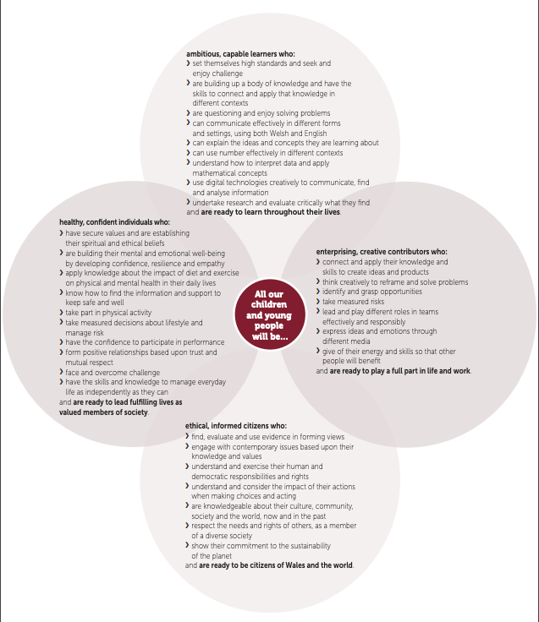
Source: Donaldson, G. (2015) ‘Successful Futures’ Independent Review of Curriculum and Assessment Arrangements in Wales. Available at: https://gov.wales/sites/default/files/publications/2018-03/successful-futures.pdf (Accessed: 14 October 2021).
Appendix 2
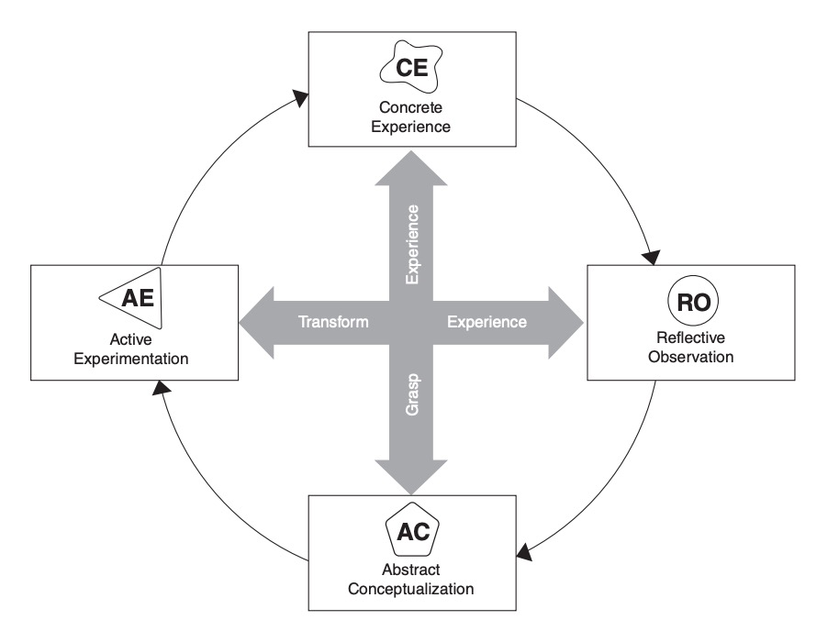
Kolb’s Experiential Learning Cycle
Source: Kolb, D. (1984) Experiential learning: Experience as the source of learning and development. Englewood Cliffs: Prentice-Hall.

Appendix 3
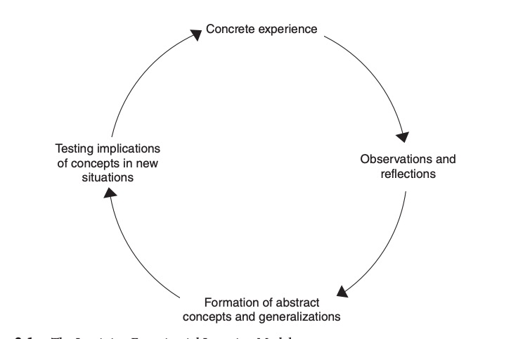
Lewin’s Experiential Learning Model

Source: Kolb, D. (1984) Experiential learning: Experience as the source of learning and development. Englewood Cliffs: Prentice-Hall.

Appendix 4
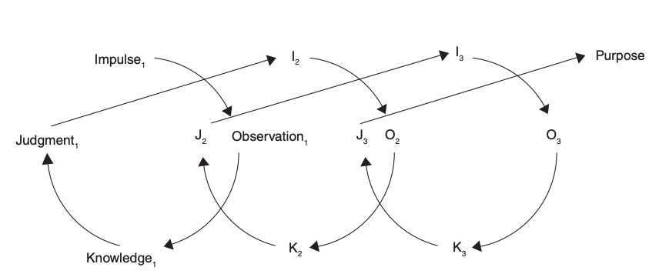
Dewey’s Model of Experiential Learning

Source: Kolb, D. (1984) Experiential learning: Experience as the source of learning and development. Englewood Cliffs: Prentice-Hall.

Appendix 5
Gibbs Reflective Cycle
Source: Gibbs, G. (2013) Learning by doing. Oxford: Oxford Centre for Staff and Learning Development.

Appendix 6
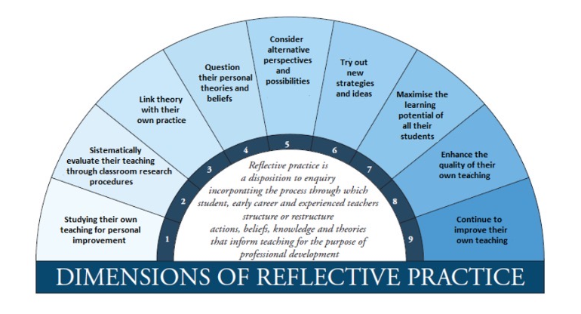
Zwozdiak-Myers’ Nine Dimensions of Reflective Practice
Source: Zwozdiak-Myers, P. (2012) The teacher's reflective practice handbook. Abingdon: Routledge.

Appendix 7
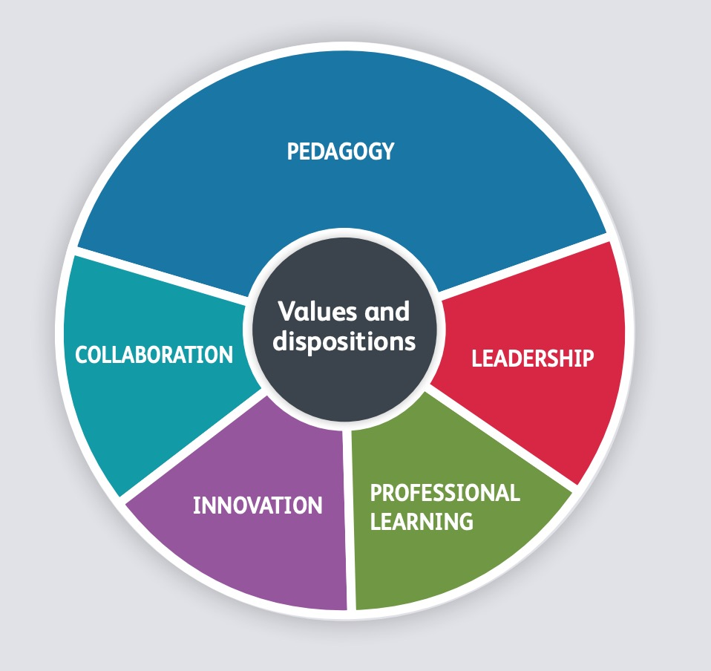
Professional teaching standards

Source: Welsh Government. (2018) An introduction to the professional standards for teaching and leadership. Available at: https://hwb.gov.wales/api/storage/932d8940-56f5-4660-aa85-afb4e87560a9/an-introduction-to-the-professional-standards-for-teaching-and-leadership.pdf (Accessed: 14 October 2021).

Appendix 8
Maslow’s Hierarchy of Needs

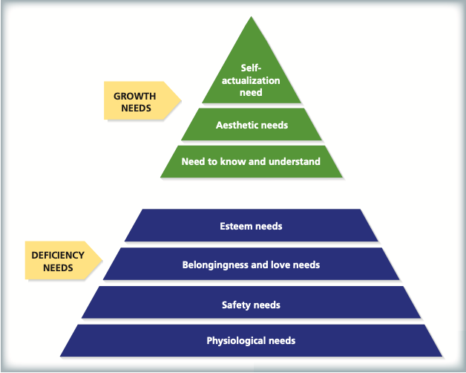
Source: Slavin, R. (2018) Educational Psychology: Theory and Practice. New York: Pearson Education, Inc.

Appendix 9
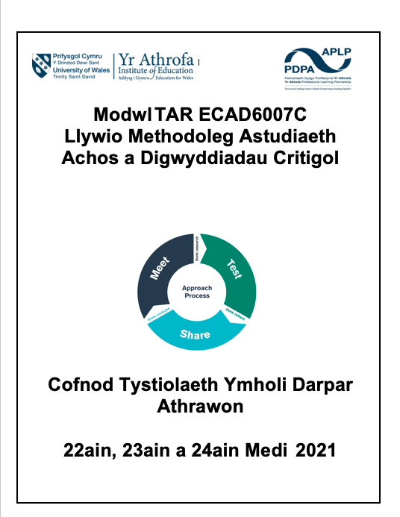
STEER booklet





