

Therapy Assistant Practitioner Level 4 Diploma: Demonstrating Practice Module

Therapy Assistant Practitioner:
Demonstrating Practice Logbook


Name: Rhiannon Edwards
Supervising Therapist/ Mentor: Laura Willis
Date commenced: December 2023
Cohort two: Module two Moule Code PJ14CY01: CDN188 / BMAC4020 Document completed: November 2023
Therapy Assistant Practitioner Level 4 Diploma: Demonstrating Practice Module

The content page includes a check list of evidence to be collected with columns to help correspond the continents.

Contents | Pages | Appendix
- Log of supporting documents from mentor:  - Log of assessments and goal setting.  - Log of a wide range of assessments.  - Log of clinical interventions within scope of practice.  - Log of risk a risk assessment and how it informs practice.  - Report on learner’s time and workload management.  - Log of compliance with mandatory training.  - Copy of a recent Personal Development Appraisal Review (PDAR).  - Copy of recent supervision records (at least two).  - Completed peer review sheet. | 5-6  7-9  10-12  13-14  15  16  17-19  20-22  23-25 | 1a  1b  1c  1d  1e  1f  2a  3a  4a

Cohort two: Module two Module Code PJ14CY01: CDN188 / BMAC4020 Document completed: November 2023
The Therapy Assistant Practitioner (TAP) demonstration of competencies in the following areas:
- Log of supporting documents from mentor: | Details to include: | Date of completion: | Mentors signature:
- Log of assessments and goal setting. | A completed initial assessment or detailed screening form, including evidence of patient centred goal document. | 26/1/24 | 
- Log of a wide range of assessments. | A minimum of three assessments completed, demonstrating a range of skills and tools. | 17/1/24
- Log of clinical interventions within scope of practice. | A minimum of three interventions completed, demonstrating a range of skills within scope of practice. | 19/1/24
- Log of a risk assessment and how it informs practice. | A completed risk assessment within the workplace, which can include clinical practice or department procedure. This can include case notes, reports, DATIX or professional discussion, which consists of risk identified, how the learner managed the risk and informed progress. | 14/2/24
- Report on learner’s time and workload management. | A completed report with mentor’s feedback of the learner’s time and workload management. The report can be completed on a word document and will need to be signed and dated. The report will need to include an example of how the learner demonstrates good time and workload management. | 25/1/24
- Log of compliance with mandatory training. | A copy of the learner’s compliance with mandatory training. Compliance is required to be 80% or above. | 6/2/24

Therapy Assistant Practitioner Level 4 Diploma: Demonstrating Practice Module
Cohort two: Module two Module Code PJ14CY01: CDN188 / BMAC4020 Document completed: November 2023

Therapy Assistant Practitioner Level 4 Diploma: Demonstrating Practice Module

- Copy of a recent Personal Development Appraisal Review (PDAR). | A copy of the most recent PDAR document completed with supervisor / mentor. | 6/2/24
- Copy of recent supervision records. | A minimum of two supervision records, demonstrating attendance and contribution to supervision and agreement to actions. | 6/2/24
- Copy of peer review document. | An attached copy of the peer review document completed following observations of others presentations. | 6/2/24
This logbook was completed by:

Mentor’s name: Laura Willis Mentor’s signature: Date:14/02/2024

Learner’s name: Rhiannon Edwards Learners’ signature: R EDWARDS Date:14.2.24

Cohort two: Module two Moule Code PJ14CY01: CDN188 / BMAC4020 Document completed: November 2023
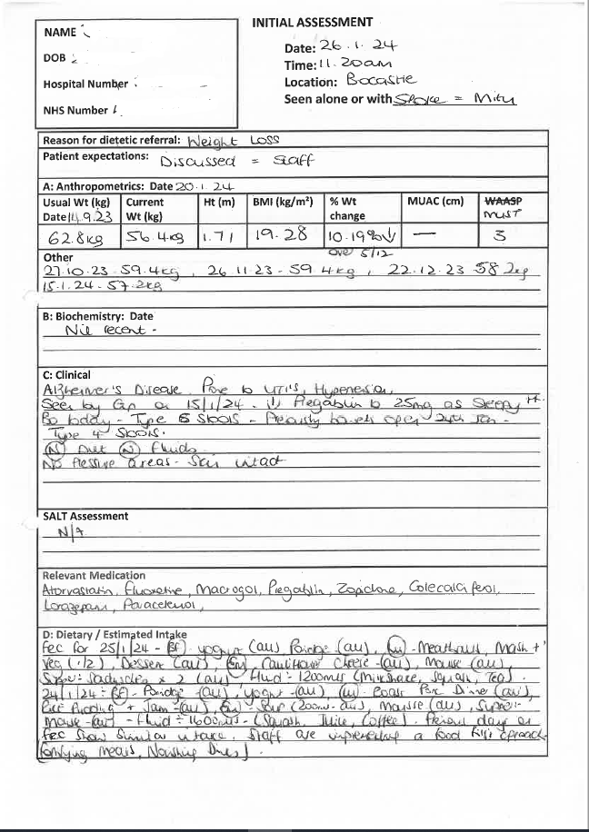
Appendix 1a

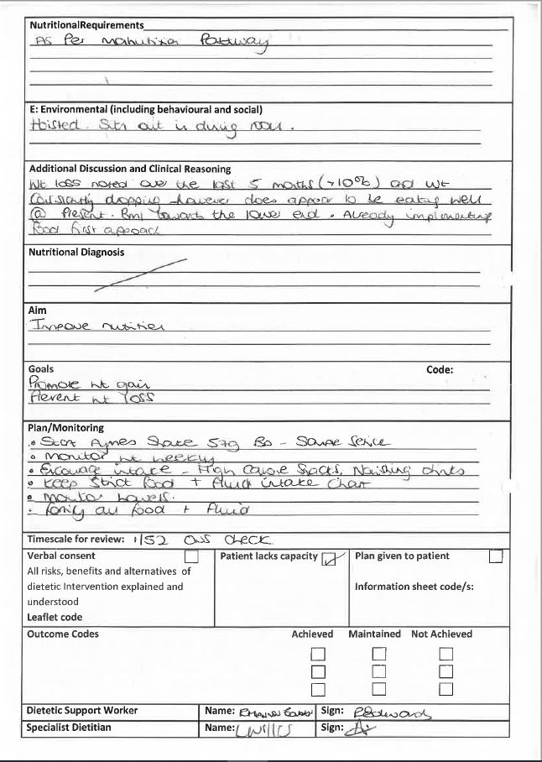
Appendix 1a

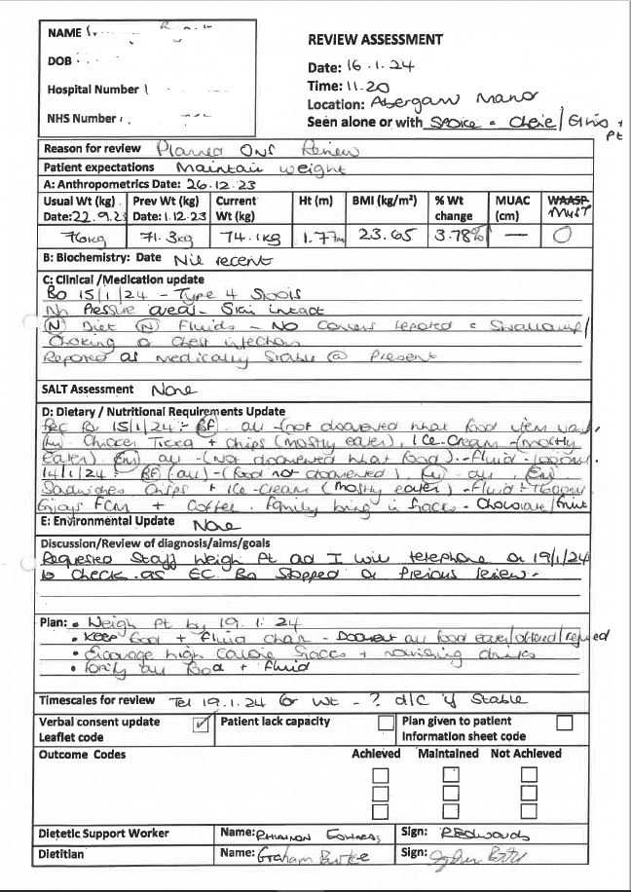
Appendix 1b

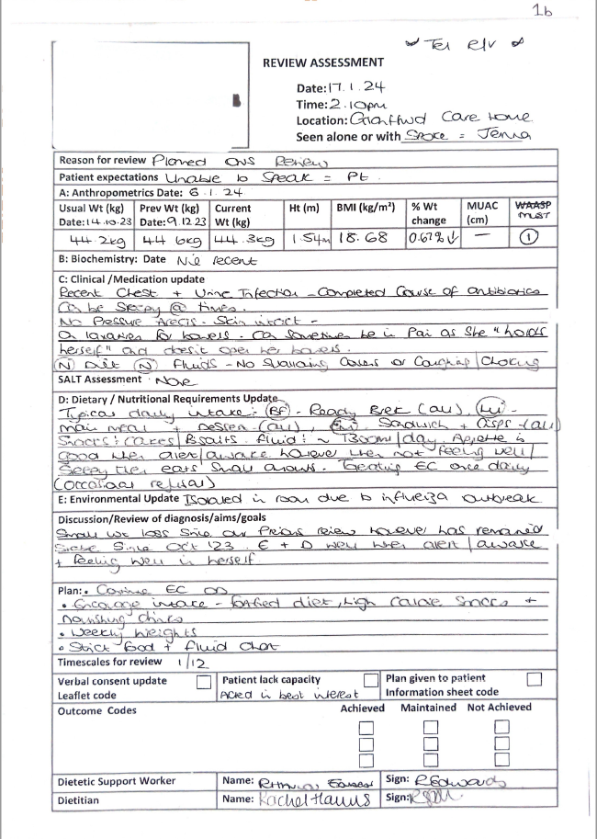
Appendix 1b

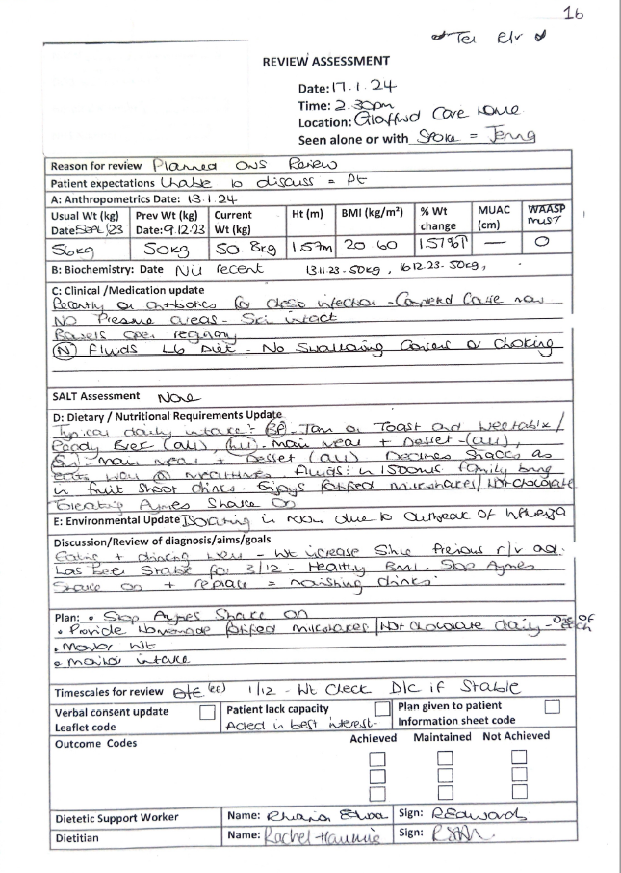
Appendix 1b

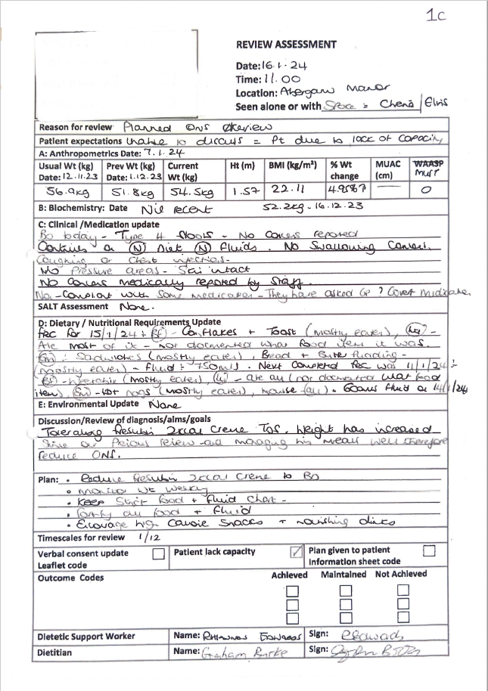
Appendix 1c

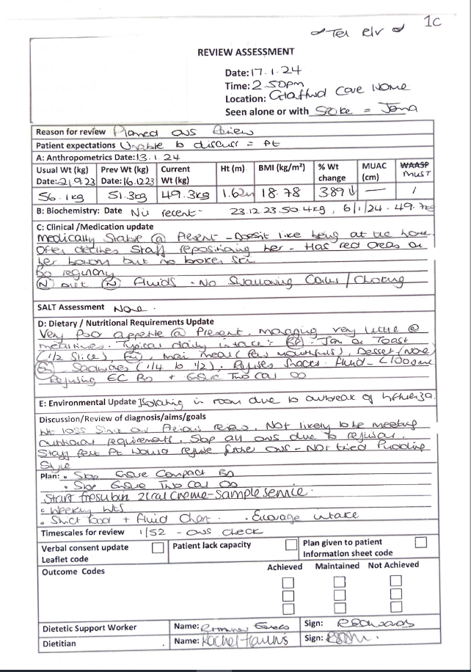
Appendix 1c
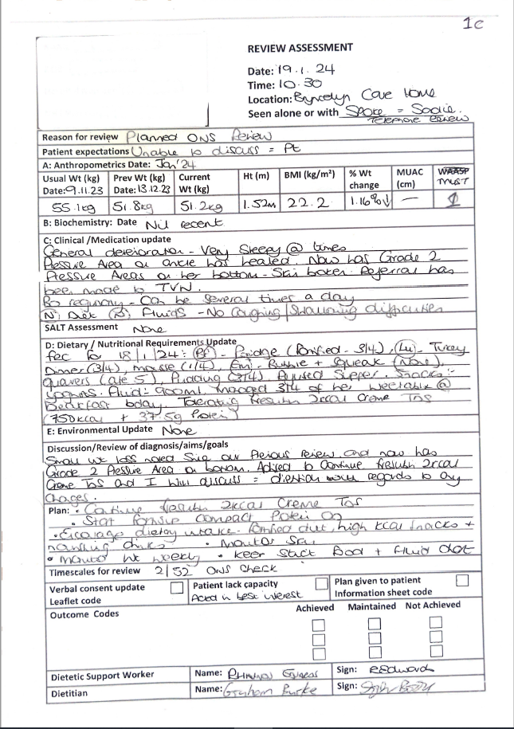
Appendix 1c

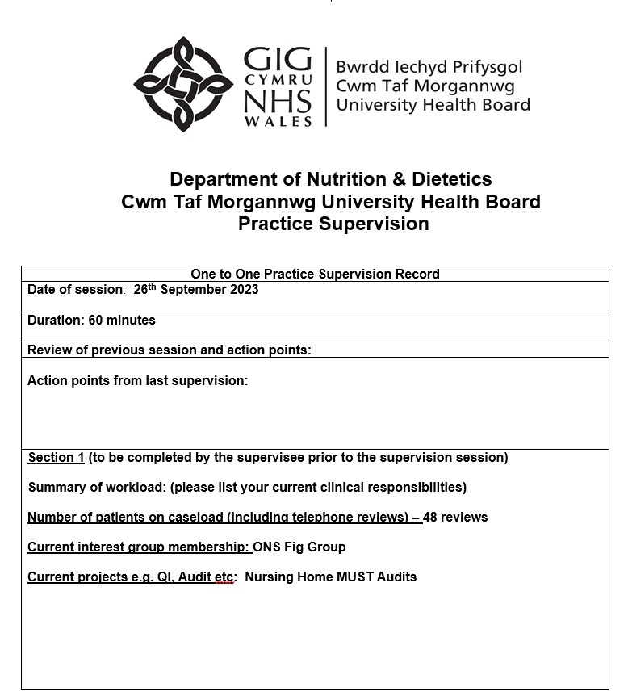
Appendix 1d

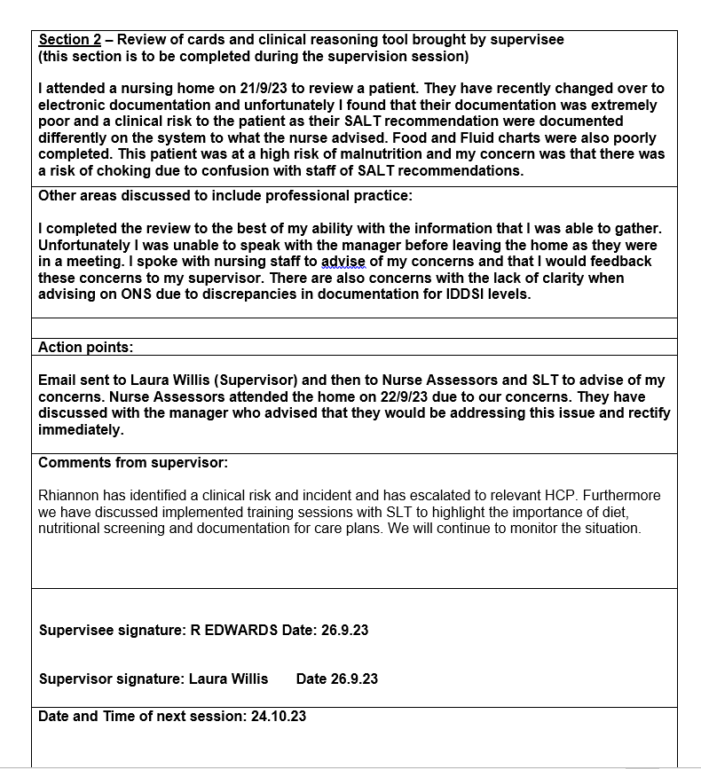
Appendix 1d

Appendix 1e

Report on learner’s time and workload management
RE: Rhiannon Sian Edwards
I have worked with Rhiannon since March 2019. Over that time period there has been several events including but not limited to COVID pandemic, short staffing and additional workload. These events have required excellent time and workload management. Rhiannon is a community based dietetic assistant practitioner and often demonstrates her ability to manager time and workload. Daily Rhiannon is able to manage her workload and is always swift but thorough when completing her work. On a weekly basis Rhiannon is able to receive referrals into the team and if not suitable for a DAP review is able to escalate appropriately. For review patients on a weekly basis she incorporates them in her workload and if required seeks support for further support if required. She is able to delegate appropriately to senior members of the team if required. Furthermore her administrative duties are complete in line with clinical standards when reviewing a patient.
An example of when she has demonstrates these excellent skills is an incident that occurred where a patient has required urgent dietetic input due to discrepancies in a feeding regimen. Despite being very late in the day Rhiannon was able to take the phone call, gather and assemble the information and communicate the plan with the care home. She was also ensured that there was adequate information was available to the clinical that was due to review the following day as she was going to be unavailable. This was an unexpected review and was able to priorities this workload at short notice whilst also ensuring the workload was prioritised for the next day.

Laura Willis (CTM UHB - Nutrition & Dietetics)

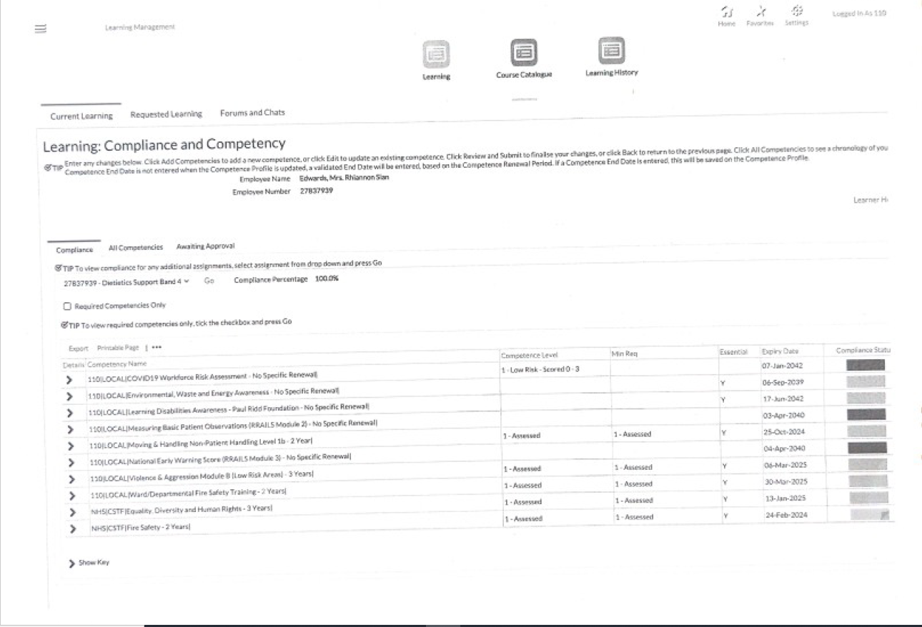
Appendix 1f
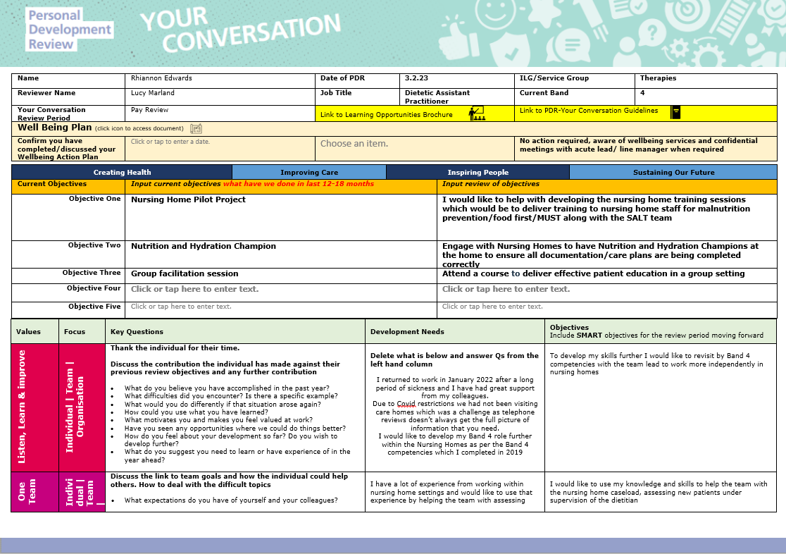
Appendix 2a
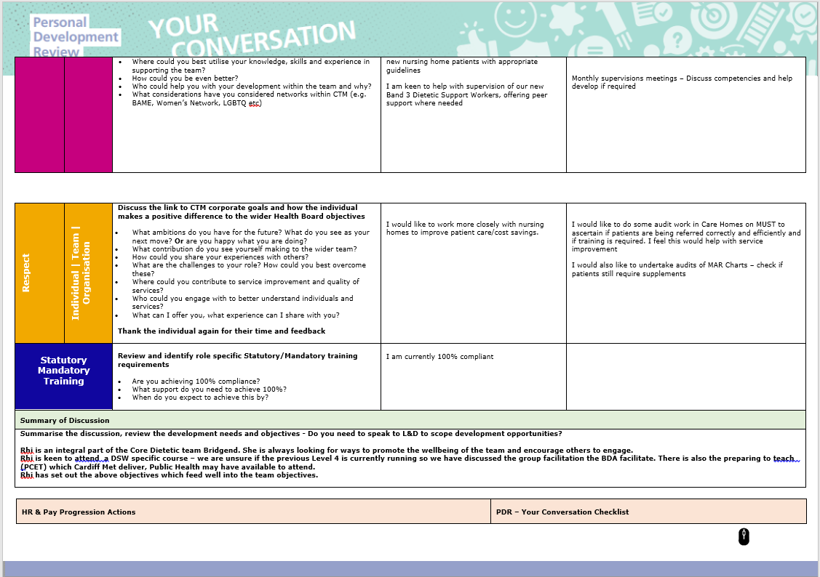
Appendix 2a

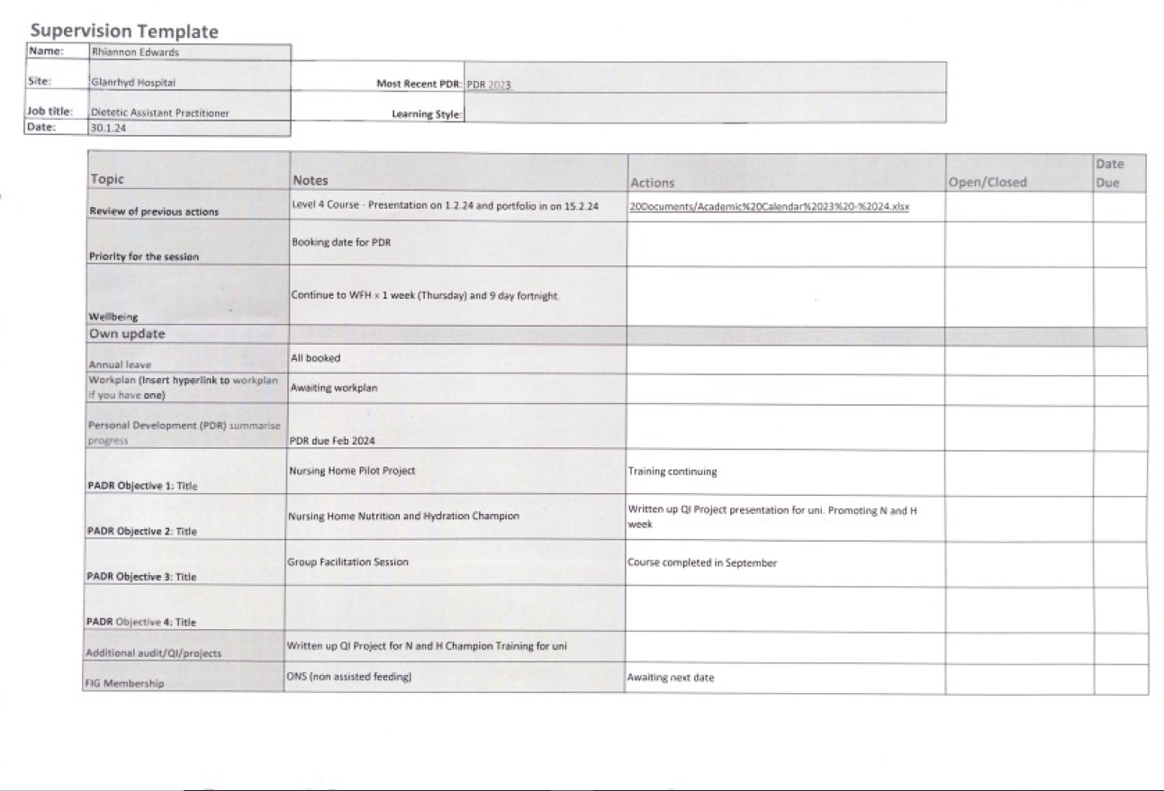
Appendix 2a 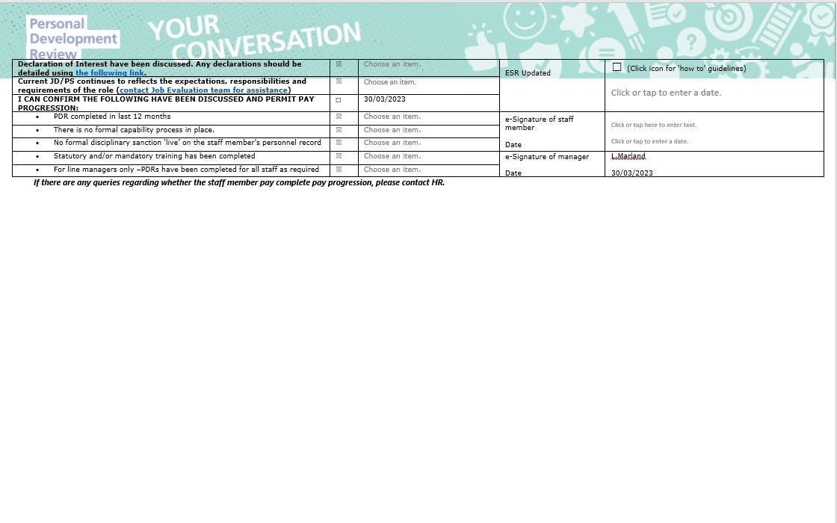
Appendix 3a

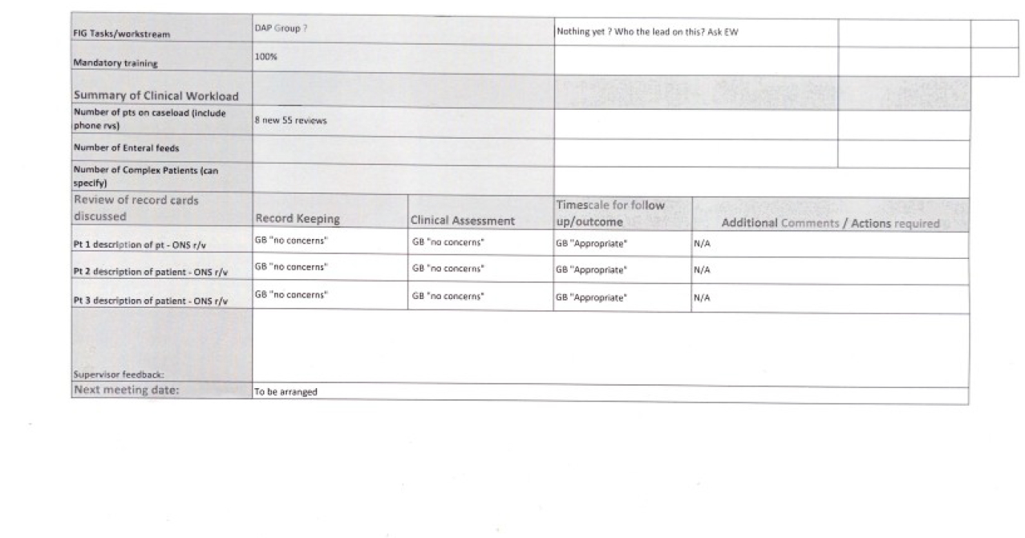
Appendix 3a

Appendix 3a
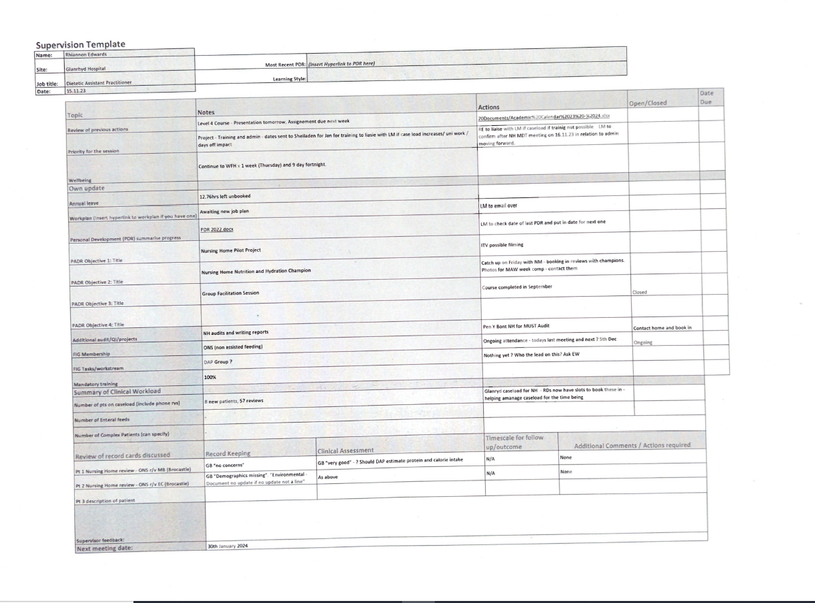
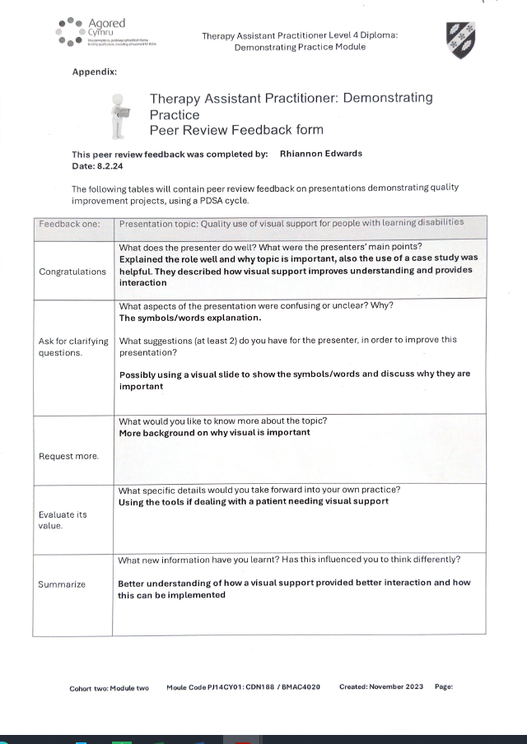
Appendix 4a

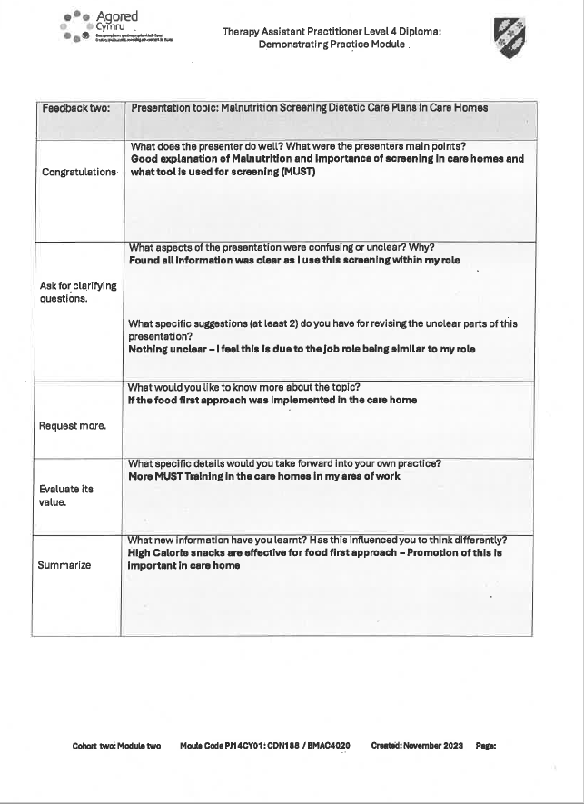
Appendix 4a
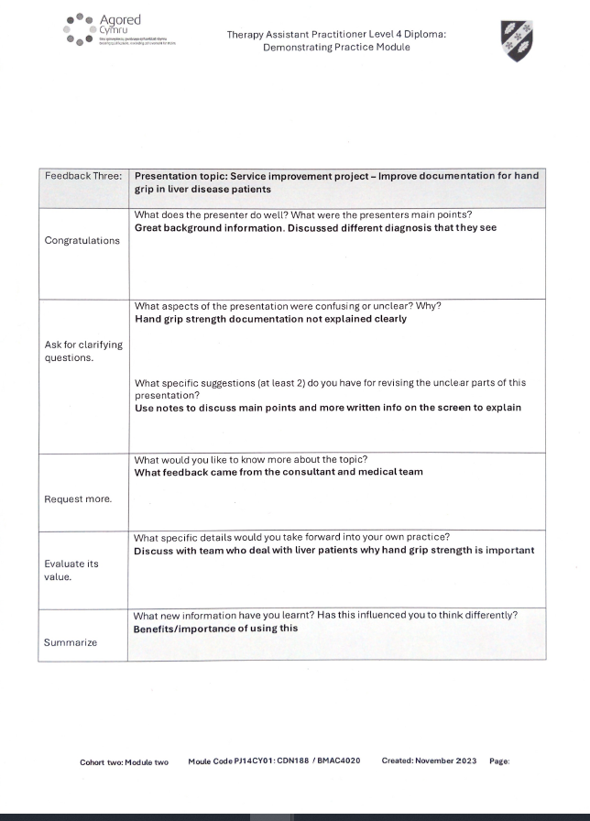
Appendix 4a

