
Student Name: | IRJ HUSSAIN
Student ID Number: | 2419541
Programme: | Certificate of Higher Education Skills for the Workplace (Health & Social Care)
Module Title: | Digital Skills and Research Methods
Module Code: | LCHS4007
Lecturer: | MARKUS KLINGELFUSS

Table of Contents
Introduction ............................................................................................... 3
Task 1: Selection of Research Topic ...................................................... 4
Task 2: Evaluating Information Sources ................................................ 5
Task 3: Research Methodologies ............................................................ 6
Task 4: Data Collection ............................................................................ 7
Conclusion ................................................................................................ 8

References ..................................................................................................9

Digital Inequalities in Type 2 Diabetes Self-Management in the UK: A Mixed-Methods Study

Introduction
Type 2 diabetes is a major and growing public health concern in the United Kingdom, affecting over 4.3 million people and contributing significantly to morbidity and healthcare costs (Diabetes UK, 2024). Effective self-management, including medication adherence, blood glucose monitoring, and lifestyle modification, is essential for reducing complications such as cardiovascular disease and kidney failure (NHS England, 2023). In recent years, digital health technologies have been increasingly used to support diabetes care. However, inequalities in access to digital tools and services persist, limiting their effectiveness among certain population groups (NHS Digital, 2022). This report explores these barriers, evaluates current research, and proposes a research approach to investigate this issue further.
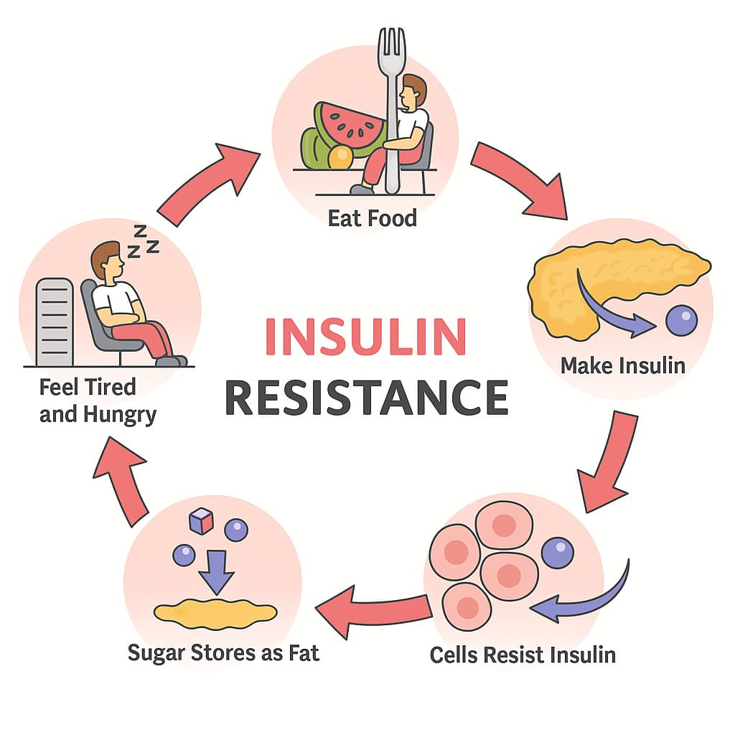

(Nadiryan, 2021)

Task 1: Selection of a Research Topic

1.1 Identification of the Issue
Type 2 diabetes continues to present a significant challenge to the UK healthcare system, with rising prevalence linked to lifestyle factors and an ageing population (Diabetes UK, 2024). Effective self-management plays a crucial role in controlling the condition and preventing long-term complications. To improve outcomes, digital health technologies such as mobile health applications, online education platforms, and remote monitoring systems have been increasingly integrated into diabetes care (NHS England, 2023). Despite these advancements, there is growing concern that not all individuals are able to access or benefit equally from these digital interventions.

1.2 Who is Affected and Why it Matters
Digital health inequalities disproportionately affect vulnerable groups, including older adults, individuals from lower socio-economic backgrounds, and some ethnic minority populations. These groups may face barriers such as limited access to digital devices, poor internet connectivity, or low digital literacy (NHS Digital, 2022). As a result, they may struggle to engage with digital self-management tools, leading to poorer health outcomes and increased risk of complications. Evidence suggests that inequalities in access to diabetes care and technology contribute to widening health disparities across the UK population (Barron et al., 2023). This is a critical issue for health and social care organisations, as it not only affects patient wellbeing but also increases pressure on healthcare services and resources.

1.3 Personal Reflection and Rationale
This topic was chosen due to its relevance to current developments in healthcare and its strong link to issues of equality and access to care. As a health and social care student, understanding how digital and social barriers impact patient outcomes is essential for effective professional practice. This topic aligns with my interest in promoting inclusive and patient-centred care. It also supports my future career goals by enhancing my awareness of how healthcare systems can address inequalities and better support individuals living with long-term conditions such as Type 2 diabetes.

Task 2: Evaluating Information Sources

2.1 Source 1: Digital Interventions in Diabetes Self-Management
A systematic review by Pal et al. (2021) examined the effectiveness of digital and mobile health interventions in supporting self-management for individuals with Type 2 diabetes. The study found that digital tools, including mobile applications and online platforms, can significantly improve glycaemic control and patient engagement when used consistently. This source is highly valuable as it draws on multiple studies, increasing the reliability and generalisability of its findings. Additionally, the use of a systematic review methodology strengthens the validity of the conclusions. However, a limitation is that the study does not fully address how socio-economic or digital literacy barriers may influence the effectiveness of these interventions. This makes it less comprehensive when considering inequalities in access.

2.2 Source 2: Inequalities in Diabetes Care and Outcomes
Research by Barron et al. (2023) highlights persistent inequalities in diabetes outcomes across England, particularly among deprived populations and ethnic minority groups. The study uses large-scale population data, making it highly reliable and relevant to the UK context. It demonstrates that individuals from disadvantaged backgrounds are more likely to experience poorer glycaemic control and higher complication rates. This source is useful in supporting the argument that health inequalities remain a major issue in diabetes care. However, while it effectively identifies disparities, it does not focus specifically on digital health technologies or how digital exclusion contributes to these inequalities. Therefore, further research is needed to explore this connection in more detail.

2.3 Source 3: Digital Exclusion and Health Inequalities
A report by NHS Digital (2022) explores the impact of digital exclusion on access to healthcare services in the UK. It identifies key barriers such as lack of access to devices, poor internet connectivity, and limited digital skills, particularly among older adults and low-income populations. This source is highly relevant to the chosen topic as it directly addresses the concept of digital inequality. It provides practical insights into why some individuals are unable to benefit from digital health interventions. However, as a report rather than a peer-reviewed journal article, it may lack the same level of academic rigour as other sources. Despite this, it remains a credible and authoritative source due to its origin within a national healthcare organisation.

2.4 Gaps in Current Research
Although existing research highlights the benefits of digital interventions and the presence of health inequalities, there is a noticeable gap in studies that combine these two areas. Specifically, limited research explores how digital exclusion directly impacts diabetes self-management outcomes in the UK. Additionally, there is a lack of qualitative research examining patients’ lived experiences of using digital tools for diabetes care. Furthermore, few studies focus on long-term effectiveness or culturally tailored interventions for diverse populations. Addressing these gaps would provide a more comprehensive understanding of how to improve equitable access to diabetes self-management support.

Task 3: Research Methodologies

3.1 Overview of Research Methodologies
Research methodologies provide a structured approach to collecting and analysing data in order to answer a research question. Three main types commonly used in health and social care research are quantitative, qualitative, and mixed-methods approaches. Quantitative research involves the collection and analysis of numerical data to identify patterns, relationships, or trends. It often uses structured tools such as surveys or experiments and produces statistically measurable results (Creswell and Creswell, 2021). In contrast, qualitative research focuses on exploring individuals’ experiences, perceptions, and behaviours through methods such as interviews or focus groups, providing in-depth understanding of complex issues (Green and Thorogood, 2018). Mixed-methods research combines both quantitative and qualitative approaches to gain a more comprehensive understanding of a research problem.

3.2 Chosen Methodology and Justification
For this study, a mixed-methods approach would be the most appropriate. This is because the research aims to explore both measurable outcomes, such as the extent of digital tool usage and self-management behaviours, and subjective experiences, such as patients’ perceptions of digital health technologies. Quantitative data can help identify patterns and the scale of digital inequality, while qualitative data can provide deeper insight into the barriers individuals face, such as lack of digital literacy or access. According to Creswell and Creswell (2021), mixed-methods research is particularly effective in health studies where both statistical evidence and personal experiences are important. Therefore, this approach would provide a more holistic understanding of how digital inequalities affect diabetes self-management in the UK.

Task 4: Data Collection

4.1 Primary and Secondary Data Collection
Data collection is a key stage in the research process and can be broadly divided into primary and secondary methods. Primary data refers to information collected directly by the researcher for a specific purpose, using methods such as surveys, interviews, or observations. In contrast, secondary data involves the use of existing information, such as academic journal articles, government reports, and healthcare statistics (Creswell and Creswell, 2021). Both types of data are valuable in health research, depending on the aims and scope of the study.

4.2 Chosen Data Type and Justification
For this research, primary data collection would be most appropriate. This is because the study aims to explore current experiences of individuals with Type 2 diabetes in relation to digital health technologies. Collecting first-hand data through surveys and semi-structured interviews would allow the researcher to gather up-to-date and context-specific information about patients’ access to digital tools, their level of engagement, and the barriers they face. Primary data would provide deeper insight into how digital inequalities directly impact self-management behaviours.

4.3 Methods of Data Collection
A combination of questionnaires and semi-structured interviews would be used. Questionnaires would generate quantitative data on patterns such as frequency of digital tool usage, while interviews would provide qualitative insights into personal experiences and challenges. This approach aligns with the mixed-methods design discussed earlier and allows for a more comprehensive understanding of the issue (Creswell and Creswell, 2021).

4.4 Advantages and Challenges
The main advantage of primary data is that it is specific, relevant, and up to date. It allows the researcher to focus directly on the research question and target population. However, there are also challenges, including the time required for data collection, potential difficulties in recruiting participants, and ethical considerations such as informed consent and confidentiality. Despite these limitations, primary data remains essential for gaining detailed and meaningful insights into patient experiences (Green and Thorogood, 2018).

Conclusion
In conclusion, Type 2 diabetes remains a significant health issue in the United Kingdom, with effective self-management playing a crucial role in improving patient outcomes. This report has highlighted the growing importance of digital health technologies in supporting diabetes care, while also emphasising the impact of digital inequalities on access and engagement. By evaluating current research, identifying gaps, and proposing a mixed-methods research approach using primary data, the report demonstrates how this issue can be further explored. Addressing these barriers is essential for promoting equitable healthcare and improving the quality of life for individuals living with diabetes.

REFERENCES
Barron, E., Misra, S., English, E., et al. (2023) ‘Trends in type 2 diabetes outcomes and inequalities in England: a population-based study’, The Lancet Diabetes & Endocrinology, 11(2), pp. 101–110.
Creswell, J.W. and Creswell, J.D. (2021) Research design: Qualitative, quantitative, and mixed methods approaches. 5th edn. Thousand Oaks: Sage.
Diabetes UK (2024) Diabetes prevalence 2024. Available at: https://www.diabetes.org.uk
Green, J. and Thorogood, N. (2018) Qualitative methods for health research. 4th edn. London: Sage.
NHS Digital (2022) Digital inclusion for health and social care. Available at: https://digital.nhs.uk
NHS England (2023) NHS Long Term Plan and diabetes care improvements. Available at: https://www.england.nhs.uk
Pal, K., Eastwood, S.V., Michie, S., et al. (2021) ‘Computer-based diabetes self-management interventions for adults with type 2 diabetes mellitus’, Cochrane Database of Systematic Reviews, 2021(3).

