3/24/2026

Design and Implementation of a Relational Database System
Module Name: Introduction to Web and Database
Concepts
Module Code: ACCA4023

Student Name: Archana Gurudas Salgaocar
Student ID: 2514522
Group: 3

Lecturer’s Name: Koushik Modak

University of Wales Trinity Saint David
LONDON CAMPUS

Table of Contents
Table of Contents 3
1. Introduction 3
2. Scenario Analysis 4
2.1 Identification of Entities 4
2.2 Attributes of Entities 4
2.3 Relationships Between Entities 6
3. Entity–Relationship Diagram (ERD) 6
4. Data Structure Development 7
5. Data Dictionary 9
6. Normalization 9
7. Sample Data Population 9
8. Query Development 9
9. Validation and Testing 11
10. Conclusion and Reflection 11
11. References 11

Table of Contents
- 1. Introduction
- 2. Scenario Analysis
- 2.1 Identification of Entities
- 2.2 Attributes of Entities
- 2.3 Relationships Between Entities
- 3. Entity–Relationship Diagram (ERD)
- 4. Data Structure Development
- 5. Data Dictionary
- 6. Normalization
- 7. Sample Data Population
- 8. Query Development
- 9. Validation and Testing
- 10. Conclusion and Reflection
- 11. References

1. Introduction
MediLink Pharmacy is a growing community pharmacy that currently relies on manual systems to manage prescriptions, stock, and customer records. These manual processes are inefficient and prone to human error, leading to inaccurate stock levels, delayed data retrieval, and potential mistakes in prescription handling.
The purpose of this project is to design and implement a relational database system using Microsoft Access. The system aims to automate pharmacy operations by organising data into structured tables and establishing relationships between them. This will improve accuracy, efficiency, and data accessibility.
MediLink Pharmacy is an expanding community pharmacy that, at present, depends upon manual procedures for managing prescriptions, inventory, and customer records. This reliance on manual methods results in inefficiencies, as tasks such as updating stock levels, recording customer information, and processing prescriptions are all handled by hand. The absence of automation introduces a greater risk of human error, which may lead to incorrect stock counts, delays in accessing information, and potential mistakes in the handling of prescriptions. As the business grows, these challenges become increasingly pronounced, underlining the need for a more robust and reliable system to support daily operations. These manual processes are inefficient and prone to human error, leading to inaccurate stock levels, delayed data retrieval, and potential mistakes in prescription handling.
The purpose of this project is to design and implement a relational database system using Microsoft Access. The system aims to automate pharmacy operations by organising data into structured tables and establishing relationships between them. This will improve accuracy, efficiency, and data accessibility.
System Objectives
The objectives of the system are:
- To manage medicine inventory efficiently
- To store customer and prescription data securely
- To track sales transactions accurately
- To reduce errors associated with manual record-keeping
- To support decision-making through queries and reports

2. Scenario Analysis

2.1 Identification of Entities
The MediLink Pharmacy system involves five main entities: Medicines, Suppliers, Customers, Prescriptions, and Sales.
Medicines store information such as name, category, price, and stock levels. Each medicine is supplied by a supplier.
Suppliers provide medicines and their details include contact and address information.
Customers represent individuals purchasing medicines.
Prescriptions link customers to medicines prescribed by doctors. Sales record all transactions between customers and the pharmacy.
This system ensures that all operations are interconnected and efficiently managed.
From the scenario, the main entities involved in the system are:
- Medicines
- Suppliers
- Customers
- Prescriptions
- Sales

2.2 Attributes of Entities
1. Medicines
Stores information about medicines available in the pharmacy.
- MedicineID (Primary Key)
- MedicineName
- Category
- Price
- StockQuantity
- SupplierID (Foreign Key)
2. Suppliers
Stores details of companies supplying medicines.
- SupplierID (Primary Key)
- SupplierName
- ContactNumber
- Email
- Address
3. Customers
Stores details of customers who purchase medicines.
- CustomerID (Primary Key)
- FirstName
- LastName
- PhoneNumber
- Address
- DateOfBirth
4. Prescriptions
Stores prescriptions issued to customers.
- PrescriptionID (Primary Key)
- CustomerID (Foreign Key)
- MedicineID (Foreign Key)
- DoctorName
- PrescriptionDate
- DosageInstructions
5. Sales
Stores records of medicine sales transactions.
- SaleID (Primary Key)
- MedicineID (Foreign Key)
- CustomerID (Foreign Key)
- SaleDate
- QuantitySold
- TotalPrice

2.3 Relationships Between Entities
Entities and Relationships:
- Supplier → Medicines 1 : Many
- Customer → Prescriptions 1 : Many
- Medicine → Prescriptions 1 : Many
- Customer → Sales 1 : Many
- Medicine → Sales 1 : Many

3. Entity–Relationship Diagram (ERD)
The ERD illustrates how data entities relate to each other.
- A Supplier supplies multiple medicines (1:M)
- A Customer can have multiple prescriptions (1:M)
- A Medicine can appear in many prescriptions (1:M)
- A Customer can make multiple purchases (1:M)
- A Medicine can appear in multiple sales (1:M)
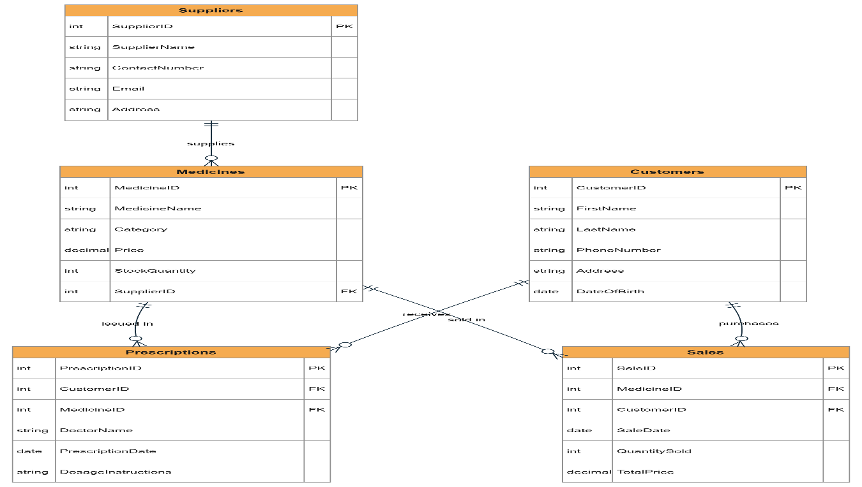
Primary keys uniquely identify each record, while foreign keys establish relationships between tables. This design ensures data integrity and eliminates redundancy.

4. Data Structure Development
The database consists of five tables:
Suppliers
- SupplierID (PK)
- SupplierName
- ContactNumber
- Email
- Address
Medicines
- MedicineID (PK)
- MedicineName
- Category
- Price
- StockQuantity
- SupplierID (FK)
Customers
- CustomerID (PK)
- FirstName
- LastName
- PhoneNumber
- Address
- DateOfBirth
Prescriptions
- PrescriptionID (PK)
- CustomerID (FK)
- MedicineID (FK)
- DoctorName
- PrescriptionDate
- DosageInstructions
Sales
- SaleID (PK)
- CustomerID (FK)
- MedicineID (FK)
- SaleDate
- QuantitySold
- TotalPrice
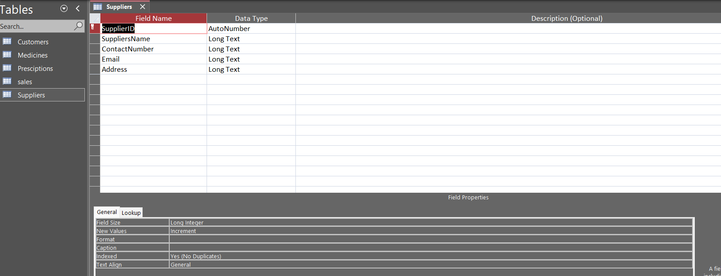
Figure2:Supplier table design
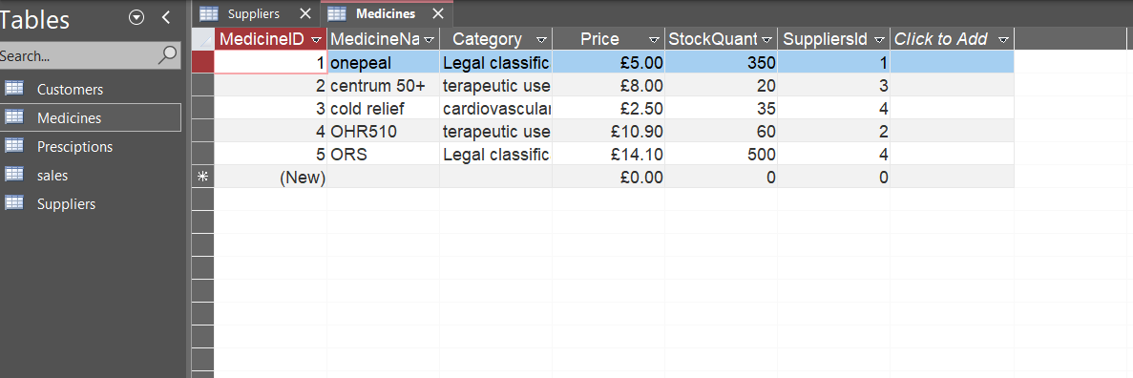
Figure 3: medicine table structure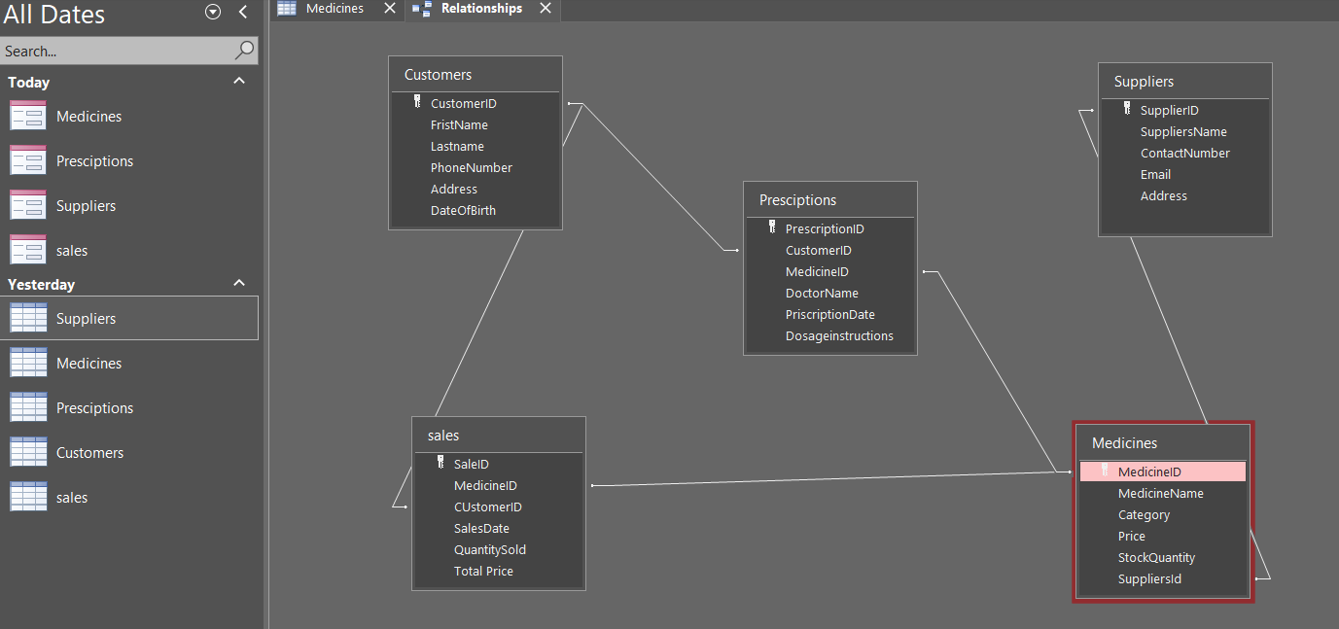
Figure 4: database relationship window

5. Data Dictionary
Field Name | Description
MedicineID | Unique medicine identifier
SupplierID | Links medicine to supplier
CustomerID | Unique customer identifier
PrescriptionID | Unique prescription record
SaleID | Unique sales transaction

6. Normalization
The database is normalized up to Third Normal Form (3NF).
- First Normal Form (1NF): Ensures all attributes contain atomic values with no repeating groups.
- Second Normal Form (2NF): Removes partial dependencies by ensuring all attributes depend on the full primary key.
- Third Normal Form (3NF): Eliminates transitive dependencies by separating supplier details into a different table.
Normalization reduces redundancy and improves data consistency.

7. Sample Data Population
Sample data was inserted into all tables to test the system functionality. This includes suppliers, medicines, customers, prescriptions, and sales records.
The use of realistic data ensures that queries and relationships function correctly.

8. Query Development
Several queries were developed to retrieve useful information.
Query 1: Low Stock Medicines
Purpose: Identify medicines that need restocking
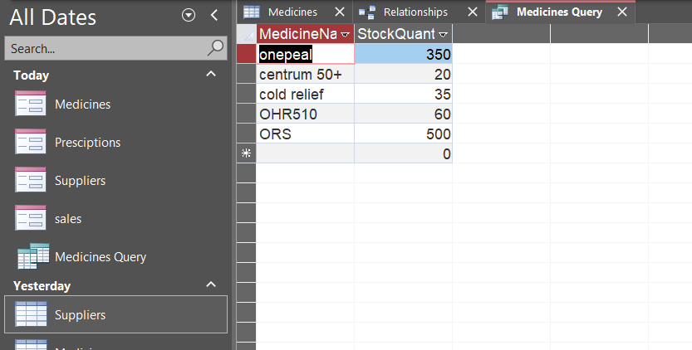

Query 2: Sales by Customer
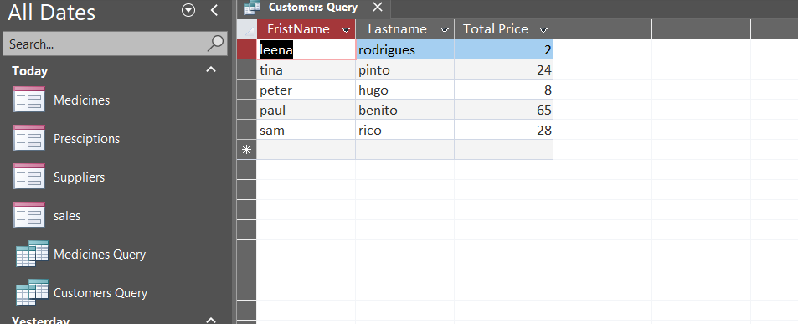
Purpose: Monitor customer purchases

Query 3: Supplier Medicines
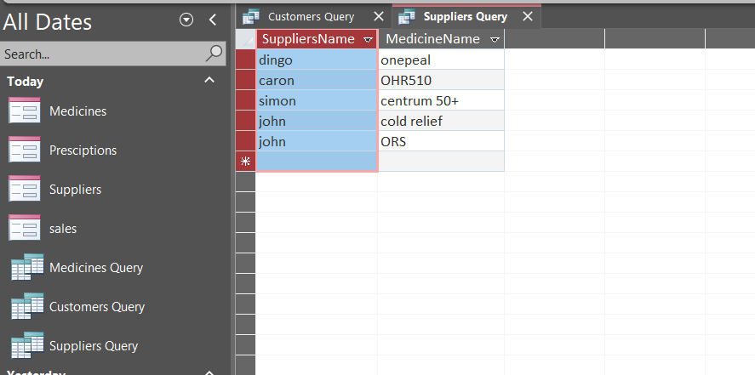
Purpose: Track supplier contributions

Query 4: Prescription Records
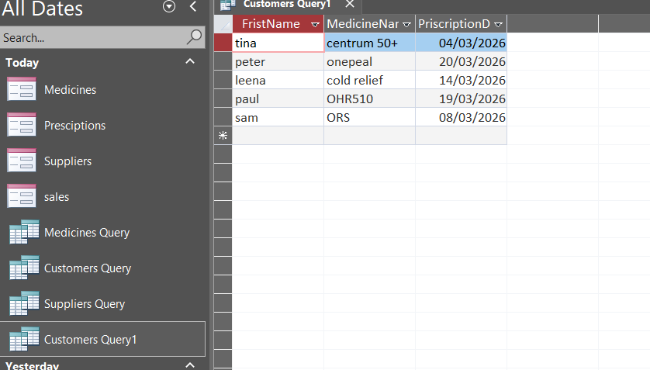
Purpose: View customer prescription history

9. Validation and Testing
The database was tested to ensure functionality and accuracy.
Test Case | Expected Result | Outcome
Add new medicine | Record saved | Pass
Invalid SupplierID | Error shown | Pass
Run query | Correct data | Pass
Add sale | Data recorded | Pass

Referential integrity ensures that invalid data cannot be entered.

10. Conclusion and Reflection
The MediLink Pharmacy database system was successfully implemented using Microsoft Access. The system efficiently manages medicines, suppliers, customers, prescriptions, and sales.
The project improved understanding of relational database design, normalization, and data integrity. It also demonstrated how database systems are used in real-world healthcare environments.
Future improvements could include automated alerts, barcode integration, and advanced reporting features.

11. References
[1] T. Connolly and C. Begg, Database Systems, Pearson, 2015. Database Design for Mere Mortals, Addison-Wesley, 2013.

