Assignment Two
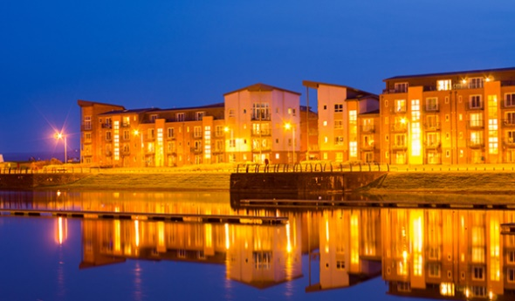
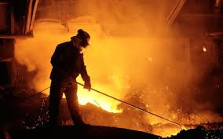

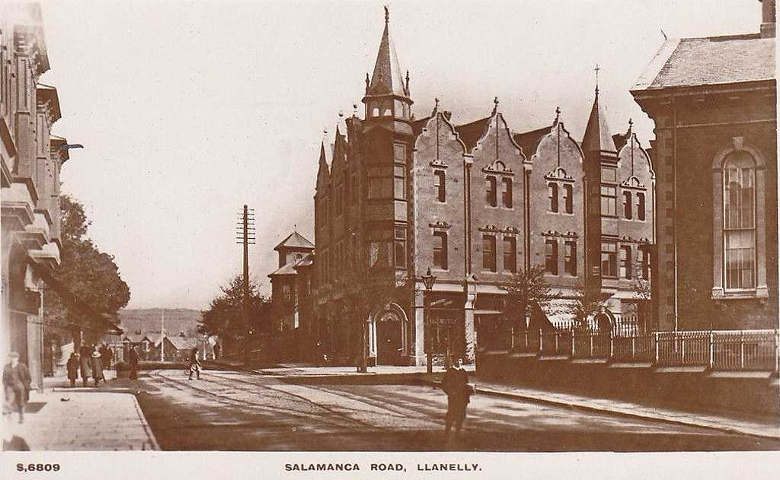

BMSP4005:

Llanelli: Distinctiveness &
REGENERATION

BA Rural Enterprise Management

Jessica Ellis
(1807462)

Contents:

- Historical Development
- Changing Fortunes
- Existing Assetts, Structures and Economic Character
- Local/ regional development strategies
- Conclusion
- Bibliography

Historical Development

Following the Devonian period, around 390 million years ago, South Wales and the Midlands inherited debris via rivers from the Welsh Basin, whereby, although a heavily dry landscape, the occasional rain had eroded a vast part resulting in new sediments. This debris helped to form the swamps. Subsequently in the later Carboniferous period, rocks in South Wales that included river-deposited sandstones which were containing pellets of coal. After the estuaries and lagoons had formed over these anaerobic swamps, the peat coal compressed due to the high content of carbon and mass volume of heat, this resulted in coal (carbonization process).
Mirroring carbonization developing over time, as do landscapes, economics, cultures and nature. As Earth’s sediments evolve due to weathering conditions, society develops too under its array of circumstances. The Earth regenerates itself, just like an economy has to in order to survive and prosper.
Situated in the South Eastern corner of Carmarthenshire and presently comprising of around 35,000 occupants, Llanelli boasts a wealth of distinctiveness; heritage and remains to perpetuate as a prominent example of regeneration, though whilst showcasing areas of natural physiognomies. In terms of sense of place, dependent on where you are or have been in Llanelli, there are contrasting thoughts and feelings. Llanelli had a proud industrial past, but fell on hard times. (Wales, 2010)

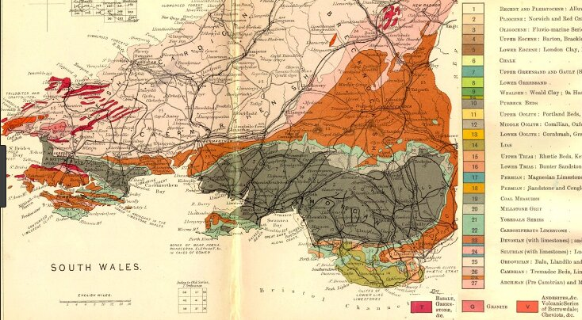

Figure 1: Coal Seams throughout Wales

Without the Welsh Basin enduring erosion and the debris transporting and regenerating into sand, finally manifesting into an organic material, it may not have fueled worldwide civilization economically when it did. Previously, due to minute capital investment, mechanical and technological limitations, and transportations, most of Llanelli’s citizens were relying on their trading of manmade and grown products, and sea coal due to the demand in ships. This involved a titanic volume of man and animal power, in which was very manual and time consuming. However, the late 1700’s saw the birth of the Industrial Revolution. Due to her vast colonial empires, political stability and affluence, Great Britain was the first to fully participate in this historic milestone, resulting in a colossal shift in society from agrarian to industrialization. Llanelli saw a very substantially economic, environmental and societal changing tide.
In addition, due to the convenience of Llanelli traders being closer to and in towns, it meant traders producing resources such as textiles, food and tools in rural areas and harder to access, were diminishing. (Ellis, 2019) “This can be comparable to the present day – products and services can be sourced from countries such as China due to the cost effectiveness.” (Hannam, 2019). The use of mechanical engineering such as steam powered trains meant products could be transported in bulk. In 1712, the initial ‘Steam Pump’ had been created by Thomas Newcomen, and this somewhat combatted coal mine flooding.
By 1750, industrialization was in full swing in Llanelli. Coal mining was imperative to the area, as not only did it invite the promise of work, it attracted a huge amount of capital investment. This was mainly due to the low lying coalfields that were rich in bituminous coal near the estuaries. At this time, Llanelli became extremely appealing for investment, especially being so close to the dock.
Prominent figures such as Chauncey Townsend, Joseph Shewen and Baronet Edward Vaughan (3^{rd)} were notorious for transmuting Llanelli. As well as national speculators entering Llanelli and purchasing land to sit on and lease for a larger yield, there were others in their shadows who subsequently followed suit too. In 1797, Alexander Raby, a former Freeman of the City of London; Ironmaster and Speculator was keen on becoming part of this lucrative movement. Raby secured a 91 – year lease around Llanelli in order to mine coal. This was not the first time Raby had taken an interest in Llanelli. He financed two ironmasters named John Gevers and Thomas Ingman to establish their iron furnace at Stradey Estate in 1791. Raby failed to relocate to Llanelli at this time, perhaps the reason he did so six years later suggests how the iron trade was being replaced by coal. Alexander Raby was a pioneer for Llanelli and is heavily regarded to this present day. Perhaps one of the reasons was due to him demonstrating his social responsibility in Llanelli. He built 1934 cottages for the mine workers, alongside a neighboring public house, named The Raby’s Arms. This promoted a sense of place and community for the workers. This brought ample immigrants with the attraction of work and accommodation. Following this, then came the interlinking of many national collieries.

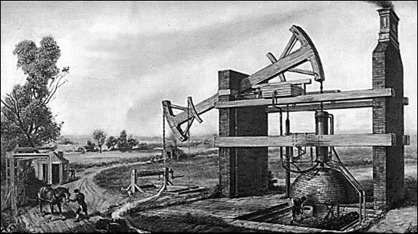
Figure Two: Newcomen’s steam engine invented around 1780 due to frequent floods in the collieries
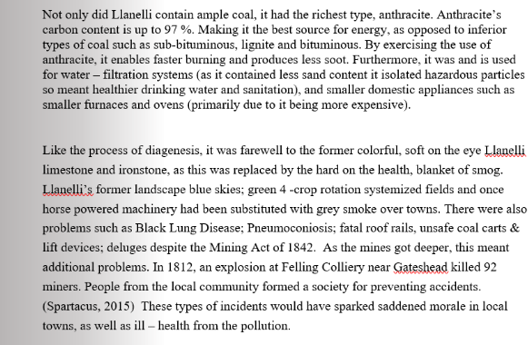
By 1895, railways were predominatly fuelled by Llanelli’s coal, and so subsequently this resulted in additional investment. At the peak of the coal boom (1880’s – 1913), Llanelli produced and globally distributed over 57,000,000 tons of coal per year, and hiring ~232,000 minors in over 620 mines. By 1923, Welsh mining employment figures rocketed to over 271,000, producing coal for domestic and commercial use such as the Great Western Railway.

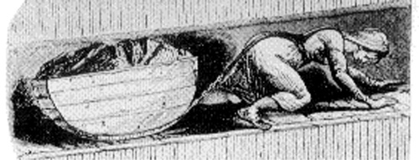
Figure Three: Ladies and children mined to afford to live
In addition to this, due to the seams being so narrow, other than pit ponies and men, women and small children were crawling down on their hands and knees. Due to finances, women even had to work throughout their pregnancies. “My last child was born on Saturday morning, and I was at work on the Friday night (Kirby, 2003). At Huskar Colliery in 1838, 11 girls (aged 8 – 16 years) and 15 boys (aged 9 - 12 years) died when a stream overflowed through a ventilation drift This prompted Queen Victoria to put pressure on the Prime Minister. In 1842, legislation passed that no females or boys under 10 would work in the mines. However, as there was only one designated commissioner to govern this law, many collieries still employed children and women.
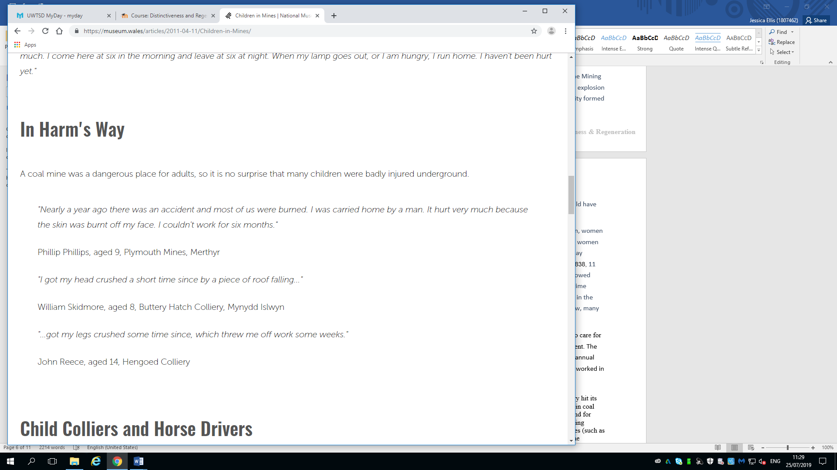

Figure Four: Real words

This all had a detrimental effect on Llanelli’s economy due to the finances needed to care for the injured minors; those effected by the pollution and the cost of repairing equipment. The Atlee Government provided the workers with compensation of up to 10% of their annual salary yearly. (O'Brien, 04.02.1993), as they recognised that 1.2 million individuals worked in the coal mining field within Wales (equating to over 20% of the population).
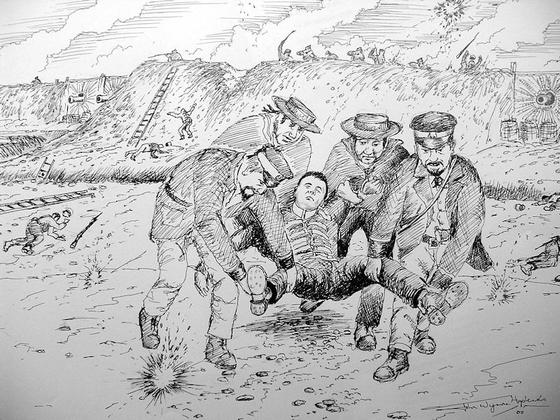
Figure five: Serious health and safety problems resulted in vast amount of deaths, including from the cholera outbreak in the 1831-1832

Changing Fortunes
Energy has always been an enabler for Earth and for human living. From wood to coal we have used these resources for warmth; eating; sanitation, transport and profit. However, the twentieth century saw the dawn of a new source – oil. Oil meant not destroying trees, and not endangering countless lives just to retrieve it, as opposed to wood and coal. Oil was less cost to attain, easier to process and manage. Crude oil was allegedly discovered in China 600 B.C, but on record Colonel Drake in Pennsylvania formally showcased it in 1859, followed by Spindletop’s discovery in Texas in 1901.
With the technological development of vehicle tenure, light bulbs and electric items, the sales of kerosene oil exponentially expanded. Then, by 1919 due to the convenience of this new revolutionary material, as well as military development such as planes tanks and ships, the demand for gasoline edged ahead of kerosene.
From 1920 onwards, the use of natural gas heavily increased and became the front-runner of energy sources.
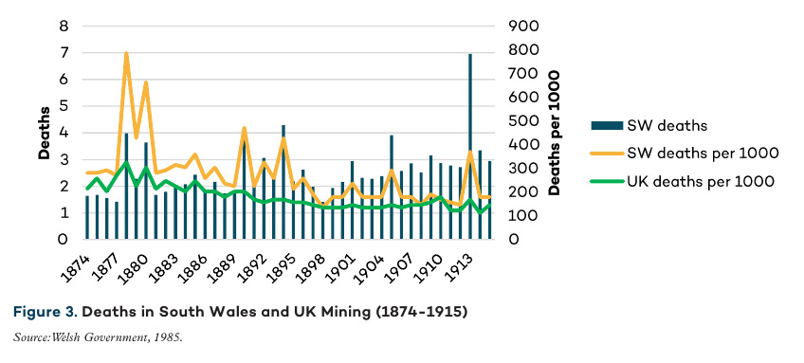
After the termination of the Second World War in September 1945, the coal industry hit its recession. (Hudson, 03.1992) This was mainly due to plenty of overseas investments in coal industries and the replacement of the oil trade. Though there continued a demand for coal, the industry was nationalised in 1947, thus almost ending the private coal mining market. This prompted less investment in mining, strengthening alternative resources (such as oil and air).
(Kitson, 2017)
By 1950, Welsh coal exports reduced to 750,000 tons, and by 1980’s the domestic coal business had dilapidated, regardless of the miners’ strike of 1984. Coal mining in Llanelli was almost deceased, stemming different regeneration strategies were in order.

Existing Assetts, Structures and Economic Character
In the present day, Llanelli is coated in distinctive assets, such as being the home to the world famous Scarlets Rugby Club; one of only 10 Wetland Centres; Trostre; Tata Steel Works and the Grade 1 Plas Llanelly House (the setting of many television programmes and ample annual events) to name but some.
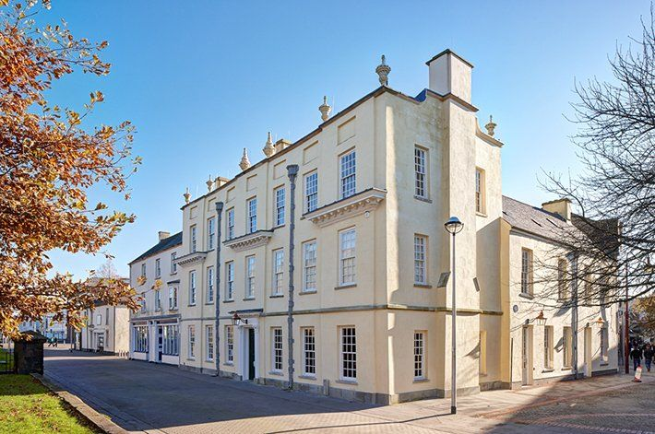

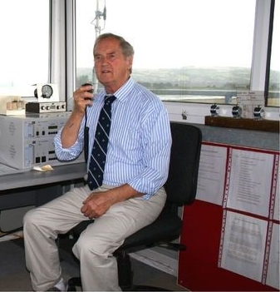
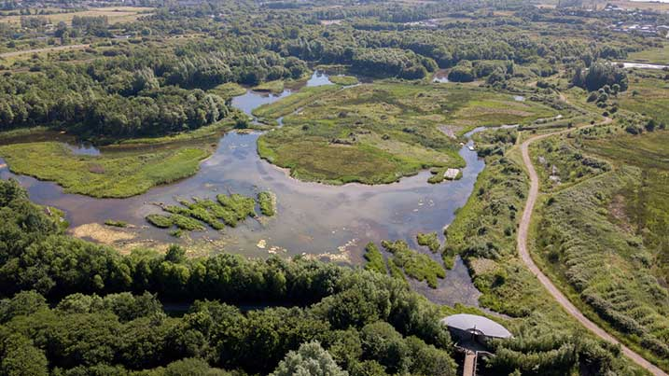

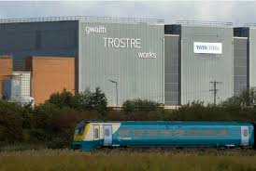

The Llanelly Copperworks Company, who had dominated Llanelli’s coal industry by over 60% throughout the coal boom, were reorganized in 1837. This was due to the main Manager, Richard Nevill orchestrating their ventures into different sectors in Llanelli. This proved a fruitful decision as they then commenced improving the infrastructure of their own docks, developing yellow metal manufacturing and developed the Cambrian Copperworks into a silver extraction and lead smelting works…

Economy:
Located in its key place for overseas transportation, Trostre is the home of one of Tata Steel Work plants. Trostre has been sustainably supplying Tata Steel since its opening in 1947, and presently employs over 650 employees in total. (Jones, 2019) It encompasses economy, society and environment sustainability, as it is such a large worldwide outfit, giving Llanelli a positive platform.
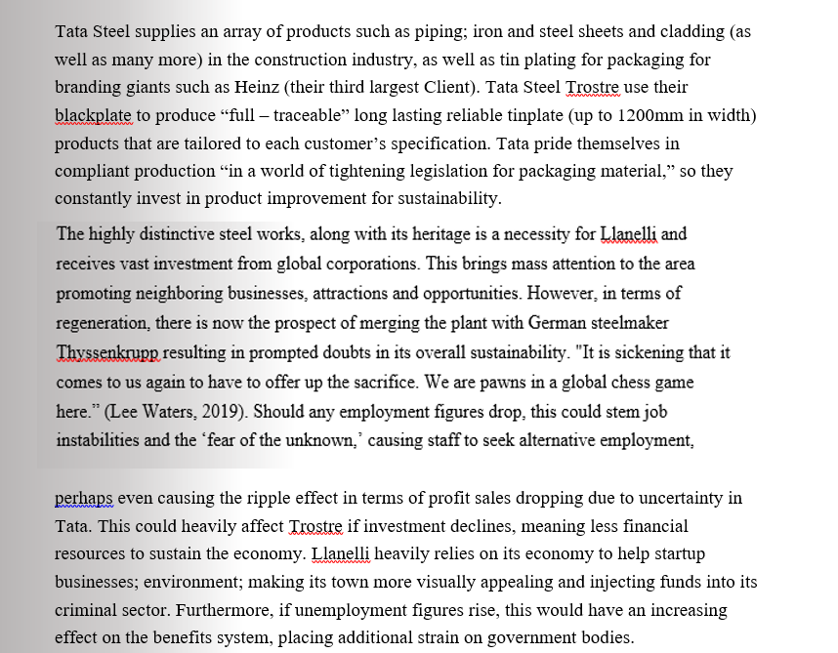
Tata Steel has a strong community ethic and social responsibility. “Founder Jamsetji Tata, passionately believed that a company should play a significant and beneficial role within the local community and society in general.” Many employees have been there over 40 years; they offer various work experience and training in many departments, and are mindful of their recycling. They are involved with UK MetalMatters Scheme helping local authorities promote curbside recycling, as well domestic packaging education programs.

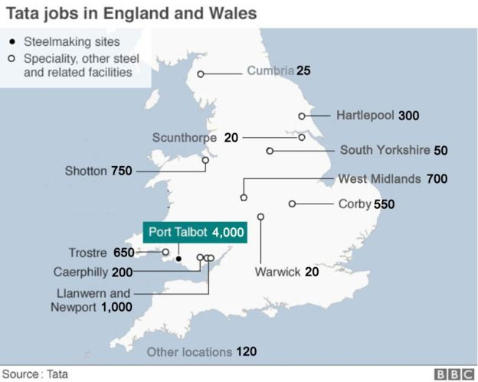


Following his £4 milli on private purchase of the Pembrey airport in 1994, Captain Winston Thomas was been awarded his MBE. Due to his extensive efforts, Llanelli has benefitted from this as it has brought inward investment offering private and commercial charter flights. Contracts such as Forestry Commission; Pembrey College of Aeronautics; MID; PDG Helicopters and Western Power Helicopters also fully exercise the use of this airport, giving Llanelli additional promotion from the rest of the UK.
“The opening of the Ffoslas Horse Race Course the first of its type built in the United Kingdom since 1937 at a cost of 24 million with the construction of 600 high quality houses in the local area. Together with Pembrey Airport and other local developments 85 million has been injected into the local economy. His investment in the derelict airport has helped boost to the local economy, has attracted in inward investment and created jobs in South and West Wales,” (MCCOLGAN, 23rd June, 2017)

Environment
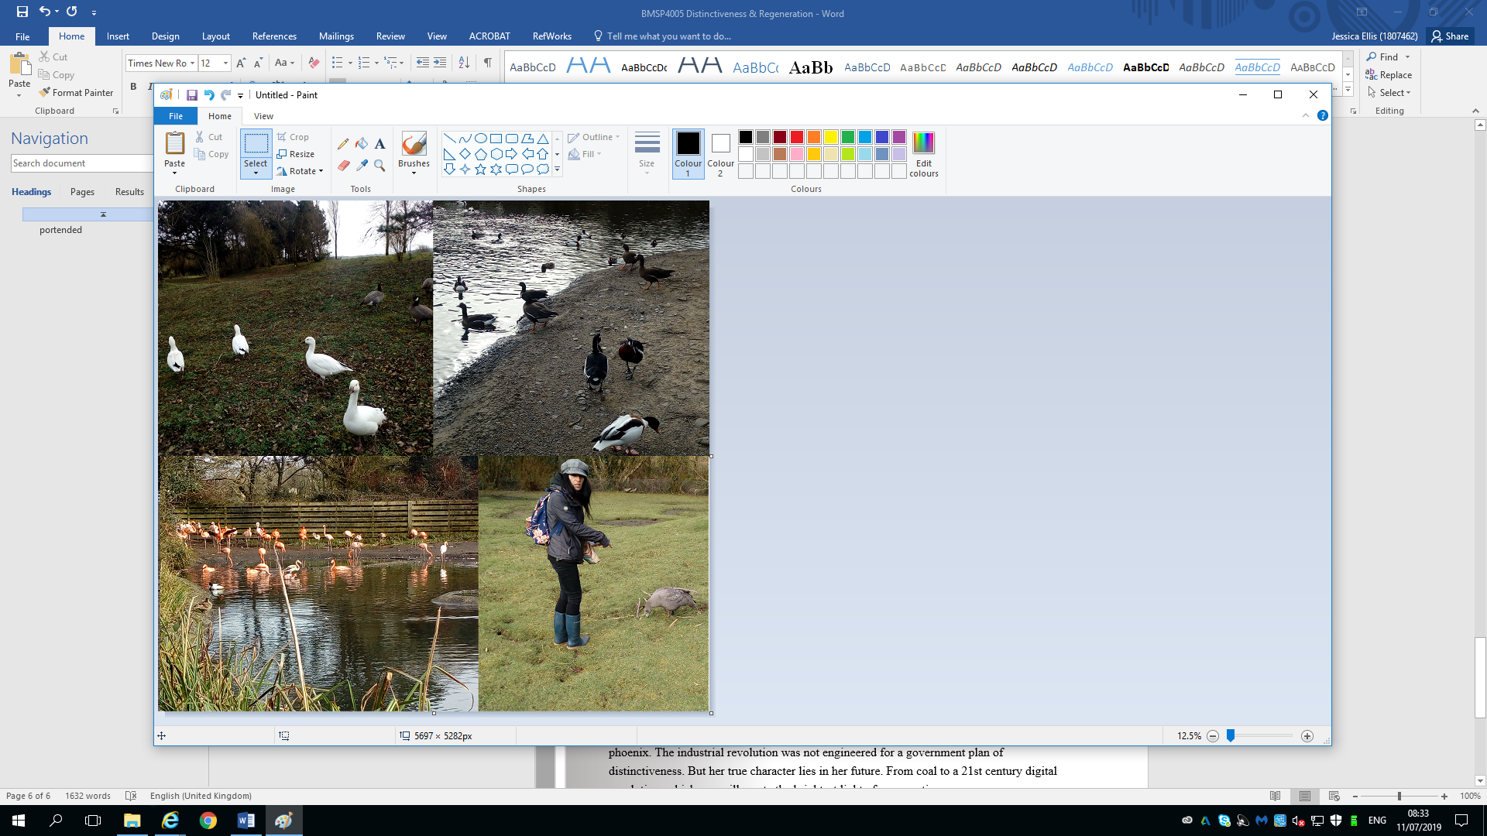
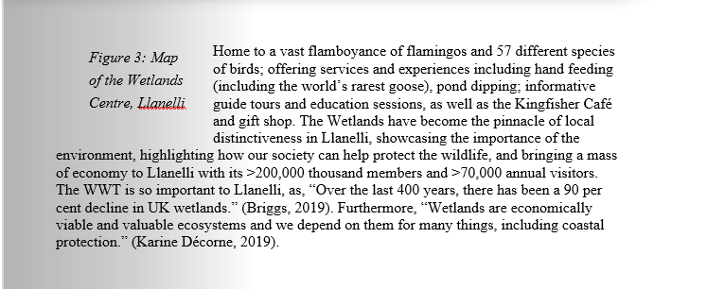
On the Northern shore of the Burry inlet rests the “birthplace of modern conservation” (Centre, 2019) . It was founded by Sir Peter Scott, founding chair of WWF (subsequently designing the sustained panda logo), former painter and broadcaster.

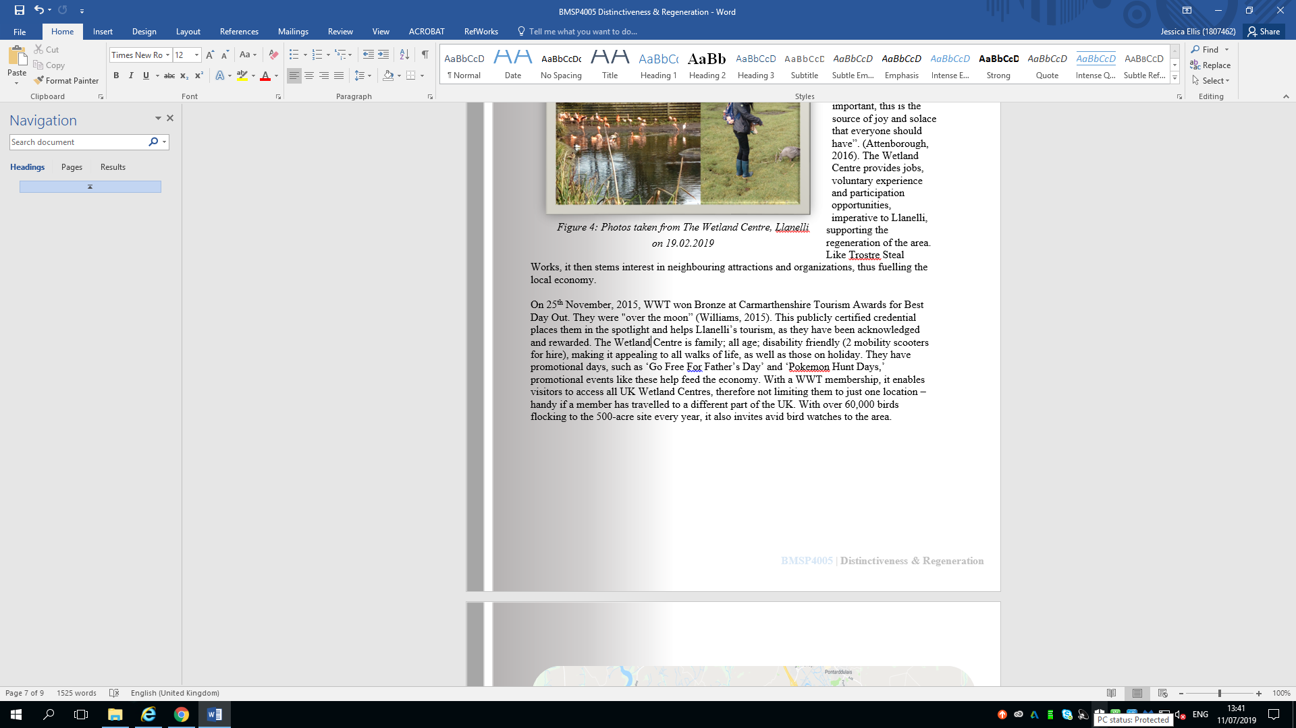
Promoting distinctiveness in Llanelli, the organization (consisting of only ten centers) opened to the public, so that anyone could appreciate and enjoy getting so close to nature.
“The Wetland Centre is also vital for local society” (Reese, 2019). The consensus of heritage, sense of place without reconstructing the authenticity, as well as deep appreciation for nature is mentally positive for society as well as wildlife. “This is what makes life important, this is the source of joy and solace that everyone should have”. (Attenborough, 2016). The Wetland Centre provides jobs, voluntary experience and participation opportunities, imperative to Llanelli, supporting the regeneration of the area. Like Trostre Steal Works, it then stems interest in neighbouring attractions and organizations, thus fuelling the local economy.
By reinvigorating Llanelli further, it shall bring more tourism and social construction thus bringing more investment so the cycle can be healthier.
A lot of Llanelli is visually unappealing, and this could deter potential investment as it is not welcoming, furthermore, it contributes to other residents’ mood and mindset (‘clear house clear mind’). From studies conducted by myself on 2nd April 2019, 9/ 10 survey participants argued that the town’s residential occupants should look after their properties more. This being said, a proposal could be that there were to be ‘three-point penalty scheme’ actioned. This could be where following three warnings of not recycling; using bins properly and maintaining your home to a sufficient standard, there would be a fine enforced to the home occupier. It could be proposed that unless a potential occupant completed a day’s training course on how to look after their home (from mold prevention/ ventilation to importance of recycling and neighborly conduct), they would not receive their government bond. By combating this visual hurdle, it could promote respectfulness for property and with the ripple effect of more home buyers.
Furthermore, my study showed that 6/ 10 of my participants were unemployed. They agreed that the prospects were shallow in Llanelli. 2/10 had completed community service.
Llanelli’s high-street is predominantly dominated by charity shops and betting outfits. There is also a strong police presence. When speaking to Carol Davis from Boots Plc, Llanelli, she says, “There is at least one shoplifter every week and because the police are so busy dealing with other incidents, we have to try to deal with them and we just can’t most of the time.” (Davis, 2019)
Now, this being said, it could be proposed that if an individual has done community service anyway, there is no reason why they can’t gain some form of accreditation for a high level of participation, and so it helps to restore the balance of the cause of the community service, and can be placed on a CV, should the potential role involve a DBS. 9/ 10 of my participants agreed that this would be a good idea. Not only would it lessen the demoralization of the community service, they would be working to a goal, as opposed to feeling like it was an endurance. Community Service could also branch out into residential gardening and commercial outlet restoration. This could inject an individual’s pride in their work; by learning new skills they could appreciate the effort it took and to resume the ‘sense of place’ to positive.
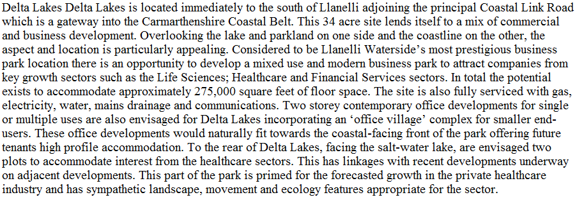
There is a strong substance misuse in Llanelli, even with communities of support resource organizations such as DAS (as well as the former ‘Choose Life’). Residents could benefit from incentive community service to prevent boredom, and keep busy focused and engaged on something productive if they were in subsequent employment. The 1970s and 1980s witnessed a period of unprecedented industrial decline in the UK. Cardiff turned to cultural industries and the production of consumer culture to reverse the industrial decline by diversifying local economies and rebuilding local communities (Evans, 2003)
Figure Nine: ‘A strategic regeneration plan for Carmarthenshire 2015-2030 – Transformations’
The town is anchored by a large Asda at the heart of the St Elli Shopping Centre which opened in 1997 and has remained an integral part of the heavily pedestrianised Stepney Street in the town centre, as well as the Odeon, providing employment and additional transport links. The £60m regeneration plan of Y Ffwrnes, Llanelly House, library and retail outlets is positive, as long as the retail outlets are occupied.
In Liverpool in 2018 The Sandon, home of where Liverpool Football Club was born was purchased for £1m. Following its extensive renovation to bring it to the 21st century, and due to its location of Anfield Stadium is has breathed life back into the community. It presently takes in over £6m revenue a year; provides 340 jobs per month and hosts over 4000 match goers every match day. The use of the newly refurbished hotel intakes approximately 12000 stays a year. The Scarlet’s Stadium is known worldwide. Although there are many hotels and b&b’s in its area, a complex such as the The Sandon would catapult Llanelli’s economy and take full advantage of this prime asset of Llanelli. “Regeneration begins with addressing what meets the needs of the people, not the business profits,” (Kate Stewart, 2019) Furthermore, as well as The Sandon, Kate Stewart has transformed a derelict building into a fully functional rehabilitation centre due to the epidemic of drug users in Liverpool. Following 20 weeks of sobriety, individuals are allowed to stay at this centre for free, and be coached in life skills and new careers.

Dumfries and Galloway council defined their strategy for regeneration as “build the local economy; provide the best start in life for young people; protect the most vulnerable people; and be an inclusive Council.”
Fact or fiction?
‘Field of Dreams’, 1989
There are vast volumes of vacant buildings, from shop outlets, business park offices residential housings and land ripe for development. In terms of image, this is demoralizing for the residents and local business owners. Incentives such as rent, rates and utility holidays could be a positive incentive for businesses to inhabit spaces, then following profits they could either repay the taxes and/ or rates back at a (for example) 10% a month timescale, or could inject a certain percentage back to the council’s money pot to help restore neighbouring shops.
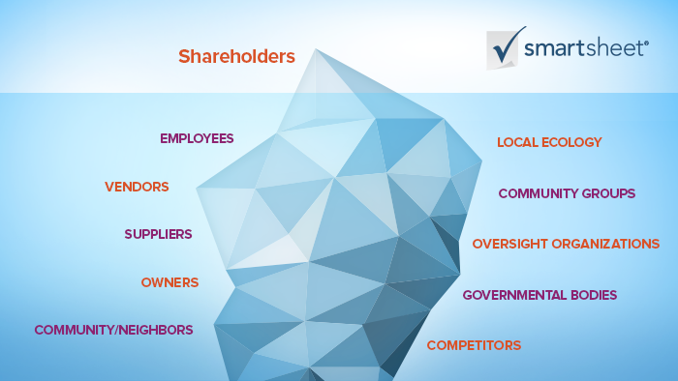
Figure eleven: Dr Freeman’s shareholder theory from 1984

Being a shareholder in a company means being financially or socially invested, as either an employer, employee investor. This could mirror Llanelli’s stakeholders. Llanelli’s stakeholders consist of the residents, council business owners, as well the financial investors inside and outside of the town. By having a stake in Llanelli’s community, they do or can contribute to the present and future manipulation of the economy.
Conclusion
Llanelli boasted the home to the biggest worldwide industry of the Industrial Revolution that was coal mining. Following over a century of Llanelli having lost its biggest field of investment. Regeneration doesn’t stop at bricks and mortar, but also in the community. Dumfries and Galloway Council stated that part of their success was down to engagement, being “an inclusive Council.” As residents in Llanelli stated in the survey on 2nd April, 2019, they have very little or no help from the Council, perhaps this could be an avenue Llanelli could also explore, as part of their regeneration projections. Developments such as Trostre and the town centre; features such as The Wetlands and Pembrey Airport; and unique assets such as Llanelly House and Scarlet’s Stadium have helped sustain Llanelli’s economy and tourism. However, Llanelli requires further pulls to the area, so it can overshadow the dim image of grim streets and drug fuelled statistics it presently has by many. Perhaps the land wrapped around Scarlet’s Stadium could be force purchased...?

Bibliography:

Bibliography
Attenborough, S. D. (2016, 05 01). The Woodberry Wetlands Centre. (T. BBC, Interviewer)
Briggs, D. B. (2019). Wildfowl & Wetlands Trust & Arts Bodies Sound Alarm Over Threats To Wetlands. Carmarthenshire: Rhys Gregory.
Centre, T. W. (2019). Who We Are. Retrieved from www.wwt.org.uk: https://www.wwt.org.uk/who-we-are/our-history/
Davis, C. (2019). Carmarthen Business and Management Llanelli Survey D & R. (J. Ellis, Interviewer)
Ellis, J. (2019). Distictiveness and Regeneration. Carmarthen: Jessica Ellis.
Evans, C. A. (2003). The cultural industries and a model ofsustainable regeneration: manufacturing ‘pop’ inthe Rhondda Valleys of South Wales.
Hannam, J. (2019). The Roots of Modern Llanelli. (C. B. Management, Interviewer)
Hudson, P. (03.1992). The Industrial Revolution: 11. Hodder Arnold.
Jones, N. (2019, 02 19). Tata Steel. (C. B. Management, Interviewer)
Karine Décorne, A. D. (2019). The Bell. The Bell, 1.
Kate Stewart, O. o. (2019). Distinctiveness and Regeneration. (J. Ellis, Interviewer)
Kirby, P. (2003). Child Labour in Britain, 1750-1870.
Kitson, T. M. (2017). The End of Coal Mining in South Wales . 1 - 33.
Lee Waters, A. (2019). Tata Steel Trostre plant could be sold in Thyssenkrupp merger. BBC.
MCCOLGAN, C. (23rd June, 2017). Llanelli Economy Boosted Thanks to Captain’s £4m Investment. Carmarthenshire.
O'Brien, P. (04.02.1993). The Industrial Revolution and British Society.
Reese, S. (2019, 02). The Wetland Cetre. (C. B. Management, Interviewer)
Spartacus, E. (2015). The Coal Industry: 1600-1925. Retrieved from Spartacus Education: https://spartacus-educational.com/CoalIndustry.htm
Steel, T. (2019). Tata Steel in South Wales. Retrieved from www.tatasteeleurope.com.
Wales, B. (2010). Welsh Town Tales. Llanelli.
Williams, N. (2015, November 26th). Centre wins bronze at CTA Awards. (C. Awards, Interviewer)

