HNC Process Operations Engineering -
Process Engineering Practice
PCPO4007

University of Wales Trinity Saint David
Pembrokeshire College
Luke Vaughan
2320126

Assessor: Rhys Hutton

Table of Contents
Introduction 2
Task 1 3
Heat Exchangers 3
Reactor on an FCCU 6
Task 2 9
CV 9
Current development action plan 10
Technical Competence 11
References 15

Introduction
This assignment includes descriptions on the operation and maintenance activities on two pieces of refinery equipment, these being heat exchangers and a rector on a fluid catalytic cracking unit.
The second part of the assignment has got my CV and a description of what I have completed in my development and what is currently in my future plans.

Task 1

Heat Exchangers
Heat exchangers are important in the process in an oil refinery, they are used to efficiently transfer heat between fluids for both the heating and cooling of them. Their operation and maintenance are critical to ensuring optimal performance, energy efficiency, and long term reliability. Good operation and maintenance of a heat exchanger will ensure that downtime should be minimal and that there will not be failures of the equipment.
Operational activities within a heat exchanger environment focus on ensuring that the exchanger runs efficiently and safely under varying process conditions. The general operation of a heat exchanger will monitoring different parameters such as fluid inlet and outlet temperatures, pressure levels, and flow rates. These parameters are crucial indicators of the system's performance and provide early warnings of potential inefficiencies or issues. For example, a significant temperature difference between the inlet and outlet of one side of the exchanger will show that heat transfer is working, whereas a decrease in the normal running temperature could signal fouling or scaling within the exchanger.
Control mechanisms for the heat exchanger are important, such as the control of inlet and outlet valves and the flow going through them, flow rate should be within a desired range so that both sides of an exchanger will get the proper heat exchange between the fluids. Additionally, maintaining the quality and composition of the fluids through the exchanger is important, as contaminants or improper fluid selection can significantly impair the heat exchanger's efficiency and lifespan. Process optimisation, achieved through fine-tuning operational parameters such as temperature and flow rate, ensures that the heat exchanger meets the specific requirements of the process.
Regular inspections are also needed for the exchanger’s operation, also play a critical role in heat exchanger operations. Visual checks for external leaks, corrosion, or unusual noises can help identify issues at an early stage, preventing minor problems from becoming bigger failures. Inspections may also involve assessing the condition of other components, such as gaskets and fittings, to ensure they are intact and functioning correctly.
Maintenance activities for heat exchangers are equally essential and typically fall into preventive and corrective categories. Preventive maintenance involves scheduled tasks designed to stop complete equipment failure. At refineries there will be an online and offline exchanger so they can be swapped when needed so the one that is currently online can have maintenance done on it. Routine cleaning is crucial to remove fouling and scaling from heat transfer surfaces, as these deposits can reduce thermal efficiency and increase pressure drops. Additionally, replacing worn out gaskets and seals is necessary to prevent leaks and maintain the integrity of the system.
Corrective maintenance can be carried out if there are specific failures or performance issues. This may include repairing or replacing damaged components, such as tubes, plates, or shells, which can degrade due to corrosion, erosion, or mechanical stress. Non-destructive testing methods, such as ultrasonic testing or radiography, are often employed to detect internal flaws that may not be visible externally, from this it can then be decided if the tubes bundle needs to be pulled for either cleaning or being replaced.
The operational and maintenance activities of heat exchangers are integral to their performance in a processing environment. Effective monitoring, control, and inspection ensure proper operations, whilst preventive and corrective maintenance decrease the risks of failure and increase the equipment’s lifespan. These allow for better reliability and efficiency in the heat exchangers to help with the final process and flow of the products.

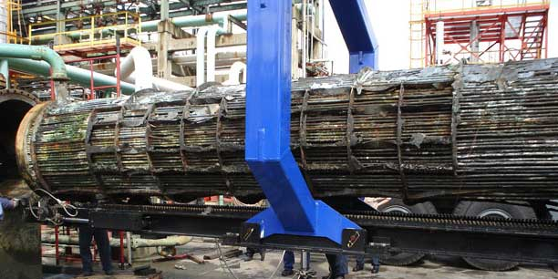
Figure 1 - Exchanger bundle being pulled
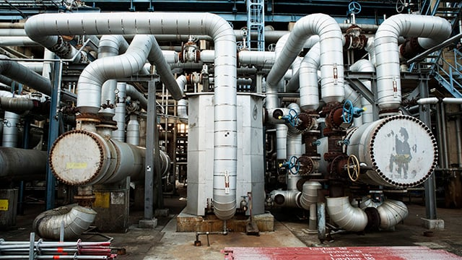
Figure 2 - Heat Exchangers

Reactor on an FCCU
The reactor in a Fluid Catalytic Cracking Unit (FCCU) is important for the refining process, in this heavy hydrocarbon feed is converted into more valuable lighter products such as gasoline and olefins with the use of a catalyst. Given its importance, the operation and maintenance of the FCCU reactor are important for achieving product yield, operational efficiency, and equipment reliability.
The operation of an FCCU reactor involves control and monitoring of multiple interconnected systems to ensure process stability and optimal performance. One of the primary tasks is maintaining the reactor temperature, as the catalytic cracking reactions are highly temperature sensitive process. Usually in normal running the reactor temperatures will range between 500°C and 700°C, if not in this range it can lead to poor cracking results and more by products such as coke build up.
The catalyst which is a zeolite based material is important in the reactors operation, there needs to be a good ratio of catalyst to oil for achieving desired product rates. This ratio is controlled by managing catalyst circulation between the reactor and regenerator, ensuring that spent catalyst is effectively regenerated and reintroduced into the reactor. (Figure catalyst cycle)
Monitoring the reactor's pressure and pressure drop is also important. There is a fluidised bed in the reactor which needs precise control of a fluidised gas which is steam, this maintains proper reaction conditions of the catalyst and that the pressure is regulated. A significant pressure drop across the reactor could indicate issues such as the catalyst not reacting properly or fouling
Product quality control is another key operational activity. Continuous analysis of reactor effluent streams for parameters such as olefin content, gasoline yield, and product distribution helps operators make adjustments to help the process.
Maintenance activities for the FCCU reactor are important for sustaining its performance and preventing unplanned downtime. These activities include both preventive and corrective maintenance strategies.
Preventive maintenance focuses on routine inspections, cleaning, and component replacements to avoid equipment failures. Regular inspection of internal components, such as the riser where the catalyst and feed go in, and the cyclones where the catalyst that has reacted with the hydrocarbon drops off, ensures that wear and damage caused by high temperatures, erosion, and catalyst abrasion are identified early. Catalyst management is also a key aspect of preventive maintenance, this involves removing the spent catalyst and having a new delivery of fresh catalyst to be used.
Corrective maintenance addresses specific failures or issues identified during operation or inspections. Such as, repairing or replacing damaged refractory linings is a common task, as these linings protect the reactor shell from extreme temperatures and from the catalyst particles. Non-destructive testing methods such as ultrasonic thickness measurements and thermal imaging are used to assess the condition of the reactor shell and detect potential hot spots or structural weaknesses. Shutdowns and turnaround are needed for any major maintenance on the reactor of the FCCU, the reactor can be inspected thoroughly, and repairs needed can be carried out. Anything that is used to transport catalyst is generally changed out due to catalyst coke build up.
The operational and maintenance activities of an FCCU reactor are important for its effectiveness in converting the heavy hydrocarbon feed into lighter, high value products. By maintaining precise control over operational parameters such as temperature, pressure, and catalyst activity, and by implementing proper preventive and corrective maintenance practices, refineries can ensure the reliability, efficiency, and safety of the reactor.
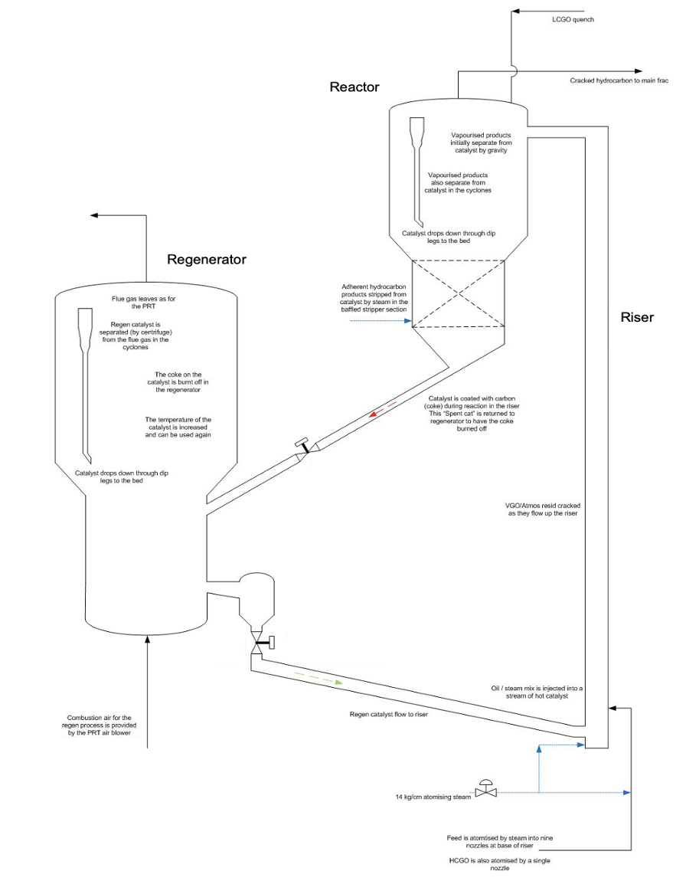
Figure 3 - Reactor with catalyst cycle

Task 2

CV
Luke Vaughan
Lukev863@gmail.com
Haverfordwest, Pembrokeshire

Currently employed at the Valero Pembroke Oil Refinery as a process operator having completed the apprenticeship with them.
Skills
- Equipment operation and maintenance
- Process optimization
- Safety protocols and compliance
- Team collaboration
- Problem solving and troubleshooting

Work Experience
Operator
Valero Pembroke Oil Refinery, Pembroke, Wales
June 2024 – Present
- Operate and monitor refinery equipment to ensure safe and efficient production processes.
- Conduct routine maintenance and troubleshoot equipment to minimize downtime.
- Adhere to strict safety guidelines and participate in regular safety drills and audits.
- Collaborate with team members to achieve production targets and maintain quality standards.
- Provide reports on operations and suggest improvements to enhance efficiency.

Education
Sir Thomas Picton School
Pembrokeshire College
- GCSE’s
- Level 3 Electrical Engineering
- Level 3 Engineering
- Level Electrical NVQ
- Studying Process Operations HNC

Current development action plan
Currently I am working at the Valero Pembroke oil refinery, having completed the apprenticeship there. Since being taken on as an operator I have completed the Pembroke Refinery Basic Operator Training (BOT) and have been assigned my first unit, this was the Fluid Catalytic Cracking Unit (FCCU), I carried out my initial training of the unit where I learnt how the unit worked, what each piece of equipment did and how the process flowed through the unit. My current development plan for working at Valero is to carry on increasing my knowledge and understanding of the unit I am working on and then will be looking to start training further into other positions on different units at the refinery. As the FCCU is the biggest unit at the refinery it is split into two sections, these being Structure and Recovery. Currently I am trained and passed out on the Recovery section of the unit, so my immediate development action plan will be to start training on the Structure part of the unit, this will allow me to have a fuller understanding of the FCCU as currently I am only doing one side of it. As other members on my shift in work are currently training positions, I am looking to be able to start training the Structure side of the FCCU in about May 2025.
When I have done that and completed that training and passed out in that second position, I would be then looking to further progress by going into a third position by training and passing out on another unit. This third unit will be dependent on the needs of my work shift and which unit has space for training.
Further again down the line once I have got my three outside operator positions I would then like the opportunity to train on the control panel of the FCCU, by this time in my career I would have had multiple years outside on the unit with a full understanding of its workings and requirements, so training the panel would be a good next step in my career at that stage.

Technical Competence
I have picked up technical competence through my learning in college and whilst on the Valero apprenticeship. Before carrying out the apprenticeship I did an electrical engineering level 3 course at the college for two years achieving a D*D grade, this gave me a good understanding of both theory and practical elements to do with electrical engineering, this course tied in well with me then going to Valero as I had a good understanding of different motors, pumps and other electrical equipment that could be found in the substations.
After my electrical course in the college I applied for and got on the Valero apprenticeship, here I furthered my knowledge and skills in an engineering capacity, completing a level 3 engineering BTEC and being on site and training there. Onsite I spent a year with the electrical department going out on jobs with them across site where I would be working on different pieces of kit such as pumps and motors, or in the substations racking stuff in and out on the distribution boards.
I then moved into the operations department where I would go out with site operators and learn from them to help me gain knowledge and understanding of the job I would be doing. I learned different routines such as taking samples and working with different pieces of equipment such as heat exchangers and other operated control equipment such as valve operation.
Whilst on site I undertook different training courses to further my development such as completing confined space entry, alkylation unit induction and doing an IOSH safety course. All of these have allowed me to further progress whilst at the refinery and gain a better understanding for what is required of me and how I can carry out my job.
Through my time spent on site I completed my apprenticeship and was taken on as an operator. I went through another training course before being assigned which unit I would be on, this was the basic operator training (BOT). On this I learnt further into the workings of different refinery equipment and other roles at the refinery. I was then given my unit being the FCCU where I carried out training to understand and know the unit, for this I completed a competency pack which was signed off by my lead operator to say they were happy that I was competent in carrying out the job.

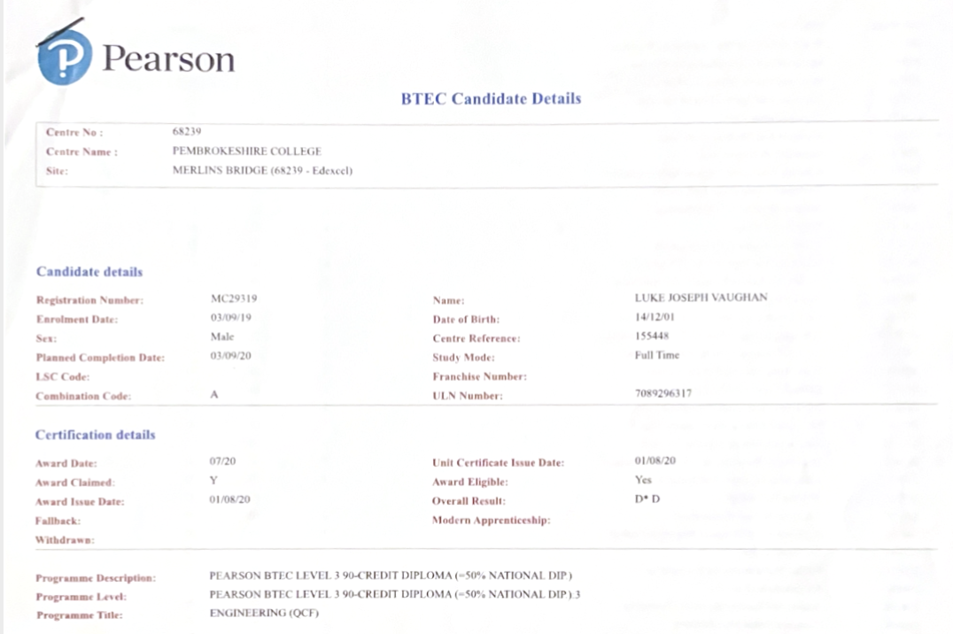
Figure 4 - Electrical Engineering Certificate

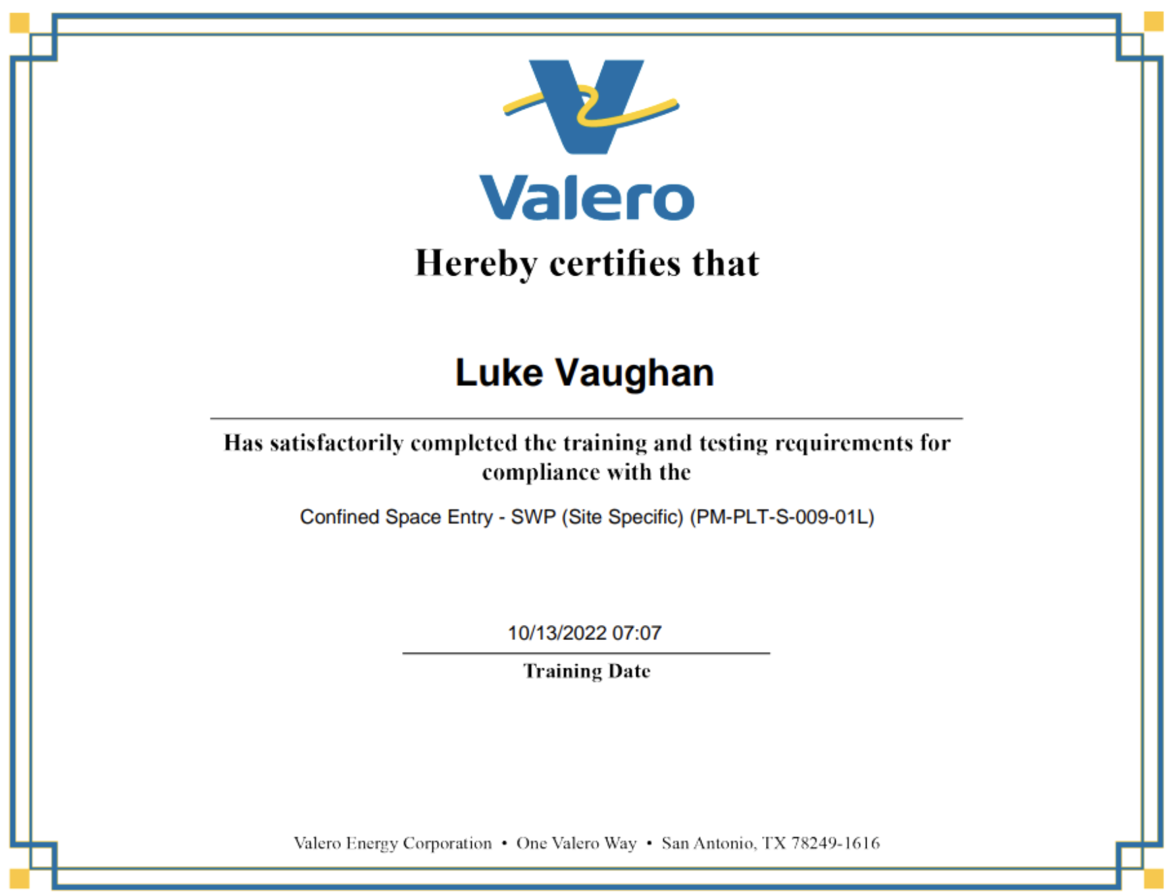
Figure 5 - Confined Space Certificate
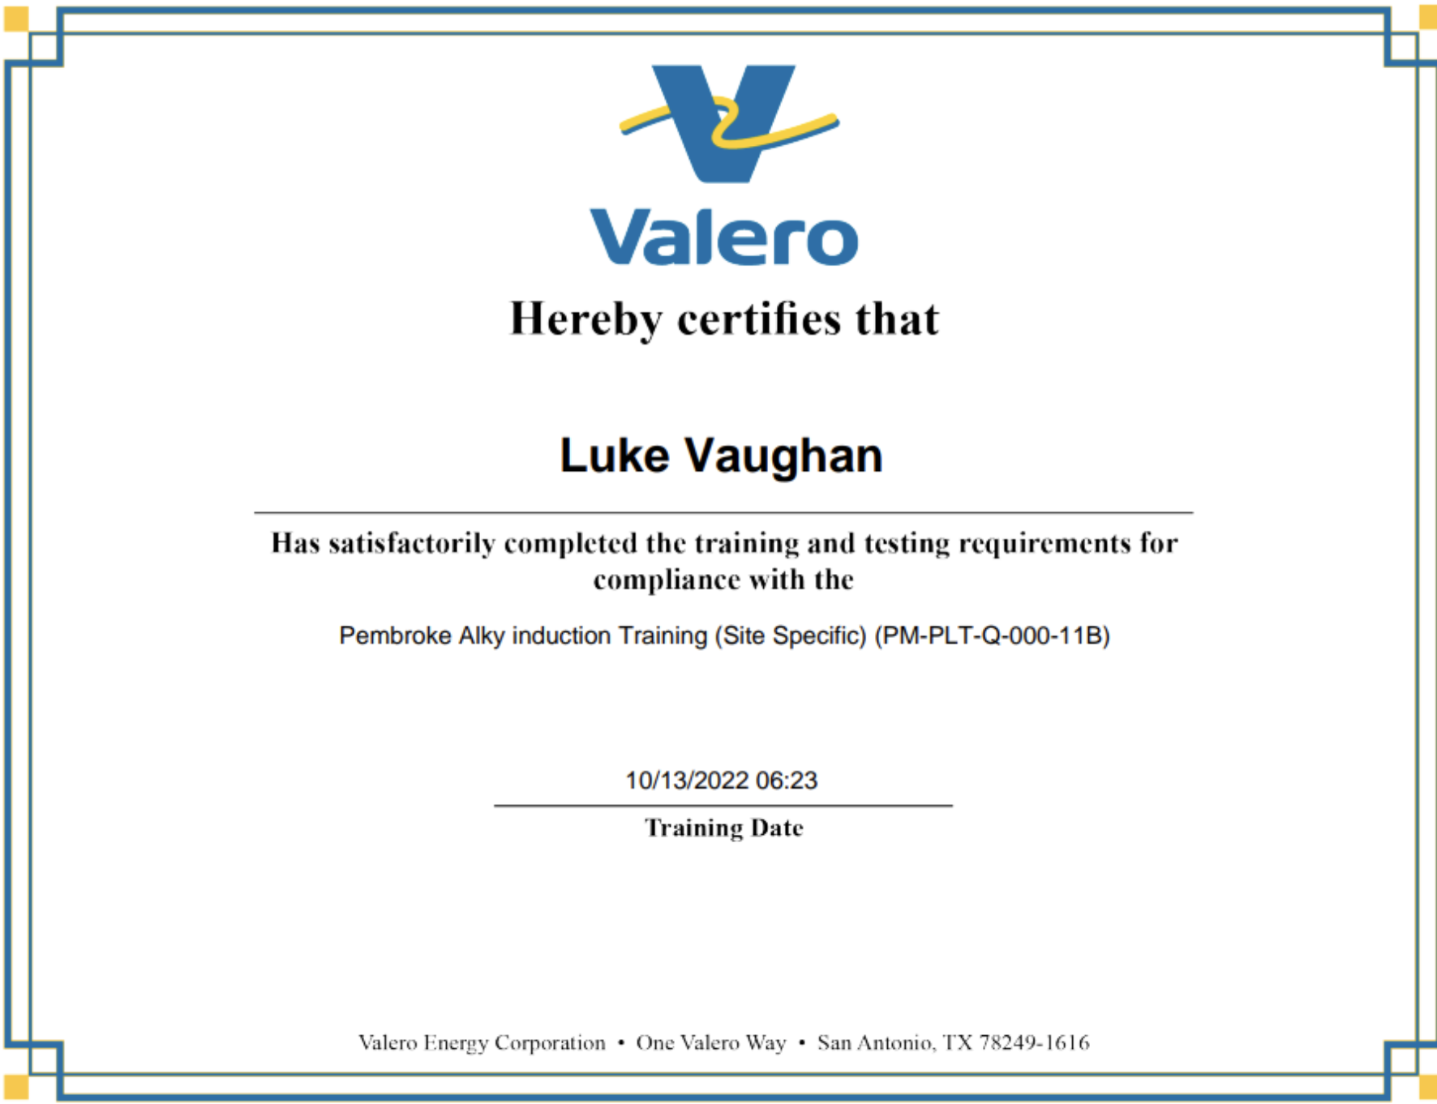
Figure 6 - Alkylation Unit Certificate
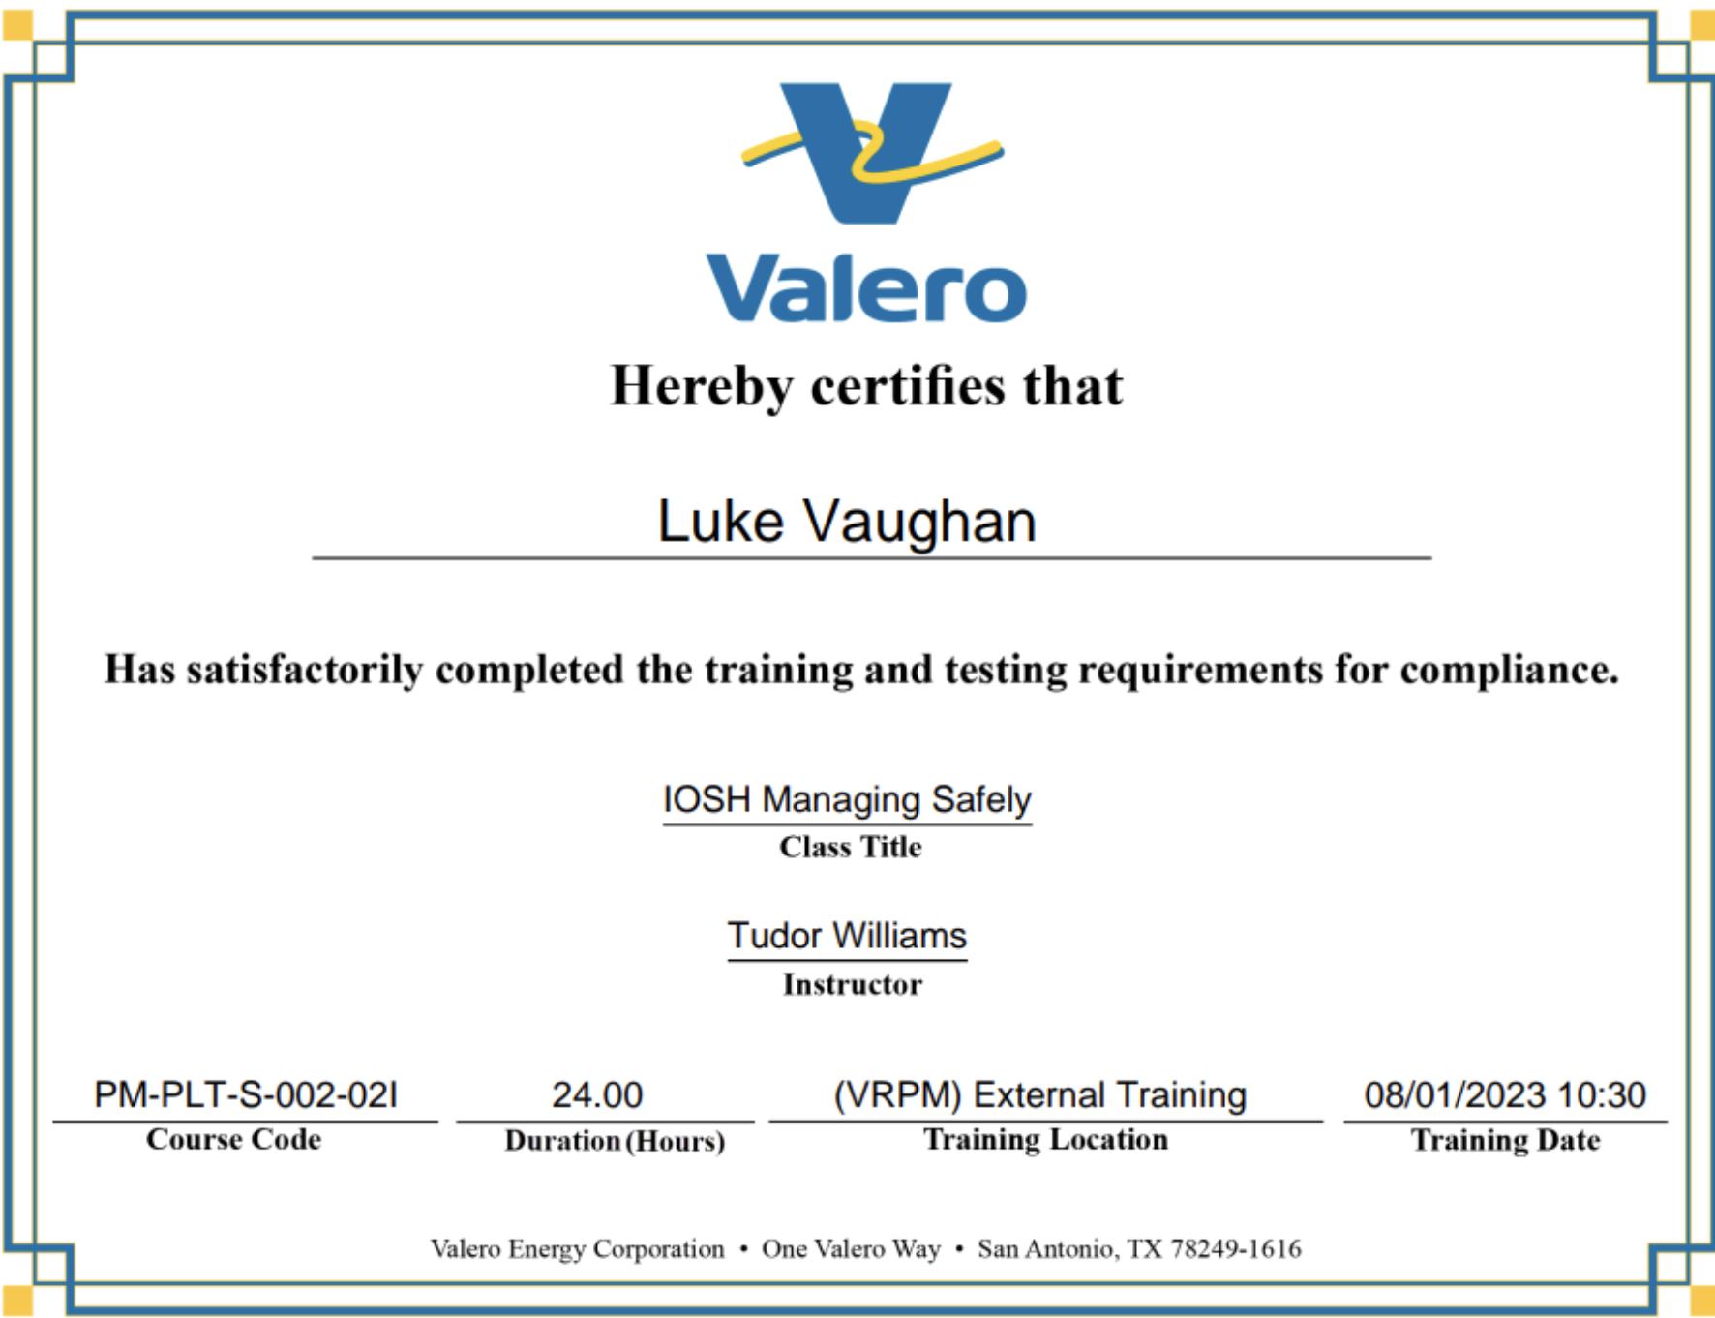
Figure 7 - IOSH Certificate

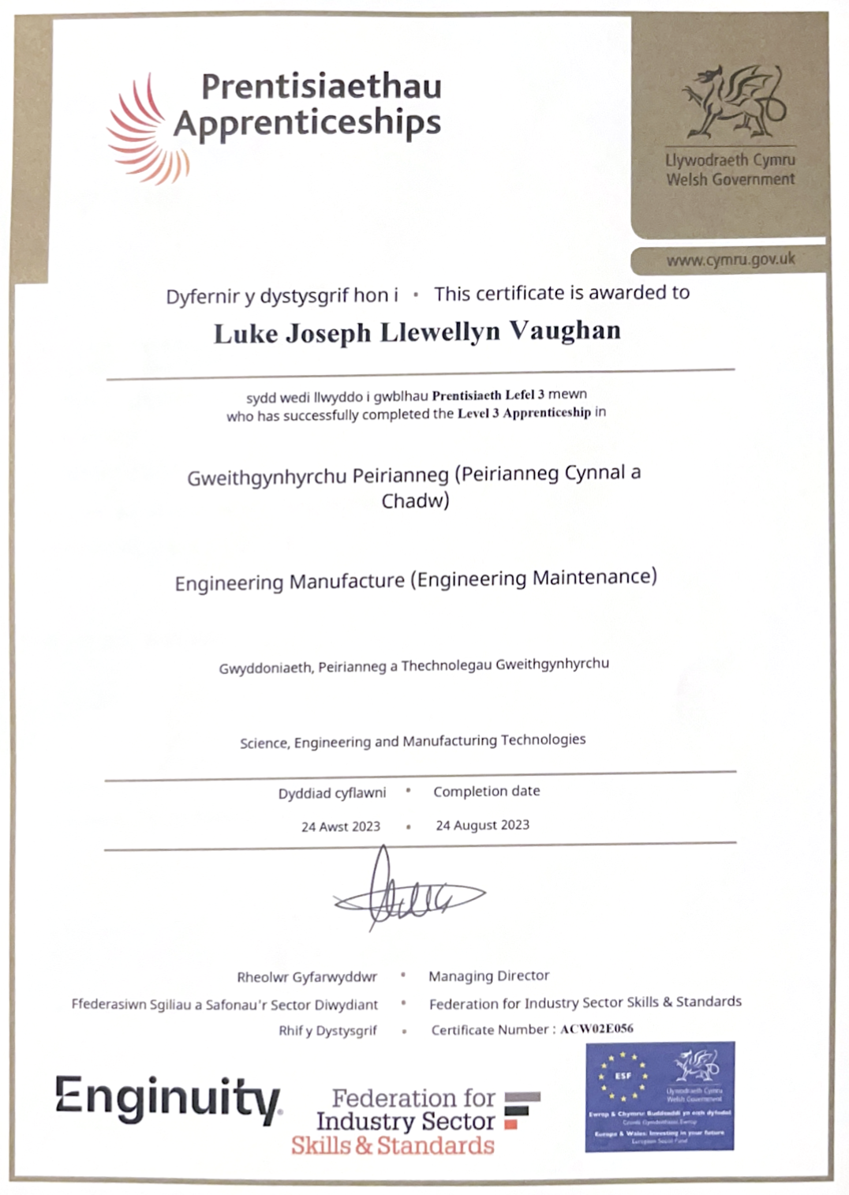
Figure 8 - Apprenticeship Certificate

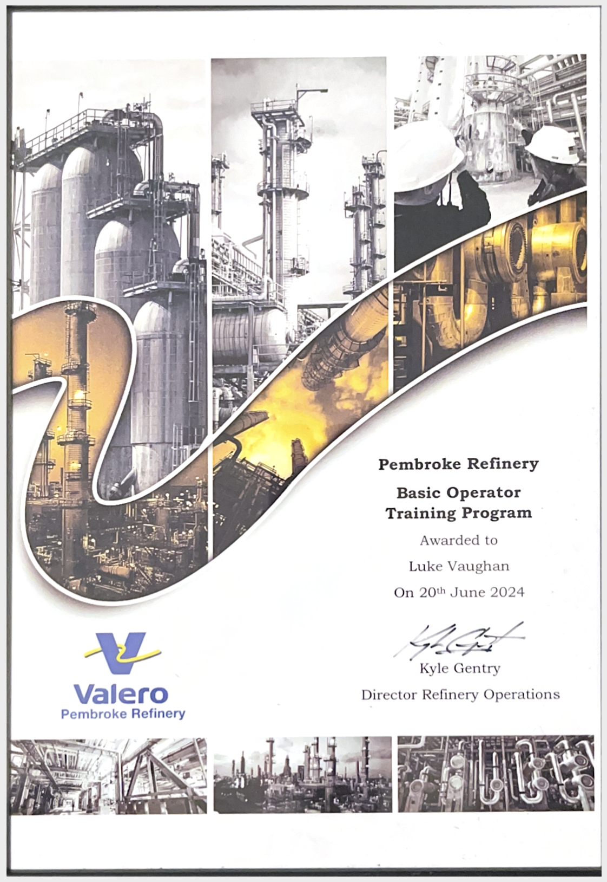
Figure 9 - BOT Certificate

References
Deaconu, A. (2024) Chemical cleaning of oil refinery heat exchangers, EPCM. Available at: https://epcmholdings.com/chemical-cleaning-of-oil-refinery-heat-exchangers/ (Accessed: 23 January 2025).
FCCUS: Crucial components in refinery turnarounds (2023) Nooter Construction. Available at: https://cicgroup.com/nooter/2023/07/18/fccu-refinery-turnarounds/ (Accessed: 23 January 2025).
Fluid catalytic cracking: How phoenix repairs your refinery (no date) Fluid Catalytic Cracking: How Phoenix Repairs Your Refinery. Available at: https://www.hightemprepair.com/blog/fluid-catalytic-cracking-unit-fccu-how-phoenix-repairs-your-refinery (Accessed: 23 January 2025).
IChemE (no date) Rules of thumb: Heat exchanger selection, The Chemical Engineer. Available at: https://www.thechemicalengineer.com/features/rules-of-thumb-heat-exchanger-selection/ (Accessed: 23 January 2025).
Improve efficiency and sustainability at minimal cost (no date) Alfa Laval. Available at: https://www.alfalaval.us/industries/energy-and-utilities/crude-oil-refinery/benefits/ (Accessed: 23 January 2025).
Rosacweb (2019) Heat exchanger maintenance procedure - by Idrojet, Idrojet. Available at: https://idrojet.com/heat-exchanger-maintenance/ (Accessed: 23 January 2025).
Valero. (2018). FCCU Control Operator Manual. Pembroke: Valero Energy Corp
Valero. (2018). FCCU Field Operator Manual. Pembroke: Valero Energy Corp
Valero. (2018). FCCU Recovery Operator Manual. Pembroke: Valero Energy Corp
Valero. (2018). FCCU Structure Operator Manual. Pembroke: Valero Energy Corp

