Name: Oana Gabriela Marin
Student Number: 1909897
Module Title: The Global Business Environment
Module Code: LCBB4005
Module Lecturer’s Name: Kenny Tang

ELECTRIC VEHICLES INDUSTRY

Table of Contents
Introduction 2
Identification of new business opportunities 2
Application of Product Life Cycle 3
Analysis of the external environment 5
PESTLE analysis 5
Porter’s Five Force Framework 6
Limitations of Porter’s Five Forces 7
Porter’s Value Chain Analysis 8
Critical assessment of other businesses linked to global automotive industry 9
Conclusion 10
References 11

Introduction
Global business environment indicates the environment of sovereign countries having exogenous factors affecting their home country. For the purpose of understanding the global environment of a product or organisation, the global environment consists of the global industry in which the venture operates. In this study identification of emerging opportunities for electric cars has been assessed by “Electric Vehicles in Europe” case. Moreover, the study includes analysis of product life cycle, determining business opportunities and analysis of external environments. Using Porter’s five forces, Porter's value chain and PESTLE analysis has also been made in the study to assess emerging opportunities of EV cars in future course of action.

Identification of new business opportunities
EV Car would make up the majority of sales of new cars in coming year. It has been assessed that total sales of EV cars till 2040 would be increased by 33% due to presence of light duty vehicles in the market. Automobile engineers worldwide are enhancing the efforts of engineers for providing value of money vehicles to customers at the same time it aids into profitability of companies. There are three business opportunities has been assessed that helps in enhancing performance of EV car industry in global environment:
Providing battery disposal services
Developing an enhanced EV technology may include such an amount of issues while operating in global automobile sector for “Electric Vehicles in Europe”. Nowadays, the battery of EV cars is similar to the battery of smartphones which is currently made of Lithium material. This material is needed to use very safely due to environmental concern. As per Evans et al. (2017), once the battery of EV cars are expired it needs to be replaced with a similar one. However, this leads to enhanced consumption of lithium material that has adverse effects on environment. Hence, providing battery disposal services is efficient approach to enhance business opportunities in future. Moreover, at the time of operating in countries such as US and UK which ranks in top ten countries for EV cars providing battery disposal services is useful approach.
Coordination with EV charging stations
It requires greater time for charging EV cars. It acts as a hurdle for EV automobile industry for increasing its customer base in global business environment. Recently, Tesla has announced to launch its own chagrining station that would be considered as advanced technology. This would help in charging the car in 30 to 40 minutes. Therefore, coordination with EV charging station is efficient approach for enhancing business opportunities for EV car producers in “Electric Vehicles in Europe”.
Battery size
Different EV cars have different sizes of batteries. For instance, in Toyota Hybrid Version size is 37. Kw. it depends over the capacity of EV cars for setting batteries in the model. Hence, working over the size of battery along with capacity of handling high voltage is a useful approach of enhancing business opportunities for EV cars.

Application of Product Life Cycle
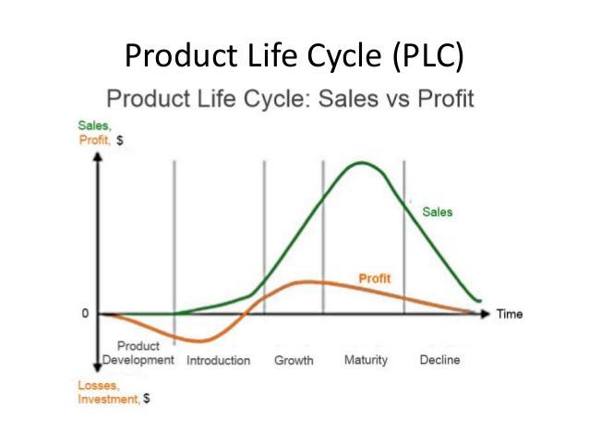
Figure 1: PLC Cycle
(Source: Influenced by Barac et al. 2016)
Globalization has enabled creation of new forms of economic interaction and has also led to creation of political forms that are quite often challenged. Huge number of international organizations has been able to govern from the process by tying up the MNC’s together. The global competitive rankings states that UK ranks tenth among the top 10 countries in comparison to the US which stands on 2nd position in terms of international trade. Considering the long term sales projection for electrical car companies it would be stated that the first stage had been with the product development stage. At this stage, when new engines are developed the customers are not much aware about the new products that have been launched. In the early 2008, the first Tesla Roadster had started to develop (Morrison, J (2016). The car range of medium electric cars had been enhanced from 73 miles in 2011 to 125 miles in the year 2018. Inclusion of hybrid electric cars and a range of battery vehicles had added fuel to the fire. 2013 had been a strong year of gaining momentum in the early stage. The growth period started as new products began to develop and a growth strategy was initiated. In this stage the sales rate is at its peak in 2018 where the sales had reached 50,000 units and had enhanced considerably for surpassing 2million units (Johnson et al. 2017). The third stage starts with the sales and projection of necessary sales growth for the car company. The long term sales growth projection ensures that there is a possible scope for the growth of EV vehicles in Europe. But due excessive prices, and shift in customer’s preferences towards substitute products, there comes a time when the sales projection falls considerably (Barac et al. 2016). It is denoted by a decline stage which ultimately creates a fall in the pattern of the sales products.
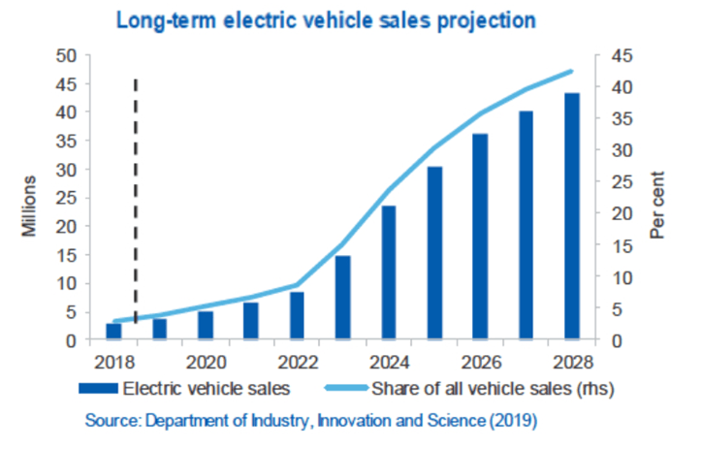
Figure 2: Sales Projection for Long-term electric vehicles
(Source: Influenced by Mikkilä et al. 2016)

Analysis of the external environment

PESTLE analysis
Factors | Analysis
Political | - Presence of political stability in global automotive industry  - Enhancing policies in automotive industry  - Enhancing quality of battery needed in EV cars with efficient political regulations
Economical | - Reduction in cost on non-renewable energy  - Presence of economic stability in global market  - reduction in cost of battery used in EV cars
Social | - Opportunities of wealth distribution in global industry  - Enhanced usage of non-renewable energy  - Reduction in carbon emission
Technological | - Increment in opportunities of EV cars  - Usage of online sales and promotion  - Greater percentage of technological advancement
Legal | - Expansion of international patent protection  - Dealing with sales regulations of countries such as Europe  - Presence of energy consumption laws
Environmental | - Usage of global policies for environmental protection  - Presence of policies for less carbon emission  - Adoption of policies for preventing exploitation of natural resources
Table 1: PESTLE analysis of EV Vehicles
(Source: Created by author)
Determination of PESTLE analysis for EV vehicles indicates that there is much scope for the automobile sectors in “Electric Vehicles in Europe” to expand in global environment. Political factors of EV cars show favourable situations for operators of such sectors as reduction in cost of non-renewable energy has been found. As recommended by Brannen, et al. (2017), implicating policies for less exploitation of natural resources aids positively into ethics and performance of an organisation. Providing battery disposal services is efficient approach to enhance business opportunities in future. Moreover, reduced usage of carbon emission is found in automobile sector that helps in contributing in environmental protection of nation. Presence of efficient technological advancement and increment in online sales helps EV producers in countries such as Europe. Further, usage of online sales and promotional techniques is adequate for enhancing position of EV automobile sector in global market.

Porter’s Five Force Framework
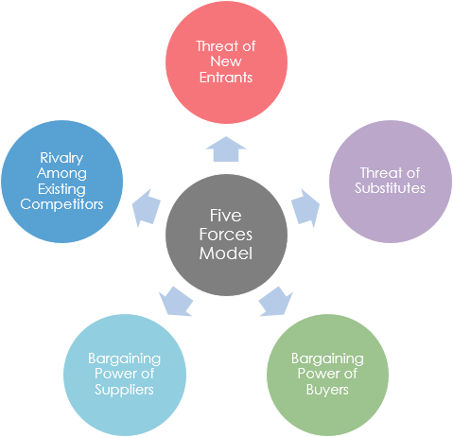
Figure 3: Porter’s Five Forces
(Source: Influenced by Ma et al. 2019)
Threat of New Entrants
Considering the automobile industry, there are threats of new entrants into the market. In the case entitled “Electric Vehicles in Europe” it is observed that sales of EV could be considerably reduced due to new firms entering the market. The scenario of car sales had not been very profitable in the initial years of its evolution in the European countries. The threat of new firms entering the market would make the situation worse and affect the sales and profitability for the EV.
Threat of Substitutes
Customers constantly keep changing their tastes and preferences as per the market demands. Based upon the threat of substitutes available it would be stated that availability of substitute products considerably reduces the scope for sales and profitability of the EV (Johnson et al. 2016). Therefore, it would be stated that the threat of substitute products can considerably affect the market share of EV cars.
Bargaining Power of the Buyers
The bargaining power of the buyers states that the ability of the buyers to make changes in the pricing strategies would affect the productivity of EV vehicles. Governmental agencies and organizations have considerable influence in changing the shape and scope of buyers bargaining power.
Bargaining Power of the Sellers
The power of bargaining for the sellers indicates the sellers having a strong power of bargaining can affect the sales margin and profit rate of EV in Europe. Suppliers have a low level of forward-integration and a considerable moderate supply level in projection of goods and services.
Rivalry among competitors
Strong competitive Rivalry between the other industries can affect the productivity and sales rate of the EV in Europe. The competitive rivalry creates a major element behind the sales and products of EV vehicles. Volvo being a carmaker had made the announcement as a part of its strategy to make new inventions of combustion machines. This might call upon the need for competitors to enter the market.

Limitations of Porter’s Five Forces
The basic limitations of Porter’s five forces are that this model takes into account a complete and a classic perfect market. It does not consider the possible linkages of information systems for businesses in the value chain. Furthermore, this model fails to consider the possible advantages that the market would bring through its strategic approaches. It aims to establish competitive tendencies in the business for being able to generate effective strategies for the same.

Porter’s Value Chain Analysis
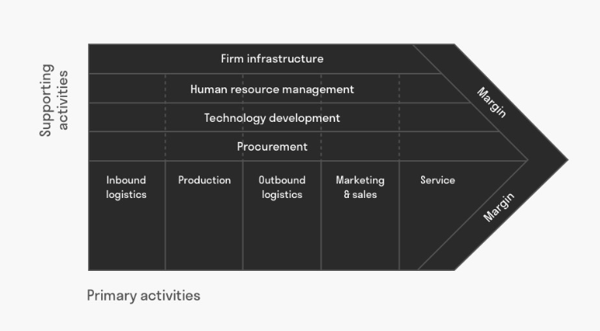
Figure 4: Porter’s Value Chain Analysis
(Source: Prajogo, 2016)
Porters’ value chain includes primary activities and supportive activities. As per Prajogo (2016), primary activity includes sales, production and maintenance of operation. Secondary activity consists of human resources and infrastructure. In case of EV cars implication of Porter's value chain can be assessed as under:
Primary Activities
Primary activities include determination of inbound logistics and outbound logistics and making adequate inter-linkage in it (Panayotou, 2016). In the process of implication value chain model in EV car industry determination of quality of cars, marketing and sales of car and services provided to customers are assessed.
Secondary Activities
In the process of improving the position of EV car industry in global business environment it is necessary to align secondary aspects of value chain with primary aspects. As per Pomponi and Moncaster (2017), secondary activities of value chain include human resource, infrastructure of firm and technological development. Hence, presence of these aspects in EV car industry helps in aligning inbound logistics and outbound logistics while operating in global industry.
There are three aspects of implicating Porter’s value chain in operation or commercial business:
- Identification of primary and sub activities
- Identification of each supportive activities
- Deriving linkage in each activities

Critical assessment of other businesses linked to global automotive industry
Automotive industry includes several business organisations that operate in auto manufacturing sectors. Many companies focus on parts of automotive and others are related with its sales, repairs or rentals (Kolk, 2016). Below are the analysis of businesses linked with global automotive industry:
Rental and dealership agencies
Rental and dealership ventures are concerned with selling and leasing new and used cars. Hence, the presence of such businesses in the automotive industry enhanced the scope of expanding operations of such sectors in the global market.
EV components manufacturers
Thus type of organisation mainly focuses on providing components of EV cars for assembling them. These types of businesses are specialised in the EV industry.
Equipment manufacturer
Equipment manufacturers are one of the main stakeholders of global automotive industry as they provided their own parts for manufacturing EV cars. Moreover, this includes tire4s, wiper blades, hoses and seats.

Conclusion
The global business environment enables setting of appropriate generation of EV vehicles. It can be concluded from the study that effective strategies help in enabling a proper direction towards growth and development. In Europe, the sale and profitability of EV cars had not shown remarkable growth in the initial years. Taking the help of PESTLE analysis and Porter's five forces an analysis has been made with regard to the adoption of appropriate decisions in the business scenario. It would help in analysing the market decisions as well as the essential strategies needed for the growth of the business. This would help in establishing support to the business organization on a major basis.

References
Barac, K., Gammie, E., Howieson, B. and Staden, M.V., (2016). The capability and competency requirements of auditors in today's complex global business environment.
Brannen, M.Y., Piekkari, R. and Tietze, S., (2017). The multifaceted role of language in international business: Unpacking the forms, functions and features of a critical challenge to MNC theory and performance. In Language in international business (pp. 139-162). Palgrave Macmillan, Cham.
Evans, S., Vladimirova, D., Holgado, M., Van Fossen, K., Yang, M., Silva, E.A. and Barlow, C.Y., (2017). Business model innovation for sustainability: Towards a unified perspective for creation of sustainable business models. Business Strategy and the Environment, 26(5), pp.597-608.
Johnson, C., Anderson, J., Appenzeller, N., Williams, B., Santulli, C. and Pallonetti, N., (2016). Evaluating the Connecticut Dealer Incentive for Electric Vehicle Sales. Transparency Specialist Evaluation.
Johnson, Whittington, Scholes, Angwin and Regner (2017). Exploring Strategy: Text and Cases, 11th Edition, Pearson Education.
Kolk, A., (2016). The social responsibility of international business: From ethics and the environment to CSR and sustainable development. Journal of World Business, 51(1), pp.23-34.
Ma, J., Yu, J. and Gong, Z., (2019), April. EV Regional Market Sales Forecast Based On GABP Neural Network. In IOP Conference Series: Earth and Environmental Science (Vol. 252, No. 3, p. 032098). IOP Publishing.
Mikkilä, M., Panapanaan, V. and Linnanen, L., (2016). The pursuit of responsible business: Corporate responsibility of Finnish companies in their global operations. In Key initiatives in corporate social responsibility (pp. 177-200). Springer, Cham.
Morrison, J (2016) The Global Business Environment. Challenges and Responsibilities, 4th Edition, Palgrave.
Panayotou, T., (2016). Economic growth and the environment. The environment in anthropology, pp.140-148.
Pomponi, F. and Moncaster, A., (2017). Circular economy for the built environment: A research framework. Journal of cleaner production, 143, pp.710-718.
Prajogo, D.I., (2016). The strategic fit between innovation strategies and business environment in delivering business performance. International journal of production Economics, 171, pp.241-249.

