MSc Digital Transformation
for the Health and Care Professions
BMDS7005

Evaluating the impact of digital systems on the development and management of hospital-acquired pressure ulcers.

Dissertation submitted in partial fulfilment of the award of
Master of Science in Digital Transformation for the Health and Care Professions

Beverley Havard
2218887
6th May 2025

Acknowledgements
The researcher extends sincere thanks to the staff at the participating wards and the Research and Development team at Cardiff and Vale University Health Board for their support during the data collection period and facilitating the opportunity to undertake this research.
The researcher would also like to thank her fellow students on the course for their continued support and encouragement throughout the last three years an to thank Ben her supervisor, whose guidance and support over the last year has been instrumental.
Finally, heartfelt thanks go to the researcher’s husband and daughters for their unwavering support, encouragement and patience throughout this journey.

Declaration

This work has not previously been accepted in substance for any degree and is not being concurrently submitted in candidature for any degree.

Signed: 

Date: 6th May 2025

I confirm this assignment is my own original work and does not include text created by a generative artificial intelligence tool.

Table of Contents
Acknowledgements………………………………………………………………………… 2
Chapter One: Background and Introduction…………………………………………4
1.0 Introduction……………………………………………………………………………….8
1.1 Background……………………………………………………………………………….8
1.2 Pressure Ulcer Overview…………………………………………………………….10
1.3 Pressure ulcers – terminology and categorisation…………………………..11
1.4 Pressure ulcers – risk/contributory factors………………………………......11
1.5 Pressure ulcers – preventative measures……………………………………..12
1.6 Pressure ulcers- current practice………………………………………………..13
1.7 Researcher background…………………………………………………………….14
1.8 Aims and Objectives…………………………………………………………………14
1.0 Overview of thesis……………………………………………………………………16
Chapter Two: Literature review………………………………………………………..16
2.0 Introduction……………………………………………………………………………16
2.1 Overview of literature search strategy…………………………………………16
2.2 Literature review themes…………………………………………………………..20
2.3 Research Question One: To what extent could areas within the skin
Risk assessment paper documentation be improved…………………………20
2.4 Theme: Documentation quality: errors, omissions and variability……20
2.5 Theme: Time intensive and resource heavy…………………………………21
2.6 Research question two: To what extent have digital systems impacted the quality of information recorded for patients?...................................23
2.7 Theme: Improved documentation quality……………………………………23
2.8 Theme: Integration with decision support systems……………………….24
2.9 Research Question Three: How do healthcare professionals perceive the usability and efficiency of digital systems compared with paper records?...............................................................................................26
2.10 Theme: User experience and workflow integration……………………….28
2.11 Theme: Challenges and barriers to digital adoption……………………..28
2.12 Theme: Change in process……………………………………………………….29
Chapter Three: Methods and Methodology………………………………………..30
3.0 Introduction…………………………………………………………………………….30
3.1 Aims and objectives………………………………………………………………….30
3.2 Research approach and rationale……………………………………………….31
3.3 Accessing and sampling……………………………………………………………32
3.4 Data collection overview……………………………………………………………32
3.5 Data collection………………………………………………………………………..34
3.6 Quantitative methods……………………………………………………………….35
3.7 Qualitative methods…………………………………………………………………35
3.8 Data analysis…………………………………………………………………………..37
3.9 Research ethics……………………………………………………………………….38
Chapter Four: Results…………………………………………………………………….39
4.0 Introduction……………………………………………………………………………..39
4.1 Research Question One: To what extent could areas within the skin
risk assessment paper documentation be improved……………………………40
4.2 Audit findings: Purpose-T chart (paper)…………………………………………41
4.3 Qualitative insights……………………………………………………………………41
4.4 Audit findings: Intentional-rounding charts……………………………………42
4.5 Qualitative insights……………………………………………………………………43
4.6 Research question two: To what extent have digital systems impacted the quality of information recorded for patients?.....................................44
4.7 Audit findings: WNCR purpose-T data…………………………………………..44
4.8 Audit findings: WNCR skin and repositioning chart data………………….45
4.9 Comparison summary……………………………………………………………….46
4.10 Qualitative insights………………………………………………………………….46
4.11 Research Question Three: How do healthcare professionals perceive the usability and efficiency of digital systems compared with paper records?...............................................................................................46
4.12 Staff survey results…………………………………………………………………47
4.13 Focus group results………………………………………………………………..48
Chapter Five: Discussion, conclusion and recommendations………………51
5.0 Introduction…………………………………………………………………………….51
5.1 Discussion………………………………………………………………………………51
5.2 Alignment of research aims with key findings………………………………..51
5.3 Research Question One: To what extent could areas within the skin
risk assessment paper documentation be improved…………………………..52
5.4 Gaps in paper-based documentation…………………………………………..52
5.5 Research question two: To what extent have digital systems impacted the quality of information recorded for patients?.....................................53
5.6 Impact of digital systems……………………………………………………………53
5.7 Research Question Three: How do healthcare professionals perceive the usability and efficiency of digital systems compared with paper records?...............................................................................................54
5.8 Staff perceptions and usability……………………………………………………54
5.9 Limitations………………………………………………………………………………56
5.10 Conclusion…………………………………………………………………………….57
5.11 Recommendations………………………………………………………………….58
5.12 Education and training……………………………………………………………..58
5.13 Policy and governance……………………………………………………………..58
5.14 Frontline staff and implications for practice……………………………58
5.15 Future research………………………………………………………………….59
References……………………………………………………………………………….59
Appendices
Appendix 1: Serious incident reporting form……………………………………85
Appendix 2: Classification of Pressure ulcers………………………………….88
Appendix 3: Skin bundle document……………………………………………….89
Appendix 4: Purpose-T document………………………………………………….90
Appendix 5: WNCR skin and repositioning chart………………………………91
Appendix 6: Intentional-rounding form……………………………………………93
Appendix 7: PICO framework………………………………………………………..94
Appendix 8: CASP checklist…………………………………………………………..95
Appendix 9: Focus group questions………………………………………………..95
Appendix 10: Staff survey questions……………………………………………….96
Appendix 11: Ethical approval Cardiff and Vale University Health Boards..99
Appendix 12: Focus group participation consent form………………………99
Appendix 13: Ethical approval form University of Wales Trinity Saint Davids…………………………………………………………………………………….101
Appendix 14: Project brief…………………………………………………………..101
Appendix 15: Work plan………………………………………………………………103

Chapter One: Background and Introduction.
1.0 Introduction
The documentation of pressure ulcer assessment and management plays a crucial role in prevention and early intervention (Akhkand et al 2020; Jacobson et al 2016). Traditionally, paper-based records have been used to track risk factors, skin assessments, and repositioning schedules. However, the increasing adoption of digital technologies in healthcare, including electronic patient records (EPRs), aims to improve documentation accuracy, streamline workflows, and enhance patient safety (Monfre et al,. 2022). The integration of digital systems, such as the Welsh Nursing Care Record (Digital Health Care Wales, 2021) supports real-time data entry, automated alerts, and standardised reporting, potentially addressing gaps in traditional documentation methods.
1.1 Background
In response to concerns raised by Healthcare Inspectorate Wales (HIW) in 2014 regarding the inconsistent and poor quality of nursing documentation across Wales (HIW, 2015; Andrews and Butler, 2014), The Welsh Nursing Care Record (WNCR) was introduced. The WNCR aimed to standardise nursing records, improve documentation accuracy, and release time to care. Developed collaboratively by the Welsh Government, Digital Health Care Wales, universities, NHS health boards and trusts, the WNCR provides an integrated digital documentation platform (Digital Health Care Wales, 2021). The system is designed to align with the Nursing and Midwifery Council’s (2015) professional code, ensuring nursing records are clear, accurate, concise, and timely. Implementation began in 2021, and the system is currently 96% implemented across inpatient wards in Wales. (See below figures 1 and 2).
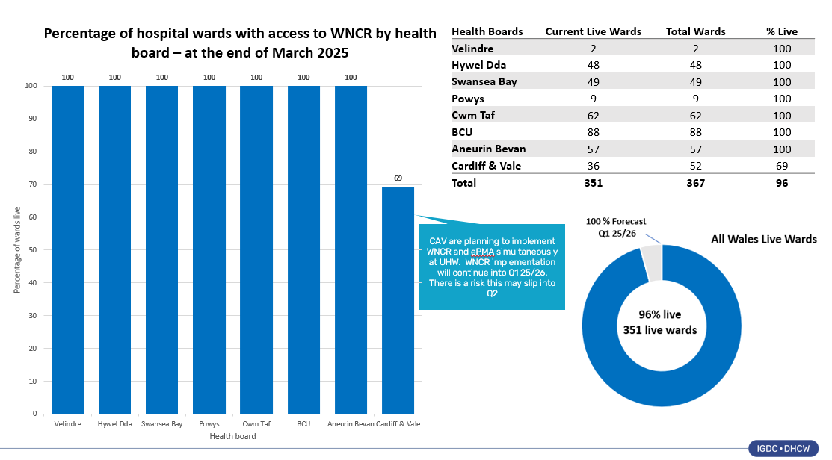
Figure 1: National implementation of WNCR by Health Board (DHCW 2025)
To date, the WNCR has standardised the Adult Inpatient Assessment, nine core risk assessments, and the inpatient note, with the aim of providing consistency in documentation across healthcare settings in Wales. Efforts are ongoing to standardise additional assessments to further strengthen this unified approach. The digital record currently includes the Adult Inpatient Assessment, Purpose T Pressure Ulcer, Pain, WAASP Nutritional, Patient Handling, Falls and Bone, Continence, Bowel, Mouth Care, Skin Inspection and Repositioning risk assessments, and the Inpatient note with over 42.4 million digital risk assessments completed as referenced in figure 2. These digital documents were designed to collect information once and reuse it multiple times, reducing unnecessary repetition and minimising the risk of transcription errors. This approach aimed to improve communication among healthcare professionals, support better auditing processes, and improve the quality of the clinical information. Ultimately, the vision was to streamline the documentation process to enable healthcare staff to spend more time focusing on patient care, which could potentially contribute to improved patient outcomes.
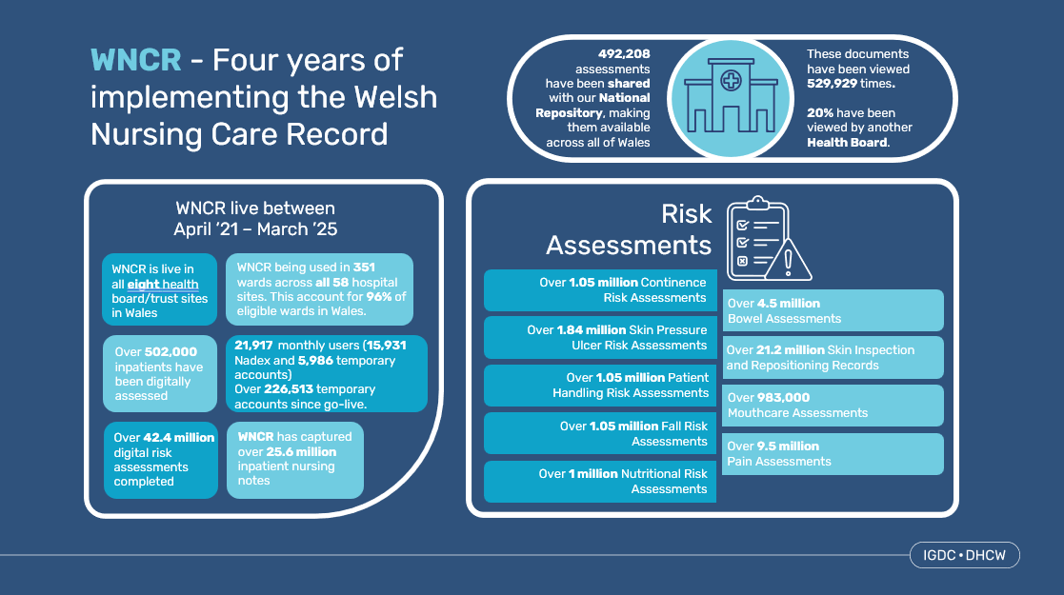
Figure 2: WNCR assessments completed up to March 2025 (DHCW 2025)
This study will focus specifically on the Skin Inspection and Repositioning Chart and the Purpose T Pressure Ulcer Risk Assessment document within the WNCR. These documents have been selected because they are essential for assessing and managing pressure ulcers, a significant concern in inpatient care (Lindqvist et al,. 2010; Jaul et al,. 2018) The primary aim is to evaluate whether transitioning from paper-based to digital documentation has enhanced the quality, accuracy, and consistency of these assessments. In addition to examining the impact on clinical outcomes, the study will also explore the user experience of healthcare professionals who interact with the digital system. This includes understanding their perceptions of usability, efficiency, and the ease of accessing and updating patient records. By combining these perspectives, the research seeks to determine whether the digital platform supports timely, comprehensive patient assessments, improves communication among healthcare professionals, and effectively reduces the risk of hospital-acquired pressure ulcers. Ultimately, the goal is to assess if digital documentation not only enhances clinical practice but also meets the practical needs of its users.
This study examines the impact of digital documentation on the assessment and management of hospital-acquired pressure ulcers compared to paper-based methods. It aims to explore how digital transformation influences clinical workflows, healthcare professionals’ perceptions of usability and efficiency, and the overall quality of pressure ulcer documentation. By analysing both qualitative and quantitative data, the mixed methods study seeks to provide evidence on whether digital systems improve patient outcomes and support best practices in pressure ulcer prevention.
The following chapter will explore the terminology and characteristics of pressure ulcers, examine both intrinsic and extrinsic contributory factors and preventative measures. It will also highlight the challenges associated with hospital-acquired pressure ulcers, including their financial and clinical implications for patients and the NHS. Furthermore, the chapter will outline current clinical documentation practices, particularly focusing on the risk assessment and preventative care bundles. Finally, the chapter will introduce the rationale, aim, and objectives of the study, which evaluates the impact for transitioning from paper-based to a digital system on the quality, accuracy, and usability of pressure ulcer documentation within a clinical setting.
1.2 Pressure ulcer overview.
In 2010, the NHS introduced a zero-tolerance policy towards avoidable hospital-acquired pressure ulcers (HAPUs), emphasising proactive prevention strategies such as regular risk assessments, repositioning, and pressure-relieving devices (National Patient Safety Agency, 2010). The policy also mandates serious incident reporting, promotes tools like the Purpose-T assessment (Appendix*) and encourages accurate documentation, staff training, and root cause analysis (Appendix *). Despite initiatives such as the Society of Tissue Viability’s STOP the pressure campaign (2024), which promotes education and preventative actions, pressure ulcers continue to cause significant patient harm and place a burden on the healthcare system (Ding et al., 2024; Kennedy, 2023).
Pressure ulcers impose both human and financial costs. Treatment costs escalate with severity, from £1,064 for a grade 1 ulcer to £10,551 for a grade 4, contributing to an annual NHS cost of £1.4 - 2.1 billion (Chamanga et al., 2015). Over 700,000 people in the UK are affected annually, with 180,000 new cases reported each year (Nuffield Trust, 2024). Globally, a systemic review found pressure ulcer prevalence among hospitalised patients to be 12.8%, with 8.4% being hospital acquired.
Guest (2021) found that pressure ulcers accounted for 5-7% of all wounds treated by the NHS between 2112/13 and 2017/18, though the study did not distinguish between hospital and community acquired cases. The National Wound Care Strategy Programme (2024) reiterates that pressure ulcers are one of the most frequently reported harms in adult in patients. Untreated, pressure ulcers can cause serious complications and death, with research showing they contribute to poor patient outcomes, longer hospital stays, and increased healthcare utilisation (Goodman et al., 2018; Anthony et al., 2004)

1.3 Pressure ulcers – terminology and categorisation.
A pressure ulcer, also known as a bedsore or pressure sore, are injuries to the skin and underlying tissue, typically caused by prolonged pressure, often on bony prominences like the heels, hips, elbows, and sacral areas. They may also result from medical devices such as oxygen tubing or compression garments (Campbell, 2016). Defined by the European Pressure Ulcer Advisory Panel, National Pressure Injury Advisory Panel, and the Pan Pacific Pressure Injury Alliance. (EPUAP/ NPIAP /PPPIA, 2019. p.4), pressure ulcers are ‘a localised injury to the skin and/or underlying tissue usually over a bony prominence, as a result of pressure, or pressure in combination with shear.’
Pressure ulcers are classified as either avoidable or unavoidable. Avoidable ulcers occur when there has been a failure in assessing risks, implementing or revising care appropriately, or monitoring effectiveness. In contrast, unavoidable ulcers develop despite comprehensive assessment, timely interventions, monitoring and patient involvement. (Department of Health, 2010). In Wales all unavoidable grade 3 or above pressure ulcers must be reported as serious incidents to the Welsh Government (see appendix 1)
Pressure ulcers are categorised depending on the thickness of damage caused to the skin. EPUAP (2019) refers to categories one, two, three, four, unstageable, suspected deep tissue injury and device related pressure ulcers (Refer to appendix 2 for pictorial examples).
Category one presents as intact red skin that does not blanch under pressure, indicating early damage. Category two involves partial thickness skin loss, appearing as a blister or shallow open ulcer with a pink wound bed. Category three is a full thickness wound that may expose subcutaneous fat, muscle, or tendon, sometimes with tunnelling. Category four extends deeper, exposing muscle, tendon, or bone, often involving supporting structures. Unstageable ulcers also involve full-thickness tissue loss but are covered with dead tissue, obscuring the wound bed. Suspected deep tissue injuries appear as localized purple skin, with an uncertain depth that may either heal or deteriorate. Device-related pressure ulcers result from prolonged pressure or shearing caused by medical equipment, leading to skin damage.
Following the categorisation of pressure ulcers, it is essential to explore the various risks and contributory factors that influence their development. These factors can vary widely and include both intrinsic and extrinsic elements, which together increase a patient's vulnerability to skin breakdown and pressure ulcer formation. Understanding these risks is crucial for implementing effective prevention strategies and improving patient outcomes.
1.4 Pressure ulcers – risk/contributory factors.
Related literature identifies a range of risk factors associated with pressure ulcer development. Firstly, Noie et al. (2024) emphasise the critical role of identifying contributory factors in pressure ulcer prevention. Physiological risk factors, such as diabetes mellitus, peripheral vascular disease, stroke, sepsis, and hypertension, can increase the risk by impairing the microcirculatory system, which in turn makes the patient more vulnerable to tissue damage. Secondly, Siebert et.al (2020) highlight non-physiological factors, including age, low body mass index, incontinence, malnutrition, immobility, skin temperature, and a history of previous pressure ulcers. These factors also contribute significantly to the development of pressure ulcers by affecting skin integrity and circulation
An issue of particular significance in the development of pressure ulcers is ageing. As life expectancy continues to rise, the prevalence of pressure ulcers among older adults has become a growing concern. According to the Organisation for Economic Co-operation and Development (2023), the average life expectancy in the UK is now 80.4 years, a significant increase from the 76 years reported by the World Health Organisation in 2000. With more people living longer, there has been a corresponding increase in hospital admissions among elderly patients, many of whom are at a higher risk of developing pressure ulcers.
Older adults account for a substantial proportion of pressure ulcer cases, with more than 60% occurring in individuals over the age of 70 (NICE, 2024). Age-related physiological changes contribute to this increased vulnerability. The skin becomes thinner, less elastic, and more prone to damage from prolonged pressure. Additionally, factors such as reduced mobility, impaired circulation, inadequate nutrition and hydration, and the presence of multiple chronic conditions, such as diabetes and cardiovascular diseases, further elevate the risk (Blair et al., 2020).
The global rise in life expectancy, driven by advancements in healthcare, improved living conditions, and better management of chronic diseases, has further exacerbated this issue (Steel et al., 2018). As a result, healthcare systems must adapt to address the needs of an ageing population, ensuring that effective pressure ulcer prevention strategies are integrated into clinical practice to improve patient outcomes.
The European Pressure Ulcer Advisory Panel (2019) identifies three primary causes of pressure ulcers. Firstly, prolonged pressure on specific body areas reduces blood flow and nutrient supply to the skin, leading to tissue damage, cell death, and lesion formation. Secondly, friction occurs when the skin repeatedly rubs against surfaces such as a bed, wheelchair, or chair, damaging the outer layer of the skin. Lastly, shear forces contribute to skin injury when underlying tissues are displaced in opposite directions, increasing the risk of deep tissue damage.
1.5 Pressure ulcers – preventative measures.
It is widely recognised that most pressure ulcers can be prevented with the implementation of effective preventative measures. (Chamanga et.al,. 2015; National Institute for Health and Care Excellence guidelines, (2024); Greenwood, 2022). Consequently, national, and international guidelines recommend implementing clinical assessments and interventions to mitigate pressure-related skin damage. Rivera et.al (2020) conducted a pilot study to evaluate the efficacy of introducing a pressure ulcer prevention bundle with the aim of decreasing the number of hospital-acquired pressure ulcers in an adult critical care unit. A skin bundle is a set of simple, evidence-based actions used together to prevent pressure ulcers (Health Service Executive 2019). It typically includes the repositioning schedule, use of pressure relieving surfaces, nutrition, hydration, and incontinence management (see appendix 3). The bundle aims to standardise care, improve documentation, and aims to help reduce the risk of pressure ulcers by ensuring key prevention steps are not missed (Kotter and Coleman 2023). The study found a 90% decrease in pressure ulcer development over a twelve-month period following the implementation of the bundle. The NPUAP/EPUAP/PPIPA (2019) guidelines recommend using a risk assessment tool for all hospital-admitted patients to evaluate their risk on admission, followed by implementing preventative measures to address the identified risks. The NICE guidelines (2024), recommend that a patient’s skin should be assessed within six hours of their arrival to a clinical area. For those patients identified as being at risk of developing a pressure ulcer, reassessment is recommended every four to six hours depending on their risk score identified.
Pressure ulcer prevention focuses on two key aspects, enhancing tissue tolerance through improved nutrition, mobility, and continence management, and reducing pressure using offloading techniques, like heel elevation for immobile patients (Hill et.al, 2022). Key interventions include hydration, nutritional support, pressure-relieving devices, and regular repositioning. Gaspar et al, (2020) explored the challenges in NHS pressure ulcer prevention, identifying factors such as patient age, nutritional status, staff training, and compliance with repositioning schedules. Their findings highlighted the need for systemic NHS reforms, including improved interprofessional communication and documentation practices, to support a more comprehensive and effective prevention approach.
Effective prevention strategies include adequate hydration and nutrition, the use of pressure-relieving cushions or mattresses, and regular repositioning schedules. Research by Gaspar et al. (2020) to evaluate the challenges of pressure ulcer prevention in the NHS, highlighted the complexity of pressure ulcer prevention, emphasising factors such as patient age, nutritional status, staff education, and adherence to repositioning protocols. Despite continuous efforts, the study identified a need for structural changes within the NHS to address the growing demand for wound care and enhance patient outcomes. In particular, the research underscored the need for better communication between healthcare professionals and improvements in documentation processes to ensure a more holistic approach to pressure ulcer prevention.
In addition to clinical interventions and specialised equipment, effective pressure ulcer prevention also depends on the knowledge and skills and training of healthcare professionals (Gress et al 2021. Charalambous et.al 2019). Education on risk assessment, early detection, repositioning techniques, and accurate documentation is essential in reducing incidence rates and improving overall patient outcomes (Hayes et al., 2023)
1.6 Pressure ulcers – current practice.
Robust nursing documentation is fundamental to fostering effective communication, ensuring continuity of care, and demonstrating compliance with professional and legal standards (NMC 2023). Furthermore, thorough, and precise documentation in skin assessments plays a pivotal role in improving patient outcomes by aiding in the prevention of complications and drives continuous quality improvements in patient care (Kottner, 2023; Black, 2015; Li, 2016)
In current clinical practice, a patient’s skin is assessed using the Pressure Ulcer Risk Primary or Secondary Evaluation Tool (PURPOSE-T). If the assessment identifies the patient “at risk” of developing a pressure ulcer, assessment guidelines recommend implementing the previously mentioned “skin bundle” to aid prevention. The University of Leeds (CTRU, 2022) conducted a multi-centre study involving 230 patients to validate PURPOSE-T as a reliable, evidence-based tool. The study demonstrated high reliability, with consistent results across different users and timeframes, and moderate to high validity, comparable to other widely used assessment tools. Healthcare professionals found PURPOSE-T to be clear, practical, and effective in categorising patient risk levels, supporting comprehensive prevention and treatment strategies. These findings indicate its clinical usability within the NHS and suggest its potential to standardise care and improve patient outcomes. While Purpose-T is primarily used in Wales, similar risk assessment tools, such as the Braden Scale (Haung, 2021), and the Norton Scale (Satekova, 2016), are widely implemented in other healthcare systems globally.
The Purpose T risk assessment aids clinical decision making by categorising patients into three distinct groups: those that at risk of pressure ulcers, those who are at risk but without current ulcers, and those with an existing ulcer, scar, or history of pressure ulcers. The tool uses colour coded categories to highlight key risk factors, guiding healthcare professionals through a structured, three step process as highlighted in appendix 4.
1.7 Researcher background
The nursing perspective was selected due to the researchers’ interest in the topic, complemented by over twenty-five years of clinical experience as a registered nurse. This background and experience provide valuable insight into the challenges nurses face, particularly in caring for patients at risk of pressure ulcer development. A reoccurring issue in this context is the inadequacy of nursing documentation, which often fails to sufficiently evidence or support the care provided. This underscores the importance of accurate and comprehensive nursing documentation, particularly in relation to skin assessments. Accurate and up-to-date records are essential for presenting a clear and precise overview of a patients’ skin integrity, facilitating the early identification of pressure ulcers, and ensuring that any changes in the patients’ skin condition or plan of care are effectively communicated within the healthcare team (Chamanga and Ward 2015). Despite these benefits, the researcher has frequently observed deficiencies in nursing documentation for skin assessments, examples include incomplete entries, such as missing dates, times, or signatures, as well as illegible handwriting and unfilled data entries.
1.8 Aim and objectives
Building on the discussion of pressure ulcer prevention and documentation practices, this study aims to evaluate the impact of digital systems on skin risk assessment and pressure ulcer management. By comparing traditional paper-based documentation with digital records, the research seeks to determine whether digital transformation has improved the quality and usability of recorded information. Specifically, the study explored three key objectives:
- To what extent could areas within the skin risk assessment paper documentation be improved?
- To what extent has the digital system made to the quality of information recorded for patients?
- How do healthcare professionals perceive the usability and efficiency of digital systems compared with paper records?

To address the research questions, the mixed methods study examines three key areas: the quality of skin risk assessment paper documentation in clinical practice, the extent to which digital systems have influenced the quality of information recorded for patients, and healthcare professionals' perceptions of the usability and efficiency of digital systems compared to paper records.

To measure and compare the quality of the risk assessment, quantitative data was collected from the paper and digital risk assessments from a sample population of 100 patients who have undergone both electronic and paper assessments. This involves reviewing the paper risk assessment forms and the digital system data. Key quality indicators were identified that define the quality of the risk assessment. This would include completeness, accuracy, timeliness, consistency, and adherence to best practice guidelines.
This study focuses on evaluating and comparing the quality of pressure ulcer prevention risk assessments by collecting and analysing quantitative data from both paper-based and digital assessment methods. The data was drawn from a sample of 100 patients who have undergone both types of assessments, ensuring a comprehensive comparison of the two approaches. As part of this evaluation, the study will assess the documentation related to pressure ulcer prevention. Specifically, a total of 100 skin bundle and Purpose T records will be collected, encompassing both paper-based and digital formats, to facilitate an in-depth comparative analysis. The review of digital records will be conducted following the implementation of the Welsh Nursing Care Record, allowing for an assessment of its impact on documentation quality and risk assessment effectiveness.
A structured approach of questions, aligned with the European Pressure Ulcer Advisory Panel (EPUAP) guidelines for pressure ulcer prevention (2019), will be employed to ensure consistency and adherence to best practices. In addition to the quantitative data analysis, qualitative insights will be gathered through structured focus groups and interviews with healthcare professionals. These sessions will take place across four randomly selected wards within the Cardiff and Vale University Health Board, providing a diverse perspective on the effectiveness and usability of both assessment methods. By integrating both quantitative and qualitative approaches, this study provides a robust evaluation of the transition from paper-based to digital risk assessments and its implications for patient care and clinical decision-making in pressure ulcer prevention.
1.9 Overview of thesis
This thesis comprises of four further chapters, each structured to address the research questions in a clear and methodical approach. Chapter two presents a literature review that explores existing evidence relevant to the study. Chapter three provides a detailed description of the mixed methodology used to gather and analyse both qualitative and quantitative data. Chapter four outlines the results of the paper and digital documentation audits, along with findings from the staff survey and focus group interviews. Chapter five offers a discussion of these findings, integrating literature and study results to evaluate the impact of the digital system compared to paper records, and presents the conclusion and recommendations, reflecting on the implications of the findings for clinical practice, policy development, and future research in pressure ulcer prevention and documentation.
The following chapter will evaluate existing literature related to pressure ulcer prevention, documentation methods, and the role of digital systems in clinical practice.
Chapter two: Literature review
2.0 Introduction
Chapter one provided an overview of the study, introducing the topic of evaluating the impact of digital systems on the assessment and management of pressure ulcers. It outlined the significance of pressure ulcers, contributory factors and the three key research questions guiding this study. Building on this foundation, chapter two will examine the existing literature in relation to the three research questions, exploring the effectiveness of both paper and digital methods of documentation, along with the impact of introducing a digital patient record on clinical workflows and patient care.
To address the three specific research questions, a separate literature search was conducted for each of the three objectives to ensure a broad and diverse range of literature was gathered. The research encompassed both empirical and non-empirical literature to ensure a comprehensive understanding of the topic. Incorporating both types of literature was essential to address best practice standards and policies, ensuring that the study aligned with current guidelines for effective pressure ulcer prevention, to support the research questions, and to inform the methodology of the analysis.
2.1 Overview of literature search strategy
Empirical and non-empirical research were considered in this study to ensure a comprehensive understanding of the topic. Consequently, a range of literature sources, including government reports and policy documents were reviewed to provide real-world evidence and practical insights from healthcare organisations. A systematic review of the literature was conducted using the Patient/Population, Intervention, Comparison, Outcome (PICO) framework, as outlined by Caldwell et al. (2011). This framework was selected to organise and contextualise the study within the existing evidence base on both paper and digital skin assessment documentation, while also incorporating the perspectives of healthcare professionals (Appendix 5). Serving as a bridge between clinical questions and real-world health research, the PICO framework supports the identification of key variables such as target populations and interventions, allowing the researcher to focus on practical, patient-centred issues and measurable outcomes. Specifically, “P” refers to the population, patient, or problem under investigation; “I” denotes the intervention being explored, such as a change in documentation practice; “C” represents the comparison group, for example, paper records versus digital systems; and “O” outlines the intended outcome, including improvements in documentation quality or patient care.
With reference to screening criteria, this literature review incorporates specific inclusion and exclusion parameters to ensure relevance and applicability. The review includes studies examining digital and paper-based skin assessment methods for pressure ulcer documentation, focusing on adult patients (aged 18 and above) within hospital or nursing home settings. Peer-reviewed studies, reviews, and meta-analyses published within the last ten years were prioritised to provide contemporary insights. However, seminal works published before this period were also considered if they made a significant contribution to the field. Studies focusing on paediatric patients, community care settings, or those published in languages other than English were excluded to maintain the study's focus on relevant healthcare environments.
The literature search strategy was designed to comprehensively address the study’s research questions while ensuring a robust and systematic approach. To address the first research question exploring areas for improvement in paper-based skin risk assessment documentation, an initial search was conducted using the electronic databases CINAHL, PUBMED, NHS Wales library and the University of Wales Trinity Saint David library. The search terms ("skin risk assessment" OR "pressure ulcer risk assessment") AND ("paper documentation" OR "manual documentation") AND ("improvement" OR "documentation gaps") yielded one result. To broaden the scope, a second search using (“risk assessment”) AND (“pressure ulcer prevention”) AND (“documentation”) retrieved 997 results. After screening titles and abstracts, this was narrowed to 125 articles, with further scrutiny reducing the selection to 15 key papers. Following an in-depth review, nine papers were identified as the most relevant to addressing the first research question.
To address the second research question whether digital systems have improved the quality of recorded patient information, the same databases were searched using the terms (“electronic health records”) OR (“digital systems”) AND (“data accuracy”) OR (“documentation quality”), yielding 497 results. Screening titles and abstracts reduced this to 75 articles, followed by further evaluation to identify nine key papers. After a final analysis, six papers were selected as the most suitable for answering this research question.
For the third research question, which examined healthcare professionals’ perceptions of digital systems versus paper records in skin assessment and pressure ulcer management, a search using the terms (“electronic health record”) OR (“digital documentation”) AND (“user satisfaction”) OR (“nurse perception”) AND (“usability”) OR (“ease of use”) retrieved 196 results. Title and abstract screening narrowed this to 40 articles, with further analysis identifying 21 key papers. A final selection process resulted in 10 papers being deemed most relevant.
In addition to database searches, manual searching was conducted to ensure a thorough literature review. This included reviewing government and healthcare organization websites, such as the Nuffield Trust, as well as grey literature. The snowball technique was also employed, identifying additional relevant studies by reviewing reference lists of selected papers. This multi-faceted approach aligns with best practices in literature reviewing, as discussed by Aveyard, (2019) and Ridley, (2012), ensuring a comprehensive and robust exploration of the topic. In total, 25 articles were selected for discussion, offering a comprehensive overview of the documentation practices and user perspectives across both digital and paper-based documentation.
To ensure the quality and rigor of the selected studies, a structured appraisal process was undertaken. The Critical Appraisal Skills Programme (CASP) checklists were used to help evaluate the quality, credibility, and relevance of the studies in this review (Appendix 6). CASP provides a structured tool that guide the assessment of qualitative and quantitative research, allowing the reviewer to identify strengths, limitations and potential bias in study design and reporting. Each selected study was appraised against criteria such as clarity of research aims, methodology, data collection process and relevance of the research findings to the research question. The use of CASP supported a transparent and consistent approach to identifying high-quality studies to include in the review.

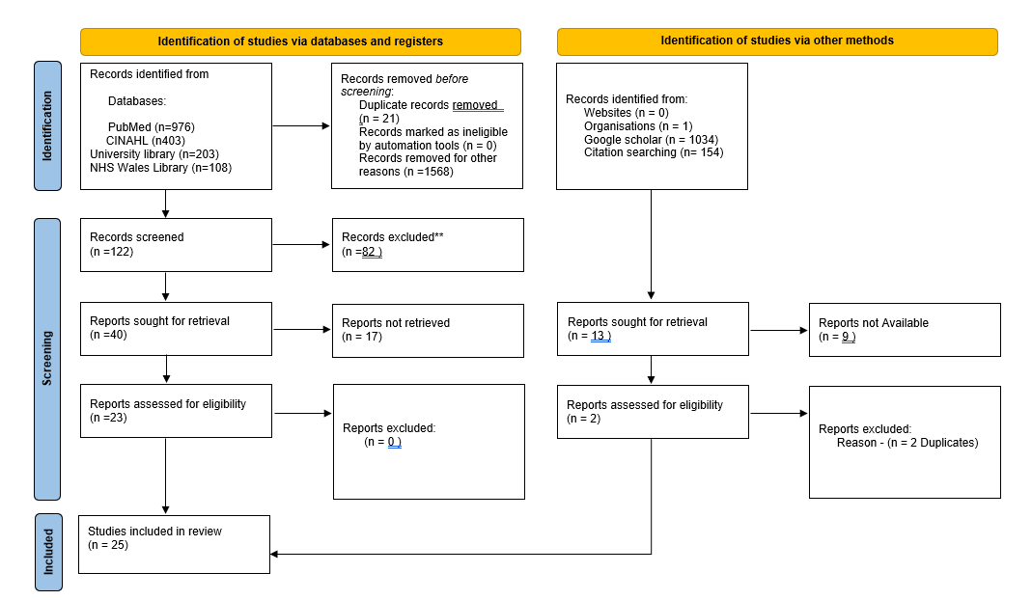

Figure 3: PRISMA chart – Literature identified and reviewed to inform the study (Page et al 2021)

2.2 Literature review themes:

A thematic analysis was conducted on the 25 selected articles, revealing multiple themes related to pressure ulcer management and documentation. While several themes emerged, this study focuses on the most significant ones within its scope, including the inconsistency in the quality of paper documentation, the potential of digital systems to enhance pressure ulcer management, and the challenges of transitioning from paper-based to digital documentation. Due to word and time constraints, broader implications of digitalisation on clinical workflows and patient outcomes were not explored in depth. This selective focus provides a nuanced understanding of both the advancements and persistent barriers associated with digital documentation in clinical practice.
2.3 Research question One: To what extent could areas within the skin risk assessment paper documentation be improved?
Accurate and consistent documentation is essential in pressure ulcer management, ensuring continuity of care and patient safety (Hansen and Fossum 2016). However, variability in record keeping, along with errors and omissions, can compromise clinical decision making and patient outcomes (Furtado, et.al 2023, Lien et.al 2023). The Nursing and Midwifery Council Code of Practice (2015) emphasises that nurses must maintain clear, accurate, and timely records as part of their professional duty, yet inconsistencies in documentation remain a significant challenge (Jacobson, et.al 2016). This section will explore the challenges of documentation errors, omissions, and variability in pressure ulcer management, assessing their impact on patient care and clinical practice.
Key Themes:
2.4 Documentation quality: errors, omissions and variability
Paper documentation is prone to errors and omissions, such as illegible handwriting, misplaced records, and incomplete information (Jenkins et.al 2019). These issues can delay necessary interventions and result in missed opportunities to mitigate patient risk (Clifton et al. 2015). Studies highlight significant gaps in documentation, particularly during key stages of care, highlighting the need for accurate record-keeping to prevent care omissions and enhance patient outcomes (Joseph, 2022). Inconsistent or incomplete documentation may lead to failures in capturing a patient’s condition, documenting responses to treatment (Jagannath et.al 2021; Azevedo, 2021; Othman et.al 2020), or may involve the use of unclear abbreviations, increasing the risk of misinterpretation or overlooking essential information (Gligor 2024).
Jackon, et.al (2016) conducted a quality improvement initiative in a 1,242 bed American Hospital to reduce hospital-acquired pressure ulcers, 40% of which were deemed as preventable. The initiative analysed nursing documentation to identify gaps in preventative care. Baseline data showed frequent absence of records for repositioning, heel elevation, and skin checks under medical devices. The project aimed to simplify and standardise documentation for assessment, prevention, and treatment. Revisions included prompts for repositioning, heel elevation, and inspecting skin under devices. From 2010-2011 to 2012-2013, avoidable ulcers reduced by 67% and checks under devices improved by 6%, highlighting the need for ongoing improvement strategies.
Comparable with the previous study, Li (2016) conducted a retrospective, comparative, descriptive study to evaluate the quality and completeness of nursing documentation on pressure ulcers and to explore its association with pressure ulcer incidence across four intensive care units. Using the European Pressure Ulcer Advisory Panel (EPUAP) Pressure Ulcer Assessment guidelines (2019), 196 patient records (98 with and 98 without ulcers) were analysed over a 12-month period. The study identified significant deficiencies in nursing documentation, with frequent omissions of ulcer appearance, grading, treatment, and records of care needs requiring nursing interventions. The study concluded that improving documentation practices is essential to improve patient outcomes.
Similarly, Hansel and Fossum (2016) conducted a cross- sectional audit in five Swedish nursing homes over eight weeks, examining 155 patient records alongside physical assessments to evaluate the accuracy of pressure ulcer documentation. Using EPUAP (2019) guidelines, they assessed risk factors such as sensory perception, mobility, nutrition, and the use of pressure relieving devices. Findings revealed 33 patients had pressure ulcers on examination, while 38 were recorded, with 17 ungraded. Of 59 patients using pressure-relieving mattresses, only 10 were recorded; similarly, 42 of 44 patients with chair cushions were unrecorded. The study highlighted significant gaps between care delivery and records, recommending improved staff training and exploration of digital systems to improve accuracy and consistency.
As highlighted by the literature, accurate documentation is essential for effective pressure ulcer management, ensuring continuity of care and patient safety. In contrast, errors, omissions, and inconsistencies in record-keeping can negatively impact clinical decisions and patient outcomes (Tubaishat et.al 2015). Several of the studies identified, highlight significant gaps in documentation, such as missing preventative measures and incomplete patient care records. These deficiencies emphasise the need for improved documentation practices and staff training. Addressing these challenges, however, requires substantial time and resources, which will be discussed in the next section
2.5 Time-intensive and resource heavy
Efficient documentation is a crucial aspect of healthcare delivery, yet the time-intensive nature of paper-based systems presents a significant challenge. Recent studies have shown that documentation time has significantly increased in recent years, with one study reporting that nurses can spend up to 35% of their shift on documentation-related tasks alone (Munroe, et al 2022). This trend has sparked debate about the balance between clinical care and administrative responsibilities. Manual handling, storage, and retrieval of paper records add to the workload of healthcare professionals, straining resources in already demanding environments. Research suggests that these inefficiencies have become increasingly burdensome in recent years (De Groot, et.al 2022; Patterson, et.al 2023). While the administrative demands of documentation are well recognised (Qian, et.al 2023; Royal College of Nursing 2013), discrepancies often exist between the actual time spent and nurses’ perceptions of their workload (Michel & Laurent, 2017).
Excessive documentation has increasingly been recognised as a significant contributor to the burden experienced by nurses and midwives, diverting valuable time away from direct patient care (Cooper, et.al 2021; Gesner, et.al 2022; Brown, et.al 2020). Increasing administrative demands have led many to view documentation as a burden rather than a support tool, contributing to reduced job satisfaction and burnout, especially when it is repetitive or lacks clinical relevance (Heur, et.al 2016; Tsai, et.al 2020). I t has been suggested that paper-based systems tend to worsen these issues due to their time-consuming nature, requiring manual entry, filing and retrieval (Tahseen, et.al 2020; Bogeskov, et. al 2018; Lavender, et.al 2016)
A study conducted by White et al. (2015) in two medical units in Australia aimed to evaluate how registered nurses allocate their time across key clinical responsibilities and other work activities. The observational study revealed that documentation accounted for a significant portion of nurses' workload, with an average of 21% of their time dedicated to record-keeping. In contrast, other essential nursing tasks received comparatively less time, including clinical assessment (8%), medication administration and treatment (13.2%), patient support and education (4.6%), and care coordination activities (12.6%). These findings highlight the disproportionate burden of documentation in nursing practice, potentially reducing the time available for direct patient care. The study underscores the need to reassess documentation processes to enhance efficiency and ensure that nurses can prioritise critical patient-centred activities.
In comparison, a small observational time and motion study by Cooper et.al (2021) in Western Australia examined the time nurses spent on documentation compared to their perceived time spent, as assessed by an anonymous survey. The study included a sample of fifteen nurses with a total years of experience ranging from six to forty years. The findings revealed that nurses spent an average of 30% of their time on documentation, whereas their perceived time, according to the survey, ranged between 30% and 50%. The study concluded that even though the participants overestimated the time spent on documentation, it still occupied a significant proportion of their workload and suggested that the burden of paperwork may contribute to nurses’ frustrations therefore suggests the documentation process be reviewed, streamlined and minimised, allowing nurses more time for direct patient care.
Following the review of literature, other core challenges are associated with paper-based documentation. Firstly, the duplication of entry, where information is repeatedly recorded across multiple forms, increasing the likelihood of errors (Crisp et al., 2019). Secondly, the vulnerability of paper records to physical damage, misplacement, or loss poses a risk to patient safety and continuation of care (Royal College of Nursing 2016). And lastly, from a governance and audit perspective, there are limitations to extracting and analysing data timely and efficiently, hindering quality improvement initiatives and slowing response times in recognising trends (Campbell & Rankin 2018). Nurses are often required to complete records away from the point of care, which fragments clinical workflows and reduces time available for direct patient interaction (Westbrook et al., 2010). Moreover, the inability of paper systems to support real-time updates leads to delays in multidisciplinary communication and care planning, particularly when patient conditions change rapidly (Topaz et al., 2017).
Collectively, the factors discussed above highlight the challenges of paper documentation and the implications in clinical practice. The next section will discuss the impact of introducing a digital system on the quality of care we record for our patients.
2.6 Research Question Two: To what extent have digital systems impacted the quality of information recorded for patients?
Digital records have the potential to support structured data entry, automated prompts, and real-time updates, improving accuracy, completeness, and consistency. While integration into clinical settings poses challenges, such as system compatibility, outdated technology, staff training, and data security, the transition from paper to digital is widely seen as beneficial. Improved documentation supports better accessibility, efficiency, and data analysis, ultimately enhancing patient care by ensuring clear, accessible information across settings. This section explores how digital systems affect documentation quality, particularly in pressure ulcer prevention and management.
Key Themes:
2.7 Improved documentation quality
Comprehensive and accurate documentation in nursing risk assessments plays a crucial role in identifying potential patient risks, facilitating timely and appropriate interventions, and promoting patient safety (Muinga, et.al 2021). Well-documented records ensure that essential information is consistently recorded, easily accessible, and effectively communicated among healthcare providers, ultimately supporting better clinical decision-making and continuity of care (Mathioudakis ,et.al 2016).
For example, Bail, et al. (2020) conducted a retrospective audit involving twenty randomly selected patient records, ten digital and ten paper based, from a medical ward in Australia aiming to evaluate documentation quality. The findings indicated that digital records demonstrated greater documentation integrity (p<0.05) and more frequent evidence of completed nursing interventions addressing identified risks (p<0.05), highlighting deficiencies in the paper records, including illegibility and incomplete entries. These gaps are critical, as thorough documentation is essential for supporting clinical reasoning and ensuring patient safety (Jacobson et al 2016). The study suggested that digital systems offer opportunities to enhance documentation quality through features such as automated reminders, visualisation tools for interpreting clinical data, and nudges to reinforce best practice behaviours’ (Lindsay and Lytle,2022). While the study acknowledged limitations in both paper and digital documentation systems in fully capturing and communicating nurses' clinical reasoning, it highlighted the greater potential of digital systems to address these challenges through targeted technological advancements.
Similarly, Akhu-Zaheya, et al. (2018) used a retrospective, descriptive, and comparative design to compare the quality of nursing documentation in paper-based versus electronic health records (EHRs). The researchers reviewed 434 patient records from medical and surgical wards in two hospitals in Jordan. Their analysis focused on three key aspects of documentation: content, structure and process. The findings showed that the electronic records were better in terms of structure and process, however, paper records were found to have a higher content quality and detail. Despite these differences, the overall quality of nursing documentation in both systems was rated as low, the study attributed this to gaps in nurses’ skill in applying the nursing process effectively.
In contrast, Nguyen, et al. (2017), conducted a quantitative study in Australia using questionnaires distributed to health professionals. The study aimed to evaluate the impact of EPRs on various aspects of clinical practice, including quality of care, communication, and workflow efficiency. The findings highlighted several advantages of digital nursing documentation. Notably, the use of automated error-checking features, such as alerts for incorrect entries or missing fields, which help minimise human errors commonly associated with paper records. Furthermore, eliminating illegible handwriting in digital records contributes to greater clarity and reliability. Additionally, the study found that requiring nurses to document care before leaving the bedside improved patient safety by ensuring up-to-date information and enhancing patient observation. The structured data entry process in digital systems also reduced the risk of missing critical information, as nurses were required to complete each section before moving on to the next. While EHRs offer benefits in organisation and real-time documentation, the study concluded that maximizing their effectiveness depends on system optimisation and adequate training of staff.
The literature suggests that digital systems have improved the quality of patient documentation by enhancing accuracy, completeness, and consistency through structured data entry and real-time updates. Despite challenges like system compatibility and staff training, research shows that digital records offer significant advantages over paper-based systems, particularly in supporting clinical decision-making and patient safety (Lindsay and Lytle 2022). The following section will explore how integrating digital systems with decision support systems can further improve clinical decision-making and patient outcomes.
2.8 Integration with Decision Support Systems
This section explores the role of clinical decision-support tools integrated within digital systems, which help enhance clinical decision-making and improve patient outcomes (Khairat et al 2018). A clinical decision support tool is a software feature designed to assist healthcare professionals in making informed, evidence-based decisions during patient care (Ng et. al 2022). These tools often rely on algorithms that compare patient data against established clinical guidelines and best practices, ensuring that care recommendations align with current medical standards. They also help reduce human error by standardising decision-making processes, improving the accuracy of documentation, and supporting timely interventions (Morrow et al 2023, Nashwan et.al 2024, Rony et.al 2024). Additionally, decision support tools can enhance patient safety by prompting healthcare professionals to complete tasks that are essential for patient care (Jung et al 2023), such as documenting risk factors or administering preventive treatments at the right time.
Many digital systems incorporate clinical decision-support tools, such as diabetes management, falls risk alerts, or medication safety alerts which are software solutions designed to improve the accuracy and efficiency of nursing documentation by integrating standardised terminologies and real-time decision support. These tools provide prompts to guide nurses in documenting risk factors and recommending evidence-based interventions. For instance, if a patient is identified as high-risk, the system may automatically suggest preventive measures such as repositioning schedules, specialised mattresses, or environmental monitoring with temperature and humidity sensors to support clinical decision-making (Silva et al., 2022).
Rose et al (2022) conducted a randomised pre-test-post-test study in a rural American hospital with 105 patients following the implementation of an EPR. An initial audit revealed poor documentation of patient repositioning. To address this, a sensor-based monitoring system was introduced featuring wearable devices that transmitted real-time positioning data and reminders to clinical monitors. The system also integrated with the EPR, incorporating patient-specific data such as age, body mass index, diagnosis, and pressure ulcer risk. Participants were divided into an intervention group using the sensor system and a control group using manual documentation. Findings showed that repositioning was recorded over twice as often in the intervention group. The sensor system provided more complete and accurate records, including body positions and reasons for missed repositioning. According to EPUAP (2019) guidelines, high-quality documentation is defined by completeness, accuracy, and timeliness, standards improved by the sensor system. In contrast, the manual records were often incomplete, delayed, and added to staff workload, while the sensor system appeared to improve documentation without increasing burden.
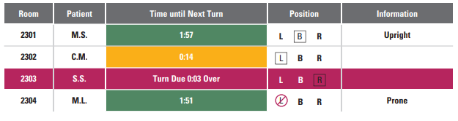

Figure 1: Example of data displayed on monitors from the wearable device (Rose et.al 2022)

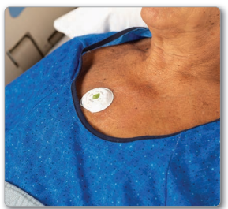

Figure 2: Example of a sensor placed on a patient (Rose et.al 2022)
In summary, clinical decision-support tools integrated into digital systems have the potential to enhance clinical decision-making by providing real-time, evidence-based recommendations and reducing human error. These tools have the potential to improve documentation accuracy, ensure timely interventions, and support better patient outcomes by standardising processes and prompting essential care tasks (Manaktala et.al 2017). Studies indicate that sensor-based monitoring systems, for example, improve the completeness, accuracy, and timeliness of patient documentation, ultimately reducing the nursing staff’s workload and enhancing patient safety. The next section will discuss how healthcare professionals perceive the usability and efficiency of digital systems compared to traditional paper records.
2.9 Research question Three: How do healthcare professionals perceive the usability and efficiency of digital systems compared with paper records?
The successful implementation of digital systems in healthcare settings is not solely dependent on the functionality of the technology itself but also on how healthcare professionals perceive and interact with these systems in their daily practice (Adedeji et al. 2022). These user experiences, shaped by factors such as system usability, ease of access, training and workflow integration, directly influence how effectively digital tools support clinical decision-making and care delivery (Qin et al. 2017). This section discusses the user experience and workflow integration, examining how clinicians evaluate digital systems in comparison to traditional paper methods. In doing so, it highlights the challenges and barriers to digital adoption, which often fall into organisational, technical, financial, and human categories (Moen, 2003). Finally, by exploring the clinicians’ responses to the EPR, this section will provide an insight into the change process, revealing how engagement, perceived usefulness, and system support affect the willingness of staff to embrace digital transformation.
Key themes:
2.10 User experience and workflow integration
The transition from paper-based records to digital documentation in healthcare has been extensively explored in academic literature, with particular focus on the usability, efficiency, and integration of electronic systems. While digital platforms promise improved data accessibility, workflow optimisation, and clinical decision-making support (Silva, 2022; Beckman et al., 2021), their successful adoption depends heavily on their alignment with clinical processes and user needs (Guimaraes, 2021; Tsai et al., 2020).
Challenges with digital documentation often arise due to inadequate training, poorly designed interfaces, and disruptions to clinical workflow (Sowan et al., 2019). For example, Jones (2016) found that digital systems that are not user-friendly or poorly integrated into daily routines can be perceived as burdensome and time-consuming. Usability is therefore recognised as a critical determinant in digital adoption (Hadji et al., 2016), and systems that are intuitive, customable, and responsive to clinical demands tend to gain more acceptance (Frennert., 2023; Douma et al., 2024)
Conversely, systems with poor interoperability, inefficient navigation, and unstable technical performance are linked to clinician dissatisfaction, documentation errors, and fragmented workflows (Veenstra et al., 2022; Lee, 2022). These issues not only impact the quality and completeness of records but also have downstream effects on patient safety and care outcomes (Hadji et al., 2016).
The literature indicates that while digital documentation can enhance workflow efficiency, it may also lead to unintended issues such as increased cognitive load, burnout, digital literacy gaps, resistance to change, and poor integration. Ehrler et al (2021) conducted a time and motion study involving 40 clinicians and found that, following EHR implementation, bedside documentation was initially recorded on paper before being transcribed electronically, resulting in inefficiencies and reduced staff satisfaction (Sowan et al., 2019). To address this, mobile devices were introduced to streamline the process and reduce record fragmentation. This intervention reduced the task time by 4.10 minutes and increased patient interaction by 1.45 minutes. The intervention improved workflow, staff satisfaction, and EHR acceptance, underscoring the need for systems that aligns with clinical practice.
Similarly, Silva (2022) reports that many healthcare professionals find digital systems beneficial for streamlining workflows by reducing documentation time and improving access to patient data. Key features such as real-time access, automated data entry, and integration with other healthcare systems are perceived as major contributors to efficiency (Jedwab et.al 2019). In contrast, paper-based systems are often considered labour-intensive due to the manual nature of completing, storing, and retrieving records (Wang et.al 2018).
Despite these advantages, the literature presents mixed findings on the overall impact of electronic patient records (EPRs). While some studies emphasise benefits such as improved workflow and communication (Beckman et.al 2021; Mullins et al. 2020), others highlight significant challenges (Sharma et.al 2021; Burns 2024). A qualitative study was conducted in Saudi Arabia by Islam (2018) to understand participants views, feelings and challenges following EPR implementation and found that technical issues, such as system downtime and software glitches, disrupted workflow efficiency and caused frustration. The study also noted that some nurses resisted the transition to digital records due to concerns about making errors, particularly when handling critical patient information. These findings suggest that while digital records have the potential to improve efficiency, their success depends on system reliability and user confidence.
In addition, a qualitative study was conducted by Wynter et al. (2021) in a large public health hospital in Australia evaluating nurses' experiences following the implementation of an EHR, found that while digital systems improved real-time access to patient data and reduced medication errors through automated alerts, they also led to cognitive overload and disrupted workflows. Nurses reported difficulties navigating complex interfaces, managing frequent software updates, and remembering multiple login credentials. Furthermore, lack of integration between systems led to fragmented information and inefficiencies in care coordination. These findings align with broader literature suggesting that while EPRs can improve clinical workflows and patient outcomes, their effectiveness is contingent on system usability, staff training, and seamless integration with existing healthcare technologies (Cresswell and Sheikh, 2020. Sittig and Singh, 2021).
Further illustrating these mixed perspectives, Smyth et.al (2024) conducted a cross-sectional survey with 80 registered nurses in Australia to evaluate the impact of EPRs on nursing practice and patient relationships. The study examined four key areas: nurses' experiences with EPRs, the impact on specific nursing tasks, patient perceptions, and the training and support provided during implementation. While some participants reported improved communication within the multidisciplinary team and the ability for multiple healthcare professionals to document simultaneously, negative feedback was more prevalent. Concerns included system limitations, lack of integration with existing workflows, and the physical barrier created by computers during patient interactions. Additionally, ergonomic issues related to prolonged computer use emerged as a potential health and safety concern for staff.
Overall, the literature offers a balanced perspective on EPRs, acknowledging their potential to improve workflow efficiency, real-time data access, communication, and documentation (Silva, 2022; Beckman et al., 2021). However, their effectiveness relies heavily on usability, system design, and integration into clinical workflows (Guimaraes, 2021; Wynter et al., 2021). Poorly designed systems can increase inefficiencies, cognitive burden, and staff dissatisfaction (Frennert et al., 2023; Islam, 2018). Successful implementation depends on user-centred design, sufficient training, and interoperability with existing technologies (Creswell and Sheikh, 2020; Ehrler et al., 2021). Overall, aligning EPR systems with clinical practice is essential to ensure they support rather than disrupt care delivery.
2.11 Challenges and barriers to digital adoption
While digital systems offer significant benefits, healthcare professionals also highlight several challenges such as technical issues, digital capability and a change within clinical practice (Taylor, 2017). Common concerns include difficult-to-use-systems causing a delay of nursing tasks (Zadvinskis et.al 2018), system downtime, technical glitches, and steep learning curves, particularly for staff unfamiliar with digital tools (Wynter et al., 2022). Additionally, the perception that digital systems can be cumbersome or overly rigid may lead some clinicians to prefer the flexibility of paper-based records (Provenzano et al 2024). The successful adoption of any digital system relies on the alignment between the individual, the task, and the technology, as described by the fit between individuals, task, and technology model proposed by Kujala et al. (2020). This model suggests that the integration of information technology in clinical settings is influenced by the compatibility of three key factors: the characteristics of the users (such as computer anxiety and motivation), the features of the technology (including usability, functionality, interoperability, and performance), and the demands of clinical tasks and workflows (such as organisational structure and task complexity). Therefore, for effective implementation, the system must be suitable for the user, relevant to the task, and fit for purpose, ensuring that users can collect the necessary data for their intended specific requirements (Prgomet et.al 2019). The following section will explore the changes in processes that may influence the integration of digital systems into clinical practice.
2.12 Change in process
Change is an inevitable aspect of healthcare, driven by advancements in technology, evolving patient needs, and policy reforms. In nursing, change initiatives often aim to improve patient care, enhance efficiency, and streamline workflows (Taj et.al 2019). However, implementing change in healthcare settings is complex and requires careful planning, effective leadership, and staff engagement (Deokar and Sarnikar 2016, Cohen 2015). One of the significant barriers to successful change implementation is change fatigue, a phenomenon where nurses experience exhaustion, disengagement, and resistance due to frequent or poorly managed changes (Goedhart et al., 2020). When change is imposed without adequate support, communication, or resources, nurses may feel overwhelmed, leading to decreased morale, reduced job satisfaction, and even burnout (Camilleri 2019). Successful implementation requires careful planning, training, and ongoing support (Mitchell and Kan 2019)
Change management in clinical environments is challenging due to factors such as resistance to new processes or systems, the complexity of healthcare settings, and the need for specialised training (Taj et.al 2019). The introduction of new technologies or processes can increase workload and stress, particularly if staff are insufficiently supported (Veenstra et al, 2022). Barriers such as poor communication, lack of staff involvement, and technological limitations can further successful adoption (Kaihlanen et.al 2023). Organisational culture and leadership also play key roles that influence success of digital transformation, underscoring the importance of careful planning, training, and ongoing support (Mitchell and Kan 2019)
Digital transformation in healthcare is often perceived as a daunting process, especially by frontline professionals like nurses, who are instrumental in ensuring safe, evidenced based care (Brommeyer et al., 2024; Kleib et al., 2021). As healthcare evolves in response to technological and socioeconomic shifts, it is essential that nurses receive appropriate resources and support to adapt (Kelly et al., 2020). Literature also indicates that healthcare professionals’ attitudes towards EPRs vary depending on their experience and clinical context. While many acknowledge improvements in efficiency and data accuracy (Robinson et al., 2015), others express a preference for paper-based records due to their familiarity and usability in low-tech environments (Mahdizadeh, 2022; Huang, 2021).
A webinar presentation by Tolliday (2023), following the implementation of an EPR in a Cambridge hospital, emphasised that successful digital adoption relies on clinician involvement at every stage. The presentation further suggested that a do with rather than a do-to approach. The do-to approach involves making decisions about change without input from the affected staff, leading to potential resistance and disengagement. In contrast, the do with approach emphasises collaboration, where clinicians actively participate in the decision-making and implementation process (Mokoena-Beer et.al 2025). This inclusive approach fosters greater staff engagement, reduces resistance to change, and ensures a smoother transition as staff feel more empowered and involved in the process (Ahmad & Cheng 2018).
Furthermore, digital implementation often necessitates procedural and protocol changes, which can initially increase workload and stress for healthcare professionals (Jeilani et al., 2025). Nurses with lower digital literacy may feel less confident using new systems, potentially impacting morale and job satisfaction (Oudbier et al., 2024) Inadequate training and limited support further hinder successful adoption (Mohess and Gomes, 2024). Zaman et al. (2021), in a study conducted in Austria, found that nurses perceptions of an EPR varied by age, with younger nurses reporting greater confidence in digital tools due to their familiarity with technology. In contrast, older nurses, who has less early exposure to digital systems, expressed more reluctance and anxiety toward digital adoption. These generational differences highlight the need for tailored training strategies to improve digital competence for all nursing staff (Risling, 2017).
This chapter explored the documentation of skin risk assessments, comparing paper-based and digital systems with a focus on usability, data quality, and user experiences. Paper documentation was found to be inconsistent, error-prone, and time-consuming, underscoring the need for greater standardisation and efficiency. In contrast, digital systems have been associated with improvements in completeness, accuracy, and standardised records, partly due to the integration of clinical decision support tools that aid timely patient care. While digital tools offer clear benefits for documentation quality and potentially improve patient outcomes, healthcare professionals reported varied experiences. Key challenges included poor workflow integration, usability issues, and resistance to change. Based on these insights, the next chapter will detail the methodology used to evaluate the impact of digital transformation in relation to pressure ulcer management.
Chapter three: Methods and Methodology
3.0 Introduction
Building on the findings from the literature review, this chapter outlines the research methodology used in the study. It describes the design, approach, data collection, and analysis techniques employed to explore the effectiveness and impact of digital transformation in skin risk assessment and pressure ulcer management. Each data collection method was aligned to one or more of the study’s research questions, providing a structured framework for understanding both outcomes and user experience.
3.1 Aims and objectives
This study aims to evaluate key aspects of documentation practices and digital record systems within a healthcare setting, with a particular focus on skin risk assessments and pressure ulcer management. By examining both paper-based and digital documentation, the research seeks to identify opportunities for improvement and assess the impact of digital transformation on clinical practice. Specifically, the study explored three key objectives:
- To what extent could areas within the skin risk assessment paper documentation be improved?
- To what extent has the digital system made to the quality of information recorded for patients?
- How do healthcare professionals perceive the usability and efficiency of digital systems compared with paper records?
3.2 Research Approach and rationale
This study adopted a mixed methods approach. Mixed methods research is defined as a methodological approach that combines both quantitative and qualitative data collection and analysis techniques. This approach is employed to gain a more comprehensive understanding of complex research questions, as it allows for the triangulation of data (Creswell 2024). The value of mixed methods research lies in its ability to balance the strengths of both quantitative and qualitative methods to provide a richer and more nuanced perspective (Clark et al, 2016; Robson, 2011).
There are several types of mixed methods research designs, including explanatory sequential, exploratory sequential, and convergent designs (Curry et al 2013). In this study, a convergent design was chosen, where both quantitative and qualitative data were collected concurrently but analysed separately to provide a comprehensive understanding of the impact of digital versus paper-based documentation (Creswell and Plano-Clark, 2017).
This study uses a pragmatic approach, which provides the flexibility to integrate both quantitative and qualitative methods to explore complex real-world phenomena (Kaushik and Walsh 2019). Pragmatism is useful here because it acknowledges that no single method or perspective can fully capture the reality of healthcare practice, especially during a digital transformation. In this context, the study seeks not only to measure the outcomes of the digital system (for example, improvements in accuracy or completeness) but also to understand the healthcare professionals’ experiences and perceptions in relation to the digital system.
The decision to use a pragmatic approach is underpinned by the ontological view that reality is both singular and multiple, the objective data (such as audit results or completion rates) and subjective perspective (such as nurses’ lived experiences) both represent valid forms of knowledge (Morgan, 2007). This aligns with the study’s aim to assess not only how digital systems effect documentation quality, but how staff interact with and perceive these changes (Scott and Briggs, (2009).
From an epistemological perspective, pragmatism allows for the application of methods best suited to answering specific research questions (Creswell and Planko Clarke, 2017). This is particularly relevant to this study, which seeks to evaluate the impact of digital systems on nursing documentation quality through quantitative analysis, while also exploring user perceptions through qualitative interviews and survey questions. A mixed methods approach was therefore selected to offer a more comprehensive understanding of the research problem.
The rationale for choosing this methodological approach is also practical. In the context of a healthcare organisation undergoing a digital transformation, it is essential to explore not only the outcomes but also the process of change from the perspective of those involved. This approach supports the need to inform both policy and practice with evidence that reflects real-world complexity (Shaw et al, 2018).
3.3 Accessing and sampling
This study adopted a pragmatic mixed-methods design, integrating both quantitative and qualitative approaches to evaluate clinical documentation practices before and after the implementation of a digital system.
The qualitative aspect of the study was conducted across four purposively selected wards within Cardiff and Vale University Health Board, all of which were scheduled to implement the Welsh Nursing Care Record (WNCR) in the forthcoming weeks. The sample included 20 participants who completed the paper-based staff survey and 26 participants who responded to the digital survey. In addition, focus groups were held with a total of 10 staff members, comprising four registered nurses and six healthcare support workers, all of whom had used the WNCR system for a period exceeding three months.
The quantitative element involved the same four ward areas. A random sample of 100 adult patient records was audited for each documentation type. This included paper-based records such as Intentional-rounding and Purpose-T forms. After the implementation of WNCR, an equivalent sample of 100 digital records was reviewed from the same wards to enable a direct comparison between the paper and digital documentation systems.
Access to the research setting was gained through engagement with senior nursing staff within Cardiff and Vale University Health Board, who supported the identification of suitable wards for inclusion in the study. The wards were randomly selected from a list of the first ten wards planned to implement WNCR, which aligned with the study’s timeline and enabled a timely comparison between digital and paper-based documentation systems. Planning the data collection and gaining access posed some challenges due to staffing pressures and patient acuity levels, which limited staff availability to engage, plus ward closures due to infection control protocols, which restricted movement between wards and limited the pool of participants. To mitigate these barriers, flexibility in scheduling and data collection methods was essential, alongside an empathetic approach that respected the constraints the staff were under.

3.4 Data collection overview
Data collection was conducted between November 29th and March 23rd, 2025, from four wards within Cardiff and Vale University Health Board. These wards were randomly selected from the first ten to implement WNCR, ensuring participants had recent exposure to both paper and digital documentation systems. The selected wards included an acute respiratory ward, an acute stroke ward, a medical ward and a rehabilitation ward. Participants, comprising of registered nurses, student nurses and health care support workers, were recruited via voluntary participation. utilising a mixed-methods approach comprising both surveys and structured focus groups, as summarised in Table 1 below. The table summarises the alignment between each of the study’s research questions and the corresponding data collection methods used. It demonstrates how a mixed methods approach was used to triangulate findings and improve the validity of the research. The methods included an open-access online survey, which yielded 47 responses: 36 registered nurses, 4 health care support workers, 1 specialist nurse and 6 student nurses (table 3). Excluding responses marked as not applicable, the average years of experience among participating registered nurses was 16.5 years (table 2). The structured focus group consisted of a Ward Sister, three registered nurses, and six healthcare support workers.

Table 1: Data collection methods
Research Question | Documentation audit (objective data) | Staff survey (perception-based survey) | Staff focus group (in-depth insight) | Type of data collected
To what extent are there areas within the skin risk assessment paper documentation that could be improved? | Yes | Not applicable | Not applicable | Audit findings (completeness, clarity, consistency)
To what extent has the digital system improved the quality of information recorded for patients? | Yes | Not applicable | Not applicable | Comparison of accuracy, completeness, timeliness of records
How do healthcare professionals perceive the usability and efficiency of digital systems compared with paper records? | Not applicable | Yes | Yes | Staff perceptions on usability and practical experience
Table 2: Survey participants total years of experience as a Registered Nurse

Table 3: Survey participants by role

3.5 Data collection
As previously discussed, this study uses both quantitative and qualitative data collection methods. The quantitative element involved auditing paper-based and digital skin assessment records to evaluate documentation quality, completion rates, and consistency. This approach provided measurable evidence of how each method supported pressure ulcer prevention and management. For the qualitative element, data were gathered through focus groups with nursing staff to explore their experiences using both documentation systems. These discussions offered insight into the perceived benefits, challenges, and the impact of each method on workflow and patient care. In addition, a staff survey was distributed to collect further qualitative feedback, enabling nurses to share their views on the advantages, limitations, and potential improvements of each documentation methods. Table 4 below describes the data collection plan for this study.
Table 4: Data collection Schedule
Date | Location | Action | Audience
29.11.24 | Teams meeting | Introduction | Ward managers of selected wards
29.11.24 | CAV | Floor walking - engagement | Nurses, HCSW
 | Emailed Ward managers and digital clinical nurse specialist teams | Microsoft forms survey (paper) opened | Ward managers/ Digital CNS team
06.12.24 | CAV | Floor-walking share survey QR code | All clinical staff
06.12.24 | CAV | Paper audit data gathering
16.12.24 |  | WNCR implemented Ward 1 and 2
20.12.24 | CAV | Paper audit data gathering
09.01.25 | CAV | Paper audit data gathering
 |  | WNCR implemented Ward 3
22.01.25 | CAV | Floor-walking share survey QR code | All clinical staff
 | CAV | Floor-walking staff engagement | All clinical staff
27.01.25 |  | WNCR implemented ward 4
 | Emailed Ward managers and digital clinical nurse specialist teams | Microsoft forms survey (digital) opened | Ward managers/ Digital CNS team
 |  | Microsoft forms survey (paper) closed
 | CAV | Floor-walking encouragement to complete staff survey | All clinical staff
21.03.25 | CAV | Focus group interviews | Sister/RGNs/HCSW
21.03.25 | CAV | Floor- walking – share survey QR code | All clinical staff
 |  | Microsoft forms survey(digital) closed

3.6 Quantitative methods
Quantitative data were gathered through documentation audits to evaluate the quality, completeness, and consistency of skin assessment records (Purpose-T risk assessment/Intentional-rounding charts). A total of 200 documents of each risk assessment were audited including 100 paper-based and 100 digital records (WNCR) across four randomly selected wards, an acute respiratory ward, an acute stroke ward, a medical ward, and a rehabilitation ward. The sample size was selected to ensure adequate representation across documentation types and clinical settings while remaining feasible within the study’s timeframe.
The audit tool was designed in alignment with best practice guidelines from the European Pressure Ulcer Advisory Panel (2019), and the Nursing and Midwifery Council (2023) documentation standards. This alignment helped to systematically assess whether the key elements, such as, risk identification, documentation completeness, and preventative interventions, were consistently recorded in line with recommended clinical practices. Each component of the documentation was rated using the Likert scale (poor, below average, average, good, very good), a widely accepted tool for measuring ordinal data in health research (Joshi et al, 2015), with the option to add comments to enable a more nuanced evaluation of quality and compliance.
3.7 Qualitative methods
Qualitative data were collected via a focus group and anonymous staff surveys. One focus group was held, comprising a total of ten participants (four registered nurses and six health care support workers). A semi structured guide (Appendix 7) was used, covering themes such as system usability, impact on workflow, and communication. Focus groups are well-suited for uncovering collective responses to systemic changes (Blease et al, 2023). The selection of participants with diverse roles aimed to capture a range of experiences relating to documentation practices. An anonymous survey was also conducted via Microsoft forms and distributed through ward managers and QR codes. The survey included open and closed questions designed to explore healthcare professionals’ experience with the paper documentation process, aimed to gain an understanding of staff perceptions of the paper documentation quality, usability in clinical practice, and any observed strengths or limitations. (Topaz and Pruinelli, 2022), advocate use of anonymous digital surveys as they are known to enhance data quality and encourage honest feedback
A key facilitator of successful data collection was building a rapport with ward teams prior to conducting focus groups or audits. This aligns with the findings by O’Brien et al (2014) who emphasise that rapport building is an important element in qualitative data collection, especially when engaging with healthcare professionals. Establishing trust with participants has been recognised as essential in qualitative research, where professional hierarchies, sensitivity around practice and time pressures can affect participation (Regnault et al 2018). By conducting informal visits to the wards before formal data collection began, the researcher was able to familiarise themselves with staff, observe routines, and present the study in a non-intrusive manner. This approach helped foster open and honest responses, establish credibility, and encouraged participation, consistent with recommendations from Kvale and Brinkman (2015) who highlight the importance of relational ethics and mutual trust in qualitative interviewing.
The focus groups served to explore critical themes identified in the literature, including system adoption, perceived impact on patient care, and usability of the digital documentation platform. Qualitative interviews provide a valuable platform for healthcare professionals to articulate their firsthand experiences with the documentation practices within their clinical environment. These interviews facilitate a deeper understanding of the challenges and benefits associated with both paper-based and digital documentation. Blease et al (2023) underscore the efficiency of focus group interviews in capturing nuanced perspectives of healthcare professionals, highlighting their role in uncovering complex, context-specific insights that may be overlooked in quantitative studies.
During the focus group sessions, structured questions were asked (Appendix 8) with particular emphasis on how WNCR has influenced clinical workflows, communication practices, and the overall documentation process. Each participant was given the opportunity to share their experiences and raise pertinent points, ensuring a comprehensive exploration of the topic. The selection of the variety of roles was instrumental in selecting individuals who could provide diverse and insightful perspectives on the transition from paper-based to digital methods of documentation, thereby enriching the data collected. This methodical approach aligns with the findings of Wosney et al (2024) who advocate for qualitative in-depth interviews to explore the lived experiences of healthcare professionals during a digital transformation process.
In addition to the focus groups, a staff survey was conducted to further explore healthcare professionals’ perceptions of both paper-based and digital skin risk assessment documentation systems. The survey was created and distributed via Microsoft Forms, providing ease of access across devices and allowing for anonymous submission.
The link to the survey was initially sent to ward managers, who were asked to disseminate it to their respective teams. To enhance visibility and response rates, the researcher also conducted floor-walks across the wards, engaging with staff directly and encouraging participation. A QR code linking to the survey was also shared with the digital teams to share during departmental handover meetings and ward-level governance discussions, providing additional access points for staff to complete the form at their convenience.
Recent studies support this approach, highlighting that anonymous surveys improve data quality by allowing participants to respond openly and honestly without fear of repercussions (Murdoch et al., 2014). Moreover, these findings emphasise the value of involving end users in assessing the real-world impact of electronic health records on staff performance and job satisfaction (Topaz and Pruinelli, 2022; Baillie et al., 2021).Similarly, Black et al (2021) suggest that focus groups, in particular, are effective for revealing the nuanced experiences of healthcare professionals as they navigate the adoption of digital technologies in high-pressure settings.
Despite these efforts, the survey yielded a total of 46 responses, with 20 responses related to the paper-based skin risk assessments and 26 responses concerning the digital system. Although the sample size was relatively modest, it provided a useful cross-section of views, particularly in capturing real-time staff experiences and preferences. The lower response rate may reflect survey fatigue, workload constraints, or limited familiarity with the digital platform among some staff, which are consistent with patterns reported in existing literature (Cajita et al., 2021. Saini & Talwar 2023). Nonetheless, the combination of quantitative metrics (e.g., Likert-scale responses) and qualitative free-text feedback offered valuable insights into staff attitudes toward both systems, contributing meaningfully to the overall analysis of documentation usability and adoption.
3.8 Data analysis
The researchers understanding and application of thematic analysis were informed by existing literature, with key contributions from Creswell et al (2020); Matta (2022), and Park et al (2020) who provided foundational guidance on conducting thematic analysis in applied health research. Creswell et al (2020) emphasise the importance of thematic analysis in qualitative research, highlighting its utility in capturing rich, detailed insights into participants perspectives and experiences. Matta (2022) extends this by discussing how thematic analysis can be particularly valuable in the context of healthcare interventions, where understanding the nuances of participants experiences is key for improving practice. Similarly, Park et al (2020) suggests that thematic analysis in healthcare research is pivotal to explore healthcare practices, patient experiences, and professional perspectives, all of which are essential to improve the effectiveness of health systems.
Additionally, the analysis was approached from a realist epistemological stance, assuming that participants language reflected real experiences and perspectives regarding documentation practices. By interpreting participants language as a genuine representation of their lived experiences with documentation systems, therefore grounding the findings in real-world contexts. This aligns with the literature advocating for thematic analysis in practice-orientated settings, as articulated by Nowell et al (2017), who suggested that thematic analysis is not only valuable for exploring abstract concepts but also for providing actionable insights in applied settings like healthcare.
Quantitative data were analysed using Microsoft Excel. Descriptive statistics, including frequencies and percentages, were used to compare documentation performance across paper and digital systems. The choice of Excel as the primary analytical tool was guided by its accessibility, familiarity, and its capabilities in handling basic to moderate levels of statistical analysis (Taylor et al 2013). These statistical methods provided a structured framework for identifying trends and assessing the comparative performance of the two documentation systems.
For the qualitative data gathered from the focus group and survey responses, a thematic analysis approach was employed. Thematic analysis is a widely used method for identifying, analysing, and reporting themes within qualitative data, offering flexibility and depth of insight using Braun and Clarke’s (2021) six- phase framework, familiarisation, coding, theme development, review, definition, and reporting. Transcripts and data were manually coded and organised into themes, which were refined and reviewed iteratively to ensure they accurately reflected the data
All qualitative and quantitative data were stored in a secure database requiring a two-step authentication process. This approach was taken to comply with the General Data Protection Regulation (EU 2016), ensuring all data were handled responsibly. Additionally, the study followed the and the research ethics framework provided by the University of Wales Trinity Saint Davids University ethics committee. In addition, data was anonymised during transcription and analysis to preserve participant confidentiality.
3.9 Research ethics
This project was designed as an evaluation rather than formal research. Following consultation with the Research and Development department at Cardiff and Vale University Health Board, it was confirmed that NHS ethical approval was not required (Appendix 9). However, ethical approval was obtained from the University of Wales Trinity Saint David (see Appendix 10), and the study was conducted with integrity in line with ethical standards (Bos, 2020), ensuring participant anonymity and protection of any patient-identifiable information.
The researcher’s role as a clinical informaticist with direct national-level involvement in WNCR presented a potential for introducing bias into data collection and analysis (Luijendijk et al 2020). Recognizing this risk, the study implemented methods to maintain objectivity and mitigate potential bias. For example, random samples were selected, the same criteria were used to evaluate each data set, and the interviews and surveys were conducted with open questions to prevent coercion.
Participants of the study were provided with written information outlining the study aims and purpose prior to taking part in the focus group. At the beginning of the focus group, details regarding the study purpose, researcher contact details, confidentiality and data storage were shared. Consent was obtained for audio recording and data storage, with clear information about deletion of recordings and data storage following the completion of the study (Appendix 11).
This chapter outlined the research approach, methodology, and methods employed in the study to evaluate the impact of digital systems on hospital-acquired pressure ulcers. By adopting a mixed-methods approach, this study combined quantitative audits of documentation quality with qualitative insights into nurses' experiences. The selected convergent design enabled the collection of both types of data concurrently, providing a well-rounded view of how documentation practices affect clinical workflows.
Quantitative data was gathered through systematic audits of both paper and digital skin assessment records, while qualitative data were collected through focus group and staff surveys. This combination offered both measurable outcomes and real-world experiences, facilitating a greater understanding of the documentation transformation process. The chapter also discussed ethical considerations, access and sampling strategies, and steps taken to ensure rigor and objectivity in data collection and analysis.
Particular attention was paid to challenges such as staff availability, potential bias due to the researcher’s dual role, and constraints related to time and access, highlighting the importance of flexibility and empathy in conducting healthcare-based research. Despite these challenges, the study’s methodological integrity was maintained using standardised tools, transparency in process, and triangulation of data sources.
The next chapter will present the study's findings, it will share the results from the audits, focus groups, and staff surveys, offering a comparative analysis of paper-based and digital documentation methods. In doing so, the chapter aims to understand how digital documentation influences pressure ulcer assessment and management and to explore healthcare professionals' experiences with the digital transformation.

Chapter four: Results
4.0 Introduction
Building on the research design and data collection methods detailed in Chapter Three, this chapter presents the findings from the mixed-methods approach used to evaluate the impact of digital systems on the assessment and management of hospital-acquired pressure ulcers. The results are structured according to the study's three research questions, combining quantitative data from audits of both paper and digital documentation with qualitative insights drawn from focus groups and staff surveys. The aim is to highlight key differences, improvements, and challenges associated with the transition from paper-based to digital documentation in clinical settings.
The chapter begins by outlining the data collection procedures, describing the methods employed throughout the research process. The core of the chapter focuses on the documentation audit, offering a comparative analysis of paper and digital skin assessment charts in terms of quality, completeness, and adherence to protocol. This
quantitative analysis is enriched by qualitative narratives obtained through open-ended survey responses and interviews with nursing staff, providing a comprehensive account of user experiences and perceptions.
Together, these data sources are analysed in an integrated manner to provide a multidimensional understanding of the observed outcomes. The objective at this stage is not to interpret the results in depth, but to offer a clear and structured overview of the data as collected and analysed. Further interpretation and discussion of the findings will be addressed in the subsequent chapter.
4.1 Research Question 1: To what extent could areas within the skin risk assessment paper documentation be improved?
The audit of 100 patient records revealed that a portion of the paper documentation lacked comprehensive assessments, with missing entries related to skin inspections, repositioning schedules, and pressure ulcer risk scores. The following sections will discuss the audit results in more detail.
4.2 Audit findings: Purpose-T chart (paper)
The first evaluation was conducted of the Purpose T risk assessment tool assessed key documentation standards, including legibility, patient identification, nurse signatures, timely completion, and inclusion of risk factors (see figure *) The findings showed that the key risk factors, perfusion (82%), moisture (83%), nutrition (71%), and diabetes (69%), were commonly assessed. However, nurse signatures and printed names appeared in only 60% of assessments. The frequency plan was documented in 34% of cases, indicating gaps in completing the overall risk evaluation. Timeliness of assessment appeared to be problematic, with only 42% of assessments completed within six hours of admission. Documentation of previous pressure ulcer history was missing in 51% of records.

Table 5: Findings from the Purpose T document audit.

4.3 Qualitative insights:
Staff feedback from the focus group interviews aligned with these findings. Participants described the form as lengthy and difficult to manage, with one staff nurse stating, ‘The amount of paperwork is so much, it takes ages’. Access to the document was inconsistent, with reports such as, ‘We can normally find them, but if we run out, we have to go to another ward to borrow them.’ And ‘patient files often missing or found on another patients bed causing confusion especially if you don’t know the patients’. Issues with incomplete and unclear records were frequently noted. Comments included ‘There are lots of empty boxes on the charts’ and ‘Not all sections are completed.’ Table 6 below shows the results from the staff survey on quality and access to the Purpose-T chart.

Table 6: Findings from staff survey on paper Purpose-T document
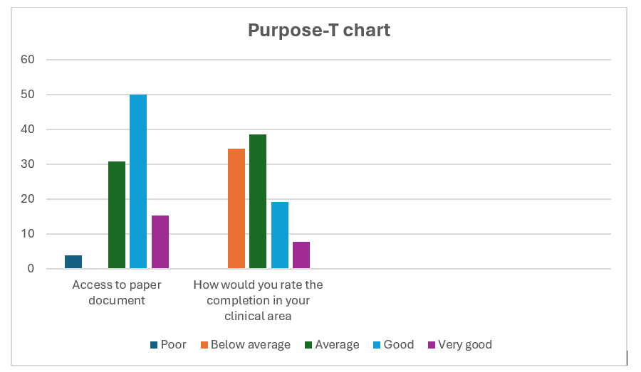
4.4 Audit findings: Intentional-rounding charts:
The findings from the second audit to evaluate key elements within the intentional-rounding document (Table7) revealed that while some elements of documentation were consistently completed, such as the recording of the surface type (100%) other significant areas showed notable gaps. Full patient details were included in 82% of records, and only 60% were signed by a nurse, suggesting incomplete professional accountability. Furthermore, 84% of records documented a repositioning frequency plan appropriate to the patient’s risk level, which aligns with best practice. However, there was a complete absence of documentation related to off-loading the heels and consideration of skin under medical devices, both scoring 0%. These omissions represent significant gaps in pressure ulcer prevention practices and suggest that while the document prompts some key actions, it may not sufficiently capture all necessary aspects of risk management.

Table 7: Findings from the intentional rounding/skin bundle document audit.

4.5 Qualitative insights:
Qualitative data supported and contextualised these audit findings (Table 8). In the staff survey (from 20 registered nurses, 1 specialist nurse, 3 student nurses and 2 health care support workers,) the perceptions of the document's accessibility varied: 8% rated access as poor, 28% as below average, and 18% as very good. This variability suggests inconsistency in how the document is distributed or maintained across wards. More importantly, when asked whether the document enabled comprehensive pressure ulcer prevention, 63% of respondents rated it poor or below average. Completion of the document was also a concern raised by a staff nurse, with the majority rating it as below average (37%) or poor (15%).
Focus group discussions echoed these concerns. Staff frequently described time constraints as a barrier to thorough documentation, with one Ward sister stating, ‘Too much paperwork to complete, it takes a lot of time.’ A student nurse also questioned the form’s clinical relevance, noting, ‘Intentional-rounding does not ask the right questions to prevent pressure damage; it’s different to what we are taught in the University.’ These qualitative insights appear to align with the inefficiencies and limitations of the current paper documentation, reinforcing the audit findings and indicating persistent gaps in content, usability, and the overall effectiveness of the tool in supporting pressure ulcer prevention.

Table 8: Findings from staff survey on paper intentional - rounding document
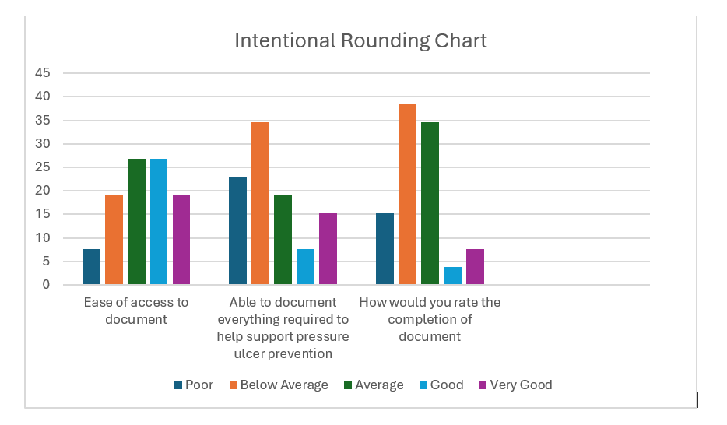

4.6 Research Question 2: To what extent has the digital system made any difference to the quality of information recorded for patients?
4.7 Audit findings: WNCR Purpose-T data
(Table 9) below, presents the audit results of documentation completed within the WNCR across seven key areas relevant to pressure ulcer prevention: frequency plan, nutrition, and medical device perfusion, perception, moisture, and diabetes. Across all entries, approximately 76.77% of entries were marked “Yes,” indicating completed documentation, while 24.24% were “No,” reflecting incomplete entries. This consistent pattern suggests that while most elements are being recorded, approximately one in four remain uncompleted. This finding provides a quantitative overview of documentation practices within the sample and helps to frame subsequent qualitative insights regarding factors that may influence completeness, such as usability, time constraints, or familiarity with the system.

Table 9: WNCR Data Purpose-T

4.8 Audit findings: WNCR Skin and repositioning chart data
Table10: Audit results from the skin and repositioning chart in the WNCR

Within the WNCR system, the pressure ulcer prevention tool is referred to as the skin and repositioning chart, as opposed to a ‘skin bundle’. Audit findings demonstrated in (table 10) above show 100% completion rates across all key indicators, demonstrating full compliance with pressure ulcer prevention documentation in these areas
4.9 Comparison summary:
Table 11: comparison of paper versus digital completion
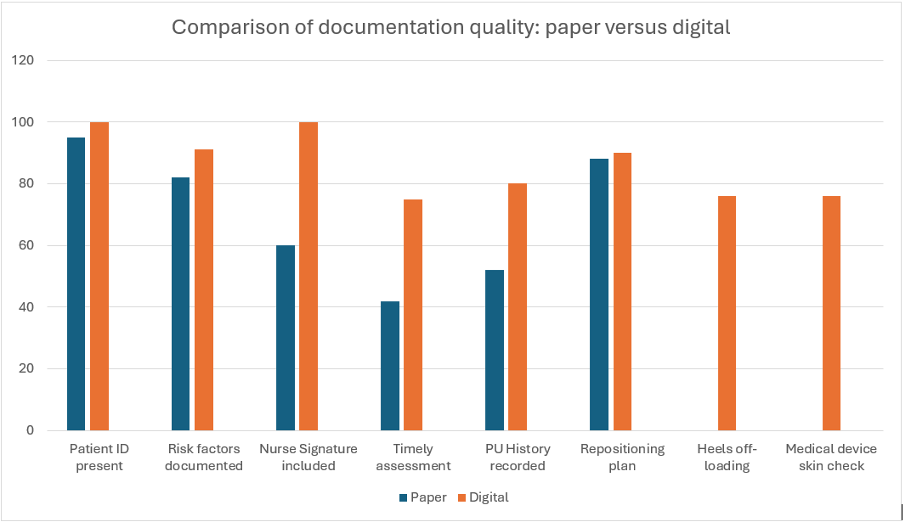
(Table 11) above compares the quality of documentation between paper-based and digital systems across several key metrics, showing consistently higher completion rates in the digital records, particularly for considering skin under a medical device, off-loading of the patient’s heels, recording pressure ulcer history, and inclusion of nurse signatures.
4.10 Qualitative insights:

Staff comments from the discussions during the focus groups suggested that the digital system was perceived as more efficient, particularly for retrieving patient information during handovers. One registered nurse noted ‘WNCR is much better to document findings on pressure ulcers. I like the information available to support staff like the pictures of PU grades.’ Survey responses However, some participants reported difficulties with navigating the digital interface, suggesting that initial training and familiarity levels affected the perceived usability. For instance, one health care support worker stated, ‘I missed the training session on the system therefore found it difficult to use initially’. Technological limitations also posed challenges, with several staff noting unreliable connectivity. Comments included ‘Wi-Fi is an issue’, ‘couldn’t get access for over an hour’ and ‘system not reliable enough’. These barriers affected the overall perception of usability, particularly in busy environments.

4.11 Research Question 3: How do healthcare professionals perceive the usability and efficiency of digital systems compared with paper records?
Many staff members reported that the digital system facilitated quicker, more accurate documentation and minimized redundant entries. Some participants expressed concerns about the initial learning curve and technical issues, such as system downtime or slow connectivity, which occasionally disrupted workflow. Survey responses indicated that while some nurses preferred paper records for their familiarity, many recognised the potential for miscommunication due to illegible handwriting or misplaced forms.
4.12 Staff survey results
Table 12: Staff perspectives on both paper and digital nursing documentation
Comments on WNCR system | Comments on paper documentation
Paper was easier doing the turns | No actual skin bundle used here in CAV they use intentional-rounding which doesn’t really assess what is required to keep patients safe
I missed the training sessions on the digital system therefore found it difficult initially to use | Intentional-rounding does not ask the right questions to prevent skin damage. Different to what we are taught in the University
WNCR is much better to document findings on pressure ulcers. I like the information available to support staff like the pictures of PU grades | Rounding forms are not skin specific. We need another form
I prefer this method, quicker and easier than paper | Patient’s files often found on another patient’s bed causing confusion especially if you don’t know the patients
Wi-Fi is an issue! Couldn’t get access for over an hour recently. Much prefer the digital system though to paper, it is clearer to read and understand plus staff are completing the whole form. Something that wasn’t happening on paper | No clear guidelines on IR form for the inspection of a patient’s skin
Don’t like the digital record. Prefer paper to do my notes | Poor compliance with all documentation here
The digital system is better than paper forms, easier to understand and reduces the problem of lost charts. Wi Fi is hit and miss though which stresses me out | There is not enough space on the IR form to add anything. Boxes too small
Wi- Fi is always dropping or very slow, makes it difficult to document on patient care | Lots of empty boxes on lots of documentation
Couldn’t get log on access for ages, staff too busy | Too much paperwork to complete and it takes a lot of time
The digital system is much better than paper, but we need all docs on there please | Spend too much time on paperwork and not enough with patients
Coloured time alert useful to ensure they are all up to date | Paper documentation takes so much time
More questions to answer on the skin chart. I do like the advice sections you can click on | Can never find the right charts
Having to sort out a new password for each placement is going to be a challenge, nurses are always so busy to take the time to support | Patient notes often missing, takes ages sometimes to find them
(Table 12) displays an example of some of the comments from participants in the ‘additional comments’ section of both the paper and digital surveys.

Table 13: Results from staff survey (WNCR)
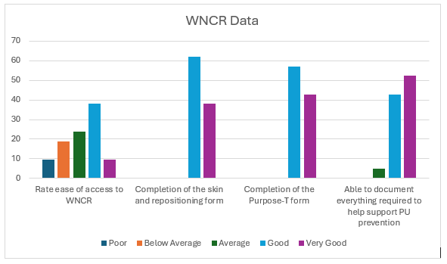
The results in (table 13) shows how health care professionals perceive the systems accessibility, usability and support for pressure ulcer prevention documentation. Ease of access to WNCR received mixed responses. While a significant portion of users rated access as either good (40%) or average (25%), with around 18% rating it below average and 10% poor. Only a small number of respondents (10%) considered access to be very good. In contrast, feedback on the completion of the skin and repositioning form was positive. Around 62% of participants rated it as good, and another 37% as very good, with no responses falling in the lower rating categories. Similarly, the completion of the Purpose-T form was positive, with 58% rated it good, and 42% selected very good. The highest levels of satisfaction were seen in the category “Able to document everything required to help support PU prevention. Here, 53% rated the system as very good, and 43% as good, with only a small proportion choosing average
4.13 Focus group results
The results revealed key themes around usability, efficiency, and challenges to adoption. Many staff noted that the digital system allowed for faster, more accurate documentation and helped reduce duplication. One staff nurse shared, ‘The digital system is much better than paper forms, easier to understand and reduces the problem of lost or misplaced charts.’ Another staff nurse commented, ‘Much prefer the digital system to paper, it is clearer to read and understand, plus staff are completing the whole form, something that wasn't happening on paper.’ Whereas one staff nurse commented ‘I love WNCR, the only issue is we have to access more than one system, why can’t these systems talk to one another? it would save so much time’. And lastly a ward Sister commented ‘conducting investigations and audits is so much quicker when I have most of the information in one place.
However, concerns were also raised about the initial learning curve and technical difficulties. Several participants highlighted challenges such as missed training sessions and insufficient preparation time, with one saying, ‘I missed the training sessions on the digital system therefore found it difficult initially to use the new system,’ and another health care support worker noting, ‘I Would have liked more training before we changed over from paper, 20 minutes is too short.’ Access issues were also a theme, as some agency/student nurses reported difficulty obtaining a temporary access to WNCR during busy shifts, with comments from one agency staff nurse saying ‘It is a real challenge to get login details when the ward is busy and nurses don't have the time to support,’ and ‘Couldn't get log on access for ages, staff too busy.’
Connectivity problems further impacted usability, with staff describing how ‘Wi-Fi is an issue! Couldn't access WNCR for over an hour recently,’ and ‘Wi-Fi always dropping or very slow makes it difficult to document on patients’ care.’ Despite these issues, many preferred the digital approach overall, appreciating features like integrated guidance and clearer presentation. One participant expressed, ‘WNCR is much better to document findings on pressure ulcers. I like the information available to support staff, like the pictures of PU grades,’ while another added, ‘Really like the system better than paper but we need more iPads.’
Notably, while some still preferred traditional methods—such as one health care support worker stating, ‘Paper was easier to use doing the turns,’ and another registered nurse saying, ‘ I don’t like the digital record. Prefer paper, quicker to do my notes’, another registered nurse explained ‘we need body maps in WNCR because we have to substitute with a paper copy which is frustrating’, the general sentiment reflected a recognition of digital documentation's benefits, alongside a call for improved infrastructure and support. Despite these challenges, many respondents felt that digital documentation ultimately saved time and supported more accurate patient care.
Table 14: Findings from staff survey on WNCR
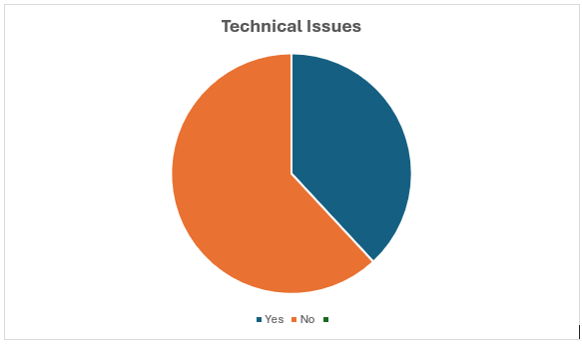

Table 15: Findings from staff survey on WNCR
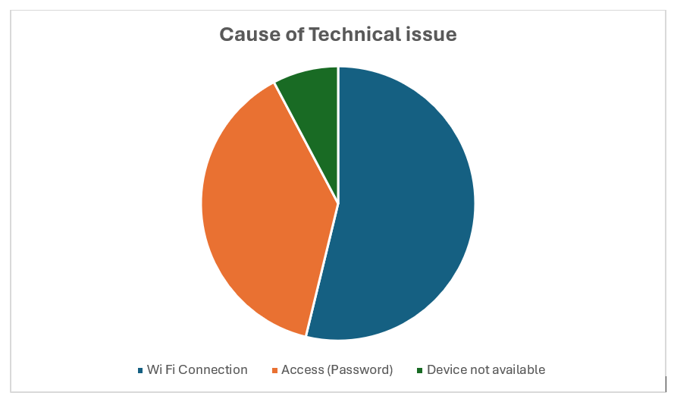
As demonstrated in tables 14 and 15 During the staff focus groups and surveys, participants were asked whether they had experienced any technical difficulties while using the WNCR system and, if so, what the cause was. Technical issues were commonly reported, with 60% of nursing staff indicating that they had encountered difficulties with the system. These challenges were consistently noted across both data collection methods. The most frequently reported issues included poor or patchy Wi-Fi connectivity (67%), lack of access to appropriate devices (11%), and difficulties with system access or password entry (22%).
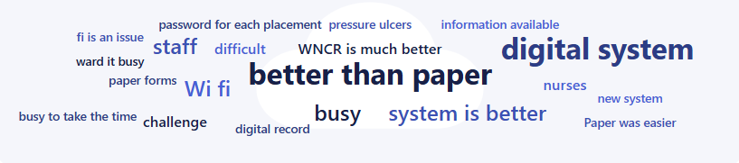
Figure 3 Word Cloud of respondents’ opinions on WNCR
Based on the respondent’s perception of WNCR is depicted in the above word cloud (figure 3) suggests that healthcare professionals prefer the digital system to paper, however there has been challenges to overcome during the digital transformation.
This chapter presented the results of a mixed-methods evaluation investigating the transition from paper to digital documentation in the context of pressure ulcer prevention. Through audits, staff surveys, and focus groups, the findings revealed that while paper-based records often lacked consistency, completeness, and accessibility, the digital system demonstrated notable improvements in documentation quality and efficiency. However, the implementation of digital tools also introduced new challenges, particularly around technical access, system reliability, and training adequacy.
Quantitative data indicated higher completion rates and more consistent recording of essential care elements in the digital system, while qualitative insights highlighted staff appreciation for real-time access and improved clarity. Nonetheless, barriers such as limited device availability, Wi-Fi issues, and unfamiliarity with the system negatively impacted user experience. Feedback from staff emphasised the need for better infrastructure, training, and ongoing support to ensure successful adoption and sustained improvements in care quality.
Overall, while digital documentation showed clear benefits over traditional paper records, achieving its full potential depends on addressing the technical and organisational issues that hinder optimal use. The next chapter will present a discussion of these findings, comparing them to existing literature and exploring their implications for clinical practice. It will also offer recommendations to address the challenges aimed at overcoming the identified challenges and improving the implementation and overall effectiveness of the digital transformation within healthcare.
Chapter Five: Discussion, conclusion and recommendations
5.0 Introduction
The aim of this mixed-methods study was to compare the quality and completeness of skin assessment documentation between paper-based records and the WNCR, with a particular focus on pressure ulcer risk assessments. Quantitative audit data were used to examine documentation patterns and performance across key indicators, whilst qualitative insights from nursing staff provided contextual understanding of user experience, system usability, and implementation challenges.
5.1 Discussion
The study addressed the aims by identifying both improvements associated with digital documentation, such as increased completion rates and standardisation, as well as ongoing barriers, including technical limitations, accessibility issues, and training needs. This chapter presents a critical discussion of these findings in relation to existing literature and explores their implications for clinical practice, policy, staff education, and future research. The discussion is structured around the study’s three research questions, followed by a synthesis of conclusions and a set of practical, targeted recommendations aimed at improving digital transformation and guiding future research.
5.2 Alignment of research aims with key findings
This section highlights how the study’s findings respond directly to the original aims and objectives. It synthesises the evidence generated through both quantitative and qualitative methods to demonstrate the extent to which the study captured the impact of digital documentation on skin assessment practices. By exploring performance trends, clinical risks, user experiences, and systemic challenges, the research offers a comprehensive understanding how the WNCR has influenced pressure ulcer documentation and related clinical workflows.
5.3 Research Question 1: To what extend could areas within the skin risk assessment paper documentation be improved?
5.4 Gaps in paper-based documentation
The audit and qualitative data clearly identified several deficiencies in the paper-based documentation, in both the purpose-t risk assessment and the intentional-rounding charts. Among the most prominent issues were incomplete entries, omissions of key risk factors, inconsistent recording of pressure ulcer history, and delays in completing assessments within the recommended six-hour window post admission. These findings are consistent with a well-documented body of literature that highlights longstanding concerns about the reliability and quality of nursing documentation in paper-form (Seranto and Kinnunen 2009; Andrews and Butler 2014; Instefjord et al 2014; Preben et.al 2021; Muinga et.al 2021).
From a clinical safety perspective, these documentation lapses pose significant risk to patients. Incomplete or delayed assessments may result in a failure to identify high risk patients, thereby delaying essential interventions such as pressure-relieving equipment, repositioning schedules, and nutritional support. Llagostera-Reverter et al (2023) emphasise that poor documentation practices can directly compromise patient outcomes by obscuring clinical decision-making, delaying interventions or leading to miss-communication within clinical teams. Additionally, the National Pressure Ulcer Advisory Panel (2023) also recognises timely and thorough risk assessment as fundamental to effective pressure ulcer prevention, underscoring that delays in documentation can result in missed early interventions and increased patient vulnerability.
Moreover, the inconsistency in documenting previous pressure ulcer history limits the ability of healthcare providers to assess ongoing risk and plan preventative interventions appropriately (National institute of Clinical Excellence, 2024) As highlighted by (Tubaishat et al., 2015) continuity of care is reliant on accurate and comprehensive risk assessments, missing information may lead to a failure to identify high-risk patients, thus increasing the likelihood of harm.
Feedback from the nursing staff during focus groups and surveys reinforced these concerns. Many described the paper forms as incomplete, cumbersome, difficult to locate, and disconnected from clinical workflows. These insights reflect real-world barriers to timely documentation, where systemic inefficiencies may overshadow clinical priorities, especially in under-resourced or high-acuity environments. Such findings align with the work of Blair et al (2020), who highlight how the burden of documentation in time-pressured environments often leads to retrospective charting, reduced attention to detail, and increased risk of clinical error. Poor documentation is not merely an administrative issue, it directly impacts clinical judgment, interprofessional communication, and ultimately, patient outcomes (Campanella et al 2016)
Staff feedback supported the audit results, with nurses reporting that paper forms were often difficult to locate, lengthy, and burdensome within the time pressured clinical environment. These inconsistencies not only compromise the quality of recorded information but also represent potential risks to patent safety through missed or delayed interventions (Charalambous and Goldberg 2016). This has also been linked to increased nurse burnout. Gesner et al (2022) found that excessive documentation requirements contribute to clinician burnout syndrome, affecting the quality of care provided. Similarly, Bogeskov and Grimshaw-Aagaard (2018) reported that nurses perceive documentation as a significant burden, often detracting from clinical care.
In summary, the audit and qualitative findings highlight several limitations associated with paper-based documentation. These findings highlight the potential for avoidable harm, inefficiencies in workflow, and systemic vulnerabilities that hinder high-quality, safe patient care. These insights provide a critical context for assessing the benefits and remaining challenges of implementing digital systems, as explored further in the subsequent sections of this chapter.
5.5 Research Question Two: To what extent have digital systems impacted the quality of information recorded for patients?
5.6 Impact of digital systems
The introduction of the WNCR system appeared to improve several aspects of documentation quality. The audit demonstrated increased completion rates and more consistent recording of risk indicators. Staff reported that the digital system improved clarity, reduced duplication, and enabled faster retrieval of patient information. These improvements reflect wider evidence suggesting that well implemented electronic systems can improve data accuracy and support safer clinical decision-making (Schneider 2015; Vernic 2024). These improvements are well-supported in the literature. EHRs, when effectively implemented, improve data completeness, support clinical workflows, and enhance decision-making. Research has consistently demonstrated that EHRs can reduce errors, promote standardisation in care delivery, and ultimately enhance patient safety (Motsi, 2024)
One key patient safety advantage of digital systems is their role in reducing the likelihood of documentation being missed or lost. In paper systems, records are prone to physical misplacement, illegibility, or damage, which can compromise patient care. (Danhausen et al 2015). By contrast, digital records are securely stored, backed up, and accessible by multiple members of the care team, which enhances transparency and accountability (Robinson et al 2015). This not only reduces the risk of missed interventions but, also provides a comprehensive clinical history that supports more informed decision-making.
Another critical benefit identified in the findings was the ability of staff to access records remotely, including from different clinical areas. This functionality significantly improves continuity of care, particularly during patient transfers or shift changes, by allowing immediate visibility of up-to-date clinical data in addition to improving communication by supporting multidisciplinary working enabling timely collaboration across teams (Soldanescu et al 2025).
Importantly, the digital format has the potential to reduce the risk of transcription errors and facilitate automated prompts and alerts, which support compliance with best practices, for example, if a pressure ulcer risk assessment is not completed within the recommended timeframe, the system can generate reminders, helping ensure timely interventions. Such features can act as crucial patient safety nets and are considered one of the most important strengths of modern electronic documentation systems (Baillie et al., 2021)
In addition to improving documentation quality, the WNCR also had a positive effect on staff satisfaction. Participants reported that the system saved time by reducing duplication, eliminated the need to hunt for paper forms, and made documentation more intuitive. These findings are consistent with studies showing that well-designed digital systems can reduce administrative burden, allowing staff to focus more on direct patient care (Campella et al., 2016; Zadvinskis et al., 2018).
However, persistent infrastructure issues, such as limited access to mobile devices, poor Wi-Fi coverage on some wards, and slow login processes, undermined these benefits to some extent. These barriers often led to delays in real-time documentation, which could contribute to frustration and reduced perceived efficiency. This echoes concerns in the literature where the digital divide and infrastructure gaps are known to hinder the successful adoption of health information systems (Qin et al 2017; Kataria et al 2020). It is widely acknowledged that the success of digital transformation in healthcare depends not only on the software but also on the availability of reliable hardware, connectivity, and ongoing technical support (Kataria and Ravindran 2020; Irwin et al., 2024))
In summary, the findings from this study demonstrate that digital documentation systems such as WNCR can improve the quality of patient documentation. The improvements in data accuracy, completeness, and accessibility not only can reduce patient risk but possibly contribute to more efficient clinical workflows and greater staff satisfaction. While technical challenges remain, particularly around infrastructure, the overall impact of digital systems on healthcare documentation is encouraging. The following section will further explore healthcare professionals’ perceptions of digital versus paper records, offering deeper insight into how frontline staff experience and evaluate this change in practice.
5.7 Research Question Three: How do healthcare professionals perceive the usability and efficiency of digital systems compared with paper records?
5.8 Staff perceptions and usability
The study revealed that nurses generally perceived the WNCR system positively, especially in terms of improving legibility, structure and clarity of documentation. Staff reported that the digital record was easier to complete and less prone to errors often found in paper-based documentation, such as illegible handwriting or misplaced charts. The inclusion of prompts, reminders and pictorial diagrams within WNCR, was highlighted as a valuable feature that helped guide clinical decision making and ensured important information was not overlooked.
These findings mirror the broader literature, where digital systems have been shown to improve clinical documentation, increase compliance, and support decision making (Alotaibi and Federico, 2017). Enhanced usability not only leads to better patient outcomes but also improves staff satisfaction and confidence in the system, as shown in recent studies (Ratwani et al, 2021; Oudbier et al., 2024).
Additionally, participants noted a reduction in duplication, an ability to access records remotely, and improved speed of information retrieval, all of which streamlined their workflow. These features also mitigated the risk of losing or misplacing documentation, a common concern with paper records (Naamneh et al 2024). The digital systems ability to ensure up to date, centralised, and complete records contributes to a safer clinical environment by reducing the likelihood of missed care or delayed interventions (Greenhalgh et al 2017).
Staff experiences of WNCR were largely positive, particularly in terms of improved legibility, streamlined documentation, and better integration of pressure ulcer prompts. Many respondents reported that they preferred WNCR to the traditional paper-based documentation, citing time-saving benefits and improved structure. Moreover, participants found the time saving nature of WNCR beneficial, particularly in high-pressure clinical settings where documentation often competes with direct patient care for time and attention. This is consistent with the literature by Nguyen et.al (2022) which found that electronic documentation could reduce administrative burden and allow more time for patient care.
Nevertheless, several challenges were identified that influenced staff perceptions of the usability of WNCR. Issues such as insufficient training, difficulty obtaining login access, and the initial unfamiliarity with the system were commonly reported. These findings highlight the importance of robust training and ongoing support during digital transformation, aligning with previous research by Wynter et al (2021) and Zaman et al (2021), who observed that staff confidence in digital systems is closely linked to prior experience and the quality of training opportunities provided.
Another concern raised was the frustration caused by dual systems, some parts of the patient record remain on paper, while others were digital. This fragmented approach led to increased confusion, increased risk of documentation errors, made the documentation process feel disjointed. Literature supports these concerns; Campbell et al (2019) note that partial digitalisation without full integration undermines the potential benefits of EHRs and can negatively impact user satisfaction.
These challenges have implications for clinical practice. Insufficient training, barriers to login access, and the persistence of hybrid documentation systems can hinder timely and accurate record-keeping, reduce staff confidence, and potentially compromise patient safety (Motsi 2024; Lindsay et al, 2022) . In high-pressure clinical environments, where time and workload pressures are significant, digital systems like WNCR must be intuitive, accessible, and fully embedded into routine workflows (Mullins et al 2020). Evidence further emphasises these points. Wynter et al (2021) stress that staff confidence and engagement with digital systems are directly influenced by the quality of training received, while Zaman et al (2021) highlight previous digital literacy also shapes how staff adapt to new technology. NHS digital (2019) similarly underlines that successful digital transformation depends on comprehensive training, clear communication, and consistent technical support.
Without sufficient infrastructure, training, and full system integration, the potential improvements in patient care, workflow efficiency, and data quality offered by digital documentation may not be fully realised. Finally, broader policy initiatives support these findings. The UK governments “A plan for Digital Health and Social Care” (2022) outlines significant investment plans to digitalise NHS and social services, emphasising the necessity of strong digital foundations, including reliable Wi Fi connectivity, robust hardware, and comprehensive staff training, to fully unlock the potential of digital transformation.
In summary, healthcare professionals acknowledged significant benefits of the WNCR, especially regarding usability, safety and efficiency. Improved legibility, easier access to records, and time savings were key advantages, which contributed to improved patient care and higher staff satisfaction. However, technical limitations, lack of training, and the burden of dual documentation systems posed ongoing challenges that require addressing. To fully realise the potential of digital systems, it is important that healthcare organisations invest not only in infrastructure but also in user centred design, robust implementation, and ongoing support mechanisms. Only then can digital documentation systems truly replace paper-based practices and be embraced as reliable, effective tools for modern healthcare delivery.
The challenges reported, such as insufficient training, difficulty accessing login credentials, and the dual-system approach, where some documentation remains on paper, highlight barriers to digital transformation. These issues can hinder timely documentation, reduce staff confidence in using the system, and potentially compromise patient safety. In clinical settings, where time is limited and workload is high, digital systems like WNCR must be intuitive, accessible, and fully embedded into routine practice. Research by Wynter et.al (2021) emphasises that staff confidence in digital systems is closely linked to the quality and extent of training received, while Zaman et al (2021) found that prior experience with technology also influences how effectively staff engaged with new digital systems. Similarly, NHS Digital (2019) outlines that successful digital transformation in healthcare is contingent upon robust staff training, clear communication, and continuous support. Without adequate infrastructure, training, and system integration, the potential benefits of digital documentation in improving patient care, efficiency, and data accuracy may not be fully realised. The UK government's "A Plan for Digital Health and Social Care” paper (2022) outlines the importance of digital infrastructure, including Wi-Fi connectivity, in transforming health and social care services. The plan includes significant investments to digitise the NHS and support digital transformation in social care, emphasising the need for robust digital foundations.
5.9 Limitations
While this study provides important insights into the impact of digital documentation on pressure ulcer management, several limitations must be acknowledged.
Firstly, the study was conducted within a single Health Board, which may limit the generalisability of the findings to other healthcare settings with different systems, resources and organisational cultures. Secondly, the sample size for the qualitative component (focus group and surveys) was relatively small and may not fully represent the diversity of all staff across the organisation. Thirdly, and importantly, the WNCR system had only been implemented for two months prior to the evaluation. As a result, staff may not have been fully accustomed to the system, and the findings may reflect earlier adoption challenges rather than long-term experiences of digital documentation. It is possible, that user confidence, system integration, and operational efficiency could improve over time.
Furthermore, the research was conducted by a single researcher alongside her full-time role, alongside the access to clinical areas for data collection and the facilitation of focus groups occasionally presented challenges. Busy ward environments, combined with infection control constraints, limited opportunities to engage with staff and gather data in a timely manner.
Finally, the rapid pace of digital health technology development means that the findings offer a snapshot in time. Ongoing system updates, infrastructure improvements, and organisational changes could influence digital documentation practices beyond the study period.
5.10 Conclusion:
This study evaluated the impact of the Welsh Nursing Care Record on pressure ulcer prevention and management, using a mixed methods approach combining audits and staff feedback. It examined documentation quality, system usability, and the implications for clinical practice.
Paper-based documentation posed notable risks to patient safety due to incomplete, delayed and inconsistent entries. In contrast, the introduction of WNCR improved the quality, completeness and accessibility of patient records, helping facilitate safer, more efficient care. Staff overall preferred the digital system to paper but identified barriers such as limited device availability, infrastructure issues, inconsistent training, and the frustration caused by dual paper and digital systems way of working.
These findings highlight the need for good technical infrastructure, comprehensive training, and full integration to maximise the benefits of digital transformation. Although this study was limited to a single Health Board, with short evaluation period, it offers valuable insights into digital documentations role in improving patient care.
The limitations of the study, including challenges relating to data collection and the timing of the digital implementation, have also been discussed to provide context for the interpretation of the findings.
In conclusion, as healthcare continues to digitalise, research must continue to evaluate not only the technical success of digital systems, but also their real-world impact, user experience, and contribution to safer, more efficient patient care.

5.11 Recommendations:
This study explored the quality and consistency of skin assessment documentation by comparing paper-based records with the WNCR. Using both quantitative audit data and qualitative feedback from nursing staff, the study examined how each system supported accurate, complete, and timely documentation. Drawing from the in-depth analysis in Chapters 4 and 5, several important insights have been identified, highlighting both the strengths and limitations of the WNCR. These insights have informed a set of focused recommendations to support further refinement of the digital system and improve effectiveness in clinical practice.
5.12 Education and Training
- Ongoing digital competency training: Establish comprehensive onboarding and refresher training programmes for all clinical staff, with specific focus on navigating the digital system, and understanding documentation standards
- Tailored Support for diverse learning needs: Recognise varying levels of digital literacy among staff, particularly those less familiar with technology and provide one-to-one or small group teaching sessions
- Electronic based learning: offering front line users simulation training to reflect real-time documentation tasks and the opportunity to “play” with the system in a safe environment.
5.13 Policy and Governance
- Wi-Fi and technical infrastructure: Invest in stable, ward-wide Wi-Fi and ensure sufficient devices are available at point of care
- Access management: Streamline processes for issuing temporary login credentials to reduce delay in documentation
- Audit and accountability frameworks: Introduce regular audits of digital documentation to ensure consistent use and identify areas requiring support or improvement
5.14 Frontline staff and implications for practice
- Embed digital documentation in daily workflow: Encourage Ward managers/Sisters to integrate digital documentation checks into routine safety handover procedures
- Empower staff: Create opportunities for staff to share feedback on digital tools, and ensure it is used to inform system updates or training improvements
- Improve device portability: Consider expanding the availability of lightweight, portable devices such as tablets to enable bedside documentation without workflow disruption
- Ideal case scenario would be a device attached to each bed as a permanent fixture to enable real time documentation at the bedside

5.15 Future research
- Longitudinal impact studies: Evaluate the long-term effects of WNCR on pressure ulcer prevention and Hospital-acquired pressure ulcer prevalence by comparing the data which would align with the Health Boards shaping our future wellbeing strategy (Cardiff and Vale University Health Board 2023).
- Patient centred research: Explore patient perceptions of digital documentation, evaluate how it effects their communication and trust with healthcare professionals.
- Interdisciplinary studies: Explore how digital systems affect communication and documentation across wider multidisciplinary teams, including allied health professionals.
- Explore newer technologies such as artificial intelligence, supported assessments, apps or real time alerts could uncover further innovations to improve clinical decision-making.
- Explore longer-term outcomes and the cost effectiveness of a full digital integration.

References
Adedeji, T., Fraser, H., Scott, P, (2022). ‘Implementing Electronic Health Records in Primary Care Using the Theory of Change: Nigerian Case Study’. JMIR Med Inform. 10(8): e33491. Available at: https://doi.org/10.2196/33491.

Ahmad, A., Cheng, Z. (2018). ‘The Psychology of Resistance to Change: The Antidotal Effect of Organizational Justice’. Frontiers in Psychology, 9, p.2567. Available at: https://www.ncbi.nlm.nih.gov/pmc/articles/PMC8365138/

Akhkand, S., Seidi, J., Ebadi., A. Gheshlagh, R. (2020). ‘Prevalence of pressure ulcer in Iran's intensive care units: A systematic review and meta-analysis’. Nursing Practice Today, 7(1), pp.21-29. Available at: https://doi.org/10.18502/npt.v7i1.2296 (Accessed 26/11/24)

Andersson, J., Isaksson, S., Rask, K. (2023). ‘Documentation of pressure ulcers in medical records at an internal medicine ward in university hospital in western Sweden’. Nursing Open, 10(1), 146–154. Available at: https://doi.org/10.1002/nop2.1439

Andrews, J., Butler., M. (2014) ‘Trusted to care. An Independent Review of the Princess of Wales Hospital and Neath Port Talbot Hospital at Abertawe Bro Morganwg University Health Board’. Dementia Services Development Centre. The peoples organisation’. Available at: : Written Statement - The Professor Andrews Report on Care in Princess of Wales and Neath Port Talbot Hospitals (13 May 2014) | GOV.WALES (Accessed 14.08.24)

Anthony, D., Reynolds, T,. Russell, L,. (2004) ‘The role of hospital-acquired pressure ulcer in the length of stay.’ Clinical Effectiveness in Nursing, 8:4 – 10. Available at: https:/doi.org/10.1016/jcein.2004.02.002 (Accessed 20/10/24)

Aveyard, H. (2019). Doing a Literature Review in Health and Social Care: A Practical Guide (4th ed.). Open University Press. Page 74-75.

Akhu‐Zaheya, L., Al‐Maaitah, R., Bany Hani, S. (2018). ‘Quality of nursing documentation: Paper‐based health records versus electronic‐based health records’. Journal of clinical nursing, 27(3-4), pp. e578–e589. Available at: https://doi.org/10.1111/jocn.14097. (Accessed 18/12/24)

Azevedo, O., Cruz D. (2021) ‘Quality indicators of the nursing process documentation in clinical practice’. Rev Bras Enferm. 23;74(3): e20201355 Available at: https://doi.org/10.1590/0034-7161-2020-1355 (Accessed 12/12/24)

Bail, K., Merrick, E., Bridge, C., Redley, B. (2021) ‘Documenting Patient Risk and Nursing Interventions: Record Audit’. Australian Journal of Advanced Nursing ,38(1), pp. 36–44. Available at: https://doi.org/10.37464/2020.381.167

Bail, K., Merrick, E., Bridge., C., Redley, B. (2020). ‘Documenting patient risk and nursing interventions: Record audit’, Australian journal of advanced nursing, 38(1), pp. 36–44. Available at: https://doi.org/10.37464/2020.381.167. (Accessed 17/11/24)

Baillie, L., Chadwick, S., Mann, R. (2021). ‘Nurses' experiences of digital documentation systems in hospital care’. Journal of Nursing Management, 29(2), 312–320. Available at: https://doi.org/10.1111/jonm.13116

Beckman, M., Dittmer, K., Jaschke, j., Ute Karbach, J. et al. (2021). ‘Electronic Patient Record and its Effects on Social Aspects of Interprofessional Collaboration and Clinical Workflows in Hospitals (eCoCo)’: A Mixed Methods Study Protocol. BMC Health Services Research 21:1-10. Available at: https://doi.org/10.1186/s12913-021-06377-5.

Black, A., Car, J., Pagliari, C., Anandan, C. et al. (2021). ‘The impact of eHealth on the quality and safety of health care: A systematic overview’. PLoS Medicine, 18(10) Available at: https://doi.org/10.1371/journal.pmed.1003751

Black, J. (2015). ‘Pressure ulcer prevention and management: a dire need for good science’. Ann Intern Med. 162(5):387-388. Available at: https://doi.org/10.7326/M15-0190 (Accessed 17.11.24)

Blair, M., Jones, J., Woessner, A., Quinn K (2020). ‘Skin Structure-Function Relationships and the Wound Healing Response to Intrinsic Aging’. Adv Wound Care 1;9(3):127-143. Available at: https://doi.org10.1089/wound.2019.1021. (Accessed 02/11/24)

Blease, C., Torous, J., Dong, Z., Davidge, G. et al (2023). ‘Primary care staff's views and experience of patients' online access to their electronic health record: a qualitative exploration’. British Journal of General Practice, 73(726), e67–e74. Available at: https://doi.org/10.3399/BJGP.2022.0430

Bogeskov, B., Grimshaw-Aagaard, S. (2018). ‘Essential task or meaningless burden? Nurses' perceptions of the value of documentation’. Nordic Journal of Nursing Research. Available at: https://doi.org/10.1177/2057158518773906 (Accessed 21/01/25)

Bos, J. (2020). Research ethics for students in the social sciences. First edition. Cham: Springer Nature. Available at: DOI:10.1007/978-3-030-48415-6.

Braun, V., Clarke, V. (2022) Thematic analysis: a practical guide. London: SAGE Publications.

Brommeyer, M., Whittaker, M., Liang, Z. (2024). ‘Organizational Factors Driving the Realization of Digital Health Transformation Benefits from Health Service Managers: A Qualitative Study’, Journal of healthcare leadership, 16, pp. 455–472. Available at: https://doi.org/10.2147/JHL.S487589.

Brown, J., Cooper, A., Albrecht, M. (2020). ‘Development and content validation of the Burden of Documentation for Nurses and Midwives survey’. Journal of Advanced Nursing, 76(5), 1273–1281.Available at: https://doi.org/10.1111/jan.14320

Burns, M. (2024). ‘Challenges and successes in implementing an integrated electronic patient record (HIVE) at the Manchester University National Health Service Foundation Trust, England: 1000+ legacy systems, 10 hospitals, one electronic patient record’, Health information management, 53(1), pp. 20–28. Available at: https://doi.org/10.1177/18333583231200417.

Cajita, M., Gleason, K., Han, H. (2021). ‘A systematic review of mHealth-based interventions for health promotion and disease prevention among nurses’. Journal of Nursing Scholarship, 53(5), 560–568. Available at:
https://doi.org/10.1111/jnu.12689

Caldwell, K., Henshaw, L., Taylor, G. (2011). ‘Developing a framework for critiquing health research: an early evaluation’. Nurse Educ Today. 31(8). 1-7. Available at: https://doi.org/10.1016/j.nedt.2010.11.025

Camilleri, J., Cope, V., Murray, M. (2019). ‘Change Fatigue: The Frontline Nursing Experience of Large-Scale Organisational Change and the Influence of Teamwork’, Journal of Nursing Management. 27, (3), 655–660. Available at: https://doi.org/10.1111/jonm.12725,

Campanella, P., Lovato, E., Marone, C., Fallacara, L. et al (2016). ‘The impact of electronic health records on healthcare quality: A systematic review and meta-analysis’. The European Journal of Public Health, 26(1), 60-64. Available at: https://doi.org/10.1093/eurpub/ckv122

Campbell, N. (2016) ‘Electronic SSKIN pathway: reducing device-related pressure ulcers’. Br J Nurs. 11;25(15 Suppl):S14-26. Available at: https://doi.org/10.12968/bjon.2016.25.15.s14 (Accessed 10.11.24)

Campbell, R., Rankin, J. (2018). ‘Informatics for the Modern Nurse: Embracing Technology in Practice’. Springer. Available at:
https://link.springer.com/book/10.1891/9780826133151

Campbell, M., Skovdal, M., Gibbs, A., Shung-King, M. (2019). ‘We are still putting out fires: How health systems strengthening affects the implementation of new programs.’ BMC Health Services Research, 19(1), p.746. Available at:
https://doi.org/10.1186/s12913-019-4541-6

Cardiff and Vale University Health Board (2023). ‘Health Board Strategy to 2035. Shaping our future’. Available at: SHAPING-OUR-FUTURE-WELLBEING-STRATEGY_FINAL.pdf

CASP (2023) Critical Appraisal Skills Programme Checklists. Oxford: CASP. Available at: https://casp-uk.net/casp-tools-checklists

Chamanga, E., Ward, R. (2015) ‘Documentation and record-keeping in pressure ulcer management’. Nurs Stand. 6;29(36):56-63. Available at: https://doi.org/10.7748/ns.29.36.56.e9674. (Accessed 21.12.24)

Charalambous, C., Koulouri, A., Roupa, Z, Vasilopoulos A, et.al (2019). ‘Knowledge and attitudes of nurses in a major public hospital in Cyprus towards pressure ulcer prevention’. J Tissue Viability. 28(1):40-45. Available at: https://doi.org/ 10.1016/j.jtv.2018.10.005

Charalambous, L., Goldberg, S. (2016). ‘Gaps, mishaps and overlaps. Nursing documentation: How does it affect care?’ Journal of Research in Nursing. 21(8):638-648. Available at: https://doi.org/10.1177/1744987116678900

Clark, T., Foster, L., Sloan, L., Bryman, A. (2010) Bryman’s social research Methods. (5th ed) Oxford University Press.

Clifton, D., Clifton, L., Sandu, D., Smith, G.et al. (2015). ‘Errors and omissions in paper-based early warning scores: the association with changes in vital signs--a database analysis’. BMJ Open. 3;5(7):e007376. Available at: https://doi.org/10.1136/bmjopen-2014-007376

Cohen, M. (2015). ‘The challenge of EHR acceptance by physicians’. The Journal of Medical Practice Management: MPM, 31(2), 117-120. Available at: https://www.proquest.com/scholarly-journals/challenge-ehr-acceptance-physicians/docview/1736913769/se-2

Cooper, L,. Brown,J. Eccles,S,. et.al (2021). ‘Is Nursing and Midwifery Clinical Documentation a Burden? An Empirical Study of Perception versus Reality’. Journal of clinical nursing, 30.11–12: 1645–1652. Available at: https://doi.org/10.1111/jocn.15718. (Accessed 02/01/25)

Creswell, J. (2024). ‘My 35 Years in Mixed Methods Research’. Journal of Mixed Methods Research. Available at: https://journals.sagepub.com/doi/10.1177/15586898241253892​

Cresswell, K., Sheikh, A. (2020). ‘Developing and Applying a Formative Evaluation Framework for Health Information Technology Implementations: Qualitative Investigation’. J Med Int Res, 22(6) Available at: https://www.jmir.org/2020/6/e15068/

Creswell, J., Plano Clark, V. (2017). Designing and Conducting Mixed Methods Research. 3rd ed. SAGE Publications.

Crisp, B., Anderson, M. Orme, J. (2019). ‘Improving health and social care through integrated working’. SAGE Publications. Available at:
https://uk.sagepub.com/en-gb/eur/improving-health-and-social-care/book254066

CTRU. Leeds. (2022) ‘PURPOSE-T. Registration.’ Available at: https://ctru.leeds.ac.uk/purpose/purpose-t/ (Accessed 14.11.24)

Curry, L., Nunez-Smith, M., Bradley, E. (2013). ‘Achieving integration in mixed methods designs—principles and practices’. Health Services Research, 48(6pt2), 2134–2156. Available at: https://doi.org/10.1111/1475-6773.12117

Danhausen, K., Joshi, D., Quirk, S., Miller, R. et.al (2015). ‘Facilitating access to prenatal care through an interprofessional student-run free clinic’. J Midwifery Womens Health. 60(3):267-273. Available at: https://doi.org/10.1111/jmwh.12304

Dean, E (2019). ‘NHS Improvement Guidance on Pressure Ulcer Definition and Measurement.’ Nursing older people 31.3: 11–11. Available at: NHS Improvement guidance on pressure ulcer definition and measurement (Accessed 27/11/24)

De Groot, K., De Veer, A., Munster, A., Francke, A., P et al. (2022). ‘Nursing documentation and its relationship with perceived nursing workload: a mixed-methods study among community nurses’. BMC Nursing, 21 (34). Available at: https://doi.org/10.1186/s12912-022-00811-7

Deokar, V., Surendra, S., (2016). ‘Understanding Process Change Management in Electronic Health Record Implementations’. Information Systems and eBusiness Management 14(4):733-766. Available at: https://www.proquest.com/scholarly-journals/understanding-process-change-management/docview/1844550261/se-2.

Department of Health and Social Care (2022). NHS England. ‘Policy paper: A plan for digital health and social care’. Available at: https://www.gov.uk/government/publications/a-plan-for-digital-health-and-social-care/a-plan-for-digital-health-and-social-care?utm

Department of Health (2010). ‘Defining Avoidable and Unavoidable Pressure Ulcers’. Available at: ﻿﻿﻿﻿﻿﻿﻿﻿﻿﻿﻿﻿﻿﻿Pressure ulcers: avoidable or unavoidable? Results of the National Pressure Ulcer Advisory Panel Consensus Conference - PubMed (Accessed 04/01/25)

Digital Heath Care Wales (2025). Implementation statistics. (not shared in the public domain).

Digital Health Care Wales (2021) ‘Introducing the Welsh Nursing Care Record, podcast.’ Available at: https://dhcw.nhs.wales/files/podcast/wncr-transcript-english-pdf/. (Accessed 01.0.24)

Ding, X., Yu, Z., Yao, H., Xu, X. et al (2024). ‘Global burden and trends of disability‐adjusted life years and mortality for decubitus ulcer: A systematic analysis’. International Wound Journal, 21(1), 123–134. Available at: https://doi.org/10.1111/iwj.14604​

Douma, M., Rejeb, M., Zardoub, N., Braham, A. (2024). ‘Impact of Implementing Electronic Nursing Records on Quality and Safety Indicators in Care’. Libyan J Med. 19(1) Available at: https://doi.org/10.1080/19932820.2024.2421625

Ehrler, F., Wu, D., Ducloux, P., Blondon, K. (2021). ‘A mobile application to support bedside nurse documentation and care: a time and motion study’. JAMIA Open. 31;4(3). Available at: https://doi.org/10.1093/jamiaopen/ooab046

European Pressure Ulcer Advisory Panel (EPUAP) ‘National Pressure Injury Advisory Panel (NPIAP), and the Pan Pacific Pressure Injury Alliance (PPPIA). (2019). ‘Prevention and Treatment of Pressure Ulcers: Clinical Practice Guideline’, 3rd Edition Available at: http://internationalguideline.com/guideline. (Accessed 04.10.24)

EPUAP/NPIAP/PPPIA (2019) Prevention and treatment of pressure ulcers/injuries: The international guideline. European Pressure Ulcer Advisory Panel, National pressure injury advisory panel, and pan pacific pressure injury Alliance. Available at: CPG2019edition-digital-Nov2023version.pdf (Accessed 26/10/24)

Frennert, S., Peterson, L,. Erlingsdottir, G. (2023) ‘More work for nurses: the ironies of eHealth’, BMC health services research, 23(1), pp. 411–411. Available at: https://doi.org/10.1186/s12913-023-09418-3 . (Accessed 29/12/24)

Furtado, K., Voorham, J., Infante, P., Afonso, A, et al (2023). ‘The Relationship between Nursing Practice Environment and Pressure Ulcer Care Quality in Portugal's Long-Term Care Units’. Healthcare (Basel). 14;11(12):1751. Available at: https://doi.org/10.3390/healthcare11121751

Gaspar, S., Collier, M., Marques, A., Ferreira, C. et al. (2020). ‘Pressure ulcers: The challenge of monitoring in hospital context’. Applied Nursing Research, 53, 151266. Available at: https://doi.org/10.1016/j.apnr.2020.151266

Gesner, E., Dykes, P.C., Zhang, L., Gazarian, P. (2022). ‘Documentation burden in nursing and its role in clinician burnout syndrome’. Applied Clinical Informatics, 13(5), 983–990. Available at: https://doi.org/10.1055/s-0042-1757157

Gligor, L., Rusu, H., Domnariu, C., Muller-Staub, M. (2024). ‘The quality of nursing diagnoses, interventions, and outcomes in Romanian nursing documentation measured with the Q-DIO: A cross-sectional study’. Int J Nurs Knowl. 35(3):298-307. Available at: https://doi.org/10.1111/2047-3095.12446. (Accessed 21/12/24).

Goedhart, N., Verdonk, P., Hoekstra, T., Largo-Janssen, A. (2020). ‘Change fatigue among nurses: A concept analysis’. Journal of Nursing Scholarship, 52(3), 299-308. Available at: https://doi.org/10.1111/jnu.12553

Goodman, L,. Khemani, E,. Cacao, F,. Yoon, J. et.al. (2018). ‘A comparison of hospital-acquired pressure injuries in intensive care and non-intensive care units: a multifaceted quality improvement initiative’. BMJ open quality, 7(4), pp e000425-e000425. Available at: https://doi.org/10.1136/bmjoq-2018-000425 (Accessed 19.10.24)

Greenhalgh, T., Wherton, J., Papoutsi, C., Lynch, J. et al. (2017). ‘Beyond Adoption: A New Framework for Theorizing and Evaluating Nonadoption, Abandonment, and Challenges to the Scale-Up, Spread, and Sustainability of Health and Care Technologies’. Journal of Medical Internet Research, 19(11), e367. Available at: https://doi.org/10.2196/jmir.8775

Greenwood,C., Nelson,E., Nixon,J., (2022). ‘Comparative effectiveness of heel-specific medical devices for the prevention of heel pressure ulcers: A systematic review’. Journal of Tissue Viability 31(4), 579-592. Available at: Comparative effectiveness of heel-specific medical devices for the prevention of heel pressure ulcers: A systematic review - ScienceDirect. (Accessed 30/12/24)

Gress, B,. Beresova, A,. Tkacova, l,. Magurova, D,. et.al (2021). ‘Nurses’ Knowledge and Attitudes towards Prevention of Pressure Ulcers’. International Journal of Environmental Research and Public Health, 18(4), p.1705.
Available at: https://www.mdpi.com/1660-4601/18/4/1705.

Guest , J. (2021) ‘Burden of wounds to the NHS: what has changed since 2012/13?’. Wounds UK 17 (1) Available at: Burden of wounds to the NHS: what has changed since 2012/13? – Wounds U K (wounds-uk.com) (Accessed 22/10/24).

Guimaraes, N. (2021). ‘Complexity, Design and Culture: convergence for digital experiences’, Interaction design & architecture(s)’, (47), pp. 274–305. Available at: https://doi.org/10.55612/s-5002-047-013.

Hadji, B., Martin, G., Dupuis, I., Campoy, E, et al (2016). ‘14 years longitudinal evaluation of clinical information systems acceptance: the HEGP case.’ Int J Med Inform. 86: 20–9. Available at https://doi.org/10.1016/j.ijmedinf.2015.11.016

Hayes C, Fox, A., Scott-Thomas, J., Graham ,Y. (2023). ‘Pressure ulcer prevention in practice.’ Br J Community Nurs. 1;28(Sup6):S14-S21.Available at: https://doi.org/ 10.12968/bjcn.2023.28.Sup6.S.14. (Accessed 12.09.24)

Hansen, R., Fossum, M. (2016). ‘Nursing documentation of pressure ulcers in nursing homes: comparison of record content and patient examinations’. Nurs Open. 7;3(3):159-167. Available at: https://doi.org/10.1002/nop2.47

Health Inspectorate Wales (2015) Dignity and Essential Care Inspections Thematic report. Available at: 150910deci1415en.pdf (hiw.org.uk) (Accessed 14.11.25)

Health Service Executive (2019). Pressure Ulcers to Zero: The SSKIN Care Bundle. Available at: https://www.hse.ie/eng/about/who/nqpsd/patient-safety-programme/sskin-care-bundle-2019.pdf

Heuer, A., Parrott, J., Percival, D., Kacmarek, R. (2016). ‘Examining the Phenomenon of the Administrative Burden in Health Care, Allied Health, and Respiratory Care’. J Allied Health. 45(2):152-6. Available at: https://www.jstor.org/stable/48721913

Hill, J., Edney, S., Hamer, O., Williams A, et al (2022) ‘Interventions for the treatment and prevention of pressure ulcers’. Br J Community Nurs. 1;27(Sup6): S28-S36. Available at: https://doi.org/10.12968/bjcn.2022.27.7.314 (Accessed 27.09.24)

Huang, C., Ma ,Y., Wang, C., Jiang, M, et al. (2021). ‘Predictive validity of the braden scale for pressure injury risk assessment in adults: A systematic review and meta-analysis’. Nurs Open.8(5):2194-2207. Available at: https://doi.org/ 10.1002/nop2.792

Instefjord, M., Aasekjaer, K., Espehaug,B., Graverholt,B. (2014). ‘Assessment of quality in psychiatric nursing documentation - a clinical audit,’ BMC nursing, 13(1), pp. 32–32. Available at: https://doi.org/10.1186/1472-6955-13-32.

Islam, M.M., Poly, T.N., Li, Y. (2018) ‘Recent Advancement of Clinical Information Systems: Opportunities and Challenges’. Yearbook of Medical Informatics 27(1), pp: 83–90. Available at: https://doi.org/10.1055/s-0038-1667075. (Accessed 12/01/25)

Irwin, P., Hanson, M., McDonald, S., Noble D. et. al (2024). ‘Nursing students’ perspectives on being work-ready with electronic medical records: Intersections of rurality and health workforce capacity’. Nurse Education in Practice.77:103948. Available at: https://doi.org/10.1016/j.nepr.2024.103948 (Accessed 15.01.25)

Jackson, D., Hutchinson, M., Barnason, S., Li, W. et.al. (2016) ‘Towards international consensus on patient harm: perspectives on pressure injury policy’, Journal of nursing management, 24(7), pp. 902–914. Available at: https://doi.org/10.1111/jonm.12396.

Jacobson TM, Thompson SL, Halvorson AM, Zeitler K. (2016). Enhancing Documentation of Pressure Ulcer Prevention Interventions: A Quality Improvement Strategy to Reduce Pressure Ulcers. J Nurs Care Qual. 31(3):207-14. Available at: https://doi.org/10.1097/NCQ.0000000000000175.

Jacobson, T., Thompson, S., Halvorson, A., Zeitler, K. (2016). ‘Enhancing Documentation of Pressure Ulcer Prevention Interventions: A Quality Improvement Strategy to Reduce Pressure Ulcers’. J Nurs Care Qual. 31(3):207-14. Available at: https://doi.org/10.1097/NCQ.0000000000000175.

Jagannath, S. , Sarcevic, A. , Multak, N. Myers, S. (2021). ‘Understanding Paper-Based Documentation Practices in Medical Resuscitations to Inform the Design of Electronic Documentation Tools.’ Pediatric Emergency Care, 37 (8), e436-e442. Available at: https://doi.org/10.1097/PEC.0000000000001676

Jaul, E., Barron, J., Rosenzweig, J P., Menczel ,J. (2018). ‘An overview of co-morbidities and the development of pressure ulcers among older adults.’ BMC Geriatr. 11;18(1):305. Available at: https://doi.org/10.1186/s12877-018-0997-7.

Jedwab, R., Chalmers, C., Dobroff,N., Redley, B. (2019) ‘Measuring nursing benefits of an electronic medical record system: A scoping review’, Collegian (Royal College of Nursing, Australia), 26(5), pp. 562–582. Available at: https://doi.org/10.1016/j.colegn.2019.01.003

Jones, T.( 2016). ‘Outcome Measurement in Nursing: Imperatives, Ideals, History, and Challenges.’ Online J Issues Nurs. 21(2):1. Available at: https://doi.org/ 10.3912/OJIN.Vol21No02Man01

Jeilani, A., Hussein, A. (2025). ‘Impact of digital health technologies adoption on healthcare workers’ performance and workload: perspective with DOI and TOE models.’ BMC Health Serv Res 25, 271. Available at: https://doi.org/10.1186/s12913-025-12414-4

Jenkins, M,. Davis, A. (2019) ‘Transforming Nursing Documentation’. Stud Health Technol Inform. 21. 264. 625-628. Available at: https://doi.org/10.3233/SHTI190298.

Joseph, B., Sulmonte, K., DeSanto-Madeya, S., Koeniger-Donohue, R., et al (2022). ‘Improving Accuracy in Documenting Cardiopulmonary Arrest Events’. Am J Nurs. 1;122(4):40-45. Available at: https://doi.org/10.1097/01.NAJ.0000827332.60571.70.

Joshi, A., Kale, S., Chandel, S. and Pal, D.K., 2015. ‘Likert scale: Explored and explained.’ British Journal of Applied Science & Technology, 7(4), pp.396–403. Available at: https://doi.org/10.9734/BJAST/2015/14975

Jung, H., Park, H., Lee, H. (2023). ‘Impact of a Decision Support System on Fall-Prevention Nursing Practices’. J Patient Saf. 19(8):525-531. Available at: https://doi.org/10.1097/PTS.0000000000001168.

Kaihlanen, A., Elovainio, M., Virtanen, L., Kinnunen, U. et al. (2023) ‘Nursing informatics competence profiles and perceptions of health information system usefulness among registered nurses: A latent profile analysis’, Journal of advanced nursing, 79(10), pp. 4022–4033.: https://doi.org/10.1111/jan.15718.

Kataria, S., Ravindran, V. (2020) ‘Electronic health records: a critical appraisal of strengths and limitations.’ J R Coll Physicians Edinb. 50(3):262-268.Available at: https://doi.org/10.4997/JRCPE.2020.309.

Kataria, S., Ravindran, V., Yaduvanshi, P. (2020). ‘Challenges to Digital Health Innovation: Understanding Infrastructure and Adoption Gaps.’ Health Systems, 9(1), 35-48. Available at: https://doi.org/10.1080/20476965.2019.1709491

Kaushik, V., Walsh, C. (2019). ‘Pragmatism as a Research Paradigm and Its Implications for Social Work Research’. Social Sciences, 8(9), 255. Available at: https://doi.org/10.3390/socsci8090255​

Kelly, J., Campbell, K., Gong, E. et.al (2020). ‘The Internet of Things: Impact and Implications for Health Care Delivery.’ J Med Internet Res. 10;22(11):e20135. Available at: https://doi.org/10.2196/20135.

Kennedy E. (2023). ‘An Evidence-Based Approach to Protecting Our Biggest Organ: Implementation of a Skin, Surface, Keep Moving, Incontinence/Moisture, and Nutrition/Hydration (SSKIN) Care Bundle.’ J Dr Nurs Pract. 1;16(1):62-80. Available at: https://pubmed.ncbi.nlm.nih.gov/36918286/ (Accessed 12.19.24)

Khairat, S., Marc, D., Crosby, W., Sanousi, A., 2018. ‘Reasons for physicians not adopting clinical decision support systems: critical analysis.’ JMIR Medical Informatics, 6(2), p.e24. Available at:
https://doi.org/10.2196/medinform.8912

Kleib, M., Nagle, L., & Furlong, K. (2021). ‘Nursing education and training on electronic health record systems: A scoping review.’ Journal of the American Medical Informatics Association, 28(12), 2740–2750. Available at: https://doi.org/10.1093/jamia/ocab200

Kotter, J., Coleman, S. (2023) ‘The theory and practice of pressure ulcer/injury risk assessment: a critical discussion.’ Journal of wound care, Vol 32, No 9. Available at: https://doi.org/10.12968/jowc.2023.32.9.560 (Accessed 28/12/24)

Kujala, S., Ammenwerth, E., Kolanen, H., Ervast, M. (2020). ‘Applying and Extending the FITT Framework to Identify the Challenges and Opportunities of Successful eHealth Services for Patient Self-Management: Qualitative Interview Study.’ J Med Internet Res. 12;22(8). Available at: https://doi.org/10.2196/17696 (Accessed 09/01/25)

Kvale, S., Brinkmann, S. (2015). Interviews: Learning the Craft of Qualitative Research Interviewing (3rd ed.). SAGE Publications.

Llagostera-Reverter, I., Luna-Aleixos, D., Valero-Chilleron, M., Mecho-Montoliu, G. et al. (2023) ‘Improving Nursing Assessment in Adult Hospitalization Units: A Secondary Analysis’, Nursing reports (Pavia, Italy), 13(3), pp. 1148–1159. Available at: https://doi.org/10.3390/nursrep13030099.

Lavander, P., Meriläinen, M., Turkki, L. (2016). ‘Working time use and division of labour among nurses and health-care workers in hospitals: a systematic review.’ J Nurs Manage; 24(8): 1027–1040. Available at: https://doi.org/10.1111/jonm.12423. (Accessed 10/01/25)

Lee S. (2022). ‘Effect of Electronic Medical Record Quality on Nurses' Perceived Usefulness and Ease of Use’. Comput Inform Nurs. 1;40(8):562-570. Available at: https://doi.org/10.1097/CIN.0000000000000845

Li, D. (2016). ‘The relationship among pressure ulcer risk factors, incidence and nursing documentation in hospital-acquired pressure ulcer patients in intensive care units’, Journal of clinical nursing, 25(15–16), pp. 2336–2347. Available at: https://doi.org/10.1111/jocn.13363. (Accessed 01.11.25).

Lien, R., Wang, C., Hung, S., Lu S, et.al (2023). ‘Reduction in the Incidence Density of Pressure Injuries in Intensive Care Units after Advance Preventive Protocols’. Healthcare . 25;11(15):2116. Available at: https://doi.org/10.3390/healthcare11152116

Lindsay, M., Lytle, K. (2022). ‘Implementing Best Practices to Redesign Workflow and Optimize Nursing Documentation in the Electronic Health Record’. Appl Clin Inform. 13(3):711-719. Available at: https://doi.org/10.1055/a-1868-6431.

Lindqvist, E., Sommar, P., Stenius, M., Lagergren, J. (2020). ‘Complications after pressure ulcer surgery - a study of 118 operations in spinal cord injured patients.’ J Plast Surg Hand Surg. 54(3):145-150. Available at: https://doi.org/10.1080/2000656X.2020. (Accessed01.12.24)

Luijendijk, H., Page, M., Burger, H., Koolman, X. (2020). ‘Assessing risk of bias: a proposal for a unified framework for observational studies and randomized trials.’ BMC Medical Research Methodology, 20, pp. 1-9. Available at: https://doi.org/10.1186/s12874-020-01115-7

McCray, S., Donaldson, A,. (2024). ‘Early Identification, Intervention, and Prevention of Hospital-Acquired Pressure Injuries Using a Nurse-Driven Pressure Injury Prevention Program.’ Clin Nurse Spec. 01;38(5):210-220. Available at: https://doi.org/10.1097/NUR.0000000000000840 (Accessed 14.09.24)

Manaktala, S., Claypool, H., (2017). ‘Evaluating the impact of a computerized surveillance algorithm and decision support system on sepsis mortality.’ Journal of the American Medical Informatics Association, 24(1), pp.88–95. Available at:
https://doi.org/10.1093/jamia/ocw056

Mahdizadeh, J. (2022). ‘Challenges and opportunities of using the national electronic health record from the perspective of iranian nursing staff: OJNI’. On - Line Journal of Nursing Informatics, 26(1) Available at: https://www.proquest.com/scholarly-journals/challenges-opportunities-using-national/docview/2637287496/se-2

Matta, C. (2022) ‘Philosophical Paradigms in Qualitative Research Methods Education: What is their Pedagogical Role?’, Scandinavian journal of educational research, 66(6), pp. 1049–1062. Available at: DOI: 10.1080/00313831.2021.1958372. (Accessed 03.05.25)

Mathioudakis, A., Rousalova, I., Gagnat, A., Saad, N. et.al (2016). ‘How to keep good clinical records’. Breathe, 12(4), 369–373. https://doi.org/10.1183/20734735.018016

Michel, Y., Laurent, A. (2017). ‘The content and meaning of administrative work: A qualitative study of nursing practices’. Journal of Advanced Nursing, 73(3), 605–616. Available at: https://doi.org/10.1111/jan.13160​

Mitchell, M., Kan, L. (2019). ‘Digital Technology and the Future of Health Systems’. Health Syst Reform. 2019;5(2):113-120. Available at: https://doi.org/10.1080/23288604.2019.1583040

Moen A. (2003). ‘A nursing perspective to design and implementation of electronic patient record systems’. J Biomed Inform. 36(4-5):375-8. Available at: https://doi.org/10.1016/j.jbi.2003.09.019

Mohess, K., Gomes M. (2024). ‘Engagement strategies adopted by the nursing information officer team in preparing nurses for the implementation of an integrated electronic health record’. Nurs Manag. 5;31(6):28-34. Available at: https://.org/10.7748/nm.2024.e2135.

Mokoena-Beer, L., Smith, J., Patel, R. (2025). ‘Collaborative versus directive approaches to change management in healthcare: A comparative study.’ Journal of Healthcare Management, 40(2), 123–135. Available at: https://doi.org/10.1234/jhm.2025.0402

Monfre, J., Batchelor, F., Skar, A. (2022). ‘Improving Skin Assessment Documentation in the Electronic Health Record to Prevent Perioperative Pressure Injuries’. AORN J. Jan;115(1):53-63. Available at: https://doi.org/10.1002/aorn.13573. (Accessed 06.10.24)

Morgan, D. L. (2007). ‘Paradigms lost and pragmatism regained: Methodological implications of combining qualitative and quantitative methods’. Journal of Mixed Methods Research, 1(1), 48–76. Available at: https://doi.org/10.1177/2345678906292462 (Accessed 02.05.25)

Morrow, E,. Zidaru, T,. Ross, F,. Mason C,. et.al. (2023). ‘Artificial intelligence technologies and compassion in healthcare: A systematic scoping review’. Front Psychol. 13:971044. Available at: https://doi.org/10.3389/fpsyg.2022.971044.

Motsi, L., (2024). ‘Electronic health records model to improve the quality of patients’ healthcare.’ Health S A, 29. Available at: https://doi.org/10.4102/hsag.v29i0.2414

Muinga, N., Aberjirinde, I., Paton,C.,English, M. et.al. (2021) ‘Designing paper‐based records to improve the quality of nursing documentation in hospitals: A scoping review’, Journal of clinical nursing, 30(1–2), pp. 56–71. https://doi.org/10.1111/jocn.15545.

Mullins, A., O’Donnell R., Mariam, M., Rankin, D. et al. (2020). ‘Health outcomes and healthcare efficiencies associated with the use of electronic health records in hospital emergency departments: A systematic review.’ Journal of Medical Systems, 44(12). Available at: https://doi.org/10.1007/s10916-020-01660-0

Munroe, B., Curtis, K., Considine, J., Buckley, T. et al (2022). ‘The impact of documentation burden on nurses in the emergency department: A qualitative study’. International Emergency Nursing, 62, 101170. Available at: https://doi.org/10.1016/j.ienj.2022.101170

Murdoch, M., Simon, A., Polusny, M., Bangerter, A. et al (2014). ‘Impact of different privacy conditions and incentives on survey response rate, participant representativeness, and disclosure of sensitive information: a randomized controlled trial’, BMC Medical Research Methodology, vol. 14, pp. 90.Available at: https://doi.org/10.1186/1471-2288-14-90

Naamneh, R., Bodas, M. (2024). ‘The effect of electronic medical records on medication errors, workload, and medical information availability among qualified nurses in Israel– a cross-sectional study.’ BMC Nursing, 23, 270. Available at: https://doi.org/10.1186/s12912-024-01936-7

National Institute for Health and Care Excellence (2024). Pressure Ulcers. Quality Standard [QS89]. Available at: https://www.nice.org.uk/guidance/qs89 (Accessed 14.11.24)

National Patient Safety Agency (2010). Defining avoidable and unavoidable pressure ulcers Available at: http://www.patientsafetyfirst.nhs.uk/ashx/Asset.ashx?path=/PressureUlcers/Defining%20avoidabl e%20and%20unavoidable%20pressure%20ulcers.pd.

National Wound Care Strategy programme (2018) Stop the pressure. Available at: http://nhs.stopthepressure.co.uk (Accessed 27/11/24)

National Wound Care Strategy Programme (2024). Pressure Ulcer recommendations and clinical pathway. Available at: NWCSP-PU-Clinical-Recommendations-and-pathway-Updated-21st-May-2024.pdf (nationalwoundcarestrategy.net)

Ng Z., Ling, L., Chew, H., Lau, Y. (2022). ‘The role of artificial intelligence in enhancing clinical nursing care: A scoping review.’ J Nurs Manag. 30(8):3654-3674. Available at: https://doi.org/10.1111/jonm.13425.

Nguyen, L,. Wickramasinghe, N,. Redley, B,. Haddad, P. et al. (2017) ‘Exploring nurses’ reactions to electronic nursing documentation at the point of care’, Information technology & people (West Linn, Or.), 30(4), pp. 809–831. Available at: https://doi.org/10.1108/ITP-10-2015-0269.

NHS Improvement Pressure ulcer categorisation group (2019) Pressure Ulcer Categorisation. Available at: http://nhs.stopthepressure.co.uk/ Accessed 20/11/24

NHS Digital, (2019). The NHS Long Term Plan: Supporting Digital Transformation. Available at:
https://digital.nhs.uk/about-nhs-digital/our-work/transforming-health-and-care-through-digital-technology

NHS Wales. (2018) Pressure Ulcer Reporting and Investigation: All Wales Guidance. Available at: welsh-health-circular-on-revised-pressure-ulcer-reporting-including-the-reporting-of-serious-incidents.pdf

Noie, A., Jackson, A., Taheri, L. et al. (2024) ‘Determining the Frequency of Pressure Ulcers Incidence and Associated Risk Factors in Critical Care Patients: A 3‐year Retrospective Study.’ International wound journal 21.11: e70120. Available at: Determining the frequency of pressure ulcers incidence and associated risk factors in critical care patients: A 3‐year retrospective study - Cardiff University and NHS Wales Libraries (Accessed 23.10.24)

Nowell, L., Norris, J., White, D., Moules, J. (2017). ‘Thematic Analysis: Striving to Meet the Trustworthiness Criteria.’ International Journal of Qualitative Methods, 16(1), 1–13. Available at: https://doi.org/10.1177/1609406917733847

Nursing and Midwifery Council (2023). Records Management Policy. Available at: https://www.nmc.org.uk/globalassets/sitedocuments/data-protection/records-management-policy.pdf.

Nursing and Midwifery Council (NMC) (2015). The code: professional standards of practice and behaviour for nurses and midwives. Available at: The Code: Professional standards of practice and behaviour for nurses, midwives and nursing associates - The Nursing and Midwifery Council (Accessed 04.09.25)

Nuffieldtrust (2024). Evidence for better health care. Inpatient falls and pressure ulcers. Available at: Inpatient falls and pressure ulcers | Nuffield Trust

O’Brien, B., Harris, I., Beckman, T., Reed, D., Cook, D. (2014). ‘Standards for reporting qualitative research: a synthesis of recommendations’. Academic Medicine, 89(9), 1245-1251. Available at: https://doi.org/10.1097/ACM.0000000000000388

Organisation for Economic Co-operation and Development (OECD). (2023). Health at a Glance 2023: OECD Indicators. OECD Publishing. Available at: https://doi.org/10.1787/health_glance-2023-en (Accessed 04.11.24)

Othman, E., Shatnawi, F., Alrajabi, O., Alshraideh, J. (2020) ‘Reporting Nursing Interventions Classification and Nursing Outcomes Classification in Nursing Research: A Systematic Review.’ Int J Nurs Knowl. 31(1):19-36. Available at: https://doi.org/10.1111/2047-3095.12265 (Accessed 29.04.25)

Oudbier, S., Souget-Ruff, S., Chen, B., Ziesemer, K. et.al (2024). ‘Implementation barriers and facilitators of remote monitoring, remote consultation and digital care platforms through the eyes of healthcare professionals: a review of reviews.’ BMJ Open. 10;14(6):e075833. Available at: https://doi.org/10.1136/bmjopen-2023-075833 (Accessed 14.03.25)

Page, M., McKenzie, J., Bossuyt, P., Boutron, I. et al. (2021). The PRISMA 2020 statement: an updated guideline for reporting systematic reviews. BMJ. 372. (n71). Available at: https://doi:10.1136/bmj.n71. (Accessed: 14/01/24).

Park, Y., Konge, L., Artino, A., (2020).‘The Positivism Paradigm of Research. Academic medicine’. journal of the Association of American Medical Colleges, 95(5), 690–694. Available at: DOI: 10.1097/ACM.0000000000003093. (Accessed 02.05.25)

Paterson, C., Roberts, C., Bail, K. (2023). ‘Paper care not patient care’: Nurse and patient experiences of comprehensive risk assessment and care plan documentation in hospital. Journal of Clinical Nursing, 32(3–4), 523–538. Available at: https://doi.org/10.1111/jocn.16291

Preben, S., Snibsoer, A., Espehaug, B. (2021). ‘Improving the quality of nursing documentation at a residential care home: a clinical audit’, BMC Nursing, vol. 20, pp. 1-7. Available at: https://doi.org/10.1186/s12912-021-00629-9

Prgomet, M., Georgiou, A., Callen, J., Westbrook, J. (2019). ‘Fit Between Individuals, Tasks, Technology, and Environment (FITTE) Framework: A Proposed Extension of FITT to Evaluate and Optimise Health Information Technology Use.’ Stud Health Technol Inform. 21;264:744-748. Available at: https://doi.org/10.3233/SHTI190322.

Provenzano, M., Cillara, N., Curcio, F., Pisu, M, et.al (2024). ‘Electronic Health Record Adoption and Its Effects on Healthcare Staff: A Qualitative Study of Well-Being and Workplace Stress.’ Int J Environ Res Public Health. 28;21(11):1430. Available at: https://doi.org/ 10.3390/ijerph21111430.

Qian, Y., Ausserhofer, D., Simon, M., Zúñiga, F. (2023). ‘Administrative burden in Swiss nursing homes and its association with care workers’ outcomes—a multicenter cross-sectional study.’ BMC Geriatrics, 23, (40). Available at: https://doi.org/10.1186/s12877-023-04022-w

Qin, Y., Zhou, R., Wu, Q., Huang, X, et.al. (2017). ‘The effect of nursing participation in the design of a critical care information system: a case study in a Chinese hospital.’ BMC Med Inform Decis Mak. 17(1):165. Available at: https://doi.org/10.1186/s12911-017-0569-3

Regnault, A., Willgoss, T., Barbic, S. et al. (2018). Towards the use of mixed methods inquiry as best practice in health outcomes research. J Patient Rep Outcomes 2, 19. Available at: https://doi.org/10.1186/s41687-018-0043-8
Robertson, A., Cresswell, K., Takian, A., Petrakaki, D. et al. (2015). Implementation and adoption of nationwide electronic health records in secondary care in England: qualitative analysis of interim results from a prospective national evaluation. BMJ, 341, c4564. Available at: https://doi.org/10.1136/bmj.c4564

Rose, A., Cooley, A., Yap, T., Alderden, J, et al. (2022). ‘Increasing Nursing Documentation Efficiency with Wearable Sensors for Pressure Injury Prevention’. Crit Care Nurse.1;42(2):14-22. Available at: https://doi.org/10.4037/ccn2022116 (Accessed 02/01/25)

Rony, M., Numan, S., Johra, F., Akter, K, et.al. (2024). ‘Perceptions and attitudes of nurse practitioners toward artificial intelligence adoption in health care.’ Health Sci Rep. 21;7(8). Available at: https://doi.org/10.1002/hsr2.70006.

Royal College of Nursing (2016). Every nurse an e-nurse: Insights from a consultation on the digital future of nursing. Available at:
https://www.rcn.org.uk/professional-development/publications/pub-005779

Royal College of Nursing. (2013). Survey of district and community nurses in 2013. RCN Policy Briefing 14/14. Available at: https://www.rcn.org.uk/-/media/royal-college-of-nursing/documents/policies-and-briefings/uk-wide/policies/2014/1414.pdf​

Richards, D., Bazeley, P., Borglin, G., Craig, P. et.al. (2019). Integrating quantitative and qualitative data and findings when undertaking randomised controlled trials. BMJ Open, 9(11) Available at: https://doi.org/10.1136/bmjopen-2019-032081

Ricon, T,; George, M. (2023) ‘If you didn’t chart it, you didn’t do it: a retrospective chart review of errors omission in endoscopy care’. Gastrointestinal Nursing 21(3). Available at: https://doi.org/10.12968/gasn.2023.21.Sup3.S1

Ridley, D. (2012). The Literature Review: A Step-by-Step Guide for Students (2nd ed.). SAGE Publications. Page 55-56

Risling, T. (2017). ‘Educating the nurses of 2025: Technology trends of the next decade.’ Nursing Education Perspectives, 38(1), 57–59. Available at: https://doi.org/10.1097/01.NEP.0000000000000115.

Rivera, J., Donohoe, E., Deady-Rooney, M., Douglas, M,. et.al. (2020). ‘Implementing a Pressure Injury Prevention Bundle to Decrease Hospital-Acquired Pressure Injuries in an Adult Critical Care Unit: An Evidence-Based, Pilot Initiative.’ Wound Manag Prev. 66(10):20-28. Available at: https://doi.org/10.1016/j.wmp.2020.10.0028 (Accessed 14.09.24)

Saini, M., & Talwar, R. (2023). ‘Understanding staff engagement in digital health research: Strategies for improving survey response rates’. Journal of Health Services Research & Policy, 28(1), 21–29. Available at:
https://doi.org/10.1177/13558196221140555

Saranto, K., Kinnunen, U. (2009). ‘Evaluating nursing documentation - research designs and methods: systematic review’, Journal of advanced nursing, 65(3), pp. 464–476. Available at: https://doi.org/10.1111/j.1365-2648.2008.04914.x.

Satekova, L., Ziaková, K., Zelenikova, R. ‘Predictive validity of the Braden Scale, Norton Scale, and Waterlow Scale in the Czech Republic’. Int J Nurs Pract. 2017 Feb;23(1). Available at: https://doi.org/10.1111/ijn.

Schneider, H. (2015). ‘Electronic patient record as the tool for better patient safety,’ Bundesgesundheitsblatt, Gesundheitsforschung, Gesundheitsschutz, 58(1), pp. 61–66. Available at: https://doi.org/10.1007/s00103-014-2081-6.

Scott, P., Briggs, J. (2009). ‘A Pragmatist Argument for Mixed Methodology in Medical Informatics’. Journal of Mixed Methods Research, 3(3), 223–231. Available at: https://journals.sagepub.com/doi/10.1177/1558689809334209

Seibert, J., Barch,D., Bernacet, A., Kandoliv, A. et.al (2020). ‘Examining Social Risk Factors in a Pressure Ulcer Quality Measure for Three Post-Acute Care Settings’, Advances in skin & wound care, 33(3), pp. 156–163. Available at: https://doi.org/10.1097/01.ASW.0000651456.30210.8a.

Sendall, C., McCosker, L., Brodie, A,. Hill, m,. et.al. (2018). Participatory Action Research, Mixed Methods, and Research Teams: Learning from Philosophically Juxtaposed Methodologies for Optimal Research Outcomes. BMC Medical Research Methodology 18. Available at: https://www.proquest.com/scholarly-journals/participatory-action-research-mixed-methods-teams/docview/2158329403/se-2

Sharma, V., Ibrahim, A., van der Veer, S., Martin, G., et al (2021), "Adoption of clinical risk prediction tools is limited by a lack of integration with electronic health records", BMJ Health & Care Informatics, vol. 28, no. 1. Available at: https://www.proquest.com/scholarly-journals/adoption-clinical-risk-prediction-tools-is/docview/2550698675/se-2?accountid=130472
Shaw, S., Hogle, L., Borycki, E., Kushniruk, A. (2018).
‘Digital health and the problem of patient access: A sociomaterial perspective’. Health Informatics Journal, 24(2), 182–193. Available at: https://doi.org/10.1177/1460458216655345. (Accessed 02.05.25)

Silva, A., José, M., Fernando, R., Filipe., O, et.al. (2022). ‘A Review of Intelligent Sensor-Based Systems for Pressure Ulcer Prevention.’ Computers 11, no. 1: 6. Available at: https://doi.org/10.3390/computers11010006. (Accessed 14/01/25)

Sittig, D., Singh, H. (2021). ‘Applying Requisite Imagination to Safeguard Electronic Health Record Transitions’. J Amer Med Inform 29 (5) 1014 – 1018. Available at: https://academic.oup.com/jamia/article/29/5/1014/6504033

Society of Tissue Viability (2024). Fundamentals of pressure ulcer care. Available at: Fundamentals of pressure ulcer care - November 2024 - Society of Tissue Viability (Accessed 10.10.24)

Soldanescu, I., Lobiuc, A., Dimian, M. (2025). ‘The Impact of Electronic Health Records on Healthcare: Global Benefits and Challenges,’ Applied Medical Informatics, 47(1). Available at: https://ami.info.umfcluj.ro/index.php/AMI/article/view/1119

Sowan, A,. Vera, A,. Malshe, A,. Reed, C.(2019).’Transcription Errors of Blood Glucose Values and Insulin Errors in an Intensive Care Unit: Secondary Data Analysis Toward Electronic Medical Record-Glucometer Interoperability’
JMIR Med Inform 2019;7(1): Available at: https://doi.org/10.2196/11873 (Accessed 01/02/25)

Steel, N., Ford, J., Newton, J., Davis, A. et al. (2018) ‘Changes in health in the countries of the UK and 150 English Local Authority areas 1990–2016: a systematic analysis for the Global Burden of Disease Study 2016.’ The Lancet. 392 (10158), 1647-1661. Available at: https://doi.org/10.1016/S0140-6736(18)32207-4. (Accessed 26/11/24)
Smyth, W., Bogiatzis, M., Irving, M., Holland, S. (2024) 'One size does not fit all': Nurses' and midwives' opinions about using electronic medical records. Australian Journal of Advanced Nursing. 2024;41(4):4-13. Available at: https://doi.org/10.37464/2024.414.1205 (Accessed 06/01/25)

Tahseen, S., Al-Surimi, K., Al-Kahtani, N. (2020). ‘Quality of nursing documentation: Paper-based health records versus electronic-based health records’. International Journal of Nursing Practice, 26(6). Available at: https://doi.org/10.1111/ijn.12844

Taj, F., Klein, M., Halteren, A. (2019). ‘Digital Health Behaviour Change Technology: Bibliometric and Scoping Review of Two Decades of Research’. JMIR Mhealth Uhealth. 13;7(12):e13311. Available at: https://doi.org/10.2196/13311.

Taylor D. (2017). ‘A Literature Review of Electronic Health Records in Chiropractic Practice: Common Challenges and Solutions.’ J Chiropr Humanit. 24(1):31-40. Available at: https:// doi.org/10.1016/j.echu.2016.12.001

Topaz, M., Pruinelli, L. (2022). ‘Evaluating the usability of electronic documentation in nursing’. International Journal of Medical Informatics, 160, 104704.Available at:
https://doi.org/10.1016/j.ijmedinf.2022.104704

Topaz, M., Ronquillo, C., Peltonen, L.M. (2016). ‘Nurse informaticians report low use of standardized nursing terminologies in electronic health records.’ Journal of the American Medical Informatics Association, 23(6), 1102–1109. Available at:
https://academic.oup.com/jamia/article/23/6/1102/1752375
Topaz, M., & Pruinelli, L. (2017). ‘Big Data and Nursing: Implications for the future’. Stud Health Technol Inform. 232:165-171. Available at: https://doi.org/10.3233/978-1-61499-738-2-165

Tolliday C. (2023) ‘Hospital technology. Transforming health care.’ Nursing Times webinar. Available at: https://doi.org/ntevents.app.swapcard.com/event/nursing-times-digital-skills-webinar-senes-patient-flow/plannings/RXZ1bnRWaWV3XzQz.

Tsai, C., Eghdam, A., Davoody, N., Wright, G, et al (2020). ‘Effects of Electronic Health Record Implementation and Barriers to Adoption and Use: A Scoping Review and Qualitative Analysis of the Content.’ Life (Basel). 10(12):327. Available at: https://doi.org/10.3390/life10120327

Tubaishat, A., Tawalbeh, L., Alazzam, M., Alazzam, M. (2015). ‘Electronic versus paper records: documentation of pressure ulcer data’, British journal of nursing, 24(6), pp. S30–S37. Available at https://doi.org/10.12968/bjon.2015.24.Sup6.S30 (Accessed 27.01.25)

UK Government, (2022). A Plan for Digital Health and Social Care. Department of Health and Social Care. Available at:
https://www.gov.uk/government/publications/a-plan-for-digital-health-and-social-care

Upadhyay, S., Hu, H. (2022) ‘A Qualitative Analysis of the Impact of Electronic Health Records (EHR) on Healthcare Quality and Safety: Clinicians’ Lived Experiences’. Health Services Insights.15. Available at: doi:10.1177/11786329211070722

Veenstra, G., Rietzschel, E., Molleman, E., Heineman, E, et al. (2022) ‘Electronic health record implementation and healthcare workers’ work characteristics and autonomous motivation-a before-and-after study’, BMC medical informatics and decision making, 22(1), pp. 120–120. Available at: https://doi.org/10.1186/s12911-022-01858-x

Vernic, C., Stefaniga, S., Apostol, A., Muntran,C. (2024). ‘The Impact of Digitisation of Intensive Care Services on Patient Safety in the Pius Branzeu Emergency County Hospital in Timisoara,’ Applied medical informatics, 46(Suppl. S1), pp. S20–S20. Available at: https://doi.org/ jRoMedINF2024

Welsh Government (2023) Digital and data strategy for health and social care in Wales: Policy and strategy document. Available at: https://www.gov.wales/digital-and-data-strategy-health-and-social-care-wales-html?utm

Westbrook, J., Duffield, C., Li, L., Creswick, N. (2010). ‘How much time do nurses have for patients? A longitudinal study quantifying hospital nurses' patterns of task time distribution and interactions with health professionals’. BMC Health Services Research, 11(319). Available at:
https://bmchealthservres.biomedcentral.com/articles/10.1186/1472-6963-11-319

White, D., Jackson, K., Besner, J., Norris, J. (2015). ‘The examination of nursing work through a role accountability framework.’ J Nurs Manag. 23(5):604-12 Available at: https://doi.org/10.1111/jonm.12186

Wosny, M., Strasser, L., Hastings, J. (2024). ‘The paradoxes of digital tools in hospitals: Qualitative interview study’. Journal of Medical Internet Research, 26, e56095. Available at: https://doi.org/10.2196/56095

Wynter, K. Holton, S, Nguyen, L,. Sinnot, H et al. (2022). ‘Nurses’ and midwives’ experiences of the first phase of the implementation of an electronic medical records system’, Australian health review, 46(2), pp. 188–196. Available at: https://doi.org/10.1071/AH21118. (Accessed 19/12/24)

Wynter, K., Holton, S., Considine, J., Hutchinson, A, et al (2021). ‘Nurses' experiences with electronic medical record systems: A mixed-methods systematic review.’ Journal of Advanced Nursing, 77(5), pp.2099–2112. Available at:
https://doi.org/10.1111/jan.14730

Zadvinskis, I., Smith, G., Yen, Y. (2018) ‘Nurses experience with health information technology: Longitudinal qualitative study’. JMIR Med. Inform. 6, e38. Available at: https://doi.org/10.2196/mediform.8724 (Accessed 10/02/25)

Zaman, N., Goldberg, D., Kelly, S., Russell, R., Drye, S. (2021). ‘The Relationship between Nurses’ Training and Perceptions of Electronic Documentation Systems’. Nursing Reports, 11(1), 12–27. Available at: https://doi.org/10.3390/nursrep11010002

Zaman, S., Kibria, G., de Wit, J., Hoque, M. (2021). ‘The impact of digitalisation on healthcare services in developing countries: A systematic literature review’. BMC Health Services Research, 21(1), p.139. Available at:
https://doi.org/10.1186/s12913-021-06150-9

Appendices:
Appendix 1: All Wales review tool for pressure damage investigation. (NHS Wales, 2018)
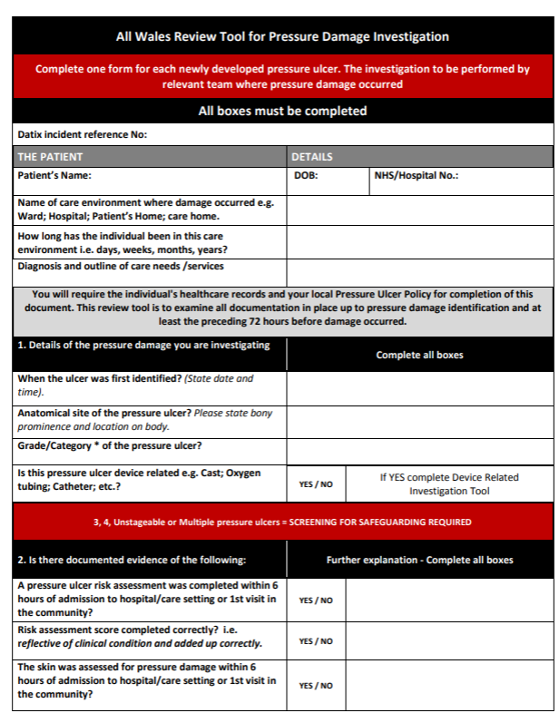
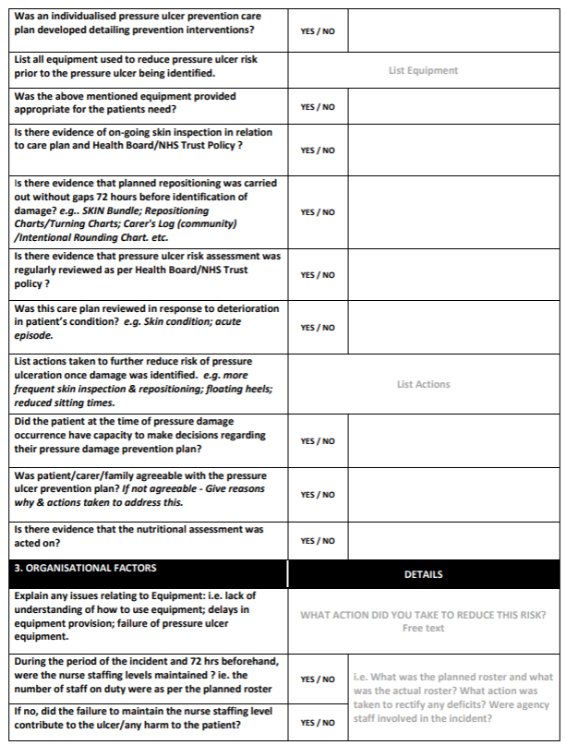
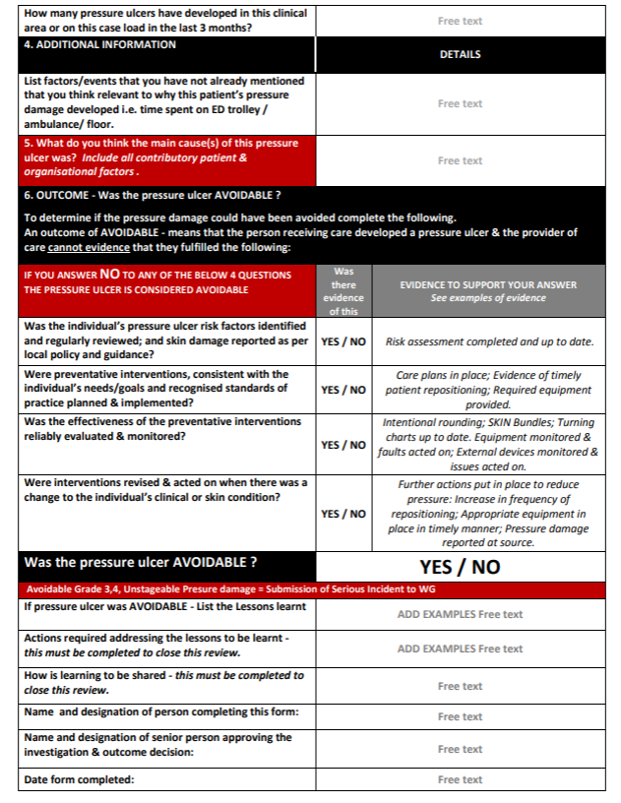

Appendix 2: Pressure ulcer grades (NHS Wales, 2018)

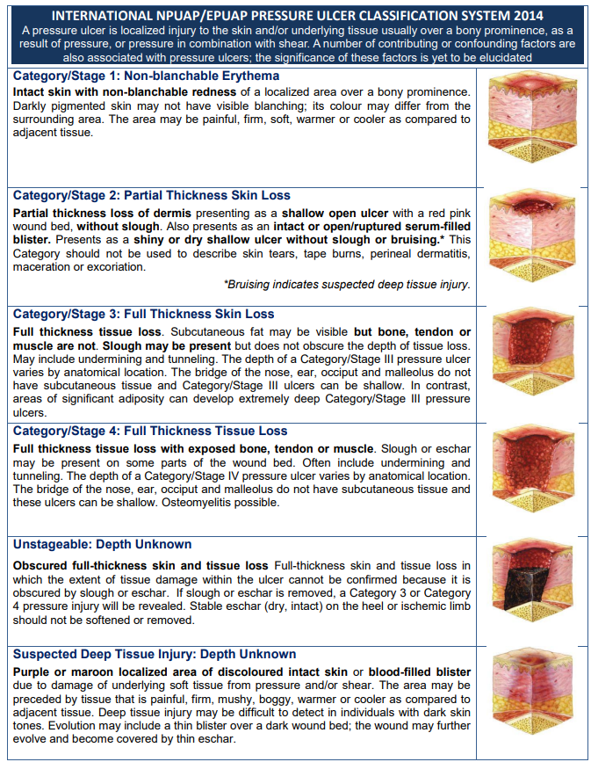

Appendix 3: Example of a skin Bundle used in clinical practice (Swansea Bay University Health Board 2025)
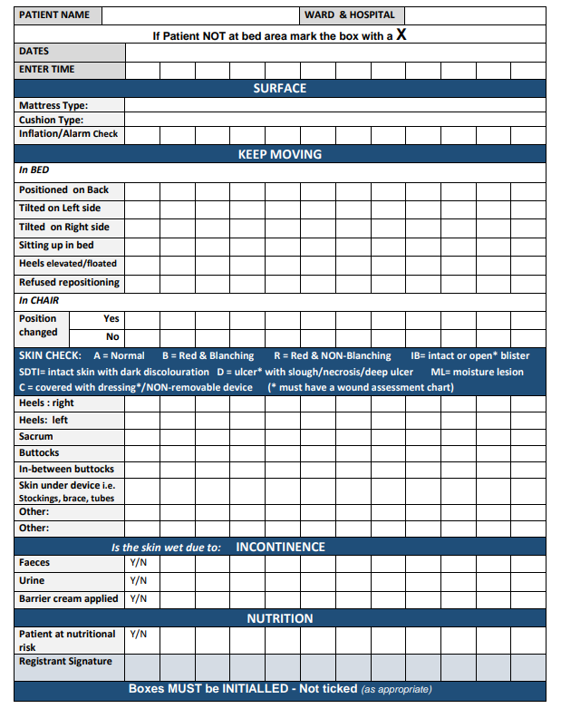

Appendix 4: All Wales Purpose T risk assessment paper document (NHS Wales 2018)
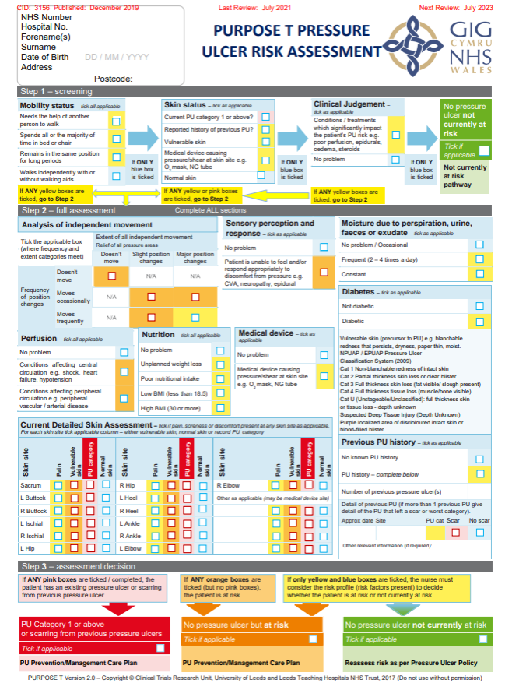

Appendix 5: Skin and repositioning (Welsh Nursing Care Record)
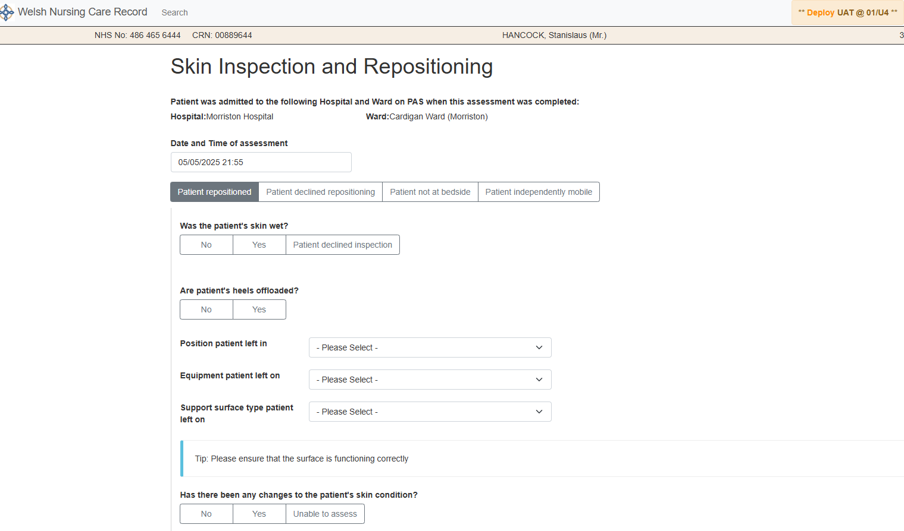

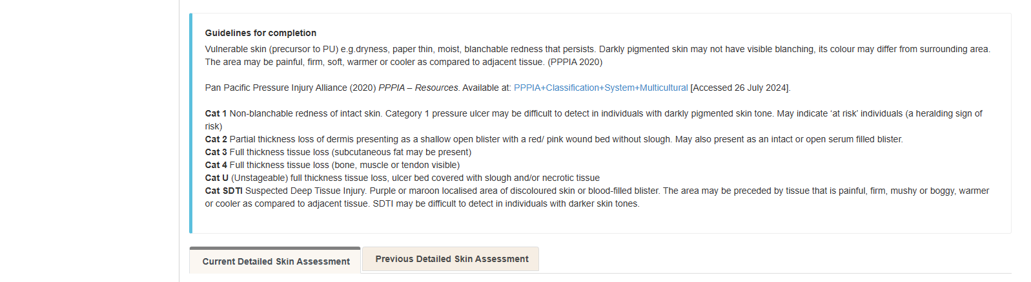
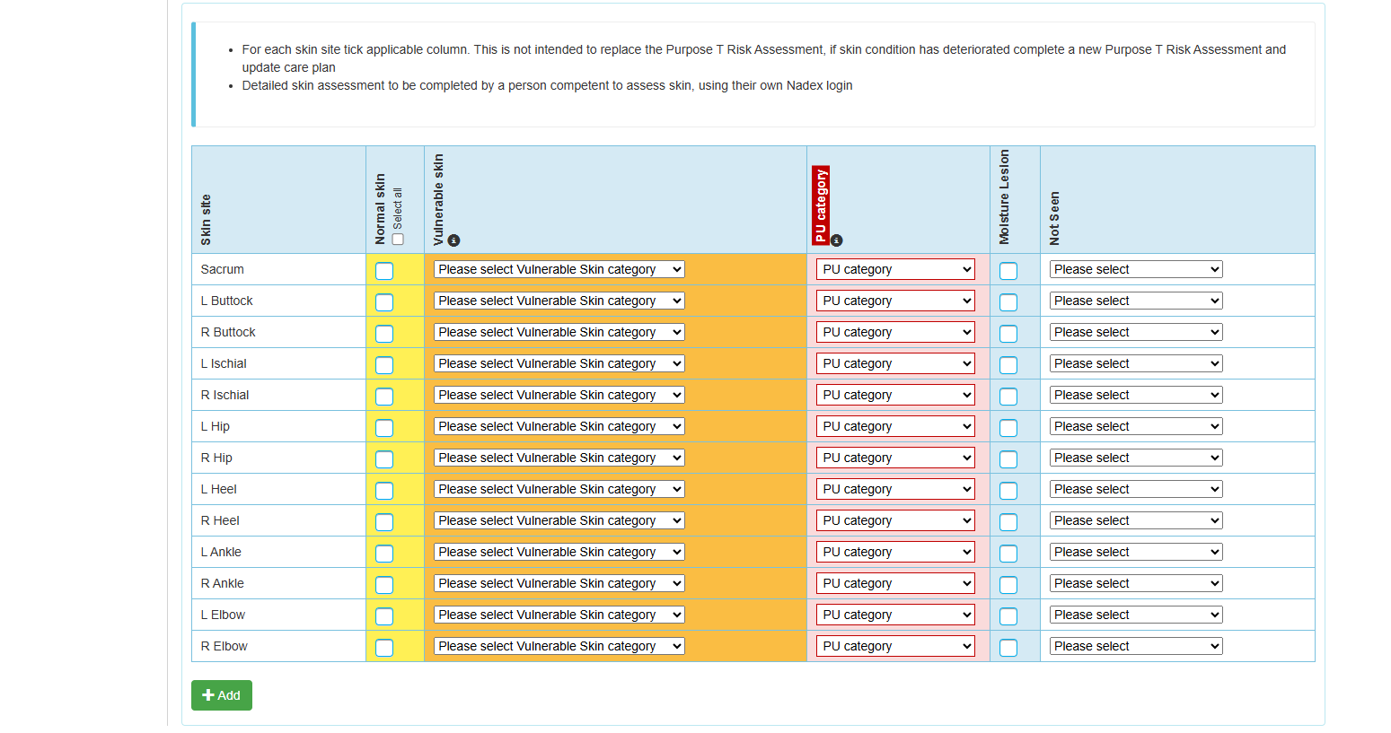
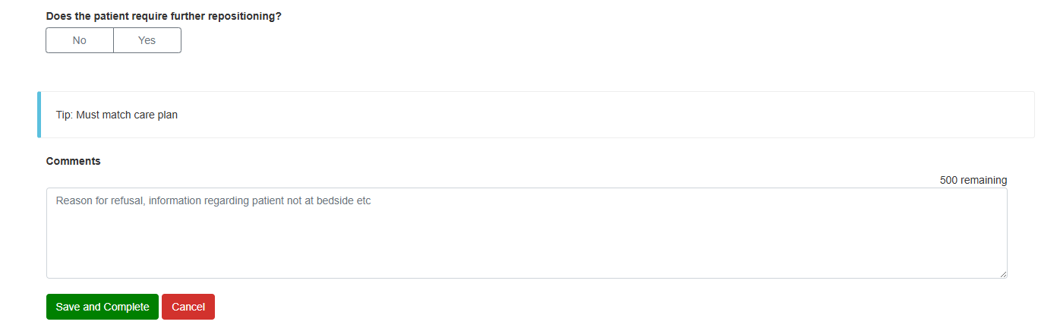

Appendix 6: Cardiff and Value University Health Board (2019) Intentional-Rounding form (skin bundle incorporated into the form)
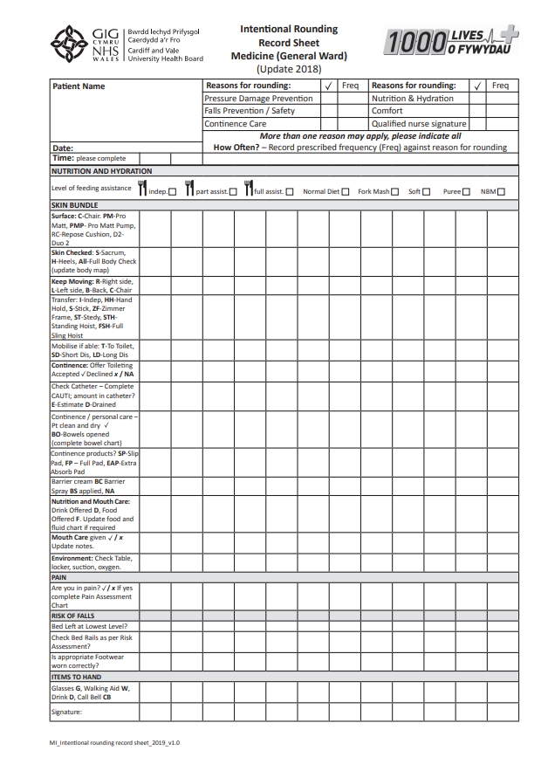

Appendix 7: PICO Framework (Caldwell e al 2017)
PICO Element | Key Words | Details
Population | Nursing staff  Registered nurses  Hospital wards  Health care professionals | Adoption  Integration
Intervention | Electronic health record  Electronic patient record  Welsh Nursing Care Record  Digital systems  Data accuracy  Skin risk assessment  Pressure ulcer risk assessment  Paper documentation | Usability  Functionality  Preference  Evaluation  Ease of use  User satisfaction  Documentation gaps
Comparison | Paper based documentation | Benefits  Challenges  Patient outcomes  Staff perceptions
Outcome | Documentation quality  Usability  Staff experience  Pressure ulcer prevention  Clinical outcomes | Advantages  Disadvantages  Infrastructure  Job satisfaction

Appendix 8: Adapted CASP checklist for mixed methods research (CASP 2018)
CASP Question | Yes/No/Can’t tell
Was there a clear statement of the aims of the research?
Is the mixed methodology approach justified for the research aims?
Was the research design appropriate to address the aims?
Was the recruitment strategy appropriate for the aims?
Were the methods of data collection clearly described?
Was the data collected in a way that addressed the research issues?
Was the relationship between the researcher and participants considered?
Has the study adequately considered ethical issues?
Was the data analysis rigorous?
Were the findings clearly stated and supported by evidence?
How valuable is the research

Appendix 9: Staff focus group interview questions
 | Question raised
1 | Can you tell me what you like or dislike about paper-based nursing documentation – in particular, the skin risk assessments
2 | Can you tell me what you like or dislike about WNCR – in particular, the skin risk assessments
3 | How would you rate the completion of paper-based documentation?
4 | How would you rate the completion of the WNCR documentation?
5 | Are you able to document everything you need too on pressure ulcer prevention on the paper charts?
6 | Are you able to document everything you need to on pressure ulcer prevention within WNCR?
7 | Have you experienced any technical issues since implementing WNCR? If so, would you like to share causative factors?
8 | How many years’ experience have you as a registered nurse?
9 | How would you rate the ease of access to paper documentation – in particular skin assessments?
10 | Have you anything further you would like to discuss regarding documentation in either paper or digital format?

Appendix 10: Staff survey questions
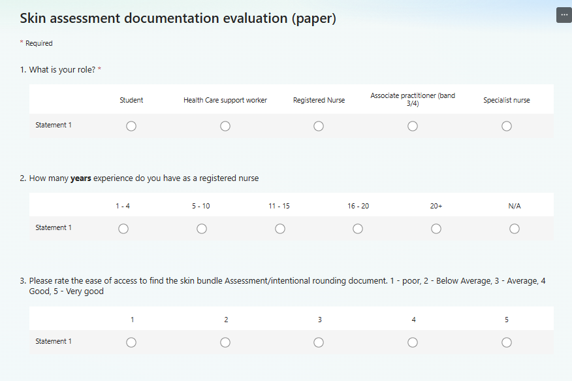
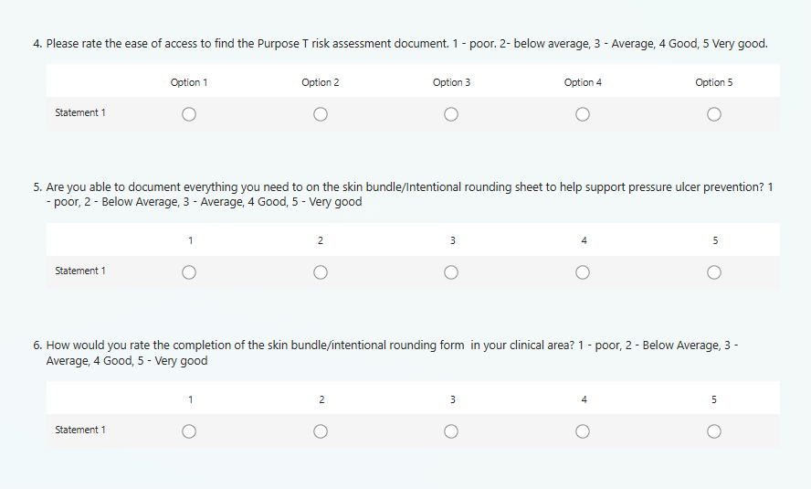
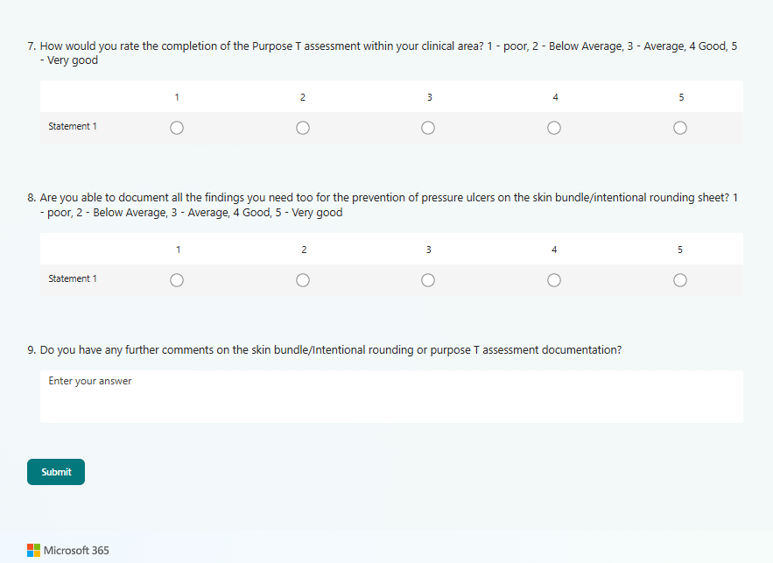

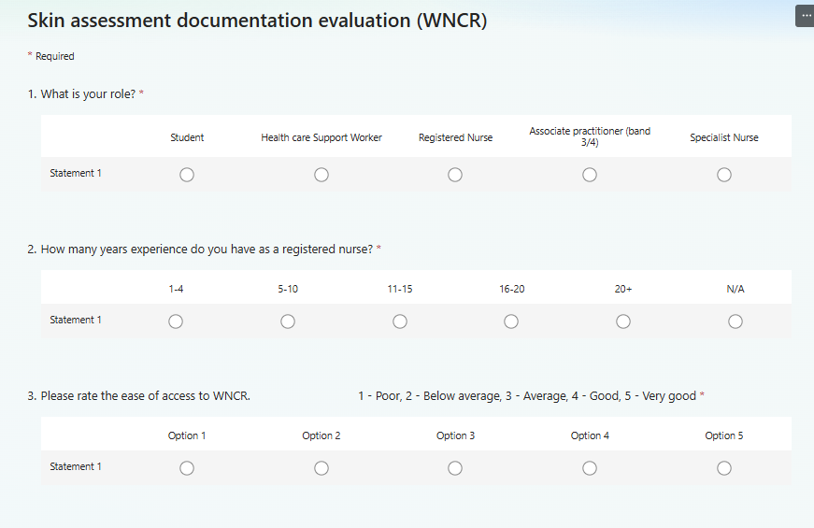
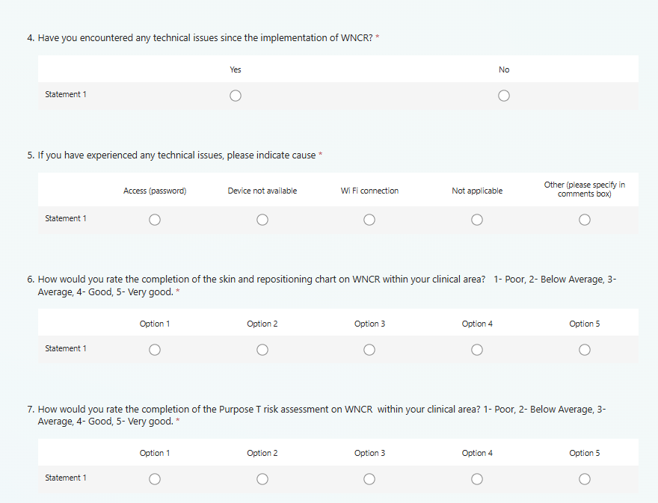
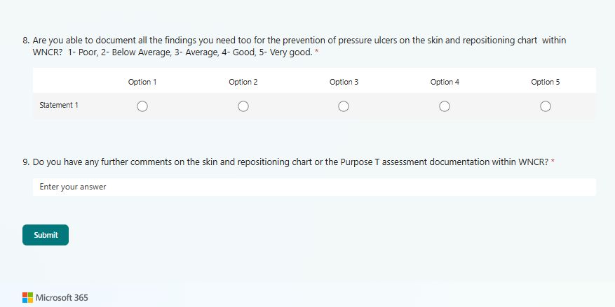

Appendix 11: Ethical approval Cardiff and Vale University Health Board
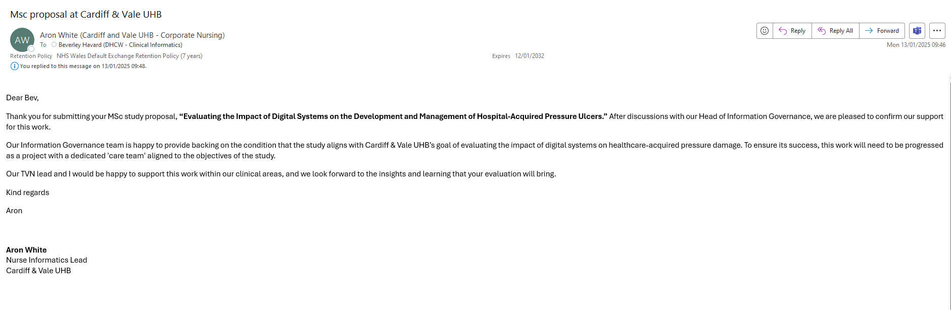

Appendix 12: Focus group participation consent form
Informed Consent Form for Focus Group Participation
Study Title: Focus Group Discussion on Nursing Documentation Practices
Principal Investigator: Beverley Havard
Institution/Organization: University of Wales Trinity St David.
Contact Information: Beverley.havard2@wales.nhs.uk

Introduction
You are invited to participate in a focus group as part of a study examining nursing documentation practices. This consent form provides you with information about the study and your rights as a participant. Please read the information carefully, and if you agree to participate, kindly sign the consent form at the bottom.

Purpose of the Study
The purpose of this study is to explore nurses' experiences, challenges, and perceptions regarding nursing documentation, including the use of paper-based and digital systems. The findings aim to improve the quality and efficiency of nursing documentation in clinical practice.

Study Procedures
- You will participate in a focus group discussion lasting approximately 60 minutes. The discussion will be audio-recorded for transcription purposes.
- During the focus group, you will be asked questions related to your experiences with nursing documentation, challenges faced, and suggestions for improvement.
- The discussion will be facilitated by Beverley Havard, who will guide the conversation to ensure all participants have the opportunity to share their views.

Voluntary Participation
Your participation in this study is entirely voluntary. You may choose to skip any question or withdraw from the focus group at any time without question.

Confidentiality
All responses will remain confidential. Your name and any identifying information will not be linked to your responses in any reports or publications.
The audio recordings will be securely stored and only accessible to the research team. After transcription, the recordings will be deleted.

Potential Risks
There are no foreseeable risks associated with participation in this focus group. However, if you feel uncomfortable discussing certain topics, you are free to skip questions or leave the group at any time.

Benefits
While there may be no direct benefits to you, your participation will contribute valuable insights into nursing documentation practices and may help improve the processes and systems used in clinical settings.

Contact Information
If you have any questions or concerns about the study, please contact Beverley Havard at Beverley.havard2@wales.nhs.uk.

Consent Statement
By signing below, you are indicating that you have read and understood the information provided above, and you agree to participate in the focus group.

Participant’s Name (Printed): ___________________________
Participant’s Signature: _______________________________
Date: ______________________________________________

Researcher’s Name (Printed): ___________________________
Researcher’s Signature: _______________________________
Date: ______________________________________________

Appendix 13: Ethical approval form University of Wales Trinity Saint Davids
PG2 Application for Ethical Approval (1).pdf

Appendix 14: Project brief
Title: “Evaluating the impact of digital systems on the management of hospital-acquired pressure ulcers”

Introduction (Context and aims)
Introduce pressure ulcers and their impact (including the biology)
Introduce the Welsh Nursing Care Record
Explain the paper process of documentation
Explain WNCR and the digital skin and repositioning chart
Aim is to analyse the impact on patient care/outcomes of the Welsh Nursing Care Records digital skin and repositioning chart on hospital-acquired pressure ulcers.

Scope (problem summary, study objectives)
Hospital acquired pressure ulcers are the most common form of harm reported to the Welsh Government. The aim of this assignment is to explore the benefits of introducing digital documentation in healthcare, particularly for the management and prevention of pressure ulcers.
The study will concentrate on one Health Board in Wales

Objectives:

- Understand the current quality of skin risk assessment documentation within Cardiff and Vale University Health Board.

- What is the difference between paper and digital records that informs clinical practice and supports clinical decision- making?

- Determine if there are any improvements in the quality of the skin assessment documentation following the implementation of the EPR. Is there evidence of improved mitigating factors for pressure ulcer prevention following the implementation of the EPR?

Research questions
- How do digital systems compare to paper records in terms of accuracy and completeness of skin assessment documentation?
- What impact to digital systems have on the early detection and management of hospital-acquired pressure ulcers compared to traditional paper records?
- How do healthcare professionals perceive the usability and efficiency of digital systems versus paper records in the context of skin assessment and pressure ulcer management?
Literature review
Review existing research on HAPI risk factors and prevention strategies
Explore the quality of paper-based nursing documentation
Explore the potential benefits of digital documentation in healthcare, particularly for pressure ulcer prevention
Analyse studies on the impact of the WNCR (Bangor study)
Methods
Mixed methods approach:
To evaluate the quality of skin risk assessments in the clinical setting, a document audit form will be developed to evaluate the quality of the skin and repositioning charts, alongside the Purpose-T pressure ulcer risk assessment. The questions will align with the national wound care strategy framework. Information gathered will be repositioning schedule, contributing factors and the general compliance of document completion. The audit form will adhere to the Nursing and Midwifery Councils code of practice, ensuring no identifiable patient or staff information is collected.
Data for this study will be gathered from a selection of wards within Cardiff and Vale University Health Board. Although an element of random selection will be incorporated to improve representativeness, that sampling strategy will also be influenced by the availability of wards that are among the first to implement WNCR. This approach is necessary due to the project timescales, and the specific aim of conducting a comparative analysis between paper-based documentation and digital system.
A digital questionnaire will be created with clear, concise questions and conducted with nursing staff to gather their perceptions of both paper and digital documentation practices regarding the quality of information gained during the assessment and explore the user experience
Focus group interviews with nurses and other health care professionals will be carried out to gain insights into the changes in documentation practices and any challenges encountered
The data will be captured using data collection sheets created within a spreadsheet, with a separate section for each observation.
A comparison between paper and digital nursing documentation will be completed using excel and presented alongside the qualitative findings from the staff surveys and focus group.

Appendix 15: work plan


