SECTION 1
Part A
- A variable is a memory location. Most of the operations concerning the variable have a greater effect on the memory location that stores the variable. In C#, a declaration of all variables should be done before they are used in a program. However, during the execution of a program the variable stored can be changed .
A variable can be a constant variable that is referred to as fixed values that the program may not alter during its execution and it is called literals. Constants carry any of the data types like a floating constant, a string literal, a character constant, or integer constant. Constant variables cannot be changed after their definition.
Variables can be declared to a constant number or using the CONST keyword. Setting a variable to constant number without the word const allows others or yourself to overwrite the existing values while using the CONST keyword allows variables to always store the same value that is unmodified at the compilation time of the program. When the variables are stored as constant values it means that it cannot change during the running of the program. Some of the values that can be set as constant values in any program include the pi values . The pie values is constant values that is used in calculating the area of circle and the parameter of the circle. The constant variable are usually declared as the global variables. This means that the constant value can be accessed from anypont of the program.
- Data types is useful in specifying the exact data type that a variable in C# can hold effectively. Since C# is a strongly typed programming language it makes it mandatory that each and every data is predefined as the programming language and the variables defined should be described with one of the types of data (Yadav, Shishir, & Patel, 2020).
Data types are in 3 categories
- Value data type
It stores the variable values directly in memory and it also accepts unsigned and signed constants. The memory size of data types in value data type can change according to 32 or 64bit operating system. There are various value data types in C# which include signed and unsigned, floating points, Decimal types, character types, and Boolean types
- Reference Data Types
This contains a memory address of the variable value. It refers to the memory location of a program. When the data is changed in the memory location by a variable, there is an automatic reflection of the changed value in other variables. This is because the reference type will not directly store the variable values in memory. The built-in reference type includes string and objects.
The object type is defined as the eventual base class for all types of data Common Type System c# . The object is identified for the class of the System. Object. The types of an object can be assigned different values of other value types, predefined type, reference type, and user-defined. However, it requires the conversion of types before value assignation . Conversion of value type to the type of an object is known as boxing while conversion of type of an object into a value type is known as unboxing.
Dynamic Type stores various types of value in the dynamic data type variables. Normally, the checking of types is done during the runtime of the program.
String Type enables the developer to allocate string values to a variable of any string. It is identified by the System. String class and the acquisition is from object type . The value for a type of string can be allocated by making use of string literals in two forms which are @quoted and quoted.
- Pointer Data Type
This contains an address of the memory that holds the variable value that is it stores the memory address of another data type. It uses address operators which include an ampersand(&) used to determine the variable address and indirect operator which is an asterisk(*) to access the value of an address.
C# is strongly typed language meaning that all of its operations are first of ally checked for the type by the compiler to ensure compatibility of the type. It does not allow any illegal operation to be compiled. This helps to avoid errors and adds up to the program's reliability. For this to be achieved, all expressions, variables, and values have a type. Besides, the type a value determines what operation is allowed on it. An operation allowed on one type might not be allowed on another.
Type conversation.
This is converting one data type to another data type. It ensures that the variables are processed correctly by the function. A good example is the conversion of integers to a string (Buonanno, 2018). This can be done to bring out the comparison between two numeric values but one of the values is saved as a string the other one is saved as an integer
Another useful conversion is converting a floating-point numeric data into an integer value. This can be useful in the performance of various calculations in an effective way when the decimal accuracy is not required.
There are two ways of type conversion
- Implicit type conversion
It is done automatically by the compiler without any external trigger from the user. it converts a smaller type size to a larger type size . This takes place in an expression more than one data type is present. It normally happens when the two data types are well-matching and when the developer allocates the value of data types that are smaller to data types that are bigger.
For instance, in C#, the integer data types are well-matched with each other however the conversion of data type automatically is not required is reinforced from numeric type to Boolean or char. Furthermore, boolean and char fail to match with each other. Before conversion, the compiler first of all checks the compatibility according to figure, and then it decides whether it has there some errors or its all right or.

Example
using System;
namespace Casting{
class Impl{
public static void Main(String []args)
{
int k = 57;
long l = k;
float f = l;
// Display Result
Console.WriteLine("Int value " +k);
Console.WriteLine("Long value " +l);
Console.WriteLine("Float value " +f);
}
}

}

The output will be :
Int value 57
Long value 57
Float value 57

- Explicit Type Conversion
This is triggered by external users manually. It converting a larger type to a smaller size type it is useful for incompatible data types where automatic conversion cannot be done, target-type specifies the desired type to convert the specified value to, and at times, it may result into the lossy conversion .

Example
using System;
namespace Casting{
class Exp{
public static void Main(String []args)
{
double a = 765.12;
int k = (int)a;
Console.WriteLine("Value of k is " +k);
}
}
}

The output will be:
Value of k is 765
Here due to lossy conversion, the value of k becomes 765 and there is a loss of 0.12 value

There are different ways of converting variables into different type variables.i.e the int data type can be converted into double values string values or even float values. In c3 language there is a specific methos that is used in converting values from int to other data types. The following shows the the value that can be used in converting the int type to string data types , in converting int to double the function double .Parse() can be used.in converting the int values to strings we use string .Parse(). The sting method tostring() also in c# languade is used in converting any type of data to string so that they can be printed. From the above we can conclude that c# programming language is type of object oriented programming language that supports all the process of converting values to other type of data. This makes it very easier for the programmer to make application since the application can take any type for data from the user and use the same to perform different operatio in the applicaton .

- Control structures
Control structures are used to control the flow of execution of a program. If you want to execute a specific block of instructions only when a certain condition is true, then control statements are useful .If you want to execute a block repeatedly, then loops are useful.
There are three types of control structures.
- Sequential
This is a default mode whereby the program is executed line by line in the order which it appears .This the mail stuctrure that used by many application . The program executes each line of the code line by line ,it starts with line 1 , 2,3 like that .
- Selection
This is used for decision and branching. It allows the program to choose between more than one alternative path . It includes if, if/else, and switch statements.
- Repetition
This allows looping through the same code multiple times in succession. The number of repetitions of code is based on the criteria defined in the loop structure which is usually true or false expressions .Loops structures include while, do-while, and for loops.
While loop validates a condition and then executes the code block as long as the condition defined in the while stands true while in a do-while loop, the condition is evaluated at the end of the loop instead of beginning. It will execute the statement inside the loop boundary at least once and in for loop, it is mostly used on counting variables. It is effective if you know the exact number of iterations that you need to perform for the loop. The repeation structure repeats the executon of the code from time to time until the a certain condion is reached. if the code does not meet the condition that the program will stop executing .loops ar mainly used int his control stucure like forming the fibanacci number an other values. Therefore control structure are very important while making application they allow repeation of code which acts as an advantage to users since they can resuse the codes and save the time . Reuse of codes in program makes the application run swiftly such that the lines of codes are few thus the applciaon will run faster .

Part B: interpretation

This application is designed in as such a way that it asks uses to enter width and height of the window either between 0.75 and0.5. if the width that is entered is less than mid-width and is greater than the max-width then it asks the user to give the height of the window between 0.5 and 5. When the height of the window is less than mid-height and greater than the mid-height then the application will calculate the wood length and the glass area. The following flowchart shows the working of the application.
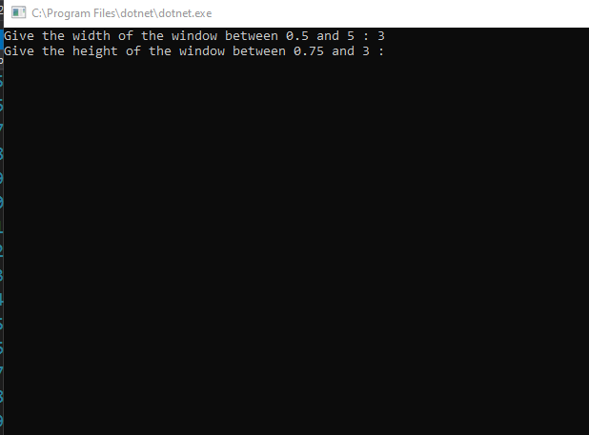
Figure 1: asks information from the users
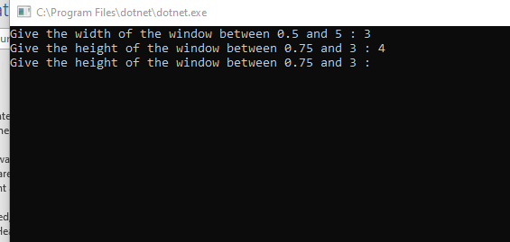
Figure 2: asks the height information from the users.

The application continues to ask for information from the user until the correct information is entered.

The code is explained as shown below
namespace ConsoleApp2
{
class Program
{
static void Main(string[] args)
{
// the variables to be used in the application are declared
double width, height, woodLength, glassArea;
const double MAX_WIDTH = 5.0;
const double MIN_WIDTH = 0.5;
const double MAX_HEIGHT = 3.0;
const double MIN_HEIGHT = 0.75;
string widthString, heightString;

do// the do while loop
{
Console.Write("Give the width of the window between " + MIN_WIDTH + " and " + MAX_WIDTH + " : ");// prints information on the screen
widthString = Console.ReadLine();// reads the width length from the sceen
width = double.Parse(widthString);//convers the widthstring to a double data type
} while (width < MIN_WIDTH || width > MAX_WIDTH);// compares the interfes values

do //wo while loop
{
Console.Write("Give the height of the window between " + MIN_HEIGHT + " and " + MAX_HEIGHT + " : ");//prints information on the screen
heightString = Console.ReadLine();// reads the values from the screen
height = double.Parse(heightString);//converts the height values to double
} while (height < MIN_HEIGHT || height > MAX_HEIGHT);//compares the height values

woodLength = 2 * (width + height) * 3.25;//calculates the woodlenth
glassArea = 2 * (width * height);//calculates the glass areas

Console.WriteLine("The leng of the wood is " + woodLength + " feet");//prints the woodleng informaion
Console.WriteLine("The area of the glass is " + glassArea + " Square metres");//prints the glass are information on the screen.
}
}

}

Part c implementation

Exercise 1: Program to calculate the average.
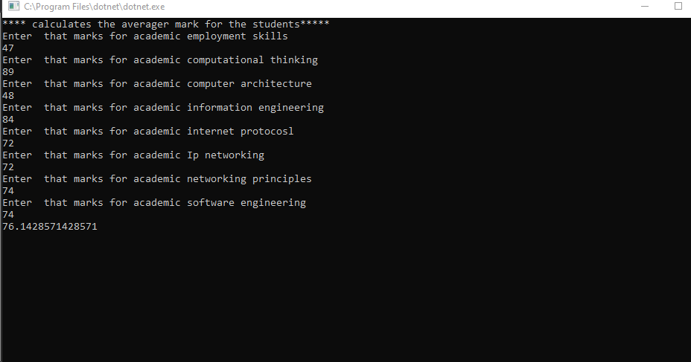
The above is the screenshot of the programming calculating the marks of the students

Exercise 2: Program to calculate the radius of the circle.
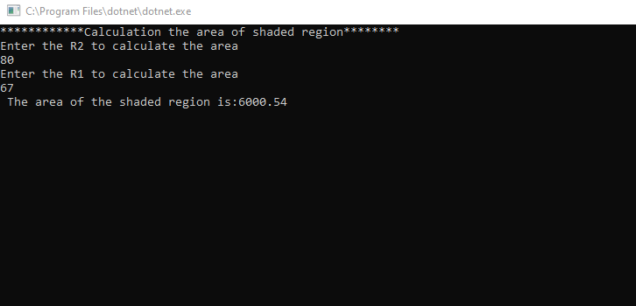

Exercise 3
Flow chart
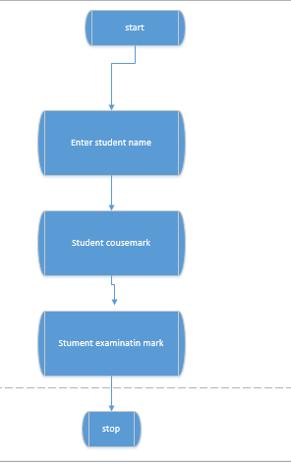
The above shows the flow chart that will be used in creating the application it has the follwong components,the start button ,entering the student details and stopping the process.
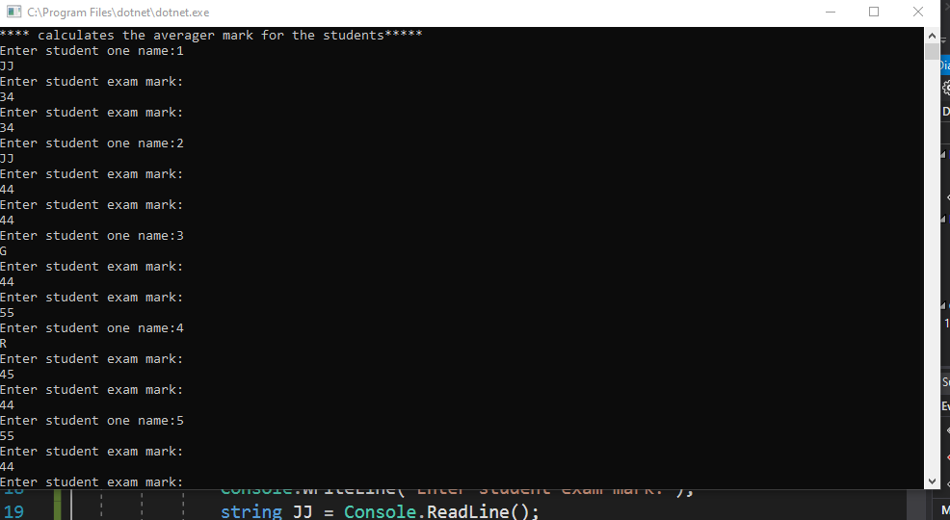

Bibliography
Sheehan, L, Learning Functional Programming in Go. in , Packt Publishing, 2017.
Monroe, W, The constant and variable errors of educational measurements. in , Urbana, University of Illinois, 2011.
Roueche, J, B Herrscher, & G Baker, Time as the variable, achievement as the constant. in , Washington, American Association of Community and Junior Colleges, 2014.
Agator, P, "Convert dataset variables into macro variables: a new approach with the CALL SET routine and the SCL FETCH function.". in Pharmaceutical Programming, 3, 2010, 88-91.
Schultz, R, "Stochastic programming with integer variables.". in Mathematical Programming, 97, 2016, 285-309.
Dussault, J, J Ferland, & B Lemaire, "Convex quadratic programming with one constraint and bounded variables.". in Mathematical Programming, 36, 2015, 90-104.

L Sheehan, Learning Functional Programming in Go, in , Packt Publishing, 2017.
W Monroe, The constant and variable errors of educational measurements, in , Urbana, University of Illinois, 2011.
J Roueche, B Herrscher & G Baker, Time as the variable, achievement as the constant, in , Washington, American Association of Community and Junior Colleges, 2014.
P Agator, "Convert dataset variables into macro variables: a new approach with the CALL SET routine and the SCL FETCH function", in Pharmaceutical Programming, vol. 3, 2010, 88-91.
R Schultz, "Stochastic programming with integer variables", in Mathematical Programming, vol. 97, 2016, 285-309.
J Dussault, J Ferland & B Lemaire, "Convex quadratic programming with one constraint and bounded variables", in Mathematical Programming, vol. 36, 2015, 90-104.

