Name: Lucian – Mihai Ilie
Student Number: 2126669
__________________________________________________________

WORKSHEET 5 – TESTING (Hunting for Treasure)

For this worksheet, the program can be implemented in a number of different ways and demonstrate different features.
Create your own test set to demonstrate strengths and/or limitations of your solution. Use as many of the template boxes below as you need.

Test: 0
Screenshot(s) of output:
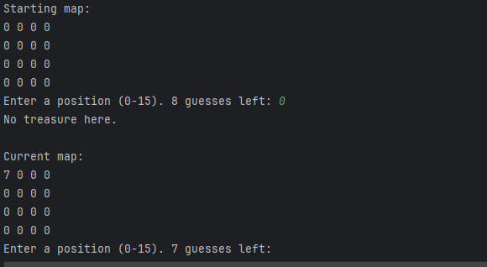
Result: Did the programme behave as expected ie syntactically and logically correct?
YES
The programme behaved as expected. The input 0 was accepted because it is within the valid range of 0 to 15. If the treasure was not at position 0, the programme displayed “No treasure here” and marked the position on the map with 7. If the treasure was at position 0, it displayed the winning message.

Test: 7
Screenshot(s) of output:
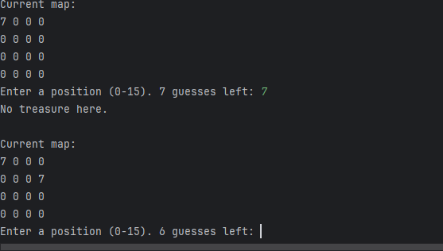
Result: Did the programme behave as expected ie syntactically and logically correct?
YES
The programme behaved as expected. The input 7 was accepted as a valid position. The programme checked whether the treasure was at position 7 and then updated the map correctly. If no treasure was found, the square was marked with 7.

Test: 15

Screenshot(s) of output:
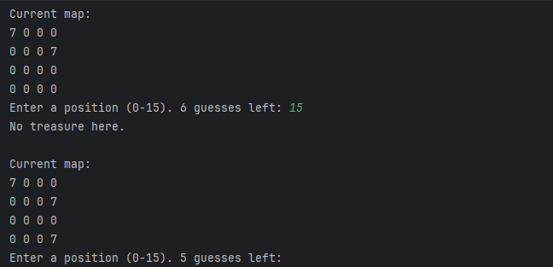
Result: Did the programme behave as expected ie syntactically and logically correct?
YES
The programme behaved as expected. The input 15 was accepted because it is the highest valid position. The programme checked the final position in the list without causing an error and updated the current map correctly.

Test: 16
Screenshot(s) of output:
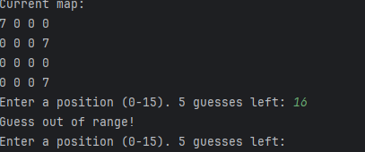
Result: Did the programme behave as expected ie syntactically and logically correct?
YES
The programme behaved as expected. The input 16 was rejected because it is outside the valid range of 0 to 15. The programme displayed “Guess out of range!” and asked the user to enter another position. This shows the validation works correctly.

Test: -1
Screenshot(s) of output:
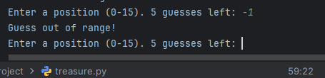
Result: Did the programme behave as expected ie syntactically and logically correct?
YES
The programme behaved as expected. The input -1 was rejected because it is below the valid range. The programme displayed “Guess out of range!” and did not count it as a valid guess until the user entered a number between 0 and 15.

Test: Find a treasure!
Screenshot(s) of output:
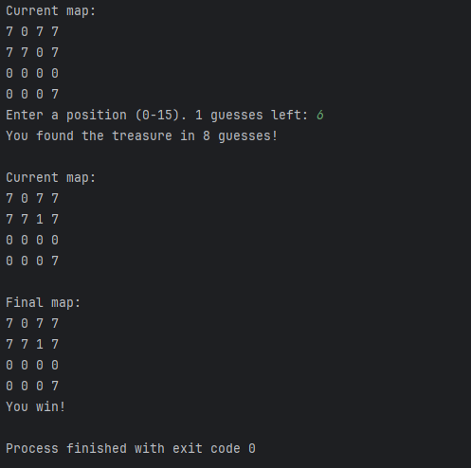
Result: Did the programme behave as expected ie syntactically and logically correct?
YES
The programme behaved as expected. When the user guessed the correct treasure position, the programme displayed “You found the treasure” and showed how many guesses were used. The map was updated to show the treasure position with 1, and the programme ended with the message “You win!”

Test: Didn’t find a treasure!

Screenshot(s) of output:
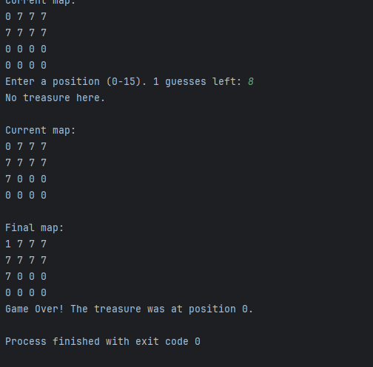
Result: Did the programme behave as expected ie syntactically and logically correct?
YES
The programme behaved as expected. After the user used all 8 guesses without finding the treasure, the programme displayed the final map and revealed the treasure location. It also printed “Game Over!”, showing that the maximum guesses limit worked correctly.

Final code:

import random
def printMap(gameMap):
for counter in range(0, 16, 4):
row = gameMap[counter:counter+4]
print(" ".join(str(x) for x in row))
gameMap = [0] * 16
treasurePos = random.randint(0, 15)
gameMap[treasurePos] = 1
displayMap = [0] * 16
maxGuesses = 8
guesses = 0
found = False
print("Hunting for Treasure!")
print("Guess a position from 0 to 15.")
print()
print("Starting map:")
printMap(displayMap)
while not found and guesses < maxGuesses:
while True:
try:
guess = int(input(f"Enter a position (0-15). {maxGuesses - guesses} guesses left: "))
if 0 <= guess <= 15:
break
else:
print("Guess out of range!")
except ValueError:
print("Invalid input! Please enter a number.")
guesses += 1
if gameMap[guess] == 1:
print(f"You found the treasure in {guesses} guesses!")
displayMap[guess] = 1
found = True
else:
print("No treasure here.")
displayMap[guess] = 7
print()
print("Current map:")
printMap(displayMap)
print()
print("Final map:")
displayMap[treasurePos] = 1
printMap(displayMap)
if not found:
print(f"Game Over! The treasure was at position {treasurePos}.")
else:
print("You win!")

