
haversons ltd
Financial management for the hotel industry

January 1, 2019
University of Wales Trinity Saint David
Celia McClelland 1813622

Executive Summary

This report deliver knowledge and understanding on zero-based budgeting method and will show the limitations and expectations for Haversons Ltd. The reports objective is if Haversons will receive an advantage after being introduced to the zero-based budgeting scheme. It will help Haversons observe in what way the company could utensils this method for every department in their company.
Foremost, this report will assess the method from both sides of the positioning of operating non-identical budgeting practices to precisely measure the function of their organisation. Additionally, the main focus is recognizing crucial gains of performing the zero-based budgeting over traditional methods used which are listed below in the introduction.
Towards the findings the zero-based budgeting is hard to construct if the manager does not have the correct skills. However, if Haversons Ltd decided to use the zero-budgeting method, the company would have an advantage of appreciated understanding of their financial records/statement. The disadvantage is nevertheless, due to skill base required a sensible idea would be for the company to analyse their accounts more closely so the company can recognise what method is more beneficial.

Table of Contents
Executive Summary 1
1. Introduction 3
2. Zero Based Budgeting 4
2.1 Zero-based budgeting 4
2.2 Advantages of Zero-based budgeting over Traditional Based 4
2.3 How the Organisation Might introduce Zero-based Budgeting 4
3. Conclusion 5
4. Reference List 6

Introduction
Zero-based budgeting is where a company budgets the income by detracting the expenditures which start from zero. Zero-based budget, means the company acknowledge their expenditures which match the revenue calculations that is monthly payments so every pound in the revenue is going towards a function Cruze.R. (2019).
Haversons need to have full explanation of how the revenue is being spent which will show how well managed the company’s assets are. Firstly, by understanding the expenditures and how they relate to the company’s revenues. The departments that can affect the profitability is important, the financial report is crucial as it explains the departments expenses.
A successful budgeting method has to have evidence which is supportive of the financial analysis for quicker results. The documentations make it manageable for revenue cost than a budget organised by marginal growths over previous annual reports.
Below is table of other budgeting methods that haversons could use, but this report focuses on a zero-based budgeting technique.
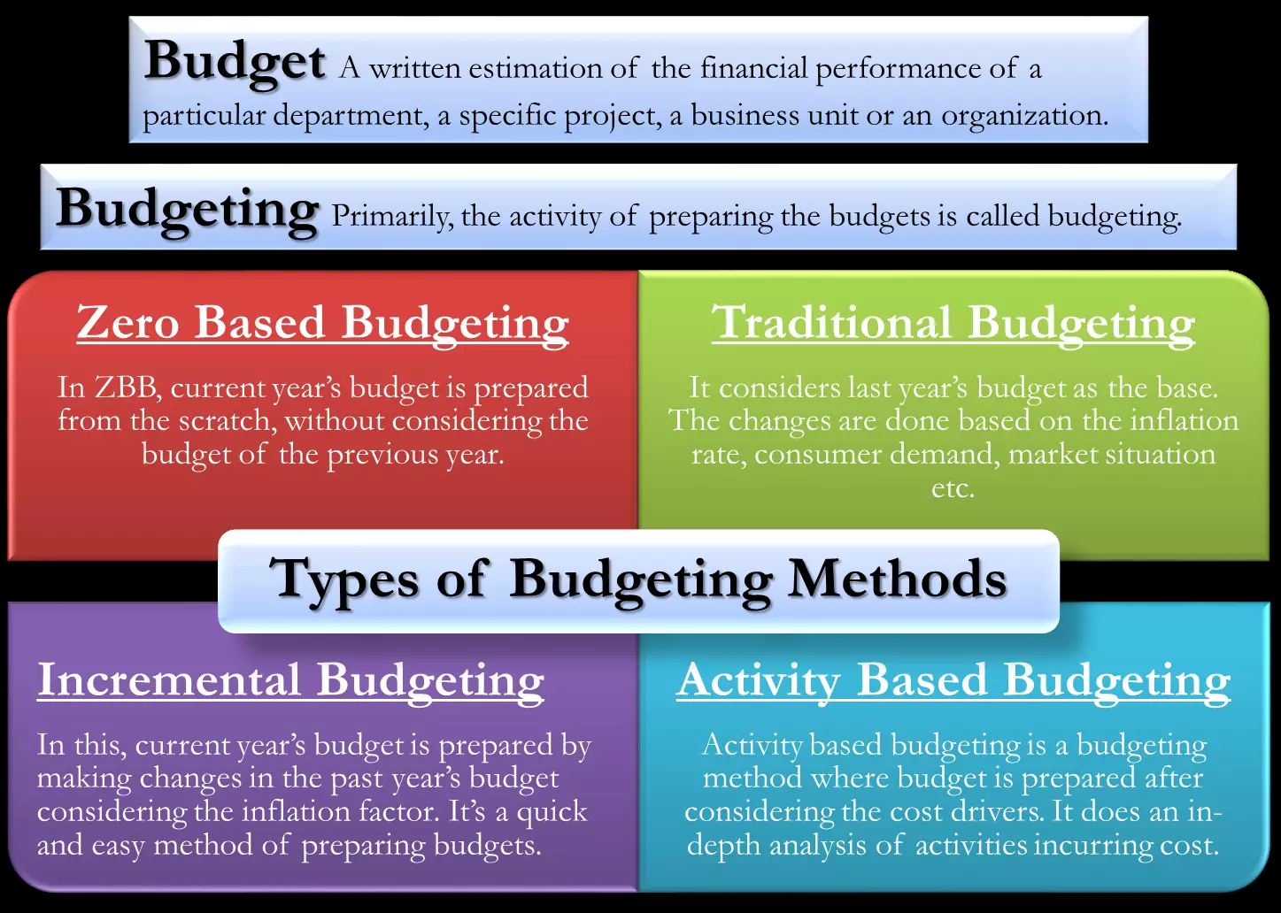
“Occasionally, financial plan may not go to plan, in previous years demonstration suggestively advanced or lesser costs, reliant on the general industry position and other outgoing factors” CFI . (2015).
Managers feel undervalued by using the zero-budgeting scheme that assesses the efficiency of their methods. The zero‐based method includes administration, communication, training for the member of staff who deals with the account will be a complicated examination process. Managers who struggle in decision making, need to evolve in producing acceptable results to create a reliable analysis, defining the minutest skills, positioning unrelated plans

Zero Based Budgeting

Zero-based budgeting

Haversons budget do not base it on previous years revenue budgets, the zero-based budgeting, accounts for every expenditure before haversons add it to the total budget. The aims of this method are to decrease expenditure by looking at what departments can have a decreased each month. By each department calculating a financial report for annual review it allows harvestons to know where the expenses are going and which department budget can be decreased. The key to running a successful buisness is to discover what expense from each department and if they do not profit the company, by making cuts in a department , the company will channel other methods to complete the cut budget within the premises.
The buisness needs to focus on :
- Reckoning the company’s targets
- How to accomplish new strategies
- How to cut costs
- Organise revenue
- What is the predicted revenue?
- How much is each department expensive and what revenue will you be left with?

2.2 Advantages of Zero-based budgeting over Traditional Based

 | Zero based vs traditional budgeting
Justification of data | Zero-based budgeting there is no past or historical data.  The cash flow requirement needs to be correct(all types of expense)  Traditional budgets, from the financial report the departments expenses are above from the annual budget need to be justified.
Ease of Modification of Budget Components | zero-based budgeting easier to eliminate an existing or new asset, more flexible  Traditional budgeting is changing the budgeting technique. ,depends on previous year’s budget
Based for budgeting | Zero-based budgeting is done considering the base as zero.  Traditional budgeting uses previous year’s budget as a baseline to make current year’s budget
Allocation of resources | In zero-based budgeting priority decisions more, revenue is given to the thriving department.  Traditional budgeting is decided based on last year’s decisions
Time required | zero-based budgeting is time consuming traditional budgeting is less time-consuming.
Ease of preparation and training | special skills and knowledge to prepare zero-based budgets.  traditional budgets are as it doesn’t include hard calculations

2.3 How the Organisation Might introduce Zero-based Budgeting
Technology is the future and for haversons to be successful they need to adapt with the times. Budgeting by spreadsheets is hard especially if there is a mistake. By using excel it is a lot quicker and does all the calculation for you. Another reason is due to budgeting using the spreadsheets can be inaccurate with calculation which can cause a lot confusion. Because there are 4 methods to choose from which are described in the introduction it allows for a lot more accuracy.
By the company investing in training programmes can cut a lot of cost downs , resulting into knowing what the latest technology is and how to use it. Technology is the way forward and new software’s are being invented to ensure that daily working tasks are easier. For buisness to succeed haversons need to ensure that if they use the zero-based budgeting that the is a realistic predicted revenue and the skills to do the calculations on excel.

Conclusion

The conclusion examination process of this report has been very brief due to there being a number of different methods to use for budgeting. For Haversons Ltd that the organisation budgeting method choice is challenging depending on the skill set of the accountant who deals with the financial year review. The zero-based budgeting is rather complex to use if the manager doesn’t have correct excel knowledge. Nerveless the manager should understand how to use this method once having the training it will be easy to use once you know the formulas. However, I feel the incremented budgeting would be more ideal for Haversons due to having a more realistic idea of the profit they may make taking into consideration of prices increasing for the expensive. Whereas the zero- based budget can be hard to decide on a realistic annual revenue.

4.Budget Calculations

- Write down your predicted revenue
- Work out each month’s cash and credit sales on this assignment 60% credit and 40% cash sales, however it swapped in September
- Identify the invoice dates for month 1 (52%) formula = credit month before * 0.52 and month 2 (47%) formula = 2 months before hand*0.47
- Identifying the 5% discount the formula is month 1 52% *0.05
- The formula for the total month 1 credit is – the month credit – 5% total of the same month
- To calculate bad debt, you will need to take the previous credit total – new credit total
- After this calculation you should have your final credit total for each month
- Change the previous calculations (52% of each month) to your new calculations for your total credit
- Write down the monthly expenses for 2020 if it is annually paid which is one payment, or annual which is spread over the months.
- Add up the expensive for each month and then for this case study you will get the total of a month of expenses x0.26 then divide by 100 to give the predicted interest that month will have
- The formulas for the final stage are: (the company will have a predicted open cash balance for the start of the year that goes in January balance B/C)
- Net cash flow in month = is total receipts – total payments
- Balance C/F = =balance b/f +net cash flow in month
- Balance B/C = the total of the balance c/f will become the balance b/f because of them carrying over each month earning
Examples are carried out below :
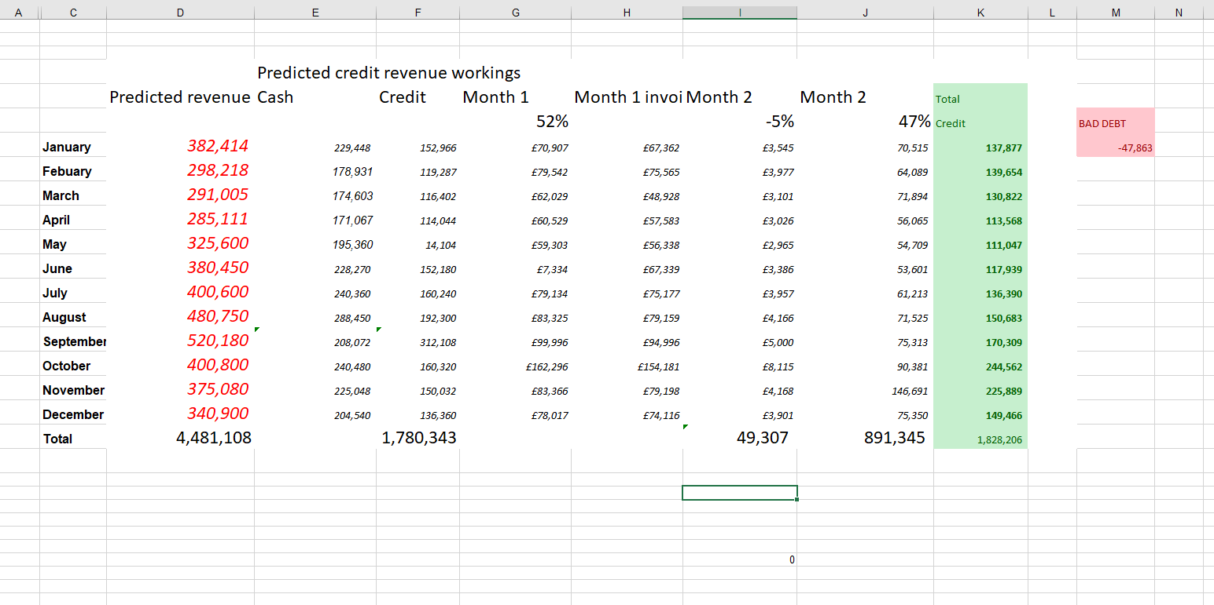
Stage 1

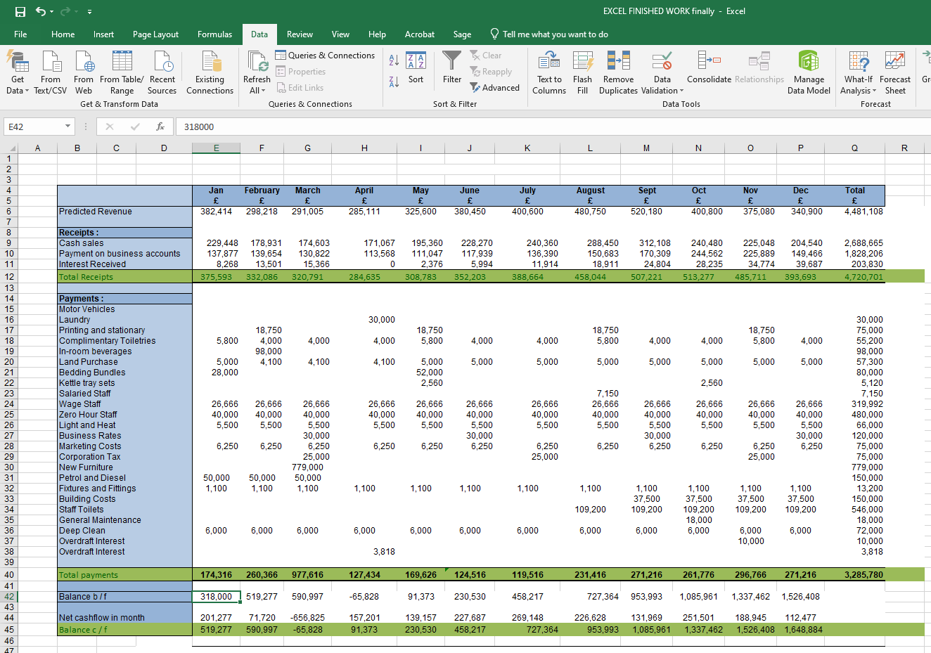

Stage 2

5. Reference List

Cruze.R. (2019). How to Make a Zero-Based Budget. Available: https://www.daveramsey.com/blog/how-to-make-a-zero-based-budget. Last accessed 04/11/2019.
CFI . (2015). A budget starting from scratch. Available: https://corporatefinanceinstitute.com/resources/knowledge/accounting/zero-based-budgeting/. Last accessed 04/12/2019.
Pyhrr.A (2012). Handbook of Budgeting, . 6th ed. UK: John Wiley & Sons, Inc. p667-696.
Lanita.W , Lokman.M. (2004). Information technology and the performance effect of managers’ participation in budgeting: evidence from the hotel industry. International Journal of Hospitality Management. 24 (1), p21-39.
Nugus.s (2005). Buy eBook - £19.49 Get this book in print▼ 0 Reviews Write review Financial Planning Using Excel: Forecasting, Planning and Budgeting Techniques. 2nd ed. oxfordshire: CIMA publishing . p3-221
Flamholtx.E. (1983). Accounting, budgeting and control systems in their organizational context: Theoretical and empirical perspectives. Accounting, Organizations and Society Accounting, Organizations and Society. 8 (2-3), 153-169.
Lorain, M,García ,A and Sastre.F. (2015). Cuadernos de Gestión. Traditional budgeting during financial crisiS. 15 (2), P65-90

