
First 1,000 Days (Source: Daily Clip Art, No Date)
The first one thousand days are from when the child is conceived until their second birthday. As a practitioner or guardian, it is important to think about what a a baby requires. The key themes that will be discussed are development, environment, relationships, stimulation, nutrition, and awareness of needs. The first one thousand days are significant as it is a period of rapid development. Parents can care givers have a massive impact on the baby’s development. All of the topics fall under the three following subheadings enabling environment, enabling adults, and enabling experiences. As stated by (Leadsom,2020) "Two is too late" this quote tells me as a practitioner just how vital the first one thousand days are of a Childs life. By the age of two the child could have already developed poor early years relationships. This supports the fact that early intervention is key. Early influences up to the age of two helps the child to form an understanding of the world around them and therefore forms the foundation of the child development.

Enabling Environment (Source: Treats and Trinkets, 2014).
An enabling environment is an environment that has been adapted in order to fulfil a Childs needs. The environment can be language rich. A language rich environment is a learning area that has been designed and thought-out, which aims to further the Childs language skills. Practitioners are able to use engaging resources and adult interaction. The space should provide a range of stimulus, as a result of this the Childs language skills will develop effectively. Language rich environments such as a day care setting are able to improve a Childs speech and language skills if this is something they find difficult. Organisation, displays, and books are just a few examples that can develop a Childs language. Whilst attending placement I have found that the classroom displays are extremely effective and helpful as it gives the child a boost of confidence when their work is put on the wall. In the classroom we also have a list of colours on the display which has resulted in majority of the children learning their colours well. Books are able to help babies familiarise themselves with different textures and sounds. As some books contain different materials and sound buttons. Twinkl, (No Date). A curriculum frames a Childs learning and a pedagogy is the way that practitioners teach, enabling children to learn through rich experiences. Power School, (2021).

Theorist's (Source: Grokchain, 2022).

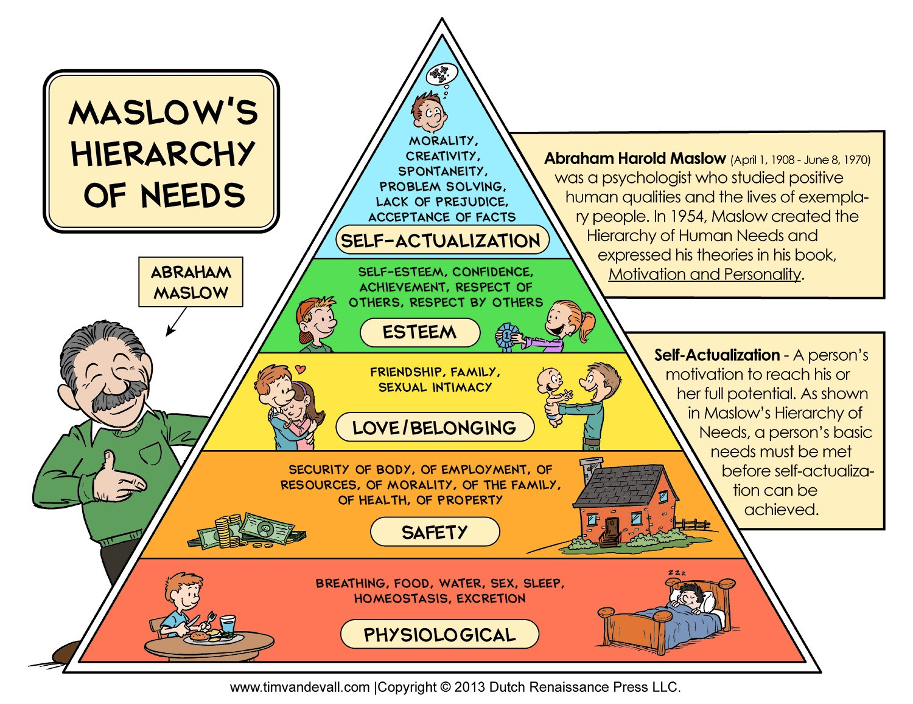
1 - (Source: Miscetcetera.com, 2014)
Maslow created the theory, a hierarchy of needs. Maslow's theory argues that there are five stages of human needs these are displayed in a pyramid. His theory was published in 1943. In order to reach the top of the pyramid you must work your way up. Physiological needs are at the bottom of the pyramid this includes needs such as eating, drinking, and sleeping. A baby requires these needs in order to survive. Safety is the second stage of the pyramid babies will feel safe by being inside where it is dry and warm. Once the baby feels safe, they will seek love and belonging which is stage three. Babies can feel loved through cuddles and attention from the people they are attached to. At stage for we look for esteem and self confidence from others. Babies can be reassured that they are doing something well by receiving a clap or a smile. This will boost their confidence and encourage them to do it again. Stage five is self actualisation this allows your baby to feel relaxed and become creative. Sprouts, (2017).
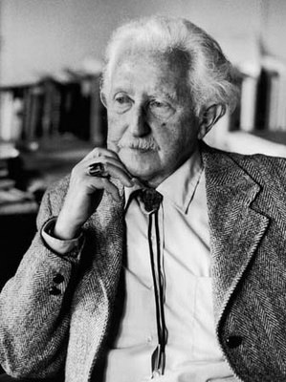
2 - (Source: Wadlow, 2021)
Erickson created eight stages that he believes everyone passes through from birth to death. At each stage we require different needs to be met and meet new people. Throughout life we gain more knowledge and understanding. Stage one is basic trust and mistrust this is carried out during infancy, when you are between the ages of one and two. Infants ask themselves if they can trust the world and wonder if it is safe. Babies form a strong attachment to their main caregiver this tells them if they can trust someone now then they can also trust others in the future. On the other hand, if the baby is in fear constantly then they will develop doubt in people and mistrust resulting in long term side effects in their future. The key to a Childs develops is the bond they have with their main caregiver. Sprouts, (2017).
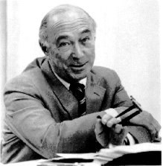
3 - (Source: Wagner, 2006)
Bruner has a three-step approach of learning in a spiral curriculum. First is hands-on learning then learning with images and finally transforming what you have learnt into language. We constantly revisit topics and skills that we have learnt previously and improve them. Sprouts, (2020). For example, as a child you cut two pieces of cake and share one with your friend. Whilst attending school you are taught fractions by dividing a circle into pieces this sparks your memory of sharing the cake. Then the third step is to learn the correct terms such as a whole, half, third and quarter etc. All of which frames formal progression.

Resoprosity, Object Permanent, and Embodiment (Source: Cut Soft, No Date).

Reciprocity is exchanging things with others for example a high five, cuddle, handshake or a smile. A startle reflex is the automatic reaction to danger. Babies are sensitive to touch and are born with social interaction. Babies enjoy eye contact as it shows their caregiver is engaged. Babies have a positive reaction to faces and moving shapes as it catches their eye. They are born with built in behaviours that are revealed over time. Furthermore, they are extremely dependent on their main caregiver which is usually the mother. Newborns brain context is smooth, it crinkles up over time in order to fit in more information. Nurons in the baby’s brain pass on information. Mothers can work out the babies signals over time once they have familiarised themselves with their child. An example of this would be they baby rubbing their eyes when they are tired. Babies will have an internal body clock which is based on light and temperature. Repetition is important when trying to get your baby into routine. Babies and toddlers are unable to manage their own emotions this is why they often have temper tantrums at the age of two. Cortisol increases blood pressure, stress, and heart rate. However, it can have a positive effect on the child in small doses. You will notice babies tend to look straight on this is because their ears work simultaneously. It is important to listen, look and respond to your child by following these three steps you will receive the best possible outcome. There are lots of nerve endings in the mouth this is why young children tend to put everything in their mouth. As a result of this the child is able to taste new things and feel new textures. Babies are born with their own personally preferences such as likes and dislikes. They are influenced by other moods around them and are able to red how people are feeling. Moodle, (2021).
Object permanent is when young babies think that if you're not in their eyesight you do not exist as they get older, they understand that you will come back. For example, if they throw a toy off their highchair and can not see it on the floor, they think that It as disappeared and therefore no long exists on earth. Tummy time is important with very young babies as it teaches them how to hold their own head up. As a result of tummy time the babies head also stays round and therefore does not get flat at the back from laying down all the time. Moodle,(2021).
Embodiment is discovering the world of objects, facially expressing an emotion, using verbal language, and even developing consciousness. Our experiences grounded in some way in the properties of our bodies. Embodiment is all our five senses working together. Babies link moving and learning through the five senses. This is called Kinaesthesia. The nerves for kinaesthesia are located in the muscles. When the muscles stretch and shrink these nerves send signals to the brain. Furthermore, the kinaesthetic system enables both inhibitory and engages activation nerves in the brain. According to (The Motor Story, No Date) "Inhibitory means the signals sent to the brain when we move help to ignore some stimuli bombarding the brain that we don’t need to pay attention to." And "Activation means that this movement also has an alerting or energising component." As a result of this when we stretch, we are able to focus to a higher standard and become more energised. Additionally, any activity that requires physical movement starts this kinaesthetic system. The more muscles that you use and activate the more energising stimulation occurs in the brain. Physical activities that work the muscles develop the body and brain. The Motor Story, (No Date).

Building Brains (Source: Research outreach, No Date).
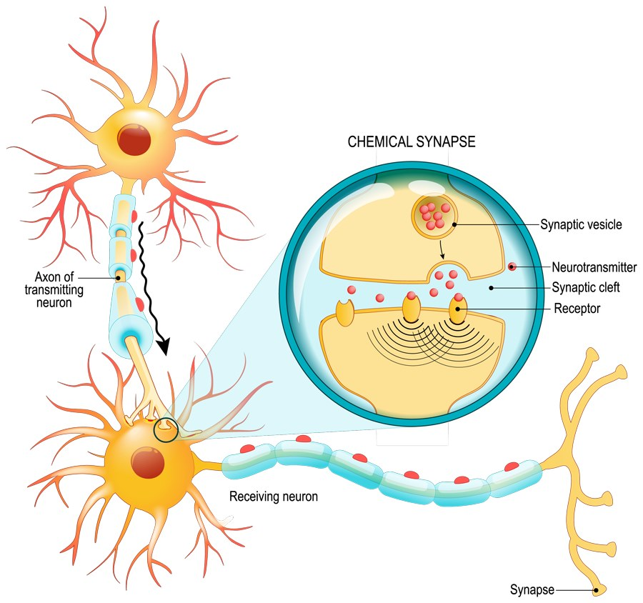
The brain gets bigger overtime as the baby gains more knowledge and understanding. The brain becomes densely packed together. Every experience increases connections. There are eighty-six billion connections in the brain. The brain starts to develop in the mother’s womb. Nurons are information processing cells in the brain as shown in the diagram. Nutbrown, (2005).

Enabling Adults (Source: Simmons,2017).

A baby relies massively on an adult in order to survive. Serve and return is a technique. Babies respond to our voices and closeness. They also respond to our eye contact, touch, music, and facial expressions. Professional love is a topic that has many arguments for and against. There should be an appropriate balance and there is a climate of wariness surrounding this topic. It takes time for both the practitioner and the child to form a close and loving bond. Furthermore, there is no skill set that can be taught in order for a practitioner to feel love towards a child. As a result of this practitioners are either able to form these bonds or not. Professional love allows the practitioner to care for the child and be able to read what the child need in order to feel loved at any given time. Gerhardt, (2015) There are five developmental pathways they are belonging, communication, exploration, physical development, and well-being. Moodle, (2021) All babies should be given the chance to explore their surroundings and the world around them as this helps to further their development. Communication is very important parents should talk to their baby and repeat sounds the baby makes back to them, this encourages the baby to babble. As practitioners it is important to ask yourself how can you support the development of these connections? Singing can encourage the baby to make sounds. Parents can also carry out fun activities and talk to your baby. Repetitiveness is extremely efficient, and parents must be consistent. Positive relationships, messy play, love, socialising, tummy time, nutrition and being nurturing are all factors that have a positive impact on a baby’s development. As a parent it is important to have a supportive partner to that you do not feel isolated and alone. Whether the person supporting the parent is the baby’s other parent or a family member/ friend, it is vital that the parent has someone to talk to so that they do not feel overwhelmed. Babies form strong attachments to the mother whilst they are in the womb. The mother is often the person the baby relies on to be fed whether that is breast feeding or bottle fed. Furthermore, the mother is also often the first person to do skin to skin with the baby. Skin to skin contact it said to have many benefits for both the mother and the baby. Skin to skin helps to regulate the babies body temperature, it improves breast feeding and it has even been said that it improves the likeliness of post-natal depression. Sunnybrook Hospital, (2014). Nutrition is important in order for growth. Breast feeding is said to provide the baby with the best balance of nutrition, is easy for the baby to digest and rarely causes allergic reactions. Furthermore, the baby is less likely to have stomach problems. It has been researched and babies who are breast fed are less likely to develop certain cancers and diabetes later on in life. There are also many benefits of breast feeding for the mother, women who breast feed are more likely to return to their pre- pregnant size at a faster pace. Intermountain Healthcare, (2017). The health and wellbeing of the mother is important to maintain throughout the pregnancy furthermore, and when the baby is born. As stated by (NHS Inform, 2020) the mother should set realistic goals for herself and note progress throughout the pregnancy. It is important to get a full night’s sleep and eat regular, healthy, balanced meals. The mother should try to be as active as she can. Going on walking and being outdoors is good for your mental health and your body as the mother is breathing in fresh air.

Enabling Experiences (Source: Daily Clip Art, No Date).
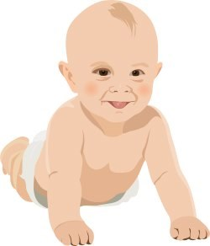
As a practitioner we offer many different experiences throughout the Childs early years. The experiences are meaningful and adapted to each individual. Furthermore, the experiences all have a purpose to further a certain area of the Childs development. The experiences are also hands- on. The verity of experiences should encourage a Childs independence, challenge the child to push themselves and the achieve a goal at the end. The child will start to feel involved and committed to reach their goal. As a practitioner it is important to support the child when they are trying to show you what they require. Children should be given choices and options to experiment with. Mothers are able to encourage their child to be creative by setting up small activities such as a treasure basket. (Ette Tele, 2021) States that Emmi Pickler believed that "each child has the right to be respected and cared for in line with their own natural development". Emmi Pickler created an institute in order to take philosophy and turn it into a researched study. Emmi Pickler shared her knowledge with other caregivers to carry out her theory, as a result of this the Emmi Pickler care home was created. Emmi Pickler stated that each child should not be limited by the amount of time they are given to complete an activity, they should have an endless amount of time so that they are able to finish the task to the best of their ability. When a child is rushed, they can feel like they are under extreme pressure. Each child should be given the opportunity to learn their own limits so that they come to terms with what they can and cannot do. Every child learns and develops at their own pace it is important to understand this and not to compare one child to another. Each child should get the chance to learn from their own experience and to make decisions/ opinions themselves. Whilst working in the care home the care givers had to build a relationship with the children so that they trusted each other and therefore gain a mutual respect. Each child deserves your full attention in other to meet their required needs. Emmi Pickler suggests that it is vital to not interrupt a Childs play so that they have their own freedom and are allowed to do what they want to a certain extent. Pickler believed that outdoor play furthered the children's development and was great for their well-being. In the Pickler care home, the cots that the babies slept in were even placed outside when it was dry. As a result of this the children developed their senses. Pickler created the climbing arch (Gabriel, 2022) stated some of the benefits. The Pickler arch enhances gross motor development as the child is able to learn how to pull themselves up and hold their own weight using their strength. The arch enables open-ended play so that the child is able to use their imagination and the possibilities are endless. Furthermore, it increases spatial awareness so that the child is aware of their surroundings. The arch provides the child with vestibular stimulation this allows them to gain more knowledge about balance. Additionally, it strengthens the Childs limbs and bones so that they are sturdier.
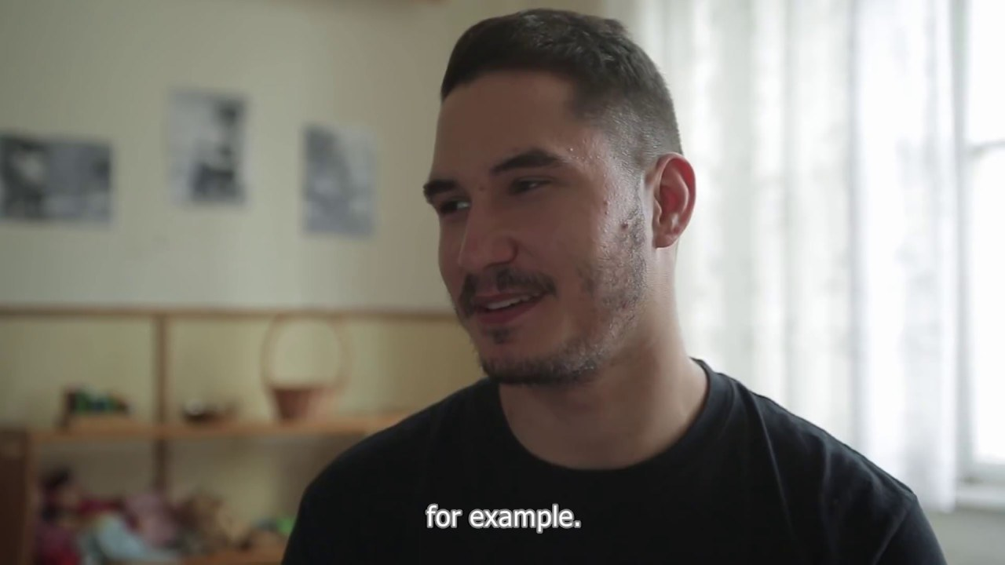
4 - Pikler USA, (2018)

Zone Of Proximal Development (Source: Ateneu,No Date).
The zone of proximal development is the space between what a child can do independently and what a child can complete with adult guidance or help from a fellow peer. Furthermore, the outer circle is what they are completely unable to do. The zone of proximal development is a key aspect to Lev Vygotsky's theory and links with scaffolding learning. Billings and Walqui (2022). Lev Vygotsky observed what a baby was able to do at that current time and thought about what they can do in order to progress. A baby is able to reach out but if you give them something to reach out for that will stretch and push themselves that little bit further. Wood, Bruner, and Ross introduced Lev Vygotsky to the scaffolding theory. Scaffolding is when a practitioner models or demonstrates how to solve an activity and then takes a step back. However, the practitioner is there to offer support if required. This theory shows that when children are given support whilst leaning something new, they stand a better chance of using that knowledge independently. Study.Com, (No Date). Lev Vygotsky's theory about the zone of proximal development provides children with learning experiences. Jean Piaget's theory about the four stages of cognitive development shares similar views with Lev Vygotsky's theory. The four stages of cognitive development are the sensorimotor stage: birth to two years, preoperational stage: ages two to seven, concrete operation stage: ages seven to eleven, and formal operational stage: ages twelve and up. Cherry, (2020) Piaget believed that a child’s intellectual development was not a fixed trait and can change based off of the child’s interaction with the environment. Piaget’s theory suggest that children learn through experience and doing things themselves I have witnessed this by observing the children during my placement. Piaget’s theory explains that all children should have equal opportunities to one another and that children should learn from hands on tasks, though their own personal experiences.Piaget theory was based around the child central approach this tells practitioners that the child is the main focus.

Conclusion (Source: Picpedia.org, No Date).

To conclude, the first one thousand days of a baby’s life are extremely important as it provides the foundations for their future. Anything that happens in the Childs first one thousand days can have a long-term impact on their future and how they view others. I have found that there are many different theorist that have a verity of views and opinions on a baby’s first one thousand days. However, as a mother you need to trust your own instincts and you know what is right for your child.

Reference List (Source: Katula, 2014).

Ateneu.(No Date) Assembling Materials and Sequencing, Focus on Subject. Available at: http://ateneu.xtec.cat/wikiform/wikiexport/cmd/lle/clsi/modul_4/apartat_4 (Accessed 12th January 2022).
Billings, E and Walqui, A. (2022) Zone of Proximal Development: An Affirmative Perspective in Teaching ELLs. Available at: https://www.wested.org/resources/zone-of-proximal-development/ (Accessed 12th January 2022).
Cherry, K. (2020) The four stages of cognitive development. Available at: https://www.verywellmind.com/piagets-stages-of-cognitive-development-2795457 (Accessed 12th January 2022).
Cut Soft. (No Date) Babyfube Vektorgrafik. Available at: https://www.cutsoft.de/vektorgrafik_babyfuesse.html (Accessed 13th January 2022).
Daily Clip Art. (No Date) Sleeping baby clip art. Available at: http://www.dailyclipart.net/clipart/category/baby-clip-art/ (Accessed 9th January 2022).
Daily Clip Art. (No Date) Smiling baby clip art. Available at: http://www.dailyclipart.net/page/45/ (Accessed 9th January 2022).
Ette Tele. (2021) The Emmi Pikler approach. Available at: https://ettetete.com/blogs/news/ultimate-article-about-emmi-pikler-apporach-and-principles?ls=en&cache=false (Accessed 12th January 2022).
Gabriel, E. (2022) The best Pikler triangle for kids. Available at: https://www.thetot.com/baby/indoor-active-play-with-the-pikler-triangle-by-sprout/ (Accessed 12th January 2022).
Gerhardt, S. (2015) Why love matters: How affection shapes a baby's brain. second edition. Boca Raton, FL: Routledge.
Grokchain. (2022) Bitcoin script 101. Available at: https://bitcoindev.network/bitcoin-script-101/ (Accessed 13th January 2022). Intermountain Healthcare. (2017) 11 Benefits of breastfeeding [Video]. Available at https://www.youtube.com/watch?v=Lb9aCjbvBV4 (Accessed 9th January 2022).
Katula, P. (2014) Writing across disciplines builds connections. Available at: http://news.schoolsdo.org/2014/09/writing-across-disciplines-builds-connections/ (Accessed 9th January 2022).
Leadsom, A. (2020) Two is too late. Available at: https://www.andrealeadsom.com/news/20120519/two-is-too-lateImages (Accessed 9th January 2022).
Miscetcetera.com (2014) No Title. Available at: http://miscetcetera.com/2014/05/04 (Accessed 12th January 2022).
Moodle. (2021) Lecture 3. Available at: lecture/Darlith 3 (Accessed 13th January 2022).
Moodle. (2021) Lecture 5. Available at: https://moodle.uwtsd.ac.uk/pluginfile.php/559496/mod_resource/content/1/Lecture%20enabling%20environments.pptx(Accessed 9th January 2022).
NHS Inform. (2020) Your mental health and wellbeing in pregnancy. Available at: https://www.nhsinform.scot/ready-steady-baby/pregnancy/relationships-and-wellbeing-in-pregnancy/your-mental-health-and-wellbeing-in-pregnancyVideos (Accessed 12th January 2022).
Nutbrown , C. (2005) 'Brain studies and neuroscience'. in key concepts in early childhood education and care. [online]. London: SAGE publications Ltd.p.
Picpedia.org. (No Date) Creative Commons Chalkboard Conclusions Image. Available at: https://www.picpedia.org/chalkboard/c/conclusions.html (Accessed 13th January 2022).
Pikler USA. (2018) Pikler baby- Jancsi Interview [Video]. Available at: https://www.youtube.com/watch?v=2Oyl6uxnaEE&t=8s (Accessed 9th January 2022).
Power School. (2021) Pedagogy in education. Available at: https://www.powerschool.com/resources/blog/pedagogy-in-education-more-than-just-a-buzzword/ (Accessed 10th January 2022).
Research outreach. (No Date) Cryo-electron tomography and synaptic transmission in the brain. Available at: http://researchoutreach.org/articles/cryo-electron-tomography-synaptic-transmission-brain/ (Accessed 13th January 2022).
Simmons, L. (2017) Download PNG image – Parents Transparent Image. Available at: https://freepngimg.com/png/27696-parents-transparent-image (Accessed 9th January 2022).
Sprouts. (2020) Bruner's 3 steps of learning in a spiral curriculum [Video]. Available at: https://www.youtube.com/watch?v=rZfAsbhfL_Y (Accessed 13th January 2022).
Sprouts. (2017) Maslow's hierarchy of needs [Video] . Available at: https://www.youtube.com/watch?v=O-4ithG_07Q (Accessed 13th January 2022).
Sprouts. (2017) 8 stages of development by Erik Erikson [Video]. Available at: https://www.youtube.com/watch?v=aYCBdZLCDBQ (Accessed 13th January 2022).
Study.com (No Date) Scaffolding in education: Definition, Theory and Examples. Available at: https://study.com/academy/lesson/scaffolding-in-education-definition-theory-examples.html (Accessed 12th January 2022).
Sunnybrook Hospital. (2014) Benefits of skin to skin [Video]. Available at: https://www.youtube.com/watch?v=RDo__wXAmdE (Accessed 9th January 2022).
The Motor Story. (No Date) Kinesthesia. Available at: http://themotorstory.org/sensory-processing/kinesthesia/ (Accessed 13th January 2022).
Treats and Trinkets. (2014) Stuff and Things 2/28/14. Available at: http://treatstrinkets.blogspot.com/2014/02/stuff-and-things-22814.html (Accessed 9th January 2022).
Twinkl. (No Date) Language-rich environment. Available at: https://www.twinkl.co.uk/teaching-wiki/language-rich-environment (Accessed 10th January 2022).
Wadlow, R. (2021) Sigmund Freud: A Sense of Mission in Troubled Times. Available at: http://www.ovimagazine.com/art/13451 (Accessed 13th January 2022).
Wagner, M. (2006) Jerome S. Bruner, Video games, and the Read/Write Web. Available at: https://edtechlife.com/jerome-s-bruner-video-games-and-the-readwrite-web/ (Accessed 13th January 2022).

