Title: Marketing plan
Student name: Petruta Roxana Toma
Student ID number: 2232075
Module: Marketing Essentials
Module code: BMIH4005
Lecturer’s name: Christopher Wilkin
Word count: 1571

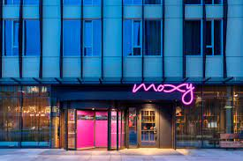

Table of Contents
1 Introduction 2
2 Situation Analysis 2
2.1 Company: SWOT analysis (Micro analysis) 2
2.2 Customers: Segmentation and Targeting/ Customer Profile 3
2.3 Competitors: Perceptual positioning map, Bowman’s strategy clock 3
2.4 Collaborators 3
2.5 -Climate: PESTLE (Macro analysis) 3
3 Objectives 4
4 Strategy 5
5 Tactics 5
6 Marketing mix: 5
6.1 Product 5
6.2 Place 5
6.3 Price 6
6.4 Promotion RACE/ 6
7 Action 7
8 Control (100 Words) 7
9 Conclusion 8
10 References 8
11 Appendices 9

Introduction
The purpose of this marketing plan is to market the product effectively in order to determine its success. Further, it will use the SOSTAC strategy while adding the Gannt chant in order to determine the time of this marketing plan and strategy. Further, it will also use the bowman strategy to argue the different competitors with the hotel. The hotel chosen for this report is Moxy Hotel to make its marketing plan. It provides leverage to the marketer to use digital marketing to gain an unprecedented understanding of their consumers (Reed, 2014).

Situation Analysis

Company: SWOT analysis (Microanalysis)
Strengths:  - It is built upon the legacy of Marriot.  - It is affordable and targets all people.  - It has an unprecedented hotel environment with the provision of all amenities.  - It provides price per value. | Weakness:  - People need to be made aware of this brand.  - There are many competitors in the market.  - It cannot monetize the Marriot segment (George, 2018).
Opportunities:  - It provides Marriot International membership.  - It also targets the growing millennial segment.  - It should be grow and expand in novel destinations as demanded by customers. | Threats:  - Customers have the perception of high prices due to Marriot's legacy.  - There is also the continuation of the economic recession.  - There are more alternatives within a same price range and target market.

Customers: Segmentation and Targeting/ Customer profile
Segmentation: Millennials and seasoned travellers, Gen Z and youth, elite class and high prices
Targeting: The main targets are youth and tech-savvy people looking for affordable prices and good services that can provide them with a good environment.
Customer’s profile: The customers’ profile of Gen Z are successors of Millennials. Hence, people born from 1997 to 2012 are targeted (George, 2018).

Competitors: Perceptual positioning map, Bowman’s strategy clock
Appendix 1 shows that Moxy is in the middle mainly in the map and provides neutral prices and good services also. Hence, the main competitors are Ibis, Motel One, Holiday Inn Express, Hampton by Hilton and citizenM Hotels.
According to appendix 2, Moxy in Bowman's strategy is considered as differentiation. This strategy ranges from full merchandise diversity to exceptional features within a core product.

Collaborators
Moxy Hotels and Megan Massacre have joined hands with the tattoo artist to deliver complimentary tattoos motivated by the brand's Blank Canvas art program. It helped show the hotel's more playful and bolder side through tattoo studios and allowed guests to celebrate emerging tattoo artists in a more 'permanent' way (Tolentino, 2019).
Moxy hotel also contacted New York-based Indiewalls, a tech-dependent company that links artists and designers to get artwork for the hotel. It showcased the art which targets youth (Fox, 2017).
Moxy also collaborated with the award-winning theatre, Upright Citizens Brigade, to train hotel employees for good customer service and courtesy (Williams, 2022).

-Climate: PESTLE (Macro analysis)
Political  - Political uncertainty can impact the hotel business negatively.  - International relations can affect a hotel's business.  - Any attack can close or decline the business in the country. | Economic  - There are many competitors in the global market.  - Economic stability can increase the hotel business.
Social  - The earning individual's income is the main factor contributing to it.  - The perception and thinking of individuals also create the foundation for the business. | Technological  - The hotel is tech-savvy.  - There are free Wi-Fi services available in the hotel.  - Digitalization of services is also provided, which affects the business.
Legal  - The minimum wage is the main component that should be focused upon.  - If the hotel breaks any law, it is punishable, which will tarnish its reputation and image. | Environment  - Sustainability and eco-friendly products to be used by the hotel.  - The hotel should overlook at green-friendly policies in the hotel.

Objectives
Specific: To be as specified in the marketing plan through the target market and means of the marketing plan.
Measurable: To measure the success of the marketing plan through different tactics. The tactics are mainly feedbacks, revenue and crowd at the hotel.
Achievable: To achieve the marketing plan with the given resources and time.
Relevant: To be relevant in this marketing and focus on the hotel.
Time-bound: To fulfil and achieve the marketing plan success within a given time period.

Strategy
The hotel's value proposition mainly depends on creating an environment based on nonconformity, open-mindedness, and originality. These values mainly make up the hotel's basic surrounding. Further, it is backed by Marriot's legacy loyalty program, offer quick entrance to the world market and to all global platforms (Jenny, 2018).
The organization’s value proposition is different from other hotels due to its focus on being youth and specifically tech-savvy and fun hunters in order to market their hotel. Further, the value proposition will be delivered through digital marketing to the targeted customers.
Nowadays, youth is mainly more fun-hunting and technological individuals who want technology, especially free Wi-Fi services. Youth is mainly on digital gadgets; hence this hotel will use whole digital means to market the hotel (Lein et al., 2015).

Marketing mix:

Product
The product mainly offered is the hotel with many different amenities available. The employees are trained after their recruitment to satisfy the customers. Hence, the services include parking, a restaurant, a bar, a 24-hour desk for help, a non-smoking hotel, game room, 24-hour check-in and free Wi-Fi. Selectively, the rooms are mainly equipped with soundproof rooms, air conditioning, desk, housekeeping, clothes rack and flat screen TV (Booking.com) (Devries, 2018).

Place
The hotel is located in London, UK. The hotel in London is near to central London and is located near the property. It is also near Olympic Stadium, which is 1.2 km from MOXY London Stratford, while Victoria Park is 2.8 km away. The nearest airport is London City Airport, 6 km from the property. Hence, the guests who knows where the hotel is located can avail of numerous public transport or public transport. The guests can also use google maps or the main website to locate the hotel (Booking.com) (Devries, 2018).

Price
The price of this hotel varies from £146 to £149 per night. Thus, comparatively, the pricing is low for the customers but provides excellent services in order to build brand value (Marriott).

Promotion RACE/
Reach: Thus, the plan will be reached first through market research through chosen sampling from the youth about their needs. Hence, the marketing plan will be made according to the needs and expectations from the hotel. Then, a yearly plan will be made in which influencer marketing, affiliate marketing and social media platforms will be used (Bala and Varma, 2018).
Act: The act will be according to the plan when the influencer will be contacted. Affiliate marketing will be started first. Then, a linked page on Instagram will be made where the guests will show their stay at the hotel through new clicks and pictures. It will also be done showing reviews and feedbacks.
Convert: The implementation of the digital marketing will be converted through people's response. The sale is mainly offline which will be communicated through online site as the target market set are engaged through digital media.
Evaluate: It is the long-term plan to engage customers with the hotel. Thus, through site, social presence, email, and direct interactions will help boost customer lifetime value. It will be measured through repetitive activities like full-house and sharing pictures through social media (Bala and Varma, 2018).

Action
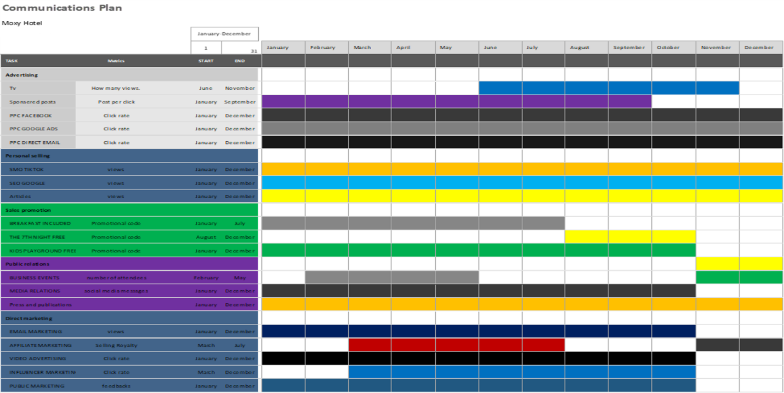

The Gannet chart is defined as the framework in which the activity or any behaviour will be implemented (Sharon and Dori, 2017). Thus, for this marketing, the year is planned to do the whole marketing plan. Thus, social media planning, influencer marketing and affiliate marketing will also be planned. Digital marketing has been a gradual process; hence it will take from 10 months to 12 months also in order to determine its effectiveness and efficiency. Further, this plan provides the framework for this marketing plan. Therefore, a plan will help work in a sequence of activities which is needed.

Control
The success will be measured using metrics decided in the marketing plan. Thus, the feedback, views on the articles, affiliation from people, and likes from people, revenue generation and clicks on the website help determine the success. From this, the marketing plan also targets new customers in order to build a new market (Desai and Vidhyapath, 2018). Thus, old customers will be engaged to enhance their loyalty and satisfaction. The target market selected mainly sticks to one thing of their liking. Hence, it is crucial to benefit from loyalty by making positive attitudes towards the brand and also increasing profits.

Conclusion
To sum up this report, the challenges encountered as a marketer was related to the process being too slow and gradual. However, it is a slow process with the results determined slowly. Further, another challenge encountered was limited resources which was used and available. The affiliate marketing caused more problems than any other marketing tactic.
The recommendations mainly include being grateful for the available resources and time due to digital marketing being an easy platform to use. The strategies should be made according to the target market and time.

References
Andi, B.B., 2021. THE IMPACT OF BRAND IMAGE ON CUSTOMER LOYALTY IN MOXY BANDUNG HOTEL (Doctoral dissertation, Poltekpar NHI Bandung).
Bala, M. and Verma, D., 2018. A critical review of digital marketing. M. Bala, D. Verma (2018). A Critical Review of Digital Marketing. International Journal of Management, IT & Engineering, 8(10), pp.321-339.
Booking.com Moxy London Stratford, London, UK (no date) Booking.com. Available at: https://www.booking.com/hotel/gb/moxy-london-stratford.en-gb.html?aid=356980&label=gog235jc1DCAsoUEIVbW94eS1sb25kb24tc3RyYXRmb3JkSDNYA2i1AYgBAZgBCbgBF8gBDNgBAgBAYgCAagCA7gC6KyboAbAAgHSAiRhZDFiMTgzNy03ZmRlLTQzZGEtYTFlZi0zMGUwNGQ2OTkxOTXYAgTgAgE&sid=ff7b14dbd6b8912ebe250a2728f8e639&dist=0&keep_landing=1&sb_price_type=total&type=total& (Accessed: March 7, 2023).
Bowen, J.T. and McCain, S.L.C., 2015. Transitioning loyalty programs: A commentary on “the relationship between customer loyalty and customer satisfaction”. International Journal of Contemporary Hospitality Management, 27(3), pp.415-430.
Desai, V. and Vidyapeeth, B., 2019. Digital marketing: A review. International Journal of Trend in Scientific Research and Development, 5(5), pp.196-200.
Devries, P.J., 2018. THE BIG SLEEP. Business Traveller, pp.32-38.
Fox, J.T. (2017) Art with moxy: How a hotel found its groove via art, Hotel Management. Available at: https://www.hotelmanagement.net/design/art-moxy-how-a-hotel-found-its-groove-via-art (Accessed: March 7, 2023).
George, R., 2021. Market Segmentation, Targeting, and Positioning. In Marketing Tourism and Hospitality: Concepts and Cases (pp. 221-246). Cham: Springer International Publishing.
Jenny (2018) Why moxy hotels target guests who are 'fun hunters', Globetrender. Available at: https://globetrender.com/2018/02/09/moxy-hotels-fun-hunters/#:~:text=Owners%20recognise%20Moxy's%20value%20proposition,per%20cent%20of%20signed%20deals. (Accessed: March 7, 2023).
Lien, C.H., Wen, M.J., Huang, L.C. and Wu, K.L., 2015. Online hotel booking: The effects of brand image, price, trust and value on purchase intentions. Asia Pacific Management Review, 20(4), pp.210-218.
Marriot. Welcome to Moxy London Excel. New London budget & lifestyle hotel near Excel & City Airport- Moxy Hotel London. Available at: https://www.marriott.com/en-us/hotels/lonor-moxy-london-excel/overview/ (Accessed: March 7, 2023).
Reed FIDM, D., 2014. SOSTAC: The guide to the perfect digital marketing plan. Journal of Direct, Data and Digital Marketing Practice, 16(2), pp.146-147.
Sharon, A. and Dori, D., 2017. Model‐Based Project‐Product Lifecycle Management and Gantt Chart Models: A Comparative Study. Systems engineering, 20(5), pp.447-466.
Tolentino, C. (2019) Moxy Hotels to offer complimentary tattoos with artist Megan Massacre, Travel Daily. Available at: https://www.traveldailymedia.com/moxy-hotels-megan-massacre-collaboration/ (Accessed: March 7, 2023).
Williams, R. (2022) Moxy Birmingham NEC, a Marriott Hotel, Birmingham: Info, photos, reviews: Book at Hotels.com, Hotels.com. Available at: https://uk.hotels.com/ho1361156384/moxy-birmingham-nec-birmingham-united kingdom/? locale=en_GB&amp;pos=HCOM_UK&amp;siteid=300000005 (Accessed: March 3, 2023).

Appendices
Appendix 1
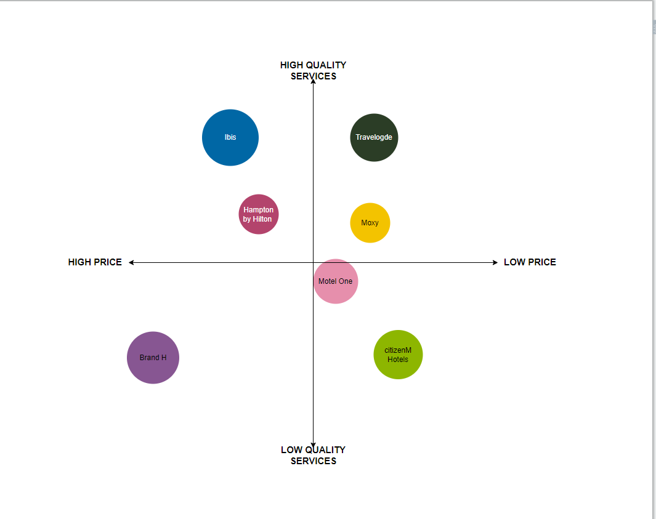

Appendix 2
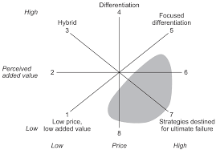

Appendix 3



