Critical Evaluation of Technologies Used in the
Construction of Bryn Bragl

Created For:
Rhodri Thomas

Created by:
Tomos Williams

Date Completed:
January 09th 2026

Contents
1. Introduction 3
2. Development Context and Project Summary 3
3. Construction Methods and Building Envelope 4
3.1 The Fabric First Design Method 4
3.2 Structural Insulated Panels (SIPs) 4
3.3 Airtightness and Thermal Performance 5
4. Design Influences: Technology and Local Environment 5
4.1 Climatic Environment 5
4.2 Spatial Orientation and Volume Composition 5
4.3 Integration of Technologies 5
5. Building Services Strategy 6
5.1 Sustainable Low-Carbon Heating and Hot Water 6
5.2 Mechanical Ventilation with Heat Recovery (MVHR) 7
5.3 GSE in roof Photo Voltaic (PV) Panels 7
5.4 Tesla Powerwall 2 Home Battery 8
5.4 Controls and User Engagement 8
6. Critical Evaluation and Comparison with Other Developments 9
6.1 Strengths and Innovations 9
6.2 Challenges and Limitations 9
7. Conclusions and Recommendations 9
7.1 Conclusions 9
7.2 Recommendations 10
References 11

1. Introduction

The construction sector is now expected to account for around 39% of global CO2 emissions, including both operational and embodied carbon (IEA, 2021).
The residential sector is considered to account for approximately 20% of total greenhouse gas emissions in the UK. This is mostly due to the amount of space heating and hot water consumed by the UK population (BEIS, 2021).
The governments of the United Kingdom and Wales have responded by tightening the imposed limitations in order to reduce the amount of carbon dioxide produced by households and make them more energy efficient, helping to combat fuel poverty. Wales has a particularly bad problem with energy-efficient homes because its housing stock is older, there are many people living in fuel poverty, and the country relies heavily on heating systems that use fossil fuels such as gas, oil, and wood (Welsh Government, 2021).
As a result, the government is putting increasing pressure on housing groups and construction businesses to design low-carbon, low-cost homes capable of coping with the effects of climate change. When viewed from this perspective, the Bryn Bragl complex in Bridgend is a pioneering example of environmentally responsible residential development in South Wales.
Wales & West Housing is constructing Bryn Bragl, which will have fourteen flats, with assistance from Zenergy Design and other professionals. The idea is to develop two four-bedroom residences, eight two-bedroom semi-detached homes, and four one-bedroom apartments. The CIBSE Residential Project of the Year 2024 award made the development known across the country. This award was given because the facility was technologically innovative and performed well in the real world. It is also important to note that Bryn Bragl was designed with a healthy energy balance in mind. This demonstrates that it generates more energy than it consumes each year, and any excess energy is fed back into the national grid. (Wales and West Housing, 2023).
I will examine the construction technique employed and the way in which the properties were developed in order to demonstrate and evaluate the buildings as a whole, as well as share my thoughts on whether or not they were successful in their effort to develop positive energy features.

2. Development Context and Project Summary

Planning references P/17/393/FUL and P/18/410/FUL indicate that Bryn Bragl, a Bridgend development, has successfully completed the permission procedure. The Welsh Government's Innovative Housing Programme funded the effort. The program's purpose is to stimulate new ideas in housing design and delivery, with a focus on making it more accessible and reducing carbon emissions (Welsh Government, 2020).
The Welsh School of Architecture at Cardiff University chose Solcer House, a research-oriented building, as a model for this concept. The Solar House demonstrated that combining high-performance fabric, renewable energy sources, and cutting-edge energy management technology may result in a net-positive energy dwelling. Bryn Bragl shows a significant evolution of this concept in the process of transforming a single experimental prototype into a multi-unit residential complex designed for social housing. Powell et al. (2019).
It is worth noting that the client brief placed equal emphasis on buildability, occupant comfort, and sustainability. As a result, the project team made an attempt to combine cutting-edge technology with proven successful methods. This was done to ensure that occupants with varied levels of technical competence and comprehension could grasp the systems, and that the housing association could sustainably maintain them.

3. Construction Methods and Building Envelope

3.1 The Fabric First Design Method

The fabric-first design method is one of the main ideas behind the Bryn Bragl development. This design approach puts a higher priority on lowering energy use through the building envelope rather than relying on mechanical or electrical systems to make up for poor fabric performance (Zero Carbon Hub, 2016).
By minimising heat loss, building services may be made smaller and more complex, which will in turn make them work better.

3.2 Structural Insulated Panels (SIPs)

The main method used to construct the building's envelope at Bryn Bragl is with structural insulated panels, or (SIPs) for short. A stiff, insulated core is sandwiched between two structural facings, which are usually oriented strand board (OSB) for short. This is the general makeup for SIP panels.
Modules are put together on-site after being made off-site in a controlled environment. They are used to build walls, roofs, and floors. (SIPs) It has a lot of benefits when it comes to performance and the environment.
Seamless insulation with little thermal bridging, which enhances the material's exceptional thermal performance.
Superior airtightness, which helps reduce uncontrolled air infiltration and the related heat losses.
A shorter building program, which reduces the amount of energy used on the site and the amount of manpower that is required.
Precision manufacturing of panels, which results in less waste during construction,
Specifically, in situations when the craftsmanship on the site fluctuates.
Research conducted by the NHBC Foundation reveals that structural insulated panels (SIPs) have the potential to exceed traditional masonry construction in terms of thermal efficiency and airtightness consistency (NHBC,2018).

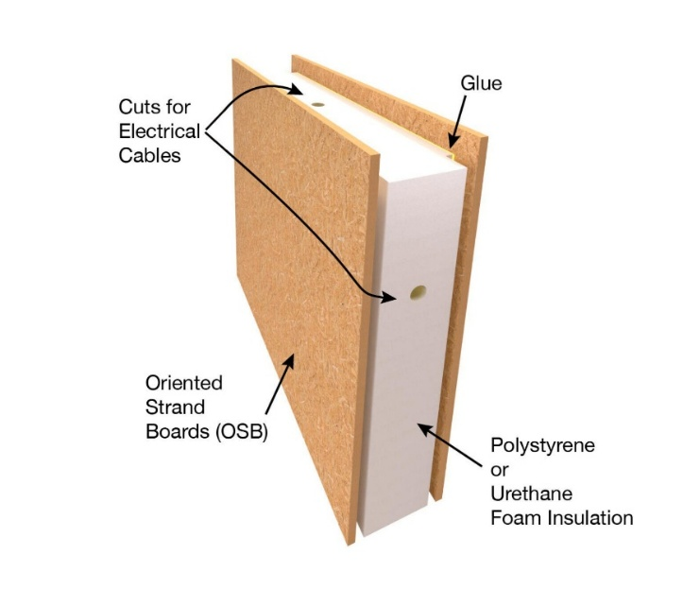 (Hill, 2023)

3.3 Airtightness and Thermal Performance

Due to the fact that uncontrolled air leakage may be responsible for a large amount of heat loss in traditional buildings, airtightness is considered an essential component of low-energy housing and also contributes to reduced heating costs for the occupant. Through the use of the SIPs building technique, it is possible for Bryn Bragl to attain airtightness values that are far higher than those that are generally obtained in conventional homes and complexes that use traditional masonry construction.
The use of triple-glazed windows and elevated levels of insulation in the walls, roofs and floors of the building, in conjunction with the construction fabric, results in a considerable reduction in the amount of space heating demand. This decrease is needed in order to enable the adoption of low-temperature heating technologies, such as heat pumps, which function most effectively in buildings that have enough insulation (Energy Saving Trust, 2022).
From the point of view of operational carbon, the improved fabric performance immediately leads to a reduction in energy consumption and a decrease in emissions over the lifespan of the building.

4. Design Influences: Technology and Local Environment

4.1 Climatic Environment

Generally, Bridgend has a warm maritime climate with pleasant winters, moderate summers, and a lot of rain most of the time. Solar irradiation levels are lower in this part of southern Wales compared to those in other parts, but they are still high enough to allow for a lot of photovoltaic power generation when systems are installed and set up correctly (Met Office, 2022).
Bryn Bragl's design took into account the climate conditions in the area, which shows that they understood how to reduce discomfort and heat loss. Buildings are positioned to catch the most sunshine while avoiding strong winds.

4.2 Spatial Orientation and Volume Composition

Roof heights, building layouts, and orientations were designed to maximise solar panel performance. The south-facing roof slopes received the most attention, and every attempt was made to minimise shadows from nearby buildings. The windows were strategically placed to let in more light and to keep the heat in but also positioned in a way that reduced the risk of overheating from solar gain. Due to the houses modest size, the outer surface area is smaller than the inner volume, which aids in the retention of heat (Wales & West Housing, 2023).
According to the Building Research Establishment, this concept has been proven to significantly increase energy performance and is frequently used in the construction of low-energy dwellings. (BRE, 2022).

4.3 Integration of Technologies

The early and extensive deployment of low-carbon technology represents one of the most significant advantages presently held by the Bryn Bragl initiative. Rather than retrofitting renewable energy systems onto a standard design, the buildings were originally conceived to integrate solar panels, battery storage, and mechanical ventilation systems. In contrast, the systems were integrated into a standard design. Many of the trade-offs that are frequently observed in such developments are lessened by this integrated approach. When sustainability elements are added to a project at a later stage of the design process, they can occasionally result in poorer performance or aesthetic challenges, which is not the case in Bryn Bragl (CIBSE, 2022).

5. Building Services Strategy

5.1 Sustainable Low-Carbon Heating and Hot Water

In keeping with the goals of decarbonisation, Bryn Bragl does not use gas-powered furnaces. Instead, heating and hot water are provided via heat pump systems powered by electricity. The operation of heat pumps entails extracting low-grade heat from the ambient environment and subsequently elevating that heat to a temperature suitable for practical use. Heat exchangers offer significantly higher efficiency compared to direct electric heating. (Energy Saving Trust, 2022).
In homes with sufficient insulation, such as Bryn Bragl's, heat pumps may maintain comfortable interior temperatures by employing moderate output temperatures. This minimises the related running costs and greatly improves the system's efficiency.

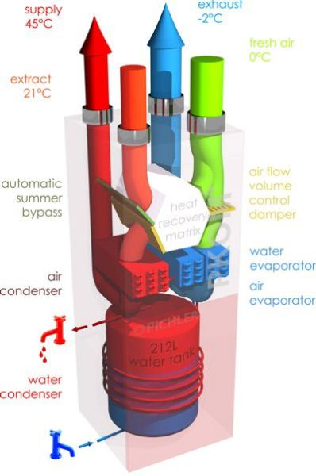 (Anon, 2022)

5.2 Mechanical Ventilation with Heat Recovery (MVHR)

The system, which includes a hot water storage tank with a capacity of 212 litres, is housed in a single unit to conserve valuable floor space. An application for a smartphone or tablet can be used to manage the system, which is ready to combine with renewable energy sources such as photovoltaic (PV) panels and is smart grid ready. The pioneering two-circuit heat pump technology not only provides hot water but also heats and cools the room. Superior quality filters (F7 for supply air and M5 for extract air) remove minute particles, dust, pollen and mould spores, resulting in cleaner air within the building (Pichler, 2026).
Because the building shell is completely impervious, controlled ventilation is also required. To reduce heat loss and provide a consistent supply of fresh air, Bryn Bragl employs mechanical ventilation with heat recovery (MVHR) systems that reach heat recovery efficiencies of up to 90%. Mechanical ventilation and heating and cooling (MVHR) systems transfer heat from extracted air to incoming fresh air.
The indoor air quality improves, the likelihood of condensation is minimised, and occupant comfort increases. In contrast, (MVHR) systems must be meticulously commissioned and maintained on a regular basis. (CIBSE, 2020).

5.3 GSE in roof Photo Voltaic (PV) Panels

One of the distinguishing qualities of GSE in roof systems is the universal compatibility. This device supports both portrait and landscape orientations, making it compatible with about 95% of framed solar modules currently on the market. The system is totally watertight, and the designs have been tested for both fire resistance and mechanical strength against wind and snow. Professional installers can install a typical 16-panel array in as little as six hours. This is only one of the many benefits of this product. The design requires a minimum of one hundred millimetres of space between the solar modules and the roof substructure. This is done to ensure that there is enough airflow, which is required to keep the panels operating efficiently. It may be used on roof slopes ranging from 12° to 50°, making it excellent for both new construction and restoration projects (GSE, 2020).
The solar panels on the roofs of every home in the development are supposed to generate more power each year than the residents need.

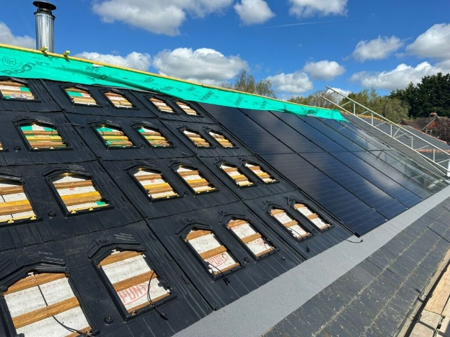 (ANON, 2026)

5.4 Tesla Powerwall 2 Home Battery

The Tesla Powerwall 2 is a well-known lithium-ion household battery that has a capacity of 13.5 KWH and has the ability to store solar energy, supply backup power, and save money by lowering energy consumption. Installing it in the United Kingdom may cost anything from £8,000 to £10,000. It is being gradually phased out in favour of the updated Powerwall 3, which provides advanced energy management, seamless interaction with solar photovoltaic systems, and a guarantee that lasts for ten years. In order to create extra storage of 135 kWh, it is possible to stack up to 10 units. Stylish and compact, wall or floor mounted, and suitable for use both indoors and outdoors (TESLA, 2026).
The International Energy Agency says that battery storage makes it much easier to use renewable energy for personal consumption, which is an important part of energy-positive performance. Sending extra electricity to the grid can assist with bigger plans to cut down on carbon emissions (IEA, 2021).

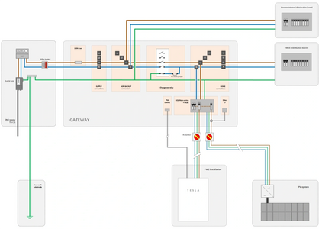

(Egensys, 2024)

5.4 Controls and User Engagement

Residents can easily keep an eye on and regulate how much energy they make, store, and use thanks to advanced monitoring and control systems, based on research done by the UK Green Building Council (UKGBC, 2019).
Giving people real-time feedback can make the system work better and, therefore, make them more aware of how much energy they are using. Nevertheless, the effectiveness of such systems is highly contingent upon the degree of understanding held by the occupants. Residents may not interact with the controls or may misuse them if adequate instruction and guidance are not provided. This will lead to a decrease in the overall effectiveness of the technology.

6. Critical Evaluation and Comparison with Other Developments

6.1 Strengths and Innovations

The creation of the Bryn Bragl development has proven that it is possible to create energy-positive houses within the social housing sector. A few of the key strengths are:
- A method that stresses the cloth initially.
- Innovative and efficient incorporation of renewable technology.
- Elimination of heating produced by fossil fuels.
Considerable alignment with the standards of future regulatory agencies.
Initiatives like BedZED in London and Passivhaus-certified housing complexes in Exeter, where there has been documented proof of reduced energy use and increased tenant satisfaction, have demonstrated a similar degree of success (BRE, 2018; Passivhaus Trust, 2020).

6.2 Challenges and Limitations

Bryn Bragl, while its success, also exposes some issues that are common to sustainable housing, including the following:
- A higher initial investment in capital.
- An increase in the complexity of the design and commissioning.
- A dependence on the actions of the occupants.
- The failure of certain early low-carbon dwelling complexes to meet their expectations might be attributed to points such as insufficient commissioning or a lack of tenant education. (Zero Carbon Hub, 2016).
Bryn Bragl mitigates these risks through monitoring and support, but long-term performance data monitoring will be essential to confirm how successful the project is.

7. Conclusions and Recommendations

7.1 Conclusions

With regard to the development of environmentally appropriate residential construction in South Wales, the establishment of Bryn Bragl represents a significant step forward. It has shown that it is possible for the development to achieve the best outcome of energy positive operation while also delivering high levels of comfort for the occupants it serves. Building fabric with high performance, building services with low carbon emissions, and the generation of renewable energy are the means by which this objective is fulfilled.
The findings of this study demonstrate that innovative building techniques and technologies may be effectively implemented on a larger scale at a community level, providing valuable insights that can be used for the creation of housing in the future. In addition to that, the project indicates that these things are capable of being accomplished successfully.

7.2 Recommendations

Any construction companies that are interested in making the transition towards more ecologically friendly methods, should consider the following advice
- It is recommended that you make the implementation of a fabric-first method a regular habit.
- It is imperative that low-carbon technologies be incorporated from the very beginning of the design process.
- It is important to pay attention to the processes of commissioning, monitoring, and occupant engagement.
- Instead of concentrating just on the initial expenditure, it is recommended that initiatives be evaluated according to how well they work in general.

References

BEIS (2021) Heat and Buildings Strategy. London: Department for Business, Energy & Industrial Strategy.
BRE (2018) Lessons from Low-Energy Housing. Watford: Building Research Establishment.
BRE (2019) Structural Insulated Panels: Performance and Applications. Watford: BRE.
CIBSE (2020) Guide B: Heating, Ventilating, Air Conditioning and Refrigeration. London: CIBSE.
CIBSE (2022) TM65: Embodied Carbon in Building Services. London: CIBSE.
Energy Saving Trust (2022) Heat Pumps in Homes. London: EST.
IEA (2021) Energy Storage and Renewables. Paris: International Energy Agency.
Met Office (2022) UK Climate Averages. Exeter: Met Office.
NHBC Foundation (2018) Modern Methods of Construction. Milton Keynes: NHBC.
Passivhaus Trust (2020) Social Housing Case Studies. London: Passivhaus Trust.
Powell, T., Densley-Tingley, D. and Jones, R. (2019) The Solcer House: Energy Positive Housing in Wales. Cardiff: Cardiff University.
UKGBC (2019) Advancing Net Zero Homes. London: UK Green Building Council.
Wales & West Housing (2023) Homes of the Future Near Completion in Bridgend. Available at: https://www.wwha.co.uk (Accessed: 2026).
Welsh Government (2020) Innovative Housing Programme. Cardiff: Welsh Government.
Welsh Government (2021) Net Zero Wales. Cardiff: Welsh Government.
Zero Carbon Hub (2016) Closing the Gap Between Design and As-Built Performance. London: ZCH
https://www.totalhome.co.uk/ventilation/?pid=594(Accessed:2026) (Anon, 2022)
https://www.solar-voltaics.com/blog/in-roof-vs-on-roof-solar-panels-which-is-right-for-you/ (Accessed:2026)
https://www.gseintegration.com/ (Accessed:2026) (GSE, 2026)
https://www.tesla.com › en_gb › powerwall (Accessed:2026) (Tesla, 2026)
https://egensys.co.uk/tesla-powerwall-2 (Accessed:2026) (Egensys, 2026)
https://www.risedesignstudio.co.uk/blog/exploring-structural-insulated-panels-are-sips-right-for-your-self-build-project (Accessed:2026) (Hill, 2023)

