

How can Marketing Communications be employed to entice new clients through social elements for Luxury manufacture
Christian Dior SE

STUDENT NAME:YOANA DIMITROVA
STUDENT ID:2021302
SUPERVISOR:TUSHARA BALENDRAN
MODULE:LCBB6000

Abstract:
The research mainly aims to probe the concepts of “Marketing Communications” and the importance in enticing new customers via the means of social components by the luxury manufacturer Christian Dior SE. In this study, the organization under consideration is the Christian Dior SE and it is commonly known as Dior and a French multinational luxury fashion house regulated and chaired by a “French Businessman Bernard Arnaullt”. The study would also help the company to curate effective communication strategies that would not help them to effectively interact with their existing consumers, but also would help them to earn prospective customers via different mediums. The study would take under consideration discussions entailing social media tools, online reviews, advertisements and other elements of integrated and effective brand communication. The study shows that the luxury services and products are built around the story about why one does what he or she does beyond monetary gains and profitability. In today’s digital era, it is important for luxury brands to use various online or digital media platforms for communicating with the clients as these platforms can target a wide online audience.

Acknowledgements:

Table of Contents
Chapter 1: Introduction: 2
Background 2
Rationale of the study: 2
Research gap: 2
Aims, objectives and research questions: 3
• Overarching aim of the research: 3
• The research objectives: 3
• The research questions: 3
Dissertation outline: A brief outline of each chapter in the dissertation: 4
Chapter 2: Literature review: 5
Chapter overview: 5
Importance of integrated marketing communication for luxury brands: 5
Digital marketing and its effects on consumer acquisition: 6
Dior’s current digital marketing strategy: 7
Brand equity: 9
• RACE model 9
Main pros and cons of the model: 10
Best practices with regard to integrated communication marketing for enticing new consumers: 10
Gaps in literature: 12
Chapter 3: Research Methodology: 13
Chapter overview: 13
Research philosophy: 13
Research approach: 13
Research strategy: 14
Choice of method: 14
Time-scale: 14
Sampling 15
Data collection/analysis: 15
Ethical considerations: 16
Chapter 4: Data analysis and discussions 17
Data Interpretations: 20
Chapter 5: Conclusion and recommendations: 28
Conclusion/summary: 28
Linking with objectives: 28
Research limitations: 29
Recommendations: 29
Future implications: 30
Future research: 30
References: 31

Chapter 1: Introduction:

Background
For the brands that are looking for success within the luxury sector, one of the most important factors is the authenticity and establishment of trust amongst the minds of people. The brands have to create strategies so that people believe in their brands’ stories and hence they have to make their communication credible, and meaningful to them (Kaur, 2017). The services and products are built around the story about why one does what he or she does beyond monetary gains and profitability (Arora and Faisal, 2022). In today’s digital era, it is important for luxury brands to use various online or digital media platforms for communicating with the clients as these platforms can target a wide online audience. In this study, the organization under consideration is the Christian Dior SE and it is commonly known as Dior and a French multinational luxury fashion house regulated and chaired by a “French Businessman Bernard Arnaullt” (Alghizzawi, 2019).

Rationale of the study:
The study would mainly focus on identifying the factors for the selection of the various aspects of effective and integrated communication marketing for the promotion of luxury brands. It is important to note that this study would help the company under consideration, that Christian Dior SE, to understand and learn about various ways of communication marketing, their effects and importance (Silvia, 2019). It is further to be noted that this study would help the company to fetch important insights and information about how to entice new and large numbers of customers through communication marketing through social elements (Alghizzawi, 2019). The study would also help the company to curate effective communication strategies that would not help them to effectively interact with their existing consumers, but also would help them to earn prospective customers via different mediums (Silvia, 2019). The study would take under consideration discussions entailing social media tools, online reviews, advertisements and other elements of integrated and effective brand communication.

Research gap:
It is to be noted that there is a limited number of literature and secondary sources present about the various integrated and communication marketing strategies within the fashion industry. Moreover, it is important to note that the researcher also faced difficulty in reaching out to the survey participants as it was time taking to find out the right candidates or respondents for the survey (Silvia, 2019). Since the study was set out to be carried out based on Christian Dior SE, it is worth mentioning that very limited information is available online about the current marketing strategies and the marketing gaps within this particular organization due to company policies or confidentiality issues.

Aims, objectives and research questions:

Overarching aim of the research:
The research mainly aims to probe the concepts of “communication marketing” and the importance in enticing new customers via the means of social components by the luxury manufacturer Christian Dior SE

The research objectives:
The main research objectives that are to be addressed by the study are as follows:
- To determine the present integrated marketing communication strategy that is implemented by Dior
- To investigate the present digital marketing strategies used by Christian Dior SE
- To evaluate the effect of the integrated marketing communication on the “brand equity” of Christian Dior SE

The research questions:
The study would set out answer the following research questions:
- What are the various present integration marketing strategies implemented by Christian Dior SE?
- What are the present digital marketing strategies used by Christian Dior SE?
- What are the effects of integrated marketing communication in Christian Dior SE’s brand equity?

Dissertation outline: A brief outline of each chapter in the dissertation:
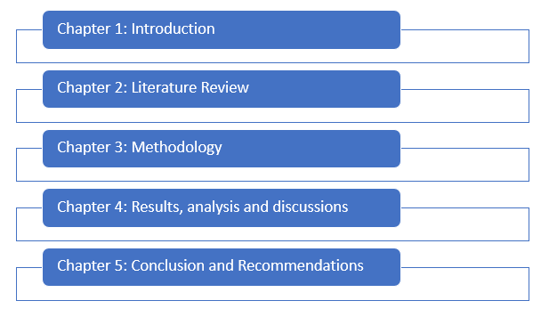
Figure: Study structure
Source: (Created by Author)
Chapter 1: Introduction: This chapter provides a brief outline of the research study’s roadmap, the rationale, aim, objectives and research questions that are to be addressed.
Chapter 2: Literature review: This chapter carries out a brief review of literature of various authentic, reliable and trust-worthy scholarly data sources such as books, journals, articles, and so on.
Chapter 3: Methodology: The chapter outlines the various methods, tools and techniques that have been taken under consideration while carrying out the research study.
Chapter 4: Data analysis and discussions: In this chapter the primary data (survey responses) would be analysed using data visualization techniques and effective interpretations would be discussed.
Chapter 5: Conclusion and recommendations: In this chapter the whole study would be summarized followed by some effective recommendations on future studies in this niche.

Chapter 2: Literature review:

Chapter overview:
The chapter entails a brief review of literature from various scholarly and authentic sources such as books, journals, research papers and so on. The relevant and insightful information from the various scholarly sources would be critically analyzed and the opinions, and findings of different secondary studies would be compared and contrasted amongst themselves to interpret relevant information addressing the aims and objectives of the research.

Importance of integrated marketing communication for luxury brands:
It is imperative for the luxury businesses like Christian Dior SE to communicate consistent stories in order to increase the effectiveness of the advertisement campaigns. Integrated marketing communications is basically a marketing technique that helps the brands in terms of bringing together all kinds of marketing efforts. According to the study of Kaur (2017), for brands such as Christian Dior SE, who are looking for success within luxury, it is vitally important for them to maintain their authenticity. It is important to note that through effective integrated marketing communication, they can integrate all the essential components of marketing for communicating similar messages to the existing and potential end-users. It is further to be noted that integrated marketing communication can go a long way in terms of spreading brand awareness amongst the consumers within a very minimal expense. According to the findings from the study of Alghizzawi (2019), this marketing strategy is very crucial for all luxury brands like Dior as generally within the luxury industry, the competition is fierce at these price points and also the luxury consumers can be utterly discerning. The strategies that the luxury brands use are generally different from what the other brands use. The role of integrated communication marketing is depicted through the figure below:
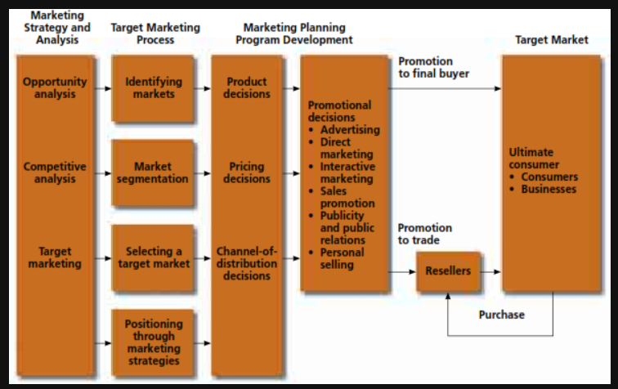
Figure: Role of Integrated Communication marketing
Source: (Phillips and Patel, 2021)
Aligning with the study by Silvia (2019), most of the luxury brands thus spend huge amounts on sponsorships and patronages of the events and causes that tend to intrigue the potential customers of the brand. It is further to be noted that marketing sponsorship should further focus on the events that are potentially related to the core of the brand and it is a very prestigious event. As per the notion of Muniesa et al. (2020) and Arora and Faisal (2022), it can be said that communication marketing is highly crucial for luxury brands like Dior as they help to establish effective relationships with the customers and create effective brand awareness and loyalties and it eventually drives sales. For this reason, it is imperative to the luxury brands of large sizes to understand the way to effectively leverage marketing communications for attaining the goals (Blakeman, 2023).

Digital marketing and its effects on consumer acquisition:
It is important to note that digital marketing is very important for the luxury brands and according to Krizanova et al. (2019), digital marketing allows the brands to reach a wider range of audiences as compared to “traditional marketing methods”. In line with the notion of Hofacker et al. (2020), it can be said that via online channels like search engines, emails, social media and with the help of “display advertisements”, one can target the most potential customers who have been readily seeking for products. In other words, it can be said that digital acquisition is referred to as the process of enticing as well as retaining new consumers via digital marketing strategies (Leung et al., 2022). As per Kim et al. (2021), digital customer acquisition is a vital aspect in the context of luxury branding for enticing new consumers and to find the products via relevant searches and as they are already “warm led” they are certainly convinced of the products very quickly and then onboard themselves in an effective manner. Furthermore, the study by Eagle et al. (2020) further confirms that digital marketing is held responsible for the consumers to get deeper data and insights about a specific brand or its products/services and this has caused the consumers to desire the best information on everything. Therefore, based on the study Eagle et al. (2020), it can be said that in order to leverage this mindset, one has to provide the most high-graded content to the potential consumers. A customer acquisition process is depicted through the figure below:
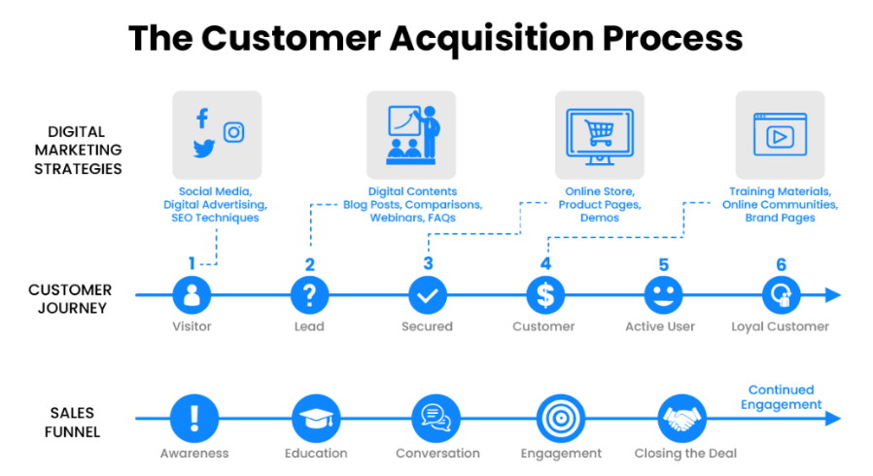
Figure: A customer acquisition process
Source: (Roy, 2022)
The study by Labanauskaitė et al. (2020) further notes that digital marketing has a very strong association with consumer acquisition and the digital marketing funnel tends to serve as a potential guide for all the actions, following each step of which, a brand can deliver the most potential and appropriate content to their consumers. Kurdi (2022) and Juska (2021) further suggest that it is important for the luxury brand owners to respect and value the time of the owners at every stage of the funnel and this broad view of consumer journey tends to allow one to urge them to move from one place to another.

Dior’s current digital marketing strategy:
For effective communication, the Christian Dior SE leverages a wide range of ad formats, starting from brand ambassadors, various narrative videos conveying the brand story to the customers, and also product focused carousels (Herhausen et al., 2020). They use numerous communication marketing ad platforms to communicate with the audiences in authentic and innovative ways. Martin et al. (2020) suggests that it entails a combination of media, online resources, engagement tools for promoting awareness regarding the businesses, and also intrigues the consumers to consider purchasing the products and services and make “future repeat purchases”. The statistics below show Dior’s brand value from 2016 to 2022 (Eagle et al., 2020).
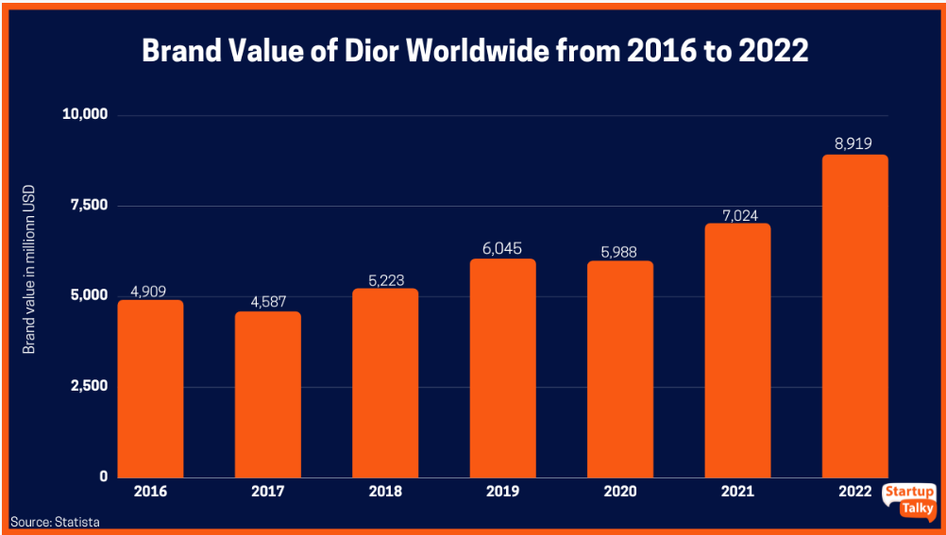
Figure: Dior’s brand value from 2016-2022
Source: (Karthikeyan, 2023)
As per Blakeman (2023), the main targeted audience of the company include affluent individuals who appreciate luxury clothing and the ones who have a good taste for sophistication, including young professionals, established elites, and so on. It is worth noting as per Leung et al. (2022) that luxury brands like Dior understand the weaknesses and the strengths of digital media in terms of integrated communication marketing and they use them in an effective manner to its benefits. Dior SE can be found on almost all social media platforms, printed media ads. reality shows, virtual exhibitions, and so on (Eagle, 2020).
It is further worth noting according to Eagle et al. (2020) that Dior also uses various segmentation strategies such as it has a number of accounts on social media platforms such as Instagram, Facebook, and so on. The core official account of Dior caters to the various primary consumers, however, there is also “Dior Homme” and this only targets the male customers in particular. According to Eagle (2020), this further allows them to potentially increase the relevance of their messaging, that appeals to one group of audience at a time.

RACE model
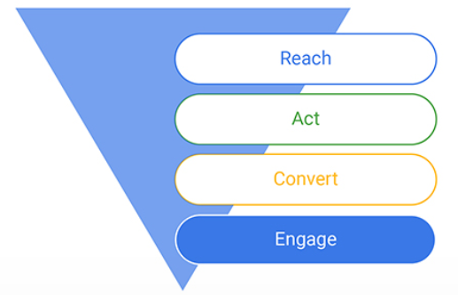
Figure: RACE model
Source: (PPCExpo, 2023)
Reach: This is the first stage where awareness generation takes place for the development of an understanding of the business with its products and services (Zaif and Cerchia, 2019). Here, Dior mainly collaborates with the most well-known brands such as Elle, Vogue, and so on to increase their brand awareness amongst their targeted customers (Zaif and Cerchia, 2019).
Act: In this phase, the brand mainly focuses on ensuring that the business is able to generate a particular volume of interaction across online as well as offline medium for lead generation (Zaif and Cerchia, 2019). Dior mainly focuses on offering various gifts and rewards to the customers by generating a ‘complimentary membership scheme” which would inspire and encourage the customers to undertake some positive buying decisions (Hossain et aol., 2020).
Convert: In this stage, Dior emphasises on taking up actual transitions of transformation of a potential customer of an existent buyer (Eagle, 2020). In this context, Dior also helps to offer personalized suggestions to their potential consumers, both online as well as online platforms to encourage positive purchasing decisions towards the purchase of a specific product from the brand (Kingsnorth, 2022).
Engage: In this phase, the brand mainly focuses on maintaining a potential long-term relationship with their customers that tends to act as a “profitability aspect” for Dior’s business (Eagle, 2020). To consumer engagement, the company runs loyalty programs for the sales of their products where the loyal consumers are given with some points that they redeem in their next purchases (Pelucchi et al., 2022).

Main pros and cons of the model:
- Pros:
It is a very useful model for the business with digital marketing approaches and also help making the right decisions and plans in terms of new product launches, and developing new business and marketing models (Zaif and Cerchia, 2019). This model helps in maximising the marketers’ reputation and increasing return on investments (Herhausen et al., 2020).
- Cons:
The RACE model of integrated communication marketing of Dior is not very suitable for traditional marketing based approaches (Zaif and Cerchia, 2019). Also, if one fails to implement the model correctly, it may result in negative marketing outcomes and may lead to negative publicity of the business (Perevozova et al., 2020).

Best practices with regard to integrated communication marketing for enticing new consumers:
According to the findings of the study by Kushwaha et al. (2020), one of the most potential forms of digital marketing strategy for enticing new consumers is social media marketing and the notion of Herhausen et al. (2020) and Blakeman (2023) further posits that social marketing strategies tend to vary across one platform to another. It is worth noting that according to the idea of Eagle et al. (2020), on platforms like Instagram and TikTok the most common norm of marketing is to post numeros videos everyday, while on the other hand, in the case of LinkedIn, the maximum, number of posts should be two to five per week as this is the way to stay effective and efficient on these platforms. Again, the suggestion by Krizanova et al. (2019) posits that “paid advertisements” via social media platforms such as TikTok, instagram and so on tend to boost the posts and hence the target audiences have higher probabilities to see them. Again, the idea of Silvia (2019) suggests that brands can also set some specific demographic on the basis of gender, locations, ages, and so on and hence can keep it open in order to reach a wide variety of users, based on their objectives and goals. The flowchart of integrated marketing communication is depicted below:
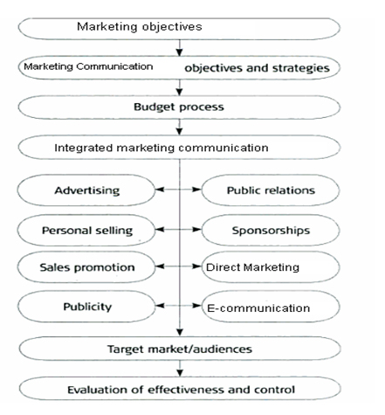
Figure: Flow chart for Integrated communication marketing
Source: (Marketing Evolution, 2023)
Furthermore, the study by Perevozova et al. (2020) confirms that integrated marketing is mostly undertaken by the luxury brands as a strategy for delivering a uniform and consistent set of messages across different marketing channels and used by the brands (Leung et al., 2022). Again, these marketing strategies tend to provide utter consistencies wherever the consumers choose to interact with a brand (Alghizzawi, 2019). . Thus, in line with the notion of Herhausen et al. (2020), it can be said that without an integrated marketing strategy, the risk of delivering mixed messages or for communicating in an non-uniform voice or a disconnected tone persists. In the case of luxury brands like Dior, the findings of Veleva and Tsvetanova (2020) suggest that combined brand messaging processes can be considered including online as well as traditional media. It is needed to align communications amongst all touchpoints of the “consumer journey map”. With it, the target audiences tend to get some consistent experiences of the company anywhere.
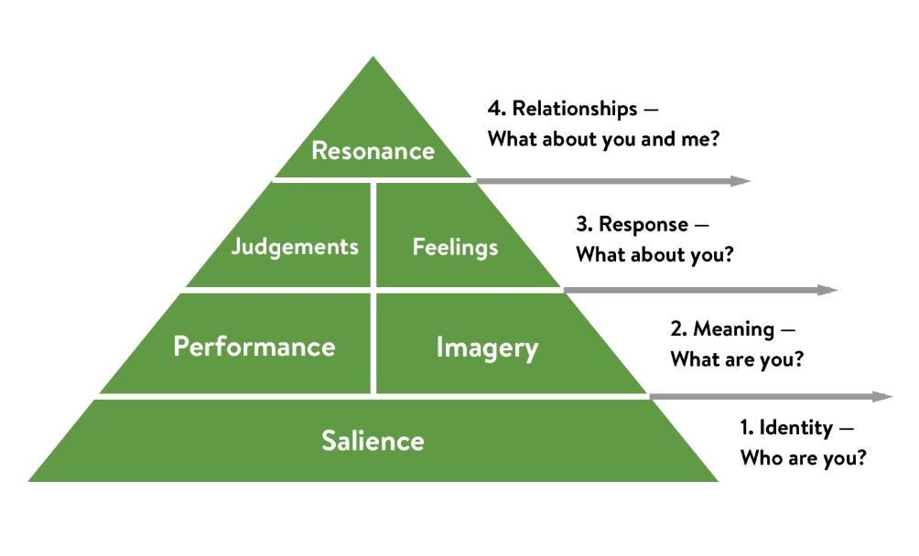
Figure: Keller’s Brand Equity Model
(Source: Moorhead, 2023)
The above model is “Keller’s Brand Equity Model” which depicts the stages of building brand equity. As per this model brand equity is built through a ground up approach. Relating this to the case of Dior, it can be said that in order to build effective brand equity, first they should establish salience by identifying who they are or what their aims, objectives, missions and visions are and then they should establish good performance and reputation (imagery) providing value to the customers through their business activities. In the next stage, they should develop positive judgements and feelings in the minds of the audience about themselves responding to their ques, queries and feedback. In the last stage, they can succeed to create a strong brand equity by resonating well with the customers, that is, by aligning with their needs, demands and trends.

Gaps in literature:
The availability of recent literature about the various aspects of integrated communication marketing in the field of fashion industry is very limited. In addition, one of the most significant gaps in the literature is that Dior’s website does not reveal much about its current marketing strategies, the challenges it faces and the future marketing plans.

Chapter 3: Research Methodology:

Chapter overview:
Research methodology is a logical and a systematic plan for resolving problems and the chapter entails the overall approach of the researcher in doing the research. This chapter would mainly ensure reliable, valid and relevant results of the study that would address the aims and objectives of the study. In addition to this, it also encompasses the types of data that are going to be collected from the research and the ways, tools and techniques that would be used for collecting data.
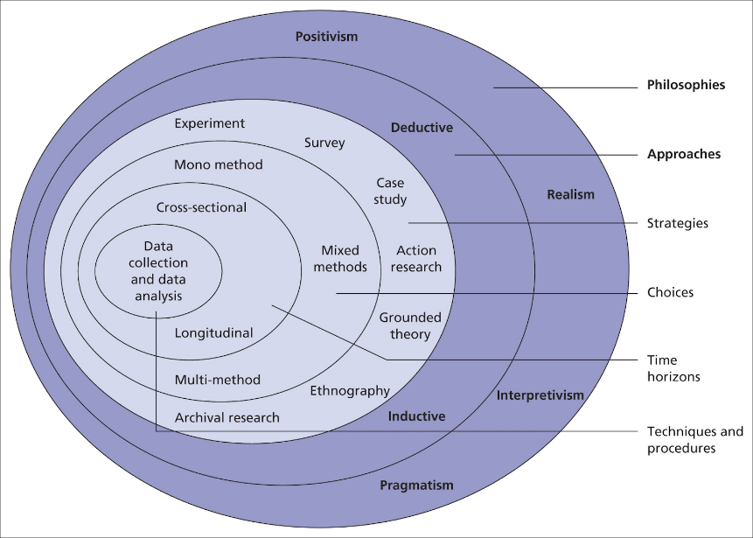
Figure: Research Onion
Source: (Sahay, 2016)

Research philosophy:
The research philosophy mainly entails a number of beliefs that tend to guide the executions and designs of a research study and offers ways to understand the scientific research. Here, the research would be considered “Positivist research philosophy” (Chen and Song, 2019). This is the ideal research philosophy for this research as it mainly deals with the facts and knowledge and mainly depends on “reasoning” and “measurements”. In positivist philosophy, the knowledge is revealed from a measurable or a quantifiable “observation of activity” or action. As per this philosophy, if something cannot be measured, it cannot be known for certain. With this research philosophy, the researcher would be able to meet the necessities and scientific aims of the research (Chen and Song, 2019).

Research approach:
It is to be noted that deductive approach are the top-down approaches and are mainly based on logical approaches where the researcher tend to progress from generic ideas to specific conclusions (Ball, 2019). Also, deductive approach in this study would depend on making logical premises and basing a conclusion on the premises, however, it does not depend on making inferences.

Research strategy: A survey method is chosen for the primary research in this study.
Type of investigation: Primary research is defined as data collection method where research data is collected first hand. It also means accessing the direct sources (participants) and not depending on previously existent information.
The primary research would take place in the form of a survey questionnaire where the participants would be asked a set of close-ended questions about their preferences in terms of marketing communication and importance of communication marketing for enticement of new clients. They would be asked about the factors affecting the purchase decisions and choices of luxury fashion consumers and how these can be influenced positively through integrated communication marketing (Nayak and Narayan, 2019). The questions of the survey would be so formed that the responses help the researcher to reach interpretations and inferences aligning with the aim and objectives of the research.
Advantages and disadvantages of Primary Research:
Advantages | Disadvantages
- More up to date results  - More relevant data in terms of research topic  - Researchers have more control over the process | - It is a bit expensive  - It is time-consuming in nature  - The data have low variability

The researcher would take under consideration a quantitative survey method for the current research which would be carried out with the help of 50 survey respondents and 8 close-ended survey questionnaires. The survey participants would be the ones who have experience working in the communication marketing fields and the ones who have knowledge in terms of how communication marketing works in terms of attracting new customers in the luxury fashion market (Regmi et al., 2016).
Secondary data would be collected via a literature review. Furthermore, the findings from this primary research would be compared and contrasted with the secondary data, that is the insights obtained from the literature review. One of the main justification behind choosing this method of research is that in a quantitative survey, generally a large sample of participants are considered and thus have stronger statistical power and also foster collection of large data and information and thus generate validated and generalizable outcomes (Regmi et al., 2016).
Advantages and disadvantages of Secondary research:
Advantages | Disadvantages
- Faster and easy way to conduct  - Very negligible research costs  - The data are more validated | - The data may lack specificity  - Lesser control over the research insights and model  - Non-confidential and chances of redundant data

Choice of method:
Quantitative research can be defined as a method that rely on numerical and measurable. On the other hand, qualitative research is a method that depend on “personal accounts” or “documents” that demonstrate the way people respond in a thorough manner. The study would undertake a quantitative research approach in the form of a survey questionnaire. It is important to note that the researcher would consider deductive reasoning in the current research context (Sileyew, 2019). Here, in this study, only quantitative data will be collected this is the mono method
Advantages and disadvantages of Quantitative Research

Advantages | Disadvantages
This research’s data are verifiable and quantifiable and concerned with facts | Confined with only figures and numbers
Can be carried out in an anonymous manner | This is associated with complex testing models
Usually faster than qualitative research methods | Can be expensive sometimes

Time-scale:
The time-scale depicts the total amount of time required by the researcher to complete the study. This helps to set realistic milestones that ultimately lead to the completion of the research on time. Here, the research would be completed within 70 days or 10 weeks (approximately).

Data collection/analysis:
In the survey, 50 known or acquainted people would be chosen as a sample of the research and they would be reached out by the researcher in person. The informed consent would be sent to the participant through e-mail in their personal mailbox (Thunberg &amp; Arnell, 2022). In addition to this, the survey would take place online where each participant would be sent the close-ended questionnaire through mail. The responses would be documented in the form of and represented graphically (through bar graphs) for further analysis and evaluation.
Sampling: Sampling is defined as a method of selecting a group that one would actually gather data from research. Sampling is basically a process that helps to test research hypotheses regarding certain features of populations.
Sampling size: Here, 50 participants (survey respondents) would be chosen on the basis of purposive sampling, and hence here the sample size of the research is 50.
Sampling type: Here, purposive sampling basically refers to the process of “non-probability sampling techniques” where the units are selected due to the fact that the participants have the features that are needed within the research (Campbell et al., 2020).
Sampling method: Purposive sampling is used to select the participant units so that they can be selected on purpose such as the people who are the marketers of fashion products from luxury brands and the owners of the luxury fashion businesses (Campbell et al., 2020).
Advantages and disadvantages of purposive sampling:
Advantages | Disadvantages
Suitable for a large number of qualitative research design | Sometimes may lead to research biases
Provides opportunities for creating generalization from the data | Difficult to defend the “representative nature of a sample
It is cost-effective and time-effective | Not a very suitable method for applying to large population group

Data analysis method: The graphical representations of the survey responses would be further analysed and interpreted through different themes of discussions through an “exploratory analysis”. It should be noted that “Exploratory Data Analysis (EDA) entails an approach that identifies the generic patterns within the data and the patterns involve features and outliers of data that could be unexpected and it is an important step in “data analysis” (Regmi et al., 2016). Microsoft Excel would be used to generate graphs based on the survey responses. The survey responses would help the researcher to understand the various patterns of marketers perceptions in terms of integrated communication marketing and their importance for luxury fashion brands (Regmi et al., 2016).

Ethical considerations:
The researcher would strictly take care of the ethical considerations of the research as all the participants would be sent an informed consent form where all the information about the research process would be provided, including the purpose of the research, how the responses would be used and its scopes (Nayak and Narayan, 2019). Only after receiving the consent of the participants, they would be asked to take part in the research and no one would be forced or insisted from participation (Regmi et al., 2016). Also, in the whole research, the identity or any personal information of the participants would not be revealed for confidentiality purposes. Throughout the research process, the research has taken care of the fact that no ethnicity, religion, belief system or individual is harmed or hurt by any means (Nayak and Narayan, 2019). The research results are based on genuine outcomes of the survey research and based on the relevant insights drawn from literature review.

Chapter 4: Data analysis and discussions
Survey data:
- How important is communication marketing for a luxury fashion brand?
Options | Response Frequency
Very important | 30
Important | 10
Moderately important | 5
Not important | 5

- Do you think communication marketing helps in attracting new consumers?
Options | Response Frequency
Yes | 35
No | 2
May be | 13

- What is the most important practice in integrated communication marketing?
Options | Response Frequency
Consistency | 25
Sales alignment | 10
Teams’ collaboration | 10
All the above | 5

- Do you think Christian Dior SE needs to focus more on communication marketing?
Options | Response Frequency
Yes | 40
No | 2
May be | 8

- Which platforms would you prefer the most as the most potential platform for communication marketing?
Options | Response Frequency
Facebook | 23
Instagram | 20
Twitter | 4
LinkedIn | 3

- Who are the most targeted audiences for communication marketing?
Options | Response Frequency
Youth | 30
Millennials | 19
All the above | 1

- In which areas, Dior SE would be benefited with integrated communication marketing?
Options | Response Frequency
Customer acquisition | 20
Brand awareness | 10
Stakeholders’ satisfaction | 10
All the above | 10

- Which are the areas where Dior SE needs to make more investments to enhance integrated communication marketing?
Options | Response Frequency
Personal selling | 5
Digital campaigns | 18
Public relations | 12
All the above | 15

Data Interpretations:
- How important is communication marketing for a luxury fashion brand?
Options | Response Frequency | Percentage
Very important | 30 | 60%
Important | 10 | 20%
Moderately important | 5 | 10%
Not important | 5 | 10%

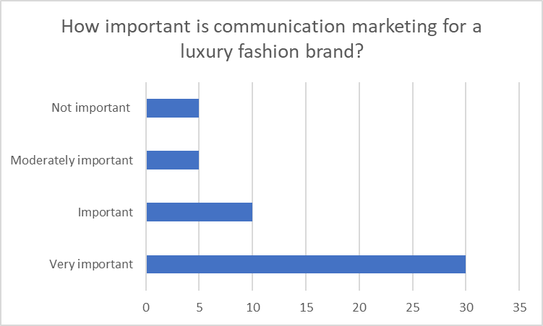
Figure: Response to the question no. 1
Interpretation: The above responses suggest that 60% of the total participants believe that communication marketing is important for a luxury fashion brand. Therefore, it can be inferred that the importance of communication marketing for luxury brands like Dior SE is inevitable. This further aligns with the findings of Blakeman (2023)who suggests that in order to grab success in the luxury sector, it is important to establish authenticity and it can be achieved through integrated communication marketing as through this, people believe in the brand and its products and hence foster overall financial gains.
- Do you think communication marketing helps in attracting new consumers?
Options | Response Frequency | Percentage
Yes | 35 | 70%
No | 2 | 4%
May be | 13 | 26%

Figure: Response to the question no. 2
Interpretations: From the response chart, it is clear that 70% of the total respondents have said that they believe that communication marketing helps in attracting new consumers. Thus, it can be said that communication marketing has an important role to play in enticing new customers. This finding further aligns with the suggestions by Leung et al. (2022) which states that communication marketing plays a big role increasing the brand awareness and also assures that people know that the business exists.
- What is the most important practice in integrated communication marketing?
Options | Response Frequency | Percentage
Consistency | 25 | 50%
Sales alignment | 10 | 20%
Teams’ collaboration | 10 | 20%
All the above | 5 | 10%

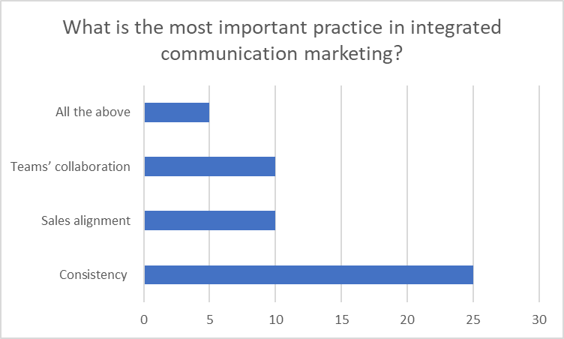
Figure: Response to the question no. 3
Interpretations: As per the above response chart, it is apparent that the maximum number of participants, that is 50% of the total participants, have answered that consistency is the most vital aspect and practice within the field of effective communication marketing. However, 20% of the participants agree that team’s collaboration is important and 20% of the participants believe that sales alignment is the most important practice and 10% believe all the 3 aspects are important ones. This finding is in line with the findings of Eagle (2020) who suggest that the most successful way to implement integrated marketing communication is by presenting a product using some same or similar set of products in the digital media with consistent wordings.
- Do you think Christian Dior SE needs to focus more on communication marketing?
Options | Response Frequency | Percentage
Yes | 40 | 80%
No | 2 | 4%
May be | 8 | 16%

Figure: Response to the question no. 4
Interpretations: The response chart indicates that 80% of the total participants believe that Christian Dior SE needs to focus more on communication marketing. This means that Christian Dior somewhat lacks in communication and hence a more integrated marketing approach is required. This aligns with the notion of Pelucchi et al. (2022), that is, integrated marketing is important for luxury fashion brands as this makes consistent deliveries possible and increases brand recognition and fosters consumer trust.
- Which platforms would you prefer the most as the most potential platform for communication marketing?
Options | Response Frequency | Percentage
Facebook | 23 | 46%
Instagram | 20 | 40%
Twitter | 4 | 8%
LinkedIn | 3 | 6%

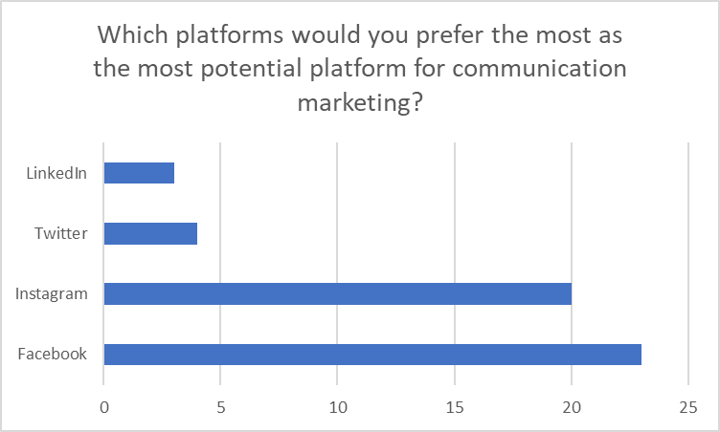
Figure: Response to the question no. 5
Interpretations: The above response chart shows that 46% of the total number of participants believe that Facebook is one of the most potential platforms for communication marketing and the next highest number of positive responses were for “Instagram”. However, Twitter and LinkedIn got the least number of responses. From here, it can be inferred that the user-base of facebook and instagram aligns the best with the categories of the most potential consumers of Christian Dior SE. On the other hand LinkedIn is a place for professional people and twitter has limitations on the characters of the posts. It aligns with the findings of Krizanova et al. (2019) which suggests that most fashionistas and young purchasers of fashion apparels and accessories are present actively on Facebook and Instagram and thus are most potential platforms for communication marketing.
- Who are the most targeted audiences for communication marketing?
Options | Response Frequency | Percentage
Youth | 30 | 60%
Millennials | 19 | 38%
All the above | 1 | 2%

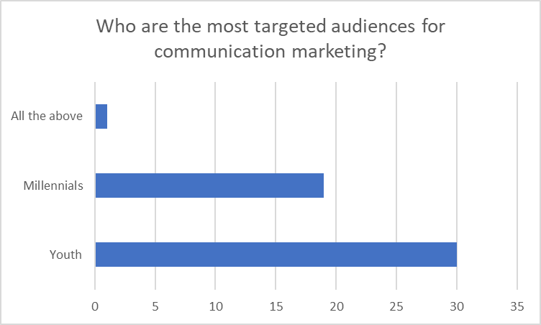
Figure: Response to the question no. 6
Interpretations: From the above response chart, it is important to note that youths are considered to be the most potential buyers of luxury fashion brands and hence they are the most targeted ones. However, it is not to be forgotten that nowadays, the millennials are also present on the digital media platforms and hence communication marketing can also raise awareness against the millennials and thus 38% said that millennials are more potential buyers than youths. Herhausen et al. (2020) also suggests that since millennials are most likely earning, there is a possibility for them to be the potential buyers of fashion products.
- In which areas, Dior SE would be benefited with integrated communication marketing?
Options | Response Frequency | Percentage
Customer acquisition | 20 | 40%
Brand awareness | 10 | 20%
Stakeholders’ satisfaction | 10 | 20%
All the above | 10 | 20%

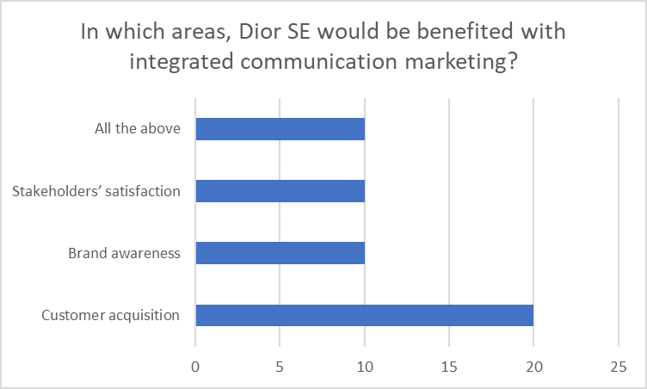
Figure: Response to the question no. 7
Interpretations: It is clear from the above response chart that 40% of the participants, that is the majority of the participants, believe that customer acquisition is the most significant field in which the company has benefited. However, 20% of the participants suggest that it mainly fosters brand awareness and another 20% suggests that it fosters “stakeholders satisfaction” and the rest 20% suggests that it fosters all the three options. Comparing this with the findings of Leung et al. (2022) , it can be said that integrated communication marketing tends to produce unified brand experience and awareness for the customers and hence increases their trust and loyalty towards the brand and also help in enticing new customers, which further generate stakeholders’ satisfaction.
- Which are the areas where Dior SE needs to make more investments to enhance integrated communication marketing?
Options | Response Frequency | Percentage
Personal selling | 5 | 10%
Digital campaigns | 18 | 36%
Public relations | 12 | 24%
All the above | 15 | 30%

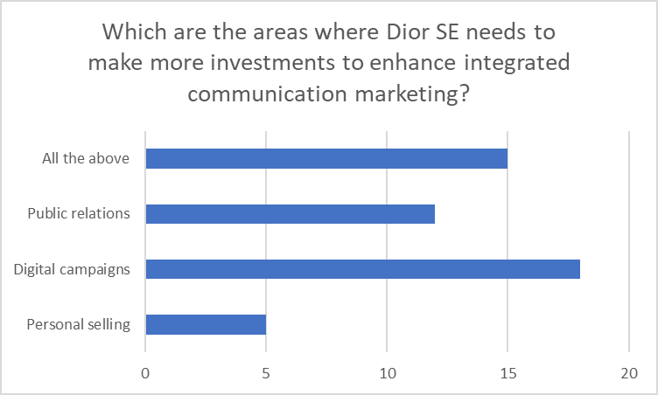
Figure: Response to the question no. 8
Interpretations: The above response chart shows that the majority of the participants, that is 36% of the participants believe that “digital campaigns” is the main area where Dior SE needs to make more investments to enhance integrated communication marketing. However, the next highest response was received for all the three options that is “digital campaigns”, “public relations”, and “personal selling”. 24% of the participants responded that public relations is an important area of communication marketing and 10% responded that personal selling should be focused on enhancing communication marketing. The suggestion by Perevozova et al. (2020) depicts that the combination of effective digital campaigns or social media ads, public relations and personal selling would eventually result in efficient and successful integrated communication marketing.

Chapter 5: Conclusion and recommendations:

Conclusion/summary:
The research has entailed a brief and a thorough research on communication marketing for enticing new consumers. The overall findings of the study suggests that social media platforms are the most potential platforms for communication marketing. All luxury brands like Christian Dior SE need to be actively present on Social media.
However, in order to successfully employ integrated communication marketing through social elements within a luxury brand realm such that of Christian Dior SE, it can be said that the brands need to figure out what channels and which social media marketing tools would work the best for them. The findings of the study also reveal that social elements such as Public relations, digital media ad campaigns, personal selling and so on can be leveraged to employ communication marketing within the business.
The findings of the study suggests that social media platforms, such as Facebook, Instagram and so on are the most popular communication tools and as these platforms readily allow the businesses to interact with the various targeted audiences and help building relation with them. Thus, it can be summarised by stating that integrated communication marketing not only helps to increase brand awareness and consumer loyalty, but also help the luxury brands like Christian Dior SE to entice new customers.

Linking with objectives:
- To determine the present integrated marketing communication strategy that is implemented by Dior: The findings of the paper suggest that Dior SE has made potential strides in terms of integrated marketing strategies and it is noteworthy that the influencer marketing techniques are the most potential ones. The findings also suggest that Dior tends to seek a number of influential people on some crucial communication media and also focuses on personal selling. So, it can be said that the overall integrated marketing efforts contribute to great profitability.
- To investigate the present digital marketing strategies used by Christian Dior SE: The study suggests that Dior has a number of social media accounts and they potentially focus on digital marketing strategy. They have numerous social media accounts on instagram, there are some core Dior official accounts that cater to the primary consumers. Social media platforms like instagram, Facebook, Twitter, YouTube and so on are heavily used by Dior as their core digital marketing strategy. Also, the findings suggest that they use email marketing and show their latest collections and chat with the customers to collect their opinionated feedback.
- To evaluate the effect of the integrated marketing communication on the “brand equity” of Christian Dior SE: The findings of the study suggest that the consumers tend to feel empowered in making “informed purchase decisions” due to effective integrated marketing communication. As a result, effective integrated marketing communication tends to help the consumers to be satisfied with the products they purchase from the company, and therefore, Dior’s marketing communication mix tends to use personal selling as one of their major integrated marketing strategies for creating better consumer experience and consumer better. Thus, based on the findings of the study, it can be said that the effects of integrated marketing communication lead to increased market share, greater brand equity, and better perceived quality.

Research limitations:
It is important to note that the research has taken under consideration a survey its primary research strategy, but it somewhat lacks insight on the integral plans and course of action of the chosen company, that is “Christian Dior SE” due to lack of information about the firm’s future plans on their website or on any scholarly website. In addition to this, the response to integrated communication marketing is different in different countries, but this research, due to lack of time, could not assess the effects of integrated marketing of the chosen organization within different geographic locations.

Recommendations:
- It is important for luxury brands like Christian Dior SE to gain authority by being available on all channels the consumers are on.
- The brands should focus on acquiring more and more channels as the number of channels are directly proportional to the number of eyes to see the brand messages.
- It is imperative to note that brands must emphasise on consistency and repetition of messages and content in order to keep the brand on the top of the consumers’ mind.
- Brands can establish effective brand awareness with consistent and attractive graphics and headlines as it would help reinforcing campaign themes by increasing brand equity.

Future implications:
The study would help the future entrepreneurs to learn about the most intriguing strategies of integrated communication marketing and also this study can also help the present marketers and owners of the luxury fashion businesses to use integrated communication marketing tactfully and intelligently. The marketers would also be able to know about what to do and what not to do in communication marketing and hence it would be useful for future luxury business to implement effective IMC strategies.

Future research:
The future research can take place to bridge the gaps of the current study. The future research can focus on the implications or the effects of integrated communication marketing in different geographic locations. In other words, the researchers can focus on the specific integrated marketing communication strategies that would work best for what specific geographic locations.

References:
Alghizzawi, M., 2019. The role of digital marketing in consumer behavior: A survey. Int. J. Inf. Technol. Lang. Stud, 3(1), pp.24-31.
Arora, K. and Faisal, M., 2022. The Use of Data Science in Digital Marketing Techniques: Work Programs, Performance Sequences and Methods. Startupreneur Business Digital (SABDA Journal), 1(2), pp.143-155.
Ball, H.L., 2019. Conducting online surveys. Journal of human lactation, 35(3), pp.413-417.
Blakeman, R., 2023. Integrated marketing communication: creative strategy from idea to implementation. Rowman & Littlefield.
Blakeman, R., 2023. Integrated marketing communication: creative strategy from idea to implementation. Rowman & Littlefield.
Campbell, S., Greenwood, M., Prior, S., Shearer, T., Walkem, K., Young, S., Bywaters, D. and Walker, K. 2020. Purposive sampling: complex or simple? Research case examples. Journal of research in Nursing, 25(8), pp.652-661.
Chen, C. and Song, M., 2019. Visualizing a field of research: A methodology of systematic scientometric reviews. PloS one, 14(10), p.e0223994.
Eagle, L., Czarnecka, B., Dahl, S. and Lloyd, J., 2020. Marketing communications. Routledge.
Eagle, L., Czarnecka, B., Dahl, S. and Lloyd, J., 2020. Marketing communications. Routledge.
Eagle, L., Czarnecka, B., Dahl, S. and Lloyd, J., 2020. Marketing communications. Routledge.
Herhausen, D., Miočević, D., Morgan, R.E. and Kleijnen, M.H., 2020. The digital marketing capabilities gap. Industrial Marketing Management, 90, pp.276-290.
Herhausen, D., Miočević, D., Morgan, R.E. and Kleijnen, M.H., 2020. The digital marketing capabilities gap. Industrial Marketing Management, 90, pp.276-290.
Herhausen, D., Miočević, D., Morgan, R.E. and Kleijnen, M.H., 2020. The digital marketing capabilities gap. Industrial Marketing Management, 90, pp.276-290.
Hofacker, C., Golgeci, I., Pillai, K.G. and Gligor, D.M., 2020. Digital marketing and business-to-business relationships: a close look at the interface and a roadmap for the future. European Journal of Marketing, 54(6), pp.1161-1179.
Hossain, T.M.T., Akter, S., Kattiyapornpong, U. and Dwivedi, Y., 2020. Reconceptualizing integration quality dynamics for omnichannel marketing. Industrial Marketing Management, 87, pp.225-241.
Juska, J.M., 2021. Integrated marketing communication: advertising and promotion in a digital world. Routledge.
Kaur, G., 2017. The importance of digital marketing in the tourism industry. International Journal of Research-Granthaalayah, 5(6), pp.72-77.
Kim, J., Kang, S. and Lee, K.H., 2021. Evolution of digital marketing communication: Bibliometric analysis and network visualization from key articles. Journal of Business Research, 130, pp.552-563.
Kingsnorth, S., 2022. Digital marketing strategy: an integrated approach to online marketing. Kogan Page Publishers.
Krizanova, A., Lăzăroiu, G., Gajanova, L., Kliestikova, J., Nadanyiova, M. and Moravcikova, D., 2019. The effectiveness of marketing communication and importance of its evaluation in an online environment. Sustainability, 11(24), p.7016.
Krizanova, A., Lăzăroiu, G., Gajanova, L., Kliestikova, J., Nadanyiova, M. and Moravcikova, D., 2019. The effectiveness of marketing communication and importance of its evaluation in an online environment. Sustainability, 11(24), p.7016.
Kurdi, B., Alshurideh, M., Akour, I., Alzoubi, H., Obeidat, B. and Alhamad, A., 2022. The role of digital marketing channels on consumer buying decisions through eWOM in the Jordanian markets. International Journal of Data and Network Science, 6(4), pp.1175-1186.
Kushwaha, B.P., Singh, R.K., Varghese, N. and Singh, V.N., 2020. Integrating social media and digital media as new elements of integrated marketing communication for creating brand equity. Journal of Content, Community & Communication, 11(6), pp.52-64.
Labanauskaitė, D., Fiore, M. and Stašys, R., 2020. Use of E-marketing tools as communication management in the tourism industry. Tourism Management Perspectives, 34, p.100652.
Leung, F.F., Gu, F.F. and Palmatier, R.W., 2022. Online influencer marketing. Journal of the Academy of Marketing Science, pp.1-26.
Leung, F.F., Gu, F.F. and Palmatier, R.W., 2022. Online influencer marketing. Journal of the Academy of Marketing Science, pp.1-26.
Martin, S.L., Javalgi, R.R.G. and Ciravegna, L., 2020. Marketing capabilities and international new venture performance: The mediation role of marketing communication and the moderation effect of technological turbulence. Journal of Business Research, 107, pp.25-37.
Moorhead. L., 2023. ‘Resize Multiple Images to Be the Same Size?’ (Miro, 17 June 2021) <https://community.miro.com/ask-the-community-45/resize-multiple-images-to-be-the-same-size-5101> accessed 2 December 2023
Muniesa, R.L. and Giménez, C.G., 2020. The importance of the loyalty of fashion brands through digital marketing. Journal of Spatial and Organizational Dynamics, 8(3), pp.230-243.
Nayak, M.S.D.P. and Narayan, K.A., 2019. Strengths and weaknesses of online surveys. technology, 6(7), pp.0837-2405053138.
Pelucchi, E., Fagas, G., Aharonovich, I., Englund, D., Figueroa, E., Gong, Q., Hannes, H., Liu, J., Lu, C.Y., Matsuda, N. and Pan, J.W., 2022. The potential and global outlook of integrated photonics for quantum technologies. Nature Reviews Physics, 4(3), pp.194-208.
Perevozova, I., Horal, L., Mokhnenko, A., Hrechanyk, N., Ustenko, A., Malynka, O. and Mykhailyshyn, L., 2020. Integration of the supply chain management and development of the marketing system.
Regmi, P.R., Waithaka, E., Paudyal, A., Simkhada, P. and Van Teijlingen, E., 2016. Guide to the design and application of online questionnaire surveys. Nepal journal of epidemiology, 6(4), p.640.
Sahay, A., 2016. Peeling Saunder's research onion. Research Gate, Art, 3(2), pp.1-5.
Sileyew, K.J., 2019. Research design and methodology. Cyberspace, pp.1-12.
Silvia, S., 2019. The importance of social media and digital marketing to attract millennials’ behavior as a consumer. Marketing, 4(2), pp.7-10.
Veleva, S.S. and Tsvetanova, A.I., 2020, September. Characteristics of the digital marketing advantages and disadvantages. In IOP Conference Series: Materials Science and Engineering (Vol. 940, No. 1, p. 012065). IOP Publishing.
Zaif, A. and Cerchia, A.E., 2019. Integrating Online Marketing Strategies in B2B Companies. Ovidius Univ. Ann. Econ. Sci. Ser, 19(2), pp.614-620.

Appendix:

Sample questionnaire:
- How important is communication marketing for a luxury fashion brand?
Options
Very important
Important
Moderately important
Not important

- Do you think communication marketing helps in attracting new consumers?
Options
Yes
No
May be

- What is the most important practice in integrated communication marketing?
Options
Consistency
Sales alignment
Teams’ collaboration
All the above

- Do you think Christian Dior SE needs to focus more on communication marketing?
Options
Yes
No
May be

- Which platforms would you prefer the most as the most potential platform for communication marketing?
Options
Facebook
Instagram
Twitter
LinkedIn

- Who are the most targeted audiences for communication marketing?
Options
Youth
Millennials
All the above

- In which areas, Dior SE would be benefited with integrated communication marketing?
Options
Customer acquisition
Brand awareness
Stakeholders’ satisfaction
All the above

- Which are the areas where Dior SE needs to make more investments to enhance integrated communication marketing?
Options
Personal selling
Digital campaigns
Public relations
All the above

