

Module: (LCBB4005) Global Business Environment

Student’s Name: Madalina Ana Maria Ochesel
Student ID: LCBB4005\2114285
Lecturer’s Name: Mr. Akinseye Aluko
Due date: 12\01\2022

Table of contents

- Introduction……………………………………………………………. Page 3

- PESTLE………………………………………………………………. Page 4

- SWOT Analysis………………………………………………………. Page 5

- Porter’s Five Forces……………………………………………………Page 7

- Value Chain……………………………………………………………Page 7-8

- Reference List…………………………………………………………. Page 9

A

utomobile industry is a challenging field, so wide which is so difficult to penetrate without considering what rivalry you must face. It is well known that the rivalry is very intense, and each brand has already their reputation. Each brand has its own marketing strategy to win their customers, creating a relationship, fulfilling their desires.
The world is changing, desires are changing, they are offering the dream car for you.

The cars are a necessity, a day-to-day significant source of transport for everybody. Nowadays the car industry is a huge market where you can choose what you want, based on the price, brand, features and availability, making your choice on what the car can offer for the price they are asking.

This case study will show an internal and external analysis about the brand Mercedes, a popular and loved company for its authenticity and luxury cars provided along the years.

M
ercedes-Benz is a German automobile brand has a long history for moving around and providing luxury vehicles, focusing on development, production sales and services. (Mercedes-Benz, 2020) They have been innovative since 1886 when Karl Benz introduced the first petrol-powered car, the vehicle which changed transportation for many people continuing to produce to this day. The first tests for safety measures appeared on a Mercedes-Benz in 1951 (Bible, A. 2018)

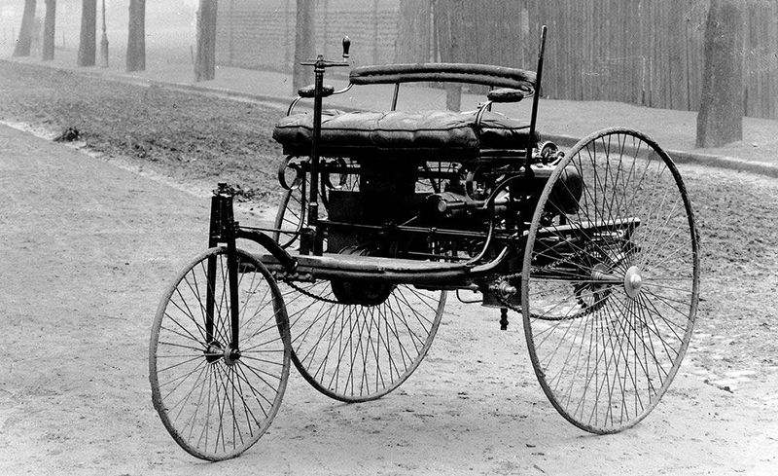
First three-wheeled car

Based on PESTLE we can analyse the external environmental factors.

The political factors can be explained by the uncertainty across Europe, Middle East and Latin American markets. In the United Kingdom one of the highest importance political factors in the automobile industry is the system of taxation, this is mainly based on the engine of the cars.

The economic factors are mainly based on each country economic, since the rise of fluctuation affects the production by uprising the prices of the cars.

The concept of social is often defined by each individual and each person’s income, the variety of categories of individuals who have bigger salaries and can afford luxury contemplating on wealth, Mercedes-Benz has this ability of selling the cars to those people.

Mercedes can easily find the future demands recognizing the relationship between people and their vehicles. Due to environmental concerns the brand aims to a hybrid incorporate, future can bring automatic cars, which involves no driver to get reduced the number of accidents and harms on environment.

Mercedes is recognised to bond to the regulations, laws and government of the state. The company is well-known for the constancy regarding safety and environmental protection.

The brand has a positive relationship with the environment, joining agencies for climate enforcement laws as it is a recognised as a danger for each country, but at the same time the investments are chased with a high importance due to rivalry strategies in the market. Since is only ISO certified the changing of the climate in the UK is in its concerns.

SWOT Analysis

Strengths  Automobiles have a huge importance, value and global leader, allowing people to move, work and travel. The brand Mercedes-Benz has a powerful influence of this era. Mercedes has also invested in electric and hybrid cars producing environmentally friendly luxury cars, self-driving cars also in process of building. It had a big presence on sports under McLaren Mercedes in Formula 1, as a result for investing huge amounts of money in manufacturing and brand growing. | Weaknesses  The intense competition means less market, the market is so big, and the brand should compete with other brands as well, on prices and quality.
Opportunities  For a brighter future and for even more success Mercedes should focus on the development of hybrid cars, trying to emerge the market around the world, the company getting more prosperous. | Threats  The Government Policies, recensions and pandemics are big struggle for the automobile industry. The competition such as BMW might affect the wellness of the company.

The following is showing the rivalry between what features Mercedes-Benz and BMW are offering for the prices requested.

Both are taken in consideration for the luxury provided and the latest options available.
Customers rely on what the brand is providing for the featured desired model based on price, they want to know which one offers more for the money. Based on a comparison for BMX VS Mercedes-Benz, it is well seen:
Mercedes-Benz | VS | BMW
Starting MSRP $32,700 | CLA vs. BMW 2-Series |  | Starting MSRP $34,800
241 hp | C-Class vs. BMW 3-Series |  | 180 hp
Standard 12.3-Inch Display | E-Class vs. BMW 5-Series |  | Standard 10.2-Inch Display
Standard Active Brake Assist | GLA vs. BMW X1 |  | Optional
Standard Driver Attention Monitor | GLC vs. BMW X4 |  | Feature Not Offered
Starting MSRP $52,200 | GLE vs. BMW X5 |  | Starting MSRP $56,950
The above it is the comparison between Mercedes-Benz VS BMW Available at: https://www.mbtemecula.com/mercedes-benz-vs-bmw/

In this case it is obviously that Mercedes-Benz is winning the market for what they offer, options that

Mercedes cars are much more classy and luxurious looking beauties than BMW which does not make much impact on the road. Mercedes three-pointed Star makes you stand out on the road whereas BMW is not noticed much by people on the road. So, Mercedes brand carries much more weightage in terms of class and luxury.

Porter’s Five Forces Analysis

Threat of New Entrants is weak due to the big number of options and alternatives already present on the market. For Mercedes-Benzes is very low and most of the companies already existing, they have their reputation and are old brands. The level of competition is a major barrier especially for the new entrants which should invest large capital trying to be on the same level with the old bosses to become a recognized business. There are many several factors that minimize the threat of new entrants as global presence, level of popularity, and customer loyalty as well. The threat of new entrants for our brand is at minimum.

Bargaining the Power of Suppliers is low, the suppliers must play according to the rules set by cars brands. The companies such as Daimler AG the source for the parts of the cars is mainly based in China or Brazil, their suppliers are divided around the world do not hold any significant bargaining power. None of them want to lose the contracts and must follow the rules of the contracts, Mercedes-Benz holds a significant power in purchasing raw materials in the bargaining power of suppliers.

Bargaining the Power of Buyers is strong, there are small individuals customers that buy single vehicles, but there are existing customers which buy in a bigger quantity, buyers that have the power to bargain at a lower price. Mercedes has a high power in bargaining focusing on the maintaining the same image the brand has always had.

Threat of Substitutes is medium because of the substitutes and alternatives methods of transport like buses, trains and planes, but none of the can offer the accessibility and convenience that an automobile can give. For Mercedes the threat of substitutes comes from rivalry, from many brands from car industry, Audi, Porches and Tesla. A few factors which limit the threat of substitutes include customer experience, brand image and quality. Mercedes-Benz created an identity along the years which helped maintaining the threat from substitutes.

The strategy Daimler follows is focused on the technological development for a profitable growth mainly the designing the future cars, hybrid and driverless cars, maintaining the lane on the economy changelings and rapidly changing of the customer preferences. The brand is aimed to high standards, people with big careers in favor of luxury things, choosing a car with prestige. Mercedes-EQS, one of the models has been promote in the best 19 cars of the year of 2021.
The mission is to continually improve the quality, the customer service, business process awareness of the environment and a better relationship with their partner business. Designers at Mercedes-Benz tend to modernity combined with tradition with an expression of modern luxury focusing on the brand’s image to their customers fulfilling their desires by new innovations.

The Mercedes-Benz logo consisting of a three-star pointed inside the circle monitoring “on land, in water, and in the air”, it can be seen on all Mercedes-Benz vehicles, on official websites, various catalogues and showroom buildings.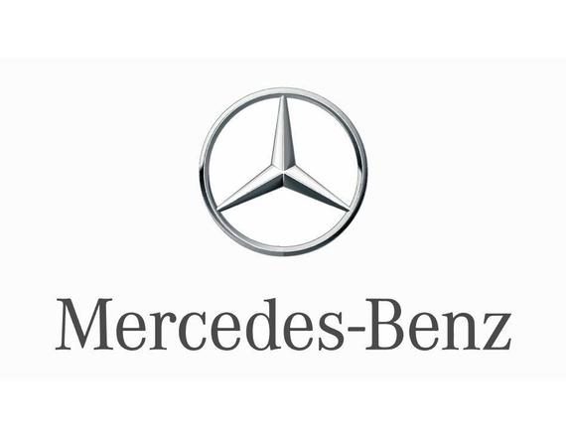
The use of value chain analysis can optimise the finances, products and information flow. The improved information flow can help the company identify and exploit new opportunities and reduce external threats. The effective implementation of the value chain analysis of Mercedes-Benz can improve the material and product flow due to improved demand and sales forecasting. The inventory management also improves as Mercedes-Benz can minimise the delays by tracking activities throughout the supply chain. Modern customers place high importance to the quick response and convenient access to the important product related information. By analysing the value chain of the Mercedes-Benz, we can find sources of competitiveness. The brand can find internal and external activities through the value chain lens. The internal factors and activities within same organisational and external between different firms.

Mercedes-Benz value chain analysis can be used in the competitive strategies, choosing the right one about cost leadership by having acknowledge about competitor’s cost structure.

Reference list

Mercedes-Benz, (2020), ‘The Mercedes-Benz AG at a glance – About us’ Available at: https://www.mercedes-benz.com/en/company/ Accessed on 11th of January 2022

Bible, A. (2018), ’11 things you didn’t know about Mercedes-Benz’, Available at: https://www.roadandtrack.com/car-culture/g22064109/mercedes-benz-facts/ Accessed on 11th of January 2022

Mercedes-Benz of Temecula, (2020), ‘Mercedes-Benz VS BMW’ Available at: https://www.mbtemecula.com/mercedes-benz-vs-bmw/ Accessed on 11th of January 2022

Xilu, (2020) ‘PESTLE Analysis Automobile Industry: Mercedes’, Available at: https://tmqresearch.com/pestle-analysis-automobile-industry-mercedes-uk/ Accessed on 11th of January 2022

Keynes, L. (2021), ‘BMW or Mercedes – which brand is better for 2021’, Available at: https://www.motorverso.com/bmw-vs-mercedes/ Accessed on 11th of January

MBA Skool Team, (2021), ‘Mercedes-Benz SWOT Analysis, Competitors & USP’, Available at: https://www.mbaskool.com/brandguide/automobiles/1300-mercedes-benz.html Accessed on 12th of January 2022

Bhasin, H. (2020), ‘SWOT Analysis of Automobile Industry’ Available at: https://www.marketing91.com/swot-analysis-of-automobile-industry/ Accessed on 11th of January 2022

Barreto, L. (2019), ‘Why McLaren and Mercedes have joined forces again for 2021’ Available at: https://www.formula1.com/en/latest/article.why-mclaren-and-mercedes-have-joined-forces-again-for-2021.13KAgEaykDn1Y2O0ZwvNDa.html Accessed on 12th of January 2022

Pratap, A. (2021), ‘Mercedes-Benz five forces analysis’, Available at: https://notesmatic.com/mercedes-benz-five-forces-analysis/ Accessed on 12th of January 2022

Pratap, A. (2021), ‘Automotive Industry Five Forces Analysis’, Available at: https://notesmatic.com/automotive-industry-five-forces-analysis/ Accessed on 12th of January

Daimler, (2020), ‘Mercedes-Benz Strategy update 2020’ Available at: https://www.daimler.com/investors/events/capital-market-days/2020-mercedes-benz-strategy-update.html Accessed on 12th of January 2022

Duffy, T. (2021) ‘The 19 coolest electric vehicles we saw in 2021’, Available at: https://www.gearpatrol.com/cars/a38506452/new-electric-vehicles-2021/ Accessed on 12th of January 2022

J.H. (2020) ‘Mercedes-Benz Brand Analysis-A Story of Success’, Available at: https://lifeonfour.co/car-talk/mercedes-benz-brand-analysis/ Accessed on 12th of January 2022

Byrne, T. (2018), ‘Value Chain Analysis of Mercedes-Benz’, Available at: https://www.essay48.com/value-chain-analysis/13619-Mercedes-Benz-Value-Chain-Analysis Accessed on 12th of January 2022

