Hotel Placement - Placement Project BMIH6006 and BMIH6008

Student:
Belu Teodor Catalin (2116226)

Module Lead:
Dr. Ernest Balutie Wavei

Enhancing employee engagement: an analysis of the latest techniques of Marriott Hotel - Cardiff to boost interaction between workers

Executive summary

This paper reviews the employee engagement practices at Marriott Hotel Cardiff, focusing on the measures the hotel has implemented to foster a motivated, loyal, and high-performing workforce. Adhering to Marriott's global standards, Marriott Cardiff employs a range of strategies to enhance both cognitive and emotional engagement among its employees, aiming to create a positive and supportive work environment.

The hotel places a strong emphasis on communication, with structured feedback mechanisms such as surveys, individual check-ins, and regular meetings, ensuring employees feel valued and heard. This approach aligns with research that emphasizes the importance of feedback in motivating employees and improving their learning. However, while these communication efforts are effective, there is room for improvement in terms of real-time feedback systems, which would allow employees to provide immediate input, addressing concerns faster and enhancing overall engagement.

Training and development are central to Marriott Cardiff’s engagement strategy. The hotel offers a variety of professional development programs, focusing on skill-building and career progression, which enhances employee loyalty. These programs, designed around Marriott’s instructional systems framework, include pre-training assessments and post-training evaluations to ensure effectiveness. The hotel also emphasizes leadership development and internal promotions, which helps create a sense of career growth among employees. Marriott Cardiff’s commitment to training is in line with literature suggesting that well-structured development programs increase employee engagement and organizational commitment.

Another key element of Marriott Cardiff’s strategy is team building and fostering a collaborative culture. The hotel organizes regular team-building exercises that encourage interaction and strengthen relationships, promoting teamwork and improving employee morale. This approach supports findings that cohesive teams contribute to better engagement and overall performance. Marriott Cardiff’s leadership also focuses on employee recognition, with programs like the "Spirit to Serve Our Associates" (STARS) and the J. Willard Marriott Awards of Excellence. These initiatives highlight outstanding achievements in guest service, teamwork, innovation, and leadership, reinforcing the importance of acknowledging employee contributions to boost morale and engagement.
Work-life balance and employee wellbeing are also central to Marriott Cardiff’s engagement strategy. Offering flexible work schedules, wellness programs, and mental health support, the hotel creates a supportive environment that reduces burnout and fosters a healthier, more productive workforce. Research supports the idea that a positive work-life balance contributes to improved employee wellbeing, which in turn enhances job performance and engagement.
While Marriott Cardiff’s engagement practices are commendable, there are areas where improvements could be made. Incorporating real-time feedback platforms would enable quicker responses to employee concerns and help maintain a responsive and dynamic communication system. Additionally, personalizing training and development opportunities to better align with individual career goals could significantly enhance engagement. Current training programs are broad but tailoring them to each employee’s unique aspirations would increase their sense of value within the organization.

In conclusion, Marriott Cardiff has implemented a comprehensive and effective employee engagement strategy that aligns well with industry best practices and existing research. By continuing to refine these practices, particularly through the use of technology and more personalized development opportunities, Marriott Cardiff can further enhance its employee engagement, fostering a motivated, loyal, and high-performing workforce.

Table of contents

- Introduction:

In recent years, employee engagement has become a crucial priority for organizations, particularly in industries where the quality of service is directly linked to the motivation and morale of employees. This is especially true for businesses like Marriott Cardiff, where employee engagement is fundamental to ensuring high levels of customer satisfaction. Engaged employees are those who are passionate about their work and committed to the company’s goals, playing a pivotal role in the organization’s overall success. Employee engagement strategies, when executed effectively, can result in improved employee retention, increased productivity, and a stronger sense of organizational loyalty. In the hospitality sector, like at Marriott Cardiff, the quality of service delivered by frontline staff is vital for distinguishing the brand, gaining competitive advantages, and fostering customer loyalty. Rabiul et al. (2023) assert that the performance of employees in service roles directly impacts brand reputation, and thus, employee engagement becomes a key business strategy.

Sharma (2019, p. 21) identifies three levels of employee engagement: engaged, unengaged, and disengaged. Engaged employees are those who actively commit to the organization’s goals, displaying enthusiasm and a strong sense of alignment with the company’s mission. They are fully dedicated and contribute actively to the success of the business. In contrast, unengaged employees participate in their work but lack the passion and drive to excel or contribute significantly to the organization’s objectives. Disengaged employees, however, are the most concerning. They are dissatisfied with their roles and are less likely to perform to their full potential. Such employees may exhibit negative behaviours’ that can hinder team morale, leading to higher turnover rates and a decline in service quality. For organizations like Marriott Cardiff, it becomes essential to identify ways to shift disengaged employees toward higher levels of engagement.

To achieve this, companies must understand and address the evolving needs of their employees. These needs shift as employees progress in their careers and personal lives, and what satisfies an individual at one point may not continue to meet their needs in the future. Therefore, it is essential for organizations to remain flexible and responsive to these changes in order to maintain a highly engaged workforce. Regularly assessing employee satisfaction and addressing concerns promptly can prevent disengagement and boost morale.

This is where Maslow's Hierarchy of Needs offers valuable insights. In the 1940s, Abraham Maslow, along with Carl Rogers, made significant contributions to humanistic psychology, focusing on individual potential and self-actualization (Pichére and Cadiat, 2015, p.4). Maslow’s model, often depicted as a pyramid, outlines a progression of human needs, starting with basic physiological needs at the base and advancing to self-actualization at the top. According to Maslow’s theory, individuals must first satisfy their basic needs—such as food, shelter, and security—before moving on to higher-level needs like love and belonging, esteem, and ultimately, self-actualization.

For organizations like Marriott, understanding where employees are in this hierarchy can help tailor engagement strategies effectively. Addressing employees' basic needs, such as job security, fair compensation, and a safe work environment, is essential to establish a foundation for engagement. Only after these foundational needs are met can employees focus on more complex needs such as personal growth, recognition, and the pursuit of career development. Research indicates that employees with pronounced power demands are more inclined to align with organisational objectives, often prioritising the company's interests over their own, which leads to enhanced organisational identification and integration (Zhang et al., 2024).

- Literature review

Definition of employee engagement

The lack of a universally accepted definition of employee engagement provides organizations with a unique opportunity to define what engagement means within their own context. This question often sparks diverse perspectives among stakeholders. Some individuals express discomfort with the absence of a clear definition, while others embrace the opportunity to develop their own interpretations and frameworks (Drew, 2023). Despite the absence of a conventional definition, recurring themes such as involvement, commitment, discretionary effort, collaboration, motivation, and performance consistently emerge across the literature (Bridger, 2018, p. 4). These themes reflect the core elements of employee engagement that are commonly discussed, but organizations vary in how they conceptualize and define these factors.

In some cases, organizations may opt not to provide a formal definition of employee engagement, instead focusing on creating a positive and engaging workplace culture. These organizations may prefer terms like "creating a great place to work" or similar phrases that capture the essence of engagement without delving into specific definitions ( Sharma, 2019). However, regardless of the approach taken, it remains essential that the senior leadership team within the organization has a shared understanding of what employee engagement entails. A clear definition, or at a minimum, a common understanding, is necessary to ensure that engagement initiatives are effectively aligned and implemented across the organization. Without such alignment, efforts to improve engagement may lack coherence and fail to achieve desired outcomes.

The literature offers a range of definitions and conceptualizations of employee engagement. Berkowitz (2020) defines employee engagement as the actions taken by management to align employees' personal and professional goals with the organization's mission and strategic objectives. This alignment aims to improve product and process outcomes, fostering a sense of purpose and commitment among employees. This perspective underscores the importance of integrating employees' individual motivations with the broader organizational goals, thus enhancing overall engagement and productivity.

Further elaborating on the dimensions of employee engagement, Chandani et al. (2016), as quoted by Chakraborty et al. (2024), identify three distinct dimensions of engagement: intellectual engagement, emotive engagement, and social engagement. Intellectual engagement refers to employees' cognitive investment in their work, which involves problem-solving, critical thinking, and contributing innovative ideas to the organization. Emotive engagement focuses on employees' emotional connection to their work, including feelings of pride, passion, and dedication to the organization. Lastly, social engagement pertains to the interpersonal aspects of work, such as collaboration, communication, and the sense of belonging within the organizational culture. These three dimensions together provide a comprehensive view of employee engagement, illustrating that engagement is not a one-dimensional concept but rather a multifaceted construct that encompasses cognitive, emotional, and social elements.

Leadership and employee engagement

The role of leadership in fostering employee engagement is a critical area of focus in organizational research. Leadership theories, particularly transformational leadership, emphasize the importance of inspiring, motivating, and intellectually stimulating employees (Carasco-Saul et al., 2015). Transformational leaders encourage followers to transcend their own self-interest for the good of the group and often evoke high levels of engagement through charisma and vision. Authentic leadership, which integrates ethical considerations with organizational behaviour, also plays a significant role in nurturing employee engagement. Leaders who are transparent, ethical, and committed to fostering a positive work environment help build an atmosphere where employees feel valued and motivated to contribute their best work (Johnson, 2022).

Empowering leadership is another leadership style that has been widely recognized for its positive impact on employee engagement. Empowering leadership involves sharing power with employees, granting them autonomy, and encouraging participation in decision-making processes. Amundsen and Martinsen (2014) and Lee et al. (2017b) highlight that empowering leadership enhances employees' psychological empowerment, self-efficacy, organizational citizenship behaviours’, and job satisfaction. Empowered employees feel more competent, confident, and motivated, which leads to greater involvement in their work and an increased sense of ownership over their tasks. By creating an environment where employees have the authority to make decisions and influence outcomes, empowering leadership promotes higher levels of engagement and productivity (Kim et al., 2018).

Kim et al. (2018) argue that employee empowerment confers several organizational advantages, including improved employee attitudes, motivation, and overall engagement. Employees who feel empowered are more likely to exhibit positive behaviours’, take initiative, and contribute beyond their formal job responsibilities, which ultimately benefits the organization by enhancing overall effectiveness. Moreover, empowered employees experience higher job satisfaction, as they perceive their roles as more meaningful and impactful (Martínez-Córcoles et al., 2021). Empowering leadership creates a work environment that supports self-management and involvement in decision-making, which leads to a greater sense of job satisfaction. The Team Characteristics Model (TCM) further elucidates how empowering leadership influences team satisfaction, suggesting that initial levels of emotional tolerance (ETL) within teams can predict team job satisfaction, with increasing levels of control and influence over tasks as teams gain experience (Strubler and York, 2007) .

Employee engagement and Corporate Social Responsibility

Another significant factor influencing employee engagement is Corporate Social Responsibility (CSR), though empirical studies exploring this relationship remain somewhat limited. Scholars have differing views on how CSR influences employee engagement, with some considering it as an extra-role behaviour, while others view it as an in-role expectation (Cao & Lee, 2023). Rupp et al. (2018) contributes significantly to this discourse by highlighting the positive influence of employees' perceptions of their employer’s CSR on their work engagement. Their research underscores the importance of work engagement for both employee well-being and organizational productivity. By utilizing Self-Determination Theory (SDT) and the organismic integration perspective (OIT), Rupp et al. (2018) examine how CSR motivations and perceived autonomy affect the relationship between CSR and employee engagement. Their findings suggest that CSR perceptions can act as a boundary condition, moderating the effect of CSR on engagement levels.

Supporting this view, Zhou et al. (2018) provide additional evidence that employees’ perceptions of CSR significantly enhance organizational pride, which in turn boosts job satisfaction and affective commitment. Their study, based on data from 296 managers and employees across 12 Chinese organizations, further highlights the critical role of sustainable practices and CSR in providing a competitive advantage. These findings suggest that CSR can serve as a mechanism for fostering greater employee engagement by aligning organizational values with employee interests and societal responsibility.

Govand Anwar and Bafer Abd Zebari (2015) also emphasize the effectiveness of CSR in promoting employee engagement. They argue that CSR initiatives demonstrate an organization’s commitment not only to its workforce but also to broader societal interests and social accountability. This connection between CSR and engagement underscores the importance of management's role in nurturing employee dedication, belief, and the capacity to contribute to organizational success. By aligning CSR initiatives with employee values, organizations can foster an engaged workforce that is motivated by a sense of purpose beyond financial rewards.

- Methodology

This study seeks to analyse the latest employee engagement tactics employed by Marriott Hotel Cardiff, with particular emphasis on enhancing contact among staff members. The study will depend solely on secondary data sources to examine the organization’s engagement strategies, owing to the absence of primary data collecting. A qualitative secondary data analysis methodology will be utilised, drawing on publicly accessible material, organisational records, academic literature, and case studies to examine the employee engagement strategies of Marriott Hotel Cardiff.

This research will apply a qualitative design to analyse current secondary data, aiming to thoroughly understand the measures implemented by Marriott Hotel Cardiff to improve employee engagement. Secondary data analysis is especially advantageous when access to main data is unfeasible, providing significant insights into organisational procedures remotely. The research will collect data from several sources, including scholarly articles, industry reports, business records, and publicly available resources such as the hotel's website and social media accounts.

A substantial amount of the secondary data will be obtained from scholarly articles, books, and academic journals that examine employee engagement, particularly in the hotel sector, concentrating on Marriott International. This will offer theoretical frameworks and optimal techniques that Marriott Hotel Cardiff can employ in its engagement initiatives. Furthermore, case studies from various Marriott sites, in conjunction with reports issued by Marriott or other organisations, will offer additional context regarding employee engagement methods inside the organisation.

Social media and employee evaluations from platforms like Indeed will be examined to obtain insights into employee satisfaction, organisational culture, and the efficacy of engagement efforts. These materials will yield qualitative data that illustrate employees' experiences and perceptions, facilitating a more profound comprehension of the organisational dynamics of Marriott Hotel Cardiff.

The gathered secondary data will undergo thematic analysis, concentrating on repeating patterns, tactics, and procedures pertinent to employee engagement. The essential components of engagement, such as leadership participation, communication methodologies, professional growth opportunities, recognition systems, and team-building efforts, will be assessed concerning Marriott's tactics (Harris, 2024). The analysis will examine the influence of leadership styles on motivation, training programs that foster collaboration and personal development, employee autonomy in decision-making, recognition and reward systems, and strategies for improving communication and teamwork across departments.

This research will critically evaluate the efficacy of Marriott Hotel Cardiff's staff engagement strategies by analysing the findings within the framework of established employee engagement models. The study seeks to uncover effective strategies that enhance engagement and facilitate good employee interactions, while offering recommendations for development grounded in industry best practices.

This study minimises ethical problems since no primary data is gathered. All secondary data will be obtained from publicly accessible materials, with proper citations for all references. Confidential or proprietary information from Marriott Hotel Cardiff will not be employed, thereby guaranteeing the study complies with ethical standards in data utilisation. The technique guarantees that the study relies exclusively on publicly available information, offering a transparent and ethical framework for evaluating employee engagement activities at Marriott Hotel Cardiff.

- Case Study Hotel Overview and Findings:

Marriott International – worldwide organisation

Marriott International, is a prominent global hospitality enterprise that has transformed from a simple root beer stand into one of the largest and most powerful hotel chains worldwide (Marriott and Brown, 2012, p 4). The company's establishment and expansion were anchored on its emphasis on client satisfaction and innovation. The inaugural hotel of Marriott, the Twin Bridges Marriott Motor Hotel, commenced operations in Arlington, Virginia, in 1957, signifying the commencement of its venture in the hospitality industry.

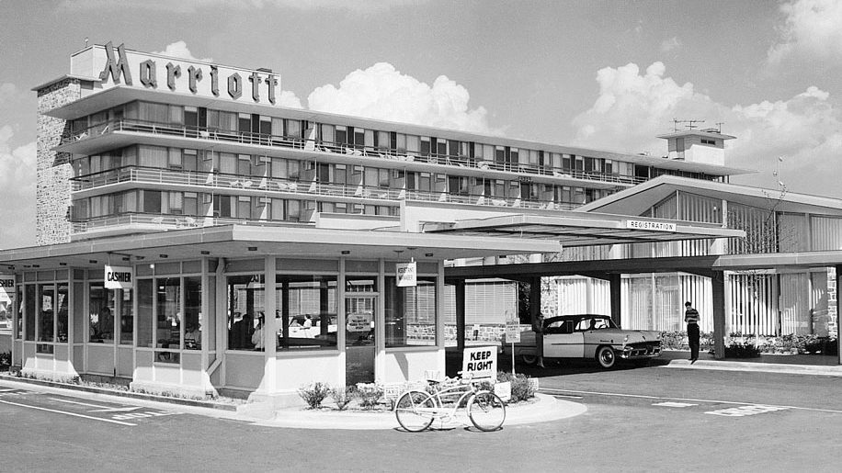
Snapshot: 1957 Marriott’s first hotel – Business Traveller Magazine
(Harby, 2016)

Founded in 1957, the company has since expanded considerably, operating in over 130 countries and territories, with more than 7,500 properties globally. The company’s globalization officially began in 1992, and its expansion continued throughout the 20th century as Marriott acquired and managed properties worldwide (Gupta, 2018). A major milestone in Marriott's history occurred in 2016 when it completed the acquisition of Starwood Hotels & Resorts. This strategic move significantly expanded Marriott's brand portfolio and solidified its position as a global leader in the hospitality industry.

Positioning itself as a dominant entity in the global hospitality sector, the company possess a substantial economic portfolio that encompasses several market sectors, geographic areas, and unique consumer requirements. This growth trajectory has been propelled by the company's emphasis on purchasing and managing a diverse portfolio of brands, encompassing luxury and premium hotels as well as more economical, select-service alternatives. Marriott's superscale is characterised by its extensive global presence, with over 7,500 hotels across more than 130 countries and territories globally. The company is recognized as one of the largest hotel brands worldwide, not just in terms of room availability but also in terms of revenue. According to Business Travell News (2025), Marriott recently announced its full-year growth figures for 2024, which highlighted a record number of gross openings, totalling 123,000 rooms. This increase represents a 6.8 percent year-over-year growth in its room portfolio. Additionally, Marriott signed a record 1,200 deals in 2024, resulting in a total of 162,000 new rooms. As of the end of 2024, Marriott’s pipeline includes more than 577,000 rooms, continuing the company’s strong growth trajectory. According to Luxury Hospitality Magazine (2025) the company archived over 7% net rooms grow in 2024 across Europe, Middle East and Africa.

The company currently manages a wide array of brands that serve various consumer segments within luxury, premium, and select-service hotels and resorts. The company's portfolio features several of the most renowned and recognisable brands in the hospitality sector. Prominent Marriott brands encompass: Marriott Hotel which is the flagship brand of the company offering premium services for business and leisure travellers in over 500 locations globally, Sheraton, Westin Hotels & Resorts, Courtyard by Marriott, Fairfield by Marriott, JW Marriott, Le Méridien. Autograph Collection Hotels, Renaissance Hotels, Moxy Hotels and also one of the most elegant and exquisite brands in the world The Ritz-Carlton (Marriott International, 2025).

Marriott Cardiff

Marriott Cardiff is a prestigious hotel situated in the centre of Cardiff, the capital of Wales. This hotel, part of the esteemed Marriott International network, provides a blend of luxury, comfort, and convenience, rendering it an optimal selection for both business and leisure travellers. Marriott Cardiff is strategically located within walking distance of key attractions, including Cardiff Castle, the Principality Stadium, and the lively Cardiff Bay neighbourhood. This strategic position enables guests to effortlessly enjoy the
city's abundant history, culture, and entertainment offerings.
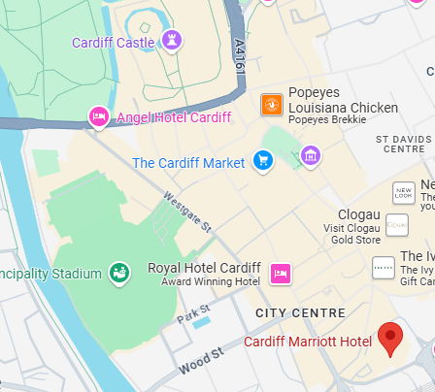

(Google Map, 2025)
The hotel provides a combination of elegance, comfort, and contemporary conveniences, showcasing an array of elegantly furnished rooms and suites, diverse dining selections, a fully equipped fitness centre, and comprehensive meeting and event facilities (Hospitality Online, 2025).
Key Features:
- Stars: The hotel holds a 4-star rating, emphasizing comfort and quality service (TripAdvisor, 2025).
- Rooms: Marriott Cardiff features 205 guest rooms and suites, designed with contemporary style and comfort (Business Travel News by NorthStar, 2025). Each room comes equipped with modern amenities, including high-speed internet access, flat-screen TVs, air conditioning, and plush bedding. Some rooms offer upgraded services such as access to the Executive Lounge, larger spaces, and stunning views of the city.

Services Offered:
- Dining: The hotel has diverse eating alternatives offered by Browns Brasserie and Bar, featuring a full-service restaurant that offers both local and foreign cuisine, in addition to a bar/lounge for informal beverages and meals (Browns Brasserie and Bar, 2025).
- Fitness: Marriott Cardiff boasts a fully equipped fitness centre for guests looking to stay active during their stay.
- Event Spaces: The hotel offers facilities for meetings and events, including conferences, business meetings, and social gatherings accommodating up to 400 guests (VisitCardiff.com, 2025). It includes adaptable meeting spaces, cutting-edge audiovisual technology, and expert event coordination services (Merriott Cardiff, 2025).
- Leisure: Other amenities include an on-site spa and room service, offering relaxation and convenience for guests.
- Parking: The hotel provides on-site parking, a crucial amenity for travellers using automobiles.

Employees:
- Number: The precise personnel count remains undisclosed, nonetheless, being a component of a prominent international brand, the hotel guarantees exceptional service throughout all divisions, including front desk operations, housekeeping, and event management. The hotel provides a comprehensive array of elegance, convenience, and superior services, rendering it a favoured option for both brief visits and extended business engagements in the city.
- Employee engagement: at Marriott Cardiff is cultivated through Marriott International's esteemed corporate culture, which prioritises respect, inclusivity, and empowerment. Marriott exemplifies an organisation that has effectively executed methods to enhance employee engagement through authenticity, purpose, and a sense of belonging. Their "Be" campaign emphasises three fundamental stages: Begin, Belong, and Become, facilitating profound connections between individuals and their roles as well as the organization's overarching objective (Biswas, 2024). Marriott has constantly been acknowledged for its dedication to fostering a healthy workplace atmosphere. The company's worldwide Employee Engagement Survey emphasises employee satisfaction, allowing personnel to influence the workplace atmosphere. Marriott's leadership fosters transparent communication, developmental opportunities, and acknowledgement of accomplishments, hence enhancing morale and participation at the local level (Leppla, 2016).
- Turnover Rate: Although exact turnover figures for Marriott Cardiff are not accessible, the hospitality sector frequently encounters elevated turnover rates owing to the seasonal characteristics of the employment. Marriott International aims to minimise turnover by providing competitive salaries, training initiatives, and opportunity for professional progression to its workforce. As it can be seen in Appendix 1, according to Statistica. Com (2025), in 2024, the multinational hotel corporation Marriott employed around 155,000 individuals globally. This figure attained its zenith in 2016, with the acquisition of Starwood Hotels & Resorts Worldwide. Employment subsequently experienced a substantial fall in the next year and again during the COVID-19 epidemic. Growth was observed once more in 2022, 2023, and 2024.
- Benefits: Marriott Cardiff employees receive a comprehensive benefits package from Marriott International, which includes healthcare coverage, paid time off, retirement plans, and access to discounted hotel accommodations worldwide. Marriott also offers ongoing professional development opportunities designed to enhance skills and support career growth. According to Varghese & Noronha (2024), to foster a positive workplace culture and improve employee satisfaction, the company has implemented various initiatives such as the Marriott Bonvoy Employee Recognition Program, the Associate Satisfaction Survey, My Marriott Journey, and the TakeCare Program and invests heavily in employee training and development, offering online courses, hands-on training, and leadership development programs. Performance management plays a key role in Marriott’s operations, with a well-structured process for goal setting, performance evaluations, feedback, and coaching. Employee performance is recognized and rewarded through programs like the "Spirit to Serve" initiative. Additionally, Marriott’s human resource development strategies include managing a culturally diverse workforce, with cross-cultural training that enhances collaboration, communication, operational effectiveness, and service excellence.

Swot Analysis:
- Straights
- Strong Brand Recognition and Reputation – Marriott Cardiff advantages from its affiliation with Marriott International, one of the largest and most esteemed hospitality corporations globally. According to Brand Finance (2024) the Marriott brand's worth has increased by 3% to USD 3.1 billion, making it the fourth largest international hotel brand globally in 2024.
- Loyalty Program - Marriott Bonvoy – is a comprehensive hotel loyalty program offering six tiers with distinct rewards and points (Mizerak, 2024). Members, both new and existing, can register via the mobile app or online, accessing a dashboard to track benefits, points, and activity. Members advance through Elite tiers based on the number of nights spent at Marriott properties. Points are earned at a rate of one point per $1 USD, with additional opportunities to earn through activities like event hosting, dining, sightseeing, and credit card usage. The more points accumulated, the greater the rewards, with credit cards allowing members to purchase points for prizes.
- Location – As can be seen in Appendix 2, the location of Marriott Cardiff is a significant advantage. The hotel, located in a great neighbourhood of Cardiff, offers convenient access to major business centres, shopping districts, and tourist attractions. The vicinity to the city's renowned sites, including Cardiff Castle, the Millennium Stadium, and the National Museum, renders it an appealing option for travellers. Moreover, its central location guarantees easy access to transit hubs, including Cardiff Central Station and international airports, attracting both domestic and foreign travellers.
- Weaknesses
– Price Sensitivity - Marriott Cardiff's price is set at a premium tier relative to budget and mid-range competitors in the Cardiff market. This underscores the hotel's opulent amenities, although it may restrict its attractiveness to budget-conscious travellers or individuals seeking more economical lodging alternatives. The average nightly rate for the hotel is £118, however, during peak periods, the price can exceed £650 per night (Online Reservation, 2024). In a competitive environment, especially when local competitors provide lower rates, Marriott Cardiff must meticulously oversee its pricing strategy to reconcile profitability with market demand.
-High operating cost - As part of a premium international brand, Marriott Cardiff is required to uphold high operational standards, including luxury amenities, staff wages, regular maintenance, and technology investments, which can result in higher costs.
- Opportunities
-expansion of the loyalty program - is an opportunity for the Marriott to attract new members and to encourage repeated visits from loyal customers.
- leverage increased expenditure per patron- Even though Wales saw a 13% decrease in visits in 2023, there was a 30% increase in spending, reaching £458m, despite an 11% decrease compared to 2019 figures (Gov. Wales, 2024). This indicates that there are still opportunities for Marriott Cardiff to capitalize on higher spending per visitor, adapt its offerings to attract more high-spending guests, and leverage the growing demand for premium experiences.
- Threats
- Marriott Cardiff encounters significant local competition from numerous hotels, encompassing inexpensive chains and global brands. Economic instability may adversely influence travel demand, potentially impacting Marriott's income. Consumer preferences are changing, as platforms like as Airbnb challenge conventional hotel business models. Online travel companies may diminish direct booking rates, potentially affecting income. Adverse publicity or service deficiencies could undermine Marriott Cardiff's reputation, perhaps resulting in diminished guest loyalty and repeat patronage.
PESTEL Analysis:
- Political Factors - Marriott Cardiff is subject to various governmental regulations, including tourism laws, hotel standards, and travel safety protocols. The Welsh Government continues to support the development of tourism in the country. In 2020, Visit Wales, the Welsh Government’s team responsible for promoting the visitor economy, developed the "Welcome to Wales Plan," setting key objectives for the tourism sector (Wales Government, 2020). Additionally, the Welsh Affairs Committee initiated an inquiry in 2022 into the tourism industry in Wales and the measures the UK Government can take to promote it internationally (UK Parliament, 2022). These government initiatives play a significant role in shaping the tourism landscape in Wales and directly impact the operations of hotels like Marriott Cardiff.
- Economic Factors – As shown in Appendix 3, the Welsh economy is recovering post-Covid and Brexit, reflecting the broader UK economic trend (Welsh Government, 2025). According to the National Statistics (2025), the UK’s gross domestic product (GDP) is projected to grow by 0.8% annually in 2024, following a 0.4% increase in 2023. The services sector, which includes hospitality, was the main contributor to this growth, rising by 1.3%. This positive economic outlook is beneficial for Marriott Cardiff, as increased economic activity and consumer spending could lead to higher demand for travel and accommodation, contributing to the hotel's growth and profitability. Additionally, the Organisation for Economic Co-operation and Development (2024) revised its 2025 UK GDP growth forecast upward from 1.2% to 1.7%, further boosting the prospects for the hospitality industry.
- Social Factors - Cardiff’s growing population and its economic, cultural, and political evolution have a mixed impact on tourism. While the city's strong communities, educational institutions, and youthful, diverse population make it an attractive destination, the increase of 68,438 residents since 1995 has created pressure on infrastructure, transport, and public services, potentially affecting the tourism experience (Cardiff Public Service Board, 2023). Traffic congestion, overcrowded transport, and limited green spaces could detract from visitors’ enjoyment. Environmental challenges like climate change may also threaten sustainable tourism. With slower population growth expected, Marriott Cardiff will need to adapt to the evolving demographic, including catering to young adults and managing increased demand for tourism services sustainably.
- Technological Factors - Marriott Hotel Cardiff can benefit from Wales focus on harnessing technology to boost its economy (McGeehan, 2024). As digital connectivity and infrastructure improve, the hotel can leverage these advancements to enhance guest experiences, streamline operations, and stay competitive. The growth of innovation hubs and accelerators in Wales may also lead to new business opportunities, improving the local economy. Additionally, the digital transformation of government services and strengthened cybersecurity measures can create a safer and more efficient environment, attracting more visitors and business to the city.
- Environmental Factors – According to OnePlanet Cardiff (no data), in 2019, Cardiff's annual emissions were estimated at nearly 1.8 million tonnes of CO2e. By 2021, the reduction was minimal, with emissions slightly decreasing to 1.78 million tonnes CO2e, largely due to the effects of the Covid-19 lockdown and the subsequent return to normal activities.
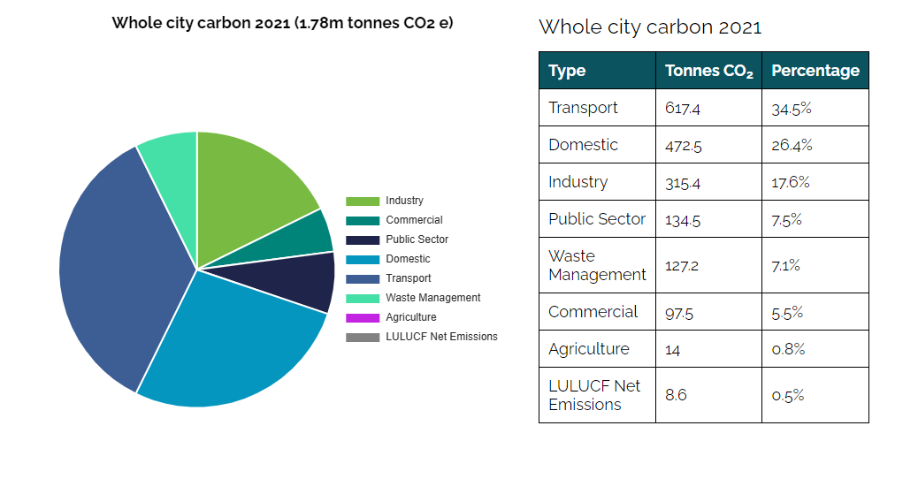
(OnePlanet Cardiff, 2025).
Cardiff Council has set a target to achieve carbon neutrality by 2030 and has begun collaborating with city-wide partners to develop a roadmap and action plan. For the hospitality industry, including Marriott Hotel Cardiff, these efforts signal the need to adopt sustainable practices to align with the city’s carbon neutrality goals. Marriott can enhance its green credentials by investing in energy-efficient technologies, reducing waste, and sourcing eco-friendly products. Embracing sustainability will not only help the hotel meet regulatory requirements but also appeal to environmentally conscious travellers, positioning Marriott Cardiff as a leader in sustainable hospitality.

- Legal Factors - Brexit has significantly impacted the hospitality industry, including Marriott Hotel Cardiff, through changes in immigration regulations and supply chain disruptions. The revised immigration policies have led to a shortage of workers, particularly in roles such as housekeeping and food service, affecting operational efficiency. Additionally, the complexities introduced by Brexit have caused fluctuations in the availability of goods and services, impacting the hotel’s supply chain. Moreover, the uncertainty surrounding Brexit has influenced the UK’s attractiveness as a travel destination, resulting in fluctuations in tourist arrivals. Marriott must adapt by diversifying staffing strategies and ensuring a reliable supply chain to maintain service quality.

- Employee Engagement at Marriott Cardiff discussion and analysis:

In the hotel sector, employee engagement is pivotal for fostering organisational success and enhancing client pleasure. Employees with high engagement typically lead to diminished turnover intention, enhanced customer service, superior financial performance, lower job stress, and elevated psychological well-being (Rabiul et al., 2023).

As a premier hotel brand, Marriott has continually emphasised employee engagement to ensure that its workforce feels valued, engaged, and motivated to deliver excellent service. This section rigorously examines and evaluates the research findings concerning the employee engagement strategies of Marriott Hotel Cardiff, investigating the ramifications of these approaches, recognising their constraints, and offering significant insights into how these methods can improve overall operational efficiency.

Review of Current Employee Engagement Practices at Marriott Cardiff:

Marriott Hotel Cardiff, adhering to its parent company's global standards, has instituted various measures to augment staff engagement and boost worker connection. These encompass organised communication channels, continuous training and development programs, empowerment efforts, and staff recognition systems. The hotel seeks to enhance cognitive and emotional engagement within its personnel through these strategies.
- Employee Feedback and Communication Channels
At Marriott Cardiff, effective communication between management and staff is central to fostering a productive work environment. Regular meetings and feedback mechanisms, such as surveys and individual check-ins, ensure employees feel valued and heard. This approach aligns with Xing's (2023) research on the relationship between negative feedback and employee motivation to learn. Xing identifies two key factors influencing the response to negative feedback: the attribution of the feedback and the employee's core self-evaluation (CSE). Employees with high CSE tend to view negative feedback as a performance-driven tool, thereby enhancing their motivation to learn, while those with low CSE often interpret feedback negatively, leading to reduced motivation and performance.
However, according to Zhu (2023) there are limitations in existing training and development research on supervisor feedback and employee voice. First, the research assumes that employees' desire to contribute constructively to the organization is the primary driver of voice decisions. This assumption overlooks the possibility that employees may struggle to voice concerns despite an environment that encourages it, due to internal energy constraints. Employee voice demands significant effort, as it involves idea generation, articulation, defence against counterarguments, and conflict management. Second, the current body of research predominantly views employee voice through the lens of social exchange theory and cognitive processing, neglecting the potential influence of personal energy regulation in motivating employees to speak up.
- Training and Development
Tracey and Swart (2020) assert that developing and implementing effective professional and vocational training programs requires a multi-level needs assessment. These programs should consider relevant learner, delivery, and contextual factors to maximize learning and achieve the intended outcomes.
Employee training and development at Marriott Hotel have evolved to meet the demands of technological advancements and the increasing complexity of the hospitality industry. Marriott employs the instructional systems framework for training design, which incorporates essential elements such as program design, implementation, pre-training assessment, and post-training evaluation. This approach ensures that training programs are both effective and aligned with the organization’s objectives. Marriott has long been recognized for its commitment to employee development, offering a variety of training programs tailored to different job levels. According to Alam et al. (2024), effective human resource management practices, such as recruitment, training, remuneration, and performance management, convey to employees that they are valued and respected, thereby fostering higher levels of productivity and engagement.
At Marriott Cardiff, employees are encouraged to improve their skills through Marriott International’s extensive learning and development initiatives. These programs not only provide employees with the necessary job skills but also help them envision long-term career opportunities within the organization (Hogan, 2022). Additionally, Marriott promotes leadership development programs, fostering a culture of internal promotion and growth. This emphasis on personal development enhances employee loyalty and engagement by empowering them and supporting their career progression.
- Team Building and Collaborative Culture
Creating an environment where employees feel supported by their colleagues and supervisors is key to fostering employee engagement. According to Alla Zlenko and Elena Isaikina (2020), one of the most effective methods of personnel management is team building. The success of a company depends not only on the professionalism of employees and their competent management but also on having a close-knit, collaborative team. The primary goal of team building is to foster emotional cohesion within the team and enhance the effectiveness of teamwork. The essence of team building lies in creating the necessary environment and activities that strengthen relationships, improve communication, and promote collaboration among team members.
Marriott Cardiff promotes teamwork and collaboration through regular team-building exercises and group activities. These initiatives encourage interaction, strengthen relationships, and improve overall team cohesion. Furthermore, Marriott's system actively addresses employee concerns, promoting a transparent, responsive, and trust-based work culture. The company’s approach to building strong interpersonal bonds aligns with the research of Zhang et al. (2024), who emphasize that cohesive teams contribute to a more productive and engaged workforce. The team-building activities at Marriott Cardiff, therefore, enhance social engagement and create an atmosphere of mutual support, ensuring employees work together harmoniously to achieve organizational goals.
- Employee Recognition Programs
Maslow's hierarchy of needs theory suggests that fulfilling basic needs enables individuals to progress in their careers (Younies and Al-Tawil, 2021). This theory is particularly relevant to Marriott Cardiff, where success relies on teams working together to achieve common goals. The heuristic theory further emphasizes the importance of providing the right environment for employees to reach their full potential, fostering a sense of mission and appreciation that is crucial for engagement and performance.
Marriott International is well known as a company that cares about its employees and that it provides great benefits to all their associates around the world (Kanner, 2024). At Marriott Cardiff, employee recognition is central to maintaining a positive work environment. One of the core components of Marriott's employee recognition strategy is the "Spirit to Serve Our Associates" (STARS) program, which acknowledges and appreciates the hard work and dedication of Marriott associates worldwide (Capoor and Raghav, 2024) . This program encompasses all Marriott associates, including front-line staff, managers, and corporate employees. It recognizes exceptional achievements in categories such as guest service, teamwork, innovation, leadership, and community involvement, among others and employs various recognition methods, including certificates, pins, plaques, trophies, personalized notes, public announcements, and team celebrations. Another well-known recognition program is the J. Willard Marriott Awards of Excellence, established in 1987, which honour the best at Marriott International for their achievements, character, dedication, effort, and perseverance (Marriott International, 2025). The awards also recognize corporate citizenship, diversity, core values and innovation.

According to Ampofo et al. (2023), employee appreciation is a vital strategy for service organizations, particularly in the hospitality and tourism sectors. Marriott Cardiff’s recognition programs, such as STARS, have a direct impact on employee motivation, engagement, and retention. By celebrating achievements, Marriott Cardiff boosts morale, strengthens its organizational culture, and deepens employees' emotional commitment to the company. This, in turn, leads to higher productivity and performance, reinforcing Marriott Cardiff’s commitment to a supportive and engaging work environment.
- Work-Life Balance and Wellbeing Initiatives
Marriott Cardiff recognizes the importance of family-friendly policies in promoting employee wellbeing and organizational performance. These policies, such as flexible work schedules and wellness programs, help employees balance their personal and professional lives, leading to higher productivity and engagement. Family-friendly practices are increasingly popular in many organizations as they show employees that their company cares about their wellbeing, fostering positive attitudes and behaviours that support organizational goals (Ko, 2024).
Marriott Cardiff's commitment to work-life balance is a key element of its employee engagement strategy. In addition to competitive compensation, the hotel offers flexibility in work schedules, wellness programs, and mental health support services. By investing in these initiatives, Marriott Cardiff reduces employee burnout and enhances overall engagement. Employees who feel supported in managing their personal lives are more motivated and invested in their work, which ultimately contributes to delivering exceptional guest experiences. This approach demonstrates Marriott Cardiff’s understanding of the critical link between employee wellbeing and organizational success.
Critical Analysis of Findings in Relation to Literature
Marriott Cardiff’s engagement strategies are closely aligned with established theories on employee engagement, particularly those emphasizing employee wellbeing and a collaborative culture. These strategies reflect the findings of Haider et al. (2018), who highlight the mediating role of psychological wellbeing in the relationship between work-life balance and job performance. The study suggests that a supportive work environment that promotes work-life balance enhances psychological wellbeing, which in turn boosts job performance. The happy/productive worker hypothesis further supports this, indicating that psychologically healthy employees are more productive (Arhin et al. 2025). This underscores the importance of minimizing work-life conflicts to foster positive psychological capital and enhance performance.
Ferdous et al. (2023) further corroborate this idea in their study, which investigates the mediating role of work-life balance in the relationship between flexible work practices and employee outcomes. The study integrates boundary theory and role balance theory, predicting and testing the mediating role of wellbeing in the relationship between flexible work practices and two employee outcomes: wellbeing and turnover intentions. The findings show a positive relationship between work-life balance and employee wellbeing, with flexible work practice usage positively impacting work-life balance. Higher work-life balance leads to greater wellbeing and lower turnover intentions, particularly among younger employees.
Marriott Cardiff’s focus on employee rewards and recognition aligns with the findings of Chand et al. (2022) who studied the impact of rewards, recognition, and welfare on employee engagement and found that better rewards, recognition, and welfare resources lead to higher employee engagement, potentially resulting in higher performance and productivity. The hotel rewards and recognition policy are aligned also with Ndiango et al. (2024) study, which explored the impact of recognition on employee retention. Their study found that recognition plays a critical role in enhancing employee retention, with job satisfaction acting as a partial mediator in this relationship. The results showed that job satisfaction fully mediates the relationship between recognition and retention among middle-aged adults. However, the study also revealed statistical differences between middle-aged and young employees regarding the effects of recognition and satisfaction, as well as the mediating role of satisfaction. Younger employees may respond differently to recognition and experience varying levels of job satisfaction, which could influence their retention. This insight emphasizes the importance of tailoring recognition programs to different employee demographics, ensuring that both middle-aged and younger employees feel valued, satisfied, and motivated to stay with the organization, further reinforcing Marriott Cardiff’s commitment to employee engagement and retention.
However, despite these strengths, there are areas where Marriott Cardiff’s engagement strategy could be further developed to address emerging challenges. One key area for improvement is the hotel’s feedback system. While it currently utilizes periodic surveys and one-on-one check-ins to gather employee feedback, these methods may not be fast enough to address concerns in real-time. Incorporating modern digital platforms for instant feedback could allow employees to provide immediate input on issues such as workload, job satisfaction, or management effectiveness. This approach aligns with the findings of Lechermeie et al. (2020), who highlight the significant impact of digital technology on customer interactions with service organizations, particularly in employee-related aspects. Traditional performance management systems often fall short by lacking continuous feedback, a crucial element for the success of service firms. Lechermeie et al. (2020) investigate the effects of real-time performance feedback in digital services through a field experiment conducted with a large telecommunications provider. The study reveals that real-time feedback leads to improved service employee performance and engagement. The research extends the job demands-resources framework, showing that real-time feedback enhances engagement by increasing the perceived controllability of feedback and the service situation. This highlights the importance of integrating digital tools for continuous feedback to foster higher employee performance and engagement in service-oriented industries.
Moreover, while Marriott Cardiff offers a range of professional development opportunities, there is potential to enhance the personalisation of these programs. Currently, training is provided in a general format, but tailoring development opportunities to align with individual career goals and aspirations could significantly increase engagement levels. When employees perceive that the organization is committed to their personal career growth and takes their unique ambitions into account, it strengthens their sense of value within the company. Research supports the notion that personalized development programs lead to greater employee satisfaction and engagement, as employees are more motivated when they see a clear connection between their professional growth and the organization's support (Wang et al., 2020; Wang et al., 2022).
Rukadikar and Khandelwal (2023) further emphasize how artificial intelligence (AI) has revolutionized education and training by enabling personalized learning for employees. Artificial intelligence customizes training experiences based on individual needs, improving career advancement and overall achievement. By analysing data such as performance metrics, feedback, and learning preferences, artificial intelligence can create tailored learning paths that optimise training programs and resource management.

Limitations of the Study
While this study provides a thorough analysis of Marriott Cardiff's employee engagement techniques, there are limitations to consider. The analysis primarily relies on secondary data and existing literature, meaning that certain insights may not fully capture the specifics of Marriott Cardiff’s internal operations. Additionally, employee engagement is a dynamic and multifactorial concept, influenced by external factors such as economic conditions or societal changes, which may not be fully accounted for in this analysis.
Future research could involve primary data collection, such as employee surveys or interviews, to gain more nuanced insights into the effectiveness of Marriott Cardiff’s engagement strategies. Additionally, exploring how Marriott Cardiff’s engagement strategies are perceived by customers could provide further validation of the connection between employee engagement and guest satisfaction.

- Recommendations and Conclusion:

Based on the analysis of Marriott Cardiff’s Marriott Cardiff's present employee engagement strategies and their correlation with existing literature, numerous improvements can be proposed to further improve engagement, employee happiness, and organisational performance.
- Implement Real-Time Feedback Mechanisms: While Marriott Cardiff already uses periodic surveys and one-on-one check-ins for feedback, the addition of real-time feedback platforms could significantly improve the efficiency and effectiveness of its engagement strategy. The use of digital platforms for immediate feedback allows employees to voice concerns or offer suggestions at the moment, thus enabling swift responses from management. Real-time feedback aligns with modern trends, as outlined by Lechermeie et al. (2020), which found that continuous feedback enhances employee performance and engagement. By adopting such tools, Marriott Cardiff can create a more responsive and dynamic communication system that better supports its workforce.
- Personalize Training and Development Programs: Marriott Cardiff’s commitment to training and development is commendable, but there is room to enhance the personalization of these programs. Tailoring development opportunities to individual career aspirations and skills can significantly increase employee engagement. According to Wang et al. (2020), personalized training leads to higher satisfaction and motivation, as employees feel their personal growth is valued. AI-powered learning platforms could be integrated to customize training content based on individual needs, performance metrics, and learning preferences. This approach would not only improve employee skills but also foster a culture of continuous learning and career development.
- Refine Employee Recognition Programs: Marriott Cardiff’s recognition programs, have a positive impact on employee engagement. However, recognition strategies should be further refined to consider the diverse needs of various employee demographics. Research by Ndiango et al. (2024) suggests that younger and middle-aged employees may respond differently to recognition efforts, with job satisfaction mediating this relationship. Marriott could consider tailoring recognition strategies based on employee age, job role, and tenure. Additionally, integrating more individualized recognition methods, such as personalized notes or team-based awards, could further enhance the effectiveness of the program and ensure a broader reach within the workforce.
- Enhance Work-Life Balance Initiatives: Marriott Cardiff already offers flexible work schedules and wellness programs to promote work-life balance. However, more can be done to communicate and enhance these benefits. Employees must be made aware of the full range of work-life balance initiatives available, and management should actively encourage employees to take advantage of these offerings. Marriott could also offer wellness programs that focus on mental health, stress management, and physical health to foster a holistic approach to employee wellbeing.
- Leverage Technology for Employee Engagement: The integration of technology in employee engagement can further strengthen Marriott Cardiff’s efforts. Utilizing AI-based systems, as suggested by Rukadikar and Khandelwal (2023), can help tailor training and development programs to individual needs, enabling personalized career paths and skill development. Additionally, AI can be used to predict employee engagement trends and identify areas for improvement. Porter and Grippa (2020) highlights in their study, the benefits of AI-enabled tools for effective collaboration and sustainable growth in corporate settings and online education environments. Marriott Cardiff can explore AI-driven tools for performance tracking, feedback collection, and engagement analytics, which would help managers make data-driven decisions to improve employee satisfaction and retention.
- Foster a Culture of Open Communication: While Marriott Cardiff employs feedback mechanisms, it is essential to create an environment where employees feel comfortable speaking up without fear of negative repercussions. This includes encouraging open dialogue during team meetings, anonymous surveys, and fostering a culture of trust where employees feel their voices are genuinely heard. Marriott could also provide training for managers on how to actively listen and respond to employee concerns, promoting a culture of inclusion and mutual respect.

In conclusion, employee engagement at Marriott Cardiff is a critical element of the hotel’s operational success and overall organizational culture. The hotel has fostered an environment where employees are motivated, respected, and committed to the organization's goals through a strategic focus on training and development, employee recognition, and work-life balance. Marriott Cardiff utilizes several well-established practices to enhance employee engagement, including open communication, professional development opportunities, team-building activities, recognition programs, and wellbeing initiatives. These strategies are aligned with existing literature on employee engagement and demonstrate the hotel’s dedication to maintaining a motivated and engaged workforce.
A key strength of Marriott Cardiff’s engagement strategy is its investment in training and professional development. Marriott’s commitment to offering a range of training programs tailored to different job levels ensures that employees acquire the necessary skills and knowledge to excel in their roles. Additionally, the hotel’s emphasis on leadership development and internal career progression fosters a sense of growth and opportunity within the organization.
Overall, Marriott Cardiff’s employee engagement strategy is comprehensive and effective in creating a positive work environment that nurtures employee development, recognition, and wellbeing. By continuing to adapt and refine its strategies, particularly through the integration of personalized training programs and real-time feedback, Marriott Cardiff can further enhance employee engagement, ensuring a motivated, loyal, and high-performing workforce.

References:

Alam, M.J. et al. (2024) ‘Human resource management practices and employee engagement: the moderating effect of supervisory role’, Cogent business & management, 11(1). Available at: https://doi.org/10.1080/23311975.2024.2318802.

Alla Zlenko and Elena Isaikina (2020) ‘Team building as a management tool for building a professional team’, Ekonomìčnij vìsnik unìversitetu, (47), pp. 52–59. Available at: https://doi.org/10.31470/2306-546X-2020-47-52-59.( accessed: 06.03.2025)

Ampofo, E.T. et al. (2023) ‘The effect of employee recognition on restaurant employees’ job embeddedness, knowledge sharing and service orientation: abusive supervision as a moderator’, International journal of contemporary hospitality management, 35(10), pp. 3612–3637. Available at: https://doi.org/10.1108/IJCHM-01-2022-0036.( accessed: 06.03.2025)

Amundsen, S. and Martinsen, Ø.L. (2014) ‘Self–other agreement in empowering leadership: Relationships with leader effectiveness and subordinates’ job satisfaction and turnover intention’, The Leadership quarterly, 25(4), pp. 784–800. Available at: https://doi.org/10.1016/j.leaqua.2014.04.007.

Arhin, V. et al. (2025) ‘Happy-productive worker hypothesis in the context of education: the role of work engagement and its dimensions’, Current psychology (New Brunswick, N.J.) [Preprint]. Available at: https://doi.org/10.1007/s12144-025-07399-6. (accessed: 04.03.2025)

Berkowitz, A.E. (2020) Employee Engagement, Public libraries. Chicago: American Library Association, pp. 44–51. Available at: https://librarysearch.uwtsd.ac.uk/permalink/44WHELF_UWTSD/1ir6fgh/cdi_proquest_miscellaneous_2549303653

Biswas, S. (2024) 'Empowering Employee Engagement: The Path from Begin to Become for Marriott Hotels India Private Limited', A Grate Place to Work, 30th Aug. Available at: https:// www.greatplacetowork.in/empowering-employee-engagement-the-path-from-begin-to-become-for-marriott-hotels-india-private-limited#:~:text=Marriott%27s%20holistic%20approach%20to%20employee,leading%20to%20improved%20business%20outcomes. (accessed: 05.03.2025)

Browns Brasserie and Bar (2025) ' A warm welcome awaits you at Browns Cardiff'. Available at: https:// www.browns-restaurants.co.uk/restaurants/wales/cardiff#/ (accesses at: 05/03/2025)

Bridger, E. (2018) Employee engagement: a practical introduction. Second edition. London; Kogan Page Limited.

Booking.com (2025) 'Marriott Cardiff'. Available at: https://www.booking.com/hotel/gb/cardiff-marriott.en-gb.html (accessed: 09/03/2025)

Business Travell News (2025) 'Amid Reorg Marriott moves into 2050 with record openings'. 4th Feb. Available at: https:// www.businesstravelnews.com/Interviews/Amid-Reorg-Marriott-Moves-into-2025-with-Record-Openings (accessed: 02.03.2025)

Business Travel News by NorthStar (2025) 'Cardiff Marriott Hotel'. Available at: https:// www.businesstravelnews.com/Hotels/Cardiff-Wales/Cardiff-Marriott-Hotel-p51574462 (accessed: 02.03.2025)

Brand Finance (2024) ' Suite success: Hilton continues as the world’s most valuable hotel brand as overall sector growth slows' Available at: https// brandirectory.com/reports/hotels (accessed: 03.03.2025)

Cao, Y. and Lee, K. (2023) ‘Employee engagement in corporate social responsibility: disentangling the effects of values vs prestige’, Journal of managerial psychology, 38(6), pp. 449–463. Available at: https://doi.org/10.1108/JMP-10-2022-0528. (accessed.01.03.2025)

Cardiff Public Service Board (2023) 'Cardiff Today Report'. Available at: https:// www.cardiffpartnership.co.uk/wp-content/uploads/2022/04/Cardiff-Today-English-Final.pdf (accessed: 05.03.2025)

Capoor, E.,Raghav, S. (2024)'Amazing Workplaces®’s Post', LinkedIn. Available at: https:// www.linkedin.com/posts/amazing-workplaces_rewardsandrecognition-recognition-employeeappreciation-activity-7216672980888694784-k8J5 (accessed: 06.03.2025)

Carasco-Saul, M., Kim, W. and Kim, T. (2015) ‘Leadership and Employee Engagement: Proposing Research Agendas Through a Review of Literature’, Human Resource Development Review, 14(1), pp. 38–63. Available at: https://doi.org/10.1177/1534484314560406.

Chand, M. et al. (2022) ‘Impact of Reward, Recognition and Welfare on Employee Engagement’, International journal of hospitality & tourism systems, 15(2), pp. 79-. Available at: https://librarysearch.uwtsd.ac.uk/permalink/44WHELF_UWTSD/1ir6fgh/cdi_proquest_journals_2831286533 (accessed: 01.03.2025)

Chakraborty, S., Bezborah, P. and Das, P.C. (2024) ‘Mediating Role of Employee Engagement in Improving Productivity among Employees’, Pacific Business Review International, 16(11). Available at: https://librarysearch.uwtsd.ac.uk/permalink/44WHELF_UWTSD/1ir6fgh/cdi_proquest_journals_3108726813

Drew, H. (2023) Employee engagement. London: Henry Stewart Talks Ltd. Available at:https://librarysearch.uwtsd.ac.uk/permalink/44WHELF_UWTSD/11c0l68/alma99100589253202421

Ferdous, T., Ali, M. and French, E. (2023) ‘Use of flexible work practices and employee outcomes: the role of work–life balance and employee age’, Journal of management & organization, 29(5), pp. 833–853. Available at: https://doi.org/10.1017/jmo.2020.44.(accessed:06.03.2025)

Google Map (2025) Cardiff Marriott Hotel. Available at: https:// www.google.com/maps/place/Cardiff+Marriott+Hotel/@51.4803827,-3.1833585,15.67z/data=!4m6!3m5!1s0x486e1cb3fe31ba9b:0xc7115879de5ebbe7!8m2!3d51.4770164!4d-3.1751347!16s%2Fm%2F0h67sn8?entry=ttu&g_ep=EgoyMDI1MDMwNC4wIKXMDSoASAFQAw%3D%3D ( accessed:05.03.2025)

Govand Anwar and Bafer Abd Zebari (2015) ‘The Relationship between Employee Engagement and Corporate Social Responsibility: A Case Study of Car Dealership in Erbil, Kurdistan’, International Journal of Social Sciences & Educational Studies, 2(2), pp. 45–50. Available at: https://librarysearch.uwtsd.ac.uk/permalink/44WHELF_UWTSD/1ir6fgh/cdi_doaj_primary_oai_doaj_org_article_d0319213ff35493ab5dfa96c0005bcb3

Gov. Wales (2024) 'International inbound visits and spend to Wales. The International Passenger Survey (IPS) collects information about passengers entering and leaving the UK, and has been running continuously since 1961'. Available: https:// www.gov.wales/international-inbound-visits-and-spend-wales-html. (accessed: 03.03.2025)

Gupta, A.K. (2018) Marriott Hotels and the globalization of a brand. London: Henry Stewart Talks. Available at: https://librarysearch.uwtsd.ac.uk/permalink/44WHELF_UWTSD/1pbrh66/alma99100590180602421 (accessed: 02.03.2025)

Haider, S., Jabeen, S. and Ahmad, J. (2018) ‘Moderated Mediation between Work Life Balance and Employee Job Performance: The Role of Psychological Wellbeing and Satisfaction with Coworkers’, Revista de psicología del trabajo y de las organizaciones, 34(1), pp. 29–37. Available at: https://doi.org/10.5093/jwop2018a4.(accessed: 07.03.2025)

Han, S., Harold, C.M. and Cheong, M. (2019) ‘Examining why employee proactive personality influences empowering leadership: The roles of cognition‐ and affect‐based trust’, Journal of occupational and organizational psychology, 92(2), pp. 352–383. Available at: https://doi.org/10.1111/joop.12252.

Harbi, M. (2016) 'Snapshot: 1957 Marriott’s first hotel'. Business Traveller 1st Dec. Available at: https:// www.businesstraveller.com/features/snapshot-1957-marriotts-first-hotel/ (accessed: 03.03.2025)

Harris, L. (2024) 'Effective Management Strategies to Increase Employee Engagement'. Walden University. Available at: https:scholarworks.waldenu.edu/cgi/viewcontent.cgi?article=16622&context=dissertations (accessed:02.02.2025)

Hogan, R. (2022) 'Marriott invests in people with launch of FlexiFutures program' HM The business of accommodation in Asia-Pacific. 11th Feb. Available at: https://www.hotelmanagement.com.au/2022/02/11/marriott-invests-in-people-with-launch-of-flexifutures-program/ (accessed: 03.03.2025)

Hospitality Online (2025) 'Cardiff Marrott Hotel'. Available at: https://www.hospitalityonline.com/employers/241437 (accessed: 05.03.2025)

Johnson, W. (2022) Leadership through Learning: Teaching Your Team How to Grow with Whitney Johnson. Carpenteria, CA: linkedin.com. Available at: https://librarysearch.uwtsd.ac.uk/permalink/44WHELF_UWTSD/11c0l68/alma99100535026602421

Kanner, M.G.(2024) 'An Overview of Marriott Benefits', The Life at Marriott Blog. Available at: https://life.marriott.com/blog/marriott-benefits/ (accessed: 01.03.2025)

Ko, M.C. (2024) ‘The Structural Relationship of Family-Friendly Policies, Work-Life Balance, and Employee’ Subjective Wellbeing: Focusing on the Categorization of Family-Friendly Policies Based on the Job Demands-Resources (JD-R) Model’, Review of public personnel administration, 44(2), pp. 377–409. Available at: https://doi.org/10.1177/0734371X221136431. (accessed: 06.03.2025)

Kim, M., Beehr, T.A. and Prewett, M.S. (2018) ‘Employee Responses to Empowering Leadership: A Meta-Analysis’, Journal of leadership & organizational studies, 25(3), pp. 257–276. Available at: https://doi.org/10.1177/1548051817750538.

Lechermeier, J., Fassnacht, M. and Wagner, T. (2020) ‘Testing the influence of real-time performance feedback on employees in digital services’, Journal of service management, 31(3), pp. 345–371. Available at: https://doi.org/10.1108/JOSM-10-2018-0341. (accessed: 10.03.2025)

Leppla, A. (2016) 'Marriott International Shares Its Secret To Driving Employee Engagement', LinkedIn, 18th Aug. Available at: https:// www.linkedin.com/business/talent/blog/talent-engagement/marriott-international-shares-secrets-to-driving-employee-engagement (accessed:03.03.2025)

Luxury Hospitality Magazine (2025) 'Marriott International celebrates record breaking Development Year', 5th March. Available at: https:// lhmagazine.co.uk/marriott-international-celebrates-record-breaking-development-year/ (accessed: 06.03.2025)

Merriott Cardiff (2025)'Your event rooms at Cardiff Marriott Hotel'. Available at: https:// www.memoriesmademarriott.co.uk/cardiff/eventspaces (accessed: 02.03.2025)

Marriott International (2025) 'Brands'. Available at: https:// www.hotel-development.marriott.com/brands (accessed: 03.03.2025)

Marriott International (2025)' J. Willard Marriott Awards of Excellence'. Available at: https://www.marriott.com/culture-and-values/awards-of-excellence.mi (accessed: 01.03.2025)

Marriott, J.W. and Brown, K.A. (2012) Without reservations: how a family root beer stand grew into a global hotel company. First edition. San Diego: Luxury Custom Publishing.

Martínez-Córcoles, M. et al. (2021) ‘The power of empowering team leadership over time: A multi-wave longitudinal study in nuclear power plants’, Safety science, 133, pp. 105015-. Available at: https://doi.org/10.1016/j.ssci.2020.105015. (accessed: 01.03.2025)

Maslow’s hierarchy of needs: Updated for the 21st century. (no date). Place of publication not identified: Big Think. Available at:
https://librarysearch.uwtsd.ac.uk/permalink/44WHELF_UWTSD/11c0l68/alma99100422498802421. (accessed: 01.03.2025)

McGeehan, T. (2024)' As Wales looks to the future, how will tech support economic growth?'. TechUK, 4th March. Available at: https:// www.techuk.org/resource/as-wales-looks-to-the-future-how-will-tech-support-economic-growth.html (accessed:06.03.2025)

Mizerak (2024) 'Marriott Hotel Loyalty Program Review: The Gold Standard for Experience', Antavo a loyalty cloud, 28th Dec. Available at: https:// antavo.com/blog/marriott-hotel-loyalty-program-review/ (accessed:05.03.2025)

Ndiango, S., Gabriel, D. and Changalima, I.A. (2024) ‘Give me my flowers before I die! Linking employee recognition, job satisfaction and employee retention in logistics companies: A multigroup analysis’, Social sciences & humanities open, 10, pp. 101053-. Available at: https://doi.org/10.1016/j.ssaho.2024.101053. (accessed: 06.03.2025)

OnePlanet Cardiff (2025)'Our vision for a Carbon Neutral City by 2030'. Available at: https:// www.oneplanetcardiff.co.uk/#council. (accessed: 06.03.2025)

Online Reservation (2024) 'Cardiff Marriott Hotel'. Available at: https:// www.online-reservations.com/?hotelid=36878&gad_source=1&gclid=EAIaIQobChMIg4jrxcL9iwMVG41QBh1UKQTjEAAYAyAAEgJw6_D_BwE (accessed: 05.03.2025)

Organisation for Economic Co-operation and Development [OECD] (2024) 'United Kingdom' OECD Economic Outlook, Volume 2024, Issue 2, 4th Dec. Available at: https:// www.oecd.org/en/publications/2024/12/oecd-economic-outlook-volume-2024-issue-2_67bb8fac/full-report/united-kingdom_946788ac.html (accessed: 05.03.2025)

Pichère, P. and Cadiat, A.-C. (2015) Maslow’s hierarchy of needs. Translated by C. Probert. Namur: Lemaitre Publishing.

Porter, B. and Grippa, F. (2020) ‘A Platform for AI-Enabled Real-Time Feedback to Promote Digital Collaboration’, Sustainability, 12(24), pp. 10243-. Available at: https://doi.org/10.3390/su122410243. (accessed: 07.03.2025)

Rabiul, M.K. et al. (2023) ‘Linking human resources practices to employee engagement in the hospitality industry: the mediating influences of psychological safety, availability and meaningfulness’, European journal of management and business economics, 32(2), pp. 223–240. Available at: https://doi.org/10.1108/EJMBE-12-2020-0347. (accessed: 06.03.2025)

Rabiul, M.K. et al. (2023) ‘Motivating language and employees’ need satisfaction to service quality: conservation of resources and speech act theories’, Management research review, 46(12), pp. 1783–1801. Available at: https://doi.org/10.1108/MRR-10-2022-0720. (accessed: 01.03.2025)

Rukadikar, A. and Khandelwal, K. (2023) ‘Artificial intelligence integration in personalised learning for employee growth: a game-changing strategy’, Strategic HR review, 22(6), pp. 191–194. Available at: https://doi.org/10.1108/SHR-08-2023-0046.(accessed:10.03.2025)

Rupp, D.E. et al. (2018) ‘Corporate social responsibility and employee engagement: The moderating role of CSR-specific relative autonomy and individualism’, Journal of organizational behavior, 39(5), pp. 559–579. Available at: https://doi.org/10.1002/job.2282. (accessed: 01.03.2025)

Sharma, N. (2019) Management techniques for employee engagement in contemporary organizations. Edited by N. Sharma, N. Chaudhary, and V.K. Singh. Hershey, Pennsylvania: IGI Global. Available at: https://doi.org/10.4018/978-1-5225-7799-7.

Statistica.com (2025) 'Employees of Marriott worldwide from 2007 to 2024' 24th Feb. Available at: https:// www.statista.com/statistics/297269/number-of-marriott-international-employees-worldwide/ (accessed: 03.03.2025)

Strubler, D.C. and York, K.M. (2007) ‘An Exploratory Study of the Team Characteristics Model Using Organizational Teams’, Small group research, 38(6), pp. 670–695. Available at: https://doi.org/10.1177/1046496407304338.( accessed: 03.03.2025)

Tracey, B. and Swart, M.P. (Nellie) (2020) ‘Training and development research in tourism and hospitality: a perspective paper’, Tourism review (Association internationale d’experts scientifiques du tourisme), 75(1), pp. 256–259. Available at: https://doi.org/10.1108/TR-06-2019-0206. (accessed: 06.03.2025)

TripAdvisor (2025) 'Cardiff Marriott Hotel'. Available at: https:// www.tripadvisor.co.uk/Hotel_Review-g186460-d192339-Reviews-Cardiff_Marriott_Hotel-Cardiff_South_Wales_Wales.html (accessed: 05.03.2025)

UK Parliament (2022) 'MPs launch inquiry into establishing Wales as a global tourist destination'. Available at: https:// committees.parliament.uk/committee/162/welsh-affairs-committee/news/160874/mps-launch-inquiry-into-establishing-wales-as-a-global-tourist-destination/ (accessed: 05.03.2025)

Varghese, A and Noronha, S. (2024) 'Employee productivity and human resource practices in the Hotel Industry with special reference to Marriott International'. Journal of Emerging technology and innovative research. Jutir. org., Jun 2024, Vol. 11 Available at: https://www.jetir.org/papers/JETIR2406076.pdf (accessed: 03.03.2025)

VisitCardiff.com (2025)'Cardiff Marriott is a luxury hotel, in the heart of Cardiff city centre's cosmopolitan Café Quarter'. Available at: https:// www.visitcardiff.com/highlights/cardiff-marriott-hotel/ (accessed: 03.03.2025)

Wales Government (2020) 'Welcome to Wales: 2020 – 2025'. Available at: https:// www.gov.wales/sites/default/files/publications/2020-02/welcome-to-wales-priorities-for-the-visitor-economy-2020-2025.pdf (accessed: 05.03.2025)

Wales Government (2025)' Welsh economy in numbers: interactive dashboard' 5th March.
Available at: https://www.gov.wales/welsh-economy-numbers-interactive-dashboard' (accessed: 06.03.2025)

Wang, C. et al. (2020) ‘Personalized Employee Training Course Recommendation with Career Development Awareness’, in Proceedings of The Web Conference 2020. New York, NY, USA: ACM, pp. 1648–1659. Available at: https://doi.org/10.1145/3366423.3380236.(accessed: 07.03.3025)

Wang, C. et al. (2022) ‘Personalized and Explainable Employee Training Course Recommendations: A Bayesian Variational Approach’, ACM transactions on information systems, 40(4), pp. 1–32. Available at: https://doi.org/10.1145/3490476.(accessed: 07.03.2025)

Xing, L. et al. (2023) ‘Supervisor negative feedback and employee motivation to learn: An attribution perspective’, Human relations (New York), 76(2), pp. 310–340. Available at: https://doi.org/10.1177/00187267211038514. (accessed: 06.03.2025)

Younies, H. and Al-Tawil, T.N. (2021) ‘Hospitality workers’ reward and recognition’, International journal of law and management, 63(2), pp. 157–171. Available at: https://doi.org/10.1108/IJLMA-02-2020-0046.

Zhang, A. et al. (2024) ‘Employee power needs, leadership, and employee organizational commitment: A case study of high‐tech enterprises’, Systems research and behavioural science [Preprint]. Available at: https://doi.org/10.1002/sres.3078. (accessed: 01.03.2025)

Zhou, Z., Luo, B.N. and Tang, T.L. (2018) ‘Corporate Social Responsibility Excites “Exponential” Positive Employee Engagement: The Matthew Effect in CSR and Sustainable Policy’, Corporate social-responsibility and environmental management, 25(4), pp. 339–354. Available at: https://doi.org/10.1002/csr.1464. (accessed: 01.03.2025)

Zhu, C. et al. (2023) ‘Supervisor feedback, relational energy, and employee voice: the moderating role of leader-member exchange quality’, International journal of human resource management, 34(17), pp. 3308–3335. Available at: https://doi.org/10.1080/09585192.2022.2119093.(accessed: 06.03.2025)

Appendix 1

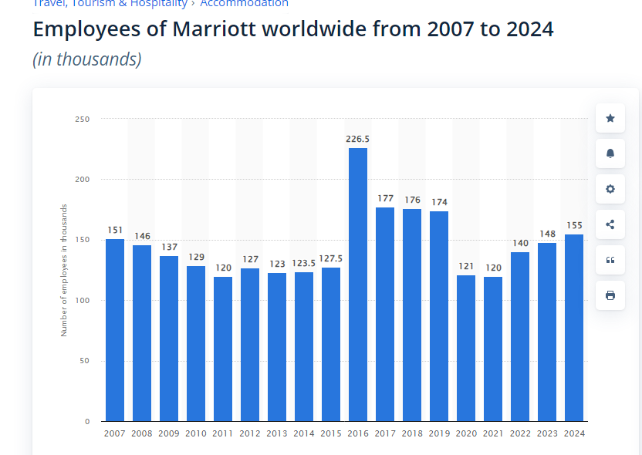
(Statistica.com, 2025)

Appendix 2

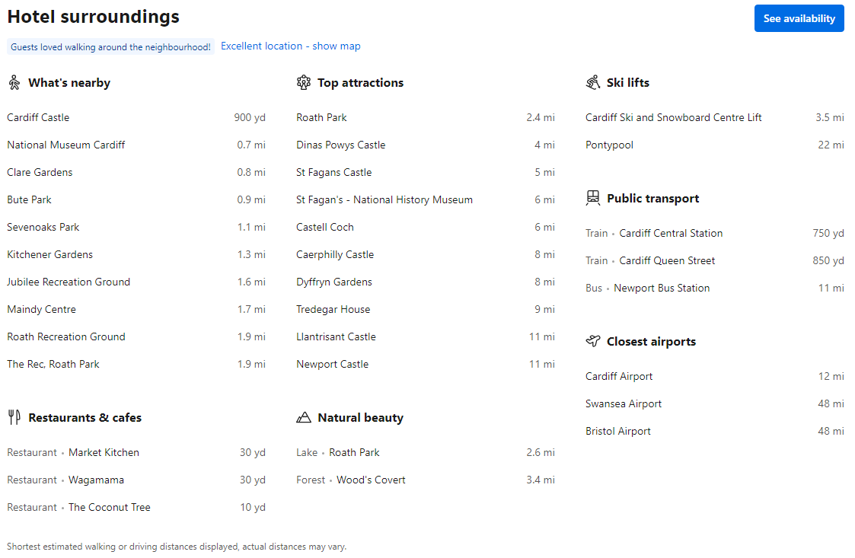
(Booking.com, 2025)

Appendix 3

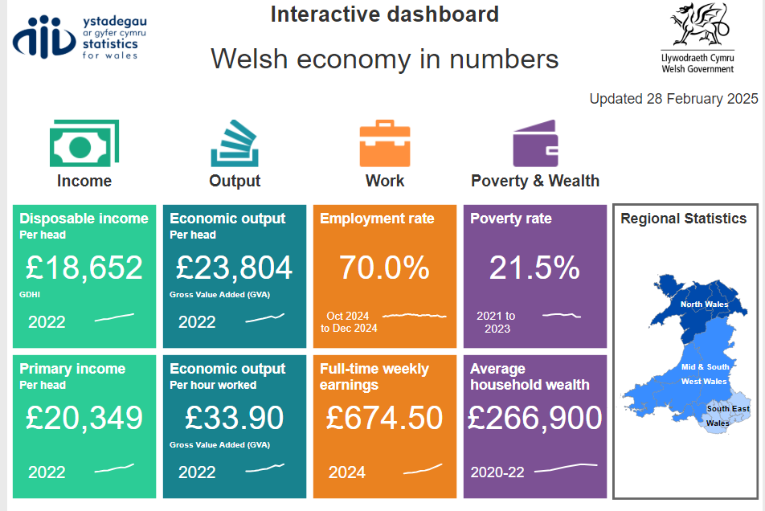
( Welsh Government, 2025)

