My Reflective Practice Learning Journey

(Brockmann, Suzanne. (1996). There is no right or wrong way to work, only your way).

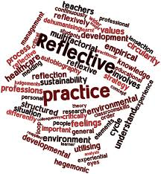
Introduction
The term reflective practice to me, just literally means, reflecting on my own practice within in my everyday life. Thinking, sharing and doing. Looking at different ways in which I could improve my co-teaching skills. As you read throughout, I will be sharing my professional learning journey with you, describing managed micro skills and critically evaluating and demonstrating my own understanding and my own views on the science of reflection within an education setting, and the issues surrounding Reflective Practice in everyday life. Is it an adaptable process? How effective is it? Is it a good skill to have? Does it really give you a better understanding of yourself and others? In everyday life, sometimes I just need to momentarily reflect. On a daily basis, I have reflected within my challenging and demanding job role as a Pupil Support Assistant within a Primary School. I am also constantly self-reflecting (to myself) within my personal life. As a mum, as a wife, as a daughter and as a friend. Today, sharing my own point of view on the matter, using my previous knowledge and co-teaching experiences, the research and literature made readily available to me through my courses studied, I am going to be exploring, sharing and expressing my thoughts and my emotions about a particular experience that has happened in my professional career with the children I work alongside, allowing me to gain valuable skills to be a valuable effective educator, how and who I gained these techniques with when certain uncomfortable and difficult situations arose out with my control and explain to you how I reflected on that particular experience, how a particular model was used? (commonly known as The Gibbs’ Reflective Cycle or Gibbs’ Reflective Model), What was learnt? The outcome on my future practice and Why I used it?
(Thompson, S. and Thompson, N. (2018). The critically reflective practitioner).

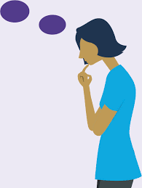

So what are Micro skills?
Micro skills are the basic foundational skills and tools used in effective helping relationships we have with one another. Using observation, communication, eye contact, giving instructions, using different body positions, giving and receiving commands, vocal tone, basic listening and questions, they help to create acceptance, aid rapport and build on the understanding from which positive changes can take place within an environment.

(retrieved from https://www.sulross.edu/sites/). (2015)
What is Reflective Practice?
Reflective Practice is the importance of lifelong learning. It is the ability to reflect on your own actions and engage in a process of continuous practice based learning. Structure.
Reflective Practice, I believe, is something that you may have explored or experienced in your life which you have to identify what has happened, what your role in this experience was, and the related emotions behind this. Reflective Practice allows you to form new ideas, identify changes to your approach for similar or future experiences. By not limiting yourself about certain vulnerable scenarios, the time it takes to reflect or how uncomfortable / challenging it may be to evaluate your own practice, if Reflective Practice is performed honestly and comprehensively, it will definitely lead to better structure, improved performance and creativity, better achieving and more confidence within oneself.
There are many models of using Reflective Practice. I personally, am inspired by The Gibbs’ Reflective Cycle.

(Gibbs, G. and Andrew, C. (2001). Learning by doing: a guide to teaching
and learning methods)

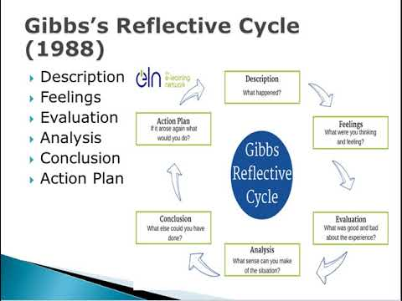

The Gibbs’ Reflective Cycle (which was inspired partly by Kolb’s Learning Cycle) was developed and published by Professor Graham Gibbs (in his book “Learning by Doing 1988). It is one of the most commonly used models within all professions. He is a world-renowned leading researcher, accomplished writer and Doctorate of Sociology, Anthropology and Philosophy. Using the common framework of reflection, it is very useful in the fact that he uses the active process of reviewing, analysing and evaluating one’s own experiences enabling people to effectively help everyday people reflect, make sense of and understand certain situations and encourages people to think systematically about these experiences, allowing them to learn or plan on the things that either went well or didn’t go well and what else could have been done differently in the future. He helps to give structure and leads you through, what he calls, the “six stages of exploring and experience”. The cycle or loop containing these six elements:-

- Description of the experience
- Feelings about the experience
- Evaluation of the experience (both good and bad)
- Analysis to help make sense of the situation
- Conclusion about what was learned and what could have been done differently
- Action Plan what would you do next time?

The terms, “one can only change what is in their control to change”, “best learned from experience” and “look beneath the surface” are terms I have heard (and come across) most of my adult life. Reflection is a key aspect of my personal and professional development that I use, or have used, to keep with the pace of challenging or changing natures of practice, helping me to ensure safe and effective care, whilst constantly improving my basic teaching and learning skills. Every day we seem to challenge ourselves. Using the Gibbs’ model when I reflect, helps me to focus on my learning journey whilst being self-aware of the situations and people around me. By using this framework / model above and learning through experience, I gain new insights. I challenge myself and others, I strategize, think and collect all the necessary information needed.
Most of the time, by using the common framework / model above, it worked for me and as part of a team. However, on some occasions I noticed that the model didn’t always apply in every situation, or in certain aspects within my career. It was dependent on certain peers, certain pupils or certain environmental surroundings. I found out that it didn’t always help me to analyze certain situations from different perspectives or with the implications of others’ actions though.

My Workplace Learning Journey
Everyday within my workplace, there have been some daily struggles, stresses and challenges. These have included health and safety issues, staff shortages, child protection issues, boundaries, self-esteem issues, lack of communication, lack of confidence issues (pupils and staff), bullying or constant competing amoungst one another to name just a few. Just reflecting back and talking about it has helped over the years whether it be verbal or written communication to one another. Having monthly meetings with management. Talking about feelings, everyone’s job roles and what is expected, best practices on individual basis’, procedures and protocols that need to be put into place for all to follow to achieve the best possible outcome and high standards for everyone involved. I suppose finding negatives and positives from the experiences or events having occurred, to then reflecting upon and then having a plan of action. It’s how we learn to teach.

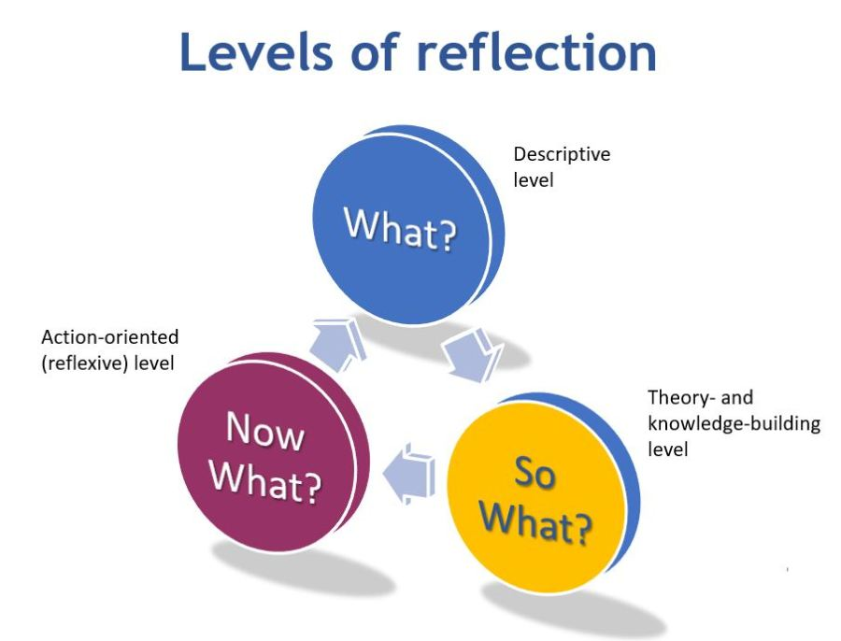

I was 26 years old and had only ever really worked in Office Administration roles. I was a slightly confident, keen, quietish hard worker who just needed a change in career and felt I had the care and compassion for this type of role. In July 2010, I was interviewed and was successful in my application for a Pupil Support Assistant Level 2 with Fife Council.
I have now worked as a Pupil Support Assistant for the past 10 years. I have mainly worked within the upper end of the school, Primary classes 5, 6 and 7. I have got a great work ethic, again learned from experience. I am friendly, trustworthy, have great listening skills and the headteacher has always informed me (year after year) I have a great connection and rapport with the older children, which is always great to hear.
Every week I work from a teaching timetable / diary consisting of the days from 9am on a Monday all the way through to 3pm on a Friday. This is shared to me by my class teacher. Having worked through some of it together, we had previously looked at what stage and where our pupils’ learning progress is at and our intended learning goals for them.
On a daily basis, I have to think about planning and preparation. What resources do I need? Where about are we working in our small groups? Why we are doing it? Who do / can I go to if something goes wrong?
I remember very vividly my first week at the school being quite a small but friendly school of only about 150 pupils. Upon being introduced to everyone I remember my first class I had the pleasure of working with was a Primary 5 class. It was a big but inviting classroom, one of our biggest Pupil to Teacher ratio classes that we had ever had which consisted of 32 children (22 of them boys) all aged between 8 and 9 years old, the class Teacher and 2 part time Pupil Support Assistants. I remember after the first week, I quickly realised that at least half of the class needed one to one or small group support or assistance one way or another. I was literally thrown in at the deep end. One of the pupils that I worked closely alongside was a boy called EW. Most of the time, he was a lovely, clever, happy talkative but hyper boy, who suffered from Autism and ADHD. I quickly realised that I was needing to get up to speed by reading his and a few of the other boys’ PLP (Personal Learning Plan).
Not going to lie, I was quite nervous and anxious when I was in that class to start off with, for all the reasons stated above, I had been told about certain barriers I might be faced with. However, looking back on it now, after gaining the experience, I realised that that specific experience, at that point in my life, for some reason made me a better more understanding, passionate and patient person. A better colleague. A better listener. A better communicator. It made me more confident as a younger working professional as at that point, I didn’t have any children of my own.
Some days were harder than others. Each day I learnt from my (and others) mistakes or misfortunes within a fast paced and challenging environment. Having to get used to my surroundings quickly. I have been involved in some tough challenges, experiences and events over the years but one of experiences I endured a few years ago, that day hit me hard, physically and mentally and made me question my role.
We had not long transitioned from Primary 5 to Primary 6, so as well as different surroundings and a new environment, there were added children into the class that was slightly different to the previous term. We knew it was going to be a bit problematic for a few of the children but especially for EW. We transitioned all the kids slowly, but especially EW working closely with him, effective and proactive planning, organising and using verbal and written communication from both me, the class teacher, EW and his parents. He had come in that Friday morning a little bit fidgety and anxious, not making much eye contact. It was the end of the week and I knew he was probably just tired. Just needed to get to the end of the day and look forward to a good weekend I kept telling him (and myself). I knew just the thing to help calm his nerves so that mum could say her usual goodbyes. I reassured her that all should be fine and informed her that if there were any problems, I would give her a call. He loved books so we got his favourite book, read it and then drew comic pictures for a while until after registration and lunches was done, then explained his jobs for that morning. All was fine then I had heard through the grapevine that there had been an incident that took place in the playground at break time with another child. Once I, and another member of staff had got to the bottom of the problem (and found a solution or so we thought), we encouraged EW to come inside for some quiet and reflection time. He had punched and slapped another child on the body and screamed in their face (for the second time that week). He asked if he could go on to the computer to play games (as he generally does at least 10 times a day and some days produces no work) so we said no, not at the moment, possibly later. We told him we wanted to try and rectify the situation and had reminded him about the rules and that there are other ways of dealing with things if he gets frustrated, that he can tell / speak to any member of staff about how he is feeling. I also informed him that unfortunately I would have to record the incident and write about it in his daily diary. He didn’t like this as he still felt he did nothing wrong. He just kept on screaming for the computer, getting louder and louder. Once inside, it was at this point, his inner anxiety took over and he went from a little bit upset to angry, aggressive and abusive. I, at that moment thought to myself, it was like a volcano erupting. He was no longer engaged or communicating with us the way he did before. Within seconds, he picked up chairs within the classroom and had thrown them around the room. He had jumped on top of the tables kicking and punching the air and then knocked them over on to the floor. Jotters and books were getting tossed into the air and directed at us. Wooden objects were getting thrown about. The computer monitor and keyboard were pushed to the floor and he had started punching himself in the face. I repeatedly asking him not to do that or why is he doing that. While all this was going on he was shouting “I don’t want to be here anymore, I hate everyone, I want to die”. At the time I remember just thinking to myself, What? So What? Now What? “just use your training, skills and experience gained to try and calm him and the situation down before anyone gets hurt and before the rest of the children come back inside”. I didn’t really have time to assess the situation. I just remember feeling a bit shocked and sad. A bit taken aback on how quickly things escalated. I remember immediately flagging down another member of staff. All thoughts and emotions were running through my head. I hadn’t seen anyone act like that before. I thought I might get hurt. I was definitely aware of the lack of help around me. I didn’t want him to injure himself. At times I felt I had lost control of the situation. I didn’t want to call on more members of staff to help diffuse the situation because sometimes a bigger audience creates more problems. I really was just scared and couldn’t seem to help him. My heart was racing. We have been told not to get too close but to be fair it’s sometimes hard not to. Sometimes you just need to think about the here and now and previous learned experiences. I tried to quickly adapt, calmly and co-operatively try to talk to him but that didn’t work. I tried to distract him but that didn’t work either. Whatever we were doing just seemed to make things worse. The good thing was nobody got hurt. I stayed within eyesight of EW, keeping my distance at all times and I got the other member of staff to go and get the Headteacher. Mrs F came through smiling and seen everything. She chatted with EW for a few seconds, took the computer, as he had asked can he now play games on it, and went to her office asking not to be disturbed. I was bewildered. My jaw just dropped to the floor when I had heard minutes later. I felt like he was being rewarded for disruptive bad behaviour. I felt like I was being undermined and not being listened to or respected as a member of staff (from EW and the HT). It led me to wonder Why had she done that? I had a huge lump in my throat as everything was going through my head. I knew myself that I could have just given him the laptop to keep him quiet, but us, as hardworking staff members have to be consistent and fair to everyone to treat all children the same and following the school’s procedures and protocols on behaviour policy. I had gotten permission to contact EW mum to inform her of what had happened. In the end, she came and got him at lunchtime as it was all a bit too much for him and he wasn’t going to produce any more work for the afternoon. Afternoon times are always the hardest for the children. I had to just carry on as normal as there were possibly 31 other children needing my support and assistance. What I didn’t do though (which I later questioned and regretted) was express to the headteacher my version of events, how I felt about what had happened and what to me, looked like she had done. Myself, the other staff member and EW didn’t get any feedback about how we had handled the situation (which was really a regular occurrance), whether good or bad or about possibly changing the way we could have maybe dealt with things. We just got told “you know how he sometimes gets when he doesn’t get his own way”. On speaking with the class teacher, I told her about my understanding of the incident. In awe and shock, she asked what my thoughts and feelings were on the matter. If the Headteacher wasn’t going to play an active part in resolving the matter, the Teacher was going to try. We both needed to work together (and with support from mum) to understand the situation, self-assess the situation, come down to his level of communicating, gently reminding him about being responsible, taking ownership and the different strategies or new approaches to use in future, if he ever felt this way again. By doing this with the teacher and mum, our relationships demonstrated mutual respect for one another. We all have the same goal for EW. I feel though, that that was the kind of support I was really needing from my Headteacher. For the rest of the day (and all weekend), it was constantly on my mind as I was back to work on Monday and dreading what could possibly happen again.
On hindsight and reflection though, this was certainly a challenging and confrontational incident I had never experienced before and didn’t want to experience again. At times I felt like I hadn’t helped in any way. I questioned myself in all aspects, after all I am part responsible for his safety, learning and progress. How could I have improved and stopped him? Were there simpler techniques that I could have tried at the time. Could I have tried to encourage him to go to the newly appointed (but undecorated) nurture room to help calm down. Could I have shouted louder and requested more members of staff to help to maybe help me understand the situation better. Could I have calmly not tried to say anything and just give him time to do what he needed to do or just have agreed to give in and just give him the laptop. I challenged all these decisions made about the incident. I just knew, over time, that it was definitely something I wanted to work on to improve on should this situation ever arise again. Over time, and with the great rapport and support from my Teacher and peers, I thought to myself, but should I have really challenged what I did or didn’t do? or did I do things to the best of my ability and was just a stumbling block? I didn’t really want to keep overthinking the situation or get stuck in my thoughts for too long. Overthinking is often linked to psychological problems and symptoms such as depression, headaches, stress and anxiety and is definitely not the declining route I ever want to go down. That is where mindfulness strategies such as writing things down, walking away from certain situations, be present in the moment, try and remove it from your head for a while, exercise or just being around someone who makes you feel good about yourself even for a little while.
As Professor Gibbs states in his methods, Learning by Doing. I suppose I can only learn by what I have done, to try and not over think every scenario and just speak my mind to others when or if I have concerns about something, whilst reiterating to myself that just by doing that, can sometimes benefit the outcome, making a huge difference in everyday learning.
Due to this incident occurring, us as Pupil Support Assistants (and the office staff) now have walkie talkies for communicating emergencies to one another. It was also decided that there are always 2 x Pupil Support Assistants in every wing of the school as a buddying support system as these types of incidents have dramatically increased over the years. Small but necessary changes and improvements.
(retrieved from https://www.theawarenesscentre.com). (2020)

Every year we are meant to have appraisals and performance reviews. I have attended a few over the past 10 years. I personally feel it is a great example of reflection. Not only to me but which effects everyone else within my workplace. Communication is key and plays a big part in my role. The feedback given and performance discussions taken place have provided me with a voice, a better understanding, new insights and opportunities, new growth, training and development opportunities, as well as a thank you from management for all the hard work put in to achieve high standards. Thus helping me to be an overall, better employee.
I realised a couple of years back I wanted to work even harder to pursue new options to further my career. I wanted to experience all aspects and different roles within this setting the more experienced I got and the gratitude I got from my pupils. To start with I was very nervous and apprehensive at the thought of completing this. I did though. Through research, hard work, determination and learned experiences (but knowing my limitations), I gained a Higher National Diploma qualification in Social Services Children and Young People in 2016. Through 2 years of theory, assessments, reports, essays, quickfire question’s, observations from my tutor, I thrived and felt very proud of myself and my accomplishments. There was no right or wrong way of learning, just believing in myself, using my skills knowledge gained throughout the years and using the materials and resources at my disposal. I enjoyed the challenges and working to deadlines. I was, and still am, also very fortunate to partake in the University of Wales Trinity and Saint David’s well designed and implemented Counselling Skills (PGCert) course, which I am currently studying. Again, I was a bit apprehensive at completing a part time degree course online as I was used to a more visual, people and classroom-oriented environment, however with such advanced technology nowadays, it has been a great experience so far shared by the 26 of us and our very helpful and accommodating tutors. I am enjoying it and gaining (at an even higher level) even more new insights into alternative methods of communication, the critical understanding and analysing of events having occurred in that moment as well as being part of other people’s experiences.

(Gibbs, G. and Oxford Centre for Staff Development (1996). Improving student learning through assessment and evaluation).
(Thompson, S. and Thompson, N. (2018). The critically reflective practitioner).



In Conclusion
In conclusion, by managing my micro skills, critically analysing, researching and comparing all my experience that I gave gained over the years, I think self-reflection / reflective practice helps us to think and grow as individuals. It is important to transition, reflect back and make changes, for the better. We all have strengths and weaknesses in our development that can either control or prevent learning. There is no right or wrong way to reflect. It is a very adaptable and easy process that can always be modified through different events or experiences. I feel it offers a good starting point, improving and converting learning and knowledge into action and change with a deeper understanding of yourself and others, making you a stronger more confident person (and making others more engaged, stronger and more confident). These are just some of the things that I have learned through everyday life. Although some people may look at self-reflection or reflective practice scenarios as possibly making them feel vulnerable, very time consuming or dwelling on the past, there are multiple positives that can come out of reflective practice.
As stated, using my relationships with others, adapting, reflecting on my thoughts and emotions process, I have developed new skills, gained new insights, grown, encouraged others, built a better rapport and deeper empathic understanding with and of others, making for a productive working environment.

