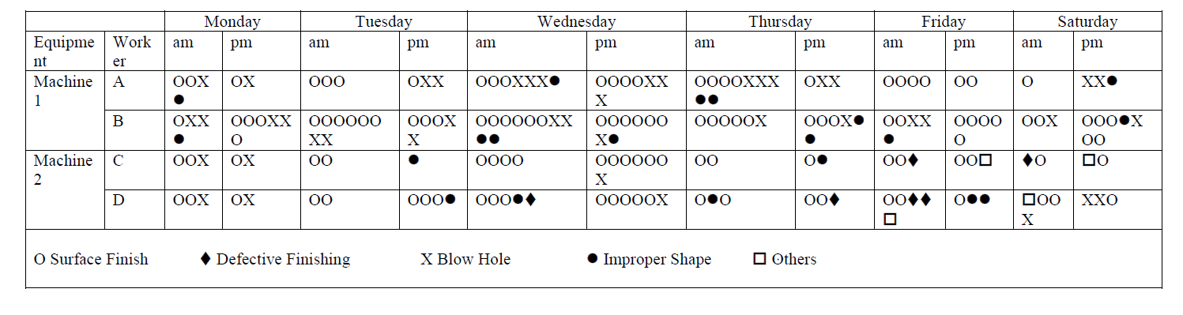
Within this report I will attempt to analyse the above defect information and produce a corrective action plan through the use of various quality tools. Many of the ideas put forward within this report are informed by a wide range of literature, and the conclusions drawn will hopefully mirror some of the concepts highlighted through close reading of the relevant texts. Due to the limited nature of the information provided to me (please see above defect data), some assumptions will need to be made in order to allow for analysis to be carried out. Whilst further detail will be discussed in terms of these assumptions later in this write-up, it should be stated early on that assumptions have been made regarding the competency of staff, quality of preventative maintenance techniques and management, and the machines used to carry out both of the tasks – sand-casting and milling.
An important tool when creating this report was the ‘Business Process Improvement Framework’ discussed by Bjorn Andersen in his Business Process Improvement Toolbox (Milwaukee, 2007). This framework sets out a six-stage process to carrying out improvement and has informed many of the ideas mentioned below, including the need for a thorough understanding of the process and a skilled workforce, as well carrying out adequate performance management.

Before moving on to looking at suggesting how improvement can be implemented within the process, it is important first to engage with the data itself. Only through this analysis can you begin to understand and/or identify the issues present that will inform the means by which you subsequently seek to amend the problem(s). With this in mind, my first step was to collect the cumulative frequency data of the defects. Across the two machines, 1 and 2, the total number of defects recorded was 197, and whilst we are unable to identify how high a percentage this is in terms of total models worked (due to lack of information), we are able to ascertain which issues are the most common.

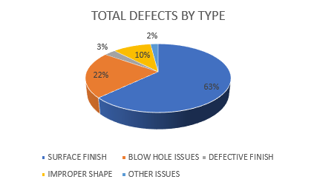

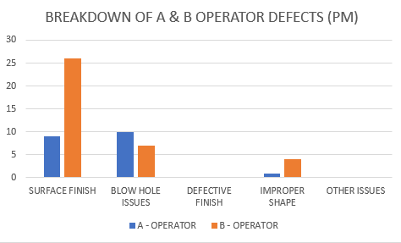
The above chart shows that Surface Finish (SF) defects were comfortably the most numerous of the defects recorded, numbering 63% of the total (which equates to 124). Issues relating to Blow Hole and Improper Shape defects were second and third in terms of frequency, numbering 43 and 20 incidences respectively. In regards to Surface Finish defects, it is perhaps unsurprising, given the total number of these defects that have occurred, to find that the numbers are fairly consistent across both machines, both shifts, and the four operators (A-D). Whilst B Operator on Machine One is a slight anomaly here, with a significantly higher number of Surface Finish defects during the afternoon shift, as can be seen below, the numbers elsewhere are much closer:

Above: Chart displaying B Operator’s much higher number of SF defects (26 to 9)
Below: In comparison to C and D Operators, where the numbers are much closer
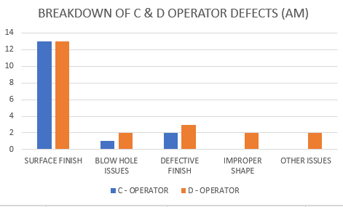

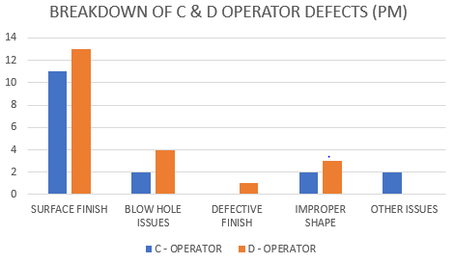

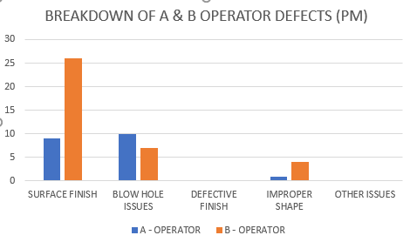
Furthermore, when looking closer at the breakdown of the defects on Machine One, the sand-casting operation, it is B Operator who is responsible for the largest percentage of the defects, across both the morning and afternoon shifts. Indeed, when looking at Machine One, it is only in the one area that A Operator is responsible for the greater number of defects; Blow Hole defects during the afternoon shift:

This data seems to suggest that human factors may be the primary cause behind these numbers, rather than physical or organisational issues (the three most commonly accepted root causes). Whilst A Operator also causes defects, B Operator causes significantly more, despite both using the same machine. Whilst assumptions can be made in terms of the operator’s experience and motivational levels for example, I believe that further investigation of B Operator’s work is necessary to highlight further trends. Further training or redeployment may be required if future analysis shows continued poor performance. Demonstratable competence records should be available for each of the operators, if this is not the case, then it is something that should be captured in action plans moving forward.
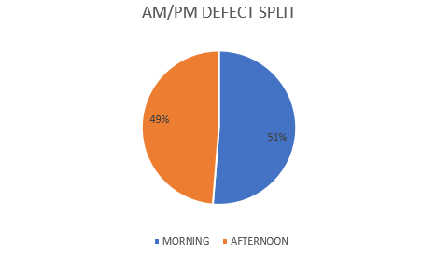

For Reference Only: The percentage split between defects in the morning and afternoon

Alternatively, rather than putting the sole focus on B Operator and their own capabilities, it could be the case that the machines being used, particularly Machine One which sees the majority of the overall defects (121 to 75 on Machine Two), are the bigger issue. Due to the larger number of overall defects on Machine One, it could, by looking at the data, be suggested that it is the machine that is the primary issue, and that B Operators higher numbers may simply come down to the fact that perhaps they are not as experienced as managing these issues as A Operator for example (?) If this was to be the case, you would need to look into the maintenance of the plant in further detail (more on which to follow) and potentially methods of limiting the ways in which the operators could erroneously interact with the process.
This idea of limiting the ways in which the operators can make mistakes originated in Japan with Shigeo Shingo as part of the Toyota Production System (TPS) and is referred to as ‘Poka-Yoke’ or ‘Fool Proofing’. Essentially, the primary aim of this principle is to eradicate the means by which operators can go wrong, leaving only the one, correct way of carrying out a task. In his book, The New Manufacturing Challenge: Techniques for Continuous Improvement (New York, 1987), Shingo’s countryman, Kiyoshi Suzaki, uses a number of case studies to show how this technique works. One particular example describes how an operator is creating defects by incorrectly placing his material beneath a tool, leading to uneven processing. Parallels can be drawn here to the two operations under investigation in this report. Surface Finish issues in particular could owe a lot to a similar issue happening in this plant/work area. Within Suzaki’s example, modifications are made to the machines that mean that the material can only be placed into the fitting in one particular way, eliminating the possibility of erroneous human interaction with the process. Certainly with Machine Two, the milling machine here in our study, there is the potential for a similar implementation. The likelihood is that we will see a positive result in terms of defect numbers when limiting the potential for human error.

The most important aspect(s) of improving a process will often come down to identifying the underlying, root causes to the inherent problems. This remains the case here with the defects present within the operation(s) covered. Whilst the above paragraphs do suggest some ideas behind the presence of defects in the process, the best means of investigating such problems will be the deployment of a bespoke analysis tool/technique. For the benefit of this report I will focus upon the use of a Cause and Effect Diagram, or an ‘Ishikawa Diagram’. This technique was popularised in Japan in the 1960s and remains a popular means of root cause analysis. Like other methods, the primary purpose of an Ishikawa Diagram is to help answer the following three questions:
- What has happened?
- How has it happened/Why has it happened?
- What can be done to prevent reoccurrence?

In order to answer these questions, an Ishikawa Diagram will often adopt other aspects of LEAN management systems, particularly 5M analysis. Like Poka-Yoke, 5M analysis traces its origins back to TPS, and suggests that there are five key areas on which to focus on when looking at root causes. These five areas – Machine (equipment used), Method (the process), Material, Man/Mind Power, and the Medium (the environment) are flexible and allow for the technique to be used in a number of scenarios. Thankfully, all five of the areas can be directly applied to this study. More recently, debate has been had over the possibility of additional areas that could be included, namely Management and Maintenance. Again, these are areas that can be investigated when analysing the defects here.

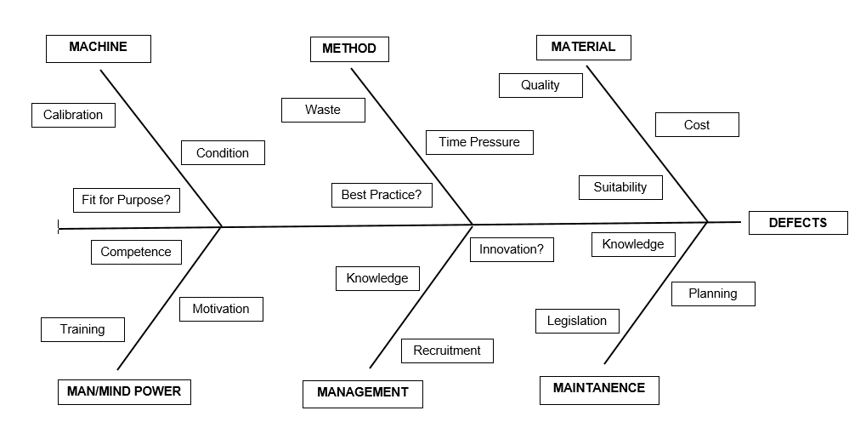
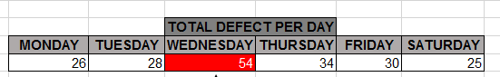
The above Ishikawa has been put together to help identify the root cause(s) that may be present here in our case. As was mentioned in the opening to this report, some assumptions have to be made here due to the lack of original information provided. For example – we cannot be sure as fact that the material used in the process is not suitable for purpose, only that a number of defects occur when working with it, similarly, we cannot be sure that maintenance is not carried out to standards set by relevant legislation, however, data does suggest that the maintenance that is carried could be both irregular and low in quality:
The above table displays the number of defects that occur per day of the week. As can be seen here, the number of defects is fairly consistent Thursday-Tuesday, with a range of 25-34, but then jumps up to 54 on the Wednesday. This would suggest that maintenance seems to be carried out no more than twice a week, possibly only on the Wednesday evening or Thursday morning. Following the Wednesday, the number of defects drops before starting to grow again slowly. Alternatively, is there something that is done either on the Tuesday (the afternoon shift one would assume) or during the Wednesday that leads to such an increase in the number of defects? Whatever way you look at the data it seems reasonable to suggest that whatever the maintenance procedure(s) that are in place, they are not sufficient. The importance of carrying out regular, quality maintenance is highlighted by the aforementioned Bjorn Andersen, who states that ‘the performance level of most processes shows a tendency to decrease over time unless forces are exerted to maintain it’. The information above seems to suggest that not enough force is being exerted in this regard.
Referring back to the Ishikawa Diagram above, we can now look to identify other potential areas of concern in terms to root causes. Rather than looking at the machines and/or maintenance plans, or alternatively the operators themselves, we should also consider the possibility that management could form the root cause here. As can be seen in the diagram, there are a number of various ways in which management can impact the process – do they have a good enough knowledge of the process for example? This is highlighted as of key importance by Andersen when discussing the ‘Business Process Improvement Framework’. After all, how can a manager fix issues without knowing what can go wrong within a process and why? Poor management can manifest itself in a number of ways, and whilst it may seem a stretch to suggest that a detached, unknowledgeable management can lead to defects occurring on the front line, there is no reason to believe that this may not be the case. Although a simple 5 Why analysis is practicably impossible in this case due to the limited information provided, it could potentially look something like this:
- Why are a range of numerous defects occurring on plant across both operations?

- Because the machines are unreliable

- Why are the machines unreliable?

- Because little preventative maintenance is carried out on plant

- Why is little preventative maintenance carried out on plant?

- Because there isn’t money in the budget to cover maintenance

- Why isn’t there sufficient money in the budget?

- Because management have different priorities than are seen as being of more pressing importance (marketing, production etc)

Whilst only a rudimentary example of how 5 Why analysis is used in these circumstances, it does serve as proof of how easy it can be to eventually attribute root causes to management.

Having now provided an analysis of the defect data, as well as using root cause analysis techniques to suggest potential reasons behind the numbers, I will now present a corrective action plan for limiting the defects experienced here. As was mentioned at the top of this report, it is Andersen’s framework in particular which is being used as a guide in the creation of this plan. The reason for this is quite simple; it is a framework which places importance on all levels of the operation – from top to bottom, and is designed for longer term improvement projects, rather than quick fixes.

Please see over:
BIBLIOGRAPHY

Andersen, B., Business Process Improvement Toolbox, (2nd Edition), Milwaukee, 2007

Ballesteros, J.S.A., Improving Air Safety Through Organised Learning: Consequences of a Technology-led Model, Oxford, 2006

Doggett, A.M., ‘Root Cause Analysis: A Framework for Tool Selection’, Quality Management Journal, 12 (4)

Edwards Deming, W., Out of the Crisis, Cambridge, 1986

Shingo, S., Zero Quality Control: Source Inspection and the Poka-Yoke System, Portland, 1986

Suzaki, K., The New Manufacturing Challenge: Techniques for Continuous Improvement, New York, 1987

Weeden, M.M., Failure Mode and Effects Analysis (FMEAs) for Small Business Owners and Non-Engineers: Determining and Preventing What Can Go Wrong, Milwaukee, 2015

Westcott, R.T, The Certified Manager of Quality/Organisational Excellence Handbook, (3rd Edition), Milwaukee, 2006

B. Andersen, Business Process Improvement Toolbox, (2nd Edition), Milwaukee, 2007, pp.4-5
R.T. Westcott, The Certified Manager of Quality/Organisational Excellence Handbook, (3rd Edition), Milwaukee, 2006, p.xvii
A.M. Doggett, ‘Root Cause Analysis: A Framework for Tool Selection’, Quality Management Journal, 12 (4), pp.34-40
S. Shingo, Zero Quality Control: Source Inspection and the Poka-Yoke System, Portland, 1986, p.23
K. Suzaki, The New Manufacturing Challenge: Techniques for Continuous Improvement, New York, 1987, pp.18-24
Suzaki, The New Manufacturing Challenge, p.20
Suzaki, The New Manufacturing Challenge, pp.20-22
J.S.A. Ballesteros, Improving Air Safety Through Organised Learning: Consequences of a Technology-led Model, Oxford, 2006, pp.17-21
M.M. Weeden, Failure Mode and Effects Analysis (FMEAs) for Small Business Owners and Non-Engineers: Determining and Preventing What Can Go Wrong, Milwaukee, 2015, pp.26-30
Andersen, Business Process Improvement Toolbox, p.3
Andersen, Business Process Improvement Toolbox, pp.3-5
Andersen, Business Process Improvement Toolbox, pp.3-5

