Information Engineering
Kaylie Shoulder 1800042
Assignment

Documentation & Proof 3
Evidence of Tables 4
Meeting User Requirements & 3rd Normal Form 6
Proof of Extra Documentation 7
Report Output 8
The Forms: 10
SQL Evidence 14
User Guide 15

Information Engineering Assignment

This documentation aims to provide you with all the information that you need to ‘get to grips’ with the database that was created for ‘Dylan’s Bookstore’. Throughout your reading of this document some of the information you will be able to view includes: an entity relationship diagram, proof of different aspects of the database, and a guide allowing you to understand how you can use the database.

Documentation & Proof

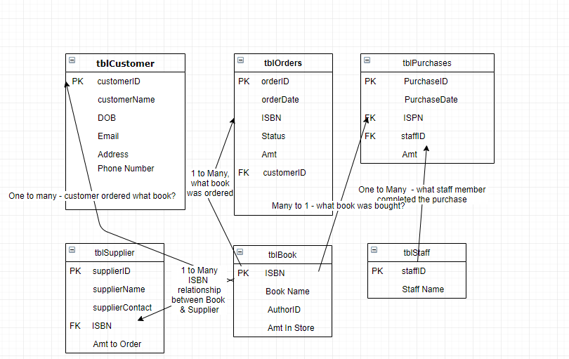
Attached above is the entity relationship diagram. As you can see, each table has its own designated Primary Key and has elements from other tables within them - these are foreign keys, and they have been clearly labelled above.

Evidence of Tables
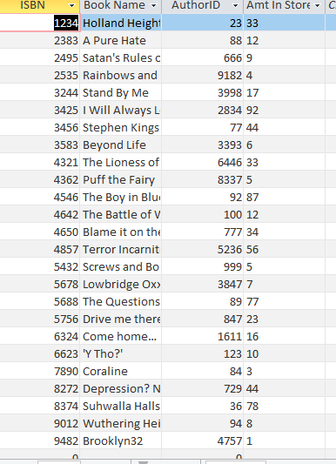 This is evidence of the ‘Book’ table - this is where all of the books information is stored.
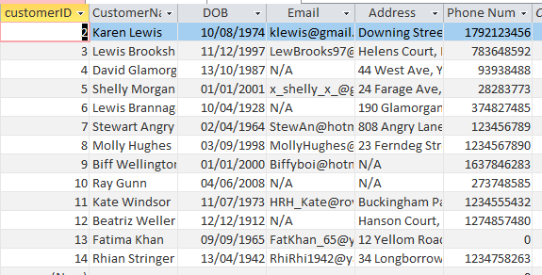 This is evidence of the ‘Customer’ table- which is where all customer information is stored.
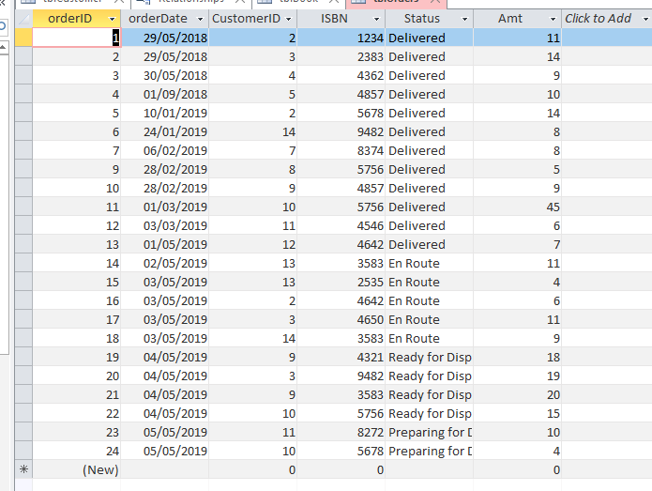 This is evidence of the Order table - here you can find information about the order ID, who ordered it, when, and its delivery status.

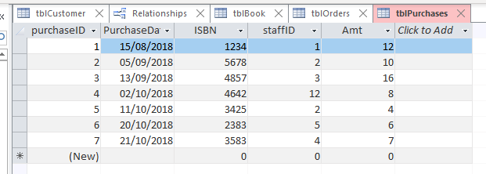This is proof of the purchases table - here all in-store purchases are recorded.

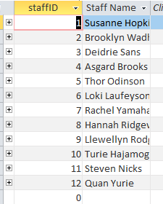 This is proof of the staff table - all staff have been given an ID number.
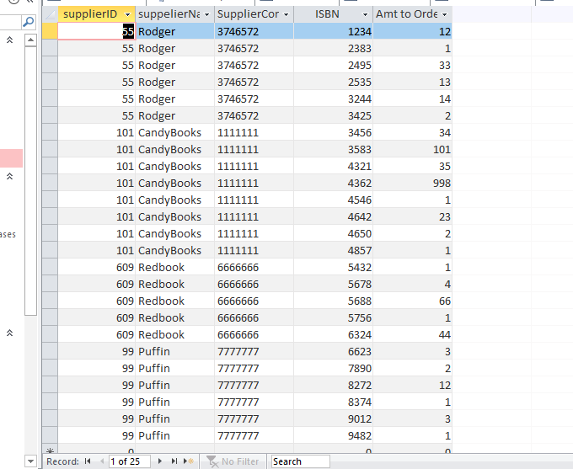 This is proof of the supplier ID- here, all information about who supplies which book, and how many need to be ordered is stored.

Meeting User Requirements & 3rd Normal Form
Having read the user’s requirements it was rather evident that their needs were very generic - they asked for very little. It is stated that the following is needed:
‘‘ · User has the ability to add or delete information from any table.
· User should be able to view on screen: Book, stock, order and customer details.
· User should be able to view ongoing customer orders.
· User should be able to query the system and print out relevant reports.
‘’
[1]
First and foremost, as an overhead statement, it can be said that this database does, in fact, meet all of the requirements of the user. The user requires to be able to add and delete records from each form - this is something that the user is able to do rather easily. Each form is equip with multiple buttons, however amongst the various buttons, there are two which enable the user to do this - one button allows the user to add a new record to the database, and the other button allows the user to simply delete the record that the form is displaying.
There are multiple forms/reports/queries that have been created which allows the user to find all of the information that they need to find rather quickly. Upon load, the database immediately displays the ‘Main Menu’ which allows the user to navigate between forms, and select to view the ‘Report Menu’ and the ‘Query Menu’ - by having such a versatile menu page, it allows the user to receive the information that they need almost immediately. In total, there are 6 tables, entitled ‘Customer’, ‘Book’, ‘Purchases, ‘Orders’, ‘Stock’, and ‘Staff’. Using these tables, the user is able to view every piece of information about the business - the book table contains all information needed about the book, the ‘supplier’ table provides all information regarding the supplier and how many books need to be ordered that month, all customer details call be found in the customer table, too. All information is easily accessible. The orders table indicates the delivery status of each item - as you can see above many state that they’re ‘delivered’, others say ‘en route’ and some are being ‘prepared for dispatch’ - by checking this table, the user is able to view any customers delivery status. Along with this, the user is easily able to make queries/view queries and print reports out by simply right clicking, pressing ‘print preview’, and then ‘print’.
In regards to the ‘normal form’ of the tables created, one can be assured in knowing that the tables were created complying to the rules of third normal form. According to ‘Essential SQL’ your tables are in 3NF if: ‘A table is in its second normal form’ and the only columns within the table are ‘non-transitively dependent on the primary key’ [2]; transitively-dependent columns are ‘dependent upon non-prime attributes’ [3]. My database does comply to 3NF rules - each section stands for itself and is not dependent on other values in order to be completed itself, it relies upon primary attributes and the primary key and nothing else. By complying to these rules, it is ensured that data integrity is secured.

Proof of Extra Documentation

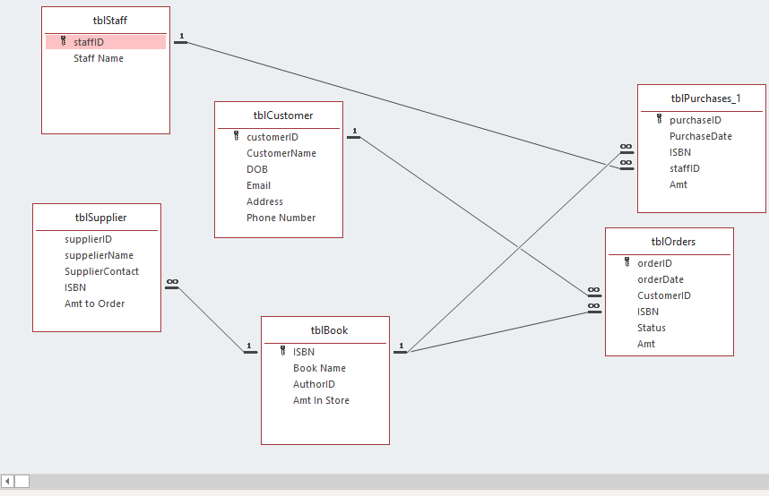 This is proof of the relationship diagram that was created to ensure that each table is linked correctly.

Report Output
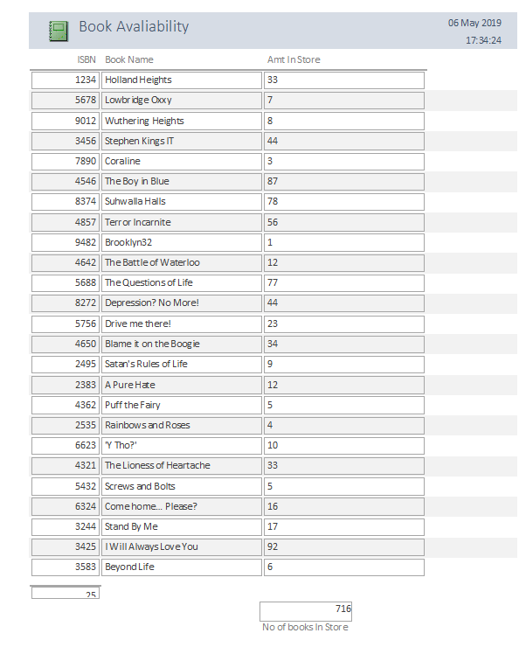
Above is a report that was created to highlight the amount of each individual book is in the store - joined with a CALCULATED sum of the amount of books they have in store (the total amount). You can also see that there is a calculation to the left- this displays the amount of different books in store (it does not include duplicates).

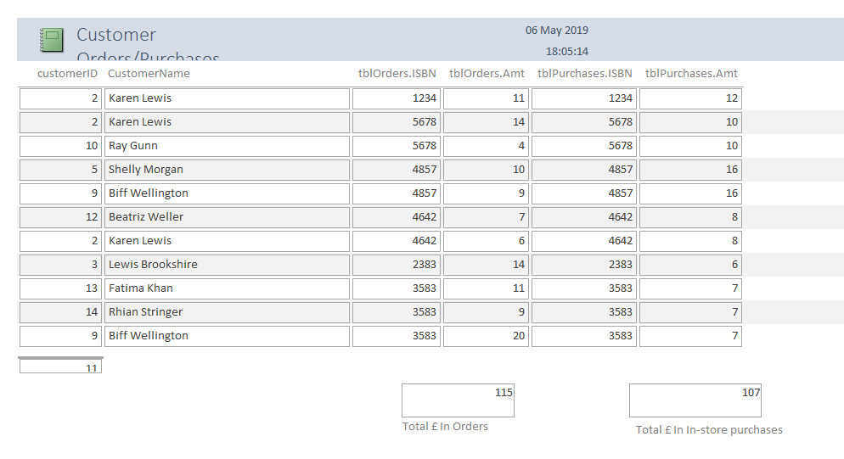
This is a report that the user can view - it clearly shows the customers which have both ordered online and bought in-store; it provides you with the customers unique ID, the ISBN of each book that was bought, the date of the orders & purchases, and the amount that was paid for each book. Below, you can see CALCULATED totals of the amount of money the company made through the combined purchases - in-store, and through orders.

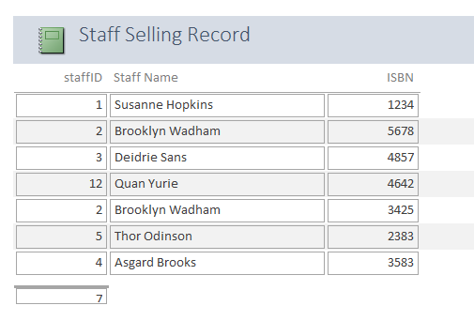

Above is a simple report that was created in order to view which members of staff were completing purchases/orders - it provides you with the ISBN of the books that were sold and which member of staff sold the book.

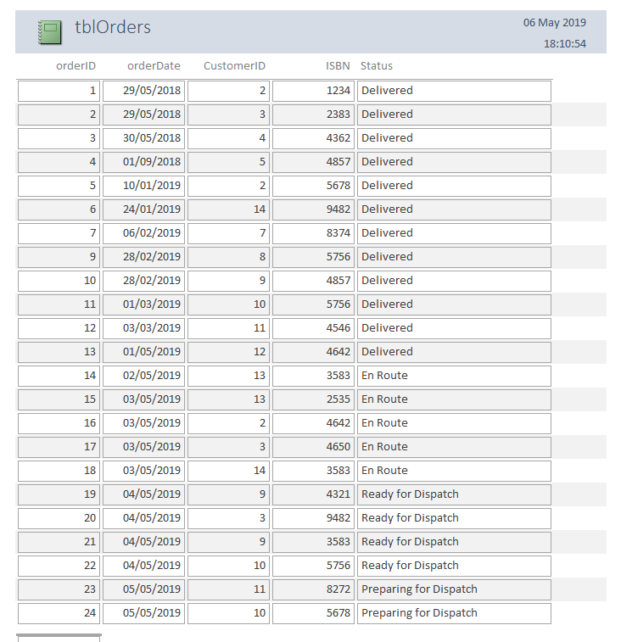

This report was generated in order to show the user what orders have been completed, when they were received, and what the order status is of each product.

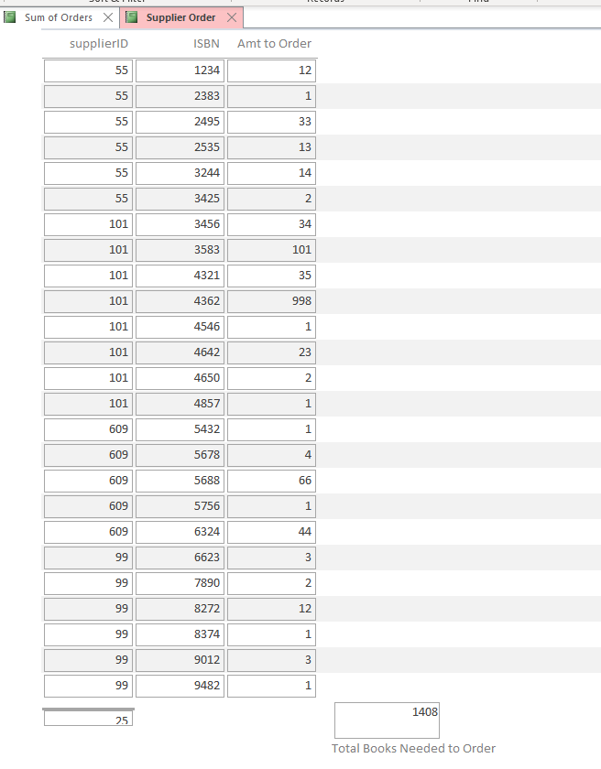

This report was made to highlight the amount of each book that needs to be ordered- provided with the suppliers ID, the ISBN, and the amount to order, a calculation of the sum of books that need to be ordered was generated.

The Forms:
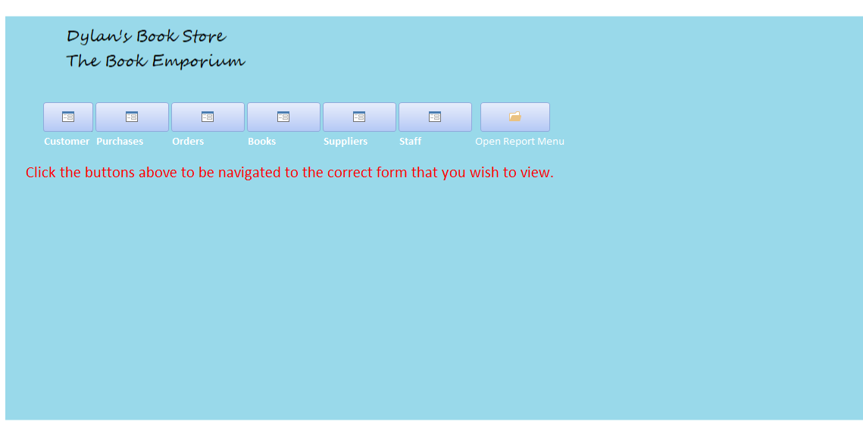

Above is the main menu.

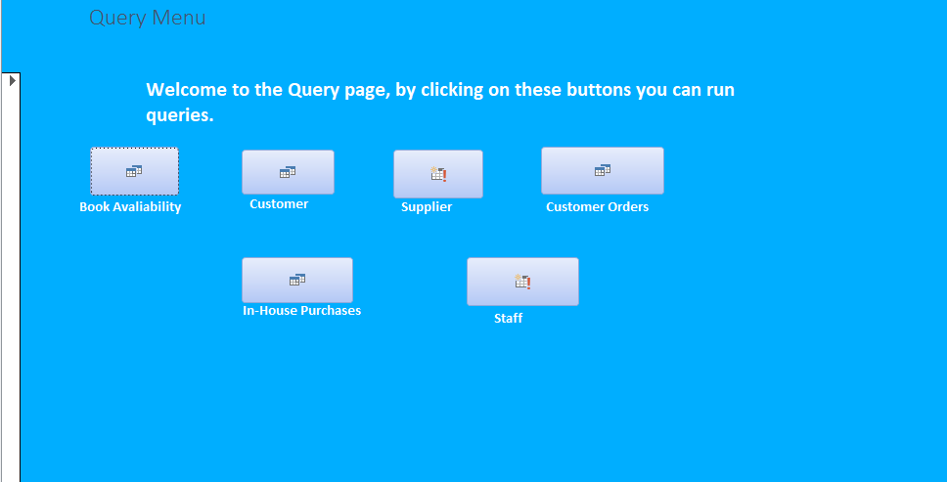

This is the query menu.
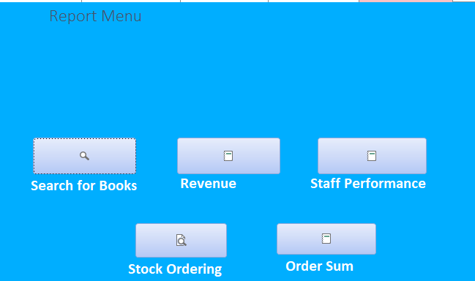

This is the report menu.

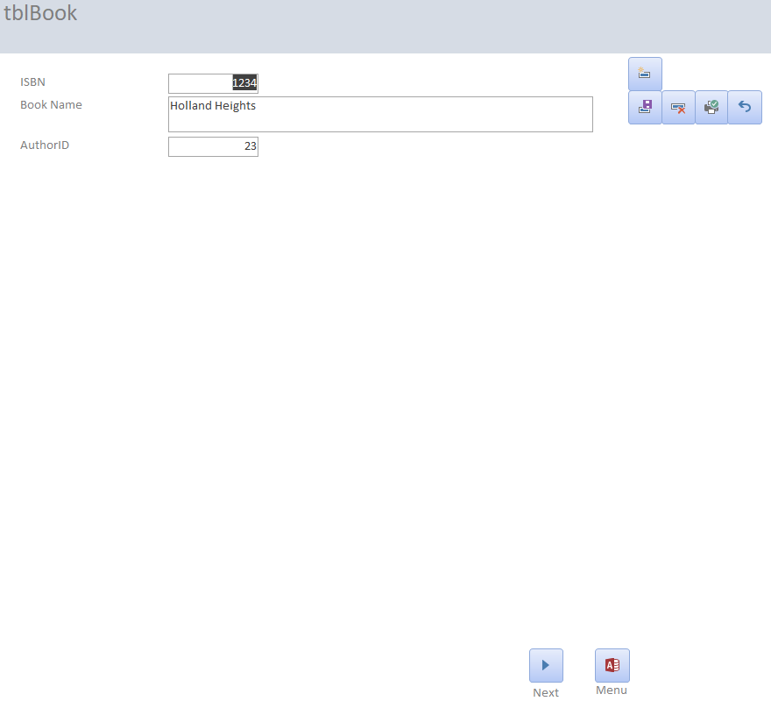Book form
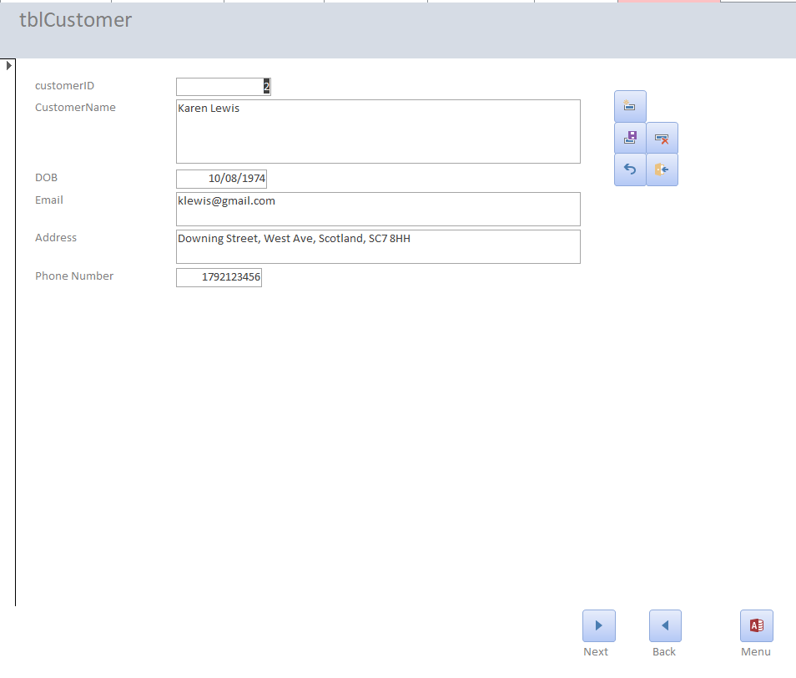customer form
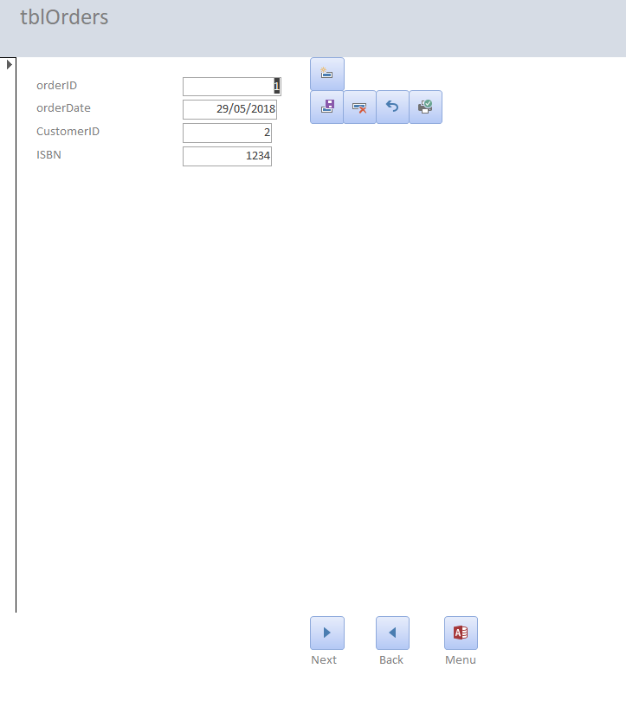order form
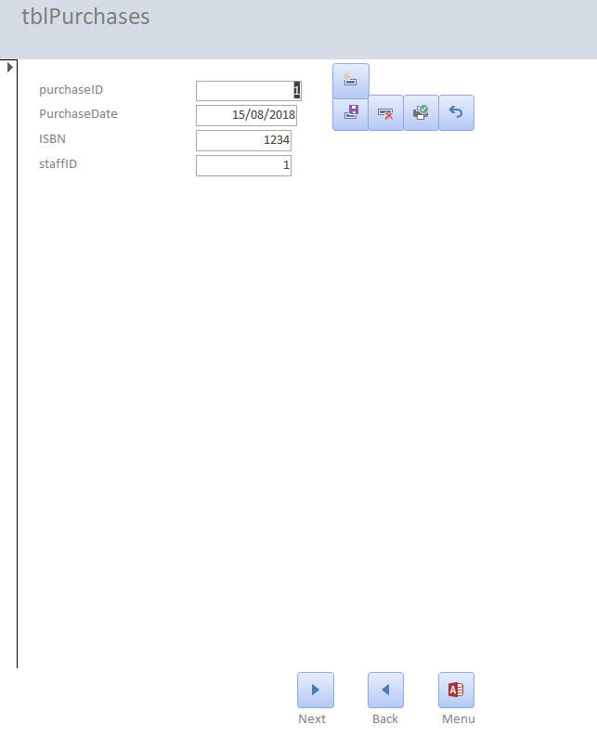

Purchase form

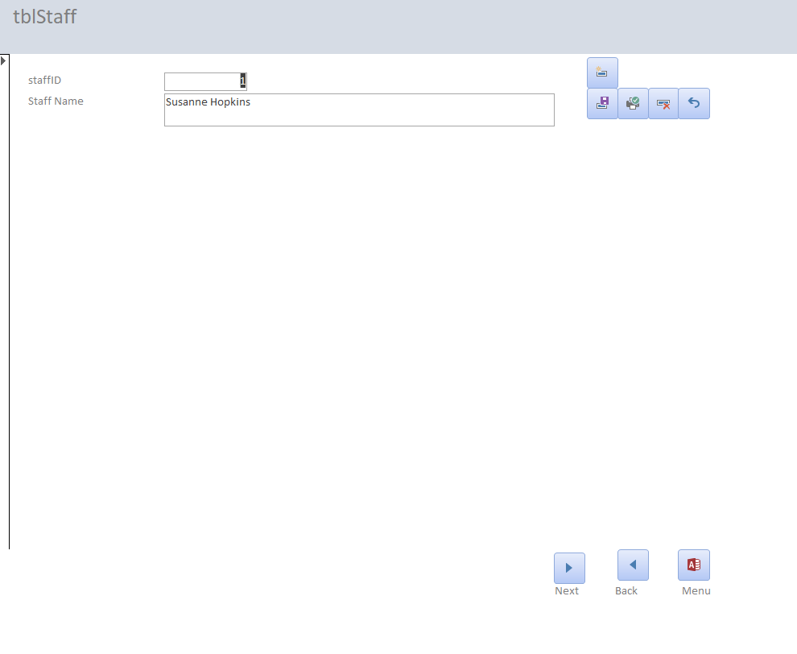Staff form

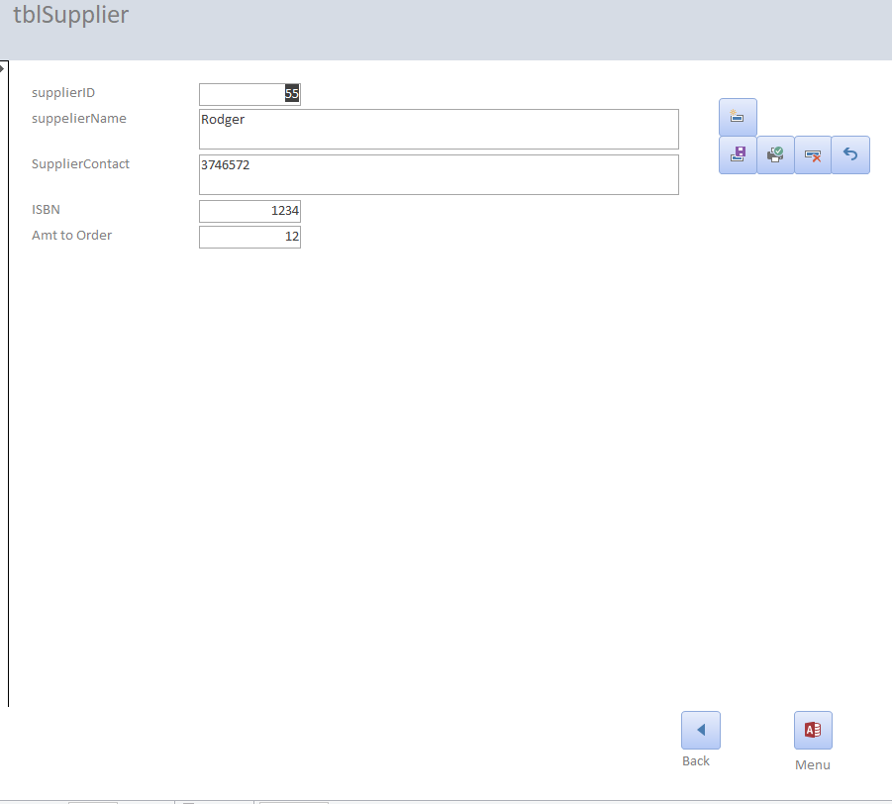 Supplier form

SQL Evidence

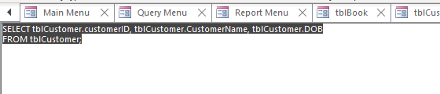

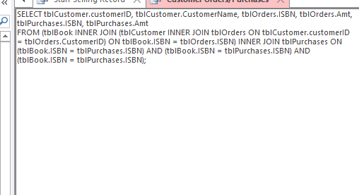

User Guide

1.A Upon load you will see a screen like the following:

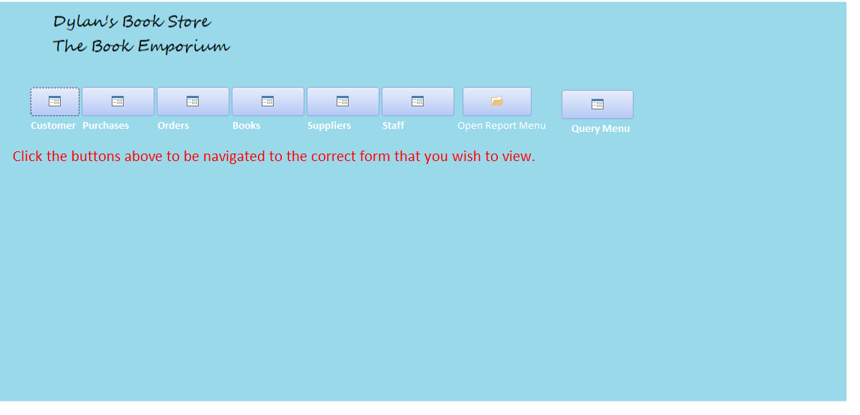
The first 6 buttons, when clicked, will direct you to the form that you selected. The last two are main menus for the: reports, and queries.
If you click a form, for example: customers, you will see something like this:

As you can see there are buttons to the side of the form.
The button order is as follows:
New record
Save
Delete
Undo
Exit

Then, at the bottom of the page, you can see the ‘next’ and ‘previous’ buttons which will direct you through the forms, and the Menu button will take you to the main menu.

In order to create a new record, simply press the ‘new record’ button, which is the button on top of the others - it will clear all the fields and allow you to input new information. Then, directly below the ‘new record’ button, is the ‘save’ button - press this after you’re happy with all the information you have inputted.

If you want to undo what you’ve written, simply press the ‘undo’ button, and it will remove everything you have written, allowing you to proceed on with your record writing.
If you wish to view the TABLES rather than the forms, you can find the tables are situated on the left of the database. 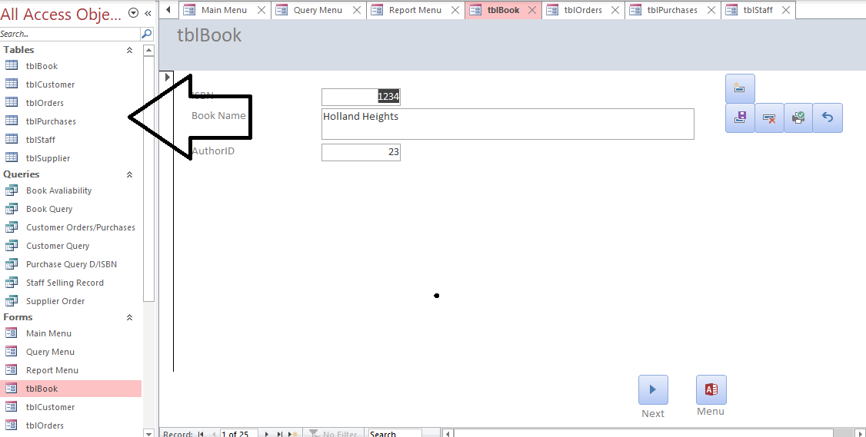
They are all clearly labelled; simply double-click on the table that you want to view it. You can also add information in this way, by navigating to the bottom, and selecting the field and typing the information.

Viewing reports: & Queries
In order to view a report, simply navigate to the main menu. On the main menu, you will see there is a button which says ‘reports’ - by clicking this, you will be directed to the report menu. The report menu will allow you to select any report that you wish. To get back to the Main Menu, simply find your reports on the left and select ‘Main Menu’.
If you want to print a report, simply find the report you wish by following the method above, and right clicking on an empty space on the report.

To view queries, navigate yourself to the main menu, and select ‘queries’ - this will take you to the query menu. Thereon, choose which query you wish to view, and press the button. This allows you to see the query.

On each form, to delete a record simply press the ‘delete’ button, which looks like this:
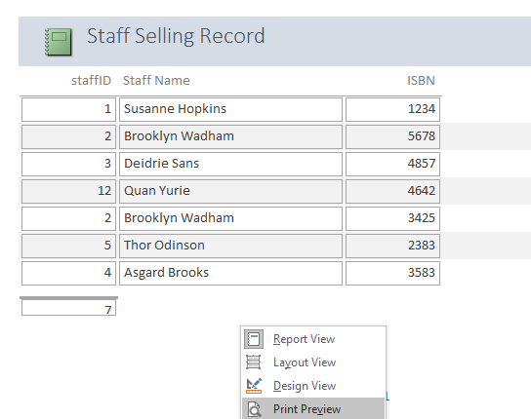
Select ‘print’ preview, then above will be an option to print.
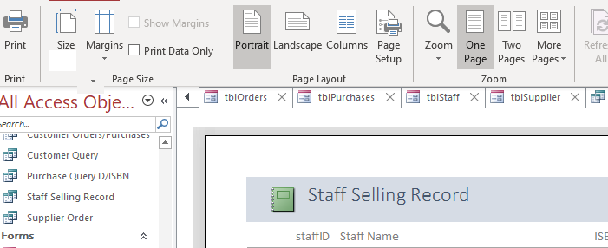
Press ‘Print’ and your report will print.

Amending Information
There are two ways that you can amend information - if you wish to do it through using tables, select the table that you wish to view.
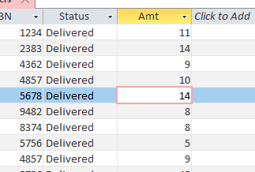Simply delete whatever is in the field, and type in the section what you wish for it to store.

If you wish to do it in forms, load up the form: and then go to the field you wish to change. Delete that information, and simply re-type! REMEMBER: Press the save button in this case! You don’t need to press save on the table, but because the information on a form comes from a table, you need to press ‘save’ so the changes go on to the table too!

 If you want to delete a record, then simply navigate to that record and press the delete button. You will be prompted asking if you’re sure, if you are - press yes.

[1] Database Design (The Book Store), B.Holland, The Specification, Task1, Online, Avaliable: https://moodle.uwtsd.ac.uk/mod/resource/view.php?id=180052

[2] ‘Database Third Normal Form Explained in Simple English, Kris Wenzel, Avaliable: https://www.essentialsql.com/get-ready-to-learn-sql-11-database-third-normal-form-explained-in-simple-english/

[3] https://www.studytonight.com/dbms/third-normal-form.php

[4] Forms, B.Holland, Avaliable: https://moodle.uwtsd.ac.uk/mod/resource/view.php?id=17804

[5]Creating Tables in Access, B.Holland, Online, Avaliable: https://moodle.uwtsd.ac.uk/mod/resource/view.php?id=17802

