BMSW6103

Lecturer: Prof Dennis Pepple

Change management portfolio

Amjad Hussain 1715254

Introduction

Leadership and management
This portfolio is based on the Royal Mails Post Offices 114 branches directly owned by the Post Office the workers are feeling underpaid therefore are not satisfied with the 2% pay rise staging a one-day strike in a disagreement over the pay, the strike will be forcing 114 Royal Mail to close for a 24-hour period, with having no collections from the sub- post offices or any cash delivery around the UK, outline 11,500 sub-post offices that are directly impacted.
The portfolio will cover stakeholder analysis using will cover stakeholder analysis using models to identify importance of the stakeholders and how to manage the categorized stakeholders the first section will outline power and politics in the organization followed by the second section focusing on models to identify and who to engage with the last section will cover the importance of conflict resolution process lastly followed through with recommendations.
Associated members of the Communication Workers Union (CWU) have not agreed over a pay freeze outlined in an annual review in 2021-2022 and a 2% rise intended for the subsequent year. The Royal Mail stated that the vast majority of its 11,000 branches will not be affected and will not be going on strike and would be open as normal opening times as usual.

It is said that the post office (2022) is recognized as an anchor to the high streets of the United kingdom providing essential mail and parcel services including financial services for example borrowing to money transfer and in the branch having secure banking, bill payments services, broadband and phone, ID services for instance checking passport application forms cash withdrawal and banking services through the banking framework agreement proposal, customers of high street banks and building societies use Post Office to deposit money, deposit cash, and cheques, and attain balances making Royal Mails, Post Office essential to the high street making it an alternative to high street banks.
Therefore, providing services for example bill payments the Royal Mails post office provide bill payment services across all Royal Mail post office branches in addition to Payzone outlets, with a having combination off over 24,000 branches located across the UK, that cover everything from utilities through to transport and ticket facilities and post office saving stamps used by customers.
Roughly six million small businesses are a vital bridge between the online and offline economy (Kutsuna, 2002). Helping to drive footfall to high streets, with one in three people visiting other high street locations for example pubs or shopping on a trip to their post office, driving an estimated £1.1 billion in additional revenue to the UK economy. Members of the Communication Workers Union (CWU) are not in agreement over a pay freeze in 2021-2022 and a 2% rise for the following year. The Royal Mail said the vast majority of its 11,000 branches were not covered by strike action and would be open as usual.
It said in a statement: "There are 114 branches typically in city centers across the UK that are directly controlled by Royal Mail. "Posters are displayed which show where the nearest alternative branches are located. Customers can additionally find more information at postoffice.co.uk/branch-fin leadership and the management styles introduced for the United Kingdom postal service the Royal Mail,

Question 1.

Organizational power and politics

Types of power
Organizational power can be vital to the organization there are various types of power the 5 types of power used by organizations according to, study conducted by two social psychologists, John R. P. French, and Bertram Raven in 1959, they identified 5 types of Power.
- Coercive Power, when the leader can be threating to employees that are not performing to his targets and they could lose their job or any bonus for instance not having any job progression. Using coercive power when you threaten that people will be punished to gain compliance.
- Reward Power, here power comes from the person’s ability to issue rewards, for example, through bonus schemes and vouchers or coupons allowing time off or extra holidays.
- Legitimate Power, here power can be from an individual's formal right to issue directives or commands the position they hold in the organization, for example, the CEO has the right to dictate the strategy.
- Expert power, here power comes from the persons experience or knowledge giving for examples, a high-ranking surgeon displays the expert knowledge for assistants to trust them.
- Referent Power, here power comes from being respected or trusted, for example, the boss who is treating everyone equally and with respect.
identified as the power that the organization has or a role and a position it holds for example a manager has power over the situation and has power over the workers and allocates tasks, for example a police person can arrest a person for a crime and for instance teachers can assign grades for the students and at the post office the power and control off the delivery of mail and collection of important special delivery of mail and parcels for parcel force delivery services, payment servies,20 million adults In the UK visited a branch of the post office weekly according to the post offices data.(2022)
the post office organizational power is power, that the Post Office is relied on by millions of customers it has stood established for over 100 years.
The power at the Post Office is Coercive Power it is owned by the government through the parliamentary department for business, energy and industry BEIS and UK and government investment UKGI, with having Paul Scully, MP as the current minister with responsibility for the affairs of the post office. According to, (mullins2006) broadly power be interpreted in terms of control, or it can have an influence over the behaviors or attitudes of other people with their agreement or without the Cultural dimensions can have an impact on the post offices organizational power for instance being governed by its legislations at the post office corporation has high power over its workers it has a CEO and government can outline the rules and the way they do the business at the post office.
Politics at that the post office
The Royal Mail has established its business by the way it conducts its business and how it remains governed for instance the politics are set by government legislations. The Post Office recognized for being the UK’s number one letters and parcels retailer and built trust as a financial services brand. And we are delivering an important social purpose by providing essential services to 11600 communities around the UK.
Our according to Royal Mail the policy states the strategy is to continue to do this, sustainably and without reliance on government support. Royal Mail losses are reducing substantially every year, according to Royal Mail and the organization is seen to be growing. Acknowledging that the company have much further to go to sustain and fill consumer habits, shifting and citizens are visiting the high street less often and choosing to shop online. They use cash less and their time is at a premium. We must adapt, as we have throughout our history. Reducing our costs and managing the risks to our cost base are critical to success. By doing this, we will become a more agile organization, better able to adapt to the competitive and fast paced sectors we work in to meet the changing needs of our customers.
Building a strong bottom line is key to building a sustainable and resilient organization that can invest to improve its proposition on an ongoing basis.

Post office power and politics data about the in organizational structure.
The data is focusing that the post office is the UK’s number parcel and letter Posting service Post Office has become a trusted financial services brand name with credit card franchise with Capital One bank involving facilities that local high street banks no not offer. Known for delivering an important social purpose in the way of providing essential services to 11600 communities around the UK especially in rural areas. The post office has become a more agile organization better able to adapt to the competitive and fast structured sectors working to meet the changing needs of the customers for example competing with Amazon logistics and delivery services.
The outcome of a process developing a strong bottom line is key to building a sustainable and resilient organization that can invest to improve its proposition on a constant foundation. The workers are using their power to demonstrate that the workers have an importance in the company.
According to (Weber) “organizational legitimacy is that organizational activity is steady with organizational rules and structures It is critical to emphasize that the organization is consistent with universal values and “motto” that legitimacy comes from consistency with social rules, legislation, and standards”.

Power and politics manifested at the post office and demonstrating how the employees are using power and politics.
The employees are using their power by going in strike the employees are not happy with the 2% pay rise and in an un agreement over a pay freeze the Royal Mail office staff are wanting an extra 5% rise totaling to 7% therefore it has had a negative impacted with the workers and the trade union demanding to protest and go on strike.
recent statements from our unions in response to changes we are making at the Royal Mail, and in particular news of the CWU’s notice to ballot for strike action. The post office has stated that they are committed to dialogue and partnership with the union.
Outlining that when industrial action is taken, the Royal mail business, and the people and their customers lose out. (Royal mail) “We always do what we can to avoid it and we have invited the CWU to consider meeting us, along with the resolution process using ACAS, services to seek a resolution and mutually acceptable way forward” (Kessler, 1995).
It has done damage to the post office the image of the crown post office has been damaged for example the post office performs services for Her Majesty's Government in the United Kingdom, 114 branches effect the 11,000 the situation has caused an uncertainty that it could happen again, and strikes could cause more delays affecting the moral of the company the moral of the crown post office.
The post office moral already affected according to High Court judgement, the British Post Office scandal it has been understood as a miscarriage of justice involving the horizon computer system installed in 2000 and 2014, the horizon computer system, installed for tasks, accounting and stocktaking, transactions, the sub-postmasters complained the system had bugs after it reported losses, some of which amounted to many thousands of pounds.
The horizon system developed by the Japanese company Fujitsu, the installed throughout the Royal Mail post office prosecuted 736 sub-postmasters and sub-postmistresses continuously average of one a week - based on information from a recently installed computer system wrongful civil and criminal prosecutions of an unknown or unpublished number of sub-postmasters and post mistresses for theft and false accounting and prosecuted for fraud offences. The cases constituted to be the most widespread miscarriages of justice in British legal history, which has necessitated for a period of over twenty years.

Question 2
Stakeholder analysis including models The Concept
Stakeholder analysis is to demonstrate how to identify the groups and institutions that can influence the organization positively or negatively. The first stage of a stakeholder analysis is to identify the key influential stakeholders for example who can be affected positively or negatively to the outcome of the crown post office likewise, stakeholder matrix is a visual description of a stakeholder evaluation.
Recognized as a stakeholder mapping the main concept of a stakeholder is to provide the decision maker with the relevant information about the stakeholders characterized groups that may be vital to the survival and the success for the organization and showing what stakeholders can be seen to affect the achievement of the organizational targets and goals installing the process can make it an easy problem resolving method.
Example of stakeholders According to (freeman 1984)” a stakeholders can be a group or an individual that has a moral claim with the organization the people who are of the stockholders and the stakeholders that are affected or can affect the achievement of the organizational objectives.
The business is only there to make money therefore people who own shares or stock are the shareholders critical evaluating the theory according to Edward (freeman) the stakeholders are the group of people that do business with the company or the people that can harm or benefit the organization. consequently, the person that can have an affect or is affected through the structure, or can affect the achievement of the organizational objectives, it can be defined as a narrow definition of a stakeholder.
The potential stakeholders critically identified at the crown post office using the matrix grid giving an outlined plan on how to engage with the stakeholders. The importance of the stakeholder engagement showing who to keep informed and who not to inform of the crown post one day strike.

Matrix grid to analysis stakeholders.

Stakeholder analysis power interest matrix grid model
Crown post office Stakeholder analysis using power matrix grid model demonstrating level of influence and involvement and outlining how the stakeholder’s involvement of interest and how the stakeholders should be dealt with.
High influence, people with the most interest, these people would be the post office managers, customers, these people need to understand everything all the corporate hierarchy, executive CEO, the trade union, and customers.
High influence, people with less interest, these people need to be provided with sufficient information kept up to date but not overloaded or overwhelmed with considerable information. government creditors banks, customers.
Low influence, people with a lot of interest, these people are to be kept adequately informed they must be talked to about any issues or concerns for instance being informed before any issues rise. investors the media suppliers internal supply chain, developers
Low influence, less interested people, these group of people need only minimal information to prevent them from getting distracted, for example Royal Mail maintenance teams.

Fig:1 power matrix grid (1991)
High  KEEP SATISFIED  INFLUENCE | MANAGE CLOSELY
MONITOR  Low  (MINIMUM EFFORT) | KEEP INFORMED

The matrix grid matrix interrelates with the crown post office for example focusing on the important stakeholders to engage and acknowledging stake holder that do not need to know and waste time on. For instance, the crown post office executive and managers the CEO the customers, need to be told subsequently they can rely on the post of documents, they need to be told all the information about the one-day strike and the crown post office maintenance or data collection teams do not want to be overloaded with the extra procedures.

Salience model analysing stakeholders at the crown post office.

Stakeholder salience theory exists as a method for explaining stakeholders the identification process has 8 areas which are categorized into 3 attributes, power, legitimacy, and urgency which can relate to a type of specific stakeholder and defining who and what counts in the management of stakeholders.
Crown post office analysis using stakeholder salience theory.
1. Dormant stakeholder, can have power to enforce the views that they may have but overall, not required legitimately the control of power they have can remain dormant.
2. Discretionary stakeholder can pose legitimacy but can lack power and urgency can have an influence on the organization.
3.Demanding stakeholder with urgent claims lack power and legitimacy to attract the decision maker or manager.
4.Dominant stakeholder powerful and legitimate can have a substance view with the management.
5.Dangerous stakeholder can have power and urgency can lack legitimacy and can be negative towards the organization.
6.Dependent stakeholder can have urgent claims and legitimate view often relied on additional stakeholders because they can have lack of power and influence in the organization.
7.Definitive stakeholder they should be given the most they should engaged in all the stages of the change management process have input in all the decision making and receive feedback on the progress these stakeholders can change between the various stages.
8. Non stakeholder, groups or individuals that do not fit the categories the Salience model assumes non stakeholders.

Power According to Salacik & Pfeffer: Power is the ability of those who possess power to bring about and the outcomes they desire. Power can remain the capacity to effect or affect organizational outcomes. (Mintzberg) German sociologist, (Max Weber) defined power as “The probability that one actor within a social relationship will be in a position to carry out his own will despite resistance.”
Legitimacy A manager in a work environment has legitimate leadership power to instruct team members on how to approach creates a hierarchy establishment clear line of authority in an organization. Everyone involved understands their responsibilities and knows who to see if they have a problem.
Urgency is those with a time sensitive claim involving a stake critical to either themselves or the company or both. While each of the three dimensions can grab the attention of managers, in some combinations, they are likely to be even more salient. The combination of power, legitimacy, and urgency (Owusu, Antwi and Kendie, 2021).

Fig:2 saliance model (1997)
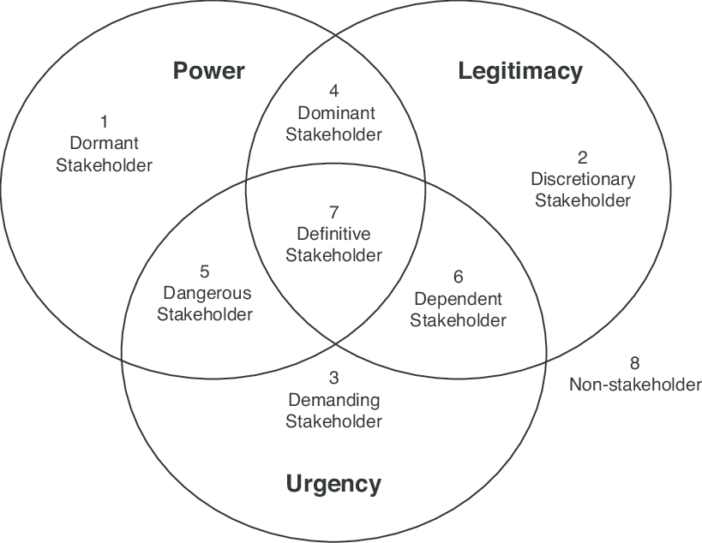

Importance of stakeholder analysis models

Power interest Matrix grid to the stakeholder analysis models show which stakeholders are most important and how they can be managed to implement the change management model the stakeholders are interrelated to the models Salience model and power interest matrix grid the salience model and the power interest matrix grid model shows who to involve and keep informed and the Salience model has categorized stakeholders in the organization’s decision process outlining the urgency during a change management process and categorize who are the critical stakeholders.
the method the post office can deal with justifying the importance of the stakeholders and if they need to be informed and outline how the initial stakeholders must be kept informed.
limitations of the stakeholder analysis model’s
One could argue that the stakeholder theories have become a normal for organizations to use as a decision-making method, salience stakeholder model has drawbacks claiming the interests of the group are excessively broad and ambiguous does not take an individualistic view, on which stakeholders matter the most you cannot please everyone, for instance some stakeholder may disapprove of the actions limitations to the model can remain that it is not categorized for all the important individual it can provide opportunities for revising changing individualistic views.
stakeholder matrix grid can have limitations involving additional people in the decision-making process, involving extra time and resources for example making list of the stakeholders putting stakeholder in groups and outlining which stakeholders are most important that need to know every detail (Hillen and Nevins, 2018). Screening which stakeholders to leave alone and understanding the stakeholder, through means of grid matrix analysis which can slow processes down. overall study suggests the benefits can balance more than the disadvantages for the stakeholder power matrix grid suggesting it be capable of developing into a process to follow for segregating and prioritizing the stakeholders. causing compromised decisions in group decisions the difference of opinion for instance. This can result in a compromised decision-making process. (Ye, Liang and Hu, 2018)
Therefore, The Communication Workers Union (CWU) has stated its response to the vote, according to Royal Mail’s official Twitter account acknowledged the company was “disappointed” that CWU members held a ballot for strike action Royal Mail proposed it would hunt to find and an agreement before the strike action takes place (Farrell, 2013).
after the corporation's workers vote to take strike action, a compromised decision must be made it cannot be made to please all the stakeholders of the post office.
For instance the customers not happy about not being able to use the Post Office on the certain day and having to use sub post offices that can therefore cause an flood of customers in the sub post offices find local for example business that need to post the mail and customers needing to deposit or pay bills and data checking services and collection of parcels for parcel force collection compromised decision can be outlined putting the customer stakeholders in one category because the needs can differ from customer to customer.
Triggering subjective decisions, the individual decisions are not objective. This is because the decisions depend on the knowledge, beliefs, and moral attitude.
Consequently, according to (Hodges, 2013) the models can sometimes be acknowledged as a subjective process necessitating that it is the CEO who makes decisions, which only benefits himself and his organization.
Question 3.
Thomas Kilman’s Conflict resolution model
The different conflict resolution approaches and models according to study the appropriate approach for resolving the conflict.
The Thomas model, (Trippe and Baumoel, 2015) The Thomas–Kilmann conflict resolution model can be a complex theory of conflict styles into a format that can easily understood and implemented by everyone.
It stands on the assumption that although most people will ‘default’ to one conflict the Kilmann’s model developed in the 1970s by Kenneth Thomas and Ralph Kilmann, describing the conflict as the condition in which people’s concerns are incomparable. Doubt the things which two people care about have been opposed to then there is conflict.
The Thomas-Kilmann Conflict Mode Instrument (TKI) evaluates an individual’s behavior during conflict situations that exists in actual, daily situations which the concerns of two people are incompatible. Participating in disputed situations, the situation can describe a person’s behavior along two essential dimensions assertiveness, the extent towards which the individual attempts to satisfy his or her own concerns, and cooperativeness, the extent popular the direction of which the individual attempts to satisfy the other person’s concerns. (Thomas and Kilmann, 1978) These two dimensions of behavior can be applied to define five methods of dealing with conflict. Dispute resolution techniques assist the resolution of hostilities between factions (Thomas and Kilmann, 1978).
Thomas Kilmann, model uses questionnaire to outline strengths and weakness during a conflicting situation. A conflict can remain a sensitive issue working out valid questions demonstrating social wellbeing and entailing several prohibitions and practical methodological problems. Demonstrating that it can be seen as a necessary development for organizations, (Melnichuk, 2021).

Thomas Kilmann dispute resolution five conflict-handling modes. Collaborating
For example, when creating something new the need is to work together with people who have different needs and problems combing need to be assertive and cooperative, people who collaborate attempt to work with others and have the confidence to do this when trying to identify a mutual solution that can help both sides equally. In this style, which is the opposite of avoiding and where both sides can get what they want, and negative feelings are avoided. Collaborating works best when the long-term relationship and outcome are important for instance, planning for integrating two departments into one,” where you want the best of both in the newly formed department.”
Competing
Those who compete are assertive and uncooperative and willing to have more interest in their own concerns at another person’s expense. Using this style works when you don’t care about the relationship, but the outcome is more important, such as when competing with another company for a new client.
Accommodating
Is recognized as an element of self-sacrifice when accommodating to satisfy the other persons need. Although it may appear significant, it could take advantage of the weak and cause resentment. You can use accommodating when you really don’t care about the outcome of a great deal but do want to maintain or build in support of future planning.

Avoiding
Those who avoid conflict tend to be unassertive and uncooperative while diplomatically sidestepping an issue or simply avoiding themselves from a difficult situation and may not have the confidence to take care of the problem. “Use this when it is safer to postpone dealing with the situation or you don’t have as great a concern about the outcome, such as if you have a conflict with a co-worker about their ethics of using social media or Tik Tok on the job.”
Compromising
This style aims to find an expedient, mutually acceptable solution that partially satisfies both parties in the conflict while maintaining various assertiveness and cooperativeness. This style can be better to use when the outcome is not important and you are misusing extra time and effort for example, when you want to just decide and move on to more important things and are willing to give a little to get the decision made.

Fig :3 Thomas Kilmann model (2010)
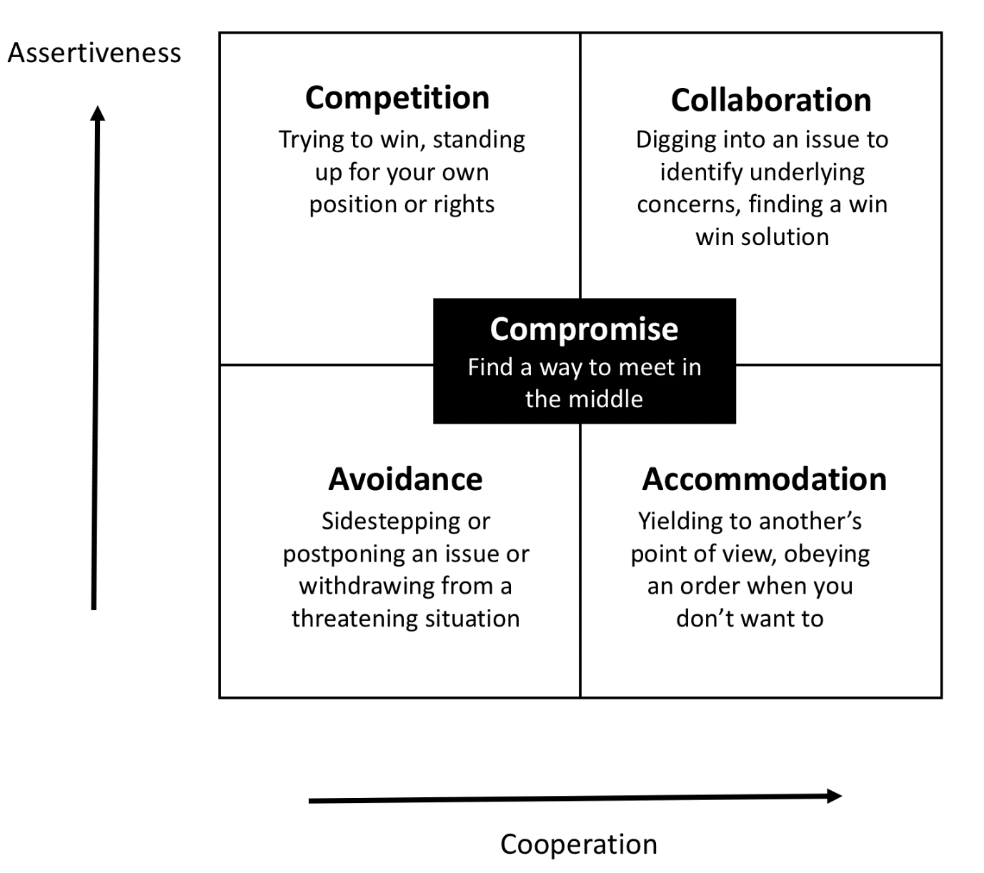

Dispute resolution process.
Dispute resolution process can be stressful and a sensitive area involving time involving disagreements dispute settlement is the process of resolving disputes between groups. The potential one-day strike Royal Mail wants to save money by not giving the workers a pay rise they deserve, and the workers are disputing the pay rise the post office can lose customers. The customers will lose the confidence in the post office and could choose other delivery organizations for example, FedEx Corporation, DHL, although that could necessitate in the customers desiring to choose to stay with DHL or FedEx corporation, resolution is sometimes used interchangeably with conflict resolution, although conflicts are commonly more deep-rooted and lengthier than disputes. Royal Mail has considered meeting along with the resolution process using ACAS, services to seek a resolution and mutually “acceptable way forward”(Nkansah, 2015).

For instance the customers not happy about not being able to use the post office on the certain day and having to use sub post offices that can therefore cause an flood of customers in the sub post offices find local for example business that need to post the mail and customers needing to deposit or pay bills and data checking services and collection of parcels for parcel force collection compromised decision can be outlined putting the customer stakeholders in one category because the needs can differ from customer to customer.

Recommendations
The portfolio has demonstrated that the stakeholders must be identified using a stakeholder power matrix grid and outlined who to satisfy how to manage and who to monitor and who to inform and who not to inform how important they are to entail the change. Using the Salience model to analyze the stakeholders and process has 8 areas which are categorized into 3 attributes, power, legitimacy, and urgency and how they should be handled to gain a joint outcome using, Thomas Kilmann’s conflict resolution model. Not have a one-day strike
According to study, The Communication Workers Union (CWU) must come to an agreement with Royal Mail they have to consider new aspects for example extra bonus instead of the 7% rise and accept 4% pay increase with yearly bonus before the company's workers vote to take strike action. Data suggests Royal Mail employed around 162,000 permanent postal workers, of which 143,000 are based in the UK and 90,000 were postmen and post mistress therefore it is a win-win situation for the royal mail workers.
Demanding to stop the Workers union at Royal Mail voting in to take future strike action in August and September,2022 in a dispute over pay. The vote comes not long after rail workers with the RMT Union undertook three days of strike action. resolution process suggest diverse ways in which resolution can be met or be worked towards, using relevant data.

References list
Corporate.postoffice.co.uk.2022. [online] Available at: <https://corporate.postoffice.co.uk/en/about/our-story/who-we-are/>
Farrell, S., 2013. Royal Mail workers win pay increase of 9% over three years. [online] the Guardian. Available at: <https://www.theguardian.com/uk-news/2013/dec/09/royal-mail-workers-pay-increase> [Accessed 7 December 2021].
Guardian. 2022. Royal Mail staff vote to strike in pay dispute. [online] Available at: <https://www.theguardian.com/business/2022/jul/19/royal-mail-staff-vote-strike-pay-dispute-cwu> [Accessed 10 August 2022].
Hillen, J. and Nevins, M., 2018. MANAGING AND INFLUENCING YOUR MOST IMPORTANT STAKEHOLDERS. Leader to Leader, 2019(91), pp.37-43.
Hodges, J., 2013. Wecanunderstand complex models (at least, sometimes). Environmetrics, 24(8), pp.527-528.
Kessler, S., 1995. Trade union recognition: CIR and ACAS experience. Employee Relations, 17(6), pp.52-66.
Kutsuna, K., 2002. The Relationship Between Private and Public Financing for Small Businesses. Japanese Economy, 30(2), pp.3-28.
Thomas, K. and Kilmann, R., 1978. Comparison of Four Instruments Measuring Conflict Behavior. Psychological Reports, 42(3_suppl), pp.1139-1145.
Trippe, B. and Baumoel, D., 2015. Beyond the Thomas-Kilmann Model: Into Extreme Conflict. Negotiation Journal, 31(2), pp.89-103. [Accessed 7 August 2022].
Melnichuk, A., 2021. The K. Thomas - R. Kilmann questionnaire: the vulnerabilities of the diagnostic tool. Vestnik Yaroslavskogo gosudarstvennogo universiteta im. P. G. Demidova. Seriya gumanitarnye nauki, 15(4), pp.630-637.
Nkansah, L., 2015. Dispute Resolution and Electoral Justice in Africa: The Way Forward. SSRN Electronic Journal,.
Owusu, E., Antwi, J. and Kendie, S., 2021. Disaster Risk Management: The Exercise of Power, Legitimacy and Urgency in Stakeholder Role in Ghana. International Journal of Environment and Climate Change, pp.17-33.
Ye, D., Liang, D. and Hu,P., 2018. Three-Way Decisions with Interval-Valued Intuitionistic Fuzzy Decision-Theoretic Rough Sets in Group Decision-Making. Symmetry, 10(7), p.281.
https://i.pinimg.com/originals/36/4d/2a/364d2aec72b20b6a97e006026ae42577.jpg

