University Of Wales Trinity Saint David
Wales Institute of Science and Art


Validation and application of FEA processes
Structural Design & Fluid Analysis (ACHA6010)

Connor Smith
2101198
12/2023
Contents
List of tables and figures 3
1 Introduction 4
2 Validation 5
2.1 Cantilever beam with a uniformly distributed load 5
2.1.1 Reason for use in validation 5
2.1.2 Case methodology 6
2.1.3 Results and discussion 6
2.2 Bimetallic strip 7
2.2.1 Reason for use in validation 7
2.2.2 Case methodology 8
2.2.3 Results and discussion 8
3 Original piston study 9
3.1 Rigid Dynamics 9
3.1.1 Process justification 9
3.1.2 Methodology 10
3.1.3 Results 12
3.2 Steady-State thermal 12
3.2.1 Process justification 12
3.2.2 Methodology 13
3.2.3 Results 14
3.3 Static Structural 14
3.3.1 Process justification 14
3.3.2 Methodology 15
3.3.3 Results 16
4 Altered piston case 17
4.1 Rigid dynamics result 17
4.2 Steady state thermal result 18
4.3 Static structural result 18
5 Conclusions 20
6 References 21

List of tables and figures
Table 1 - Cantilever beam data 5
Table 2 - Effect of mesh sizing on cantilever beam simulation accuracy 7
Table 3 - Data for the bimetallic strip 8
Table 4 - Effect of mesh sizing on bimetallic strip simulation accuracy 8
Table 5 - Thermal boundary conditions 13

Figure 1 - Cantilever beam model 6
Figure 2 - Cantilever beam analysis (2.5mm mesh) 6
Figure 3 - Invar/copper bimetallic strip 7
Figure 4 - Geometry being evaluated 9
Figure 5 - Piston geometry position changes due to rotating crankshaft 11
Figure 6 - Force against time from the joint probe 11
Figure 7 - Rigid dynamics tabular data 12
Figure 8 - Piston temperature profile 14
Figure 9 - Constraint situation 15
Figure 10 - Piston equivalent stress 16
Figure 11 - Piston deformation 16
Figure 12 - Altered piston 17
Figure 13 - Second rigid dynamics tabular data 17
Figure 14 – second thermal study results 18
Figure 15 - Equivalent stress results 18
Figure 16 - new stress points 19
Figure 17 - Deformation 19

Introduction
When designing a system, geometry of the parts being created is often enormously complicated. As a result, calculating how the parts would respond to various loading conditions by traditional means is a daunting prospect, with multiple variables interacting with the component differently based on where in the component the interaction takes place. The finite element analysis (FEA) method is a computer-controlled process which breaks down these complex issues into a series of simpler problems, allowing a close approximation of the real-world interaction between the component of the loading conditions (Hutton, 2004).
FEA works by dividing the geometry of the component into several discrete chunks, called elements. These elements become a matrix equation, where each element is related to its neighbouring values by its nodes. Relating the elements in this way results in a close approximation of the original geometry in a gridded format, known as a mesh, which can then be assigned material properties and loading conditions. The computer solves, based on the appropriate equations, the deformation/stress/strain at each of these nodes (Panagiotopoulou, 2009). These results can be evaluated by design engineers to determine approximately how well a component will perform under its real-world conditions.
Whilst FEA is a useful tool for determining approximate values, it is still an approximation. The validity of these models is heavily influenced by the data and condition inputs, as well as the principles used by the solver to generate the results. This report aims to evaluate the use of ANSYS as FEA software for the case of the thermal/mechanical loading of a piston.

Validation
FEA models are only approximations of real-world scenarios. As such, the results determined by the model will always have deviations from what would be expected to happen. Validation determines whether the model is producing results that are acceptably close to the expected/real result (McCaslin, 2021).

Cantilever beam with a uniformly distributed load

Reason for use in validation
A cantilever beam is a length of material that extends horizontally from a support point on one end of the material. Upon loading a cantilever beam, it bends, causing a displacement at the free end. When a uniform force is applied to the beam, the displacement can be calculated using the formulae:
$Δ=\frac{wl^{4}}{8EI}$ $I=\frac{BD^{3}}{12}$ $P=\frac{F}{A}$
(Kazahaya, 2011)
Where w is the UDL, k is the beam length, E is the modulus of elasticity, I Is the moment of inertia, B is the width and D is the thickness.
To analyse the model correctly, the FE solving software must be able to accurately calculate deformation due to mechanical loading. A model of a cantilever beam, alongside materials data, can be used as a validation case for this, comparing the results of the simulation to the result calculated using the above formulae. The material, geometry and loading data used for this validation case is shown below.
Modulus of elasticity (MPa) | 210000
Poisson’s Ratio | 0
Length (m) | 1
Width (m) | 0.05
Thickness (m) | 0.005
Pressure (Pa) | 2750
Table 1 - Cantilever beam data
Using this data, the displacement can be calculated as 157.43mm
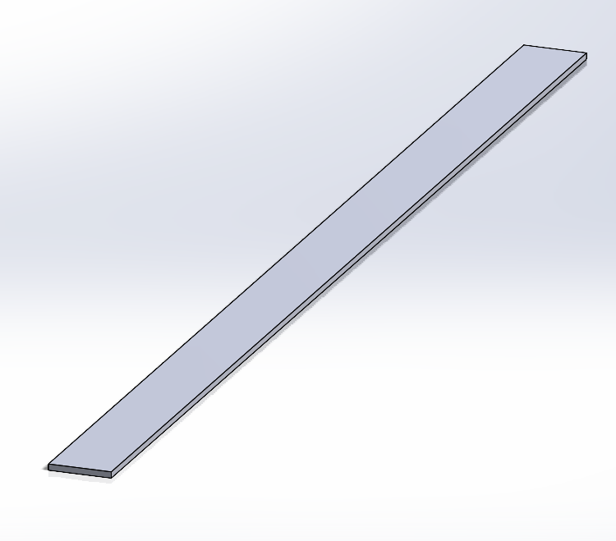
Figure 1 - Cantilever beam model

Case methodology
For the case of the cantilever beam, geometry was created in SolidWorks to the dimensions shown in section 2.1.1. This was imported over to the ANSYS workbench, where a material assignment with the required material properties was created in a static structural study. This material was assigned to the geometry in ANSYS mechanical, and a mesh was generated for the component with an element size of 5mm. One end of the beam assigned as a fixed support to constrain it, as would be the case for a real cantilever. A pressure load was applied to the top face, equalling 2750 Pa. This acts as a uniformly distributed load, which will produce results that can be evaluated against the calculated comparator. The solution for total deformation was requested in the Solution section in ANSYS, and the software was told to solve the appropriate equations for the parameters that it was given. This solution was recorded, and the simulation was rerun with different meshes to determine what effect element size had on the accuracy of the results.

Results and discussion
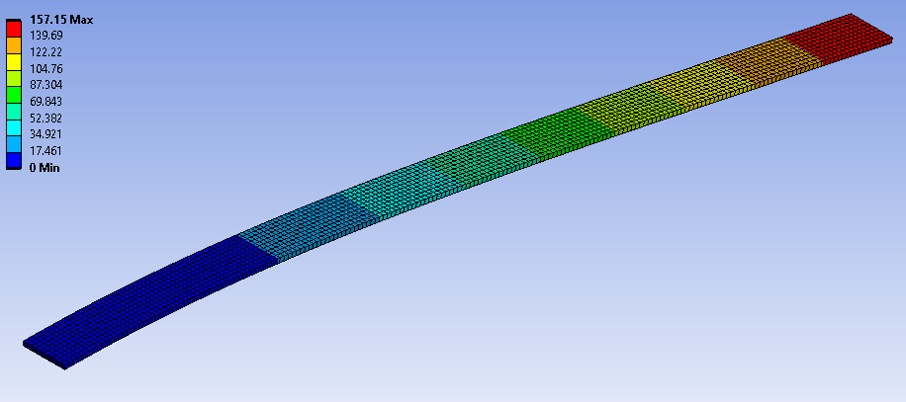
Figure 2 - Cantilever beam analysis (2.5mm mesh)

Element Size (mm) | Output Deflection (mm) | % Error from expected
5 | 157.15 | 0.178
2.5 | 157.15 | 0.178
1 | 157.15 | 0.178
Table 2 - Effect of mesh sizing on cantilever beam simulation accuracy
Table 2 shows that, for a simple cantilever beam case, the mesh sizing has no effect on the results, assuming a reasonably sized mesh. Each of the mesh sizes tested produced a margin of error of 0.178%. This is an incredibly high degree of accuracy, validating ANSYS for calculating structural changes due to mechanical loading.

Bimetallic strip

Reason for use in validation
A bimetallic strip is used in thermostats and temperature control conditions. These strips consist of two materials with dissimilar coefficients of thermal expansion bonded together. When heated, the material with the greater coefficient expands more than the material that it is bonded to, causing the strip to deflect (Rameshbhai et al, 2020). By simulating this deflection and comparing it to a calculated, expected deflection, it can be determined whether the structural FEA model being used is appropriately accurate when calculating deformation due to thermal loading.
The strip shown below is a SolidWorks model of a strip of copper bonded to a strip of invar, forming a bimetallic strip.
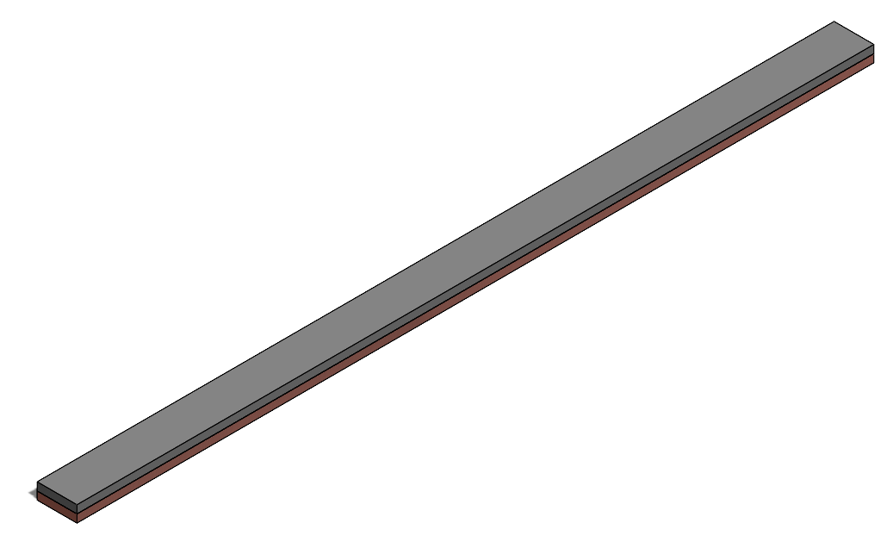
Figure 3 - Invar/copper bimetallic strip
By using the formula for calculation of deflection and material properties provided by Dub on behalf of Dlubal Software GmbH (2017), it can be calculated that the maximum deflection due to a thermal loading of 100°C is -7.049 mm. Once the FEA simulation has been run repeatedly with different mesh sizes, the similarity of the results when compared with this value will determine at what point the mesh size is most accurate, or at what point the difference in output from a decrease in mesh sizing becomes negligible (mesh independence). The data used for this strip is shown below.
Invar modulus of elasticity (MPa) | 137000
Invar Poisson’s Ratio | 0.28
Invar Thermal expansion Coef (˚C⁻¹) | 1.2*10⁻⁶
Copper modulus of elasticity (MPa) | 130000
Copper Poisson’s Ratio | 0.354
Copper Thermal expansion Coef (˚C⁻¹) | 2*10⁻⁵
Width (mm) | 5
Layer thickness (mm) | 1
Length (mm) | 100
Thermal load (˚C) | 100
Table 3 - Data for the bimetallic strip

Case methodology
To set up the bimetallic strip, two strips of the same dimensions were created in SolidWorks and mounted with the large, flat faces connecting the two. This geometry was imported over to ANSYS, where one material assignment was created for copper and another for invar using the data in section 2.2.1. The connections that ANSYS generated from the SolidWorks file were checked to make sure that they would not cause errors, as improper connections can be detrimental to calculation precision. Each strip was given one of the created materials assignments, and a mesh was creating using an element size of 1mm. One end was fixed, as this would be the case for the type of bimetallic strip that would be used in temperature sensors. After this, a thermal load of Δ100˚C was applied, and the simulation was asked to solve the relevant equations for the total deformation. This was rerun several times with different meshes to attempt to determine the effect of varied element sizing.

Results and discussion
Element Size (mm) | Output Deformation (mm) | % Error from expected
1 | 7.1233 | 1.043
0.5 | 7.123 | 1.039
0.25 | 7.1213 | 1.015
0.1 | 7.1203 | 1.001
Table 4 - Effect of mesh sizing on bimetallic strip simulation accuracy
Even at a mesh sizing of 1mm, the deformation was modelled to within 1.043% of the expected value. This is a high degree of accuracy, and so validates the use of the ANSYS for the purposes of simulating mechanical changes due to thermal loading. These results also show that a decrease in the mesh sizing results in a solution that is more accurate to the calculated value. However, below a mesh sizing of 0.1mm, ANSYS began to have issues with calculation duration due to the number of elements that it was solving.

Original piston study
FEA can be used to assess the use of components in engines to simulate how the parts perform under dynamic conditions. These studies can determine whether a part is fit for purpose and what aspects of the part can be adapted or enhanced to assist with the performance/lifespan of the product. In this case, a piston attached to a crankshaft via a connecting rod and gudgeon pin is used, with an emphasis on the assessment of the piston.
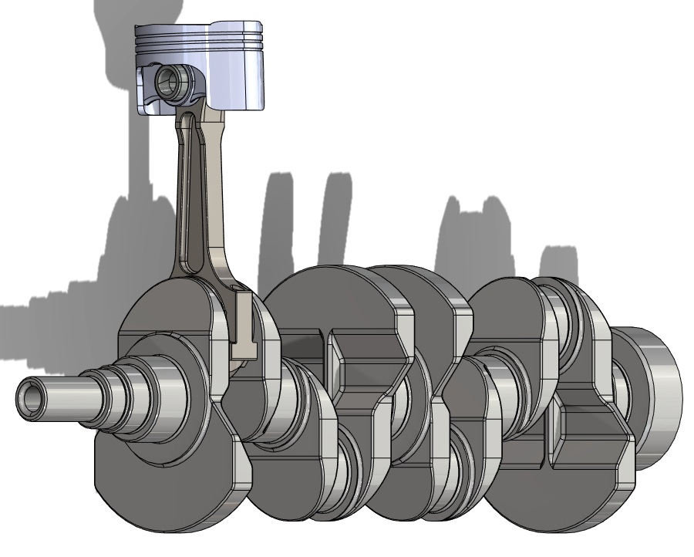
Figure 4 - Geometry being evaluated

Rigid Dynamics

Process justification
A kinematic study is an analysis that focuses on the forces involved with movement rather than the consequences or caused of said movement. Performing a kinematic analysis on the piston is vital to determining the forces involved with a rotating crankshaft and how these forces change over time (Lučić, 2022).
The way that such a study is performed in ANSYS is through a rigid dynamics study. This solver does not allow the geometry being analysed to flex or deform in any way, focusing entirely on the kinematics of the system and the forces that occur as a result. The results of this study can later be used in a static structural study to determine the stress and deformation within the component, allowing an evaluation of whether the piston is fit for purpose and potentially highlighting some areas that can be improved.

Methodology
To perform this study, both a material assignment and geometry are required. The material selected for this study was aluminium 6061 T6. 6061 aluminium has a higher strength when compared to other grades of aluminium and is suitably durable, whilst being easy to machine (Balahari & Aezhisai, 2017). T6 grade 6061 aluminium has been strengthened after forming (Davis, 2013), making it well suited to use within a cylinder. The study was given both the engineering data for Aluminium 6061 T6 and the geometry shown at the start of section 3, assigning the material to each of the assembled bodies. The auto-generated connections were deleted and revolute joints that allow for rotational degrees of freedom were implemented in their place. Two additional joints were then implemented; a body-to-ground revolute joint that would allow the crankshaft to rotate, and a general joint that constrained the translation of the piston in every direction except for translation up/down where the cylinder would be in a completed system. A mesh was generated to complete the setup, although the study will not use it for any calculations.
The solver was set up to only solve over a short period of time (0.05s), at the engine would take minimal time to achieve a complete revolution at medium to high speed. Additionally, the time step was set to every 0.001 seconds to allow for a good data resolution. ANSYS was told to solve the study when the crankshaft was revolving around the crankshaft body-to-ground joint at 4000 RPM, with a join probe at the joint between the piston and the gudgeon pin set to determine the total force at that joint. Once the solution was complete, the time step at which the forces were at their maximum was extracted so that the maximum value could be retrieved and used in the structural analysis later.
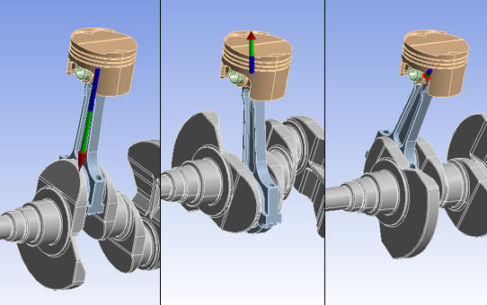
Figure 5 - Piston geometry position changes due to rotating crankshaft
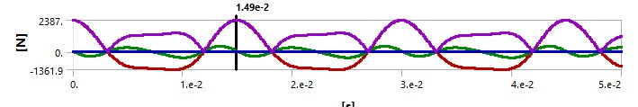
Figure 6 - Force against time from the joint probe

Results
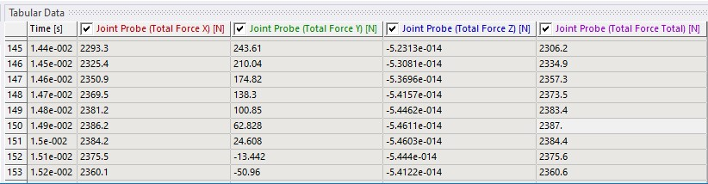
Figure 7 - Rigid dynamics tabular data
By setting up the solver in this way, it was calculated that the maximum kinematic force experienced by the piston was 2387N. This is a reasonable order of magnitude for this value, therefore it can be assumed to be relatively indicative of the real world forces that would be seen. When this value is exported across to the static structural study, it will serve as a loading condition to assist in the evaluation of the piston’s structural characteristics when the kinematic forces acting on the piston are at a maximum, providing the maximum stress and deformation on the piston. This is required to estimate whether the piston will fail.

Steady-State thermal

Process justification
Thermal conditions dramatically alter the performance of a component. Increased temperature can cause thermal stress to a component, as well as significant deformation which can interfere with the components that the piston interacts with. Either one of these can lead to component failure; if not, then creep or thermal fatigue can cause the component to fail (Xin, 2013). It is, therefore, imperative that the thermal loads be taken into consideration when assessing a component.
A steady-state thermal analysis allows the determination of a temperature profile for the component, based on the temperature that the piston is exposed to at varying points in the geometry and the heat transfer coefficients at those points. This temperature can then be exported to a structural study to account for thermal condition in that study.

Methodology
At the beginning of this process, the materials data and the geometry are imported across from the rigid dynamics study to ensure that they are constant throughout. Once the material data and components were checked, all non-piston parts were suppressed so that the solver could focus entirely of the piston. The component was changed to “flexible” in the solver (allows deformation to occur) and a mesh was generated. Based on the validation cases, a mesh size of 1mm was chosen.
To complete the study, the boundary conditions must be assigned to each of the parts of the piston, with temperatures and thermal coefficients for the crown, oil rings, skirt and underside all stated as convection conditions. A table showing these values is displayed below.
Geometry | Heat transfer coefficient | Temperature (°C)
Crown | 497.5 | 928.5
Crown side | 447.5 | 425
Main grooves | 437.5 | 190
Oil groove | 338.75 | 163.75
Underside | 675 | 91.25
Skirt | 462.5 | 107.5
Table 5 - Thermal boundary conditions
The temperature profile of the component is requested is the solutions section and the study is run to retrieve this result.

Results
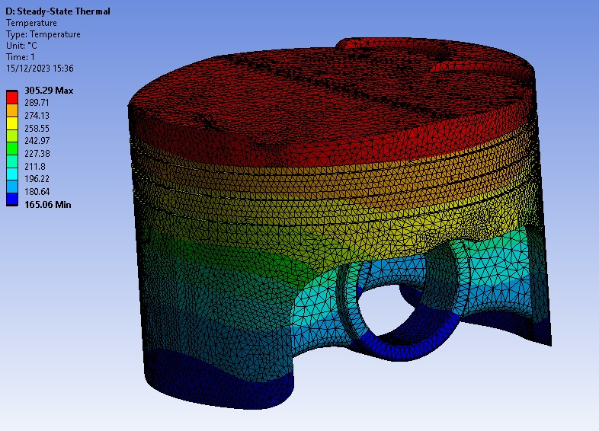
Figure 8 - Piston temperature profile
The results in this section show a temperature range of 305.29-165.06°C. This result is in a similar range to the findings of Cerit and Coban (2014), therefore can be assumed to be reasonably representative of the thermal condition of a piston under dynamic conditions. This result is required in the structural examination, therefore a decently indicative model such as this is critical to the analysis of the component.

Static Structural

Process justification
Analysing a component structurally is key to determining whether it is fit for purpose. Such an analysis must consider how the component deforms under dynamic conditions, as well as the stresses involved with the loads that occur during its life cycle. A static structural study in ANSYS allows for multiple loading cases to be imported or assigned to the geometry and can solve the structural changes based upon the material properties and these loads.

Methodology
The materials data and geometry were imported across from the rigid dynamics study to ensure that both were constant across the entire system. The material assignment of the components was checked to ensure that it had not reset to the system default. Every component except for the piston was supressed so that the solver didn’t try to perform any calculations on them, and the piston was set to flexible to allow for deformations and structural changes. The motion loads from the kinematic study were then imported as loading conditions, and the result from the thermal study was imported to inform the structural study of the temperature of the piston. A mesh was then generated; in this case, the mesh was set to 4mm for the bulk of the body and 2mm for the piston crown. Decreasing the element size any further than this proved to be computationally challenging.
This is one limitation of FEA models; they require a staggering amount of processing power to run. Breaking down the model into too many elements will result in the entire system either stalling or running for a vast amount of time, which in turn requires massive energy usage. As such, the degree of accuracy often gets capped at the minimum element size that ANSYS can solve without having major issues.
A pressure loading was applied to the piston crown to simulate the pressure of an engine, and the lower part of the connection to the pin was fixed as a constraint. This will skew the results, as this part of the component would normally deform and stress would be seen within it. The setting to constrain the model without this in ANSYS is called “weak springs”, however the studies run with weak spring encountered several errors. An image of the constrained points is shown below.
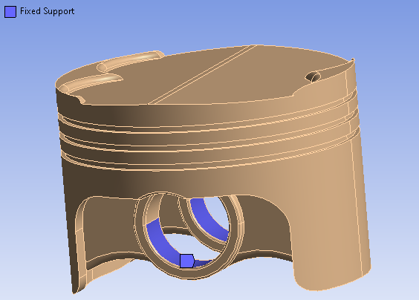
Figure 9 - Constraint situation
Once this was all set up, the solutions for equivalent stress and deformation were requested and the study was run.

Results
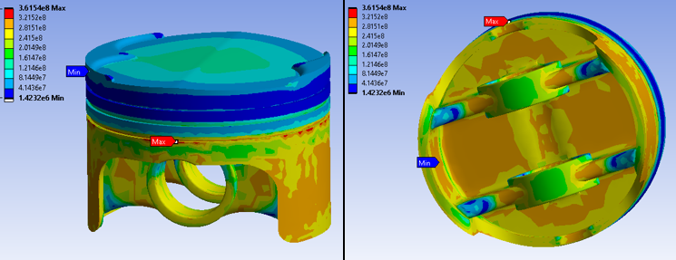
Figure 10 - Piston equivalent stress
Figure 10 shows the stress analysis for the piston performed by the static structural study. The results show a range of 1.42-361.54 MPa. The maximum value for this is higher than expected, given that the pressure was set to just below 60 bar in accordance with the works of Iliev et al (2012). This is above the ultimate strength of the material, which indicates that the component would fail around the oil ring where maximum stress occurs if used in real-world conditions. Additionally, large sections of the underside and skirt show high stresses, indicating potential failures in those regions. However, it is difficult to assume degrees of accuracy in this study despite the prior validation because the fixed supports will dramatically alter the structure of the component.
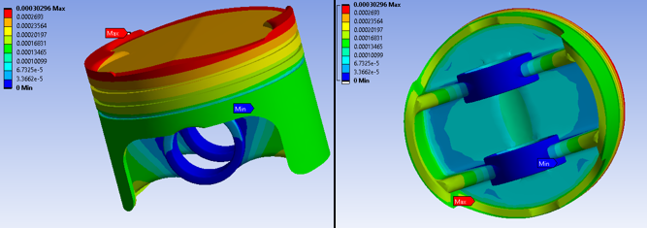
Figure 11 - Piston deformation
The deformation of the system, shown in figure 11, is highest where the temperature and pressure was highest, bleeding away further down the piston. There is limited deformation on the connection point due to the fixed supports. The maximum deformation on the piston crown is around 0.3mm, which may be acceptable depending on the tolerances of the cylinder that the piston is operating in.

Altered piston case
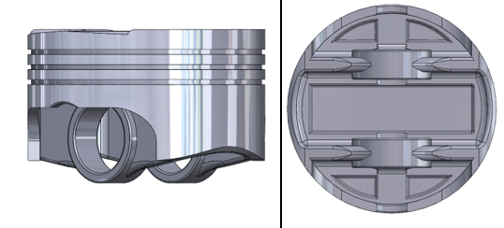
Figure 12 - Altered piston
To improve upon the original geometry, a new piston model was created and tested. This second design has a smaller skirt and has material taken off the underside, attempting to eliminate the unstressed points on the underside in section 3.3.3. It was retested using the same methodology as above.

Rigid dynamics result
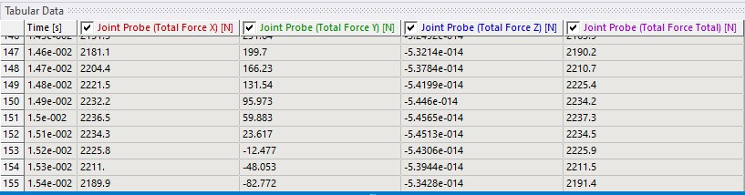
Figure 13 - Second rigid dynamics tabular data
The rigid dynamics study for this piston retrieved a lower maximum force due to kinematics than its predecessor. This was due to the lowered mass of the system. This should, in theory, reduce the stress caused on the piston, making it better suited for purpose.

Steady state thermal result
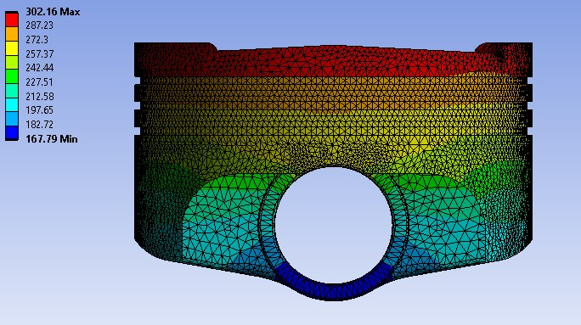
Figure 14 – second thermal study results
The thermal study resulted in a lower maximum temperature but a higher minimum temperature than the last design. This decreased upper bound may be because the mesh had changed, as any calculations in ANSYS are approximations. The decreased thermal loading should result in an increase in component performance, lowering stress and deformation.

Static structural result
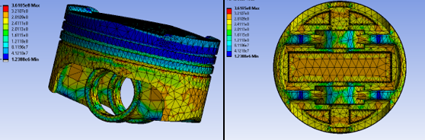
Figure 15 - Equivalent stress results
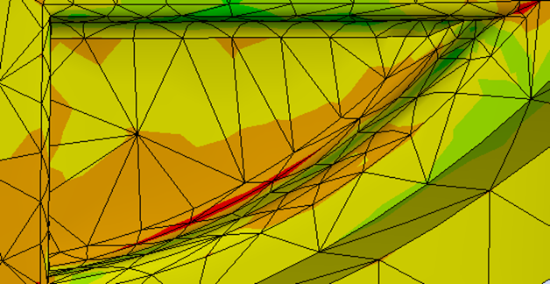
Figure 16 - new stress points
Figure 15 shows the stress results of the structural study. The maximum stress in the system has decreased, however there are new stress points being created by the rapidly changing angles cut into the bottom (see figure 16). This creates a new area in which the component can fail, and therefore should be made less steep in a future iteration of the design.
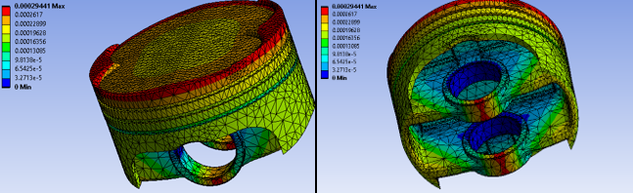
Figure 17 - Deformation
As predicted, due to a decrease in thermal and kinematic loading, the overall deformation decreased. The decrease was, however, marginal and does not outweigh the potential damage done by the new fracture points.

Conclusions
When set up correctly, FEA solvers such as ANSYS are useful tools to help approximate results for structural changes in a component and can be incredibly helpful in evaluating whether a component is suitable for use. They can provide results to a high enough degree of accuracy to base decisions regarding materials/ components upon. However, their accuracy depends on numerous factors, including mesh size, boundary conditions and constraints applied. Any issues with any of these setup points can cause deviations in accuracy, decreasing the validity of the model.

References
Balahari, K.S. & Aezhisai, V.M.S. (2017), “Design and Analysis of an IC Engine Piston using Composite Material”, European Journal of Advances in Engineering and Technology, 2017, 4 (3), pp.209-215
Cerit, M. & Coban, M. (2014), “Temperature and thermal stress analyses of a ceramic-coated aluminum alloy piston used in a diesel engine”, International Journal of Thermal Sciences 77, pp. 11-18
Davis, J.R. (2013), “Alloying: Understanding the Basics”, ASM International, pp.351-416
Dub, M. [online] (2017), “Verification Example: 0078 – Bimetallic Strip”, Dlubal Software GmbH, https://www.dlubal.com/en/downloads-and-information/examples-and-tutorials/verification-examples/000078, accessed 12/12/2023
Hutton, D.V. (2004), “Fundamentals of Finite Element Analysis”, The McGraw−Hill Companies, 1. Basic Concepts of the Finite Element Method, pp.1-5
Iliev, Simeon & Hadjiev, Kiril. (2012). ANALYSIS OF ENGINE SPEED EFFECT ON THE FOUR -STROKE GDI ENGINE PERFORMANCE. Journal Proceedings in Manufacturing Systems. 7. 229-234.
Kazahaya, M. (2011), "A Mathematical Model and Error Analysis of Coriolis Mass Flowmeters," in IEEE Transactions on Instrumentation and Measurement, vol. 60, no. 4, pp. 1163-1174
Lučić, M. (2022), “Kinematic analysis of the slider-crank mechanism of an internal combustion (IC) engine using modern software”, international scientific journal "mechanization in agriculture & conserving of the resources", ISSUE 1, pp. 11-17
McCaslin, S. [online] (2021), “Validation and Verification in Finite Element Analysis (FEA)”, Control Automation, https://control.com/technical-articles/validation-and-verification-in-finite-element-analysis-fea/, accessed 12/12/2023
Panagiotopoulou, O. (2009), “Finite element analysis (FEA): Applying an engineering method to functional morphology in anthropology and human biology”, Annals of Human Biology, 36(5), Informa UK Ltd. pp.609-623
Qianfan Xin (2013),”2 - Durability and reliability in diesel engine system design”, Diesel Engine System Design, Woodhead Publishing, Pages 113-202,
Rameshbhai, D.A. & Ashwinkumar, P.V & Gediya, N.C & Gaud, P. (2020), “Design and Numerical Analysis of Bimetallic Strip Using Finite Element Method”, IJSRD - International Journal for Scientific Research & Development, Vol. 8, Issue 8, pp. 431-436

