
DISSERTATION

Student name :Violeta Nicoleta Gheorghiu
Student ID :1817473
Proposed research title : The impact of branding on consumer behavior – A comparative analysis of student’s preferences between Apple and Samsung smartphones.

Table of Contents
Research Topic 3
Chapter 1: Introduction 3
Introduction to the research topic 3
Significance of the topic 3
Purpose of the research 3
Proposed aim, objectives and research questions 4
Chapter 2: Literature Review 5
Concepts of branding, Consumer behavior and motivation 5
Important factors of consumer behavior 6
Importance of consumer behavior concepts and strategies 6
Concepts and strategies of branding 7
Importance of branding for business organizations 7
Application of brand equity model on Samsung and Apple 7
Application of Maslow's hierarchy model on Samsung and Apple 8
Chapter 3: Research Methods and Methodology 9
Research philosophy 9
Research paradigm 9
Research approach 10
Research methodology 10
Research strategy 10
Sampling 11
Data collection methods and tools 11
Data interpretation methods 11
Ethical consideration of the research 11
Chapter 4: Questionnaire of the research 12
Chapter 5: Analysis of the collected primary data 13
Chapter 6: Conclusion and recommendations 20
Chapter 7: Further Research 21
Chapter 8: References and Bibliography 22

Research Topic
The impact of branding on consumer behavior – A comparative analysis of student’s preferences between Apple and Samsung smartphones.

Chapter 1: Introduction

Introduction to the research topic
Branding is one of the most important responsibility and activity of marketing which helps in the process of developing a positive image and brand awareness among the customers and target audience of a business organization. Consumer behavior represents the activities, initiatives and approaches taken by the customers before making the final buying decision of a product or service. The branding of the product or service of a business organizations has a noteworthy impact on the consumer behavior. This research project will discuss about the preferences and consumer behavior among students customer segments towards both Samsung and Apple smartphones.

Significance of the topic
The importance of branding for the desired success and performances of business organizations are noteworthy to a great extent. Branding elements and activities shares the products, services, benefits, features, offers and other information with the customers and creates a positive image among the customers along with a willingness to buy the products or pay for the services. Branding also helps in the process of developing credibility and trustworthiness among the customers as well. All these aspects of branding are strongly associated with consumer behavior. The consumer behavior among target customers towards the products and services of a business organization are highly influenced by the branding activities and initiatives performed to promote these. Thus, it is very important for business organizations to identify and understand the impacts and effects of branding on consumer behavior. The comparison between students’ consumer behavior towards 2 of the most popular smartphone brands Apple and Samsung will be conducted by this research project.

Purpose of the research
The major purpose of the research is to identify the impacts of branding on consumer behavior in the context of a comparison between Apple and Samsung smartphone customers who are students.

Proposed aim, objectives and research questions
The aim of the research is to perform a comparison between the preferences among students between Apple and Samsung smartphones in order to identify the impacts of branding on consumer behavior. The objectives of this research project are presented below in this part of the research proposal.
- To identify the impacts of branding on consumer behavior
- To find out the effects of branding activities of both Apple and Samsung smartphones on consumer behavior
- To identify what motivates students in buying Apple and Samsung smartphones .

The research questions of this specific research project are presented below.
- What the impacts of branding on consumer behavior?
- What are the preferences among students about smartphones from renowned brands Apple and Samsung?
- What motivates students in buying Apple and Samsung smartphones?

Rationale of the study
Research is important because today’s smartphones, through their functions they become to replace computers, not only be used to talk, also to store informations, to do payments online, to research information.
This research help each costumer choose what the best is for their personal needs is.

Chapter 2: Literature Review

Concepts of branding, Consumer behavior and motivation
The concept of consumer behavior represents the activities as well as approaches which are taken by customers before taking the final buying decision. The information about different aspects of the products and services are searched by the customers (Hoyer, MacInnis and Pieters, 2018). Additionally, customers always look for recommendations from previous users about the positive and negative impacts, overall values and benefits of the products as well. The emotions as well as attitudes of the consumers are two of the most important aspects of consumer behavior which are very important to understand and evaluate by business organizations.
The term “branding” represents the activities and processes of the development of an identity of a specific products, service, person or an organization. The activities and initiatives taken by business organizations to craft the brand in the minds of their target customers is known as branding. Different types of branding contents, activities, strategies and approaches are developed and practiced as well as implemented by business organizations for branding successfully to their target markets and accomplish desired level of performance, sales revenue, brand recognition, popularity and preferences for the brands among the customers. As stated by the American Marketing Association, brand can be defined in the form of a symbol, term, name, image or a combination of several of these elements for successfully differentiating their organization, products and services from these of the competitors operating within the same industry and approaching the similar target markets. In the opinion of Philip Kotler, the process of developing credibility and trustworthiness among target customers towards a business organization and its products or services is called branding. Giving a particular meaning, identity and feature to the products or services of a business is important aspect of branding as well. As stated by David Ogilvy, the procedures of developing a brand is called branding. In addition to that, he also stated and presented a brand as the successful and effective combination of all the different intangible features, aspects, attributes and qualities of the products or services developed and provided by business organizations to their customers for ensuring and accomplishing financial gain (O’Donohoe, 2009).
The concept of consumer can be defined and represented in several different ways. A high Number of academicians, Researchers, authors and scholars have Developed different definitions of consumer behaviour along with different strategies and initiatives which are suggested by them for the business organisations Operating in different industries and sectors all over the world and looking for modifying the consumer behaviour in the favour of their respective business organisation and for developing effective competitive advantage within the industry and outperforming the competitors operating within the same industry targeting the similar customer segments. As stated by, Solomon et al Activities and procedures of successful selection, purchasing and utilisation of different products or services by the customer of a business organisation in order to satisfy different organisational as well as personal needs and requirements of the customers of a business organisation can be defined as consumer behaviour (Solomon, 1985). The process of persuading and influencing the Buying behaviour and the final purchasing decision of a customer in the favour of a particular business and its products or services is the ultimate goal and objective of understanding the concept of buying behaviour or consumer behaviour for the marketing professionals management of different business organisations. Effective understanding of the concepts and strategies of consumer buying behaviour is highly important for business organisations to develop and modify their marketing and promotional activity, branding elements and overall management approaches in accordance with the needs and preferences of their target customers.

Important factors of consumer behavior
Consumer behaviors are influenced and affected by a number of different factors which has various levels of impacts on the consumer behavior within a person towards different products or services. These factors affecting the consumer behavior plays a great role in the decision making whether target customers decide to buy the products of a business organization or not (Solomon, 2006). Culture, social values and ethical practices are some of the external factors which affects the consumer behavior. In addition to these, the internal factors such as the psychological aspects and personal preferences of customers affect the consumer behavior to a great extent as well.

Importance of consumer behavior concepts and strategies
The aspects, strategies and concepts of consumer behavior are highly important to understand by business organizations. It helps the business organizations and marketing professionals to identify the demands, tastes and preferences of their target customers (Noel, 2009). As a result, they are able to develop and modify their products and services based on the consumer behavioral aspects of their target customers. The actions and reactions of customers to different marketing and promotional activities can be predicted by business organizations through successful evaluation of consumer behavior which eventually helps them to develop more effective and attractive marketing and promotional contents to grab the attention, preference and popularity among the customers.

Concepts and strategies of branding
Branding in marketing refers to the promotional activities and initiatives which are conducted by business organizations to present the organization and its products or services in front of the customers of the business (Blythe, 2013). It helps to create the brand image and popularity of the products or services offered by the brand. Branding involves the use of names, slogans, phrases, signs, symbols and other different brand elements and creative contents to attract the attention of the customers and increase the brand retention rate for converting the target audience into loyal customers of the business.

Importance of branding for business organizations
Branding is important for business organizations for a number of reasons. It provides good and positive reputation for the brands and business organizations within the industry and among the customers. The increase in brand value and level of profitability through increased sales are positive impacts of successful branding by business organizations (Aaker, 2004).

Application of brand equity model on Samsung and Apple
Another Highly popular and widely known name for the brand equity model of Keller is the customer based brand equity model (Bong Na, Marshall and Lane Keller, 1999). This specific model is Highly Effective and important for marketing professionals and business Organisations for successfully developing the branding and marketing as well as promotional contents and strategies of a business organisation for successfully and effectively communicating with their target customers and informing them about the products and services along with features and benefits. The major implication and logic of this specific model is the fact that, it is highly important and mandatory for the marketing professionals and business organisation to develop a positive, effective, strong and successful brand image in the minds of their existing and potential target customers. the successful development and establishment of an effective and proper brand encounter as well as customer experiences two of the most important factors of building and developing a strong brand which has high level of popularity and preferences among the target customers. A Graphical representation of the brand equity model is presented below for providing a better understanding and explanation of the concept and ideas of the model which are the important to understand for the business organisations and their marketing professionals.
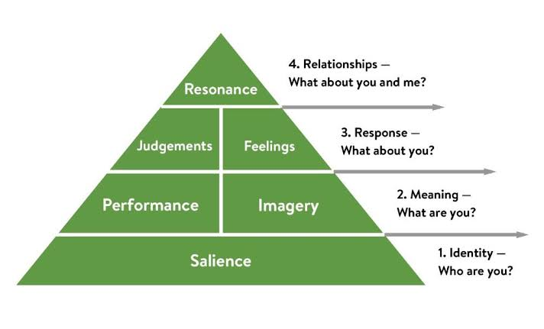
Figure: Keller's brand equity model
Smartphone brands such as Apple and Samsung Should develop clear information and branding elements in order to inform their customers about their features, benefits, prices and other different information which are important to know for the customers. a clear branding initiative and successful promotional activity for effectively communicating with the customers to develop a clear Idea and understanding among the customers about their brand and the products which are different models of Smartphones launched by a business organisation is the major Responsibility and conference of the branding activities and initiatives of Apple and Samsung in the process of promoting their products and services to different target customers. The effective features, reliability and durability of the smartphones, battery life, applications and features, storage capacity, design and other different information which are often the major and most important concern of the customers of smartphones must be clearly promoted and shared with the customers by the marketing teams and management of Apple and Samsung. It is very important to also develop sound and effective relationships with the customers to persuade them emotionally to purchase their products, choose their brand over competitors and thus, eventually increasing the brand popularity, brand retention and brand loyalty rate and level for their respective smartphones to outperform the competitors (Schiffman and Wisenblit, 2010).

Application of Maslow's hierarchy model on Samsung and Apple
The successful and effective application of this model is performed by both the smartphone brands Apple and Samsung for satisfying the needs and demands of the target customers in different steps and stages of the Maslow’s hierarchy who are in different stages in their career and professional life having different needs and demands as well as requirements. The strategic approach of both Apple and Samsung for designing and developing smartphones of different price ranges and with different features in accordance with the needs, tastes, demands, affordability level and preferences of target customers in different levels of the Maslow’s hierarchy model and successfully promoting and marketing these smartphones to the appropriate target customers are the major driver behind the success and growth of these smartphone brands. The major advantage of applying this model is the opportunity of addressing multiple motivators and incorporating different drive theories and strategies in a more comprehensive way to serve the customers in a better and effective way. However, there are several disadvantages and challenges associated with this model as well which refers to the difficulty in defining the self-actualization of customers and little importance given to incentives offered to customers.

Chapter 3: Research Methods and Methodology

Research philosophy
There exist several different research philosophies which are used and followed by researchers while performing and conducting research projects. Among these, the positivism research philosophy will be followed in this research project which considers factual knowledge and information while performing research activities (Cameron and Price, 2009). This research philosophy also puts importance on assuring the credibility, authenticity and trustworthiness of both the information and sources of information which are used for the completion of the research project. This research philosophy emphasizes on the data collection and effective interpretation activities and responsibilities performed by the researchers.

Research paradigm
The term “research paradigm” represents the processes and pattern of performing the research activities and the model of thoughts which represents the practices of the research. The research paradigm is often represented as the blueprint of a research project which includes the details research processes and strategies. This research project will follow the quantitative research paradigm. This research paradigm focuses on collecting information from performing data collection activities with the utilization of various sources.

Research approach
Research approach refers to the detailed list of activities and plans which will be followed, performed and implemented by research projects. There are 2 specific types of research approach which include: inductive research approach and deductive research approach (Hair et al., 2011). Inductive research approach is associated with developing a theory and deductive research approach is associated with testing an existing theory. The deductive research approach will be followed by this research project.

Research methodology
The methods and techniques used for the completion of the research activities are known as research methodologies. There exist 2 major research methodology. These are: qualitative research and quantitative research. The quantitative research focuses of numerical and statistical information to find out answers to research questions whereas qualitative research methodology depends on theories and concepts (Lapan, Quartaroli and Riemer, 2012). The quantitative research methodology will be used in this research project. There are several advantages of collecting only quantitative data for the research. It allows the collection of a large amount of information. Additionally, it is comparatively easier to generalize the quantitative data. Quantitative data collection makes the process of developing questionnaire faster and easier as well. There are several disadvantages of quantitative data as well. It generated closed answers and less in depth information about the research topic. There are also possibilities of misinterpretation of the information as well.

Research strategy
Performing the actual research activities requires specific plans which are known as research strategies. These are 2 major types of research strategies which include: primary research and secondary research. Primary research strategy focuses on collecting data which are newly generated specifically for the research project. On the other hand, secondary research strategy uses already existing data and information for the completion of the research. The primary data for this research project are collected through the survey by using the specifically designed questionnaire for the research. Additionally, the literature review is considered as the secondary research of this project as well.

Sampling
The people who are able and eligible to provide data for primary research are known as the population of the research. Population is often very big in size. For this reason, a smaller part of the population which includes people who are randomly selected is created for actual data collection. This smaller part of the population is called the sample of the research and this method is known as sampling (Saunders, Lewis and Thornhill, 2016).
The whole market segment of Apple and Samsung smartphones consisting students is the population of the research. Among these, 50 students from different institutions and educational levels will be selected for this research which is the sample. The simple random sampling method are used for this research project. The major advantage of simple random sampling is the easy process of analyzing the data collected for the research. The sampling errors can be easily measured by using the simple random sampling method. There are several disadvantages as well. There are larger risk of random errors and lower utilization of the expertise of the researchers.

Data collection methods and tools
The primary data collection of this research will be completed through questionnaire which contains particular questions related to the topic. The secondary data collection will be conducted online from authentic sources such as books, journal articles, research papers, newspaper articles etc. There will be 7 questions included in the questionnaire. It will be online based and created in Google forms so that it is easier to share with the respondents. It requires only 8-10 minutes to fill up the survey form and answer the questions.

Data interpretation methods
The collected quantitative primary data will be assessed with research software Microsoft Excel. The interpretation of the data will be performed by following standards which are widely followed and specified by the research.

Ethical consideration of the research
The research will follow and maintain ethical standards in both primary and secondary research. The consent of participants and confidentiality of their personal information and responses will be ensured in primary research. Proper credits will be given to sources of secondary research through citation and referencing in the secondary data collected and used for the research.

Chapter 4: Questionnaire of the research
The questionnaire which is specifically designed for this research project is presented below in this part of the dissertation. There are 7 relevant and to the point questions in this questionnaire which are related to the topic of the research. The questions are designed to be simple, easily understandable and effective way for collecting the required information regarding the research topic and to develop effective solutions to the research problems and research questions. Each of these questions are designed to identify the impacts and effects of branding activities, approaches and strategies of business organizations on the consumer behavior. The questions are intended for identifying the specific effects of branding on smartphone selection consumer behavior among students. The questionnaire is developed in a Google form and shared with the respondents of the research project with the help of internet so that they can fill up the form and answer to the questions at their convenient time and without any kind of biasness as well as external influences. The responses from the students selected for this research project are presented below in a table of results.
 | Questions | yes | no | Maybe
1 | Do you get attracted to a specific brand by the branding elements and promotional activities? | 35 | 5 | 10
2 | Are the branding contents and activities of business organizations able to grab your attention and develop interest within yourself to know more about the brand and its products or services? | 32 | 8 | 10
3 | Is the brand value highly important to you when it comes to buying a smartphone? | 43 | 3 | 4
4 | Does branding activities of smartphone brands successfully persuades you to purchase a specific smartphone? | 32 | 10 | 8
5 | Is brand value the major customer decision making driver for you while purchasing a smartphone? | 28 | 12 | 10
6 | Do you prefer Apple smartphones over Samsung smartphones because of higher brand value? | 29 | 11 | 10
7 | Do you prefer Samsung smartphones over Apple smartphone because of user friendliness and compatibility? | 42 | 5 | 3

Chapter 5: Analysis of the collected primary data

Question 1: Do you get attracted to a specific brand by the branding elements and promotional activities?
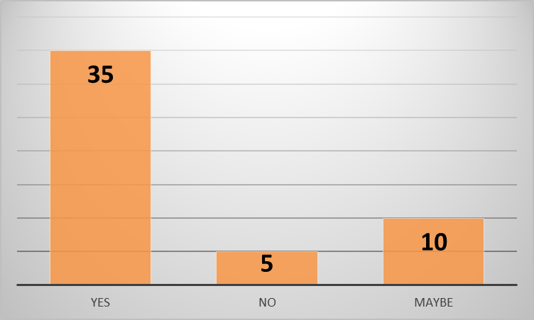
According to majority of the respondents, branding elements and promotional activities of business organizations get themselves attracted towards the products or services of the business. 35 students responded with a yes to the question. Only 5 respondents replied with a no because they do not think branding elements persuade them much for buying or purchasing their products or services. 10 of the students responded with a maybe because they think they sometimes get attracted to a specific product or service by the branding elements and promotional contents but not always. From the responses collected from the selected students for this research project, it is evident that, the branding activities of business organizations play a great role in attracting the customers and grabbing their attention towards the products or services of the business.

Question 2: Are the branding contents and activities of business organizations able to grab your attention and develop interest within yourself to know more about the brand and its products or services?
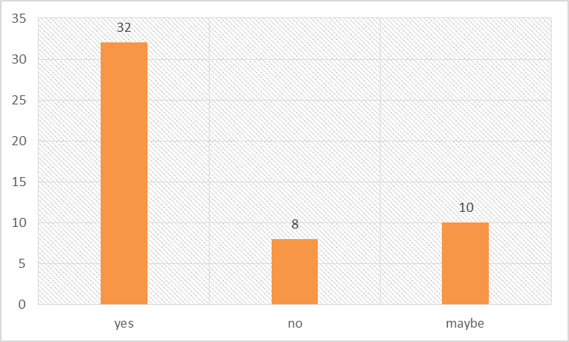
In the opinion of majority of the respondents, branding contents and elements of different business organizations develop interest and curiosity among them to know more information about the products and services of the brand. 32 of the students responded with a yes to this question whereas there were only 8 negative answers. In addition to that, 10 of the respondents replied with a maybe which represents that, they do not get curious or interested about the products or services of a business by the branding contents. From the responses collected for this specific question, it can be concluded that, majority of the customers are usually influenced and develop interests towards the products of a business through the branding contents and elements. Therefore, the brand retention rate of a business can be increased with effective and appropriate branding elements.

Question 3: Is the brand value highly important to you when it comes to buying a smartphone?

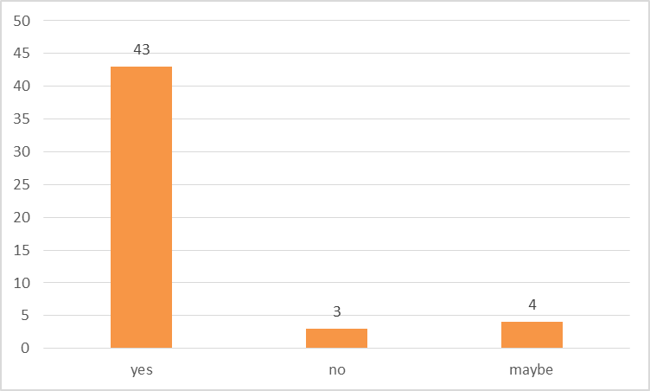
This question asked the students and respondents of the research project if the brand value is highly important to them while making purchasing decision of smartphones. Most of the students require smartphones for maintaining communication for personal and academic purpose, performing academic activities, viewing and editing academic documents etc. However, the brand value of the smartphones has become one of the most important aspects and factors while making a smartphone buying decision among students at current times because smartphones have become a status symbol and personality statement among young people and students as well. Majority of the students replied with a yes to this question and agreed that, brand value is very important for them for making smartphone purchasing decisions. There were only 3 negative responses and only 4 responses with a maybe to this question of the research project questionnaire.

Question 4: Does branding activities of smartphone brands successfully persuades you to purchase a specific smartphone?
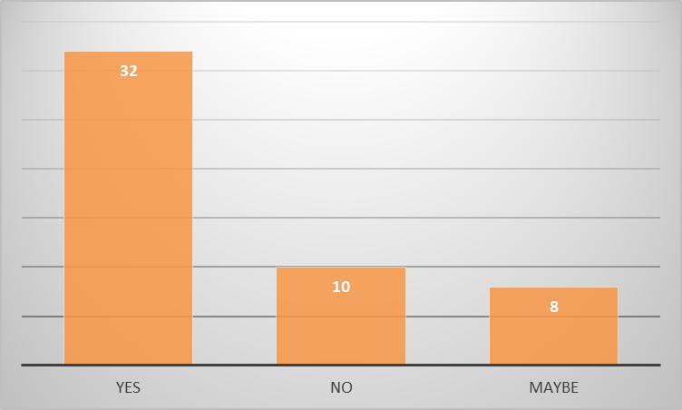
According to most of the students who participated in this research project, branding activities successfully persuade and motivate them to buy a specific brand of smartphones. There were 32 students who responded with a yes to this specific question and agreed that, branding activities strongly persuades them to buy the smartphones of that brand. There were 10 students who replied with a no and do not think that branding activities can always persuade them to buy the smartphones of a specific brand. There were 8 responses with a maybe because these students think that they sometimes get persuaded by branding elements of smartphone businesses and sometimes do not get influenced for making the final purchasing decision.

Question 5: Is brand value the major customer decision making driver for you while purchasing a smartphone?
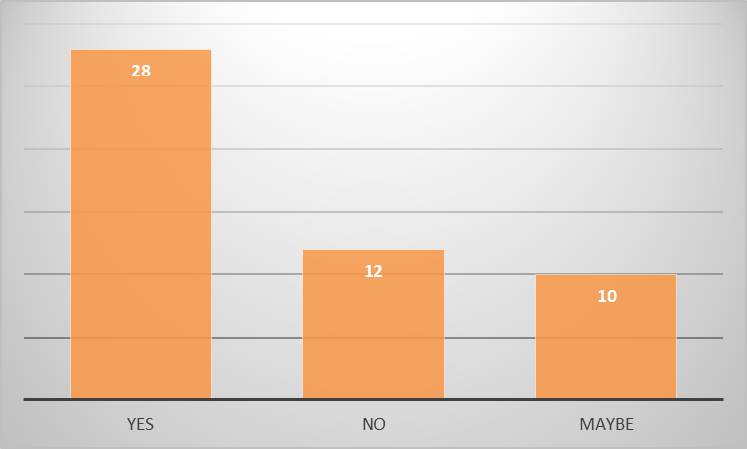
According to more than half of the respondents and students who participated in the primary data collection process of this research project, brand value is the major and most important driver of buying decision making for themselves while purchasing a smartphone. 28 of the respondents provided a positive response to this question and agreed that, the brand values of smartphone brands and businesses is the most important factor which is considered by them at the time of making decisions on which smartphone to buy for themselves. However, a noteworthy number of respondents replied with either a no or a maybe to this specific question which represents that, brand value is not the major purchasing decision making driver for themselves when it comes to buying a smartphone. They consider other important aspects such as the price, durability, longevity, performance, features and benefits, available applications, ongoing offers and discounts, compatibility and user friendliness along with several other aspects while making the decision of buying a smartphone for themselves. 12 respondents replied with a no and 10 others replied with a maybe to this question and presented their opinions that, brand value is not the major driver of the consumer decision making process of smartphones.

Question 6: Do you prefer Apple smartphones over Samsung smartphones because of higher brand value?
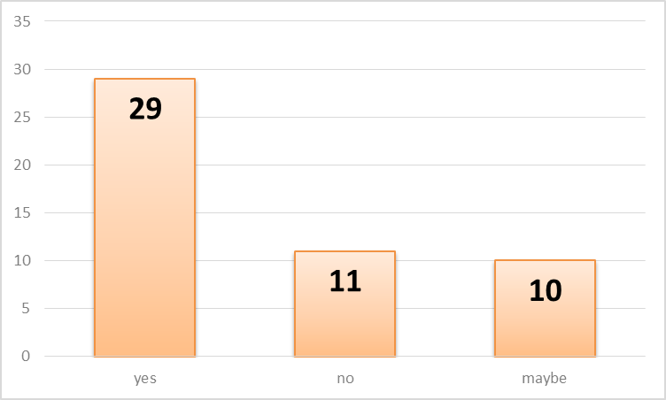
29 of the respondents replied with a yes to this question and said that, they prefer Apple smartphones more than Samsung smartphones because of the higher brand value. There were 11 students who replied with a no to this question and said that, they do not prefer Apple smartphones over Samsung smartphone because of the higher brand value and consider other important factors. There were 10 other respondents who replied with a maybe because they are not sure about the reason why they prefer Apple smartphones over Samsung and think that, there may be other factors and reasons why they prefer Apple smartphone more.

Question 7: Do you prefer Samsung smartphones over Apple smartphone because of user friendliness and compatibility?
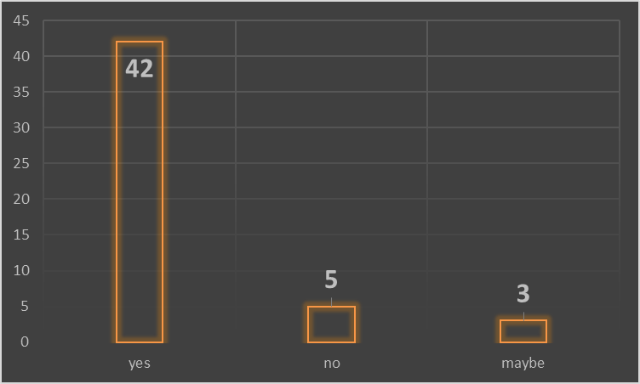
According to majority of the students, they prefer Samsung smartphones over Apple smartphones because they think that these are more compatible and user friendly for themselves. A total of 42 respondents replied with a yes to this question. There were only 5 negative responses and only 3 replies with a maybe to this question. These students do not think that they prefer Samsung smartphones over Apple smartphone because of the user friendliness and compatibility level. They either like Apple smartphones more or, like Samsung smartphones for several other reasons such as comparatively lower prices, higher availability and ease of using application required for performing academic activities and documents creation, editing and viewing regularly.

Chapter 6: Conclusion and recommendations
The completion of the research activities with desired efficiency and appropriateness depends highly on the selection of the right research methods and strategies. The successful implementation and utilization of effective research strategies and methods are crucial for assuring desired success from research projects. Thus, it is a great responsibility for the researchers to evaluate various different research strategies and methods in order to select and implement the most appropriate and effective ones in their respective research projects.
This research project was aimed to identify as well as understand the impacts and effects of branding on the consumer behavior based on the comparison between the preferences among students towards Apple and Samsung smartphones. In addition to that, the research project also has the objective of successfully identifying and understanding the effects of the branding activities and approaches of both Apple and Samsung smartphones on the student customer segments and to effectively identify which branding initiatives will be effective and appropriate for persuading students to buy smartphones of Samsung and Apple. The aims and objectives of the research project were successfully accomplished through the primary and secondary research activities. The primary research identified specific information regarding the preferences of the student customer segment, identified how their consumer decision making process is influenced and motivated by the branding activities and strategies of business organizations and also found out the drivers of the consumer buying decision among students when it comes to smartphone shopping. There were some limitations of the primary research as well because it collected information only from students in higher level education in the urban areas. Also, higher effectiveness from the primary research could be attained if some more questions were added in the questionnaire for primary data collection. A larger sample size could bring better results and findings on the research topic and questions as well. In addition to that, the secondary data of this research project collected information and developed a strong as well as clear understanding of the different concepts and strategies of customer buying behavior. Several effective strategies are recommended in this part of the research project for smartphone brands for performing their branding activities and approaches in a more efficient and successful way for accomplishing higher level of popularity, brand recognition, brand loyalty and brand retention rate among the target customers and especially to impress and persuade the student customer segments. It is imperative for the business organizations selling smartphones to develop in depth and updated knowledge about the target customers and market segments for developing appropriate and suitable branding and promotional contents for successfully communicating with and persuading these customers. Developing a strong unique value proposition is another highly required branding initiative by smartphone brands to develop a strong brand image and increase the popularity of the brand among the customers. Maintaining consistency in the branding and promotional activities is highly recommended for smartphone brands such as Apple and Samsung because consumers now a days have a lot of choices and brands available in market with different types of features and advantages as well as technologies. Maintaining consistency in the branding activities will prevent customers from getting confused while developing the buying decision. According to the primary data collected by this research project, the brand value is a very important factor for student customer segment at the time of deciding which smartphone brand they should select for themselves. According to the collected primary data of this research project, the price, user friendliness and features are other important factors which are considered with high level of sincerity by student customers while selecting smartphone brands.

Chapter 7: Further Research
Further research activities can be conducted to identify the effects of branding on the customer buying decisions in other different target markets such as professionals, senior citizens, business persons etc. In addition to that, the impacts of branding on the female and male customers and how each of these market segments react and respond to different branding activities and initiatives of business organizations selling smartphones can be identified and evaluated by further research activities. The positive and negative impacts of branding on sales revenue and popularity level of smartphone brands is another potential scope for further research as well.

Chapter 8: References and Bibliography
Aaker, D., 2004. Brand portfolio strategy. New York: Free Press.
Blythe, J., 2013. Consumer behaviour. London: SAGE.
Bong Na, W., Marshall, R. and Lane Keller, K., 1999. Measuring brand power: validating a model for optimizing brand equity. Journal of Product &amp; Brand Management, 8(3), pp.170-184.
Cameron, S. and Price, D., 2009. Business Research Methods. 1st ed. London: CIPD, pp.75-84.
Hair, J., Celsi, M., Money, A., Samouel, P. and Page, M., 2011. Essentials of business research methods. 2nd ed. Newyork: Routledge Taylor and Francis Group, pp.275-281.
Hoyer, W., MacInnis, D. and Pieters, R., 2018. Consumer Behavior. 7th ed. Boston: Cengage Learning.
Lapan, S., Quartaroli, M. and Riemer, F., 2012. Qualitative research. 1st ed. San Francisco, Calif: Jossey-Bass, pp.69-84.
Noel, H., 2009. Consumer behaviour. Lausanne, Switzerland: AVA Academia.
O’Donohoe, S., 2009. The King of Madison Avenue: David Ogilvy and the Making of Modern Advertising. International Journal of Advertising, 28(4), pp.742-743.
Saunders, M., Lewis, P. and Thornhill, A., 2016. Research methods for business students. 9th ed. Harlow (Essex): Pearson, pp.290-302.
Schiffman, L. and Wisenblit, J., 2010. Consumer behavior. 11th ed. Pearson Prentice Hall.
Solomon, B., 1985. AN ALTERNATIVE TO NEW PRODUCT DEVELOPMENT—BUSINESS PRODUCTS FOR CONSUMER MARKETS. Journal of Consumer Marketing, 2(1), pp.56-60.
Solomon, M., 2006. Consumer behaviour. Harlow, England: Financial Times/Prentice Hall.

