LEVEL 4 ASSESSMENT SPECIFICATION
Student name: | Sioned Hughes | Student ID number: | 2503173
Programme: | DA Program - BSC in Supply Chain and Logistics
Module: | Data Analytics Principles
Module code: | ACMA 4016 | Contribution to Overall Module Assessment (%): | 100%
Lecturer: | Dr Moutushi Tanha | Internal Verifier: | Dr Irina Neaga
Assignment Title: | Developing a Data-Based Report | Word count (or equivalent): | 1500 words
Submission deadline: | 01/03/2026 | Return date of provisional marks & written feedback: | 20 working days after submission
Submission method: | All written assessments, where practical and possible, must be submitted via Turnitin unless otherwise instructed by the Lecturer. (Please DO NOT put this assessment specification into Turnitin or it will match many similarities with other students’ submissions.)  Alternative submission method (if applicable):  Late submission of the assessment will result in a late penalty mark:  Work which is submitted up to 1 week late will be capped at 40% for the first attempt and will be awarded a mark of 0% for re-assessment. Late submission penalties may be lifted only if there is an approved extenuating circumstances claim.  Work submitted more than 1 week late will be considered as a non-submission and will not be marked. The work may be considered as a submission for reassessment if offered by an Examining Board or if there is an approved extenuating circumstances claim.
Academic honesty / referencing: | Academic honesty is required. In the main body of your submission you must give credit to authors on whose research and ideas your work is based. Append to your submission a reference list that indicates the books, articles, etc. that you have used, cited or quoted in order to complete this assessment.
 APPENDIX GA36a
Use of Generative AI in Assessment
(Lecturer to indicate Yes or Not against each element)
RESEARCH | For this assessment, you can use Generative AI to support you in research, including searching for bibliography, using tools to summarise, compare and interrogate materials. | Yes ☒  No ☐
STRUCTURE | For this assessment, you can use Generative AI to support you in structuring your submission, including creating a draft argument structure, identifying parts and headings, etc. | Yes ☒  No ☐
PROOFREADING | For this assessment, you can use Generative AI to check your own text/creation for grammatical and syntactical mistakes, including rephrasing of your own work within specific standards. | Yes ☒  No ☐
WRITING | For this assessment, you can use Generative AI to create text for submission. | Yes ☐  No ☒
CREATIVE | For this assessment, you can use Generative AI to create creative materials, such as images. | Yes ☐  No ☒
PROGRAMMING | For this assessment, you can use Generative AI to create and check code. | Yes ☐  No ☒
NONE | For this assessment, you are not allowed to use any type of Generative AI support. This includes research support, structure support, writing/proofreading support and creative support. | Yes ☐  No ☒

AI Acknowledgement
I confirm that I have not present any AI-generated materials as my own work in this portfolio.
However, I acknowledge that I have used or may have used the AI in the research and proofreading of my portfolio.
Name: Sioned Hughes
Student ID: 2503173
Table Of Contents:
1.0 Part 1: Supply Chain & Logistics Disruption Case: 4
1.1 Executive Summary 4
1.2 Introduction 4
1.3 Overview of the incident 5
1.4 Supply Chain Implementations 5
1.5 Understanding data for addressing the problem 6
1.6 Literature Review 7
1.7 Data Collection 9
1.8 Data Analysis 11
1.9 Discussion 13
1.10 Conclusion 13
1.11 References 14
2.0 Part 2 – Business Statistics over 5 years (2021 –2025) 15
2.1 Data collection (2021 –2025) 16
2.2 Descriptive Statistics 16
2.3 Year-wise Comparison & Discussion 18
2.4: Correlation & Regression 19
2.5: Charts 21
2.6: Gorry & Scott Morton 3x3 Decision Matrix 22

Word Count – 1534 words (excluding cover page, table of contents, acknowledgement, executive summary, diagrams, pictures, references, tables, graphs, bibliography, and appendix).

1.0 Part 1: Supply Chain & Logistics Disruption Case:

1.1 Executive Summary
Thomas Plant Hire Ltd suffered a major logistical challenge when one of its wagons and trailers broke down while returning to the Holywell depot from South Wales. This incident disrupted operations, affected transport schedules, increased costs, and required urgent resources. The company resolved the issue through a data-driven decision process that minimised downtime to four days but resulted in increased operational expenditure due to emergency procurement and labour reallocation. The findings in this report highlight the financial and operational implications of reactive maintenance and demonstrate the importance of preventative planning and supply chain responsiveness.
In conclusion, the literature highlights that downtime duration, repair costs, transport expenses, parts lead time and operational impact are key variables in assessing logistics disruptions. These factors are directly related to the Thomas Plant Hire Ltd incident, where mechanical failure created operational delays, increased costs and required urgent decision-making to restore transport capability and efficiency.
These theoretical perspectives provide a framework for analysing the operational and financial consequences of the incident examined in the report.
Several key variables were considered during the analysis of this incident:
Key Variable | Reasoning
Downtime Duration | Length of time the wagon was off the road.
Repair costs | Parts and Labour
Transport & Travel Costs | Recovery of wagon or travel costs for fitter.
Replacement lead time on parts (hours/days) | Time taken to source required parts.
Impact on operations & deliveries | Number of delayed or cancelled hires.

By assessing these variables, the financial and operational impact of this incident can be clearly identified.

1.7 Data Collection
The data used in this report were obtained from internal operational records of Thomas Plant Hire Ltd, including maintenance logs, transport records and supplier quotations collected during the incident period (Thomas Plant Hire Ltd internal data, 2025)
Reviewing these records enabled comprehensive coverage of operational and financial factors. However, the analysis is limited due to reliance on internal reporting accuracy and availability of historical maintenance data. The internal operational data provides contextual accuracy; however, potential reporting inconsistencies may affect analytical precision.
1: Supplier Quotes
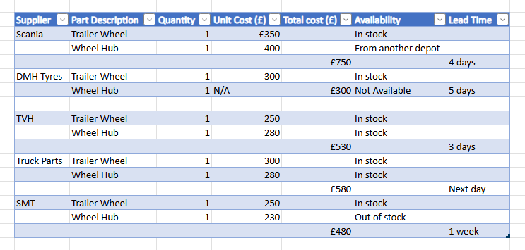
2: Labour & Travel Logs
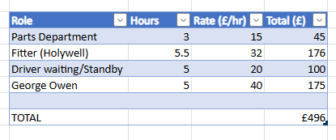

3: Transport Logs
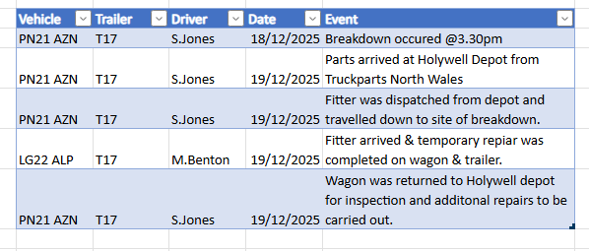
4: Hire Logs
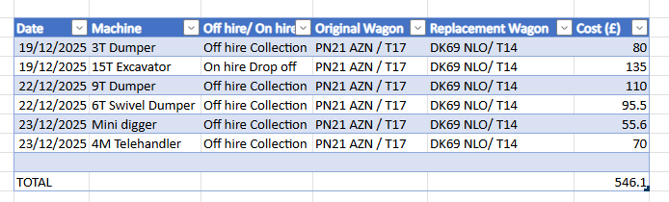
5: Breakdown Records
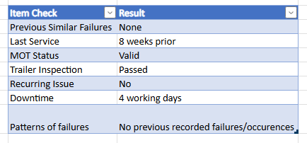
6: Cost Summary
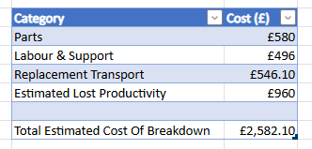

1.8 Data Analysis
These reports have been created based on the realistic daily operations of the business surrounding the time the incident occurred. From these reports collected, the analysis indicates that the disruption generated measurable additional operational expenditure and reduced transport capacity over a four-day period.
Supplier quotation data shows that, under normal circumstances, multiple suppliers offered adequate availability and competitive pricing. However, the requirement to mobilise the wagon and trailer the following day necessitated emergency sourcing from a higher-cost supplier. This highlights the financial impact of time-critical procurement, where reduced supplier flexibility leads to increased short-term expenditure.
Labour and travel data enabled full cost attribution, allowing the total financial impact of reactive maintenance to be quantified. This provides a clearer understanding of how indirect costs, such as staff time and additional travel, contribute to the overall cost of disruption.
Collecting the driver transport logs was important as we were able to assess whether any operational factors may have contributed to the issue to evolve and how this could be prevented in the future.
Analysis of driver transport logs was critical in assessing whether operational factors may have contributed to the development of the issue. This data supported evaluation of potential causative patterns and informed recommendations for preventative measures to reduce the likelihood of recurrence.
Hire log analysis enabled assessment of service disruption, facilitating evaluation of customer impact and the operational rescheduling required to maintain service continuity.
Breakdown records were reviewed to identify any recurring faults that may indicate underlying maintenance issues. This ensured that the wagon and trailer were receiving appropriate inspections and servicing to maintain asset reliability.

The cost summary captures both direct and indirect expenses, providing a comprehensive assessment of the disruption’s financial impact and supporting informed decision-making and risk-reduction strategies.
This analysis is based on short-term operational data from a single incident, which limits generalisability. Incorporating long-term maintenance trends and comparative breakdown frequency data would provide stronger predictive insight into operational risk.

1.9 Discussion
From the data created relating to the incident, the analysis shows that immediate corrective action was required to minimise operational downtime and service disruption. Therefore, the need for rapid repair increased procurement and labour costs, illustrating the economic consequences of reactive rather than preventive maintenance strategies. Increased labour and travel expenses reflect resource reallocation pressures that commonly arise during operational disruptions. Immediate action was required to reduce vehicle downtime, as prolonged disruption would have resulted in delayed deliveries and revenue loss. In addition to this, increased downtime of the vehicle could have caused an increase in safety and compliance risks and negatively impacted the company's reputation based on reliability and availability.
Finally, the analysis demonstrates that systematic data collection supports organisational learning and enables development of preventative strategies to reduce future disruption risk.

1.10 Conclusion
In conclusion, the data obtained from these reports indicates no evidence of recurring mechanical failure, suggesting the incident was isolated rather than systemic. Furthermore, it supports the statement that the incident was unforeseen and not due to a lack of servicing. This breakdown caused significant challenges to the logistics operations of the company. The data-driven response enabled efficient decision-making, minimised service disruption, and provided insight into cost drivers associated with reactive maintenance.
The incident has revealed the importance of preventative maintenance planning, spare-parts availability, and rapid information access in maintaining supply chain resilience. In addition, the findings highlight the value of improved contingency planning and supplier flexibility to mitigate the operational and financial impact of future unplanned disruptions. Implementing proactive monitoring systems and structured maintenance scheduling could further reduce operational risk and enhance long-term operational reliability.

1.11 References
- Bowersox, D., Closs D. and Cooper, M (2013) Supply Chain Logistics Management. 4th edition. New York: McGraw-Hill.
- Chopra, S. and Meindl, P. (2019) Supply Chain Management: Strategy, Planning and Operation. 7th edition. Harlow: Pearson.
- Christopher, M. (2016) Logistics and Supply Chain Management. 5th edition. Harlow: Pearson
- Hopp, W. and Spearman, M. (2011) Factory Physics. 3rd edition. Long Grove: Waveland Press.
- Ivanov, D. (2020) ‘Predicting the impacts of epidemic outbreaks on global supply chains’, Transportation Research Part E, 136.
- Mobley, R. (2002) An introduction to Predictive Maintenance. 2nd edition. Oxford: Butterworth-Heinemann.
- Thomas Plant Hire Ltd (2025) Internal operational and maintenance records. Company database.
- Wireman, T. (2004) Total Productive Maintenance: New York: Industrial Press

2.0 Part 2 – Business Statistics over 5 years (2021 –2025)
Below is an overview of sales figures, cost figures of goods sold, promotional expenses and administrative expenses over 5 years from Thomas Plant Hire Ltd. The data below provides insight into how the business operates and how the company generates revenue every year.
Thomas Plant Hire Ltd operates on a 30% uplift on all of their products to account for the promotional and administrative expenses. This is to ensure that all costs incurred are covered.
Below are the files used to create this data:
Purchases and Adjustments 01Jan20 to 02Feb26.xlsx
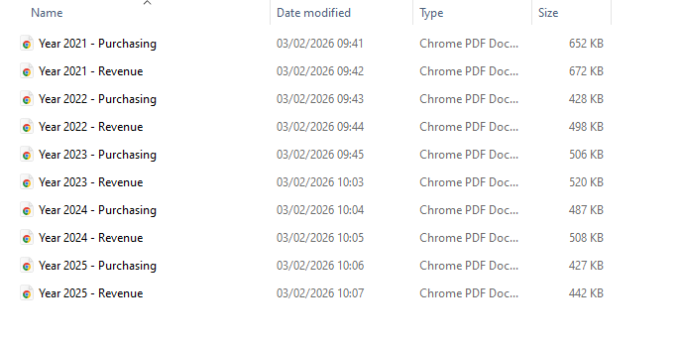

2.1 Data collection (2021 –2025)
Year | Purchasing (£) | Revenue (£)
2021 | 361,183.81 | 467,237.13
2022 | 183,411.24 | 235,617.19
2023 | 184,097.29 | 235,574.19
2024 | 251,416.80 | 325,556.50
2025 | 169,918.27 | 218,984.92

2.2 Descriptive Statistics
Purchasing Costs (2021-2025)
- Mean: £230,005.48
- Median: £184,097.29
- Mode: None
- Variance: High (£6,388,809,551.86)
- Standard Deviation: £79,930.03 (square root of 6,388,809,551.86)
Variance:
Year | Value (£) | Value – mean
2021 | 361,183.81 | + 131,178.33
2022 | 183,411.24 | -46,594.24
2023 | 184,097.29 | -45,908.19
2024 | 251,416.80 | +21,411.32
2025 | 169,918.27 | -60,087.21
Squared Difference:
Year | Difference | Squared Difference (£)
2021 | + 131,178.33 | 17,207,754,261.59
2022 | -46,594.24 | 2,171,004,604.82
2023 | -45,908.19 | 2,107,572,017.12
2024 | +21,411.32 | 458,444,356.38
2025 | -60,087.21 | 3,610,474,922.78
Total |  | 25,555,238,207.43

Calculating Variance:
25,555,238,207.43 ÷ 4 = 6,388,809,551.86
Revenue (2021-2025)
- Mean: £296,593.99
- Median: £235,617.19
- Mode: None
- Variance: High (£10,855,643,147.300
- Standard Deviation: £104,190.39 (square root of 10,855,643,147.30)
Variance:
Year | Value (£) | Value – mean
2021 | 467,237.13 | +170,643.14
2022 | 235,617.19 | -60,976.80
2023 | 235,574.19 | -61,019.80
2024 | 325,556.50 | +28,962.51
2025 | 218,984.92 | -77,609.07

Squared Difference:
Year | Difference | Squared Difference (£)
2021 | +170,643.14 | 29,118,989,332.18
2022 | -60,976.80 | 3,718,172,682.24
2023 | -61,019.80 | 3,723,415,841.44
2024 | +28,962.51 | 838,826,734.00
2025 | -77,609.07 | 6,023,167,999.32
Total |  | 43,422,572,589.18

Calculating Variance:
43,422,572,589.18 ÷ 4 = 10,855,643,147.30

2.3 Year-wise Comparison & Discussion
From the data pulled, we are able to see that the revenue exceeds the purchasing costs over the last 5 years which supports that the 30% uplift strategy is effective for this business.
In addition to this, we also notice that 2021 stands out as the purchasing and revenue year. One could argue that this is because of the major fleet investment and maintenance, as well as increased demand of machinery after the Covid-19 pandemic.
From 2022 onwards, the purchasing and revenue costs stabilise which could suggest an improvement in forecasting, better control over fleet maintenance and a more structured operational demand for machinery.
In conclusion, this data shows that Thomas Plant Hire Ltd demonstrates financial consistency and cost control over the last 5 years.

2.4: Correlation & Regression
The Data (2021-2025)
Year | Purchasing (x) | Revenue (Y)
2021 | 361,183.81 | 467,237.13
2022 | 183,411.24 | 235,617.19
2023 | 184,097.29 | 235,574.19
2024 | 251,416.80 | 325,556.50
2025 | 169,918.27 | 218,984.92
Mean Purchasing (x) = £230,005.48
Mean Revenue (Y) = £296,593.99

Correlation:
Calculate deviations from the mean:
Year | X – X | Y - Y
2021 | + 131,178.33 | +170,643.14
2022 | -46,594.24 | -60,976.80
2023 | -45,908.19 | -61,019.80
2024 | +21,411.32 | +28,962.51
2025 | -60,087.21 | -77,609.07

Multiply deviations (X – X) (Y-Y)
Year | Product
2021 | 22,384,682,131
2022 | 2,841,167,653.60
2023 | 2,801,308,572.20
2024 | 620,125,569.61
2025 | 4,663,312,487
Total | 33,310,596,413

Step 4:
25,555,238,207.43 x 43,422,572,589.18 = 1.109 x 10(21)
1.109 x 10(21) = 33,304,950,000
Step 5:
r = 33,310,596,413 ÷ 33,304,950,000 = 0.999
Analysis:
There is a strong positive relationship and correlation between purchasing costs and revenue. This means that as the purchasing costs increase, the revenue costs also increase proportionally. This result is expected in a heavy plant hire company as machinery demand increases income.
Regression:
Formula Y = a+bX
B = Slope
A = Intercept

Step 2: Calculate slope (b)
b = 33,310,596,413 ÷ 25,555,238,207.43 = 1.30
Step 3: Calculate the intercept (a)
a = Y – bX
a= 296,593.99 - (1.30 x 230,005.48)
a= -2,414
Revenue = -2,414 + 1.30X = 301,421.124

Analysis:
Revenue values can be assessed accordingly due to the purchasing costs of the company. This is because it reflects the recovery of promotional and administrative expenses through the 30% uplift on products sold to customers.
In conclusion, this shows that the company's strategy of using the 30% uplift pricing model is predictable and sustainable for both purchasing costs and revenue expectations.

2.5: Charts
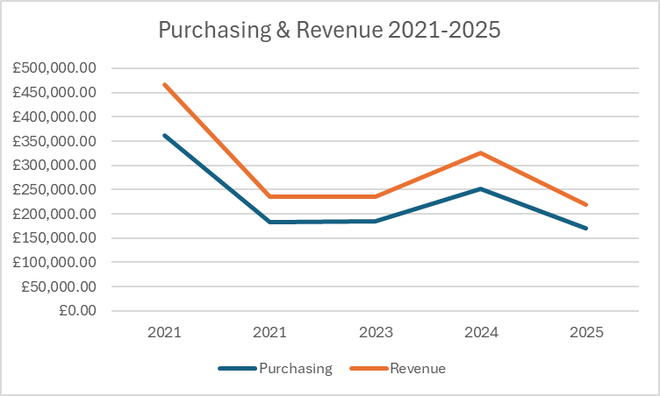
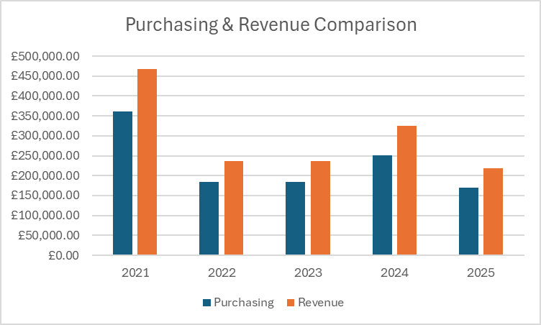

2.6: Gorry & Scott Morton 3x3 Decision Matrix
Management Level | Structured (Routine, rule-based) | Semi-structured (Some judgement) | Unstructured (High judgement)
Operational | Scheduling plant machinery maintenance based on usage levels and demand between 2022 –2023. | Adjusting weekly hire availability in line with customer demand. | Responding to unexpected breakdowns and repairs of equipment during peak periods.
Managerial | Monthly monitoring of purchasing and revenue figures in correlation with the 30% uplift rule. | Assessing annual purchasing structures based on the 2021 expenditure spike compared to other years. | Assessing supplier contracts and costs based on purchasing costs of parts over the years.
Strategic | Annual financial performance assessed from 2021-2025 data. | Planning fleet expansion based on demand over the years and revenue recovery. | Long -term business growth decisions, such as expansion to new locations and fleet enlargement.

Operational Level
- Stable purchasing throughout 2022-2023 supports the routine maintenance scheduling of machinery.
- These decisions are highly structured and repetitive.

Managerial Level:
- Historical trends indicate that the 2021 expenditure spike prompted the need for a budget review.
- Judgement is created when adjusting purchasing volumes, pricing and suppliers.
Strategic Level:
- From the data pulled, we can assess long term suggestions to support investment and expansion planning.
- These decisions are uncertain and unstructured due to the constant change in the business and relying on customers for revenue.

