
Swansea University 2020: Utilising the PESTLE analysis framework for the purposes of horizon scanning in corporate and HR strategic planning

Rebecca Griffiths
1710889
Word Count: 2193

Executive Summary
The contemporary business environment is considered volatile, uncertain, complex and ambiguous (VUCA), this is a consequence of globalisation; technological developments; demographic change; consumer predilections and global trends (CIPD, 2014; CIPD, 2018c). In order to prosper in this challenging and aggressive organisational environment, businesses must conduct effective risk analyses to remain competitive and inform future strategic direction.
A PESTLE (Political, Economic, Technological, Legal and Environmental) analysis is one such way in which organisations can forecast future threats and opportunities, which the external environment may present. Solely conducting a PESTLE analysis for this purpose has its limitations and challenged, therefore organisations should adopt a blended approach to risk analysis. A PESTLE analysis highlighted that Technology, BREXIT and demographic trends have a potential to impact future strategic direction at Swansea University (SU). As such SU should consider these trends when assessing their strategic direction.

Contents
Executive Summary

- Introduction
  - Swansea University 3
  - Rationale 4
- Discussion
  - Definitions 5
  - PESTLE Analysis 8
  - Technology 10
  - BREXIT 11
  - Demographic Trends 12

- Conclusion & Recommendations 14
- References 15
List of Figures

Figure 1: Swansea University’s Mission Statement (Swansea University, 2015).
Figure 2: The rational approach to strategy (Farnham, 2015).
Figure 3: Approaches to HR Strategy, best practice, best fit and resourced-based view (Farnham, 2015).
Figure 4. Porter’s Five Forces Framework (Grundy, 2006).
Figure 5. Potential SU HR strategic involvement due to technological change.
Appendices

AP 001: SU HR Organisational Chart
AP 002: PESTLE
- Introduction

  - Swansea University

SU is a research-led University, which offers the “right balance between excellent teaching and research, matched by an enviable quality of life” (Swansea University, 2019a). As Swansea University propels towards its centenary year (2020) it has reaffirmed its mission to “compete successfully with the traditional ‘elite’ Universities” (Swansea University, 2015). A predominant way in which SU proposes to complete with the elite is by “providing an outstanding academic environment with a balance of excellence between world-class teaching and research, driving impact that is enabled by effective regional and global collaborations” (Swansea University, 2015).

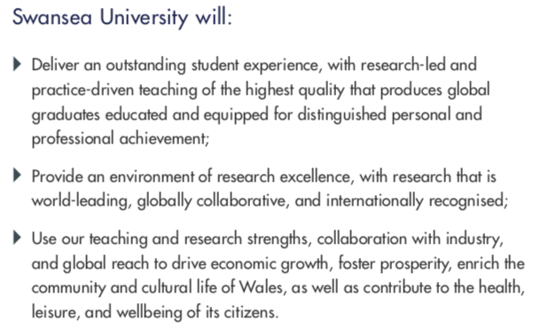
Figure 1. Swansea University’s Mission Statement (Swansea University, 2015).

As a third sector organisation (TSO), SU is governed by its board of trustees working with the Vice Chancellor (elect), Pro Vice Chancellors, staff and stakeholders to ensure that that the University’s objectives are met. SU’s HR function operates using the business-partnering model with centres of excellence in order to support corporate strategy (AP 001).

  - Rational

This report offers a critical examination of utilising the PESTLE analysis framework for the purpose of analysing the managerial and business environment in corporate and HR strategic planning at SU. The rational for the research is the unprecedented rate of change in the contemporary market. In order for organisations to remain competitive, it is imperative that they are able to respond efficiently and effectively to the pace of change (CIPD, 2014; CIPD, 2018c).

Today’s operating environment is considered VUCA, the result is an operating environment, which is constantly evolving, with the pace of change increasing the rate at which organisations needs to respond effectively and efficiently (Bruce, 2018; CIPD, 2014; Deloitte, 2013). In order to remain competitive in this challenging and dynamic environment, organisations must demonstrate effective horizon scanning to remain competitive with HR leaders leading a prominent role (CIPD, 2019b; Currence, 2018; Farnham, 2015).

In terms of organisational and HR Strategy, there is an increasing demand that an organisations people strategy simulate the overarching business strategy. As a result of today’s complex operating environment, TSO HR practices have developed a convergence to public and for-profit organisations due to funding pressures, and the need to be competitive (Baluch, 2012).

2. Discussion

2.1 Definitions

Defining HR is problematic as there is no universally agreed definition. Farnham (2015) explains that the HR function and thereby its definition are contingent on the organisation which changes over time, steered by the context of the age. Contemporary definitions of HRM refer to an evolution from traditional personnel management to a distinctive approach and philosophy towards key people orientated objectives to seek a competitive advantage (Beardwell and Claydon, 2010; Farnham, 2015; Guest; 1987; Storey, 2007).

A distinguishing feature between traditional and contemporary HRM is the contribution to strategic development and implementation (Beardwell and Claydon, 2010). Whilst it is agreed that HR strategy is not new in management practice (Farnham, 2015; Kaufman, 2001; Storey, 2007; Thomason, 1991 as cited in Farnham, 2015), there is consensus that appropriately designed and implemented HR strategy can influence business success (Armstrong, 2003; Beardwell and Claydon, 2010; Brown, 2015; CIPD, 2019b; Storey, 2007; Ulrich et al., 2015).

Corporate Strategy
Similar to the literary debate amongst academics as to the true definition and nature of HRM, defining each facet of strategic development is challenging and not within the scope of this report. Simply, strategy can be interpreted as an approach (rational, emergent or incremental) where organisations conduct various analyses to inform strategic direction and formulation of strategy to achieve organisational objectives (Beardwell and Claydon, 2010; Farnham, 2015). At SU, the current strategic direction is intentional, structured and implemented from the top down and can therefore be described as rational (figure 2).

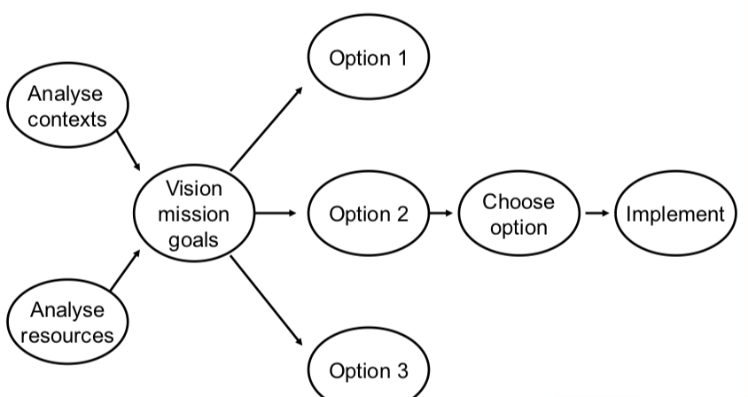
Figure 2. The rational approach to strategy (Farnham, 2015).

HR Strategy
Much of the literature concerned with HR strategy is focused on the strategic integration of corporate and HR strategy through approaches, theoretical frameworks and models (Armstrong, 2003; Beardwell and Claydon, 2010; Farnham, 2015).

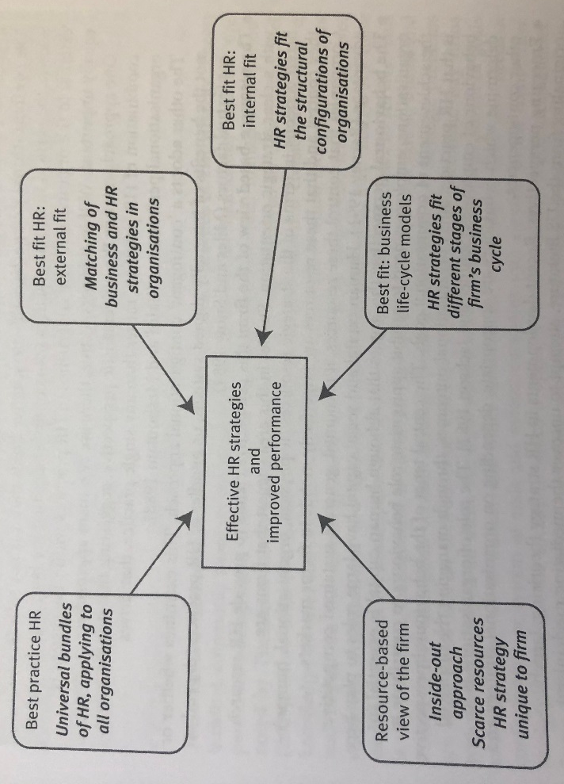
Figure 3. Approaches to HR Strategy, best practice, best fit and resourced-based view (Farnham, 2015).

The models, theories and approaches are underpinned by the idea that any HR strategy is vertically aligned with the business strategy and the external context in which the organisation operates (figure 3). Horizontal integration refers to the alignment of the varying dimensions of the HR function including its policies and practices, and is a feature of strategic HRM. At SU, the HR strategic can be categorised as the best-fit approach.

The rational of this report has highlighted the complexity of the contemporary operating environment, with many of the complex issues managed by HR (The Access Group, 2018). To react accordingly and inform corporate and HR strategy, HR leaders are required to conduct a number of analyses of the external forces with the potential to impact the organisations position within the market.
2.2 PESTLE Analysis

A PESTLE analysis is a framework used to assess the key external factors, which have the potential to influence organisational corporate and HR strategy. The CIPD (2018a) explain that the PESTLE analysis is one of the most effective frameworks due to its simplicity and flexibility. Practitioners who use the PESTLE framework can hope to understand the wider business environment by developing their strategic thinking. Strategic thinking will enable organisations to anticipate future threats and respond efficiently and accordingly. Conducting a PESTLE can also result in organisations monopolising on key business opportunities. Limitations of the PESTLE analysis framework correspond with the simplicity of the data used in the decision making with the potential to result in ill-informed strategies (CIPD, 2018a). There is also a threat that because interdependent relationships coexist between the elements of the framework too much data can contribute to an ‘endless evaluation’ of the external factors (Sammut-Bonnici and Galea, 2014). Due to the pace of change, the longevity of the analysis will also be limited, therefore, a PESTLE analysis should be conducted on a regular basis. It is further recommended that practitioners conduct the PESTLE analysis collaboratively to gain multiple perspectives in order to yield more reliable results (CIPD, 2018a).

In order to compensate for the limitations of the PESTLE framework, the literature suggests that HR practitioners use complementary strategy formulators such as SWOT and/or Porter’s Five Forces framework (CIPD, 2018b, Dobbs, 2014; Grundy, 2006). Briefly, due to word constraints, SWOT is the acronym for Strengths, Weaknesses, Opportunities and Threats. Like PESTLE, these factors form a framework of analysis for strategic planning and decision-making. Unlike PESTLE, the SWOT framework requires an internal analysis of the strengths and weaknesses of the organisation. According to MindTools (2019) the SWOT and PESTLE framework complement one another with SWOT focusing on the internal organisational position and PESTLE assessing the ‘bigger picture’. Combining the analysis can inform further development and strategic direction. A third strategic analysis (figure 4) tool is Porter’s Five Forces (PFF).
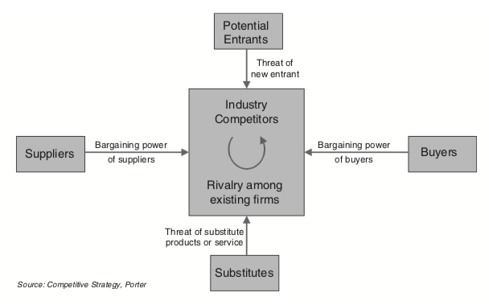
Figure 4. Porter’s Five Forces Framework (Grundy, 2006).
According to Porter (1980 as cited in Dobbs, 2014) “the collective strength of the forces determines the ultimate profit potential in the industry.” Grundy (2006) suggests that the five forces are interdependent to other strategy formulators and can be “developed into a more comprehensive and coherent strategy” (pp. 216). Utilising PFF in relation to TSO’s however poses some challenges. Brown (2015) argues that PFF as an analysis framework is primarily concerned with competitiveness and profitability, which has the potential to negate key organisational performance metrics, particularly in TSO’s.
A PESTLE analysis was conducted for the purpose of this report, with technological change, BREXIT and demographic trends highlighted as potential aggregators to strategic direction.

2.2 Technological Change
The potential impact of technological advancement on the future world of work is a topic widely discussed in the literature. Opposing arguments range from a ‘utopian’ worldview where automation allows humanity to live freely to an alternative view where working lives are at risk with robots taking over a substantial amount of jobs (CIPD, 2019d). The global debate concerning the extent to which technology will continue to shape the world of work highlights that organisational leaders need to prioritise the topic on their strategic agenda (CIPD, 2017; CIPD, 2019c; CIPD, 2019d; Deloitte, 2013; Schwartz, J. et al., 2017). A CIPD research (2019d) suggests that employer decisions will shape the future world of work and thus the rational for placing “HR – and an effective people strategy… at the heart of decisions on integrating AI and automation with the world of work” (pp. 2).

From an organisational perspective, technology has the potential to ignite extensive change in Higher Education Institutions (HEI’s). In order to remain competitive and recruit students, universities need to demonstrate that they are up to date with the latest tech (University Business, 2019). Virtual learning environments (VLE’s) and MOOCs mean that students can access education globally and 24/7 resulting in a HEI market that is more competitive than ever.
From a HR perspective, a review of the literature highlighted a number of areas where HR should be involved in the formulation of corporate and HR strategies concerning technological change (figure 5).
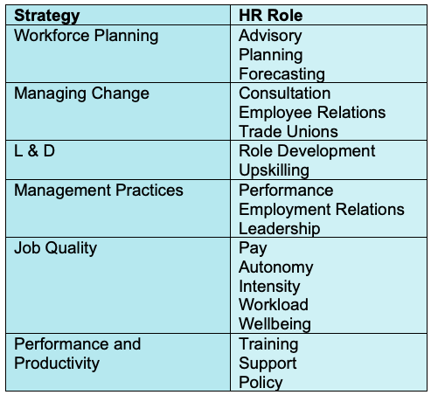
Figure 5. Potential SU HR strategic involvement due to technological change.
2.3 BREXIT
There are approximately 438,000 international students enrolled at UK HEI’s, equating to 19% as an overall percentage (Beech, 2018a). This not only results in a significant amount of student tuition fees but benefits the UK and its organisations (HEFCE, 2017; HEPI, 2018; Levent, 2016). The persistent growth of international students in the UK is subject to government policy. The current political climate in the UK is turbulent; this is because of BREXIT exacerbated by difficulties in agreeing a deal. Political instability has the potential to negatively affect student recruitment in the UK.
The threat BREXIT poses on SU’s rational organisational strategy is such that the current objectives may not be met as a result of barriers introduced my government policy. HR strategy will also need to evolve in response due to its alignment with corporate strategy.
2.4 Demographic Trends
Demographic trends are high on the agenda at most UK HEI’s. In the six years between 2010 and 2016 there has been a significant decline of 18 years olds in the UK (coined the demographic dip) resulting in an ever competitive recruitment market (Beech and Bekhradnia, 2018). Whilst the demographic dip is due to halt in 2019 however there are other demographic trends to consider. A second trend is that more 18 year olds are enrolling at University immediately after completing their level 3 qualifications (Beech and Bekhradnia, 2018). This trend is highlighted by the 0.5% decrease in 19 year old and older admission in 2017 (HESA, 2018).
From an employment perspective, demographic trends have the potential to influence the retention and recruitment of employees. The contemporary labour market has been coined ‘the multi-generation workforce’, highlighting the potential for various generations working alongside one another. This can be attributed to:
- healthy life expectancy - UK statistics from 2008 to 2012 indicate that people are healthier for an additional 2 years with the potential to work longer (Flynn, et al. 2012). The ONS (2018) has predicted that a quarter of residents in the UK will be 65 within the next 50 years.
- decrease in birth rates - Whilst the UK birth rates have reduces, the comparable death rates have also reduces indicating that mankind are living and potentially working for longer (Flynn, 2012; ONS, 2019a).
Demographic trends have in recent years had a measurable impact at SU. Due to the demographic dip, SU need to make a saving/generate more income to the value of £11.2 million to ensure financial performance. This begs the question that had this threat been appropriately assessed and strategy developed in response then perhaps this shortfall could have been incrementally rectified in previous years. HR at SU can be impacted directly and indirectly by demographic trends. Student numbers will indirectly affect HR workforce planning, l&d, change management and management practices such as performance. The demographic trends affecting employees at SU and of course the labour market have a direct impact on HR strategy indicating need for contributions to overall strategy.

4. Conclusion & Recommendations
SU like all organisations is operating in a VUCA environment, this poses significant challenges due to a number of external factors. The pace of change as a result of these factors means that the senior management team including its HR leaders should work collaboratively when analysing trends that have the potential to influence organisation and HR strategic direction (CIPD, 2018c).

Recommendation 1
- Working groups to include senior members of staff, HR Business Partners, administrative staff, legal team and students to cumulative methods of analyses assigned to particular areas of concern and in assessment of the organisational overarching strategy (Farnham, 2015).
- Consider operating a hybrid strategic approach, which allows for deflection and emergent strategies based on the findings of the collaborative analyses.

A PESTLE analysis has highlighted that SU is susceptible to change as a result of technological advancement, BREXIT and demographic trends. These trends have the potential to influence SU’s strategic direction due to opportunities and threats.
Recommendation 2
- A strategic network perspective focus, working collaboratively with partnering organisations to develop knowledge of the wider contexts of threats and opportunities (Beech, 2018b).

References
Armstrong, M. and Baron, A. (2003) Strategic HRM: The key to improved business performance. London: CIPD.

Baluch, A. (2012) Human Resources Management in Nonprofit Organizations. Abingdon: Routledge.

Beardwell, J. and Claydon, T. (2010) Human Resources Management: A Contemporary Approach. Harlow: Pearson Education Limited.

Beech, D. (2018a) ‘Higher Education in Brexit Britain: A Changing Future for International Students in the UK’, Higher Education Policy Institute [Blog]. 21 Feb. Available at: https://www.hepi.ac.uk/2018/02/21/higher-education-brexit-britain-changing-future-international-students-uk/ (Accessed: 11 November 2019).

Beech, D. (2018b) ‘Change is Coming: How Universities Can Navigate Through Turbulent Political Times’, Higher Education Policy Institute. HEPI Policy Note 7. Available at: https://www.hepi.ac.uk/wp-conteMnt/uploads/2018/06/Policy-Note-7-Paper-June-2018-2.pdf (Accessed: 18 October 2019).

Beech, D. and Bekhradnia, B. (2018) ‘Demand for Higher Education to 2030’, Higher Education Policy Institute. HEPI Report 105. Available at: https://www.hepi.ac.uk/wp-content/uploads/2018/03/HEPI-Demand-for-Higher-Education-to-2030-Report-105-FINAL.pdf (Accessed: 15 November 2019).

Bennett, N. and Lemoine, J. (2014) ‘What VUCA Really Means for You.’ Harvard Business Review. Available at: https://hbr.org/2014/01/what-vuca-really-means-for-you (Accessed: 16 October 2019).

Brown, W. (2015) Strategic Management in Nonprofit Organizations. Burlington: Jones & Bartlett Learning.

Bruce, J. (2018) ‘Change Is The New Normal. How Will You Handle It?’, Forbes. Available at: https://www.forbes.com/sites/janbruce/2018/09/05/change-is-the-new-normal-how-will-you-handle-it/#28e310613959 (Accessed: 16 October 2019).

CIPD (2005) HR Strategy: Creating the framework for successful people management. London: CIPD.

CIPD (2014) HR: Getting Smart About Agile Working. Available at: https://www.cipd.co.uk/Images/hr-getting-smart-agile-working_2014_tcm18-14105.pdf (Accessed: 28 October 2019).

CIPD (2017) The impact artificial intelligence, robotics and automation technologies on work. London: CIPD. Available at: https://www.cipd.co.uk/Images/impact-of-artificial-intelliegnce-exec-summary_tcm18-33882.pdf (Accessed: 12 November 2019).

CIPD (2018a) PESTLE Analysis. Available at: https://www.cipd.co.uk/knowledge/strategy/organisational-development/pestle-analysis-factsheet (Accessed: 15 October 2019).

CIPD (2018b) SWOT Analysis. Available at: https://www.cipd.co.uk/knowledge/strategy/organisational-development/swot-analysis-factsheet (Accessed: 09 November 2019)

CIPD (2018c) 21st Century Workforces and Workplaces. Available at: https://www.cipd.co.uk/news-views/changing-work-views/future-work/thought-pieces/21st-century-workforce-workplaces (Accessed: 17 October 2019).

CIPD (2019a) Workforce Trends. Available at: https://www.cipd.co.uk/knowledge/work/trends (Accessed: 12 October 2019).

CIPD (2019b) Strategic Human Resources Management. Available at: https://www.cipd.co.uk/knowledge/strategy/hr/strategic-hrm-factsheet (Accessed: 29 October 2019).
CIPD (2019c) Artificial Intelligence and Automation in the Workplace. Available at: https://www.cipd.co.uk/knowledge/work/technology/emerging-future-work-factsheet (Accessed: 16 November 2019).

CIPD (2019d) People and Machines: from hype to reality. Available at: https://www.cipd.co.uk/Images/people-and-machines-report-1_tcm18-56970.pdf (Accessed: 12 November 2019).

Craigmiller, J. (2018) ‘A Changing Landscape – The Past, Present and Future of HR’, HR Gazette. Available at: https://hr-gazette.com/a-changing-landscape-the-past-present-and-future-of-hr/ (Accessed: 29 October 2019).
Crittenden, W. and Crittenden, V. (1997) ‘Strategic Planning in Third-Sector Organizations’, Journal of Managerial Issues, 9(1), pp. 86 – 103.
Crittenden, W. and Crittenden, V. (2000) ‘Relationships between organizational characteristics and strategic planning processes in nonprofit organizations: JMI JMI’, Journal of Managerial Issues, 12(2), pp. 150-168. Available at: https://search.proquest.com/docview/194165839?accountid=14680 (Accessed: 09 November 2019).

Currence, J. (2018) ‘LOOK OUTWARD: Deepen your evaluative skills by scanning the political, economic, social, technological, legal and environmental dimensions in which your company operates’, HR Magazine, 63(5), pp. 20-23. Available at: https://search-ebscohost-com.ezproxy.uwtsd.ac.uk/login.aspx?direct=truw&db=bth&AN=130133423&site=ehost-live (Accessed: 26 October 2019).

Deloitte (2013) Resetting Horizons: Global Human Capital Trends 2013.
Available at: https://www2.deloitte.com/content/dam/Deloitte/global/Documents/HumanCapital/dttl-humancapital-trends6-open-talent-next-no-exp.pdf (Accessed: 6th March 2019).

Development Education Association (1999) Globalisation and Higher Education. Available at: https://www.ucu.org.uk/media/84/Globalisation-and-higher-education-.pdf/pdf/globalisation.pdf (Accessed: 15 October 2019).

Dobbs, M. E. (2014) ‘Guidelines for applying Porter’s five forces framework: a set of industry analysis templates’, Competitiveness Review, 24(1), pp. 32-45.

Farnham, D. (2015) ‘Globalisation and International Factors’, Human Resources Management in Context. London: CIPD.

Grundy, T. (2006) ‘Rethinking and Reinventing Michael Porter’s Five Forces Model’, Strategic Change, 15, pp. 213-229.

Guest, D. (1987) ‘Human Resources Management and Industrial Relations’, Journal of Management Studies, 24(5), pp. 503-521.
HESA (2018) Higher Education Student Statistics: UK, 2016/17 – Student numbers and characteristics. Available at: https://www.hesa.ac.uk/ news/11-01-2018/sfr247-higher-education-student-statistics/numbers (Accessed: 15 November 2019).
McGee, J. and Sammut-Bonnici, T. (2014) ‘Strategy’, in Cooper, C. (ed.) Wiley Encyclopaedia of Management. Available at: https://www.researchgate.net/publication/280238095_Strategy (Accessed: 26 October 2019).

Meinert, D. (2016) ‘How HR Can Influence Organizational Strategy’, SHRM. Available at: https://www.shrm.org/resourcesandtools/hr-topics/organizational-and-employee-development/pages/how-hr-can-influence-organizational-strategy.aspx (Accessed: 07 October 2019).

MindTools (2019) PEST Analysis. Available at: https://www.mindtools.com/pages/article/newTMC_09.htm (Accessed: 09 October 2019).

ONS (2018) Overview of the UK Population: November 2018. Available at: file:///C:/Users/rebecca.griffiths2/Downloads/Overview%20of%20the%20UK%20population%20November%202018.pdf (Accessed: 15 November 2019).

ONS (2019a) UK Labour Market: February 2019. Available at: https://www.ons.gov.uk/employmentandlabourmarket/peopleinwork/employmentandemployeetypes/bulletins/uklabourmarket/february2019 (Accessed: 15 November 2019).

ONS (2019b) Labour market overview, UK: March 2019. Available at: https://www.ons.gov.uk/employmentandlabourmarket/peopleinwork/employmentandemployeetypes/bulletins/uklabourmarket/march2019 (Accessed: 15 November 2019).

Hall, T. et al. (2018) The Globalisation of Higher Education. London: Palgrave Macmillan.

Hussey, D. (2002) ‘Company analysis: determining strategic capability’, Strategic Change, 11(1), pp. 43-52.

Inham, H. (2017) ‘To Lead in a VUCA World, Practice Leadership Agility’, Forbes. Available at: https://www.forbes.com/sites/hennainam/2017/10/18/to-lead-in-a-vuca-world-practice-leadership-agility/#56a47252190e (Accessed: 21 October 2018).

Juno, M. et al. (2014) ‘Globalisation, Mobility and Rankings’, QS Intelligence Unit. Available at: https://www.qs-unisolution.com/wp-content/uploads/2016/02/Globalization___Rankings_final.pdf (Accessed: 20 October 2019).

Kaufman, B. (2001) ‘The theory and practice of strategic HRM and participative management Antecedents in early industrial relations’, Human Resource Management Review, 11, pp. 505-533.

Levent, F. (2016) ‘The Economic Impacts of International Student Mobility in the Globalization Process’, Journal of Human Sciences, 13 (3), pp. 3853-3870.

Personnel Today (2002) How HR has evolved. Available at: https://www.personneltoday.com/hr/how-hr-has-evolved/ (Accessed: 29 October 2019).

Sammut-Bonnici, T. and Galea, D. (2014) ‘PEST analysis’, in Cooper, C. (ed.) Wiley Encyclopedia of Management. Available at: 10.1002/9781118785317.weom120113 (Accessed: 26 October 2019).

Schreiber, C. (2006) Human and organisational risk modelling: Critical personnel and leadership in network organisations. Unpublished Dissertations. Pittsburgh: Carnegie Mellon.

Schwartz, J. et al. (2017) ‘Forces of Change’, Deloitte Insights. Available at: https://www2.deloitte.com/insights/us/en/focus/technology-and-the-future-of-work/overview.html (Accessed: 07 October 2019).

Swansea University (2015) 2020 Strategic Plan. Available at: https://www.swansea.ac.uk/media/strategic-plan-2020-english.pdf (Accessed: 14 October 2019).

Swansea University (2019a) Swansea University [website]. Available at: https://www.swansea.ac.uk (Accessed: 16 October 2019).

Swansea University (2019b) Attraction and Recruitment. Available at: https://www.swansea.ac.uk/personnel/attraction/ (Accessed: 17 October 2019).

Swansea University (2019c) Fixed Term Employment and Staff Employed on Fixed Term Funding Streams Policy. Available at: https://www.swansea.ac.uk/personnel/policies-and-procedures/employment-and-contractual-arrangements/fixed-funded-staff/ (Accessed: 17 October 2019).

The Access Group (2018) ’HR and business strategy – the way forward’, HR Magazine. Available at: https://www.hrmagazine.co.uk/article-details/hr-and-business-strategy-the-way-forward (Accessed: 07 October 2019).

Torrington, D., Hall, L. and Taylor, S. (2008) Human Resources Management. 7th edn. Harlow: Pearson Education Limited.

UNESCO (2000) ‘Globalisation’, International Social Science, 165, pp. 421. Available at: http://www.unesco.org/new/en/social-and-human-sciences/themes/international-migration/glossary/globalisation/ (Accessed: 17 October 2019).

University Business (2019) Tech for all in Higher Education. Available at: https://universitybusiness.co.uk/Article/tech-for-all-in-higher-education/ (Accessed: 9 April 2019).

Van der Wende, M. (2017) Opening up: higher education systems in global perspective. Available at: https://www.researchcghe.org/perch/resources/publications/wp22.pdf (Accessed: 15 October 2019).

Van Rooijen, M. (2013) ‘What does globalisation really mean for higher education’, European Association for International Education [blog]. Available at: https://www.eaie.org/blog/what-does-globalisation-really-mean-for-higher-education.html (Accessed: 15 October 2019)

Weatherburn, M. (2017) ‘Don’t believe the hype: work, robots, history’, Resolution Foundation. Available at: https://www.resolutionfoundation.org/publications/15046/ (Accessed: 16 November 2019)
AP 001
SU HR Organisational Chart

AP 002
PESTLE Analysis – Swansea University October 2019

