
student Reflection on self-development


STUDENT: BOGDAN ION VIDOI
Student ID: 2209545
Module: Foreign Languages & Cultural Awareness (BMIH5003)
Lecturer: LISA BASSLER
Word Count: 484
3rd November 2023

Critically reflect on your self-development

In my reflection, I will use Gibbs’ reflective cycle to discuss the learning process in preparation for the language awareness presentation.

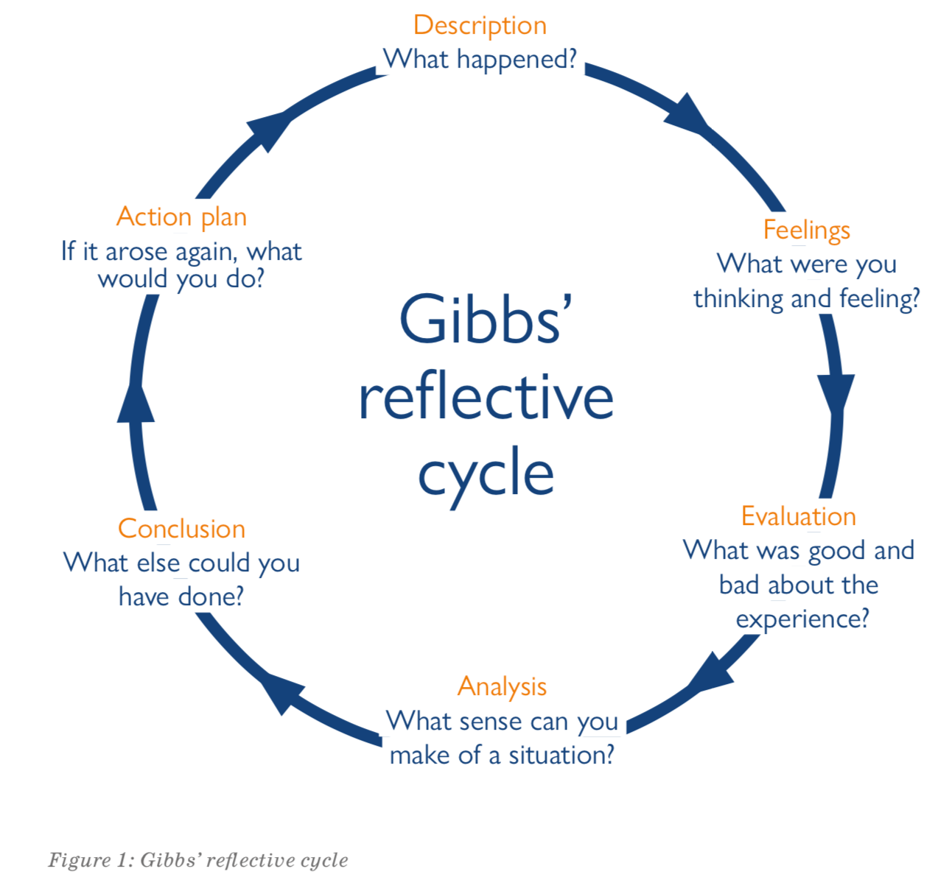

According to Whorf (1956) cited in (Thomas & Peterson, 2018), there is a long-standing belief that language shapes our perception of the world. Language plays a significant role in influencing behaviours and reinforcing beliefs and established patterns of interaction due to its use as a means of communication with others (Berger and Luckman, 1966 as cited in Thomas & Peterson, 2018).

At the first stage of the cycle (Description) as reading carefully the guidelines for the assessment and doing my research on the topic from different online books and journals, making notes, and organising them, I realised that language plays a major role in how I structure my answer and prepare my presentation. I realize that my thoughts in my native language differ from putting them into English. As Thomas and Peterson (2018) affirmed, English speakers conceive time mainly horizontally, in contrast to how time is perceived in Romanian culture or French culture.

Arrived at the next stage (feelings and thoughts), I had to agree with Thomas and Peterson (2018) that language is a cultural product that serves to uphold and sustain values, attitudes, beliefs, and patterns of behaviour. As an expat in Britain, I had to admit that Schneider's (2014) remark on foreign language ability and prior international experience as an essential asset for success was correct. Still, as he suggests, the critical factor is the willingness to communicate, which is eased if you are proficient in the language. I reflected on how this is both applicable to my presentation and relevant for hotel staff that interact with foreign guests.

Evaluation and Analysis phase.
Preparing my presentation, I improved my cultural intelligence; as explained by Schneider et al. (2014), this ability is crucial for cross-cultural competence. I developed cognitive skills to enhance my performance in a new culture. It boosted my motivation to adapt to different environments and increased my ability to engage in adaptative behaviours.
As Bird et al. (2010 cited in Schneider 2014) explained the three dimensions of intercultural competence relevant to leadership, I reflected on how my leadership is shaped by both my native culture and language as the one I found here and how this relates to maintaining cross-cultural relationships as well as the ability to manage my own emotions and strengths.

Conclusion phase.
Preparing for the presentation helped me develop a global mindset, to learn to tolerate ambiguity, balance contradictions and consider alternative viewpoints when making decisions.
I have become more open and willing to explore other cultures and learn from alternative perspectives of others, and reconcile familiar and foreign.

Action Plan Phase
Having a global mindset helped me to develop a way of thinking, retaining that multiple interpretations are likely rather than insisting on ‘one best way’.
I feel good about the process and learning accomplished.

References:
Ray French, 2015, Cross-cultural Management in Work Organisations, London: CIPD
David C. Thomas, Mark F. Peterson, 2018, Cross-Cultural Management, Essential concepts, London: SAGE
Richard Steers, Joyce S. Osland, 2020, Management across cultures, Challenges, Strategies and Skills, 4th Ed., Cambridge University Press
Susan C. Schneider, Jean Louis Barsoux & Gunter K Stahi, 2014, Managing Across Cultures, Harlow: Pearson

