

SOFTWARE DEVELOPMENT

STUDENT NAME : ANANI MATEEV
STUDENT ID : 1914594
LECTURER : PAUL JENKINS

TABLE OF CONTENTS
1 INTRODUCTION 3
2 PART A (UNDERSTANDING) 3
2.1 THE DIFFERENCE BETWEEN SETTING A VARIABLE TO A CONSTANT NUMBER AND USING THE KEYWORD CONST TO DEFINE A CONSTANT IN C#. 3
2.2 DATA TYPES AND THEIR IMPORTANCE 5
2.3 DIFFERENT TYPES OF CONTROL STRUCTURES IN PROGRAMMING 6
3 PART B (INTERPRETATION) 10
3.1 THE WORKING OF THE APPLICATION WITH A STEP BY STEP INSTRUCTIONS FOR USING THIS APPLICATION 10
3.2 A LINE-BY –LINE EXPLANATION OF HOW THE CODE FOR THE APPLICATION HAS BEEN IMPLEMENTED 10
4 PART C (IMPLEMENTATION) 11
4.1 EXERCISE 1: DESIGN AND CONSTRUCT A PROGRAM TO CALCULATE AVERAGE MARKS FOR A STUDENT ON A COURSE. 11
4.2 EXERCISE 2: DESIGN AND CONSTRUCT A PROGRAM TO ALLOW THE USER TO ENTER THE RADII TO CALCULATE THE SHADED AREA 13
4.3 EXERCISE 3: CONSTRUCT A PROGRAM TO ENTER A LIST OF NAMES OF PUPILS IN A CLASS AND THEIR CORRESPONDING MARKS FOR COURSEWORK AND EXAMINATION 15
5. CONCLUSION 18
6. REFERENCES 18

1 INTRODUCTION
In C# there are different types of variables which contain data types of specific data types. Each variable in C# has a specific data types which determined the size and layout that it will occupy in the memory in terms of values and operations that can be applied on it. Apart from variables, there are also constants which are similar to variables in that they provide named locations in memory where data value can be stored. However, for constants, once the value has been assigned, it cannot be changed. C# also uses various data types which specify which type of data should be in the fields thus ensuring programme integrity. In addition, there are control structures for controlling programme execution. This report will look at the difference between keyword CONST and setting a variable to a constant in C#, the different types of data types and how they can be converted from one data type to another as well as the control structure as used in C# programming.

2 PART A (UNDERSTANDING)

2.1 THE DIFFERENCE BETWEEN SETTING A VARIABLE TO A CONSTANT NUMBER AND USING THE KEYWORD CONST TO DEFINE A CONSTANT IN C#.
In C# a CONST keyword is used in declaring constant fields as well as constant locals. This results into a vale of constant field that is the same throughout the programme. This means that once the constant field has been assigned, the value of the field cannot be altered or changed. In C# constant fields and locals are not considered as variables. A constant in this case can be a number, a string, a Boolean or a null reference.
// use of const keyword
class CurrentAge
{

// Constant fields
public const int myAge = 28;

// Main method
static public void Main()
{

// Display the value of Constant fields
Console.WriteLine("I am: {0}", myAge);

}
}
}

Output: I am 28
The above example shows a variable myAge being changed to a constant value of 28. This means that the age cannot be changed but will remain constant at 28 whenever used throughout the programme.
This constant is a compile time constant which means it must be assigned a value during the time of declaration and this value cannot be changed throughout the programme. This means, even if the value is used in a different class, it will remain the same without change. In addition, this value can only be declared inside the methods.
C# also has an option of use of another keyword, READONLY for declaring variables and in this case the variables will be readonly variables. The readonly keyword allows for assigning the variable only when declaring the variable or in a constructor of the same class in which it is declared. This means that in case of a different class, the value will need to be declared again.
Example,
namespace Project1
{
// of the readonly keyword
using System;

class MyAge
{

// readonly variable
public readonly int myCurrentAge;

// Values of the readonly
// variables are assigned
// Using constructor
public MyAge(int a)
{
myCurrentAge = a;
Console.WriteLine("My current age is, " + myCurrentAge);
}

// Main method
static public void Main()
{
MyAge = new MyAge(29);
}
}
}
The output of the programme will be My current age is 29 instead of My current age is a. This is despite the fact that the variable myCurrentAge had been declared constant using the readonly keyword. However, since this is a new method, the output gives the declaration in the new method instead of the initial constant value.
Therefore, it is important to note that in C#, readonly is a runtime constant where the value can be changed from one class or method to another. It cannot be declared inside the method but the readonly values can be assigned in both declaration and constructor and can be used using modifiers (GeeksforGeeks, 2019).

2.2 DATA TYPES AND THEIR IMPORTANCE
C# is a language that is strongly types and as such, the types of a variable that is going to be stored must be declared. C# categorizes data types into two types, that is, value types and reference types. Value types include simple types like int, float, char, bool; enum types; struct types and null types. Reference types on the other hand include class types, delegate types, class types and interface types.
These can also be categorised as integral types which include whole numbers like byte, short, integer, long and non integral data types such as single, double and decimal. There are also Boolean data types which return true or false and nullable data types, date data types and object data types (Clark, 2013).
Conversion.
In C# the values of some of the data types can be converted to other data types. Conversion is the process where one data type is taken and used as the equivalent value of another data type. This conversion can be classified as implicit or explicit (Solis, 2012).
Implicit conversion occurs when a smaller data type is converted to a larger data types or when a derived class gets converted to a base class. In this conversion, there is no resulting loss of data, for instance, when going from an int data types to a long data type, there is no loss of precision and hence there will be no change in the value of the type. In such a case, the code will only specify the assignment operator. In other words, the compiler is able to determine that the conversion will be able to work correctly.
For example,
int Number1 = 314676320;
long Number2 = Number1;
From this example, the value of longNumber2 will be 314676320 hence no loss of data and as such, implicit conversion is done when the value hat needs to be stored in another variable is able to fit directly without losing data.
Explicit conversion
Unlike in implicit conversion where derived class can be converted into base class without loss of any data, explicit has a chance of losing data. As such, explicit conversion or casting is a process of passing information to a compiler with the knowledge of a possible loss of data. In C#, explicit casting is done by specifying the types of data that needs to be converted into within the parenthesis hence acknowledging that there may be loss of precision and data result into an exception (Michealis and Lippert, 2013). For example, when converting a double to an int, there will be loss of data as shown below.
double x = 6.123;
int i;
i = (int)x;
The output will be i = 6 showing that the data has been lost from the original data type.

2.3 DIFFERENT TYPES OF CONTROL STRUCTURES IN PROGRAMMING
There are three control structures in the C# programming, sequence control structures, decision control structures and loop control structures. Sequence control structures are line by line execution where statements are executed in a sequence in the order in which they appear in the script.
Decision control structures are depended on whether the condition is true or false thus skipping the execution of an entire block of code or even execute one block instead of another. This include IF STATEMENT, NESTED IF and IF…ELSE STATEMENT.
IF STATEMENT
This includes an if clause, Boolean expression and then body of the conditional statement. The Boolean expression can e a variable or a logical expression and is followed by a body of the statement in curly brackets. If the Boolean value is true then the body is executed but if its is false, then the operation in the body is skipped (Nakov and Kolev, 2013).
class Program
{
static void Main(string[] args)
{
{
Console.WriteLine("Enter two numbers.");
Console.Write("Enter first number: ");
int firstNumber = int.Parse(Console.ReadLine());
Console.Write("Enter second number: ");
int secondNumber = int.Parse(Console.ReadLine());
int biggerNumber = firstNumber;
if (secondNumber > firstNumber)
{
biggerNumber = secondNumber;
}
Console.WriteLine("The bigger number is: {0}", biggerNumber);
}

}

}
}
IF ELSE STATEMENT
This structure consist of the reserved word if, Boolean expression, body of conditional statement, reserved word else and else body statement.
static void Main(string[] args)
{
{
int x = 2;
if (x > 3)
{
Console.WriteLine("x is greater than 3");
}
else
{
Console.WriteLine("x is not greater than 3");
}
}
NESTED IF STATEMENTS is where an application is represented by multiplr if-structures found in each other. Example,
static void Main(string[] args)
{
{
int first = 5;
int second = 3;
if (first == second)
{
Console.WriteLine("These two numbers are equal.");
}
else
{
if (first > second)
{
Console.WriteLine("The first number is greater.");
}
else
{
Console.WriteLine("The second number is greater.");
}
}
}

}
LOOPS
Loop control structure is a control structure that allows the execution of a block in repetitive times until a specified condition is met. These include FOR LOOP, WHILE LOOP and DO WHILE LOOP.
WHILE LOOP
This loop consists of a while-clause followed by a condition and loop body in curly braces as shown below.
while (condition)
{
loop body;
}
The condition is an expression that returns a Boolean result of true or false. The while loop will check the condition first if it returns true it is executed again and again until the condition returns false (Nakov and Kolev, 2013)
class Program
{
static void Main(string[] args)
{
{

int counter = 0;
while (counter <= 5)
{
Console.WriteLine("Number : " + counter);
counter++;
}
}
}

}
DO WHILE LOOP
This takes the form;
do
{
executable code;
} while
In this loop, the body loop is executed first then the condition is checked for true or false. If the condition is true, body execution is repeated, however, when it is false the loop ends.
class Program
{
static void Main(string[] args)
{
{

Console.Write("n = ");
int n = int.Parse(Console.ReadLine());
decimal factorial = 1;
do
{
factorial *= n;
n--;
} while (n > 0);
Console.WriteLine("n! = " + factorial);
}
}

}
FOR LOOP
The FOR LOOP takes the form;
for (initialization; condition; update)
{
loop's body;
}
It contains an initialization part for the counter e.g. int i=0, a Boolean condition (i<10), a counter or updater (i++, i--, i=i+2) and the loop body.
static void Main(string[] args)
{

for (int i = 1, sum = 1; i <= 128; i = i * 2, sum += i)
{
Console.WriteLine("i={0}, sum={1}", i, sum);
}
}

}

3 PART B (INTERPRETATION)

3.1 THE WORKING OF THE APPLICATION WITH A STEP BY STEP INSTRUCTIONS FOR USING THIS APPLICATION
The user is prompted to enter a value of the width of the window between 0.5 and 5 and press enter. Once entered, the program checks if the values are within specified range. If the width is not between the 0.5 and 5 the user is prompted to re-enter width again until the user enters a value within the range. The same applies when user enters height values out of range. (do while loop executes until the condition evaluates to false).
Flowchart
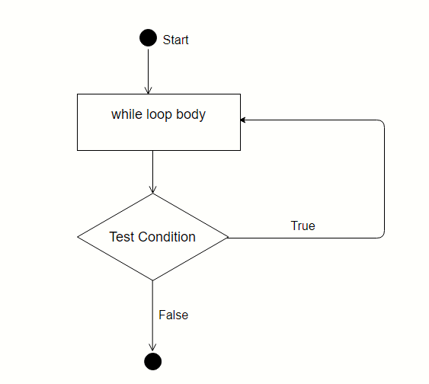

3.2 A LINE-BY –LINE EXPLANATION OF HOW THE CODE FOR THE APPLICATION HAS BEEN IMPLEMENTED
1.using System means that we can use classes from the System namespace.
2.namespace is a used to organize your code, and it is a container for classes and other namespaces.
The curly braces {} marks the beginning and the end of a block of code.
3.class is a container for data and methods, which brings functionality to your program. Every line of code that runs in C# must be inside a class. In our example, we named the class Program.
4.Static void Main method. This is the main entry point of the program. Any code inside this method will be executed. Void means the method will not return anything after execution, Static means the method can be called without being instantiated/creating object. String []args: For accepting the zero-indexed command line arguments
5. Variables are declared and some are assigned some values. The ones already assigned values have been declared using const keyword meaning the variable constants cannot be altered during program execution.
6. Do while loop. This loop executes the code first then evaluates the conditions for true or false. If the conditions evaluate to true the loop executes again until the conditions evaluate to false, the loop terminates and program proceed with execution. Code in this loop is executed sequentially.
7. Calculation; woodLength = 2 * (width + height) * 3.25; for returns result
8. Console.WriteLine() outputs/displays results in the console.

4 PART C (IMPLEMENTATION)

4.1 EXERCISE 1: DESIGN AND CONSTRUCT A PROGRAM TO CALCULATE AVERAGE MARKS FOR A STUDENT ON A COURSE.
Code
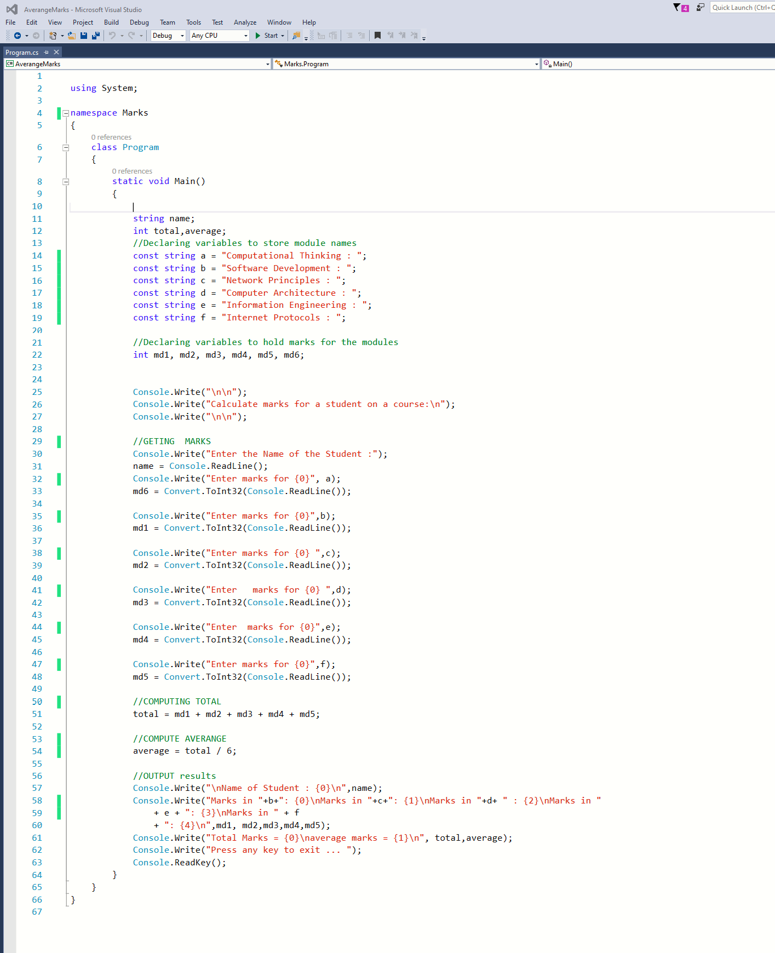

Output
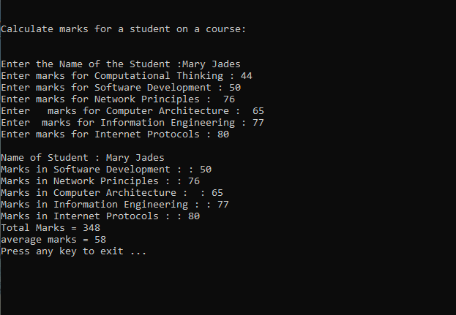

4.2 EXERCISE 2: DESIGN AND CONSTRUCT A PROGRAM TO ALLOW THE USER TO ENTER THE RADII TO CALCULATE THE SHADED AREA.
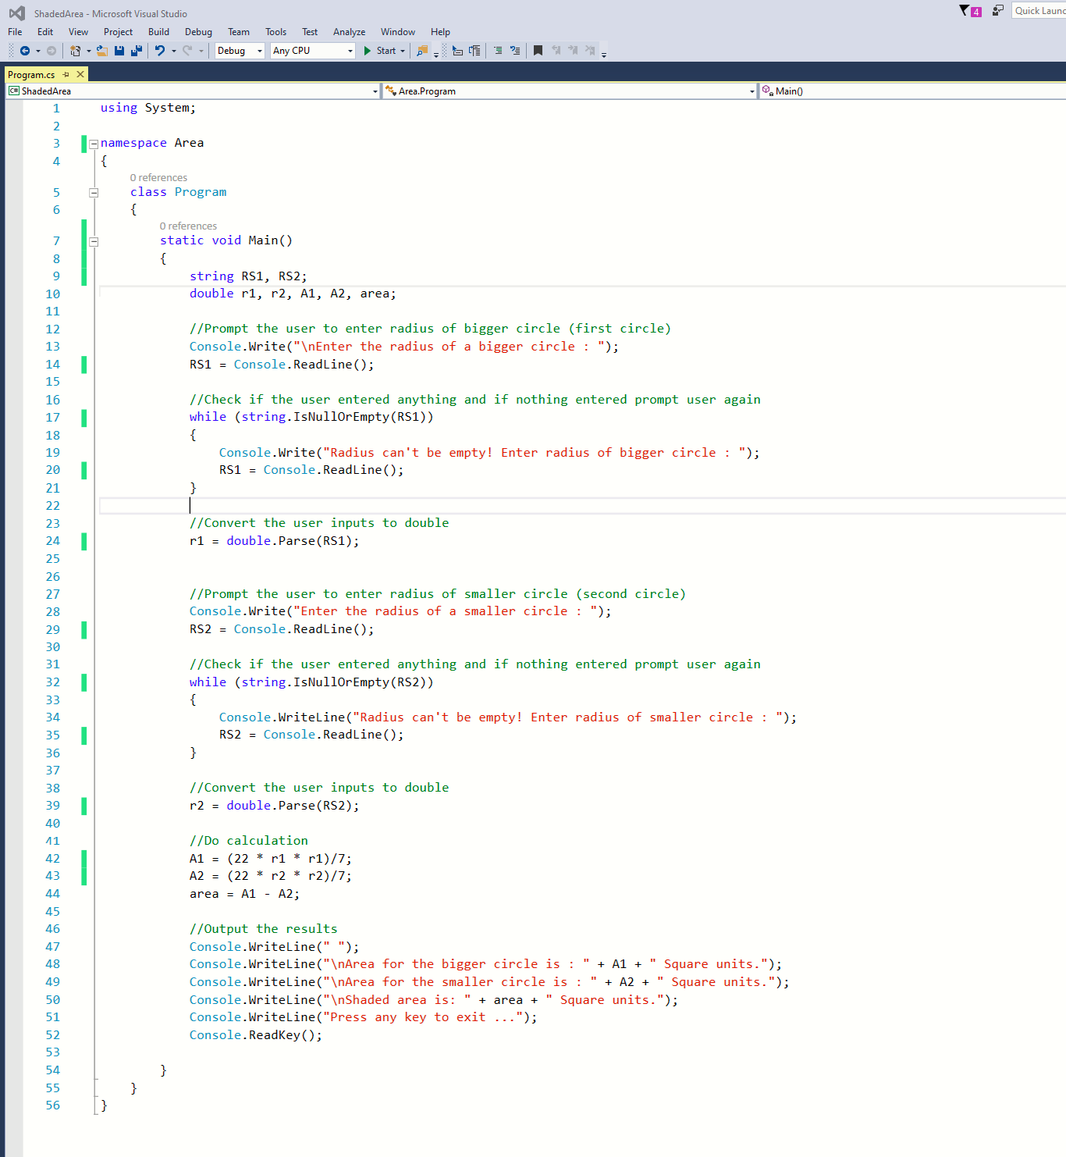

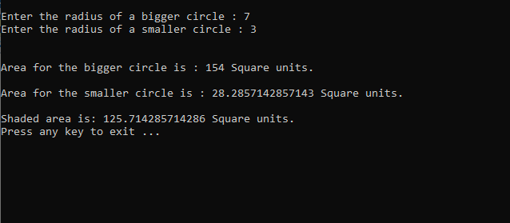

4.3 EXERCISE 3: CONSTRUCT A PROGRAM TO ENTER A LIST OF NAMES OF PUPILS IN A CLASS AND THEIR CORRESPONDING MARKS FOR COURSEWORK AND EXAMINATION
Code
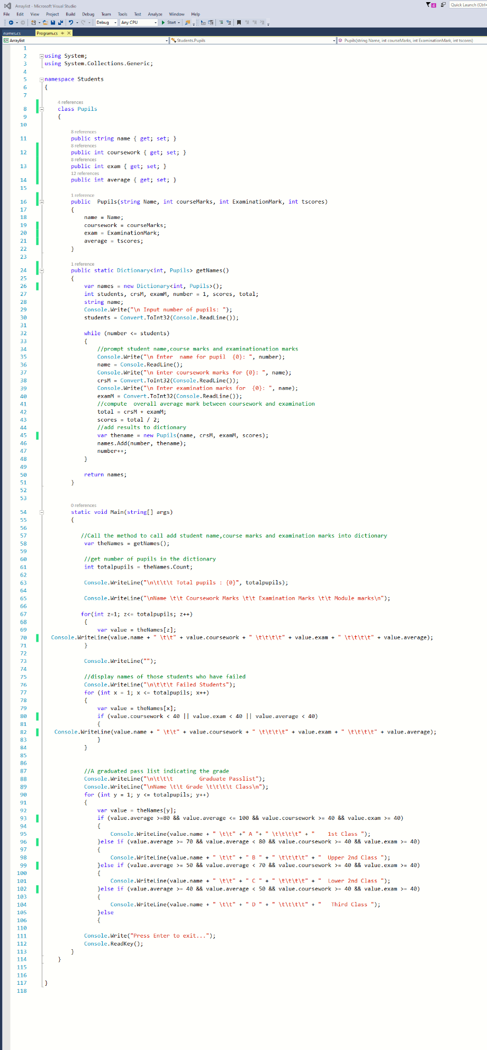
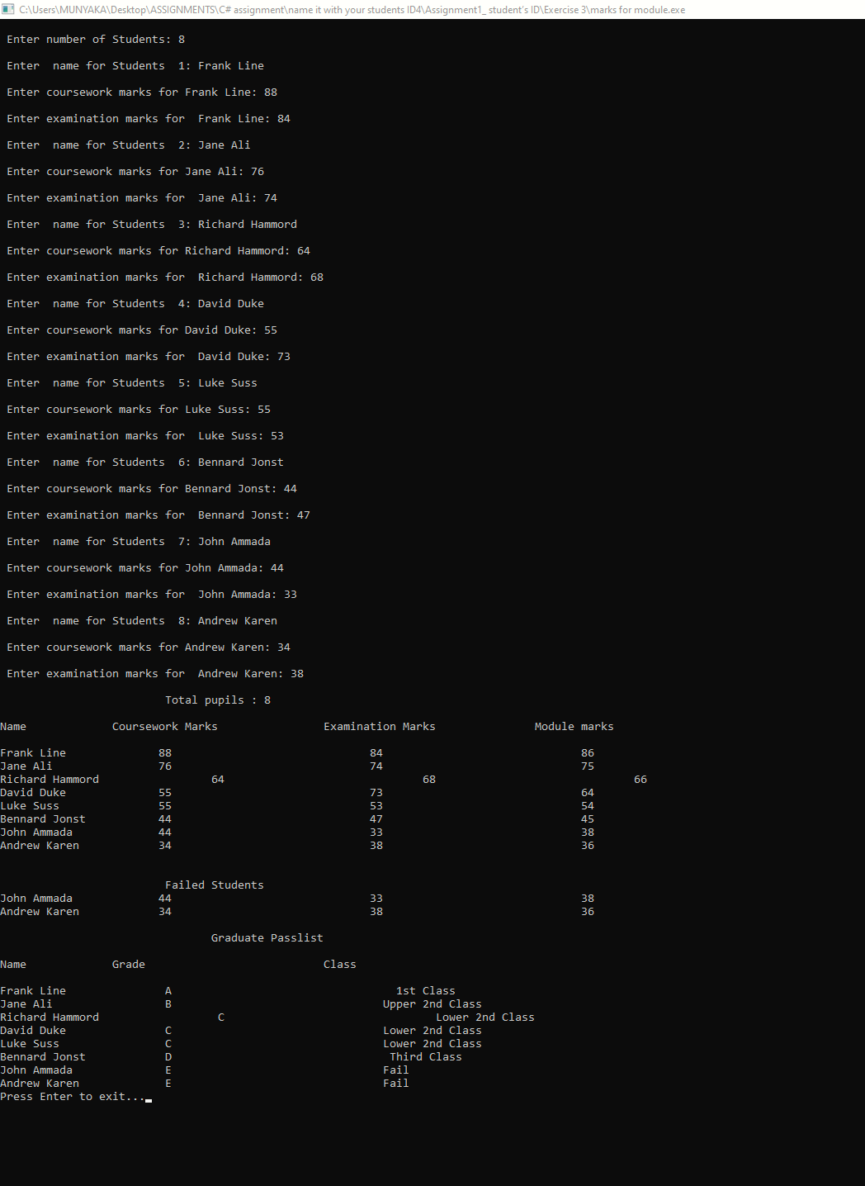

5. CONCLUSION
C# is a strongly types language and as such, it is important for developers to be aware of the various data types used in the programming language together with ways of converting from one data type to another. In addition, C# has a provision of changing variables to constant values. All these are aimed at ensuring integrity of the programmes developed using the language. The language also has control structures through which it gives direction to the execution of the programme to ensure that such concepts as conditions and repetitions are used to control the flow of code execution.

6. REFERENCES
GeeksforGeeks. (2019). Difference between readonly and const keyword in C#. [online] Available at: https://www.geeksforgeeks.org/difference-between-readonly-and-const-keyword-in-c-sharp/ [Accessed 19 Aug 2020].
Michaelis, M. and Lippert, E. (2013). Essential C# 5.0. Upper Saddle River State, NJ: Pearson Education, Inc.
Nakov, S. and Kolev, V. (2013). Fundamentals of Computer Programming with C#. Sofia, Bulgari: Svetlin Nakov & Co.
Solis, D. M. (2012). Illustrated C# 2012, 4th ed. Dordrecht: Springer.

