March 2018
Nia David (P151615)
University of Wales Trinity Saint David
Manufacturing Design & Technology
Design Development -
Polymer Processing Plant
Table of Contents
1 Introduction 2
1.1 What is Precious Plastic? 2
2 About the Injection Moulding Machine 3
2.1 Machine Comparison 4
3 Machine Improvement Ideas 9
3.1 KANO Model 9
3.2 QFD 11
3.3 Design Specification 13
4 Concept Design Solutions 14
5 Final Design Solution 18
5.1 SolidWorks Model 18
5.2 Technical Drawing 20
5.3 Material Selection 21
5.4 Geometric Dimensioning and Tolerancing (GD&T) 22
5.5 Limits and Fits 22
5.6 FMEA 23
6 Appraisal of Final Design 24
6.1 Design Area’s for Future Improvements 25
6.2 Self-Evaluation 26
7 Reference List 27
8 Appendix – Supporting CAD Images 29

Introduction

What is Precious Plastic?
Precious Plastic is a global community of hundreds of people working towards a solution to plastic pollution by boosting plastic recycling worldwide. This has been achieved by developing and sharing open source designs for basic polymer processing machinery. It is intended that individuals or small groups can use these designs, along with readily available components and materials to facilitate their own, miniaturised polymer processing and manufacturing plant capable of transforming waste plastic into useful, saleable products (Precious Plastic, 2018).

Precious Plastic creates recycling workspaces which can house 4 recycling machines within large shipping containers. The four different recycling machines include a plastic shredder, an extrusion system, a compression oven and also an injection moulding machine. All four recycling machines have been designed in such a way as to allow the entire recycling, processing and manufacturing process to fit within the workspace.
Figure 1- Workspace Example (Precious Plastics, 2018)
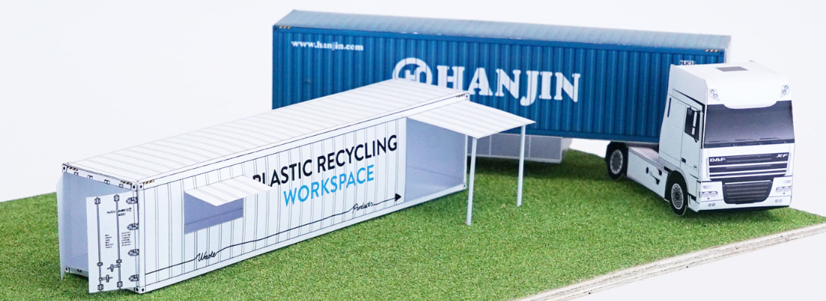

All four machine concepts have aspects of brilliance due to their modular, low cost, effective manufacturing styles however; each design also carries flaws too. I have selected the injection moulding machine to analyse, critique and appraise against the industrial equivalence. The injection moulding machine is most relevant to my working experiences as many assembly parts on the manufacturing lines where I work are supplied by companies who make injection moulded parts. I would like to compare the capabilities of Precious Plastic’s machine against the industrial equivalence.

About the Injection Moulding Machine
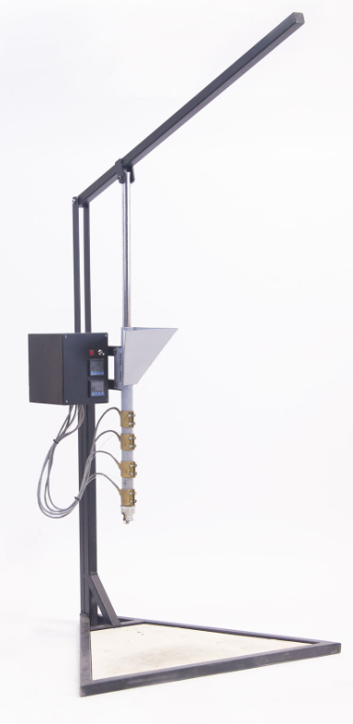
The purpose of Precious Plastics injection moulding machine is to convert recycled plastic shreds into remoulded plastic objects that serve a use. Precious Plastics (2018) state that their injection machines are capable of making small objects whilst operating at fast speeds and can also produce parts with high precision. I selected Precious Plastic’s Injection Moulding Machine for evaluation as I wanted to test if their statements are true, appraise the design and also review their process capabilities.

Figure 2- Injection Moulding Machine (Precious Plastics, 2018)
Figure 2 shows a photograph of the Injection Moulding Machine. The machine consists of a base stand, an axis, a lever, a barrel with a feeder and an electronic heating system too.

The Injection Moulding Machine is inclusive of all as the design allows basic materials, tools and universal parts to be used for the creation therefore allowing individuals from all over the world to build their own machine. The modular machine design means that components can be repaired, replaced and customised with ease. The machine is Open Sourced hence there are blueprints and tutorials demonstrating how to build the equipment that is readily available online for all to access and use.

The Bill of Materials (BoM) for the Injection Moulding Machine is displayed in Figure 3. Paul Roberts (2018) described a BoM is a hierarchical list of components used in an assembly chiefly used to estimate cost. Precious Plastics estimate the cost to build the entire unit at €131 but clarify that the price will vary depending on build location.

The BoM is easy to interpret by users of all skillsets; it carries enough description for engineers to fulfil the requirements but also it is worded simplistically therefore even individuals with no engineering knowledge could gather the mechanical and electrical parts for the machine. The BoM lists critical parts; states required material, dimension details, quantities, price and recommended locations to pick up the items.
Figure 3 - Bill of Materials
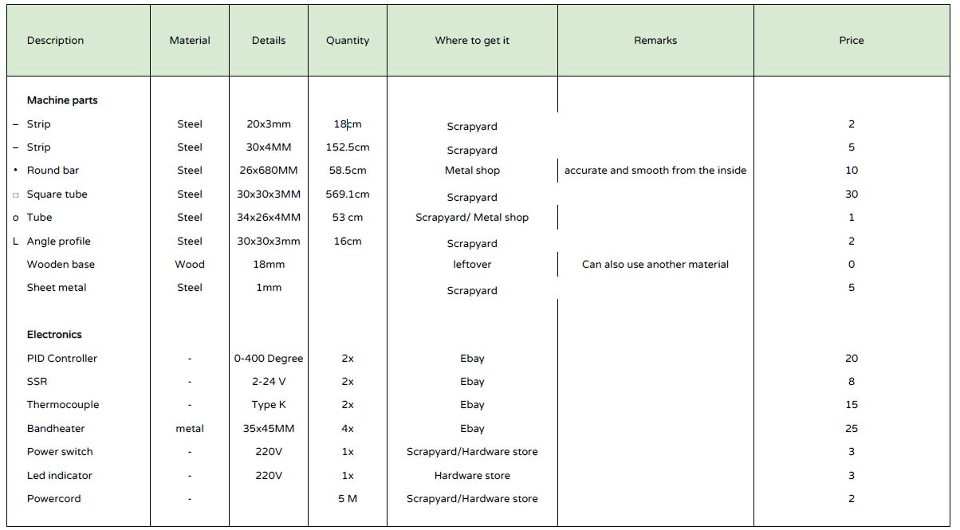

Machine Comparison
When analysing the Precious Plastics (2018) injection moulding machine against injection moulding machines used for commercial/industrial manufacturing, it is clear that there are some big differences. Precious Plastics injection moulding machines (PPIMM), as illustrated in Table 1, are inexpensive in comparison to industrial grade machines. Precious Plastics estimate the cost to build the entire unit at the low price of €131, and the number of components totals at only 15. The PPIMM has been designed in such a manner that individuals globally can build the machine, regardless of their skillset as supportive video tutorials are provided. There is a community forum open to everyone to discuss, query and help others within the recycling Precious Plastics workgroup. The simplistic design makes the equipment user friendly and easy to operate; however producing parts of high quality is not as simple due to complexities of injection moulding.
Table 1 – Commercial / Industrial Equipment Comparison
Key  ↓ - Low ↑ - High | Precious Plastic’s Injection  Moulding Machine (PPIMM) | Industrial Injection  Moulding Machine (IIMM)
Cost | ↓ | ↑
BoM Volume of Components | ↓ | ↑
Difficulty to Build | ↓ | ↑
Difficulty to Operate | ↓ | ↑
Quality of Parts Produced | ↓ | ↑
Anticipated Throughput Yield | ↑ | ↑
Production Volume Capacity | ↓ | ↑

Likewise, the BoM of the IIMM consists of many more components, often hundreds due to system complexities. For example, the IIMM includes features such as cooling systems, hydraulics, sensors etc. which the PPIMM would not include therefore the IIMM is much more difficult to build. IIMM tend not to be modular, nor are their designed open sourced or accessible to all. The complex IIMM designs have the tendency to be built by a specialist supplier and then sold as a complete unit easily costing thousands, often hundreds of thousands. The sophisticated design makes the equipment difficult to achieve perfect products at first due to the high volume of variables which can affect the output, however once an injection moulding specialist determines the required equipment parameters the equipment will be capable of producing parts consistently. An injection moulding specialist could optimise the process easily due to their technical knowledge however an individual with very low knowledge of injection moulding would not be capable of running an IIMM to its full potential.
The design intent of the PPIMM equipment is not to create products bigger than small household items otherwise it will result in reduced quality of the parts due to process limitations. Consequently the PPIMM moulds are commonly small enough to fit on the palm of a hand. The parts created from the PPIMM are usually novelty items such as fidget spinners, spinning tops, key rings and phone cases. The PPIMM is used primarily for creating parts that require no tight tolerances; however this is mainly due to the target audience who uses the items. More research is required to determine the accuracy capability which can typically be produced from a PPIMM. The small sized moulds are often inexpensive to machine and can be purchased for as little as $50. – see figure 4 for example.
Figure 4 - PPIMM Mould Examples (Precious Plastics, 2018)
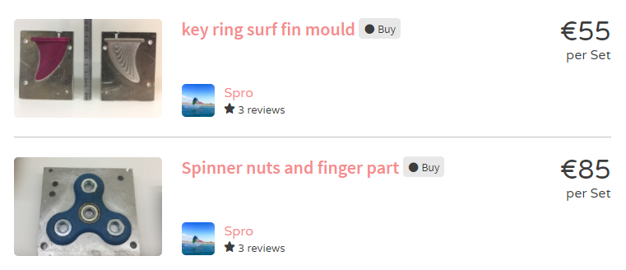

A process limitation of Precious Plastics machine is that the use of larger moulds would be likely to cause voids, sinks, porosity etc. as the system is not designed to support the travel of melt. Comparatively IIMM moulds are larger and are designed to produce parts often much more complex to those produced from the PPIMM. The price for an industrial grade mould could be £1000’s. The increased complexity of the mould is due to the inclusion of more features for example: ejection pins, cooling channels, multi-layered mould, guide pins and bushes, hydraulics and much more. These additional features improve the precision of parts, the distribution of the melt around the mould, reduce the cycle time by reducing the heat within the part via cooling channels, as well as automating the ejection step with the use of ejection pins, and automating the move of the mould using hyrdohylics. IIMM moulds require to be made out of a very durable, strong material which adds to the cost. The stronger material is required to reduce wear as the mould will be expected to produce parts every few seconds continually for often years. Introducing preventive maintenance tasks can be very effective at prolonging the life of a mould which is a small price to pay in comparison to replacing the mould entirely.

  - Process Productivity (Throughput)
If the PPIMM process efficiency were to be measured, we would understand the inherent ability for the injection moulding process to meet the specifications/ ability to process units without defects and therefore we would know the anticipated throughput yield. The throughput yield is predicted to be high as even though the parts produced will not be precise to high tolerances such as microns, the degree of accuracy the PPIMM is capable of producing is perfect for products it will create. The PPIMM will typically create products such as mobile phone cases, keyrings, spinning tops etc. and even though these parts need to be meet tolerances, they do not need the high degree of accuracy industries such as automotive, aerospace or medical would require.

  - Process Capability
Production volume capacity of the PPIMM is entirely dependent on skillset of the operator as this process is manual. An operator familiar with the PPIMM will be able to confidently produce a part on average every 5 minutes according to (Hakkens, 2015). Even if the PPIMM process included lean manufacturing techniques to improve to cycle time, the process would never be able to compete with the cycle time of industrial alternative machines. The IIMM are used for higher volume manufacturing processes and are capable of producing parts, often multiple parts within the same mould, in seconds.

  - Health and Safety (machine operators / end users / observers)
HSE Gov stated in (1974) that The Health and Safety at Work Act applies to all businesses. An employer is responsible for health and safety of their business. Health and safety laws are there to protect you, your employees and the public from workplace dangers. IIMM’s are of a much larger scale and carry much more complexities than PPIMM’s, yet in fact it is the IIMM’s which hold less health and safety risks to users due to the equipment vigorously evaluated to ensure that no laws are broken. PPIMM’s on the other hand carry lots of health and safety risks due to the equipment not needing to meet HSE standards as it is built domestically with the sole purpose of producing injection moulded parts for the user only. As expanded on further in the report, the PPIMM includes risks of burns, entrapment and also respiratory concerns. Lorraine Ferris (June 2015), a representative of Envirocare, stated that the main point of concern regarding work in ‘plastic environments’ is the exposure to by-products released during the processing of plastics, with the most notable of scenario’s being fumes released during heat treatment of plastics. Immediate effects of these may include severe irritation to the nose, lungs and eyes. In some cases, especially during prolonged exposures, the effects can be long term and irreversible. Toxic gases emitted by burning plastic materials like dioxins and furans may also cause cancer, impotence, asthma and a myriad of other detrimental effects to human beings. Analysis is recommended to be conducted on the PPIMM as per the governments Health & Safety webpage to assess whether the current plastic processing method is legal.

The most effective way of assessing exposure levels to plastic fume in the workplace is by air sampling according to the HSE.gov (1974). A popular way of doing this is by drawing a known quantity of air through a filter, which is then analysed for contaminants known to be used in the process. Following sampling, current working practices can be assessed and means of preventing or reducing exposure to hazardous substances by improving safety measures (protective equipment, PPE) and Control Strategies, such as local exhaust ventilation (LEV) can be implemented.

There are many health and safety risks associated to injection moulding processes mainly due to the principle of working with hot molten plastic called a polymer melt. The polymer melt is a burn risk to machine operators and observers as there is potential for the plasticised material to splash if appropriate guarding is not in place. IIMM’s must ensure their equipment meets the following guidelines stated by the HSE.Gov (2015) when trying to safeguard the process. “To prevent splash there should be a sliding or hinged nozzle guard with one position sensor which interrupts all movements associated with pressurising plastic material, and movement of the injection unit. The position sensor should not easily be defeated and should fail to safety. For purging outside the guarding area, there should be a manual control and a reduced speed facility. This guard should also prevent access to the trap between the forward movement of the injector unit and the fixed platen” however, the PPIMM certainly does not meet this requirement as it includes none of these safety systems due to the simplicity of the machine. The PPIMM’s however should be “insulated or guarded where maximum temperatures can exceed 80 ° C” (HSE.Gov, 2015). Additionally, the introduction of guarding will eliminate the risk of entrapment of body parts due to the mechanical movements of the PPIMM. IIMM do not have the same risk of entrapment due industrial grade machines needing to be CE marked to evidence its compliance with safety laws.

Machine Improvement Ideas

KANO Model
According to Baxter (1995) the key to successful product design is by delivering customer value, and the key to delivering customer value is to specify what the product must do to offer value to the customer. The best way of balancing the customer needs but also the manufacturer’s needs is by using the KANO Model of Quality to support/ discourage improvements.

Professor Noriaki Kano created the Kano Model in 1984 whilst studying in University (Verduyn, 2014). The KANO Model was developed with the objective of determining and categorising product attributes and their potential influence on customer satisfaction (Trzcielinski, 2014). The KANO model defines three levels of customer satisfaction named Attractive, One-Dimensional and Must-Be as shown in Figure 5.
Figure 5 - The Kano Model (Verma, 2013)
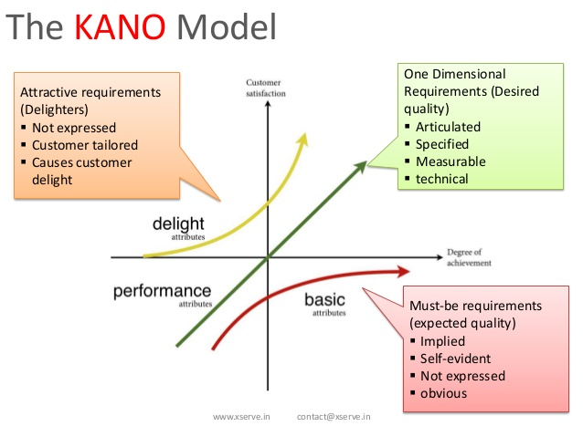
As per the KANO Model, manufactures’ should aim to meet as many ‘Must-Be’ requirements as possible as they are the expected quality the customer expects. If the Must-Be requirements are not met then the machine does not serve its required purpose and certainly will not be purchased/built by its target audience. The KANO Model shows there is a direct correlation with the ‘One Dimensional’ requirements; the greater the customer satisfaction and the greater the degree of achievement. The correlation implies that ‘One Dimensional’ performance attributes need to be maximised as high as physically possible. In some respects this statement is true however each additional performance attribute is likely to increase the overall product cost therefore a balance is crucial. Lastly, the KANO Model describes the delight attributes as ‘Attractive Requirements’. The attractive requirements include the features often not specified or expressed by the customer but that will cause additional delight. The designer’s aim is to incorporate attractive requirements where possible without increasing the difficultly to manufacture the machine, and also without increasing the cost too much either.

QFD
If the voice of the customer is not listened to; as illustrated clearly in The Kano Model; then the impact to customer satisfaction can be hugely detrimental to the success. The Quality Function Deployment (QFD) tool translates the customer requirements which will lead to customer satisfaction into design requirements (Shina, 2012). The QFD then goes on to quantify and prioritise these design requirements by means of competing product analysis and importance weighting (Baxter, 1995).

Figure 6 - QFD Performance Requirements (QFD Template from Swansea University Moodle)
The customer requirements are stated on the left side of the QFD matrix in Figure 6. It is critical that the QFD states the unspoken needs; the requirements which the customer will assume (Must-Be Requirements) and also the requirements which have excitement capabilities (Attractive Requirements). The functional requirements are stated within the top column of the QFD matrix in Figure 6. Functional requirements are measurable characteristics which will allow the designers to meet a set specification. Characteristics should be stated in a way to avoid implying a particular technical solution and instead allow the designers to create several solutions and then allow the best to be selected. In the top right hand of Figure 6 is the key which displays which each legend represents. The QFD legends define the relationships between the customer requirements and functional requirements, as well as states whether the correlation is positive or negative. Too many positive interactions suggest potential redundancy in “the critical few” product requirements or technical characteristics. According to NPD Solutions (2018), it is important to focus on the negative interactions and consider product concepts or technology to overcome the potential trade-offs by considering the trade-offs when establishing target values. The QFD template then cleverly uses all the inputted data to calculate the relative weight which reflects the importance of each attribute to ensure the design reflects the desired product.

The QFD in Figure 6 identified opportunities to surpass competitor’s capabilities, areas to equal competitor’s capabilities, and also areas where there is no room for improvement to be made. The QFD strategy will now help the new design concepts to focus on developing aspects which will bring the biggest benefits, and therefore also result in the biggest customer satisfaction.

Weighting of the QFD shows that the most important aspect of the injection moulding machine is the need to incorporate health and safety features such as guards to reduce the risk of burns to users. Health and safety is the most critical aspect of any machine, if the machine is not safe to operate then it should be locked off electrically until safety measures are introduced. Secondly, the next highest weighted factor is the need for the machine to incorporate education learning aspects. The whole purpose of the company Precious Plastic is to raise awareness of the volume of plastic wasted each year and to utilise techniques to turn unwanted plastic that would otherwise go to landfill sites into useful products. Ensuring the injection moulding machine includes factors that educate users and watchers about how and why we want to recycle is critical to the success of the company.

Further analysis of the QFD shows that the least important functional requirement is the need to change the colour of the injection moulding machine to match Precious Plastic’ corporate blue colour and also add a branded logo to the machine. The least important weighting implies that this functional requirement should not be carried forward to the end design however I disagree as even though it is not critical to the function of the machine it is very easy to achieve. Changing the colour to the corporate blue and introducing the branded logo would be categorised within the ‘Attractive Requirements’ of the KANO Model and boost customer satisfaction hugely without increasing the cost or difficulty to build.

Design Specification
Using the ‘target values’ determined from the QFD, a Design Specification has been created. A Design Specification (DS) comprises quantitative statements of what needs to be designed prior to starting to design it (M.E., 2018). Developing a good DS should save a lot of time and effort when it comes to delivering a project according to Tim Bellhouse (2016). By making the requirements clear there's no room for confusion or doubt which can only make a more efficient and effective process. The DS sets criteria by which the product is either allowed to continue with its development or be placed ‘on hold’ during quality control reviews. Creating a DS has the ability to minimise risk, provide clear instructions, deliver assurance of customer satisfaction and much more, but most importantly the DS tries to prevent commercial failure. Failure can be prevented by ensuring the product will be accepted by its target audience, function as desired, comply with legal/commercial legislations and also ensure it can be manufactured.

Concept Design Solutions
The PPIMM was designed perfectly for ease of assembly, low cost, modular and ease of operation too however, there are three core categories for design improvements which could be made as an output from the QFD to optimise the design whilst still meeting the customer requirements.
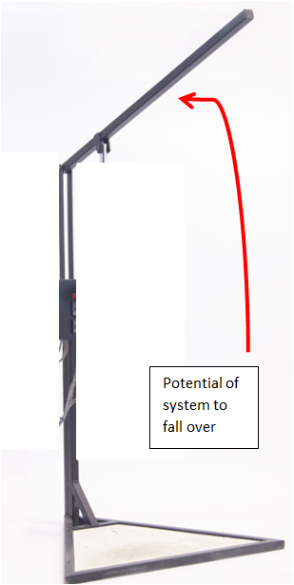
  - Design Issue 1 – Health & Safety
The most critical design error in my opinion is the lack of consideration to health and safety.
When analysing the design of the triangular based structure in isolation to the rest of the design it seems sufficient for the injection moulding process, however the triangular base is at risk of falling over when the lever is operated with any great force, especially in the upwards motion as the back of the system has less support than the front. A design solution to increase the stability of the base is needed.
Another health and safety risk with the PPIMM is that the user is at risk of being splashed with hot molten polymer which can result in burns. Guards need to be introduced to maximise operator safety. Transparent guards are recommended as it would full visibility of the process which will benefit operators and also students willing to learn. Clear guards will encourage educational and learning aspects which is absolutely necessary to achieve customer satisfaction according to the output of the QFD in Figure 6.

The electronic system also has the potential to cause electronic shocks as electricity via mains is supplied to the machine. Initially it was considered that the risk of an electrical shock to the user is very low, however introducing an emergency stop (E-Stop) button is a very inexpensive, easy addition. The E-Stop will provide safer and faster isolation of mains power. The addition of an E-Stop button will prevent operators needing to lean over the equipment to turn off the power.

Lastly there is a need for an extraction unit when processing plastics due to the fumes released during the heating process. An LEV system with appropriate filters would be suitable to prevent risks to users from exposure to fumes during operation.

  - Design Issue 2 – Lack of housing for moulds
A design flaw of the PPIMM is the lack of housing to lock injection moulds into position. Currently the design does not include any considerations to holding moulds ready for processing. The lack of housing could be considered a positive in the sense that the large availability of space accommodates a large range of size moulds offering the user lots of flexibility. On the other hand, the lack of clamping mechanisms for moulds does not encourage consistent positioning and therefore risks the quality of the product output. A design solution suggestion is for the system to incorporate an adjustable clamping mechanism for injection moulds, which tries not to limit the mould sizes able to be used.

  - Design Issue 3 – Lack of corporate & Professional look

Furthermore, a design improvement could be to develop the professional appearance of the design by introducing Precious Plastics colour scheme and logo. The physical attributes of the product will not enhance from the introduction of corporate inclusions however, all stakeholders of Precious Plastic are all building their modular, open sourced designs for two reasons; to reduce the volume of plastic wasted and also spread the word of Precious Plastics mission. Incorporating Precious Plastics logo and colour scheme throughout all builders only strengthens the professionalism of the greener planet mission.
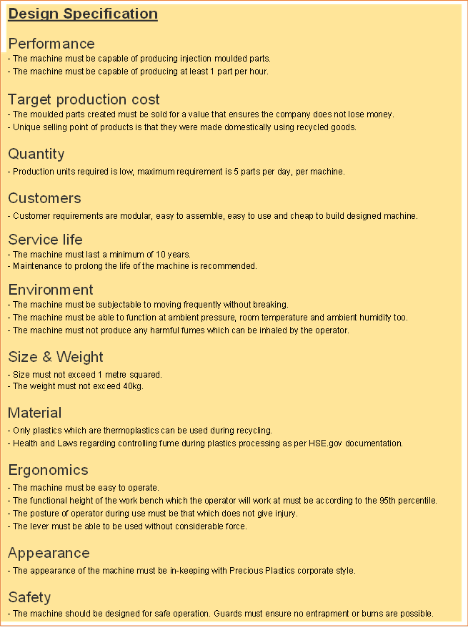
With consideration of the three design issues identified above, which were outputs from the QFD to optimise the design, the Design Specification has been created to unmistakeably state all requirements in one clear and concise list.
The design improvement ideas have been incorporated into the DS to optimise the equipment; however additional requirements often add expense. Additional expense might not always be justified by the purchaser, and therefore some customers might not be willing to pay the extra costs resulting in fewer costumers. To find the perfect balance between optimisation and customer satisfaction can be difficult hence why a Pugh Matrix was used to help determine the best design solution.

According to the documents published online from iSixSigma (2018) a Pugh matrix is a tool used to facilitate concept generation and selection. Several concepts are evaluated according to their strengths and weaknesses which options are assigned scores relative to criteria. The final selection for which design should be chosen is made based on the consolidated scores.
Table 2 - Pugh Matrix (iSixSigma, 2018)
Key  1- Worst  10 - Best | 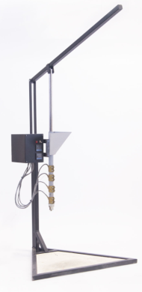 | Original stand base, opaque guards, E-stop, no fume extraction, new improved lever mechanism, no clamping mechanism for moulds. | Table top base, transparent guards, fume extraction system, E-stop, Precious Plastic’s corporate logo and colour, original lever handle mechanism, new clamping mechanism for moulds. | Table top base, transparent glass guards, reliant on windows for ventilation, E-Stop, Precious Plastic’s corporate logo and colour, new improved lever mechanism, new clamping mechanism for moulds.
Criteria | PPIMM | Design Idea 1 | Design Idea 2 | Design Idea 3
Feasibility | 7 | 9 | 8 | 5
Cost | 7 | 7 | 2 | 3
Maintainability | 7 | 7 | 6 | 6
Availability of Materials | 6 | 7 | 8 | 7
Health and Safety | 2 | 2 | 10 | 7
Educational Purposes | 2 | 1 | 10 | 10
Corporate Touches | 1 | 1 | 10 | 10
Total | 32 | 34 | 54 | 48

The output of the Pugh Matrix is that ‘Design Idea 2’ is the best as it scores the highest total figure. Design Idea 2, which is circled red, scored the best possible score of 10 for Health & Safety, educational purposes and also corporate touches. The additional of these extra machine characterises are represented negatively by the overall build cost increasing, however despite the equipment costing more than the other alternatives the system is the most safe and will not put users at risk of burns, entrapment or even damage to their lungs by inhalation of fumes. Safety is the top priority as the machine is designed for educational uses. Despite the other design having some very good initiatives too, design 2 will be the implemented design.

Final Design Solution

SolidWorks Model
The final design, as shown in Figure 7, incorporated as many features from Precious Plastics original design as possible and only modified parts which absolutely had to be upgraded. The improved design includes the original lever mechanism, the hopper, the barrel, the barrel heaters, the nozzle and also the electrical panel too. Even with the addition of the new components that price of the unit is estimated under $200 to build, and will take no longer than 4 hours to build.
Figure 7 - Final Design Image from CAD
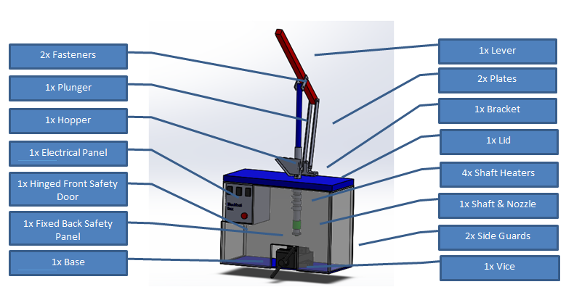

Despite some parts of the PPIMM remaining identical, other parts needed changing to optimise the design. Please refer below for the list of changes;
- As per the QFD, the highest weighted function was the need to optimise Health and Safety. The design improvement to Health and Safety are as follows-
- Safety guards have been introduced therefore the whole heating system is enclosed. The enclosure has removed all risks of burns during use however users will still be at risk when handling parts after the cycle is complete. Users will be advised on the Standard Operating Procedures (SOP) to not remove the mould from the machine too soon after the cycle as there is a risk of burns. The safety guards that have been introduced are completely transparent to allow full visibility of the process to improve educational learning opportunities too.
- The previous triangular based structure has been modified to a sturdier base. The machine has been designed to be placed on top of a desktop bench. The lack of stand improves the stability of the item, and also ensures that the weight of the item is kept as low as possible. The functional working height of the equipment has now been improved as the user can now choose a desktop bench of a height which suits their working practices best therefore improving the ergonomics.
- The electrical panel and components all remain the same, minus the addition of an emergency stop button. The simple addition provides huge Health and Safety improvements as users will no longer need to lean over the potentially hazardous operating machine to turn off the power if an emergency occurs. There is now a faster and safer approach to turning off the machine.
- An extraction unit will be introduced for LEV purposes via an extraction hose which is fitted through the back of the back guard to remove all harmful fumes.
- The PPIMM design was recognised to lack a housing location for moulds. One simple change has resolved the issue;
- A simple off the shelf vice has been included into the injection moulding machine. The vice was selected as the best method to house injection moulds as the tool is a cheap and easily accessible globally. The tool which is very affective at holding moulds of varying sizes too. The process limitation is that the vice can only hold moulds within the size of the vices bed.
- Changes to improve the corporate and professional appearance of the machine included;
- The design will now recommend within the BOM to build the machine following their Precious Plastics colour scheme, blue. Parts of the machine which could easily follow this colour code are the base, and the lid. As part of the new design Precious Plastic will add their logo to the open sourced files accessible online for creators to download, print and attach to their equipment.

Technical Drawing

Figure 8- Main Assembly Drawing
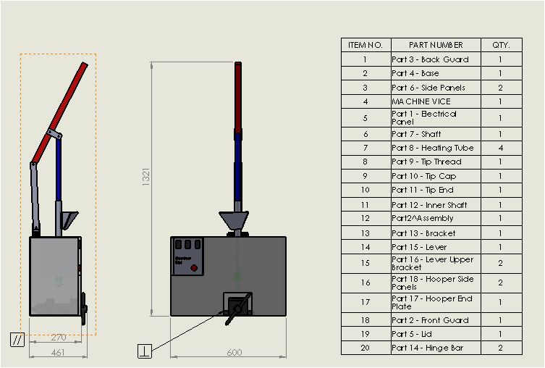
The main assembly drawing shown in Figure 8 displays that the overall dimensions of the machines footprint is in keeping with the design specifications previously stated from the customer requirements. The machine passed the factory acceptance test as the base is less 1 meter squared.

Within Figure 8 is the revised BOM. The BOM shows that there are a total of 20 different components, which is more than the previous design of 15 different components however each component is very easy to source. The only item which is not stated on the BOM is the extraction unit as there are many different extraction units available and it is best to allow the user to decide which extraction unit is the best for them. The assembly tutorials will be updated to demonstrate how to build the new unit. The updated tutorials will state recommendations for extraction units, the type of filter required for extracting plastic fumes and also state the maintenance required for extraction units for example filter changes etc. to assist builder.

Material Selection

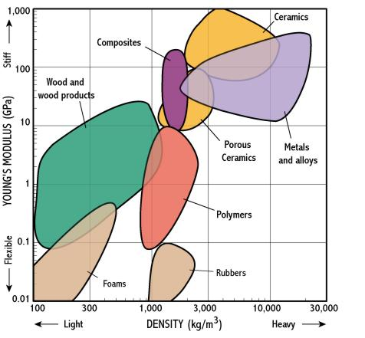
Figure 9 - Material Selection Chart (G-Engineering, 2018)
When introducing new parts to the design is was critical that the material chosen for each part was carefully decided. Firstly, the Base & Lid needed to be strong and rigid to hold the entire unit together. Analysis of materials from a material selection chart suggested that a polymer would be an appropriate level of Young’s Modulus and also have the desired medium density.
Figure 10 - Acetal Data Sheet (WS Hampshire Inc, 2018)
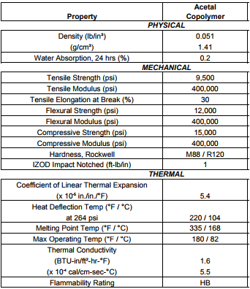
The material selected for the Base & Lid as an outcome of this information is a sheet of Acetal. The data sheet for Acetal confirms that the material is appropriate.

Acetal has a high strength, modulus, and also is resistant to impact and fatigue. It is often used as a weight-saving metal replacement. Acetal can be purchased in any colour therefore can be selected in Precious Plastics corporate blue colour too. The material is also easy to machine to size which is perfect for Precious Plastic’s machine builders.

Geometric Dimensioning and Tolerancing (GD&T)
GD&T is the overarching language used in design, manufacturing and quality inspection according to (GD&T Basics, 2018). GD&T combines a set of symbols, rules and principles to ensure that everyone is on the same page regarding how a feature or part is defined. When a design engineer hands off a drawing to a machinist, they need a common technical language for communicating exactly what must be done. The main assembly drawing in Figure 8 shows very basic GD&T symbols showing which faces must be parallel and also faces which must be perpendicular; however there are large areas to improve. The main assembly drawing lacks many of the geometric characteristics shown in Figure 11 which could be added to immensely improve the drawing.
Figure 11 - GD&T Table of Symbols (GD&T Basics, 2018)
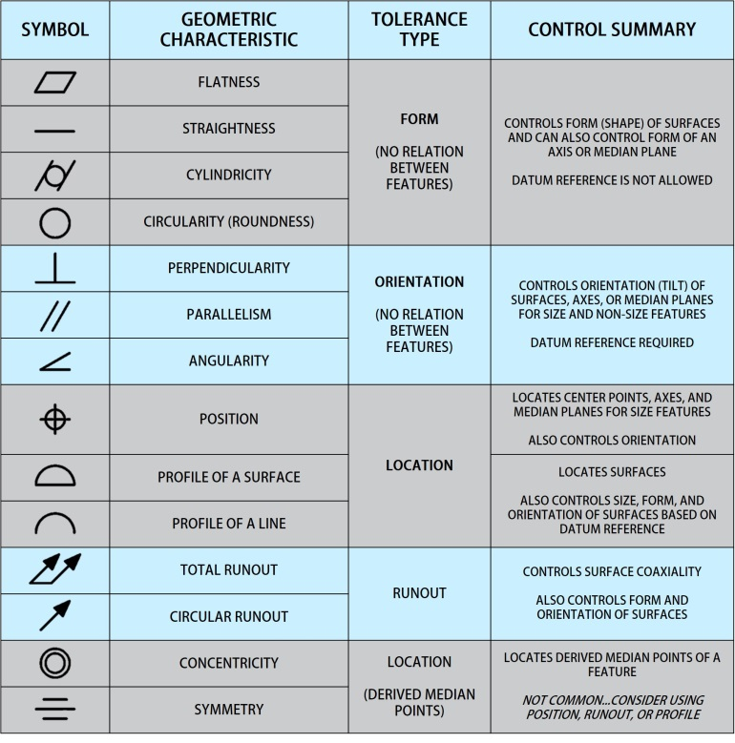

Limits and Fits
Attention to limits and fits is very important when designing a machine to be manufactured. One wrong dimension/tolerance and then the whole machine could be useless as it will be unable to be assembled appropriately. For example; a tolerance which is stated too low could result in the guarded enclosure having gaps which poses Health and Safety risks; a tolerance that is too high could result in the front door of the enclosure being unable to shut. For this design, all the critical tolerances such as the shaft, plunger, lever etc carry over the previous tolerances as the components are identical. However, for the newly introduced parts such as the guards, base, lid, and hinge bracket the geometric tolerance has been stated as ±0.2mm as the tolerances do not require a huge degree of accuracy. A 0.2mm tolerance allowance is achievable for an individual using hand tools such as hacksaw or a drill.

FMEA
Nancy R. Tague (2004), wrote in her second edition book titled The Quality Toolbox that failure modes and effects analysis (FMEA) is a step-by-step approach for identifying all possible failures in a design, a manufacturing or assembly process, or a product or service. “Failure modes” means the ways, or modes, in which something might fail. Failures are any errors or defects, especially ones that affect the customer, and can be potential or actual. “Effects analysis” refers to studying the consequences of those failures.

Table 3 – FMEA (Template from GE Medical)
 |  |  |  |  |  |  |  |  |  |  | Action Results
Item / Function | Potential Failure Mode(s) | Potential Effect(s)  of Failure | Sev | Mechanisms of Failure | Prob | Current Design Controls | Det | RPN | Recommended  Action(s) | Responsibility | Actions Taken | New Sev | New Occ | New Det | New RPN
Injected recycled material | Recycled polymer does not melt | Fails to melt therefore not injected into mould | 5 | Wrong material used. | 4 | None. | 1 | 20 | Specify which materials are suitable for the system in the SOP. | Process Eng. | SOP guidance provided. | 5 | 2 | 1 | 10
Injected recycled material | Recycled polymer does not melt | Fails to melt therefore not injected into mould | 5 | Failure of electrical component. | 1 | None. | 1 | 5 | N/A | N/A | N/A |  |  |  | 0
Injected recycled material | Recycled polymer does not melt | Fails to melt therefore not injected into mould | 5 | Poor contact of heating elements to shaft. | 7 | None. | 4 | 140 | Ensure heating elements are tight during build. Introduce monthly maintenance to ensure elements are securely fastened. | Process Eng. | Monthly maintenance task introduced. SOP updated to reflect critical requirement. | 5 | 2 | 1 | 10
Mould Housing | Mould not securely held | Polymer melt could spill | 10 | Burns to users from contact with hot polymer melt | 6 | None. | 8 | 480 | Introduce safety guards and introduce a mould housing tool. | Health & Safety and Process Eng. | Guards introduced. Vice introduced to house mould. | 10 | 2 | 2 | 40
Fumes from polymer melt | Fumes released into an uncontrolled environment | Inhalation of fumes | 10 | Damage to users lungs | 8 | None. | 8 | 640 | Introduce extraction unit suitable for polymer fumes. | Health & Safety | Extraction unit introduced. SOP updated to reflect need for extraction unit. Annual maintenance to replace filters. | 10 | 2 | 2 | 40

A small FMEA, as shown in Table 3, has been created to show how useful the tool can be for identifying failure modes, severities, probabilities and detectability’s to produce an over RPN for a current function. The FMEA then guides the user to recommend an action to reduce the RPN to as low as responsibly possible, and then states the department responsible for implementing the improvement. Finally the FMEA rescores the severity; probability and detectability in the hope that the RPN is reduce to an appropriate figure. If the RPN still remains higher than appropriate then more recommended actions can be stated.

If I were to repeat this report I would complete a FMEA at the beginning of the project to assess the original Precious Plastics Injection Moulding Machine, and then use the recommended actions to guide the design improvements in addition to the QFD, rather than relying on the QFD only.

Appraisal of Final Design
Engineering design is finding a compromise between design improvements and costs. Every company including Precious Plastics strive to improve the performance of their machines but also consider cost implications too. During the decision stages of determining whether a design would benefit from being redesigned, it was critical to make sure only design improvements that brought value to the product were chosen. Value could have been added by improving the design to manufacture aspects, increasing customer satisfaction, or even reducing the costs to build and maintain the machine.

Tools such as QFD, KANO Model, Pugh Matrix, Design Specification, Material Selection Graph, FMEA all contributed to the outcome of redesigning the machine. The redesign included the most cost justified improvements to suit the desires of the customer without increasing the difficulty to build. The BOM now has more components but all components remain very simple to source and to build. The end design is not perfect, nor is it close to industry equivalent injection moulding machines however it is almost perfect for its target audience who require a low cost solution for turning recycled plastic into saleable product. The design was published on Precious Plastics for review.

Design Area’s for Future Improvements
On completion of the improved design, the technical drawings were released onto Precious Plastics community forums on the internet for evaluation. Only a very small sample size of three individuals responded to the request to evaluate the design. The three members of the community who responded were very positive about the new improved injection moulding machine however they also had improvement suggestions too – see below;

The first reviewer commented that they liked that a vice was selected for the housing mechanism for holding moulds as the tool is very easily accessible globally at a very low cost. They appraised the corporate colour and logos, and also appraised the new improved sturdier base. The individual did however comment that the design would benefit from tolerance stack up analysis as they were nervous that if they built the machine to the current dimensions it might not fit perfectly.

Another commented that even though the hopper is the very same design as the PPIMM, the design should have changed to make the machine even easier to build as the creation of the hopper came with hidden costs due to the welding requirement. Welding is very effective for assembling the hopper but welding is not a skill that everyone has. Welding equipment is not commonly found in every household, and most would need to hire the equipment or even hire an individual to weld on their behalf due to the lack of skillset. The hopper would have benefited hugely from the design being changes to be built using brackets and bolts instead. The use a drill to assemble brackets and bolts would be simpler and would align better with the majorities’ capabilities.

Lastly, the other reviewer appraised the effort made to improve the user’s health and safety. This reviewer stated that they currently had a PPIMM and experienced burns previously from accidentally having skin contact with the heating elements during operation due to the lack of guards. The individual stated they were anxious every time they taught a new person to use the machine as they did not want others to injure themselves too, the solution of the guards was very happily accepted. This reviewer also commented that they liked that the guards suggested are transparent to encourage full visibility of the process which supports learning aspects of the process.

Analysis of the forum comments shows that even though the Voice of the Customer (VOC) was listened to at the very start and translated into a QFD, not all customer comments were listened too. Next time the information collected from the VOC would benefit from a larger sample size to hopefully include more aspects of customer opinion. If a larger sample size was used maybe the QFD would have pointed the designer to remove the need for welding and improved the design even more. Overall, the design has been very well accepted. The design is certainly not perfect, but it has a sufficient balance between function, safety and customer satisfaction.

Self-Evaluation
Overall I would deem the redesign of the injection moulding machine as a success as the CAD drawings successfully show a fully functioning, moving machine which is capable of producing injection moulded parts. The redesign included the highest weighted aspects of the VOC customer requirements and translated those into achievable functional requirements. If this report were to be repeated again I would take a larger sample of customer responses evaluating the PPIMM with the aim to collect a more detailed response. If a larger VOC sample size was taken then the likelihood would be that the reviews of the improved design would be more positive as more customer opinions would have been taken into consideration.

If I were to repeat the design steps again I would complete the FMEA sooner in the task to allow it to drive improvement ideas, rather than solely capture the work at the end. If a FMEA was done sooner in the report then potentially the RPN rating could have been reduced even further.

Reference List
Baxter, M., 1995. Product Design. First ed. Brunel, UK: CRC Press.
Bellhouse, T., 2016. NBS. [Online]
Available at: https://www.thenbs.com/knowledge/10-reasons-you-should-write-a-specification
[Accessed 26 May 2018].
Ferris, L., June 2015. Envirocare. [Online]
Available at: http://envirocare.org/plastic-fume-monitoring-exposure
[Accessed 05 June 2018].
GD&T Basics, 2018. GD&T Basics. [Online]
Available at: https://www.gdandtbasics.com/
[Accessed June 2018].
G-Engineering, 2018. Material Selection. [Online]
Available at: http://www-g.eng.cam.ac.uk/125/now/mfs/tutorial/non_IE/charts.html
[Accessed June 2018].
Hakkens, D., 2015. Community Forum. [Online]
Available at: https://davehakkens.nl/community/forums/search/cycle+time+injection/
HSE.Gov, 1974. Health and safety made simple. [Online]
Available at: http://www.hse.gov.uk/simple-health-safety/index.htm
[Accessed 29 May 2018].
HSE.Gov, 2015. Safety at injection moulding machines. [Online]
Available at: http://www.hse.gov.uk/pubns/ppis4.pdf
[Accessed 30 May 2018].
iSixSigma, 2018. Pugh Matrix. [Online]
Available at: https://www.isixsigma.com/dictionary/pugh-matrix/
[Accessed June 2018].
M.E., 2018. Product Design Specification. [Online]
Available at: http://www.me.umn.edu/courses/me4054/assignments/pds.html
[Accessed 27 May 2018].
NPD Solutions, 2018. NPD Solutions - Customer Focused Development with QFD. [Online]
Available at: http://www.npd-solutions.com/qfd.html
[Accessed 01 June 2018].
Precious Plastic, 2018. About Us. [Online]
Available at: https://preciousplastic.com/en/machines.html
[Accessed 10 May 2018].
Precious Plastics, 2018. Precious Plastics - Mould Bazar. [Online]
Available at: https://bazar.preciousplastic.com/?category=moulds&price_max=1000&price_min=0&view=list
[Accessed 29 May 2018].
Roberts, P., 2018. Bill of Materials. [Online]
Available at: http://www.billofmaterials.net/
Shina, S. G., 2012. Concurrent Engineering and Design for Manufacture of Electronics Products. 1st ed. New York: Van Nostrand Reinhold.
Tague, N. R., 2004. The Quality Toolbox. Second Edition ed. s.l.:ASQ Quality Press.
Trzcielinski, S., 2014. Advances in The Ergonomics in Manufacturing: Managing the Enterprise of the Future. Version 1 ed. United States: AHFE Conference.
Verduyn, D., 2014. KANO Model. [Online]
Available at: https://www.kanomodel.com/about-the-kano-model/
[Accessed 02 June 2018].
Verma, N., 2013. Slide Share - Kano Model for Customer Needs. [Online]
Available at: https://www.slideshare.net/niteshv/kano-model-for-customer-needs
[Accessed 02 June 2018].
WS Hampshire Inc, 2018. Data Sheet Acetal. [Online]
Available at: http://www.wshampshire.com/pdf/acetal_grades.pdf
[Accessed June 2018].

Appendix – Supporting CAD Images


