

Programme Name: Master of Business Administration
Module Name: Marketing Management
Module code: LCMB7024
Assignment Title: Assessment 2: Portfolio Brand Extension

Submitted by:
Student Name: Md. Nadimul Hasan Shuvo
Student ID: 2428681
Submitted to:
Lecturer’s Name: Dr Laila Maazouz
Module Leader of Marketing Management
Submission Date: 22.04.2025
Total Wards Count: 2721

Table of Contents
Introduction 3
Brand Extension 4
STP for the New Brand Extension 6
Segmentation 7
Targeting 8
Positioning 8
Customer Personal Profile 9
Demographic 9
Psychographic 11
Marketing Mix Strategy 12
Product 12
Price 12
Promotion 13
Place 14
Process 15
People 15
Physical Evidence 16
Conclusion 16
References 18

Introduction
A brand extension is a marketing tactic where companies use their brand recognition to introduce a new product or service in a different category through the utilisation of marketing tools and technologies (Bagozzi et al., 2021). Apple Inc., founded in 1976 by Steve Jobs, Steve Wozniak, and Ronald Wayne, is one of the world's most influential multinational technology companies (Beattie, 2024). Apple Inc. is a pioneer not only as a giant in consumer technology, but also as a brand that embodies innovation, intuitive design and a dedication to improving daily living through products like the iPhone, iPad, and Mac. In the United Kingdom, Apple has also developed a loyal audience appreciative of quality, security, and future-forward solutions.
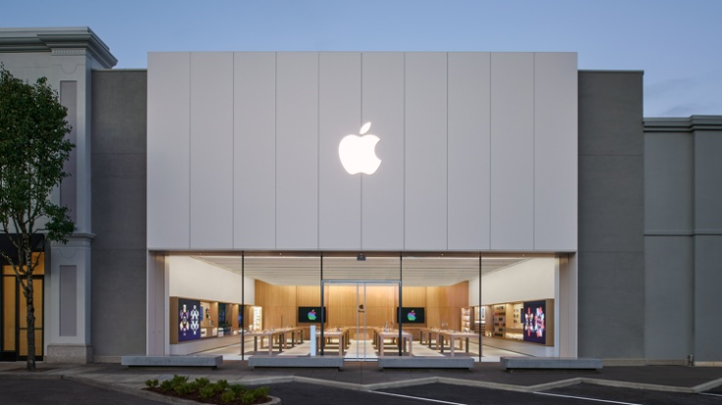
Figure 01: Apple Storefront (Source: Apple, 2025)
The travel industry in the UK has undergone some dynamic changes over the last few years. Reflective of UK travellers' desire to engage in richer, more tailored low-tech experiences, there is an increasing demand for technology that goes beyond logistics, enhancing the journey itself. Research has shown that immersive travel experiences by augmented reality (AR) are predicted to boost user engagement, and the worldwide AR market is expected to grow yearly by more than 20% over the coming years (Shukla, 2020). In light of these trends, there is a real opportunity for Apple to expand its brand into the travel and tourism space.

Thus, this report introduces a new brand extension, Apple Voyage, designed to transform travel experiences. It is an Augmented Reality-based travel assistant providing real-time, immersive destination experiences, smart itinerary planning & personalised travel guidance through Apple devices for the UK market. This report will analyse the brand extension, STP analysis, Consumer Profile analysis, as well as Marketing Mix analysis for the company to understand its effectiveness within the UK market.

Brand Extension
Description of the Proposed New Brand Extension

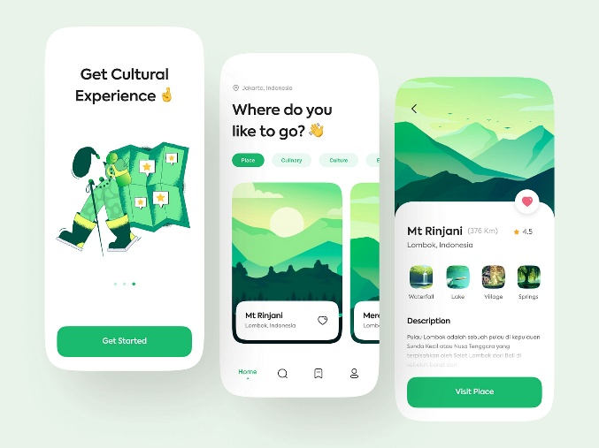
Figure02: Concept Design of Apple Voyage (Image Source: Arinasdd, 2025)
Apple Voyage, a revolutionary travel platform powered by Apple’s cutting-edge augmented reality (AR) technology that changes the way users experience and plan travel. Focusing only on the UK market, Apple Voyage provides the ultimate solution to the modern traveller by delivering real-time, personalised recommendations, interactive AR-enabled maps, and dynamic previews of destinations. The service integrates into existing Apple ecosystems like Apple Maps, Calendar, Wallet, and Apple Watch (Bradley, 2022). Users can type in a destination to receive a tailored itinerary enhanced with AR overlays that pinpoint attractions, off-the-beaten-path finds, cultural facts and recommendations for local eats or entertainment. Other features are things like real-time translation of languages, local currency for exchange and reverse AI-driven itinerary to adapt preferences, past behaviour and global events.
Alignment with Apple’s Brand Values and Market Position
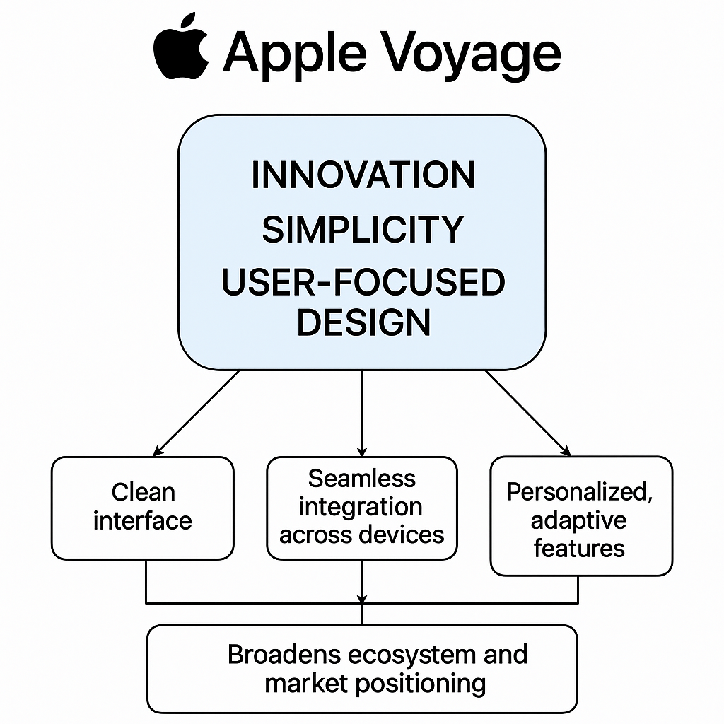
Figure 3:Alignment with Apple’s Brand Values and Market Position (Bareerah Shoukat, 2023)
The Apple Voyage concept blends perfectly with Apple’s mission of innovation, simplicity, and user-focused design. Apple has proven to be constantly adapting to cutting-edge technology while enhancing work-life (Accelingo, 2024).Apple Voyage reflects these principles by offering a clean interface, seamless integration across Apple devices, and personalised, adaptive features that evolve throughout the travel experience. The platform not only strengthens Apple’s identity as a technology leader but also enhances its positioning within lifestyle and experiential sectors. By extending into travel, Apple broadens its ecosystem in a way that feels natural, logical, and entirely consistent with its existing market position as a premium, innovative brand.
Value Addition, Market Gap Fulfilment, and Emerging Needs
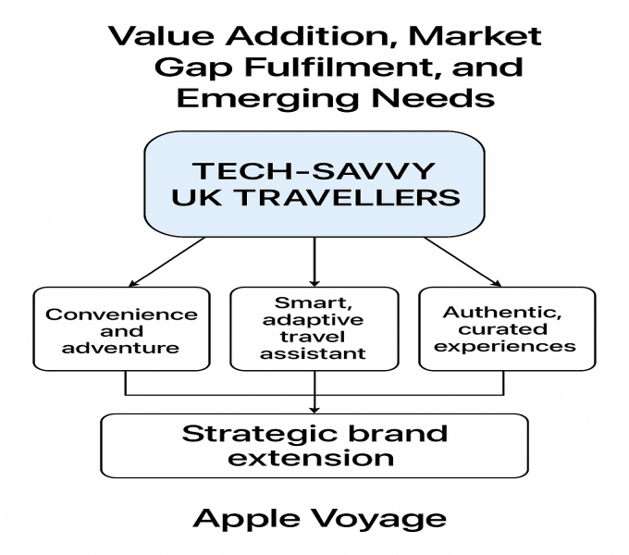
Figure 3: Value Addition, Market Gap Fulfilment, and Emerging Needs (Kumarasinghe, 2024)
Apple Voyage addresses a clear and growing demand among tech-savvy UK travellers for seamless, immersive travel experiences. In the wake of the post-pandemic travel boom, consumers increasingly seek services that offer both convenience and adventure. As highlighted by Kimunio, Nandelenga, and Makambi (2024), UK travellers are willing to invest in platforms that simplify travel planning while enhancing the overall experience. Apple Voyage responds to this demand by providing a smart, adaptive travel assistant that integrates logistics with rich, location-specific content. Collaborations with local tourism boards, cultural institutions, and hospitality providers will further enrich the platform with authentic, curated experiences. This strategic brand extension not only fills a market gap but also strengthens customer loyalty, diversifies Apple's service offerings, and repositions the brand as an essential lifestyle companion for modern travellers.

STP for the New Brand Extension
STP (Segmentation, Targeting, Positioning) marketing focuses on commercial effectiveness, selecting the most valuable segments for a business and then developing a marketing mix and product positioning strategy for each customer group (Hanlon, 2024).
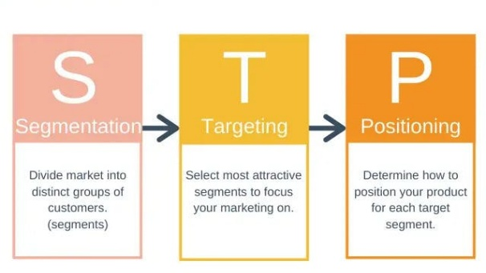
Figure 03: STP Marketing Model (Source: AWWARE, 2023)

Segmentation
For Apple Voyage, the market segmentation is structured around demographic, geographic, psychographic, and behavioral variables:
Segmentation | Details
Demographic | Age: 25–55 years; Gender: All; Income: £45,000–£90,000; Occupation: Professionals in tech, finance, marketing, and creative sectors; Education: University degree or higher.
Geographic | Urban UK areas with high tourism and tech adoption: London, Manchester, Birmingham, Edinburgh, Bristol. These cities host a high concentration of professionals and frequent domestic/international travellers.
Psychographic | Lifestyle: Experience-driven, tech-forward, curious explorers; Values: Efficiency, innovation, personalisation; Preferences: Unique, culturally immersive travel enhanced by digital tools.
Behavioral | Usage: Frequent travellers; Loyalty: High brand loyalty to Apple; Benefits sought: Convenience, personalisation, real-time updates; Technologyadoption: Early adopters of mobile and AR experiences.

Table 01: Potential Marketing Segmentation for Apple Voyage (Source: Author)
Targeting

The primary target segments for Apple Voyage are:
- Affluent Urban Professionals:Thesewill be individuals who travel for work and fun. They want efficiency, personalised recommendations and premium service integration. Their tech-savvy but deep brand loyalty to Apple makes them perfect for a service that enhances their travel experience.
- Young, Experience-Driven Travellers:This group is made up of millennials and Generation Z, who are social media enthusiasts, adventurous and love technology-driven engagement (Schaefer, 2025). They do not just seek convenience but memorable moments, shareable experiences as they travel.
- Family Vacationers:Family-centric travelers, who value interactive, educational, and entertaining travel experiences, are also a key segment. They appreciate a digitally secure and easy-to-use interface that enables adult supervision yet child-friendly travel navigation.
To enable personalised marketing initiatives, the targeting strategy combines concentrated targeting, focusing on these high-potential segments, with a multi-segment approach. By catering to the distinct travel requirements and technological preferences of each group, this approach aims to optimise market reach and enhance the overall customer experience (Kotler, Armstrong and Balasubramanian, 2023).

Positioning
Apple Voyage will act as an enhanced travel guide powered by AR; traditional trips will be turned into genuine experiences personalised to the user's custom preferences. Positioning statement for Apple Voyage:

“For the modern UK traveller seeking a seamless blend of technology and adventure, Apple Voyage provides a cutting-edge, AR-enhanced travel platform that integrates effortlessly with your digital life—delivering curated, real-time insights and interactive experiences that no other travel service can offer.”

This positioning takes advantage of Apple’s strong brand identity of innovation, premium design and integration. In a crowded travel space where competitors offer either generic or very disjointed travel solutions, Apple Voyage positions itself as a fully integrated, immersive travel companion that is seamlessly at home planning itineraries as it is enriching time on the ground with overlay real-time augmented content and personalised experiences. The service is directly built for simplicity, security, and core integration with other Apple services (Apple Maps, Calendar, Wallet), so travel starts as soon as you create a travel plan. Apple Voyage's cutting-edge focus on evolving needs of the tech-enthusiast and experience-seeker creates an authentic travel solution for UK consumers–no longer about a mere room with a view, the Apple Voyage is a sophisticated offering, revolutionising space for a new generation of UK consumers.

Customer Personal Profile
Apple Voyage is designed for a very specific kind of consumer, one who balances a command of the digital world with a desire for adventure.

Demographic
Here are the potential demographic factors and characteristics for the new brand extension:
Attribute | Description
Age | Primary customers are aged 28 to 50, reflecting a blend of young professionals and mid-career travellers who seek convenience, enrichment, and tech-driven solutions when travelling.
Gender | Gender-balanced; the service appeals equally to male and female users who are digitally engaged and value seamless travel experiences.
Income | Annual personal income typically ranges between £45,000 and £90,000. This group can afford premium subscriptions and frequently travels domestically and internationally.
Occupation | Includes professionals in technology (such as, software engineers), finance (such as, analysts, consultants), marketing, academia, and creative industries. These individuals often combine leisure with business travel and prefer tech-enhanced planning tools.
Education | Most users have at least a university degree, often from UK-based institutions, and are comfortable with high-end digital solutions.
Location | Concentrated in urban hubs such as London, Manchester, Birmingham, Edinburgh, and Bristol, where tech adoption and travel interest are notably higher.

Table02: Demographic Factors Analysis for Apple Voyage (Source: Author)

Psychographic

Here are the Psychographic characteristics:
Aspect | Description
Lifestyle & Values | These customers are explorers by nature, valuing efficiency, personalisation, and experiential richness. They often plan multi-day city breaks or cultural trips and want tools that help them discover places beyond tourist clichés.
Attitudes | Strong preference for data security, intuitive design, and seamless integration. They trust Apple as a secure, premium brand and are willing to pay extra for products that elevate comfort and utility.
Buying Behaviour | Likely to subscribe to premium digital services (such as, Apple One, Spotify Premium, Airbnb Plus). They seek value in customisation, exclusivity, and digital intelligence when choosing travel tools.
Aspirations | Aspire to experience the world more authentically and intelligently. They are motivated by cultural learning, unique activities, and the ability to plan effortlessly while staying connected through technology.
Tech Orientation | Early adopters of AR and smart technologies. Comfortable with iPhones, Apple Watch, and wearable tech, and often use multiple Apple devices.

Table 03: Psychographic Analysis for Apple Voyage (Source: Author)

Marketing Mix Strategy
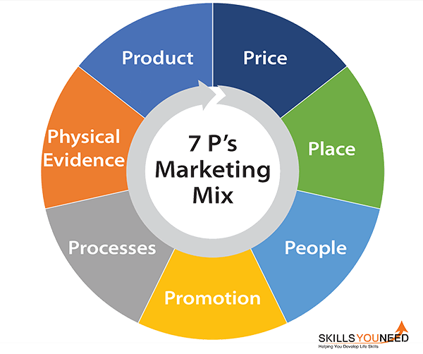
Figure 04: Marketing Mix Elements (Source: SkillsYouNeed, 2021)

Product
Apple Voyage would be integrated with the rest of Apple's technology also and functions as a smart, AR-powered travel tool. As a digital service, its core elements are interactive, real-time augmented reality overlays, personalised itineraries and machine learning-driven recommendations for individual destinations. These are not able to be used on their own, they will have to pair them itother existing Apple devices like an iPhone, iPad, or an Apple Watch. Drawing on Apple’s history of design excellence, Apple Voyage has a simple, minimalist interface paired with powerful functionality.

Price
Apple Voyage implements a premium pricing model that is justified by its value propositions, seamless integration alongside Apple’s existing ecosystem, and enhanced convenience offered to users for personalised travel arrangements. They can become subscription-based, either monthly or annual, with numerous packages targeting distinct user types.
Tier | Monthly Price | Features
Basic | £4.99 | Access to interactive maps, a basic itinerary planner, and limited AR features
Plus | £9.99 | Full AR overlays, real-time updates, offline access, trip sharing
Pro (Premium) | £14.99 | Exclusive content, concierge support, integration with Vision Pro, and early feature access

Table 04: Pricing Strategies for Apple Voyage (Source: Author)
As an example, a basic consumer tier can offer key features to casual travellers, while a premium consumer tier can pack in even more, including access to exclusive, curated travel content, priority customer support, or integrations with exclusive partnerships such as museum passes or local events discounts.

Promotion
Marketing for Apple Voyage wil include building on the strength of Apple’s brand and targeted messages for the UK travel market. D will be essential, incorporating both digital platforms and traditional media.
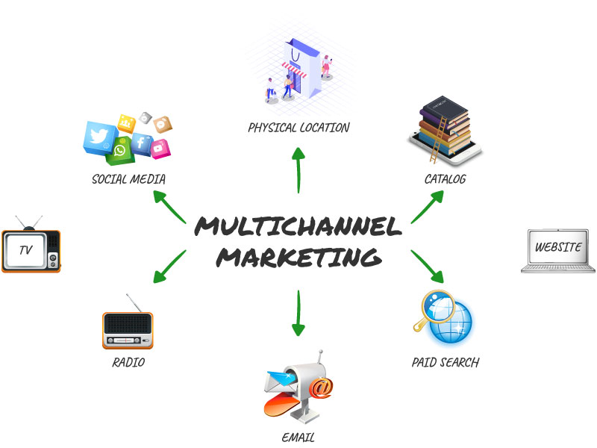
Figure 05: Multi Channel Marketing Strategy (Source: Alisha, 2020)
- Digital Channels: In-app promotions on iOS devices, push notifications, YouTube ads showcasing AR travel features, and Apple TV product placements.
- Influencer Partnerships: Collaborations with UK travel influencers and tech reviewers (e.g., @thetravelproject, @wanderlustchloe) for product reviews and live demos.
- Retail Events: Apple Store demo zones in major cities (London, Birmingham, Edinburgh) to showcase AR capabilities.
- Email Marketing: Targeted emails to Apple One subscribers and iCloud users promoting a free 1-month trial.
- AR Pop-Up Booths: Immersive AR booths in UK airports (Heathrow, Gatwick) to allow travellers to test the experience before flying.
These initiatives will help create awareness, promote free trials and convey how the Apple Voyage revolutionises travel as a more meaningful experience, simple and effective.

Place
Apple Voyage is distributed mainly digitally, which means it is accessible to the world directly through the App Store and integrated through Apple’s ecosystem. The service’s rollout in the UK market will be bolstered through localised digital channels, optimising the platform for regional content, local currency and the unique travel requirements across the UK.
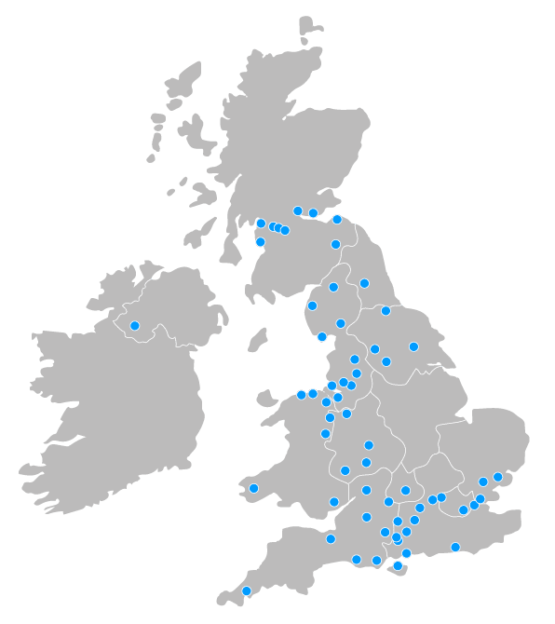
Figure 06: Targeted Place of the Apple Voyage (Image Source: Bradley, Dowrick and Lloyd-Williams, 2022)
Also, Apple can capitalise on its wide network of Apple Retail Stores to market the service to end users directly and also offer demos and customer support. Booking.com’s in-person touchpoints include strategic partnerships with well-known travel agencies, as well as with tourism boards in major cities across the UK (David, 2024).

Process
Efficiency and user experience lie at the heart of Apple Voyage and their service delivery. This starts when users onboard the platform by integrating their travel preferences, Apple account data, and travel experiences to create tailored itineraries.
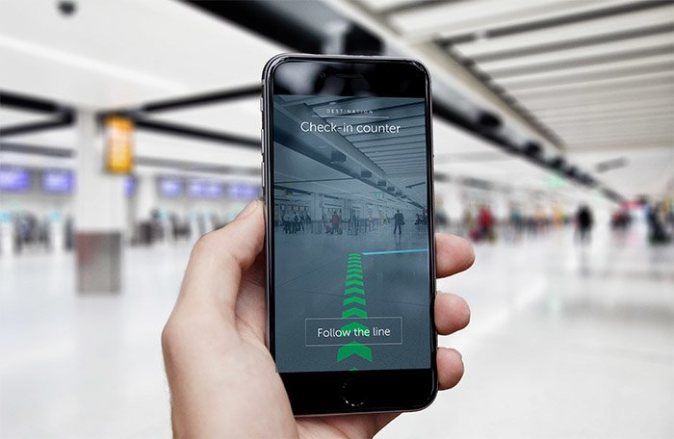
Figure 07: App Showing the Instructions for Next Move (Image Source: Evenstad, 2017)

Sophisticated algorithms further process collected data to offer immersive travel experiences enriched with real-time updates through push notifications, keeping travelers in the loop about flight updates, local events, or itinerary changes. Further, in-app customer support and a user-friendly feedback loop allow the service to improve in real-time based on the user experience (Kumarasinghe, 2024).

People
Behind Apple Voyage, Apple Inc. will have trained and experienced customer service representatives, AR technology developers, and travel industry experts who work together to help ensure an innovative and high-quality user experience. Apple’s current employees, focusing on customer support and technical innovation, will provide direct support and customised travel advice. Incorporating employee training programs tailored around digital travel advancements and specific cultural nuances present in the UK market will facilitate personable interactions (Marshall and Johnston, 2019).

Physical Evidence
The support of physical evidencewill help to convince the consumer about the product of the group and the service.Apple Voyage is an example of the strategies of the Apple group, which is based on the real experience that it can provide. This authority is expressed via the design and feel of its mobile apps, the visual fidelity and reliability of its AR features, as well as the smoothness of its integration with other Apple gadgets. Furthermore, Apple can take advantage thefollowing:
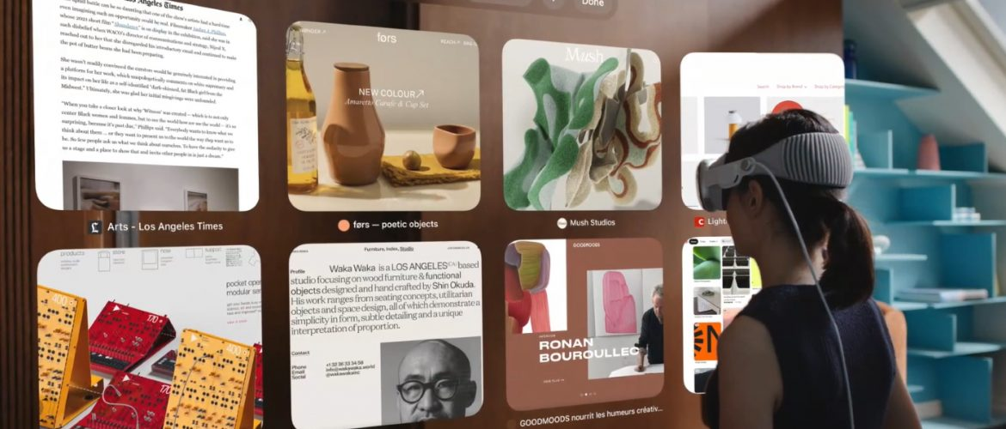
Figure 08: An example for AR-enabled Demos (Image Source: (Bareerah Shoukat, 2023)
- AR-enabled Apple Store demos and kiosks at UK airports.
- Branded visuals like interactive 3D maps, AR animations, and UI consistency across all Apple devices.
- Digital confirmations, downloadable itineraries, and personalised trip journals.
- Premium Apple packaging or printed guides for customers who opt in during promotional campaigns or bundle purchases.

Conclusion
In conclusion, Apple Voyage is a significant step into the rapidly changing landscape of immersive travel experiences, combining augmented reality and state-of-the-art technology with Apple’s innovation. It aimed directly at the synergistically tech-savvy UK market; this initiative explores new horizons for the masses, gearing towards experiential and personalised travel. Apple Voyage takes travel sites to new places by creating a holistic and user-centric travel companion that utilises real-time data, interactive AR overlays, and seamless integration with Apple products and services. With global travel trends moving towards post-pandemic recovery, the travel customer is searching for more immersive experiences, ones that will dominate logistics as well as those that aid in the exploration of their destination. Built to tackle these challenges, Apple Voyage aims to streamline travel planning while creating a stronger bond between consumers and the places in which they visit. With the fusion of regional collaborations, interactive content, and timely updates, users have access to personalised recommendations that are accurate and engaging.
Furthermore, this contribution also ensures Apple is staying ahead of its competitors, preserving its strong brand image, ecosystem, and excellence. Apple Voyage enhances its brand presence by incorporating its trusted services while staying ahead of competitors through this strategic move. Apple Voyage directs its marketing approach toward city workers and millennial generations, and households to establish its position as the essential travel tool for future journeys. As long as the company improves the quality of the product,keeps the constant innovation within the service’s features,the company will be able to provide a better user experience, to attain consumer loyaltyand a competitive advantage within the UK marketplace.

References
Accelingo (2024). Apple’s Global Strategy: Simplicity, Innovation, and Adaptability. [online] Accelingo. Available at: https://www.accelingo.com/apples-global-strategy/ [Accessed 14 Apr. 2025].
Alisha (2020). Multichannel Marketing: Definition and 7 Best Practices | NotifyVisitors. [online] Notifyvisitors.com. Available at: https://www.notifyvisitors.com/blog/multichannel-marketing/ [Accessed 14 Apr. 2025].
Apple. (2025). Apple Bridgeport Village. [online] Available at: https://www.apple.com/retail/bridgeportvillage/ [Accessed 14 Apr. 2025].
Arinasdd (2025). Travel App. [online] Dribbble. Available at: https://dribbble.com/shots/15057244-Travel-App [Accessed 14 Apr. 2025].
AWWARE (2023). Segmenting, targeting and positioning (STP) framework in marketing. [online] awwaredigital. Available at: https://awware.co/blog/stp-marketing/ [Accessed 14 Apr. 2025].
Bagozzi, R.P., Rosa, J.A., Sawhney, K. and Coronel, F. (2021). Marketing management. Upper Saddle River, N.J.: Prentice Hall.
Bareerah Shoukat. (2023, July 27). A Comprehensive Guide to Creating Apps with Apple Vision Pro. Retrieved April 22, 2025, from 10PEARLS University website: https://10pearlsuniversity.org/a-comprehensive-guide-to-creating-apps-with-apple-vision-pro/
Beattie, A. (2024). Steve Jobs and the Apple story. [online] Investopedia. Available at: https://www.investopedia.com/articles/fundamental-analysis/12/steve-jobs-apple-story.asp [Accessed 14 Apr. 2025].
Bradley, N., Dowrick, C., & Lloyd-Williams, M. (2022). A survey of hospice day services in the United Kingdom & Republic of Ireland : how did hospices offer social support to palliative care patients, pre-pandemic? BMC Palliative Care, 21(1). https://doi.org/10.1186/s12904-022-01061-9
David (2024). All About the Booking.com Affiliate Partner Program for Travel Agents. [online] Mize. Available at: https://mize.tech/blog/all-about-the-booking-com-affiliate-partner-program-for-travel-agents/ [Accessed 14 Apr. 2025].
Evenstad, L. (2017). Gatwick launches augmented reality airport navigation. Retrieved April 22, 2025, from ComputerWeekly.com website: https://www.computerweekly.com/news/450419533/Gatwick-launches-augmented-reality-airport-navigation
Hanlon, A. (2024). The Segmentation, Targeting, Positioning (STP) Marketing Model. [online] Smart Insights. Available at: https://www.smartinsights.com/digital-marketing-strategy/customer-segmentation-targeting/segmentation-targeting-and-positioning/ [Accessed 14 Apr. 2025].
Kimunio, I., Nandelenga, M.W. and Makambi, S. (2024). COVID19 and the Travel and Visitor Experience Economy: Challenges and Opportunities for the Postpandemic World. Tourist Behaviour and the New Normal, Volume I: Implications for Tourism Resilience, pp.109–126.
Kotler, P., Armstrong, G. and Balasubramanian, S. (2023). Principles of Marketing. 19th ed. Harlow: Pearson.
Kumarasinghe, J. (2024). Improving the B App to Improve Customer Experience and Operational Efficiency: From the Perspectives of User Engagement, Functionality, and Security.
Marshall, G.W. and Johnston, M.W. (2019). Marketing management. 3rd ed. New York, Ny Mcgraw-Hill Education.
Schaefer, A. (2025). How Gen Z uses social media and what that means for brands. [online] Sprout Social. Available at: https://sproutsocial.com/insights/gen-z-social-media/ [Accessed 14 Apr. 2025].
Shukla, D. (2020). AR And VR market size likely to grow exponentially. Market Survey, February, pp.84–87.
SkillsYouNeed (2021). The 7 Ps of Marketing Mix | SkillsYouNeed. [online] Skillsyouneed.com. Available at: https://www.skillsyouneed.com/lead/7-marketing-ps.html [Accessed 14 Apr. 2025].

