James Denton – 1702202
Project Management
Project Management & Research Methods
Sue Maw

Table of Contents

- Risks
  - Failure of Equipment
  - Failure of Backup Procedure
  - Loss of Personnel
  - Bugs

- Mitigating Risk Factors
  - Failure of Equipment
  - Failure of Backup Procedure
  - Loss of Personnel
  - Bugs

- Code of Practice
  - Sustainability Issues
    - Environmental
    - Social
    - Economic
  - Ethical Issues
  - Legal Issues
  - Brexit

- Quality Assurance Issues
  - QA VS Testing
  - Unrealistic Schedule
  - Misunderstanding of Functional Requirements

- Screenshots
  - Demonstration
  - Project Plan

- References

- Risks
Failure of Equipment
The equipment used to develop OQS (computers and their various components, monitors, peripherals, etc) could potentially suffer failure, resulting in personnel being unable to continue working on the project. Dependent on the amount of time required to replace or repair the faulty equipment, the deadline for a part of the project could be delayed, resulting in the entire project being set back by several days (or possibly even longer).

Failure of Backup Procedure
In the event of general component failure in an employee machine, any unsaved work would be lost. Such an event would result in loss of work, potentially resulting in overtime having to be paid to the employee to complete the work again or the missing of deadlines due to work being behind schedule. Even in the event of proper procedure being followed with regards to saving of work, there is always the possibility of storage device failure causing loss of documents.

Loss of Personnel
If it transpired that an employee had vacated their position, then this would cause a deficit in the amount of work being completed and this would have the potential to delay the project quite severely. The severity being dependent on the amount of time required to fill the position and the severity of the role.

Bugs
It is possible that in the process of producing this product, an error could be made in the programming. This could be due to a variety of reasons, but the most likely cause would be human error.

- Mitigating Risk Factors
Failure of Equipment
A study examining a million consumer PC’s states that machines that have already crashed once have a probability of 1 in 3.3 of suffering a second crash, [1] and that “White box” PC’s suffered from CPU Subsystem and DRAM failure rate of 1 in 93 and 1 in 950 respectively, vs a failure rate of 1 in 120 and 1 in 2700 respectively for “Brand name” PC’s (e.g. Dell, HP, etc.) [1].
As such, a good way of mitigating the risk of equipment failure would be to have any machines that have suffered a crash inspected before they are redeployed and used again, and any offending parts replaced. In addition, only purchasing PC’s from “Brand Name” manufacturers to ensure a good selection of reliable components and reduce the statistical risk of component failure.

Failure of Backup Procedure
A good way of mitigating the risk of document loss is to educate employees on proper save and backup procedure. This would include saving to their HDD (Hard Drive) on a regular basis (e.g. every hour) and uploading their work to a central server.
The company would also benefit from the implementation of proper backup procedures in such a central server, by having a local nightly backup and an offsite backup to protect against issues involving the working location.
A report was conducted on lifetime Hard Drive failure rates between April 2013 and December 2016. In Figure 1 below, the rate of failure for Hard Drives by drive size between 3TB and 8TB is shown. This shows that the drive size with the lowest failure rate is 3TB, with a failure rate of 1.4%. [2]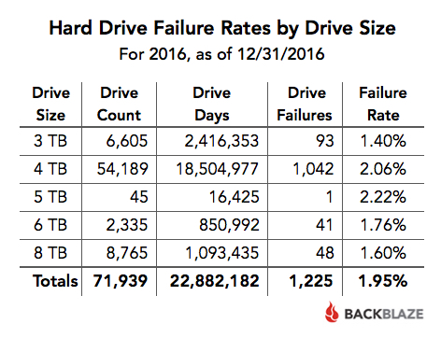

In Figure 2 below, the rate of failure for Hard Drives by Manufacturer is shown. This shows that the manufacturer with the lowest failure rate is HGST, with a failure rate of 0.60%. [2]
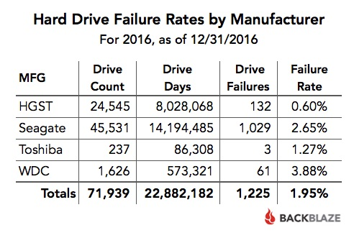
As such, a good way of mitigating loss of files due to storage failure is to use 3TB drives manufactured by HGST in personnel and backup devices to minimise the risk of drive failure and therefore loss of files.

Loss of Personnel
An employee could leave their post for a variety of reasons, ranging from career prospect to health and wellbeing. A report by LinkedIn states that the number one reason for changing jobs is career opportunity. [3] As such, it is important to ensure employees feel that there are opportunities for growth at the company to try to prevent loss of talent and the various delays ensuing.

Bugs and Compatibility issues
To limit the impact of human error as much as possible, implementing a policy outlining regular testing of code for employees to follow is a good idea. Having a team to test the program and ensure its features are all functional would also help to limit the number of bugs found in deployment by end users.

- Code of Practice
Sustainability Issues
When tackling sustainability, businesses must keep in mind the “triple bottom line”. These are people, planet and profit, as environmentally beneficial practices are associated with increased operating cost for businesses.
Sustainability can be broken down into Environmental, Social and Economic issues.
Environmental
On the issue of climate change, the most significant challenge of the current generation, a study by The European Environmental Agency found that the percentage of electricity used in Europe by the “Services” sector (e.g. IT) as of 2010 was 29.7%. [4]
As such, a good section for the Code of Practice would be “To ensure that energy efficient devices and modes (such as monitors, servers, air conditioners, lights, etc) are used where financially possible.” Another good section for the Code of Practice would be “To promote a corporate culture of powering down devices when not in use.
On the issue of e-waste, the accumulation of obsolete/broken electronic devices in landfill sites, the main factor is a lack of recycling, with only an estimated 20% of global e-waste being properly recycled, [5] and the amount of total e-waste generated by the world predicted to hit 52.2Mt (Metric Tons) by 2021, up from 44.7Mt in 2016, businesses need to work to reduce their waste. [5]
To combat this, a good section for the Code of Practice would be “To dispose of unneeded electronics in the most environmentally friendly way possible.”
Social
On the issue of personal wellbeing, businesses have a duty to their employees in ensuring that their work does not impact their physical or mental health. According to a recent survey, the largest cause of stress, depression or anxiety was workload, at 44%. [6]
As such, businesses should take such factors into account when designing their Code of Practice. A suitable section for the Code of Practice would be “To monitor employee satisfaction to ensure a healthy home/work balance.”
Economic
For businesses, economic sustainability involves ensuring that resources are used in the most advantageous way such as to maximise profits year after year. Paying employees, a fair wage is a good way of retaining employees by making them feel that they are valuable to the company. While this would, in the short term, cost more than paying the minimum, the savings in recruitment when employees inevitably leave for better opportunities would be avoided, leading to a significant saving in the long term.
Lowering employee hours can also have a large economic benefit. The slogan “Eight hours labour, eight hours recreation, eight hours rest.” Was famously pushed by Welsh activist Robert Owen. This did not become popularised until Henry Ford, who in 1914 famously lowered hours at his factories to 8 hours a day, 5 days a week and raised wages. The result of this was increased productivity and therefore profits.
As such, a good section for the Code of Practice would be “To pay employees a fair wage and work them for reasonable hours.”
Ethical Issues
Ethics, by definition, are a set of moral principles that are upheld for the benefit of humanity and is a complex issue that all businesses must face. Having reviewed the IEEE Code of Conduct, it seems that several of the rules expressed within are good candidates for the OQS Code of Conduct. For example, diversity is a great thing that promotes a wide range of views but forced diversity and minority quotas are forms of discrimination in of themselves. As such, I believe that a good section for the Code of Practice would be “To hire indiscriminately, based solely on individual talent.” and “To promote equal opportunity for all.”
The IEEE (Institute of Electrical and Electronics Engineers) Code of Conduct also outlines employee behaviour, stating “We will not engage in harassment of any kind, including sexual harassment, or bullying behavior whether in person, via cybertechnology or otherwise.” This was the inspiration for 2 lines of the OQS Code of Practice, which state “Employees will not participate in bullying, harassment or discrimination in all forms.” And “Employees will be respectful of others, and their privacy.”

Legal Issues
Every successful business has the responsibility to ensure that their activities (and by extension, the activities of their employees) fall squarely within the bounds of the law. The IEEE covers this in point 5 of the document, where it states, “We will comply with all applicable laws, rules and regulations governing IEEE’s business conduct worldwide.” This is an important piece of legal documentation and the OQS team should implement something similar. A suitable solution would be: “We will reject bribery in all its forms, avoid conflicts of interest, conform with all laws governing the protection of information, and not infringe on intellectual property.”

- Quality Assurance Issues
QA VS Testing
An understanding of QA (Quality Assurance) is required to understand why it is necessary. This causes problems for businesses as it is commonly confused with testing, the process of ensuring that the program is functional. This differs from QA, which is about the overall experience of using the software, and applies to the design, usability and adequacy of functionality. As such, testing is included with QA.
Any detail of the product that is in opposition with the client’s requirements can be considered a defect. The side of QA that we refer to as testing is called Defect Management Approach and is a system of grading defects in functionality by their severity to the project to assign priority. This is important when a product is already deployed and being used, as serious defects can have an impact on clients.
The other side of QA is known as Quality Attribute Approach, which examines functionality, reliability, usability, efficiency, maintainability and portability, [7] and examines all aspects of the product from its bare bones features to the time taken to use it.
To avoid such an issue, a QA tester should be hired by the OQS Team in addition to any software testing employees. This will ensure that the software features a fast and easy to use interface.
Unrealistic Schedule
Rushing the testing and QA phase of a software development project is a common thing in modern software development companies. Often, companies simply enact a beta branch of their software to have eager users test the software and submit feedback to avoid having to do any testing at all (e.g. Windows Insider Program). [8] This can often cause large issues for users and can be a source of bad publicity for companies and their software. [9]
As such, ensuring that there is adequate time in the schedule for the software to be QA tested and for any offending aspects to be tweaked so that the software is satisfactory, and the client is happy.

Misunderstanding of Functional Requirements
It is common for develops to not fully understand the requirements set out by a client, particularly if this is the first time working for said client. It is unreasonable to expect a programmer to know the intricacies of graphic design. As such, the onus is on the client to provide a descriptive set of requirements that are clear and concise, and on the developer to consult with the client when confusion arises regarding the specifications.
A good example of such a situation was the launch of Terminal 5 at Heathrow. Despite numerous dummy runs, the baggage transport system failed to account for the speed of baggage removal by handlers, causing the system to clog up with luggage and tens of flights to be cancelled, [10] all due to a lack of familiarisation with the day to day of baggage handling at an airport.
For OQS then, making sure that the requirements of potential users of this software are represented, and that the software is inspected by an industry insider before release to ensure that it is not lacking in functionality.

- Screenshots
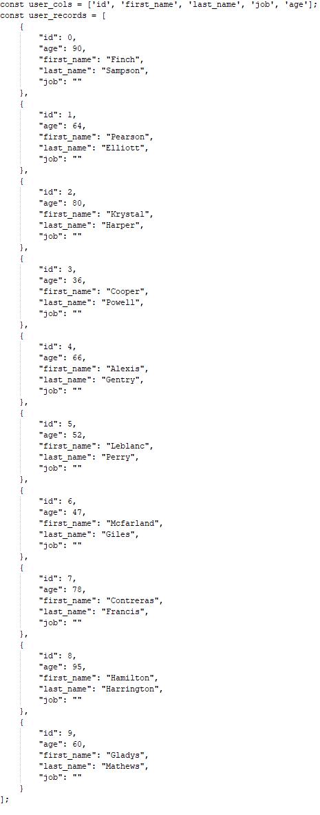
Demonstration

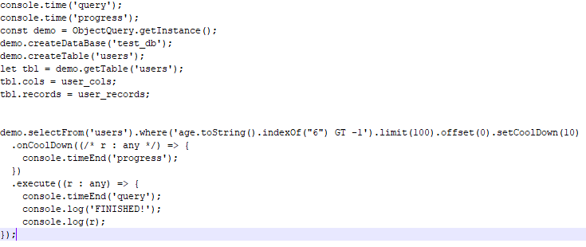

Project Plan
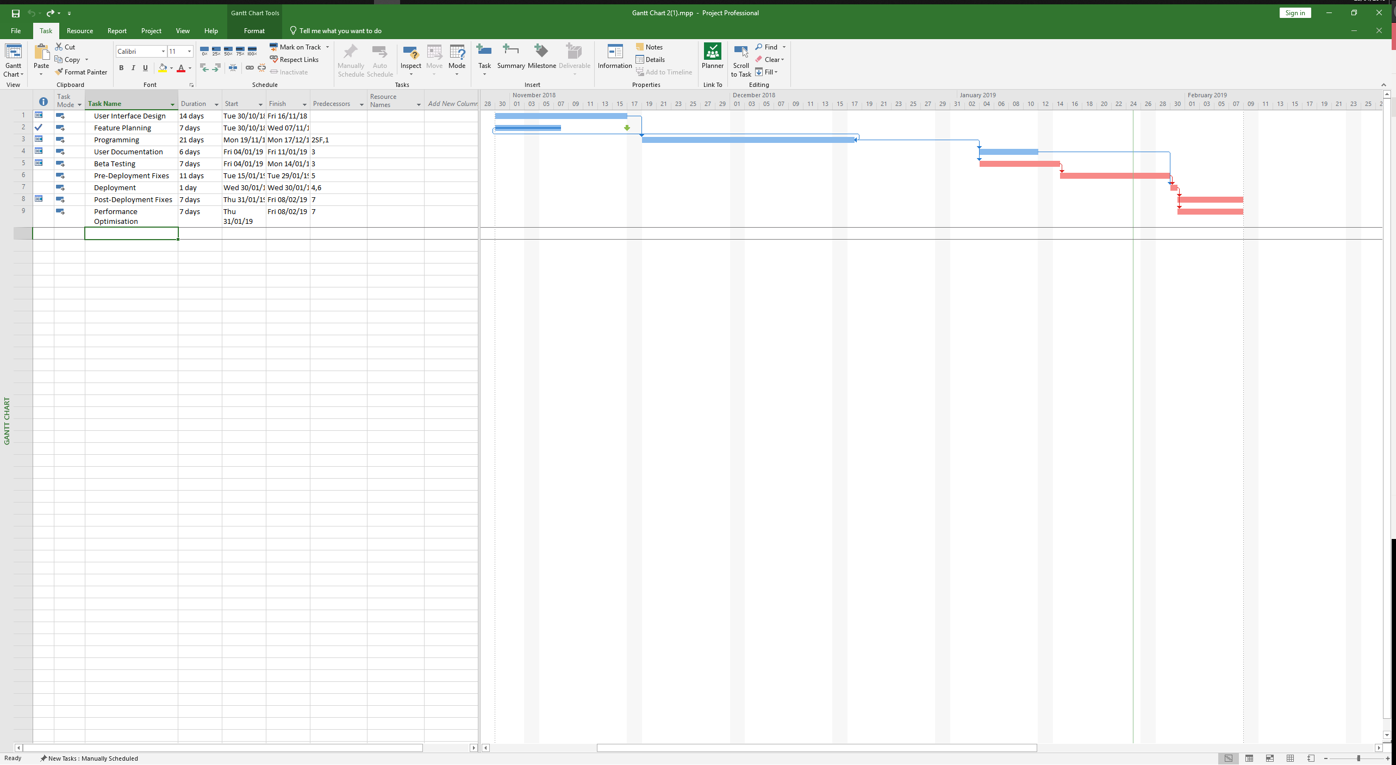

References

[1] | J. D. V. O. Edmund B Nightingale, "Cycles, Cells and Platters: An Empirical Analysis of Hardware Failures on a Million Consumer PCs," ACM, 2011.
[2] | A. Klein, "BackBlaze - Hard Drive Stats for 2016," 31 January 2017. [Online]. Available: https://www.backblaze.com/blog/hard-drive-benchmark-stats-2016/. [Accessed 23 January 2019].
[3] | A. S. A. A. B. D. K. Esther Lee Cruz, "Why and How People Change Jobs," Linkedin Corporation, 2015.
[4] | European Environment Agency (EEA), "European Environment Agency - Final electricity consumption by sector," 19 March 2013. [Online]. Available: https://www.eea.europa.eu/data-and-maps/figures/final-electricity-consumption-by-sector-5#tab-data-references. [Accessed 24 January 2019].
[5] | C. F. V. G. V. K. R. S. Baldé, "The Global E-waste Monitor," United Nations University (UNU), International Telecommunication Union (ITU) & International Solid Waste Association (ISWA), Bonn/Geneva/Vienna, 2017.
[6] | Health and Safety Executive, "Work related stress depression or anxiety statistics in Great Britain, 2018," Health and Safety Executive, 2018.
[7] | Test Institute, "Test Institute - What is Software Quality Assurance?," Test Institute, [Online]. Available: https://www.test-institute.org/What_is_Software_Quality_Assurance.php. [Accessed 24 January 2019].
[8] | Microsoft, "About Microsoft Windows Insider Program," Microsoft, [Online]. Available: https://insider.windows.com/en-gb/about-windows-insider-program/. [Accessed 24 January 2019].
[9] | P. Bright, "Ars Technica - Windows 10 October 2018 Update no longer deletes your data," Ars Technica, 10 October 2018. [Online]. Available: https://arstechnica.com/gadgets/2018/10/microsoft-fixes-october-update-file-deleting-bug-resumes-insider-testing/. [Accessed 24 January 2019].
[10] | BBC, "What went wrong at Heathrow's T5?," BBC, 31 March 2008. [Online]. Available: http://news.bbc.co.uk/1/hi/uk/7322453.stm. [Accessed 24 January 2019].

