

Reflection on Academic and Employability Skills
Joshua Watkins – 1703043
Introduction to Web Development
10 / 01 / 2018

Content
Introduction 3
Requirements 3-4
Implementation 4-5
Evaluation 6
References 7

Introduction
This report will contain information about a website that has been developed and will help to clarify why certain decisions were made during the process of creating the website. The report will outline the requirements of the website, show its implementation and lastly will evaluate the website itself.

Requirements
Purpose / Subject
The purpose of this website is to be used as an advertising and recruitment tool for a guild in the online game known as World of Warcraft. This website will allow visitors to read up information on the guild, keep up to date with current news and apply to the guild if they are interested in joining.
The content on the site will mostly be used in an effort to sell the guild to the visitors and get them interested in joining the guild in order to complete in-game content as part of a group.

Target Audience
The target audience of the website would be gamers that play World of Warcraft, it would be aimed at people between the ages of 16 – 26. These ages are more likely to be playing this game although the content must also be suitable for younger and older viewers of the website as they may also view and be interested in joining the guild.
It is for this reason that the language used is simple and easy to understand. This is also important as people all over the world play the game and English may not be their first language therefore it is important that they are also able to read and understand the site’s content.
The target audience also played a large role in the aesthetics of the site, and it is important that the content looks clean, exciting and fresh in order to attract the target audience.

Sitemap
The image below shows the sitemap of the website, and it shows which pages link to which pages. As we can see from the image below on this site it is possible to navigate to all other pages from every page.
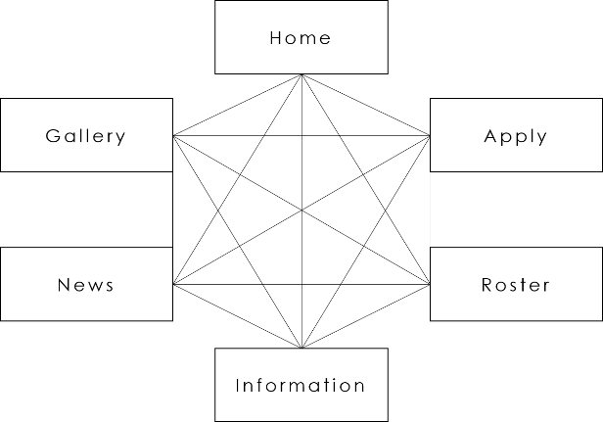

Frame
The image below shows the frame of the homepage. It is used to plan out the layout of the site. As you can see from the image below all content has a set place and this frame will be used in order to create the website.
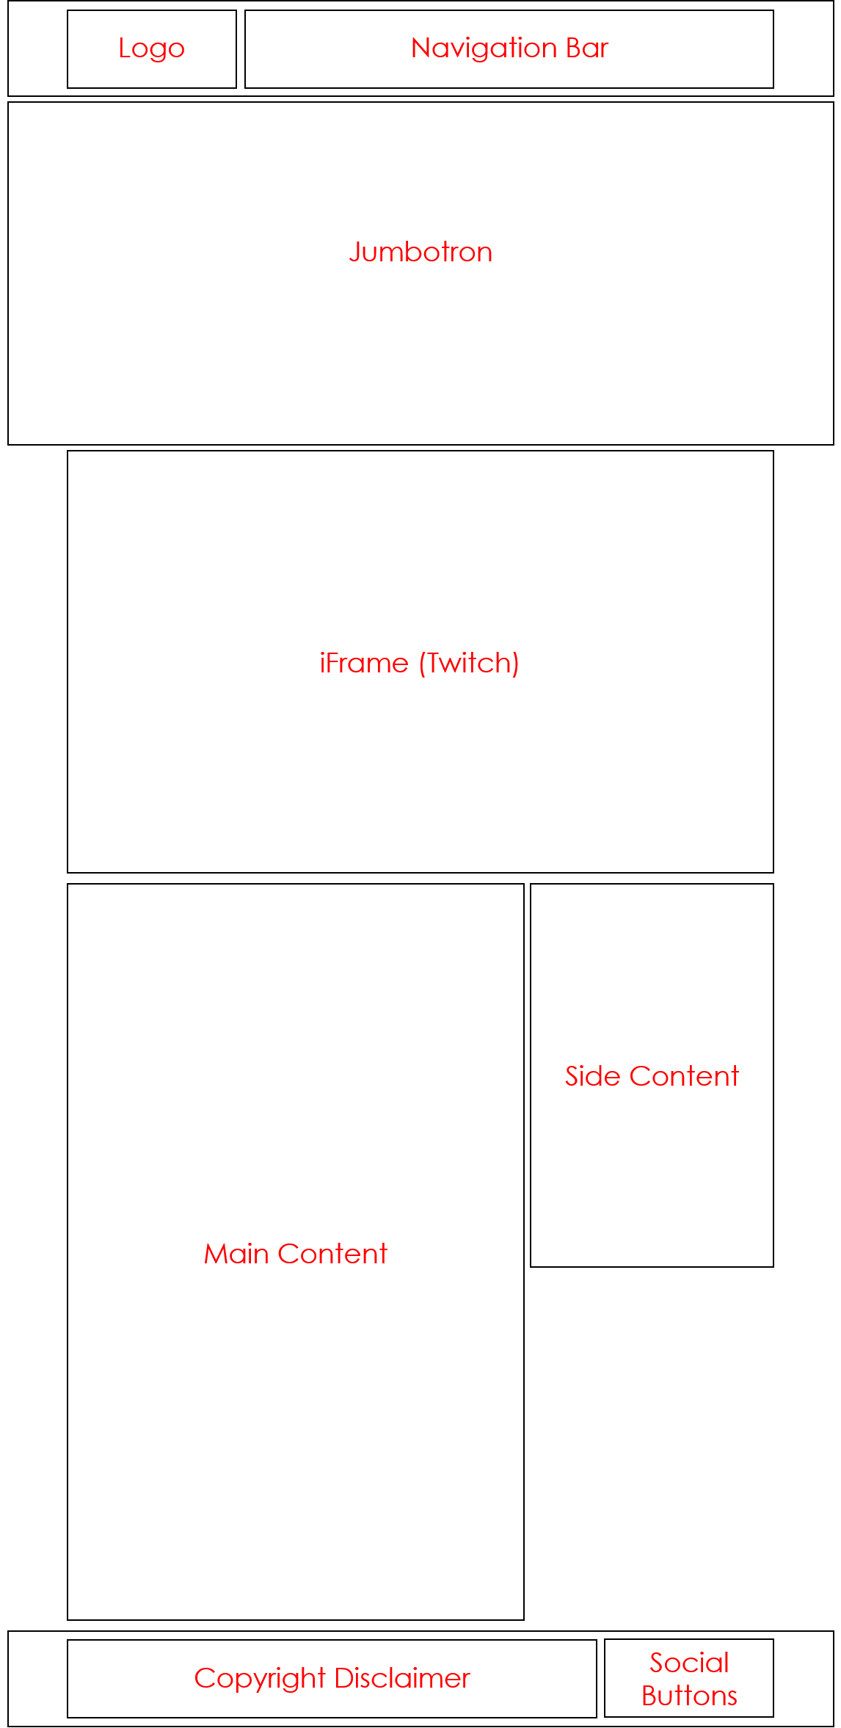

Implementation
This section will contain screenshots of the completed website, along with screenshots that show the results of the validation results.
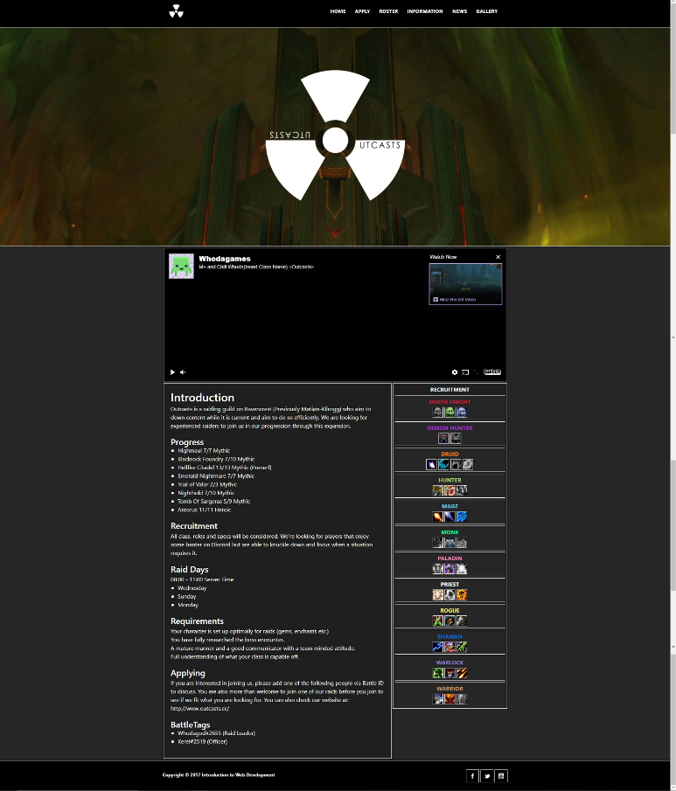

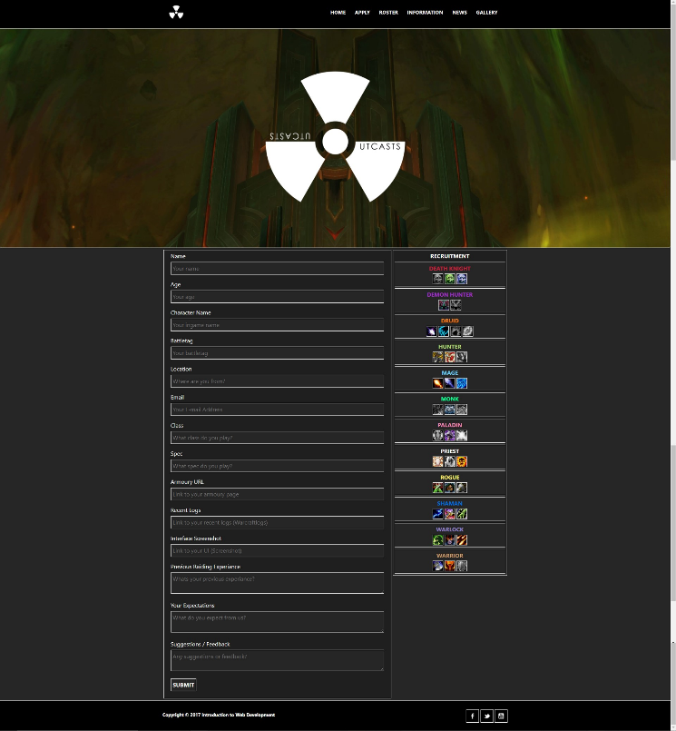
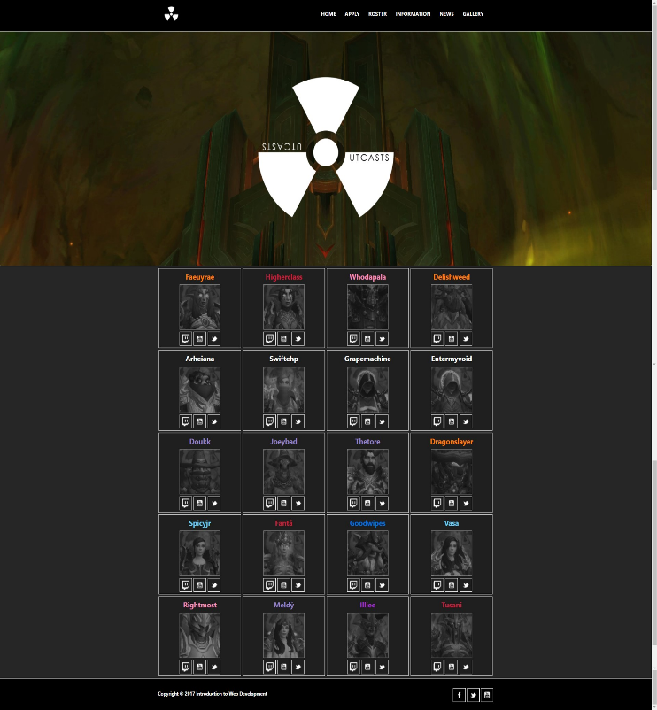

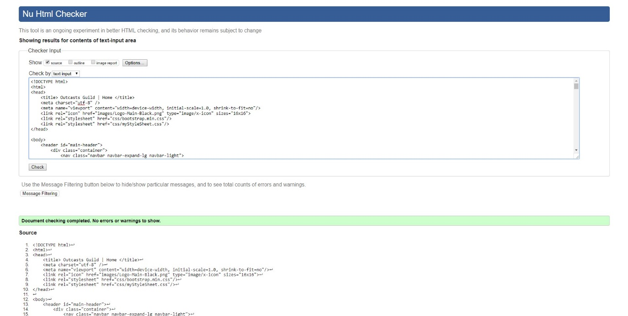

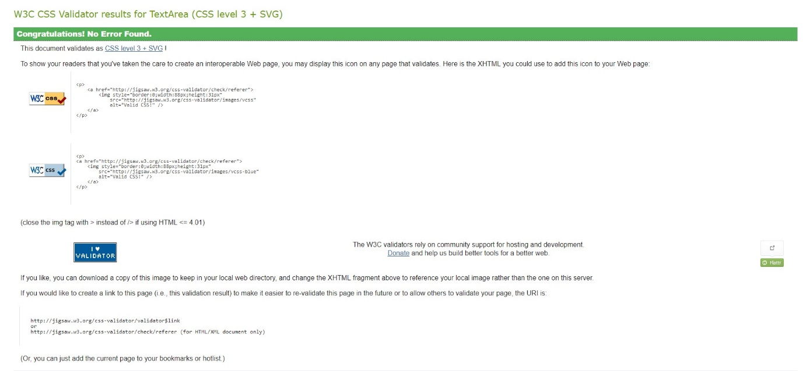

Evaluation
In this section I will be evaluating the accessibility of the website, below are some of the main headings that I will look at and briefly discuss how well I feel these areas cover accessibility.
Headings
Headings throughout the website are in an organised order, they use a consistent font and font colour. This helps to identify them as headers along with their tags.
Each header clearly states what it is in an easy to understand fashion and the colour of the font is clear and easy to read on the background of the web page.

Images / Media
Images are used throughout the site and it is important that these images are scaled well and have an “alt” tag to briefly describe what the image is displaying.
Every image on the site has an alt tag that gives a brief description of what the image shows. This allows all users to have an understanding of what content is being shown on the web page.

Colours
The colours picked for the website contrast well making them easy to view. This can be checked on numerous web sites. I have chosen mostly dark background with light foregrounds.
This is important as poor colour choice can make content very difficult to see and understand.

Forms
The forms on the website must be very clearly and easy to understand. This is to help avoid confusion and to ensure that the user enters the correct data within the form.
It is for this reason that the form on the website is clearly labelled and instructions are present within the editable text box.

Navigation
Navigation on the site is important as this is what will be used in order to move from page to page. It is for this reason that the navigation remains in a consistent location, has a consistent and easy to read font and clearly says which page it is linking to.
This allows users to quickly and easily move about the website.

References
https://www.w3schools.com/
http://contrastchecker.com/
http://validator.w3.org/
http://jigsaw.w3.org/css-validator/

marking criteria and Student FEEDBACK

This section details the assessment criteria. The extent to which these are demonstrated by you determines your mark. The marks available for each criterion are shown. Lecturers will use the space provided to comment on the achievement of the task(s), including those areas in which you have performed well and areas that would benefit from development/improvement.

Common Assessment Criteria Applied (Assignment 1) | Marks available | Marks  awarded
1. Research-informed Literature
Extent of research and/or own reading, selection of credible sources, application of appropriate referencing conventions.
Although a reference list has been provided in the report, this is just simply a list of links to the evaluation tools given in the assignment brief. However, it is evident that you have done some research in respect of the implementation of the website. (Grade mark: 40.00%) | 5 | 2
2. Knowledge and Understanding of Subject
Extent of knowledge and understanding of concepts and underlying principles associated with the discipline.
Demonstrates excellent knowledge and understanding of the standards to design and implement a website. Although you have used CSS Flexbox well, note that Flexbox is not the recommended solution for laying out an entire page's content. It is recommended that you use a grid system. Also, investigate CSS positioning to further improve your work. See comments below. (Grade mark: 85.00%) | 20 | 17
3. Analysis
Analysis, evaluation and synthesis; logic, argument and judgement; analytical reflection; organisation of ideas and evidence
Although you have provided a very good accessibility evaluation of the website and how this has been achieved in your website, you have made no reference to the WCAG guidelines. Also, you have not provided any recommendations for future improvements or the more general evaluation of the website asked for in the brief. (Grade mark: 50.00%) | 20 | 10
4. Practical Application and Deployment
Deployment of methods, materials, tools and techniques; application of concepts; formulation of innovative and creative solutions to solve problems.
An excellent attempt featuring a well-thought-out website. It is evident that you have given a lot of thought to the design and content. Well done. Please see my earlier comments about using a grid system instead of flexbox. Also, the news page would have benefitted from using CSS positioning to overlay the textual content on top of the images instead of creating an image embedded with the text. This would also improve the accessibility of the page and allow the text to scale if adjusted. See your report for additional comments. (Grade mark: 92.00%) | 50 | 46
5. Skills for Professional Practice
Attributes in professional practice: individual and collaborative working; deployment of appropriate media; presentation and organisation.
The report is well-written and presented, but requires a few improvements. See suggested improvements in your report. (Grade mark: 70.00%) | 5 | 3.5

Assignment Mark (Assessment marks are subject to ratification at the Exam Board. These comments and marks are to give feedback on module work and are for guidance only until they are confirmed. ) | Late Submission Penalties (tick if appropriate) |  | 78.5%
 | Up to one week late |  | 78.5%
 | 1st/2nd/3rd attempt? |  | 78.5%

