STRATEGIC MANAGEMENT IN HSBC HOLDINGS

Student’s Name:Uppala Naga Sai Rishitha
Teacher’s Name:
University: Univeristy of Wales Trinity Saint David
Date:

Table of Contents
Executive Summary 3
Introduction 4
Strategic analysis of HSBC Holding with external and internal environmental analysis 5
PESTLE Analysis of HSBC 5
Internal Environmental Analysis Using SWOT Model 7
Critical Evaluation of the Strategic Options 9
Ansoff Matrix 10
Bowman’s Strategic Clock 13
Implications of the proposed strategic options on different areas of HSBC Holdings 15
Porter Generic Strategies 16
Conclusion 17
Recommendations 18
Reference List 20

Executive Summary

This report has been drafted with the aim of resolving the issues that HSBC Holdings is mired in that may give way to looming threats in terms of a decline in profit margins and loss of existing customers. The author has sifted through a vast body of literature relevant to the central theme as has been dealt with throughout the report. Every section makes robust use of some of the most widely acclaimed theoretical propositions and models in management that adequately sheds light on the measures of appropriate strategic outcomes.

Introduction

In this report, the author will attempt to extensively foray into the variegated facets of strategic management in their differing impacts on consumer behaviour and organisational culture. The report will provide holistic insights after the successive culmination of all the sections into a decisive conclusion. HSBC is amongst the longest-standing financial institutions in the world and is considered to be a towering provider of financial services across some of the most prominent nations in the world with an estimable 39 million customers from every corner of the world (HSBC, 2023). HSBC Holdings (UK) is the subsidiary flagship brand of the parent company, which is called the HSBC group. The flagship, at present, is vested with the power to vote and hold shares in HSBC Bank UK and HSBC Bank plc (HSBC.co.UK, 2019).
The maiden section of the report will open with an exhaustive analysis of the external factors, in their collective efficacy, that so far have either been deterrents or have propelled HSBC Holdings plc to its current stature whereby, the two quintessential tools for managing the external environment incurred in businesses will be employed to measure the company’s advantages and disadvantages in different parameters. This will be further followed by another section that delves into the internal environment via three discursive tools, the Ansoff Matrix and Bowman’s strategic clock. This section, too, will be developed in a similar fashion to weigh out the possibilities and drawbacks of their marketing needs and penetrability and make effective strategic propositions. Moreover, the report will address and evaluate the possible outcomes of the propositions in the light of Porter’s generic strategies to adequately assess the viability of the strategic propositions in five categories, which will eventually aid HSBC in its pursuit of achieving competitive leverage in comparison with others in the market (MATEI, and APOSTOAIE, 2022). In closing, after drawing upon the tenets of strategic management, the author will address all the areas where HSBC has been deficient and make recommendations that the company can benefit from.

Strategic analysis of HSBC Holding with external and internal environmental analysis

PESTLE Analysis of HSBC

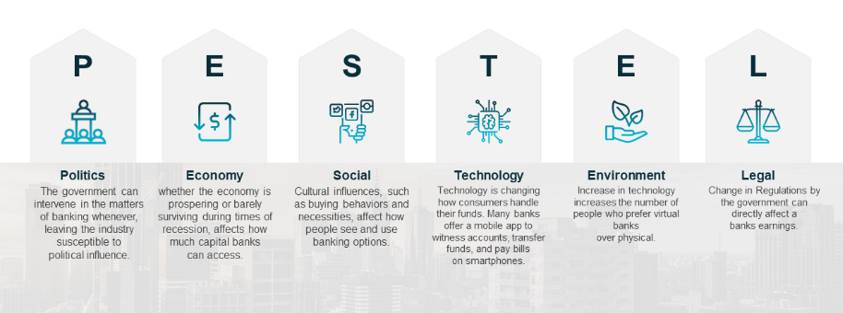
Figure 1: PESTLE Analysis
( Source: Achinas et al., 2019).
Political Factors - In the aspect of HSBC Holdings under the political section, the local ruling administration plays a deep impact in implementing various rules and regulations. Each and every entity, from a person to big established organisations have to adhere to those rules (Zorpas, 2020). The United Kingdom overall has a stable political system where there are very fragile and minimal chances of civil unrest, internal coup, or very violent armed conflict. Therefore HSBC Holdings can easily formulate strategies that will be solely based upon the stable government of the UK. It is to be noted that the local community of the nation is very vigorous. Therefore, it will be better for HSBC Holdings to establish deep connections and links with the local communities. The UK, as a nation, clings to multiple foreign treaties, as well as the ruling government, follows and respects the treaties conducted by the ex-government. This is a clear indication of stability in aspects of the rules and regulations.
Economic Factors- The economic condition of a nation like the United Kingdom is of mixed nature that primarily amalgamates characteristics that are based upon the market with few social characteristics. It is to be noted that if the employment rate of a nation is quite high, then it will furnish enough customers for the goods and services of HSBC. The recruitment regarding hiring is skillful and gifted will be quite costly (Hampton-Garland, Sechrest-Ehrhardt and Cooke, 2018). For example, the government of the United Kingdom runs on a deficit budget; therefore, sales can be boosted for a short period of time.
Social Factors- In the overall society of the United Kingdom, the education level is quite high. This will lead to findings of better income options and also higher spending. In the aspect of HSBC Holdings, before introducing new products in the market, it must evaluate the current trends in aspects of the demography. It must include only those features that go well with this section. It is to be noted that HSBC Holdings has rigid standards, particularly of health and safety; therefore, it might have to conduct business operations against those rivals with limited establishment. HSBC must perform a thorough well-planned evaluation of the behaviors and attitudes towards the authorities before even introducing a campaign based on marketing for its services and goods. The immigration policy of the government will play a small yet critical role as this leads HSBC Holdings to recruit employees from immigrants.
Technological factors- In an aspect of technology, E-Commerce is highly vital for HSBC Holdings' replica. The current e-commerce establishments of a nation play a vital role in smoothening the business operations of HSBC Holdings. As corruption and fraud ness are prevalent across all nations, HSBC must utilise digitalisation of multiple techniques to overcome the issue of fraud. HSBC Holdings also conduct a deep analysis of those regions where technology can emancipate the associates of the supply chain. This will sweep in more lucidity and also enhance pliability (Mayorga Villamar et al. 2019). If a nation supports and invests heavily in developing technologies, HSBC can take advantage of it by manipulating the situation and also hiring the finest people available.
Environmental Factors- With respect to environmental factors, HSBC Holdings must have firm CSR initiatives which are in accordance with the present situation. If the CSR policy is outdated, then a new one must be incorporated (Dess, Eisner, McNamara 2016). The recycling policy in the market and the way HSBC Holdings can act accordingly by those recycling policies. It is to be noted that the amount of budget the nation allocates to spending on energy sources that are highly renewable (Lenart-Gansiniec, 2018). HSBC holdings accordingly can thus make investments as part of its ambitious schemes. HSBC Holdings can also acquaint itself with the waste management demands that are prevailing in the market.
Legal Factors- Each and every country has various types of laws regarding health & safety (Cant, 2020). Therefore HSBC Holdings have to adjust accordingly to those laid down rules and regulations. HSBC must conduct a thorough analysis and research before conducting business operations. The laws of a nation must be in equilibrium with the business replica of HSBC Holdings. The lucidity that prevails in the judiciary procedures and system must be in orderliness which will permit HSBC to do further scheming.

Internal Environmental Analysis Using SWOT Model
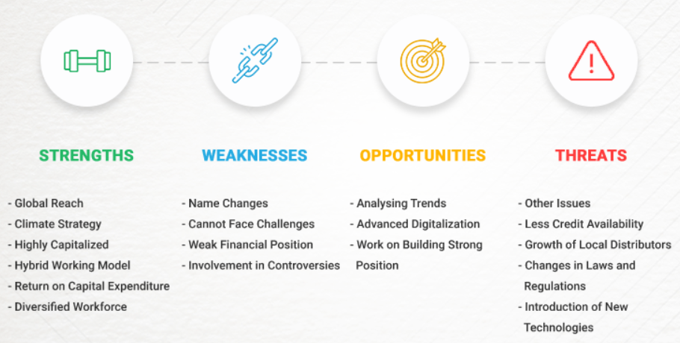
Figure 2 : SWOT Analysis
( Source: Boitrelle, 2021).
HSBC is one of those organisation that has blossomed at a fantastic rate and enchanted plenty of markets and companies all across the globe. The organisation must re-evaluate its strategy by scrutinising the Strength, Weaknesses, Opportunities, and Threats in the business dealings.
Strength - In an aspect of strength, HSBC has massive worldwide reachability. It is one of those organisations that have been very massively capitalised. This aided HSBC Holdings not only procured new assets for long-term spans but also aided in depreciating their costs (Jun, 2019). HSBC has the ability to undergo any sort of future crisis. HSBC is a very big organisation. Therefore, people from all ethnicities work, due to which there is strong bonding among the working sections of HSBC. HSBC Holdings also invested a huge section in the overall progress and also training of its employees. The business model that HSBC follows assists cooperation between the tangible and virtual workrooms that support the well-being of the employees. The organisation brought in massive returns regarding capital expenditure that aided the organisation up to an optimum level (Garner, Stead and Stead, 2014). In order to protect the environment, HSBC has also implemented multiple solutions regarding climate change. Various sustainable projects have also been undertaken by HSBC.
Weakness- HSBC Holdings has entangled its name in several scandals and various controversies, due to which the customers find it uneasy to put faith in. HSBC failed to counter the emerging challenges that surfaced while entering a new market. It not only lost a significant portion of the market share in the niche section. It is to be noted that the overall financial position of HSBC has weakened up to a great level due to a higher level of debt compared to the loan stock equities elevating at a great level (Karthikeyan and Kumar, 2022). There also was an issue of severe lack of brand recognition of HSBC Holdings. The organisation operates under different names in different nations. This greatly weakened the brand recognition of HSBC.
Opportunities- HSBC Holdings has made huge investments in order to structure its online platform. This has led to an escalation in sales channels (Johnson et al., 2017). This will be an opportunity in the near future to have a thorough knowledge of the consumers. HSBC Holdings can also use data analytics to serve its requirements. Multiple latest contemporary trends in behaviour of the customers lead to the emergence of new markets (Grant, 2015). However, it will be a great advantage for HSBC to seek the opportunity of these contemporary trends and flourish its share in the market.
Threats- The big threat of HSBC Holdings might emerge as new technologies. New technologies developed by rivals of HSBC could pose a great threat (Gutiérrez Ramírez et al., 2019). The blossoming of local distributors has generated several threats in the market as the intense rivalry is delivering higher margins to the local distributors. While conducting business HSBC had borne multiple losses. Thereby, customers of HSBC Holdings Naturally had also been furnished fewer credits (Hayes, 2014). HSBC is a type of organisation that operates in several countries; therefore, if new laws get implemented, it can tremendously threaten the overall profitability of the organisation.

Critical Evaluation of the Strategic Options
HSBC Holdings Plc has had a long history of being one of the largest establishments in the world providing services in banking and financial endeavours (Lynch, 2021). The organisation has strived to accommodate the creative will and exposure to forge strategic coalitions and policies that will be to the benefit of the employees so as to deliver a more robust and poignant service whilst addressing the varying concerns and interests of the customers. HSBC Holdings have cemented its place and rightfully so, for their inaugural pursuit of excellence to prioritise and inculcate liberalised notions of tolerance, acceptance and diversity and design a policy framework to dismantle the possibility for organisational disputes and ambiguities. One of the hallmarks of this accredited institution is its ability to adapt to the changing needs of the time (Grosse, and Meyer, 2018). The cardinal principle that has been operative in managerial implications and governance has predominantly been democratic. The establishment has served as the centrepiece and an intermediary participant in the terrain of transcontinental trade, drawing together some of the most lucrative and powerful corporations in the world. HSBC Holdings, as their repertoire necessitates, the primary niche that they have served is the capital market. However, niches or profiles are subject to change with the passage of time, commensurate to the emerging tides caused by shifts in the economy (Darr, 2018).
In the contemporary socio-economic setting, HSBC has exhibited a momentous setback owing to issues pertaining to their organisational shortcomings characterised by hefty losses, mounting debts and security breaches by anonymous hackers. In this regard, it will be suitable for the organisation to espouse an innovative onus of sustenance and culpability and address the issues encountered that have supposedly imperilled the security of the customers and the workforce alike. HSBC must task some of the most capable stakeholders and employees to lead a project that declares an emergency, accounting for investigative supervision of the silo structures and organise sessions and meetings to discuss the prospects of a revisionary transition towards the adoption of a sustainable model of leadership to steer the establishment to embrace the complexity o ideas and change. In addition to these, a calculated yet effective investment in the IT wing to develop potent insights into the pitfalls within the organisation would further the vision of change.

Ansoff Matrix
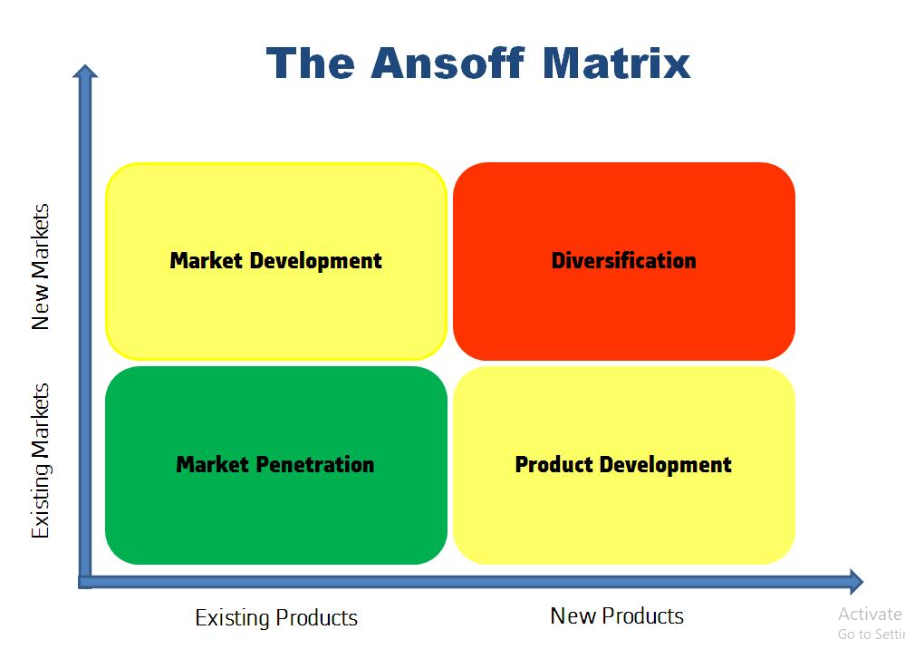
Figure 3: The Ansoff Matrix
(Source: ‘Ansoff Matrix’, 2019)
Market Penetration
Businesses and corporations are often observed to have employed this strategy to gauge the projected growth of their subsisting services, products or strategies that have been in operation, and are panning out to their interests and desired trajectory (‘Ansoff Matrix’ 2019). Considering the present predicament that HSBC Holdings is presumably grappling with, the investment analysts and the principal stakeholders must work in collaboration and underpin three prospective areas that may bolster their presence and efficacy, rendering them a force to be reckoned with in the capital market. These are, namely, setting prices and customised offers that are beneficial to the consumer. It can provide the necessary impetus to move the organisation towards achieving an improved rate in regulating the engagement and satisfaction of the customers. However, in order to corroborate this initiative, HSBC Holdings must make systematic attempts to reduce the cost expended in operational activities. This will lead to a voluminous expansion of their sales, which, in turn, will make their services affordable and relatively easier to access (Lynch, 2015). And lastly, the establishment must make effective investments to market its agenda for better penetrability ( Mckinsey & Company, 2020).
Market Development
It is the process by which businesses try to revamp their progress through the introduction of the products and services that have already set a course in the market (ECOBICI MIHAELA LOREDANA 2017). There are many different ways using which HSBC Holdings plc can make necessary appendages and modifications to bring their schemes and services a new lease of life. Firstly, the management should try and make cumulative investments in Research and Development by designating a team of Data Analysts, IT Developers, Financial Analysts and Statisticians to generate ideas and map the locus of change in the market and bring to the fore, appropriate strategies that will identify the locus of change in the market and consumer demands to pitch a relevant mode of branding that permeate the market with ease and success. Secondly, they must also take into account the cognitive reception of the customers and seek out newer ways that will shed light on pertinent issues through educative campaigns about tax frauds, hacking and the fundamental tenets of financial transactions, in a manner that is intelligible to consumers from all walks of life (Mwenda, and Obuba, 2023). And, to conclude, HSBC must speculate on the possibility of exploring new segments of consumers in existing markets and cater to their needs by tapping into their needs through the reach of their policy-reach and by exploiting marketing trends that have been surfacing.
Product Development
As opposed to market development, this process entails the quest of looking to develop and launch a completely disparate and new set of products for the sake of expansion in the market (Sigei, and Jeptoo, 2023). HSBC Holdings have been doing these through rigorous yet competitive measures that have been in prevalence throughout the course of its existence. With respect to this, perhaps, an attribute that can be categorised as particularly distinct that sets the organisation apart from other existing competitors lies in their strategic modifications of services to instil the idea of innovation and radical change within the customer’s psyche. After having successfully identified the latent scope embedded in the transition of consumer needs, HSBC then undergoes the quintessential stages to fulfil the productization of the conceived blueprint or the ideations, that will eventually be of service to the customers. This will facilitate HSBC in penetrating newer segments from the consumer group (Lynch, 2015).
Diversification
The notion of diversification can be referred to as the way in which a company ventures forth to devise a strategy with the solitary aim of developing a newer range of products that often diversifies their niche and industrial domains that will enable their image as a pioneering force in the market (Clarissia, 2020). HSBC usually follows two kinds of diversification, these are, horizontal and vertical. The former takes place when the banking institution decides tries to launch products that already exist in the market with some modifications under the banner of a new product launch, whereas, the latter takes place when HSBC chooses to engage with their clientele or potential consumers through the initiation of the launch of services that are original, in their essence and are not renditions as such. Besides these, HSBC holdings also have a track record of engaging in conglomeratic ties with other companies.

Bowman’s Strategic Clock
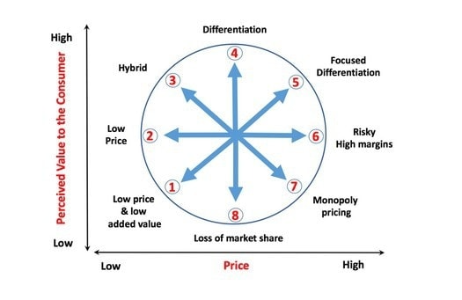
Figure 4: Bowman’s Strategic Clock
(Source: Hitesh Bhasin, 2019)
Position 1 (Low Price and low added value): According to Bowman’s clock for strategic positions, this is the first stage and is more often than not recognised as the least effective of all the forces that contribute to the manifestation of the much coveted competitive leverage (Hitesh Bhasin, 2019). In this position, HSBC needs to set the price at an extreme low to yield a sizable consumer base and as such it is the only advantage that the establishment can exploit.
Position 2 (Low price): It is the stage businesses are required to produce in bulk when they have garnered a steady customer base, therefore, has created a strategic void in the market that can only be filled with their services. Although, the scale of revenue is dependent on the surplus value of the products manufactured at a massive rate (Almutairi, (2023). In stage 2, HSBC must be wary of discrepancies in prices that may befall them as they continue to operate in the market.
Position 3 (Hybrid): It is the stage whereby a business is equipped enough to derive from various strategic options and apply the scheme of product differentiation. At this juncture, customers have developed an affinity for the products and services offered by the enterprise and as such are willing to go to any length to avail their services. Therefore, inadvertently, HSBC, upon having reached this stage will have the necessary prerogative to place a premium on their services, which then becomes a distinguishable mark for the purpose that it serves to the delight and convenience of the customers (Mintzberg, Ahlstrand, and Lampel, 2009).
Position 4 (Differentiation): Simply put, strategic differentiation is the way in which business entities search for different ways to deliver products of the highest order to their clients at economic rates (Mihajlović, and Miletić, 2022). In this position, when the business has been maintaining an impeccable margin for profitability, they tend to shift their focus on the importance of building a brand and building a credible presence in the market to attract consumers at an exponential rate. When HSBC reaches the stage of differentiation, it must endeavour to deliver the best services to its customers through offers and relaxations.
Position 5(Focused Differentiation ): It is a highly localised initiative used by businesses that have built a hegemonic dominion in the market and have accomplished an unparalleled profit margin, followed closely by an even larger and growing base of consumers hailing from different nations (Weston, and Nnadi, 2021). This stage refers to the selling of products that are high in quality at prices that can only be affordable by a few. HSBC Holdings, therefore, must, thereafter, must not falter in their quality of services while engaging with the customers.
Position 6 (Risky High Margins): This position entails unprecedented dangers as by the virtue of this method, businesses pander to consumer demands without making any alterations to the premium assigned on the products or services but however, the quality or the nature of the services offered are degraded, sometimes deliberately (Bowman et al., 2021). This is the most crucial stage as HSBC may lose a significant number of customers that have stood by the values proposed by the brand.
Position 7(Monopoly Pricing): This is a highly exclusive scenario when a given business specialises in a range of services that are not replicable and as such cannot be found anywhere else in the market (Mihajlović, and Miletić, 2022). It is possibly the most advantageous of all the positioning strategies that offer a brand the privilege of determining its price regulations as it pleases. In this regard, HSBC Holdings can have an assured advantage of a fertile scale of profit ensured by consumers who have very little choice but to subscribe to their services.
Position 8(Loss of Market Share): This is the worst-case scenario that any business may encounter as losing market shares is indicative of a company’s inability to meet the demands posed by the market. Subsequently, the entity loses its visibility and credibility. At this stage, HSBC will have no authority over the prices of the services that they provide.

Implications of the proposed strategic options on different areas of HSBC Holdings
HSBC Holdings may encounter multiple challenges and reap multiple advantages as well while implementing the strategies proposed in the previous section using Ansoff Matrix and Bowman’s strategic clock to gauge the possibilities in their prescriptive premises accounting for a vast array of standardised marketing tactics and how the marketing terrain itself operates (Kim, 2020). These strategic tools have revealed that HSBC can improve their strategic foundation in a significant number of ways, not merely to the benefit of the consumers, but to the organisation’s understanding of the determiners and chief agents that are at play in determining the most ideal dynamic while pitted against the volatile nature of the market. The principal stakeholders at HSBC Holdings (UK) can gain significant insights from the observations elicited in the light of these two decisive frameworks (Odom, and Hyams-Ssekasi, 2022). The Ansoff Matrix provides an investigative insight into how HSBC can improve their oversight and remain vigilant of the emerging ways to strengthen its reach and penetration in the market, especially among unexplored segments that they have been oblivious to. On the other hand, Bowman's strategic clock offered a picturesque framework that encompasses all the elementary aspects of the marketplace in relation to the differing strategies that they may or may not adopt.

Porter Generic Strategies
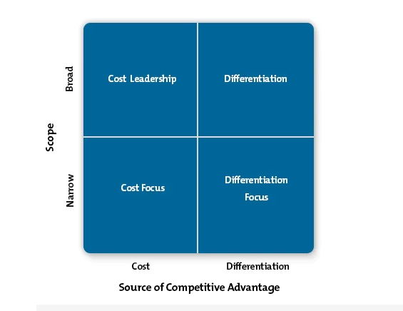
Figure 5: Porter’s Generic Strategies
(Source: Islami, Mustafa, and Topuzovska Latkovikj, 2020))
Cost Leadership- In an aspect of cost leadership, HSBC Holdings can strive to emerge as the low-cost producer among several regions in the bank industry (Islami, Mustafa, and Topuzovska Latkovikj, 2020). HSBC holdings can achieve while chasing after the goal of cost leadership strategy can hound several aspects like supply chain alternatives, economies of scale, easy procurement of raw materials, patented technology, and several other factors. HSBC Holdings must utilise the high assets, attain low operating costs (both direct and indirect). The organisation must also impose authority and take dominance over the value chain circumscribing multiple groups such as finance, marketing, and many others to make sure the cost stays low. HSBC must be careful in regard to the fragile loyalty of customers.
Differentiation- HSBC Holdings, in the aspect of differentiation, can also trail on the other banks present in the market. HSBC needs to carve a very distinctive position by furnishing a value proposition that is highly appreciated and adored by the customers. The organisation needs to select several credits in terms of goods and services that the customers of the other banks give high importance or priority. (Juliana and Nyoman, 2019). The sole target of HSBC Holdings should be to look for the premium price because of the differentiation and the uniqueness of the contributions and offerings. As differentiation is, strategy is applicable for big firms like HSBC to conduct business operations. In regards to HSBC, the competitors will not be a massive threat due to the strong brand loyalty of the consumers.
Differentiation focus: It is a strategic choice that businesses apply with the intention of segregating their products from other competitors who specialise in a similar range of products or services (Johnson, Whittington, and Scholes, 2017). Contrary to cost leadership, this is a strategic intervention that takes into consideration the onus of catering solely to the values shared by the customers and aspires to live up to that mark as part of the business model. This means that it is imperative for HSBC to have a range of services, that must, by design needs to have tangible attributes that are definable and distinguishable to the customers
Cost-focus: This is a marketing tactic that can be defined as a tactical retreat wherein companies aim for cost reduction in a localised market (Ali, and Anwar, 2021). Specific customers will turn towards other alternatives once they receive them. Overall HSBC Holdings can minimise costs and also save among those customers who always are seeking alternative and easy options. The prevailing threat of additional goods and products is quite low as there is a very negligible probability of finding another product that can fulfil the demands and requirements of consumers. HSBC Holdings must create advertising, better quality, as well as furnish great service to outperform other organisations conducting similar operations.

Conclusion
In this report, the author has extensively discussed the strategic management of HSBC Holdings. A deep, thorough strategic analysis has been done of HSBC Holding with external and internal environmental analysis. Under the external analysis, the PESTLE framework, and the internal analysis, SWOT analysis has been done. The report has furnished holistic insights post the successive culmination. Under the PESTLE analysis, HSBC's level of corruption, political instability, the government, and the level of corruption have been discussed. The government's intervention and the infrastructure had also been extensively discussed. After the PESTLE and SWOT analysis has been done, the key findings of the two implemented framework and tools have also been extensively portrayed.
After that critical evaluation of the strategic option was done, HSBC exhibited a momentous setback owing to issues pertaining to their organisational shortcomings, characterised by hefty losses, mounting debts, and security breaches by anonymous hackers. The organisation has strived to accommodate the creative will and exposure to forge strategic coalitions and policies that will be of great benefit to the employees. Ansoff Matrix has been used under which market development, market penetration, diversification, and product development aspect has been portrayed with plenty of information. There are plenty of ways by which HSBC Holdings plc can make necessary appendages and modifications to bring their schemes and services a new lease of life. Bowman's strategic clock has also been utilised by the author, under which eight positions have been shown. The implications of the proposed strategic options on different areas of HSBC Holdings have been done using Porter's Generic Strategies. The report has been developed in a similar familiar pattern to weigh out the possibilities and drawbacks in their marketing needs and penetrability and make effective strategic propositions.

Recommendations
As part of the recommendation, HSBC Holdings must lower the price of their products not for a lengthy time but for a short period of time. The target must be to appeal to a wider audience. Several jaw-dropping rewards, as well as loyalty programmes must be given. It is known this far that HSBC Holdings has made an impressive investment (Karjaya, Satris, and Suspiati 2019). HSBC must generate a digital ecosystem all around the bank, which will further ameliorate its position in the market. HSBC will attain a monopoly over the market as well as increase its overall profits (Toussaint, 2023). The organisation must also include several sub-strategies which will aid HSBC Holdings in integrating new technology as well as furnish banks to refresh its goods and products. HSBC Holdings must resource properly and also properly set up the sales. The organisation must also structure a firm marketing strategy. It will be additionally beneficial for HSBC if they enact the bank's product plans (Assibey-Yeboah, 2020).
HSBC must also conduct proper, thorough monitoring, evaluation, and also reiteration of the market. HSBC Holding also must implement Artificial Intelligence to further ameliorate the procedure of optimum perfection. HSBC Holdings can improve its diversification which will further improve its stability (Toma and Modreanu, 2022). It will also lead HSBC to perform more lending, minimise the chance of risks, and also dramatically boosts the economy. In regards to the low-price and low-added value, HSBC must set the price at an extremely low to yield a sizable consumer base, and as such, it is the only advantage that the establishment can exploit. In the aspect of low prices, HSBC must be aware of the inconsistencies prevailing in the market while they are conducting their business operations. In regards to differentiation, HSBC Holdings must flush in more and more types of things to meet up the needs and requirements of the customers, so they only prefer and give much importance to HSBC over its competitors (López-Portillo, Gómez and Rodríguez, 2022).

Reference List
‘Ansoff Matrix’ (2019) A Dictionary of Publishing. 1st edn. Oxford University Press..
Achinas, S., Horjus, J., Achinas, V. and Euverink, G.J.W., (2019). A PESTLE analysis of biofuels energy industry in Europe. Sustainability, 11(21), p.5981. https://www.mdpi.com/2071-1050/11/21/5981
Ali, B.J. and Anwar, G., (2021). Porter’s Generic Competitive Strategies and its influence on the Competitive Advantage. Ali, BJ, & Anwar, G.(2021). Porter’s Generic Competitive Strategies and its influence on the Competitive Advantage. International Journal of Advanced Engineering, Management and Science, 7(6), pp.42-51.https://papers.ssrn.com/sol3/papers.cfm?abstract_id=3863595
Almutairi, M.M.Q., (2023). The Impact Of Market Analysis On The Company Strategy. Journal of Positive School Psychology, pp.401-412.https://www.journalppw.com/index.php/jpsp/article/view/16345
Assibey-Yeboah, M., (2020). Report of the Finance Committee on the United Kingdom Export Finance (UKEF) facility agreement between the Government of the Republic of Ghana (represented by the Ministry of Finance) and HSBC Bank PLC, United Kingdom for an amount of sixty-seven million, two hundred and ten thousand Euros (€ 67,210,000.00) for the design and construction of the Obetsebi Lamptey Interchange and Winneba Road Flyover along with ancillary works (Phase 2). http://ir.parliament.gh/bitstream/handle/123456789/2029/THR%20FINANCING%20OF%20THE%20OBETSEBI%20LAMPTEY%20INTERCHANGE.pdf?sequence=1&isAllowed=y
Boitrelle, F., Shah, R., Saleh, R., Henkel, R., Kandil, H., Chung, E., Vogiatzi, P., Zini, A., Arafa, M. and Agarwal, A., (2021). The sixth edition of the WHO manual for human semen analysis: a critical review and SWOT analysis. Life, 11(12), p.1368. https://www.mdpi.com/2075-1729/11/12/1368
Bowman, C.J., Zhang, R., Balitzer, D., Wang, D., Rabinovitch, P.S., Kővári, B.P., Mattis, A.N., Kakar, S., Lauwers, G.Y. and Choi, W.T., (2021). Persistent or recurrent Barrett's neoplasia after an endoscopic therapy session is associated with DNA content abnormality and can be detected by DNA flow cytometric analysis of paraffin-embedded tissue. Modern Pathology, 34(10), pp.1889-1900. https://www.sciencedirect.com/science/article/pii/S0893395222005348
Cant, M. (2020) 'Legal Factors Affecting the Establishment of Township SMMEs in South Africa: Are They Killing Small Businesses?', The Journal of private enterprise, 35(4), pp. 61–70. http://journal.apee.org/index.php/ajax/GDMgetFile/Parte5_2020_Journal_of_Private_Enterprise_Vol_35_No_4_Winter.pdf
Clarissia, S.M.S., (2020). A study on Ansoff Matrix Technique: As a growth strategy and an adaptive learning technique adopted in the leading brand of products. BIMS Journal of Management, 18.https://bimskol.org/pdf/E-copy-BIMS-Journal-Management-Kolkata-Vol5-Issue-1-July-2020.pdf#page=26
Darr, A. (2018) Selling Technology : The Changing Shape of Sales in an Information Economy. Ithaca, NY: Cornell University Press,. Available at: https://doi.org/10.7591/9781501723667
Dess, G. G., Eisner, A., McNamara, G., (2016), Strategic Management: Texts and Cases, McGraw-Hill
ECOBICI MIHAELA LOREDANA (2017) ‘THE USE OF ANSOFF MATRIX IN THE FIELD OF BUSINESS’, Analele Universităţii Constantin Brâncuşi din Târgu Jiu : Seria Economie, 2(special issue), pp. 141–149.
edition Harlow: PearsonJun, F., (2019). Study of Relationship Between Credit Risk (Non-Performing Finance Ratio) and Internal and External Factors in HSBC Bank. SSRN. https://www.researchgate.net/profile/Fang-Jun-3/publication/329642895_STUDY_OF_RELATIONSHIP_BETWEEN_CREDIT_RISKNON-PERFORMING_FINANCE_RATIO_AND_INTERNAL_AND_EXTERNAL_FACTORS_IN_HSBC_BANK/links/5c135a534585157ac1c0bd34/STUDY-OF-RELATIONSHIP-BETWEEN-CREDIT-RISKNON-PERFORMING-FINANCE-RATIO-AND-INTERNAL-AND-EXTERNAL-FACTORS-IN-HSBC-BANK.pdf
Garner, J., Stead, W., Stead, E., (2014), Sustainable Strategic Management 2nd edition, London: England: Greenleaf Pub.
Grant, R.M., (2015), Contemporary Strategy Analysis: Texts and Cases 9th edition
Grosse, R.E. and Meyer, K. (2018) The Oxford handbook of management in emerging markets. Edited by R.E. Grosse and K. Meyer. New York: Oxford University Press.
Gutiérrez Ramírez, D.M., Gaggero Sager, L.M., Marín Hernández, S. and Muñoz Black, C.J., (2019). Proposed model for the identification and prediction of weak banks, in the context of the Basel Committee on Banking Supervision. Contaduría y administración, 64(4). https://www.scielo.org.mx/scielo.php?pid=S0186-10422019000500001&script=sci_arttext&tlng=en
Hampton-Garland, P., Sechrest-Ehrhardt, L. and Cooke, B.G. (2018) Socio-economic and education factors impacting American political systems : emerging research and opportunities. Hershey, Pennsylvania: IGI Global. Available at: https://doi.org/10.4018/978-1-5225-3843-1.
Hayes, J., (2014), The Theory and Practice of Change Management 4th edition, Palgrave
Hitesh Bhasin., (2019). What is Bowman’s Strategy Clock? Retrieved from:https://www.marketing91.com/what-is-bowmans-strategy-clock/ [Accessed on: 13th July, 2023]
HSBC., (2023). About HSBC. Retrieved from: https://www.about.hsbc.co.in/#:~:text=HSBC%20is%20one%20of%20the,%2C%20and%20Global%20Banking%20%26%20Markets. [Accessed on: 13th July, 2023]
HSBC.co.UK., (2019). HSBC UK Bank plc: About Our Services. Retrieved from: https://www.hsbc.co.uk/content/dam/hsbc/gb/pdf/insurance/home-insurance-about-our-service.pdf [Accessed on: 13th July, 2023]
Islami, X., Mustafa, N. and Topuzovska Latkovikj, M., (2020). Linking Porter's generic strategies to firm performance. Future Business Journal, 6, pp.1-15. https://link.springer.com/article/10.1186/s43093-020-0009-1
Johnson, G., Whittington, R. and Scholes, K. (2017) Exploring strategy: text and cases. Eleventh edition. New York, New York State: Pearson.
Johnson, G., Whittington, R., Scholes, K., Angwin, D.,
Juliana, J.P.E. and Nyoman, Y.N., (2019). Factors influencing competitiveness of small and medium industry of Bali: Porter's five forces analysis. Russian Journal of Agricultural and Socio-Economic Sciences, 89(5), pp.45-54. https://cyberleninka.ru/article/n/factors-influencing-competitiveness-of-small-and-medium-industry-of-bali-porter-s-five-forces-analysis
Karjaya, L.P., Satris, R. and Suspiati, S., (2019). Greenpeace, Corporations and Deforestation Crimes: A Case study of Hongkong Shanghai Bank Corporation (HSBC) in Indonesia. Jurnal Hubungan Internasional, 8(2), pp.203-214. https://pdfs.semanticscholar.org/548d/ba6878ec8cd0668b4c1130945e648ac1ab4b.pdf
Karthikeyan, K. and Kumar, M.D., (2022). SWOT Analysis of Green Banking–A Study On Customers Perception with Respect to Madurai District. Dr. Reena Shyam. https://www.researchgate.net/profile/Veilatchi-Veilatchi-2/publication/367377376_IASMS_Journal_FINAL_DECEMBER_2022/links/63cff1be6fe15d6a574483e0/IASMS-Journal-FINAL-DECEMBER-2022.pdf#page=23
Kim, S.K., (2020). Advanced Mathematical Business Strategy Formulation Design. Mathematics, 8(10), p.1642.https://www.mdpi.com/2227-7390/8/10/1642
Konbr, U. and Abdelaal, M., (2022). Utilizing Smart Systems to Enhance the Sustainability of Egyptian Administrative Buildings. Civil Engineering and Architecture, 10(7), pp.2779-2808. https://www.researchgate.net/profile/Usama-Konbr/publication/365234902_Utilizing_Smart_Systems_to_Enhance_the_Sustainability_of_Egyptian_Administrative_Buildings/links/636bdc4d54eb5f547cb98180/Utilizing-Smart-Systems-to-Enhance-the-Sustainability-of-Egyptian-Administrative-Buildings.pdf
Lenart-Gansiniec, R. (2018) Crowdsourcing and knowledge management in contemporary business environments. Edited by R. Lenart-Gansiniec. Hershey, PA: Business Science Reference. Available at: https://doi.org/10.4018/978-1-5225-4200-1.
López-Portillo, V., Gómez, S. and Rodríguez, S.E., (2022). 5 Barriers That Hinder Green Financing. https://www.wri.org/update/5-barriers-hinder-green-financing?utm_source=linkedin&utm_medium=wri+center+for+sustainable+business&utm_campaign=socialmedia&utm_term=cc7c2123-ae46-4fa6-98a2-6fbbc21f79a3
Lynch, R., (2015), Strategic Management 7th edition, Pearson: Harlow
Lynch, R.L. (2021) Strategic management. Ninth edition. London ;: SAGE.
Management, Harlow: FT Prentice Hall
MATEI, D.P. and APOSTOAIE, C.M., (2022). JUSTIFICATION OF INVESTMENT DECISIONS USING TECHNICAL AND FUNDAMENTAL ANALYSIS–A CASE STUDY APPROACH. EUROPEAN ADMINISTRATIVE AREA–INTEGRATION AND RESILIENCE DYNAMICS, p.337.https://serval.unil.ch/resource/serval:BIB_51DB1D6B2B80.P001/REF#page=338
Mayorga Villamar, C. (2019) Analysis of Technological Innovation Contribution to Gross Domestic Product Based on Neutrosophic Cognitive Maps and Neutrosophic Numbers', Neutrosophic sets and systems, 30, pp. 34–43. Available at: https://doi.org/10.5281/zenodo.3569637.
Mckinsey & Company., (2020).The vision for 2025: Hyperpersonalized care and ‘care of one’. Retrieved from: https://www.mckinsey.com/capabilities/operations/our-insights/the-vision-for-2025-hyperpersonalized-care-and-care-of-one [Accessed on: 13th July, 2023]
Mihajlović, V. and Miletić, V., (2022). Limiting factors of strategic positioning within established businesses. Ekonomski signali: poslovni magazin, 17(1), pp.107-119.https://scindeks.ceon.rs/article.aspx?artid=1452-44572201107M
Mintzberg, H., Ahlstrand, B., and Lampel, J. (2009), Strategy
Mishra, R., Singh, R.K., Kumar, S., Mangla, S.K. and Kumar, V., (2023). Critical success factors of Blockchain technology adoption for sustainable and resilient operations in the banking industry during an uncertain business environment. Electronic Commerce Research, pp.1-35. https://link.springer.com/article/10.1007/s10660-023-09707-3
Mwenda, J.M. and Obuba, R., (2023). Effect of Market Development Strategy on Performance of Animal Feeds Manufacturing Firms in Meru County. Asian Journal of Economics, Business and Accounting, 23(16), pp.170-186.http://stmopenlibrary.com/id/eprint/1832/
Odom, G. and Hyams-Ssekasi, D., (2022). An Exploration of the Implications of Human Resources Analytics for Workforce Planning. Future of Business Administration, 1(2), pp.30-42. https://www.diamondopen.com/journals/index.php/fba/article/view/345
Rajput, N., Khatter, K. and Chopra, K., (2019). Study of Green Banking in Environment Sustainability-Role of Indian Banks. Global Journal of Enterprise Information System, 11(3), pp.44-50. http://gjeis.com/index.php/GJEIS/article/download/11/11
Regner, P., (2017), Exploring Strategy Text and Cases 11th
Safari: The Complete Guide Through the Wilds of Strategic
Saxena, D., Dhall, N. and Malik, R., (2021) Sustainable Banking: A Roadmap To Sustainable Development. Corporate Governance and Sustainability Review, 5(3), pp.42-56.https://virtusinterpress.org/IMG/pdf/cgsrv5i3p4.pdf
Sigei, B.C. and Jeptoo, C., (2023). EXAMINING THE IMPACT OF PRODUCT DEVELOPMENT STRATEGIES ON THE PERFORMANCE OF REAL ESTATE COMPANIES IN NAIROBI CITY COUNTY, KENYA. African Journal of Emerging Issues, 5(5), pp.29-48.https://www.ajoeijournals.org/sys/index.php/ajoei/article/view/404
Toma, S.G. and Modreanu, A., (2022). Competing for Dominance in Global Banking. Ovidius University Annals, Economic Sciences Series, 22(2), pp.227-233. https://stec.univ-ovidius.ro/html/anale/RO/2022-issue2/Section%201%20and%202/28.pdf
Toussaint, E., (2023). HSBC: une banque au lourd passé et au présent sulfureux–CADTM. https://www.cadtm.org/HSBC-une-banque-au-lourd-passe-et
Weston, P. and Nnadi, M., (2021). Evaluation of strategic and financial variables of corporate sustainability and ESG policies on corporate finance performance. Journal of Sustainable Finance & Investment, pp.1-17.https://www.tandfonline.com/doi/abs/10.1080/20430795.2021.1883984
Zorpas, A.A. (2020) 'Strategy development in the framework of waste management', The Science of the total environment, 716, pp. 137088–137088. Available at: https://doi.org/10.1016/j.scitotenv.2020.137088.

