Programme: BSc Health and Social Care
Module: Principles of Health and Social Care Practice
Module code: BMHP5016
Name: Catarina Barroso Ngunza
Student ID: 2509011
Lecturer: Azida Zainol
Submitted on: 28 October 2026

REFLECTIVE REPORT ON PRINCIPLES OF HEALTH AND SOCIAL CARE PRACTICE: PERSON-CENTRED CARE, PARTNERSHIP WORKING AND ETHICAL PRACTICE IN MRS C’S CASE
Table of Contents
Introduction 3
Task 1: Reflection on the Importance of Principles of Health and Social Care Practice 3
Task 2: Practical Application in Mrs C’s Case 4
Task 3: Self-Reflection as a Health and Social Care Professional 6
Conclusion 9
References 10

Introduction
The practice of health and social care relies on values that safeguard dignity and align safe, responsive and ethically justifiable care. Person-centred care involves putting the values, preferences and circumstances of a person at the centre of assessment and planning; partnership working involves linking the person, family, carers/professionals and ethical practice involves determining autonomy, benefit, harm, justice, consent and confidentiality. It has been demonstrated that self-management can be enhanced by related parties through the creation of care plans, which can be reinforced by the accessibility and coordination of care (Ahmed et al. 2022). These principles are of great significance in cases such as when needs are dynamic and complicated.

Task 1: Reflection on the Importance of Principles of Health and Social Care Practice
Person-Centred Care
Person-centred care implies viewing the person as greater than a diagnosis and including dignity, preferences, strengths, relationships, culture and personal goals in care. Modern reviews recognise that, as the major qualities of centredness, there should be being unique, being heard and sharing responsibility (Feldthusen et al. 2022). This methodology embraces autonomy, trust and more pertinent care as the decisions are constructed around what the individual values as opposed to organisational convenience. The hierarchy created by Maslow can assist practitioners to address the issue of physical safety within the context of belonging, esteem and psychological needs, whereas the ecological perspective created by Bronfenbrenner allows considering the impact of families, community, and broader systems on wellbeing. Wellbeing, involvement and prevention are also strengthened by the Care Act 2014 (Government of UK, 2014). Time pressure, fragmented services, limited resources or assumptions about what the professionals believe is best, however, are areas that can undermine person-centred care. Implementation research demonstrates that a person-centred support cannot be successful with one singular intervention but a set of interacting strategies (Marulappa et al. 2022). Thus, person-centredness involves not only caring relations but practical relations in which the choice of the individual is also possible.

Partnership Working
Partnership working is a way of organising relationships among service users, families, carers, health professionals, social-care practitioners and organisations. This is its strength as it integrates expertise, enhancing continuity and minimising inter-service gaps. Inter-organisational and interdisciplinary collaboration has been proposed to be a valuable element in quality maintenance and enhancement (Simons, Goossensen and Nies, 2022). Good collaboration requires proper roles, respectful interactions, sharing of information at the right time and having real shared decisions as opposed to professionals sharing updates. Long-term care and rehabilitation evidence indicates that the nature of interprofessional collaboration is determined by team performance, organisational conditions and information exchange (Doornebosch, Smaling and Achterberg, 2022). Partnership can thus enhance coordination but there can arise tension where professional interests are different; delays in information or family desires and individual preferences may clash.

Ethical Practice
Ethical practice offers the rational framework of challenging decisions when it comes to treatment, risk, confidentiality and competing interests. The concepts of autonomy, beneficence, non-maleficence and justice remain to form the fundamental principles of biomedical ethical reasoning (Vearrier and Henderson, 2021). Autonomy needs informed voluntary choice; beneficence needs promotion of welfare; non-maleficence needs unnecessary harm; and justice deals with fairness and fair treatment. These principles are converted into everyday professional practice by consent and confidentiality. However, the principles of ethics can clash: respecting refusal of treatment can seem to conflict with beneficence, and the need of information sharing can pose confidentiality issues. Practitioners thus need reasonable consideration, capacity assessment, proper records and justifiable argument.

Task 2: Practical Application in Mrs C’s Case

Person-Centred Care in Mrs C’s Case
The care Mrs C received is an example of person-centred practice as her COPD and metastatic lung cancer are taken into account along with the anxiety, independence, family relationships, social participation, spiritual needs and future wishes. Her holistic assessment and individualised care and support plan define what is important to her, such as the level of personal care she desires, future review plans and funeral planning. According to NICE, shared decision-making must involve a combination of clinical evidence with personal preferences, beliefs and values in making care decisions (NICE, 2021). Her own health budget also enhances choice by enabling her to strategise support in a manner that makes sense and that she recognises.
Partnership Working and Shared Decision-Making
The interaction of Mrs C, her family, GP, community nurse, hospital staff, ambulance services and specialist teams is an example of partnership working. Integration and collaboration between health and social care services are emphasised in the Health and Care Act 2022 where this can enhance quality and outcomes (Health and Care Act, 2022). This is especially applicable to the case of Mrs C since the key areas in which settings need to be coordinated are related to COPD exacerbations, palliative care, hospitalisation, resuscitation, antibiotics and symptom control. The decision-making process in palliative cancer care is particularly complicated due to the changes in decisions that accompany the evolution of the illness and include both personal and systemic factors (Rabben et al. 2024). The continuity can be facilitated with the help of family participation, but professionals should keep the wishes of Mrs C as a priority.

Ethical Practice, Outcomes and Challenges
Ethical practice is also vital since the care of Mrs C is characterized by autonomy, consent, beneficence, non-maleficence and dignity. Her decisions to accept, reject or restrict treatment should be honoured where she can decide to do so after the risk and alternatives are described. The CQC Fundamental Standards mandate care being built around personal needs and preferences and also mandate dignity, respect, consent and protection against unwarranted harm (Care Quality Commission, 2026). These standards facilitate sensitive advance care planning without interfering with professional interest in safety prevailing over individual choice. The management of the risk and continued discussion (as opposed to a one-off solution) is therefore a challenge of ethical care.
Holistic care is also evident in the broader implications of the plan for Mrs C. Isolation and emotional health-related factors: weekly health walks, volunteering, lunch-club visits and better family contact; symptom management: health coaching. COPD self-management research evidence indicates that structured support has the potential to enhance patient activation over usual care (Bourne et al. 2022). The change of her Patient Activation Measure to Level 3 thus demonstrates the growing level of confidence and engagement.
Evidence from Policies and Guidelines
The present UK policy and professional guidelines in health and social care greatly support the care provided to Mrs C. The Health and Care Act 2022 encourages closer collaboration between health and social care organisations, as seen in the alignment of the GP, community nurse, and hospital teams, specialist services and social care support for Mrs C (Great Britain, 2022). NICE recommendations on shared decision-making additionally state that individuals must be assisted to comprehend accessible options and make choices that respond to their preferences, values and conditions (NICE, 2021). This is reflected in the participation of Mrs C in the decision-making with regard to palliative treatment, hospital admission, resuscitation, antibiotics and symptom management. Moreover, CQC standards stipulate that care must respect dignity, personal preferences, consent and safety (Care Quality Commission, 2026). Hence, the case of the personalised care plan of Mrs C illustrates how the national policy and professional guidance could be converted into coherent, respectful and ethically suitable practice.

Task 3: Self-Reflection as a Health and Social Care Professional
Description
The patient I assisted was during my placement. In the interaction, I first assisted him in whatever I could, yet I realised that I was focusing on the immediate care task, rather than learning more about the person and his/her specific inclinations. I thus shifted my strategy to be a better listener, to ask open questions and to enquire of the person what they actually wanted to know. My supervisor watched the interaction and recommended that I allow the patient enough time to express his preferences and to engage him more in making decisions about his care. With this strategy, the patient could articulate his needs, and it seemed that the patient was more at ease with the assistance offered and concurred with the care plan under consideration.

Feelings
I was quite confident at the start of the interaction due to the awareness that I had of the practical task that had to be accomplished. But when I realised that I had not exhaustively explored the service user perspective, I found myself being concerned that my approach was taking a task-oriented instead of a person-centred one. I was a bit confused too about the amount of intervention and when I needed to consult with a more experienced fellow worker. Communication effectiveness may promote patient-centred results with the help of better understanding, decision-making and self-management (Sharkiya, 2023). This reflection made me understand that confidence in performing care tasks is not adequate when the person does not feel listened to or consulted.

Evaluation
One of the positive moments in the experience was that I realised that it was necessary to alter my communication and provide the person with a greater chance to share preferences. My patience, empathy and willingness to listen were useful strengths. Nonetheless, I might have earlier on determined the desires of the person rather than starting with my perception of what had to occur. I also learned the value of partnership working as a result of the experience. I reported the information concerned to my supervisor and asked for advice where the case was beyond my scope of responsibility, and kept the patient engaged in the conversation. Teamwork requires clear and precise roles, a suitable share of information and communication between the professionals (Schilling et al. 2022). Improved continuity, compliance and satisfaction with care can also be achieved through communication between professionals and service users (Becker et al. 2021). I thus learned that collaborative work ought to enhance the voice of the person and not deny it.

Analysis
The incident illuminated some ethical duties. Honouring autonomy implied letting an individual relay his preferences and being a decision-maker instead of thinking that professional judgment was the one that would decide the best course of action. My duties were also related to dignity, consent, confidentiality, beneficence and non-harm. Confidentiality may be difficult in healthcare settings where private communications are either hard to achieve due to the circumstances and time constraints of the communication (Eg and Jensen, 2023). I must hence become more aware of the places of sensitive conversations, the people that can access such conversations and the information that does not necessarily require being shared.
The Reflective Cycle of Gibbs made me go beyond the incident description, changing the focus on my feelings and assessing my actions and what should change. The process of reflection may promote a more profound professional learning when an experience is critically contemplated instead of just remembered (Campbell and Rogers, 2022). Nevertheless, reflection cannot be turned into a formal exercise that is merely accomplished in order to put it down in writing since its meaning and usage are multifaceted (Schaepkens, Veen and de la Croix, 2022). My key takeaway is that person-centred practice is a practice that must be observed actively in daily interactions as opposed to merely being aware of the principles of this practice on a theoretical basis.

Conclusion
Based on this experience, I was able to determine the following strengths: empathy, patience and willingness to seek guidance. Nevertheless, I also pointed out some areas of weakness that involved initiating person-centred conversations, being confident enough to challenge assumptions, and determining when to escalate concerns. I got to know that I should initiate communication by creating what is important to the person and clarifying before I advance his or her care. I have to be also more confident in communicating with colleagues, keeping in mind consent and confidentiality.

Action Plan
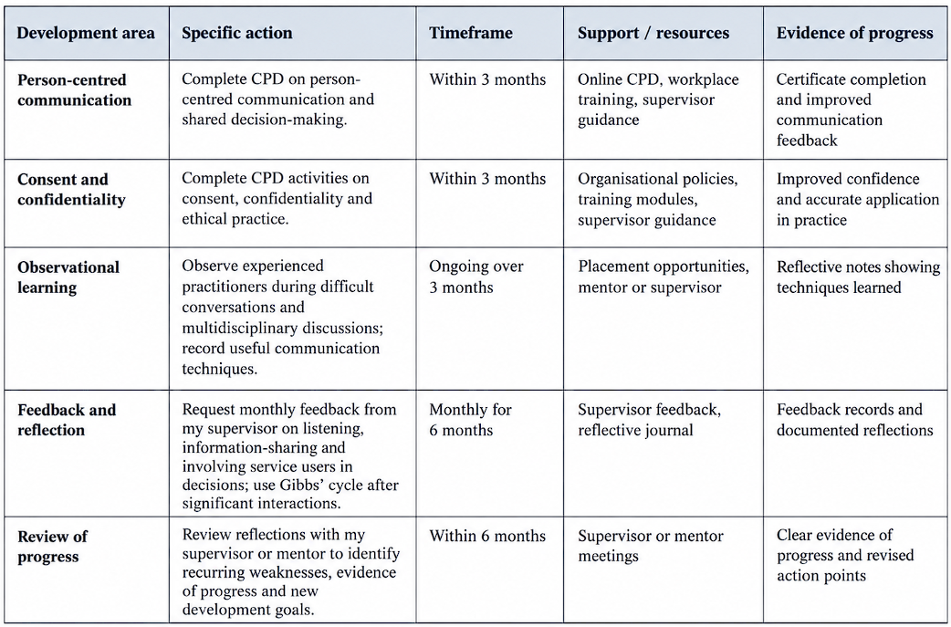
Table: Action plan
(Source: Self-Created)
In the three months, I will finalise CPD activities that address the areas of person-centred communication, consent, confidentiality and shared decision-making. Ongoing professional development helps health professionals to sustain and expand their knowledge, skills and professional performance (Al-Omary et al. 2024). I will also monitor the experienced practitioners when having difficult conversations and when discussing multidisciplinary topics and note down the communication techniques they employ. I will also ask my supervisor to provide his feedback regarding my listening, information-sharing, and service user involvement in decisions once a month. After having interacted extensively, I will document what occurred, what I have learnt, and one particular action to be improved using the Gibbs cycle.

Conclusion
Collaborative working and ethical practice go hand in hand with person-centred care as foundations of high-quality health and social care. The case of Mrs C demonstrates that successful treatment needs to address not just disease, but also individual aspirations, connection, autonomy, emotional wellbeing and future interests. Choice may be safeguarded by the use of joint decision-making and professional input coordination to identify and mitigate risk.

References
Ahmed, A., van den Muijsenbergh, M.E.T.C. and Vrijhoef, H.J.M. (2022) ‘Person-centred care in primary care: What works for whom, how and in what circumstances?’, Health & Social Care in the Community, 30(6), pp. e3328–e3341. Available at: https://doi.org/10.1111/hsc.13913
Al-Omary, H., Soltani, A., Stewart, D. and Nazar, Z. (2024) ‘Implementing learning into practice from continuous professional development activities: a scoping review of health professionals’ views and experiences’, BMC Medical Education, 24, p. 1031. Available at: https://doi.org/10.1186/s12909-024-06016-7
Becker, C., Zumbrunn, S., Beck, K., Vincent, A., Loretz, N., Müller, J., Amacher, S.A., Schaefert, R. and Hunziker, S. (2021) ‘Interventions to improve communication at hospital discharge and rates of readmission: a systematic review and meta-analysis’, JAMA Network Open, 4(8), e2119346. Available at: https://doi.org/10.1001/jamanetworkopen.2021.19346
Bourne, C., Houchen-Wolloff, L., Patel, P., Bankart, J. and Singh, S. (2022) ‘Self-management programme of activity coping and education: SPACE for COPD(C) in primary care: a pragmatic randomised trial’, BMJ Open Respiratory Research, 9(1), e001443. Available at: https://doi.org/10.1136/bmjresp-2022-001443.
Campbell, F. and Rogers, H. (2022) ‘Through the looking glass: a review of the literature surrounding reflective practice in dentistry’, British Dental Journal, 232(10), pp. 729–734. Available at: https://doi.org/10.1038/s41415-022-3993-4
Care Quality Commission (2026) The fundamental standards of care. Care Quality Commission. Available at: https://www.cqc.org.uk/about-us/fundamental-standards [Accessed on 7 October]
Doornebosch, A.J., Smaling, H.J.A. and Achterberg, W.P. (2022) ‘Interprofessional collaboration in long-term care and rehabilitation: a systematic review’, Journal of the American Medical Directors Association, 23(5), pp. 764–777.e2. Available at: https://doi.org/10.1016/j.jamda.2021.12.028
Eg, M. and Jensen, C.S. (2023) ‘The challenges of maintaining patient confidentiality in pediatric settings’, Journal of Pediatric Nursing, 69, pp. 18–23. Available at: https://doi.org/10.1016/j.pedn.2022.12.022
Feldthusen, C., Forsgren, E., Wallström, S., Andersson, V., Löfqvist, N., Sawatzky, R., Öhlén, J. and Ung, E.J. (2022) ‘Centredness in health care: a systematic overview of reviews’, Health Expectations, 25(3), pp. 885–901. Available at: https://doi.org/10.1111/hex.13461
Great Britain (2022) Health and Care Act 2022, c.31. London: The Stationery Office. Available at: https://www.legislation.gov.uk/ukpga/2022/31/contents [Accessed on 7 October]
Government of UK, (2014). Care Act 2014. Available at: https://www.legislation.gov.uk/ukpga/2014/23/contents [Accessed on 7 October]
Marulappa, N., Anderson, N.N., Bethell, J., Bourbonnais, A., Kelly, F., McMurray, J., Rogers, H.L., Vedel, I. and Gagliardi, A.R. (2022) ‘How to implement person-centred care and support for dementia in outpatient and home/community settings: scoping review’, BMC Health Services Research, 22, p. 541. Available at: https://doi.org/10.1186/s12913-022-07875-w
National Institute for Health and Care Excellence (NICE) (2021) Shared decision making. NICE Guideline NG197. London: NICE. Available at: https://www.nice.org.uk/guidance/ng197 [Accessed on 7 October]
Rabben, J., Vivat, B., Fossum, M. and Rohde, G.E. (2024) ‘Shared decision-making in palliative cancer care: a systematic review and metasynthesis’, Palliative Medicine, 38(4), pp. 406–422. Available at: https://doi.org/10.1177/02692163241238384
Rabben, J., Vivat, B., Fossum, M. and Rohde, G.E. (2024) ‘Shared decision-making in palliative cancer care: a systematic review and metasynthesis’, Palliative Medicine, 38(4), pp. 406–422. Available at: https://doi.org/10.1177/02692163241238384.
Schaepkens, S.P.C., Veen, M. and de la Croix, A. (2022) ‘Is reflection like soap? A critical narrative umbrella review of approaches to reflection in medical education research’, Advances in Health Sciences Education, 27(2), pp. 537–551. Available at: https://doi.org/10.1007/s10459-021-10082-7
Schilling, S., Armaou, M., Morrison, Z., Carding, P., Bricknell, M. and Connelly, V. (2022) ‘Understanding teamwork in rapidly deployed interprofessional teams in intensive and acute care: a systematic review of reviews’, PLOS ONE, 17(8), e0272942. Available at: https://doi.org/10.1371/journal.pone.0272942
Sharkiya, S.H. (2023) ‘Quality communication can improve patient-centred health outcomes among older patients: a rapid review’, BMC Health Services Research, 23, p. 886. Available at: https://doi.org/10.1186/s12913-023-09869-8
Simons, M., Goossensen, A. and Nies, H. (2022) ‘Interventions fostering interdisciplinary and inter-organizational collaboration in health and social care: an integrative literature review’, Journal of Interprofessional Education & Practice, 28, 100515. Available at: https://doi.org/10.1016/j.xjep.2022.100515
Vearrier, L. and Henderson, C.M. (2021) ‘Utilitarian principlism as a framework for crisis healthcare ethics’, HEC Forum, 33(1–2), pp. 45–60. Available at: https://doi.org/10.1007/s10730-020-09431-7

