
Forces in equilibrium
By
Your Name: Tamzyn Davis 1804003
Course Title: Science M3X01513
Lecturer: Gregory Owen

Contents
1 Rationale 2
2 Hypothesis 2
3 Apparatus set-up 2
3.1 Equipment 2
3.2 Example set-up 2
4 Method 3
5 Results 3
5.1 Results table 3
5.2 Results Graph 4
6 Analysis 4
7 Conclusion 5
8 Part 2 Answers 5
8.1 2 5
8.1.1 a 5
8.1.2 b 6
8.1.3 c 7
8.1.4 d 7

Rationale
The aim of this experiment is to investigate how the angle between two strings changes as an increasing load is supported between them.

Hypothesis
The prediction for this experiment is, that the higher the mass of the load supported by the string, the longer the springs will become, therefore the smaller the angle between the strings will become.

Apparatus set-up

Equipment
- Meter rule
- Clamp stand
- Spirit level
- Spring x2
- A length of string
- Protractor
- 30cm rule
- 50g masses up to 550g
- 50g mass hanger
- Cellotape

Example set-up
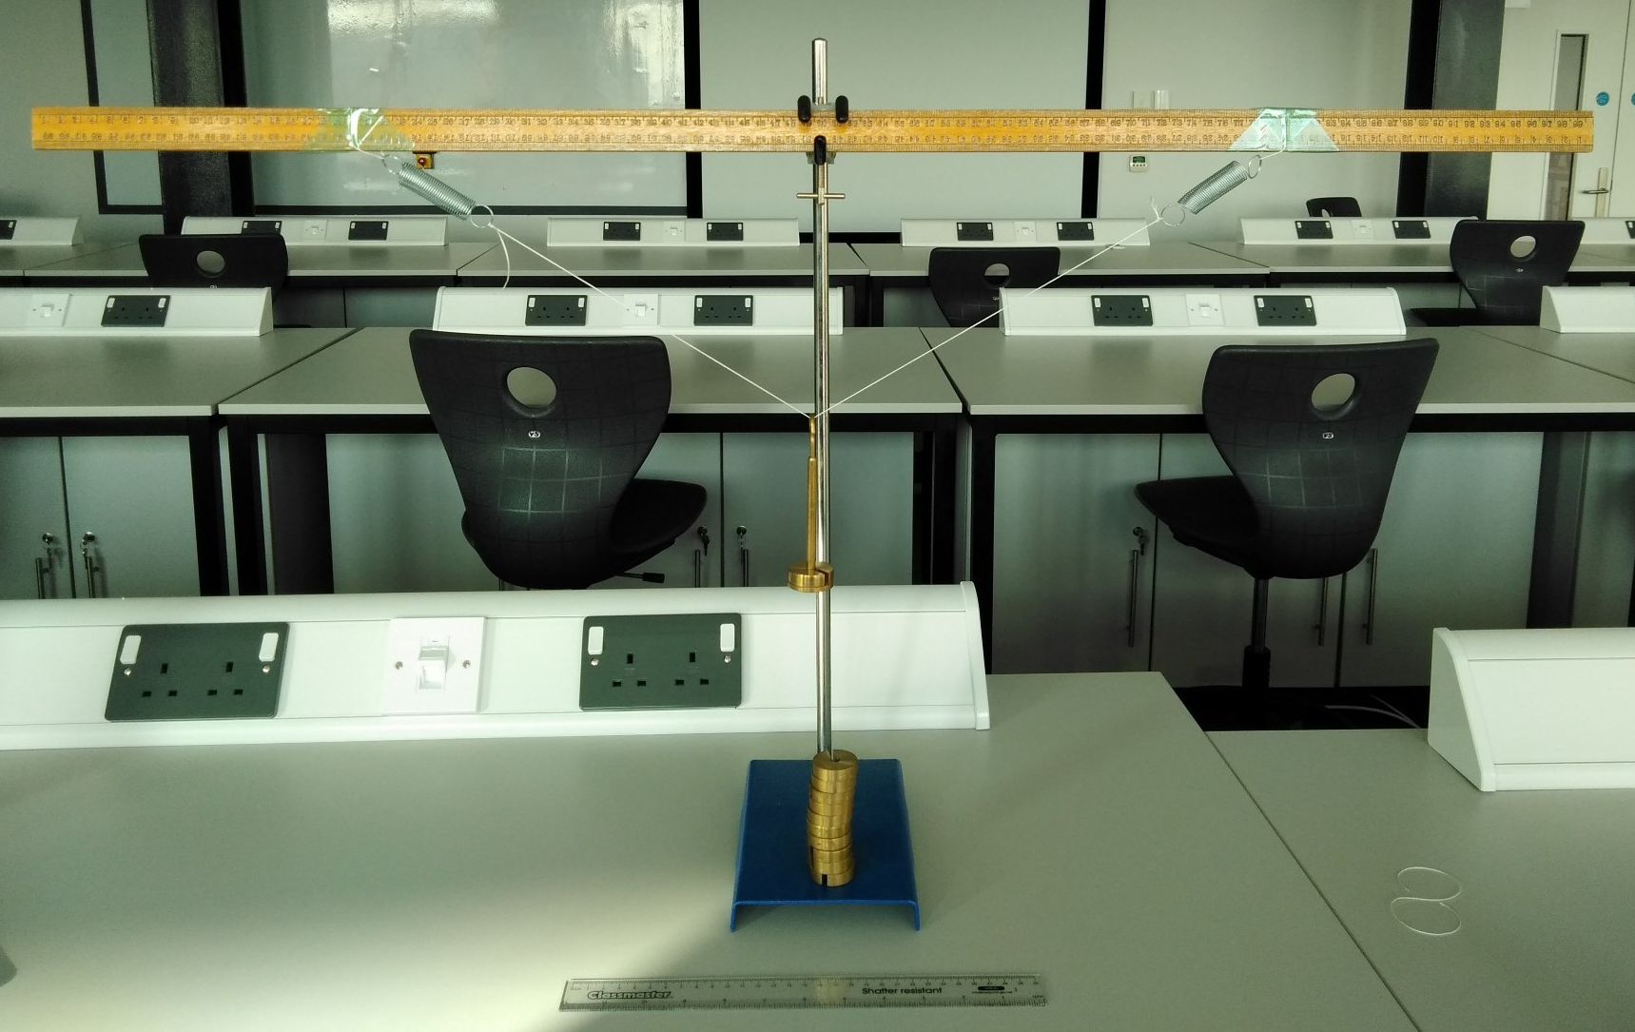

Method
- Set-up equipment as shown in section 2.2 without the mass hanger, making sure meter rule is straight with the spirit level, the string should be secured 30cm from each side of the center.
- Measure length of each spring with 30cm ruler with no mass added (including end loops) as a base reading, enter in table under mass 0g
- Add 50g mass hanger, wait for any movement to stop and measure the length of each spring and measure the angle Θ between to two strings, making sure protractor is centered with bend in string.
- When taking the measurements make sure it is at eye level for accurate results
- Add 50g mass to hanger and repeat, taking measurements of spring length and string angle at eye level
- Repeat step 5 until a total of 600g of mass has been used taking measurements each time at eye level
- Repeat experiment for more reliable data
- Take averages of spring length and angle Θ (see 4.1 explanation)
- Plot a graph using measurements with a line of best fit. (see 4.2)

Results

Results table
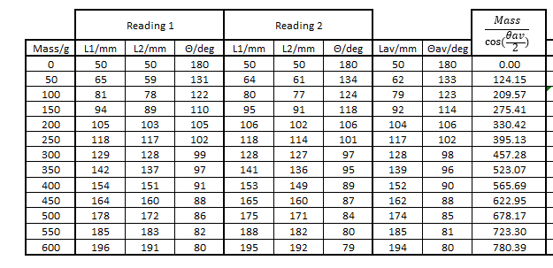

Once the Results have been collected in the table the data needs to be made more accurate, to do this the average of each measurement type needs to be found. The averages for the lengths are calculated by (L1+L2+L1+L2)/4 adding all of the length measurements together and dividing by however many measurements there are. To calculate the averages of the angle it is exactly the same (Θ+Θ)/2 add the measurements then divide the answer by however many measurements there are.
The last column in the table is calculating the drop of the string from the straight resting position, this is calculated in the above equation, where the Mass is divided by Cos of the angle divided by 2.

Results Graph

Length average (mm)

$\frac{Mass}{cos⁡(\frac{θav}{2})}$ (mm)

Analysis
The data in the table has shown us a steady increase in the drop from the straight resting position of the string when an increasing load is placed in the center. During the experiment it was noticed how uncertainties occurred due to the equipment that was used, these were calculated in the table:
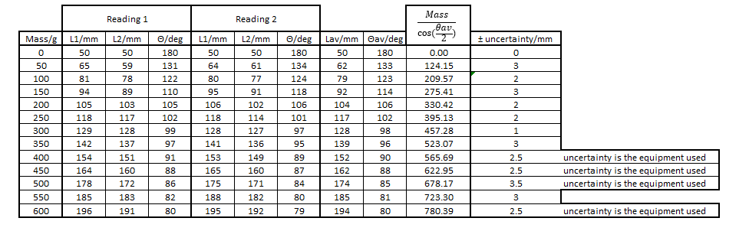

Some of these could have occurred due to the fact that each measurement was taken by eye, movement of the equipment and making sure it was at eye level isnt a fullproof way of collecting data. If other equipment was used EG. A micrometer or a vernier caliper instead of a ruler, more precise measurements could have been taken thereby reducing the uncertainty of the lengths. To reduce any uncertainties with the angle measurements a different tool could also have been used EG. A digital angle rule instead of a protractor, this would have given much more precise measurements and it can go below the 1degree that a protractor is limited to.
To have more reliable data this particular experiment was done in 50g increments rather than the 100g increments stated, this created more data points, reduced the effect of any errors and the line of best fit became much more acurate.

Conclusion
In conclusion, the data from the table and the data put into the graph have proven the hypothesis correct, there is a positive linear relationship between the spring length and the drop of the string when an increasing mass is placed in the center. This straight line of best fit was calculated from the equation Y=mx+c as shown on the graph.

Part 2 Answers

2

a

i
M = $\frac{W}{2g\cos{Θ}}$ $\cos{θ}$ = $\frac{w}{2mg}$
m$\cos{θ}$ = $\frac{w}{2g}$ M = $\frac{W}{2g\cos{Θ}}$

ii
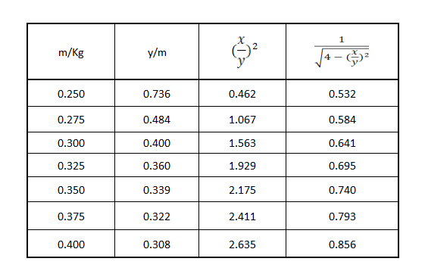

iii

b

i
gradient = $\frac{y-step (Δy)}{x-step (Δx)}$ $\frac{0.4-0.25}{0.856-0.532}$ = $\frac{0.15}{0.324}$ = 0.463 3dp

ii
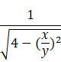
m = $\frac{w}{g}$ x
making w the subject
w = $\frac{\frac{mg}{1}}{\sqrt{{4-(\frac{x}{y})}^{2}}}$
plug the numbers in:
w = $\frac{(0.275x9.81)}{0.584}$ = 4.619N

c
percentage uncertainty = $\frac{probable error}{measurement}$ x 100%
x = 500mm +-0.2%
y = 400mm +- 0.5% 0.2+0.5 = 0.7% 0.7 x 2 = 1.4%
1.563m ± 1.4%

d

i
systematic errors are readings that follow a trend and differ systematically from the real readings which can be caused by improper use of equipment and/or badly calibrated equipment.

ii
Due to there being friction in the pulleys the y reading would decrease slower due to the weights having to overcome an extra force.

