Component 2 - Research Report
Student Name: Daniel Iulian Dinca
Student Number: 2130676
Lecturer Name: Dale Clarke
BMSW4003_BIRM
Digital Skills and Research Methods.

Contents
Introduction 3
Research design 3
Research Question 3
Method 3
Ethical Considerations 4
Results 5
Discussion 7
Conclusion 9
Appendix A 11

Introduction
This study will examine whether or not the students are willing to collaborate online. It will describe the study that has been done on this issue, as well as the methods and ethical concerns that have been taken into account. These days, students may study in new ways thanks to the widespread use of digital learning and education. Students are familiar with the basics of utilising commonplace technology. However, it is possible that they lack the requisite expertise to make full use of it. Students at the undergraduate level, it has been shown, require greater training in digital technologies in order to incorporate them into their educational experiences (Zawacki‐Richter, 2021). Digital development should be a component of lifelong learning. The fast growth of the Internet has resulted in various educational advantages. Students will only be able to reap the advantages of this wide variety of assistance if they possess the necessary knowledge and abilities to make effective use of it when they collaborate online with other students to learn or research something (Shah et al., 2022). Even though many of the students at UWTSD are returning to school after a long absence, technological advancements have fundamentally impacted the manner in which students approach their academic endeavours in the last several decades. I decided to undertake a study to see whether these students are competent in utilising the technological systems required for their course and if they would benefit from further training. Mishra, Gupta, and Shree (2020) point out that some institutions have collapsed or are about to collapse due to the ever-changing COVID-19 context and are transitioning to online and remote education and using collaboration tools in response to this.

Research design

Research Question
My chosen question was, “Are students confident in using technology to collaborate?”

Method
This inquiry will use quantitative data analysis. As a direct result of this, I devised a poll consisting of seven items, all of which were multiple-choice questions. Participants were given a list of potential responses to each question, and students were given a selection of options from which to choose in order to reply. They use Microsoft forms in the administration of the survey. The survey was attached to an email that was sent to all of the students' email addresses who were participating in the online collaborative activities. Immediately in response to the query, thirteen different pupils spoke out. I want to make use of a quantitative approach that involves the utilisation of graphs so that I may examine and comprehend the results of my research. According to Goertzen (2017), researchers who work in quantitative information management have a significant challenge when attempting to make sense of all of these data sources and use them in an efficient manner to aid in making sound decisions. In addition, as a consequence of this, electronic book collections typically consist of two primary components: an analysis of the amount of money that is allocated and spent, as well as an analysis of the manner in which books are acquired through retail orders (subscriptions), large aggregate databases, and subscriptions. We were able to identify whether or not students need more training in working together by using a Likert scale, rank order, and questions with only one correct answer. Survey research makes use of scientific sampling and well-crafted questionnaires in order to arrive at precise estimates of the characteristics of the group being studied. The use of surveys enables managers to make comparisons between distinct populations of individuals (Sukamolson, 2007). In light of the fact that the outcomes may be determinable and even immediate, I decided to tackle my research problem with the help of this approach. As a consequence of this, the replies of the student were adapted to address the question of how self-confident they are in their ability to communicate via the use of technology.

Ethical Considerations
Ethical considerations are critical to the study design and include data security, privacy for participants as well as fair and transparent treatment of them, accurate analytic reporting, and investigator safety (Nayak and Narayan, 2019).
All conversations centred on the information that had been gathered in order to preserve the level of secrecy required. At random, both male and female students from the same course level (level 4) were selected. Even if the statistics contradicted the desired result, I disclosed them all and stayed open to the feedback I received. It is important for researchers to take additional steps to ensure their work adheres to their own ethical standards while doing quantitative research because of the particular ethical issues it presents. As a participant in a research project, you have a right to know what is going on, and you have a right to be safeguarded from discomfort and secrecy. For a study to be successful, the researcher has to consider each of these aspects (Gustavsson and Beckman, 2020).

Results
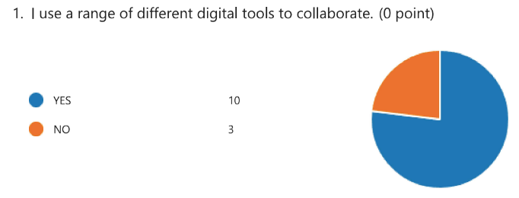
It can be observed from the depiction in the form of a diagram that the majority of the participants interact with their friends, classmates, and teachers using a variety of various forms of digital technologies.
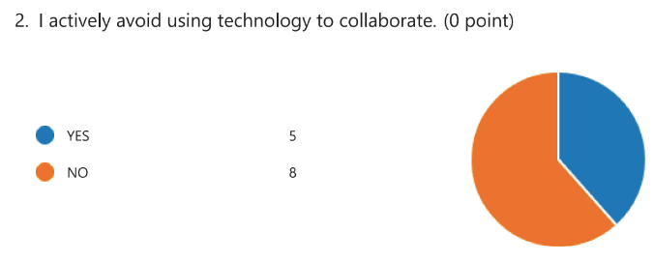
On the other hand, it has been found that a sizeable number of students avoid digital media like the plague. The primary reason for this is that they believe it needs an excessive amount of time and attention that cannot be made up for in any other way.
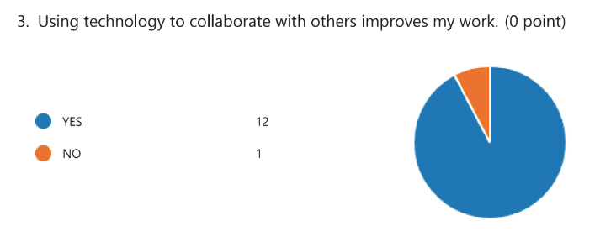
The overwhelming majority of students have discovered that collaborating with their classmates on assignments results in an overall improvement in the quality of their work. They make headway in a productive and positive direction.
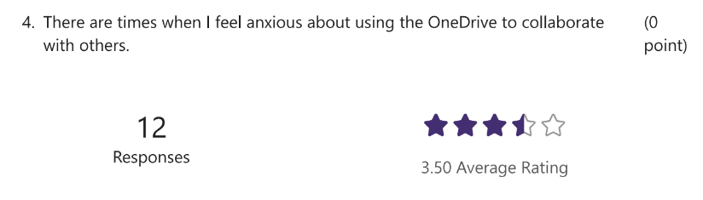
Students often report feeling anxious about collaborating with their peers using OneDrive. There was a total of 12 people responded to the survey. It ends up with an average rating of 3.5 stars.
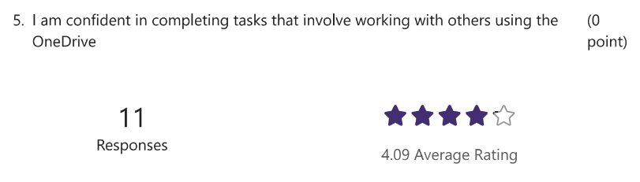
On the other hand, the great majority of students find that working together with their classmates using OneDrive is enjoyable. There was a total of 11 persons participated in the survey and gave their responses. In the end, it received an average of 4.09 stars across all ratings.
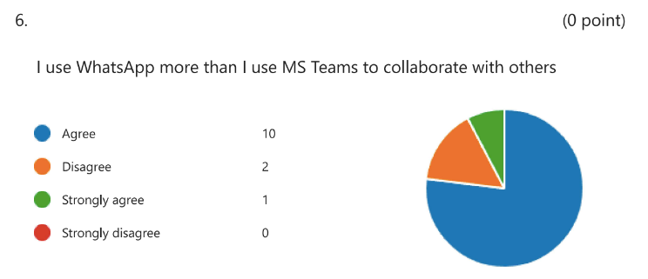
Students like utilising WhatsApp above any other sort of collaborative activity, such as working in teams. WhatsApp is an instant messaging and group messaging app. This is because the students see WhatsApp as being simpler and more personal than other messaging apps like Snapchat and Instagram.
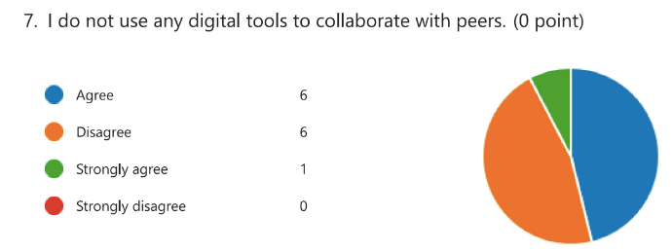
Despite this, there are still a great number of individuals who dislike being forced to use technologies that need collaboration. Instead, they choose to work alone, and after they are finished, they would rather show their work to their coworkers than discuss it with anybody else.

Discussion
The comprehensive analysis of the survey results has provided a tangible visualisation of the individual perspectives of the students on the subject of the use of collaborative technologies. There are many different tools for group work that can be found on the internet. These technologies have the ability to make life simpler for the individuals who are learning. In the research questions, several various names of collaborative tool types were presented, and students were also questioned about the degree of ease with which they found using those tools. The process of data collecting might be modified with less effort. As a result, the investigation has provided substantial new understandings pertaining to the subject as well.
It is evident from the presentation of the data in the form of a diagram that the vast majority of the participants communicate with their friends, classmates, and instructors by using a variety of different kinds of digital technology. This is the case because the vast majority of the participants use multiple different kinds of digital technology. On the other hand, it has been found that a sizeable percentage of students do not make use of any digital media at all. They believe that an excessive amount of time and attention is required, neither of which can be compensated for in any other fashion, and this is the primary reason why this is the case. They believe that this is the case because it demands an excessive amount of time and attention. The overwhelming majority of students are now aware that improving the quality of their schoolwork by collaborating with other students in their class leads to an overall improvement in the quality of the work that they produce. They are advancing in a way that is not just useful but also productive as they go forward.
Students often report that they are concerned about the prospect of collaborating with their peers while utilising the online storage service OneDrive. On the other side, the clear majority of students express delight when talking about how enjoyable it is to work together with their other classmates using OneDrive. Students are more interested in using WhatsApp than participating in any other form of group activity, including working in teams. A messaging app is what WhatsApp is. WhatsApp is a piece of mobile software that gives its users the ability to exchange instant messages to one another and take part in group discussions. The reason for this is that the students believe that WhatsApp is easier to use and provides a more personal experience compared to other messaging services such as Snapchat and Instagram. Despite this, there is still a sizeable portion of the public that strongly objects to being forced to use technology that needs their voluntary participation. They choose to work on their own instead, and when they are finished, they would rather show their work off to their coworkers than have any other person discuss it with them. It is noteworthy to take notice of this option, which was made to work alone and then present the results to others. It is thus clear that the use of collaboration tools is of significant assistance to the students in their day-to-day life. Even if students are unable to interact with one another physically, they are still able to complete their group projects and assignments on time. The sole challenging circumstance was caused by a large number of participants. In order to get a result that was both more accurate and more satisfactory, the sample size needed to be increased. The poll received responses from just 13 students. As a result, it is clear that if more students participated in the survey, there would be a chance of receiving responses that reflected a greater variety of perspectives and improved insights into the issue.

Conclusion
The present research has provided a concise demonstration of the student's attitudes toward the use of collaboration tools for the purpose of improving their levels of working together on group projects and assignments. It is common knowledge that students take pleasure in using various tools, yet, a large number of students do not have much experience with using collaborative technologies, which makes the process rather challenging for them. It is possible for the educational establishment to consider the possibility of organising special classes for the students in order to instruct them on the opportunities and appropriate utilisation of collaborative tools in order to improve their performance and obtain the opportunity to develop themselves into better learners and team workers in general.

Reference List

Goertzen, M.J., (2017). ‘Introduction to quantitative research and data’. Library Technology Reports, 53(4), pp.12-18.
Gustavsson, J. and Beckman, L., 2020. Compliance to recommendations and mental health consequences among elderly in Sweden during the initial phase of the COVID-19 pandemic—a cross sectional online survey. International journal of environmental research and public health, 17(15), p.5380.
Mishra, L., Gupta, T. and Shree, A., 2020. Online teaching-learning in higher education during lockdown period of COVID-19 pandemic. International Journal of Educational Research Open, 1, p.100012.
Nayak, M.S.D.P. and Narayan, K.A., 2019. Strengths and weaknesses of online surveys. Technology, 6(7), pp.0837-2405053138.
Shah, I.A., Jhanjhi, N.Z., Humayun, M. and Ghosh, U., 2022. Impact of COVID-19 on Higher and Post-secondary Education Systems. In How COVID-19 is Accelerating the Digital Revolution (pp. 71-83). Springer, Cham.
Zawacki‐Richter, O., 2021. The current state and impact of Covid‐19 on digital higher education in Germany. Human Behavior and Emerging Technologies, 3(1), pp.218-226.

Appendix A
1. I use a range of different digital tools to collaborate.
- yes
- No

2. | actively avoid using technology to collaborate.
- Yes
- No

3. Using technology to collaborate with others improves my work.
- YES
- No

4. There are times when | feel anxious about using the OneDrive to collaborate with others.

5. I am confident in completing tasks that involve working with others using the OneDrive

6. I use WhatsApp more than I use MS Teams to collaborate with others
- Agree
- Disagree
- Strongly agree
- Strongly disagree

7. I do not use any digital tools to collaborate with peers.
- Agree
- Disagree
- Strongly agree
- Strongly disagree

