

Student Name: Md Mohaiminul Islam Bappy
Student ID: 2431568

Title- Individual report on Zara’s international marketing strategies in the UK and India

Module Name: International Marketing- Principles and Practices

Module Code: LCMB7026

Lecturer’s Name: Tushara Balendran

Submission Date: 23-04-26

Acknowledgement of AI Tool Use

I acknowledge the use of ChatGPT (https://chatgpt.com/) on various dates between March and April 2026 to support the research, structuring, proofreading, and writing of this assignment. I used the following types of prompts:

Please give me information from academic literature and industry studies regarding the marketing approach adopted by Zara abroad in the United Kingdom and India.

Please recommend an outline for an effective marketing comparative analysis based on the PESTLE, STP, 7 Ps, and Ansoff Matrix.

Please proofread the following paragraph, making any necessary adjustments.

I hereby declare that I did not submit any text created by artificial intelligence software as my original output. All texts generated using the assistance of such software have been critically evaluated and incorporated into my analysis. I hereby declare that I have kept copies of my working drafts and other documentation before and after the use of artificial intelligence software, as required.

Table of Contents
Section 01: 5
1. Introduction 5
2. Background Information About Zara 5
3. PESTEL Analysis of the Market in Two Countries 7
3.1 Political Factors 7
3.2 Economic Factors 7
3.3 Social Factors 8
3.4 Cultural Factors (Hofstede Model of Cultural Dimensions: advantages & disadvantages) 9
3.5 Technological Factors 10
3.6 Legal Factors 11
3.7 Environmental Factors 11
5. STP and Marketing Mix (7Ps) 12
5.1 Segmentation (United Kingdom vs India) 12
5.2 Targeting (United Kingdom vs India). 13
5.3 Positioning (United Kingdom vs India) 13
5.4 Product (United Kingdom vs India) 15
5.5 Price (United Kingdom vs India). 15
5.6 Place (United Kingdom vs India). 16
5.7 Promotion (United Kingdom vs India). 17
5.8 People (United Kingdom vs India) 18
5.9 Process (United Kingdom vs India) 18
5.10 Physical Evidence (United Kingdom vs India) 19
6. Analysis of the Brand’s Directional Development Strategy in One Country 19
7. Evaluation of Ethical Issues Related to the Brand’s Marketing Mix in One Country 21
8. Recommendations on How the Company Should Go Forward 22
9. Conclusion 22
Section 02: Reflection of Section 01 Report 23
10.1 Description 23
10.2 Feelings 23
10.3 Evaluation 23
10.4 Analysis 24
10.5 Conclusion 25
10.6 Action Plan 25
References 27

Section 01:

Introduction
Zara is a fast fashion retail store that was founded in 1975 by Amancio Ortega and Rosalia Mera in Spain. Zara has a reputation of being the first to adopt the new fads and it offers quality clothes at affordable prices to its customers. The vertical integration also allows the company to design, produce and sell new products swiftly, which contributes to it remaining on the fashion wave (Nguyen, 2023). The mission statement of Zara is to provide fashionable clothes to the great number of clients and to be the leader in the fashion, and the vision of the company is not to lose its leading position in the global arena with constant innovations and introduction of sustainability. This report will examine the marketing of Zara in two markets namely India and the United Kingdom (UK). Zara ventured into India in 2010, and it has capitalized on the fast-growing Indian middle-class and the necessity to wear foreign fashion (Zhang, 2024). Zara has fashionable and inexpensive garments in cities like Delhi and Mumbai, which appeal to the youthful and trendy. The UK market is on the other hand several years old and Zara have been integrated with the international fashion and the local tastes and preferences. This report is designed to explore how Zara can align its marketing strategies to suit the cultural, economic and social aspects of India and the UK. It will elaborate the strategies of Hofstede, STP, product, price, place, and promotion, people, process and physical evidence of Zara in the two countries directional development strategies, ethical evaluation and will support this with the insights on its international marketing strategies and give recommendations on future strategies. Reflectively, a Gibbs Reflective Cycle will be used to give an account.

2. Background Information About Zara
Amancio Ortega and Rosalia Mera established Zara in Arteixo, Spain in 1975. Originally, the brand started as a small shop where you could find cheap home items; however, it soon became a fashion retailer. The initial Zara outlet proved successful because of the understanding that Ortega had in offering fashionable attire at low prices. The novel business approach that the company followed involved producing and supplying new designs as fast as possible thus enabling Zara to stay in with the latest fashion trends. It is this fast fashion that made Zara have a competitive advantage in the retail industry. The history of Zara was when the first store was opened by Ortega in 1975 and in a few years, it opened stores throughout Spain. Ortega had a revolutionary idea of vertical integration which has made the success of the company. Zara was able to react to consumer demand within record time by having control over design, production and distribution. Zara started expanding internationally by opening the first store in Portugal in 1985, then took further steps since then to expand to other parts of Europe. As time went by, the business model of Zara grew, and its stores are in major cities across the world. The mission of Zara is to offer quality fashionable clothes at low costs and made available to a large population (Adithya, et al., 2025). The vision statement of the brand is to be the world leader in fast fashion with products that respond fast to the latest trends to help the customers enjoy high-quality fashion at low prices. Zara is a company that constantly innovates and responds to the trends of the industry, while being concerned with sustainability and reducing its environmental footprint. Zara operates more than 2000 outlets across the world including the large cities in Europe, Asia and the Americas. Its worldwide growth has been marked by the approach of strategic interpretation of the local markets without compromising the brand image. The flexibility of Zara to diverse regions has enabled it to continue registering great sales in most parts of the world. In 2010, Zara ventured into the Indian market, where the demand for international fashion brands was on the rise (Punda, 2025). The launch of this brand was timely as the middle-income is growing in India and the presence of a youthful, fashionable population in the metropolitan areas. Zara concentrated on the up-market shopping malls in cities such as Delhi, Mumbai and Bangalore, which sell the global trends but at lower prices. Zara is a long-time player within the UK market. The UK was a strategic move since the country is a major fashion centre in Europe (Saraiva, 2025). Zara rapidly became one of the leading fashion stores through the combination of global styles and considering the specificity of local tastes. It has dominated the UK market with its dominance in the major cities and has flagship stores in London and Manchester.

3. PESTEL Analysis of the Market in Two Countries

3.1 Political Factors
United Kingdom – More favourable
India – Favourable but comparatively less predictable
In the political front, the United Kingdom is more favourable to Zara since it offers it a stable business environment that is both transparent and well-regulated. With good institutions, legal frameworks and predictable policy execution, Zara can plan long-term retail operations with reduced political uncertainty. This consistency is quite valuable to an international brand that needs effective supply chains, uniform compliance, as well as streamlined store operations. Moreover, the well-developed regulatory framework in the UK assists Zara in conducting business in an environment where the business-related expectations are set (Fraser, and Van der Ven, 2022) in areas like labour protection, consumer laws and corporate reporting which can add more operating and compliance costs on the company.
Conversely, India is another politically favourable country to Zara since international retailers have high growth prospects in the country. The single brand retailing sector in the country is liberalised to foreign investment, and this facilitates the growth of Zara and its entry into the market. This will provide a favourable climate to the foreign fashion companies who want to access a huge and rising consumer market. Nevertheless, India is a relatively less foreseeable country since policies, regulations and practices can be less predictable and practical operations become more complicated. Thus, United Kingdom is more favourable in terms of political stability and predictability of businesses whereas India is favourable mainly due to its high market expansion potential.

3.2 Economic Factors
United Kingdom – Favourable for stable purchasing power
India – More favourable for growth potential
The United Kingdom is economically favourable to Zara since it is a mature consumer market with a reasonably good purchasing power and defined fashion requirements that ensure reliable performance of sales. Nevertheless, the UK has a rather average growth perspective, and IMF forecasts 1.2 percent in 2025, thus growth prospects are not quick but more stable. The future growth of Zara would be more favourable in India due to the robustness of its economy with IMF reporting 6.5 percent growth in FY2024/25 and high consumption on the part of the individual population (Nguyen, 2023). This has a higher long-term potential as there is urbanisation and a growing middle-class customer base even though the market is more sensitive to price. Thus, UK is more favourable than India in terms of economic stability and long-term growth of market respectively.

3.3 Social Factors
United Kingdom – Favourable
India – More favourable for long-term demand
In this social aspect, the United Kingdom is favourable to Zara since consumers are so fashion-conscious, trend-sensitive, and are conversant with international fast-fashion brands. The positioning of Zara in the UK market is provided by the urban lifestyles, brand awareness, and frequent purchasing of clothing. Nevertheless, sustainability is becoming a major issue to consumers as well and puts a strain on fast-fashion retailers. India is more favourable in the long-run social factors due to the young population, growing middle class, increasing urbanisation and growing propensity towards the international fashion brands. Indian Gen Z consumers are becoming more digital, value-driven, and social media trend follows, and this leaves good future opportunities of Zara. Hence, the UK is more favourable to the existing fashion consumption whereas India is more favourable to potential social growth.

3.4 Cultural Factors (Hofstede Model of Cultural Dimensions: advantages & disadvantages)
United Kingdom (More favourable for Zara’s standardised fashion model)
India (Favourable but requires greater adaptation)
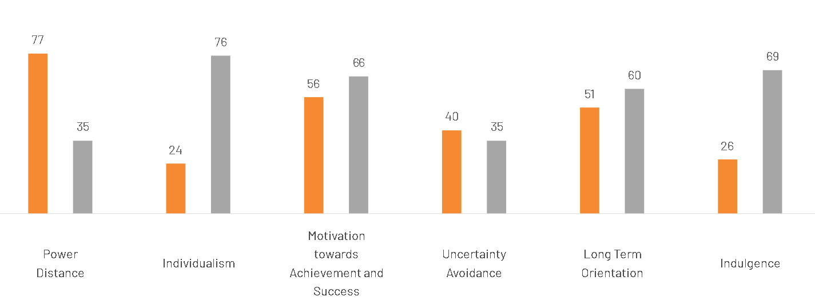
Figure 1 Hofstede's Cultural Dimensions Comparison between India and the United Kingdom
Advantages of the Hofstede Model:
- Cross-Cultural Advice: Gives very important information about the impact of cultural differences on the business and decision-making processes.
- Framework of International Strategy: This has been useful in formulating international marketing and international management strategies that are specific to the cultural values.
- Quantifiable Data: Provides clear and quantifiable measures of cultural differences among countries, and hence they can be easily compared.
- Helps in Organizational Behaviour: Assists in comprehending employee’s behaviours, motivations and communication styles within various countries.
- Widely Accepted: The model is also well known and used in academia and professional circles, so it is a dependable instrument in the process of cultural analysis.
Disadvantages of the Hofstede Model:
- Over-Simplification: Generalizes the complex cultural identities into generalized dimensions thus possibly missing the details and culture specificity of each culture.
- Frozen Data: The model relies on the information gathered a long time ago (1970s) which might not be up to date with cultural transformations or changing values.
- Regional and Sub-Cultural Differences: fails to take into consideration the regional or sub-cultural differences within the nations, which can be substantial.
- Concentrate on National Culture: Presumes that national culture is the most critical aspect of behaviour, and disregards other aspects such as globalization, generational differences or organizational culture.
Cultural Evolution: The cultural norms and behaviours may evolve as time goes by, and the model does not always reflect the changes in the dynamism. In Hofstede cultural dimensions, the United Kingdom is more individualistic and lower on power distance compared to India which is beneficial to Zara since the consumers tend to be more articulate on individual style and embrace self-directed fashion ability. This underlies the fast and trendy positioning of Zara. India, on the other hand, is more collectivist and more power distance, which means that the buying behaviour is rather driven by the family, social groups and culture expectations (Farooq, and Raza, 2024). This provides Zara with an edge against aspirational consumers, yet it poses a drawback since the product design and modesty preferences, and festive demand might need to be more localised. Thus, UK is more favourable to standardised positioning whereas India is favourable only in case Zara carefully adapts to cultural differences.

3.5 Technological Factors
United Kingdom – More favourable
India – Favourable and rapidly improving
The United Kingdom is also more favourable to Zara technologically as it boasts of a well-advanced retail business, prevalent online shopping habits, and enhanced digital business infrastructure. This reinforces the omnichannel framework of Zara, such as shopping in apps, combined inventory management, and quick online delivery. The market setting of the UK is therefore favourable to effective consumer care and high-end retailing activities. India is favourable as well and is very fast developing thanks to the spread of Digital India, the increase of the use of smartphones, the rapid growth of e-retail, and the growing popularity of digital payments like UPI. The trends provide good prospects to the online expansion of Zara, but the consistency of infrastructure has not yet been achieved in all locations. Thus, the UK is better in terms of technology, whereas India is better regarding the prospective expansion of the digital sphere.

3.6 Legal Factors
United Kingdom – More favourable but stricter
India – Favourable but comparatively more complex
The United Kingdom is more favourable to Zara in the legal context since it has a more defined, transparent and strictly enforced legal system in consumer law, retail law, product labelling and employment law. This provides Zara with a predictable business climate, but tougher labour and compliance regulations may increase retailer expenditures. India is preferable as it enables foreign retail and has a high level of legal framework to expand the business, yet it is relatively more complicated with a variety of regulatory processes, changes in compliance requirements, and variations in implementation. There exists labour protection as well as business regulation, but it might demand more of foreign companies to navigate around it. Thus, the UK is better inside of predictability whereas India is also favourable but more legal to handle.

3.7 Environmental Factors
United Kingdom – Less favourable for fast-fashion pressure
India – Favourable but with rising environmental pressure
The United Kingdom is not as favourable to Zara in the environmental dimension of its operations since there is a stronger sustainability expectation and larger concern with waste reduction, circularity and responsible consumption. This poses reputational risk to fast-fashion brands and puts them under pressure to ensure their environmental performance is improved. Comparatively, India is more favourable as the environmental pressure on fashion retail is less as it gives the market more short-term flexibility to grow (Papadopoulou, et al., 2022). Nonetheless, this strength is decreasing because India is also paying more attention to textile waste management and sustainability. Thus, UK is not such an excellent environment whereas India is good but increasingly environmentally challenging.
Similarities and Differences:
- Similarities:
  - Both markets are experiencing growing awareness around sustainability, though at different paces.
  - Environmental factors will continue to play a crucial role in Zara's strategy in both markets.
- Differences:
  - The UK has a more established regulatory framework around sustainability, making it a more challenging market for Zara in terms of environmental responsibility.
  - India, while still relatively lenient, is increasingly becoming aware of environmental concerns, with more attention being given to textile waste and sustainability practices.

5. STP and Marketing Mix (7Ps)

5.1 Segmentation (United Kingdom vs India)
In United Kingdom and in India, Zara divides its market along the demographic, geographic and behavioural lines. The segmentation in the United Kingdom is centred on the urban and fashion-driven customers with the subsets of young professionals and students, who are sensitive to global trends and possess comparatively better purchasing power. The behavioural segmentation puts emphasis on the frequent shoppers who require quick changing styles. In India, Zara divides customers primarily in the metro centres and focuses on young adults with middle and upper-middle-income levels (More, 2024). These customers are subjected to social media and aspire to the worldwide fashion labels. Thus, the UK segmentation is driven by the demand in mature fashion versus that of India where the segmentation is more compelled towards emerging, trend-driven and aspirational consumers. Zara segments its market based on VALS personality types to reach the most important psychographic segments. In UK it targets Innovators and Achievers who want to use trendy products that are of high quality to show their status. Zara focuses on Achievers in India because of their status-seeking and strives who desire to climb the social ladder, both driven by worldwide fashion trends on social media.

5.2 Targeting (United Kingdom vs India).
In the United Kingdom and India, Zara uses differentiated targeting strategy. Zara, in the United Kingdom, has been targeting fashion-oriented people, such as young professionals and students who appreciate trendy designs and do not hesitate to spend their money on fast fashion with a premium touch. The market is also not as price sensitive, and this means that Zara can retain its position in the world market. In India, Zara will focus on the luxury, upper-middle and middle-income customers who want to have imported fashion brands but are price-sensitive (Su, 2020). Its brand targets the big cities where the purchasing power is more significant. Hence, the UK targeting in Zara is more premium-driven and India is more selective and price-sensitive.

5.3 Positioning (United Kingdom vs India)
Zara is a luxury fast-fashion retailer in the United Kingdom and India that offers fashionable designs, quality, and trendy shopping experience at a greater price than mere fast-fashion retailers, yet lesser than luxurious items. This positioning will help Zara attract customers who want trendy and trend-following clothes at non-luxury prices. This positioning is effective in the United Kingdom because consumers in this country are highly fashionable and are more inclined to pay based on the quality and brand image (Lee, 2023). The role of Zara is the same in India compared to the rest of the world except that the brand is viewed to be more aspirational given that a considerable population of the customers are more price sensitive.
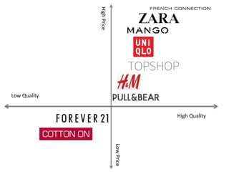
Figure 2 Perceptual Map of Fashion Brands Based on Price and Quality (Positioning of Zara and Competitors
As per the perceptual map, Zara is in a high-price high-quality segment, which also places it next to Mango and Uniqlo. This means that Zara will be regarded as a better brand compared to H&M, Pull and Bear, forever 21 and Cotton On. Therefore, Zara does not compete on low price, but on quality, trendiness, and brand image.
Similarities:
- In the United Kingdom and India, Zara can be viewed as a luxury fast-fashion retailer that provides fashionable designs at non-luxury prices. It targets the fashionable and high-quality clothing of consumers who want it at a lower price than the high luxury brands.
- The brand also competes in terms of quality, trendiness and brand image and targets the style-conscious market and not the price-sensitive shoppers.
- Both countries regard Zara as a trendy brand and consumers who need fashionable and up-to-date fashion that captures the latest trends in the world consider Zara as their preferred brand.

Differences:
- Zara positioning in the United Kingdom is like high-end fast-fashion brands because the UK consumers are more likely to spend on quality and fashionable clothing, with a more emphasis on brand image than on price.
- In India, the global positioning of Zara remains the same, but the brand is viewed as more aspirational, as the market is price sensitive. Indian consumers perceive Zara as a luxury brand that helps to demonstrate a better social position, and the high cost of the brand may not be affordable to the mass market.
5.4 Product (United Kingdom vs India)
Zara stores supply an extensive selection of trendy clothes, accessories, and shoes in the United Kingdom and India, with the emphasis on the fast-changing fashion and contemporary designs. Product offerings in the United Kingdom are more uniform and there are regular new collections in accordance with global trend in fashion. In India, Zara moderately modifies its products, depending on its climatic conditions, culture, and festival demands, including lighter fabrics and modest fashions. Thus, though Zara is globally consistent, the localisation in the Indian market is limited. Zara is a fashion retailer that has an extensive selection of fashionable clothing, accessories, and footwear both in the United Kingdom and India with a focus on evolving fashion and modern fashion. In the United Kingdom, Zara has more homogenous products offerings with their regular new collection following closely to global fashion trends. Conversely, Zara in India slightly changes its product range to meet the needs of the local context, including wearing lighter clothes in hot weather and providing modest fashion to meet cultural demands and celebrations. Although Zara is globally consistent, its localization in India is not as high as in the UK.

5.5 Price (United Kingdom vs India).
Zara uses a relatively high pricing strategy in the United Kingdom and India than the lower priced fast-fashion competitors do. This approach is more successful in the United Kingdom, as the people there tend to be more purchasing power and are more eager to pay on the fashionable designs, quality and brand image (Su, 2020). Consequently, Zara is considered trendy, but accessible by a large population of customers.
Zara in India uses the same global approach in pricing, but the brand is more expensive due to the higher price sensitivity and the lower average income levels. This renders Zara as more appealing to the high-middle-income and up-scale urban shoppers as opposed to the mass market. Thus, although Zara has a consistent pricing policy in the two countries, its products are perceived as more affordable in UK and luxury in India. What specific pricing

5.6 Place (United Kingdom vs India).
The distribution strategy used by Zara in the United Kingdom and India is a combination of physical retail outlets and online platforms. In the United Kingdom, Zara has established business presence in large cities with stores and possesses a highly effective e-commerce platform that supports omnichannel retailing. Zara in India has its operations mostly in the metro cities like Delhi and Mumbai and expanding online stores. Nonetheless, its store penetration level is less than in the UK, which represents a less extensive expansion approach to the Indian market.
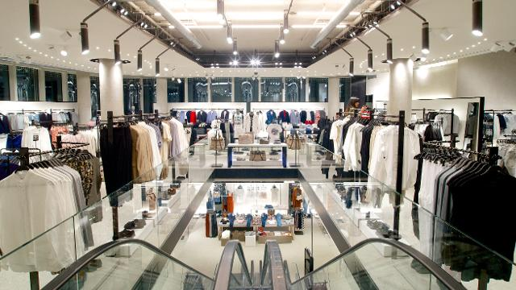
Figure 3 Zara - Oxford Street Flagship Store

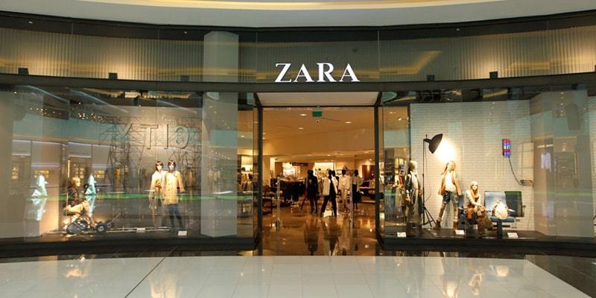
Figure 4 Zara opens largest store in Mumbai (India)

5.7 Promotion (United Kingdom vs India).
Zara promotes less through conventional advertising and more about brand image, store presentation, and high product appeal in both the United Kingdom when compared to India. In UK, Zara is favoured by excellent retailing spots, nice window displays, and effective online communication on the internet and social networks (Humne, 2020). This strategy backs the stylish and high-end fast-fashion image of the brand and makes the promotional expenses relatively low.
Zara in India also employs the same low-advertising strategy, although the digital platforms and social media are particularly significant to target young urban consumers. Moreover, the aspirational value of the foreign brands assists Zara to attract attention to word of mouth and consumer interest. Thus, the promotion of Zara is rather light and globally uniform, yet in India it must rely on the internet influence and aspiration brand more than in the United Kingdom.

5.8 People (United Kingdom vs India)
In the United Kingdom and India, people also are significant in the process of service delivery at Zara. The employees in the United Kingdom are also highly skilled to offer effective and customer-oriented service that will facilitate a hassle-free shopping process. In India training of employees on brand standards is also done but there is more focus on customer support because of the different shopping habits (Jaskulska, 2013). Thus, although Zara has a consistent staff training system throughout the world, the interaction of services in India is a bit more personal than the fast-paced retail environment in the UK.
United Kingdom:
Zara currently employs approximately 3,137 people across its UK stores and head office (The Retail Bulletin, 2023).
India:
Inditex Trent Retail India Private Limited, the company that operates Zara in India, has a workforce of around 1,454 employees as of April 2024 (The Company Check, 2024).

5.9 Process (United Kingdom vs India)
The process of Zara is anchored on the highly efficient supply chain and fast response system both in the United Kingdom and India. New collections are designed, made and shipped to stores within a short period of time thus keeping the business products in line with the trends that exist. In United Kingdom, they are very streamlined with the developed infrastructure and logistics (Aftab, et al., 2018). In India, the procedure is also alike, but it has a possibility of some delays on logistical and distribution levels. Thus, Zara has a stable globalised process with minor variations in operation among markets.
Customer complaints in both countries are dealt with by the dedicated customer service channels at Zara, which consists of online channels and in-store services. Complaints can be easily made by customers, and their concerns are solved in a timely manner with a high level of customer satisfaction being given priority. As the UK has established methods of dealing with complaints by both brick and mortar and online, India also adheres to similar timetables but with an extra emphasis on the personal approach to fulfilling the needs of the local population.

5.10 Physical Evidence (United Kingdom vs India)
The physical evidence of Zara is the store design, layout and the overall brand presentation of the store in both United Kingdom and India. The stores in the United Kingdom are contemporary, large and in strategic shopping locations, which supports the premium image of Zara. The stores in India also have the same global design in terms of clean layouts and beautiful displays, however they are only found in premium malls. Thus, Zara has a stable brand identity, based on physical evidence, whereas accessibility to the stores varies in the two markets.
Similarities and Differences:
- Similarities:
  - Both countries feature Zara’s global store design—contemporary layouts, clean displays, and high-end aesthetics.
  - The premium image of Zara is reinforced in both markets through the store atmosphere and design choices.
- Differences:
  - In the UK, Zara’s stores are more widely accessible and are in a range of prominent shopping areas, including high streets and shopping centres.
  - In India, Zara stores are more concentrated in premium malls, catering to an upscale audience and emphasizing exclusivity. This limits access for broader market segments.

6. Analysis of the Brand’s Directional Development Strategy in One Country
The directional development strategy of Zara in India can easily be analysed in terms of Ansoff Matrix which describes the way in which a company can develop by using the existing products in the existing or new markets or using the new products in the existing or new markets. Zara can find the Indian market very significant due to the high population, the expanding middle class, the high rate of urbanisation, and the rising popularity of international brands of fashion. The best four strategic choices of Ansoff Matrix that are best applicable in Zara in India are these three, which are market penetration, market development and product development (Soares, 2024). Such plans are more expedient and less dangerous as compared to diversification as Zara is still trying to build its presence in the Indian fashion retailing industry.
To begin with, penetration would enable Zara to gain more sales in the current markets particularly in major cities like Delhi, Mumbai and Bangalore. This may be done through enhancing internet communication, customer care, and the introduction of products more often to motivate customers to buy again. Secondly, the market development can also be closely appropriate since stores of Zara are primarily located in metropolitan regions. It should consider expanding its operation to Tier-2 cities like Pune, Ahmedabad, and Chandigarh since this will enable the brand to access more customers and take advantage of the increasing disposable income in these cities.
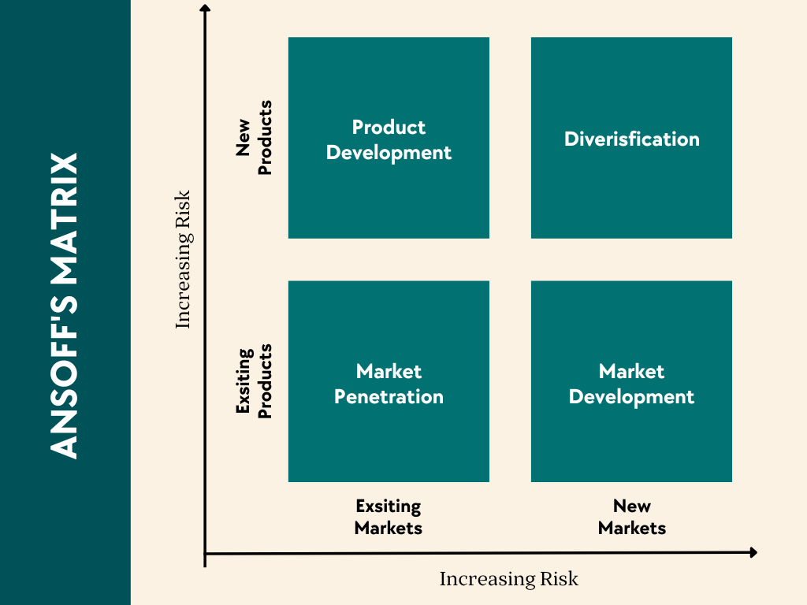
Figure 5 Ansoff Matrix Illustrating Growth Strategies Based on Products and Markets

Thirdly, product development is significant since Indian consumers possess various cultural inclinations, weather requirements, and eventual purchasing behaviour. Zara can enhance its performance by adding materials that are lighter, simple outfits, and choosy festival selections without affecting its image in the world. Lastly, this is the least appropriate variant since the decision to venture into entirely new product lines would be more risky and more uncertain. As such, the best directional development plan of Zara in India is a mixture of market penetration, market development, and product development since it would maximise sales, maximise market penetration and maximise local relevance in a balanced and sustainable manner.

7. Evaluation of Ethical Issues Related to the Brand’s Marketing Mix in One Country
The marketing mix of Zara in India addresses both ethical and unethical factors especially because of the fast-fashion industry. To start with, Zara is focusing on sustainability efforts, which include the usage of environmentally friendly materials, and recycling programmes, which is one of the ethical practices. Such activities are environmental-friendly and enhance the reputation of the brand by the socially sensitive customers (Aggarwal, and More, 2020). Second, Zara has transparent store presentation and customer service, as it upholds store presentation ethics and maintains constant customer brand experience, thus customer trust and satisfaction.
But there are also certain unethical issues. To begin with, the concept of fast fashion presents environmental concerns, since Zara creates huge amounts of clothes within a few cycles, thus, causing excessive consumption of textiles and their waste. This has a harmful effect on the environment and casts doubt on sustainability. Secondly, issues of supply chain and labour practices can be mentioned, in which employees in the manufacturing sites can experience poor working conditions or low wages. Even though Zara has made efforts to enhance the monitoring aspect, these problems continue to pose a hurdle to the fashion marketers worldwide.
Thus, even though Zara can be considered to have some ethical practices in the marketing mix, it still needs to work on sustainability and labour transparency to make its business operations look more responsible and ethical.

8. Recommendations on How the Company Should Go Forward
Zara can implement various strategic changes in its STP and marketing mix to enhance its presence in India and deal with ethical issues. To begin with, Zara needs to consider increasing its target market beyond the major metropolis and the Tier-2 consumers in the cities. This would expand market penetration and favour growth in the long-term. Second, when positioning, Zara should focus on sustainability and fashion by promoting collections that are environmentally friendly, which would make them attractive to consumers who are becoming more environmentally conscious.
Marketing mix-wise, Zara needs to add more products that are more locally oriented, which include Zara prone to climate apparel and holiday collections among others to better suit the customer needs (JANGIR, 2020). There might also be minor price changes to make the price more affordable without hurting the brand image. Moreover, Zara needs to improve its digital marketing and omnichannel to improve customer interaction.
To mitigate unethical concerns, Zara needs to enhance supply chain transparency and have fair labour practices as well as minimize environmental impact in terms of sustainable production and recycling efforts.

9. Conclusion
This report has examined Zara international marketing strategy in United Kingdom and India in terms of external environment, consumer behaviour and the STP and marketing mix strategy used by the company in the two markets. The PESTEL analysis revealed that the United Kingdom has a more stable and technologically developed market, but in India, there is a higher potential of long-term growth, as the population is larger and the middle class is increasing. The STP and 7Ps analysis has shown that Zara uses a relatively standardised international strategy and only does some localisation to local circumstances, especially in India. All in all, the key to Zara's further success will be the ability to balance the global brand consistency with the local responsiveness and enhance sustainability, ethical behaviour, and digital interaction as the means of stabilising the long-term competitive advantage.

Section 02: Reflection of Section 01 Report

10.1 Description
This reflective report is anchored upon my enrolling completion of Section 01 of the report on the international marketing strategy of Zara in the United Kingdom and India. In this report, I have studied the external market environment using the PESTEL analysis and discussed the social, cultural, and economic conditions of the two countries. I used STP and the 7Ps marketing mix, as well, to examine the way Zara functions in both markets and how its strategy varies depending on the needs of consumers and market features (More, 2024). Besides that, I examined the directional development strategy of Zara in India through the Ansoff Matrix and talked about the ethical concerns of its marketing mix. To prepare this report, it was necessary to conduct research, comparison, and critical thought, and apply marketing theories to the real global brand.

10.2 Feelings
I was a bit exasperated and anxious at the onset of this assignment, given that I was required to compare two contrasting countries and implement various marketing theories in a single report. I did not know how I should structure the information and how to relate theoretical frameworks and business practice. I have experienced some pressure as well since the report had to be critically analysed, and a clear comparison between the United Kingdom and India had to be made. But as I went on with my research I shifted towards being less apprehensive and more interested in the subject. The analysis of Zara in the two markets has made me realise that the international marketing strategies need modification depending on the environment, culture, and consumer needs. At the conclusion of the report, I was content with my progress since I was enhanced on my research skills, critical thinking and had a better approach to the global marketing strategy and international business decision making.

10.3 Evaluation
The positive aspect of writing this report was that it enhanced my skills of applying marketing theories to an international real company. PESTEL framework, STP, the 7Ps, and the Ansoff Matrix are some of the frameworks that I could employ to analyse the strategy of Zara in the United Kingdom and India. This enabled me to gain a more insight into how international brands adapt to various market conditions, consumer behaviour and cultural differences (Hong, 2025). Another area is that I enhanced my research abilities in the sense that I relied on various sources to back up my analysis.
Nevertheless, some challenges in the process were also met. Initially, comparing two countries in some balanced manner was challenging since the economic, social, and cultural traits of the markets differ significantly. It was also difficult to make the report brief and at the same time have adequate critical discussion. Besides that, arranging references and having an academic style of writing assumed more attention than I had anticipated.

10.4 Analysis
The experience on this report has enabled me to understand that there is no single standard marketing strategy that can be applied in all markets as far as international marketing is concerned. The case study of the United Kingdom and India Zara enabled me to perceive that the differences that exist between the countries in terms of political, economic, social, cultural, and technological factors do affect business decision making significantly. This means that any company should create a balance between the international standardization and localization in order to remain competitive in different countries.
I also came to realise that marketing structures are simplified when they are associated with real business situations. PESTEL helped me to understand what happens in the external environment, and STP and the 7ps gave me the opportunity to think about how Zara is addressing and servicing customers in diverse marketplaces (Sadri, and Aprianingsih, 2025). Ansoff Matrix also made me realise that the business can grow not only in new locations, but also in the needs of products and approaches to fit into the local markets. This assisted me in making my analysis more realistic and useful.
The other thing that was learnt in this process was the significance of research and organisation. I have also been taught that a good academic report must be well-structured, offer pertinent evidence and critical analysis as opposed to description. Overall, this assignment allowed me to become a more confident analytical and proved that theories of marketing could be efficiently used to give the explanation of the international strategy of a world-spanning company.

10.5 Conclusion
To sum up, the completion of this report was a learning process that enhanced my knowledge of international marketing at practice. It enabled me to acquire some valuable skills, including research, comparison, critical thinking, and translating the marketing theory into a practical business scenario. I also got to know that international marketing also requires knowledge on the differences between nations and implementing strategies that are appropriate in the local market. Another thing I learned to value in writing reports is that it requires academic organisation, facts, and analysis. Overall, this assignment helped me to become more confident in my ability to analyse the global business problem and more capable of connecting the theory with practical marketing decision-making.

10.6 Action Plan
Area for Improvement | Action Plan
Time management | I will begin future assignments earlier and create a clear weekly study schedule so that I can divide my time properly between research, planning, writing, editing, and final proofreading.
Research skills | I will use more academic journals, textbooks, company reports, and credible market sources to make my arguments stronger, more balanced, and better supported with evidence.
Critical analysis | I will focus more on comparing ideas and evaluating their significance instead of only describing information, so that my work becomes more analytical and academically stronger.
Academic writing | I will improve my paragraph structure, sentence clarity, and formal academic tone to ensure that my writing is more professional, coherent, and easy to follow.
Referencing | To ensure that I avoid the errors in both in-text and reference lists, I will practice UWTSD Harvard referencing more attentively to make sure that I cite sources correctly.
Proofreading | I will ensure that I have ample time prior to submitting to proofread grammar, spelling, punctuation, clarity, and overall presentation to enhance the final quality of my work.
Theory application | I will also practice using marketing theories and models to practical companies more frequently to ensure I relate theory and practice more successfully in subsequent assignments.
Confidence | I am going to develop my confidence through reading more independently, critical thinking, and regular writing practice which will assist me in relying more on my judgment and analysis.

References
- Adithya, R., Biswas, A., Anirudh Santhosh, K., Ankita, S., Ankita, S.A. and Nagpal, P., 2025. Revolutionizing Fast Fashion: How Zara-Inditex Uses Design Thinking to Stay Ahead.
- Aftab, M.A., Yuanjian, Q., Kabir, N. and Barua, Z., 2018. Super responsive supply chain: The case of Spanish fast fashion retailer Inditex-Zara. International Journal of Business and Management, 13(5), pp.212-227.
- Aggarwal, N. and More, C., 2020. Fast fashion: a testimony on violation of environment and human rights. International Journal of Academic Research in Accounting, Finance Management Sciences, 1(3).
- Farooq, H. and Raza, A., 2024. Cross-Cultural Consumer Behavior: A Comparative Study. Journal of Strategic Business Research, 2(1), pp.36-52.
- Fraser, E. and Van der Ven, H., 2022. Increasing transparency in global supply chains: The case of the fast fashion industry. Sustainability, 14(18), p.11520.
- Hong, T.K., 2025. Guide to Developing an International Marketing Strategy Report.
- Humne, R.D., 2020. Identification of ways in which brand image gets impacted due to online advertisements adopted by an organisation: A case study of Zara (Doctoral dissertation, Dublin Business School).
- JANGIR, M., 2020. ZARA’S CASE STUDY (Doctoral dissertation, MANIPAL ACADEMY OF HIGHER EDUCATION).
- Jaskulska, J., 2013. Quality of service and product as the main factors influencing customers' satisfaction in the clothing retailing industry in Ireland-case study of Zara Plc (Doctoral dissertation, Dublin Business School).
- Lee, T.H., 2023. ZARA, FAST FASHION, AND THE NEW GLOBAL PARADIGM FOR MARKETING COMMUNICATIONbyTing Hsuan (Vivian) Lee (Doctoral dissertation, Purdue University Graduate School).
- More, A., 2024. Analysing the Application of Behavioural Economics Principles in Zara's Marketing Strategy in India. Available at SSRN 5741625.
- Nguyen, T., 2023. Zara’s organization apparatus: what is the key behind Zara's fast fashion success?.
- Papadopoulou, M., Papasolomou, I. and Thrassou, A., 2022. Exploring the level of sustainability awareness among consumers within the fast-fashion clothing industry: a dual business and consumer perspective. Competitiveness Review: An International Business Journal, 32(3), pp.350-375.
- Punda, A., 2025. International Franchising as a Business Expansion Strategy (Bachelor's thesis, Волинський національний університет імені Лесі Українки).
- Sadri, I. and Aprianingsih, A., 2025. Strategic Marketing Approaches Leveraging the 7P Marketing Mix Framework to Overcome Sales Challenges and Enhance Purchase Intention for IELTS Programs at Athena English Course. Journal of Research in Social Science and Humanities, 5(1), pp.120-125.
- Saraiva, B.M.L., 2025. Distancing a Brand. Cases on Effective Digital Marketing for Competitive Organizations, p.367.
- Soares, M.B., 2024. Enhancing Competitiveness and Differentiation Strategies in Integrated Supply Chain A Case Study of Fast Fashion (Master's thesis, Universidade de Coimbra (Portugal)).
- Su, Y.Z., 2020. The Internationalization Strategies of Fast Fashion Clothing Retailer Brands: A Cases Study of ZARA, H&M, UNIQLO, and Gap. Wenzao Ursline University of Languages.
- Zhang, E., 2024. Behind Zara’s success: An analysis of brand marketing and management in fast fashion. In SHS Web of Conferences (Vol. 199, p. 02005). EDP Sciences.

