
Program Name | MBA
Module Name | Dissertation
Module Code | LCMB7002
Title | The Case of Anomaly Haircare.
Student Name | Krushiben Deep Patel
Student ID | 2428128


Contents
1. Introduction 2
2. Literature Review 3
3. Methodology 5
4. Expected Findings 6
5. Limitations 7
6. Timeframe 8
7. Conclusion 8
References 10
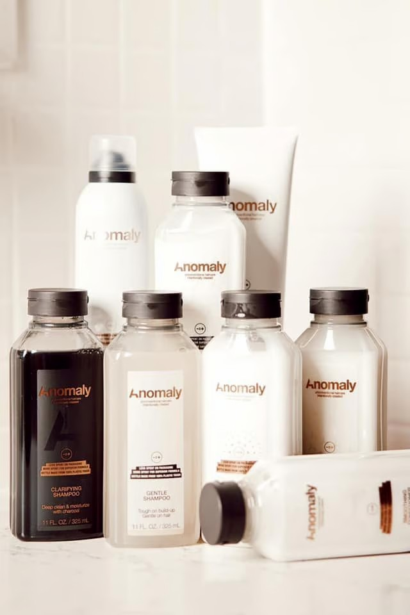

1. Introduction
Brand management has become a critical component for organisations operating in highly competitive industries such as cosmetics and personal care. In recent years, the beauty industry has experienced significant changes due to shifting consumer expectations, technological advancement, and increased awareness of environmental sustainability. Modern consumers are no longer only concerned with product performance but also with ethical production, environmentally friendly packaging, and transparency in ingredient sourcing. As a result, cosmetic companies must adopt innovative brand management strategies to remain competitive and relevant. According to Kotler and Keller (2016), brand management involves the strategic development and maintenance of a brand’s identity, positioning, and relationship with consumers in order to create long-term value and loyalty.
One emerging brand that reflects these modern trends is Anomaly, a sustainable cosmetic brand launched in 2021. Anomaly is widely recognised for its environmentally responsible practices, including the use of recycled packaging materials and simplified product formulations. The brand focuses primarily on haircare products such as shampoos, conditioners, hair masks, and styling products designed to deliver professional results while minimising environmental impact. Unlike traditional cosmetic brands that emphasise luxurious packaging and premium pricing, Anomaly aims to provide high-quality, sustainable beauty products that are accessible and affordable for a broader range of consumers.
The brand differentiates itself through its commitment to sustainability and transparency. For example, Anomaly products are packaged using recycled plastic bottles and minimal packaging waste. Many of its haircare formulations incorporate plant-based ingredients such as aloe vera, coconut oil, and botanical extracts that nourish hair while reducing reliance on synthetic chemicals. This approach reflects the growing demand for “clean beauty” products that prioritise both personal health and environmental protection. Research suggests that consumers increasingly favour brands that demonstrate ethical responsibility and sustainable practices (Ottman, 2017).
Another key factor influencing brand success in the cosmetics industry is brand identity. Brand identity refers to the visual, emotional, and symbolic elements that distinguish a brand from its competitors. These elements include brand name, logo, packaging design, product formulation, and marketing communication. According to Kapferer (2012), a strong brand identity enables companies to create meaningful connections with consumers and establish long-term brand loyalty.
This report aims to analyse the brand management strategy of Anomaly within the global cosmetics industry. The report explores how the brand integrates sustainability, affordability, and product quality to build a strong brand image and attract environmentally conscious consumers. It also examines the role of branding elements such as product innovation, marketing communication, and packaging design in shaping consumer perceptions.
The research objectives of this report are as follows:
• To analyse the brand positioning strategy of Anomaly in the cosmetics market.
• To examine the role of sustainable product development in strengthening brand identity.
• To evaluate how marketing communication influences consumer perceptions of eco-friendly cosmetic brands.
• To identify potential opportunities and challenges associated with sustainable brand management in the beauty industry.
By addressing these objectives, the study aims to contribute to a deeper understanding of sustainable brand management and its growing importance in the modern cosmetics sector.
This research focuses on analysing published academic literature and publicly available information about the cosmetic brand Anomaly. The study does not involve direct interaction with individuals or organisations. Instead, it examines existing brand communication, sustainability statements, and marketing information that are accessible in the public domain. This approach allows the researcher to explore sustainable brand management practices while ensuring that the research follows appropriate ethical standards and responsible academic practice. Ethical research requires transparency, accurate citation of sources, and careful use of information throughout the research process (Saunders, Lewis and Thornhill, 2019).

2. Literature Review
Brand management is widely recognised as a strategic process that involves developing, maintaining, and enhancing the value of a brand over time. Effective brand management enables organisations to create strong customer relationships, increase brand awareness, and generate long-term profitability. According to Aaker (1991), brand equity represents the value added to a product through brand recognition, consumer trust, and positive associations. In the cosmetics industry, brand equity is particularly important because consumers often rely on brand reputation when selecting personal care products.
The research is based on analysing existing academic publications and publicly available organisational materials. Sources used include scholarly books, peer-reviewed journal articles, industry reports, and official brand information related to Anomaly, such as product descriptions, sustainability statements, and marketing communication. These materials provide useful insight into how the brand presents its sustainability initiatives and how these messages contribute to the development of its brand identity.
The concept of brand positioning is also central to brand management. Brand positioning refers to the way a company differentiates its brand from competitors in the minds of consumers. This differentiation may be achieved through product quality, innovation, pricing strategy, or emotional brand messaging. Kotler and Keller (2016) argue that successful brands establish a clear and unique position within the market that reflects their values and target audience.
In recent years, sustainability has emerged as a significant factor influencing brand positioning in the cosmetics industry. Consumers are increasingly concerned about environmental issues such as plastic pollution, climate change, and unethical labour practices. As a result, many beauty brands have adopted sustainable production methods, cruelty-free testing policies, and recyclable packaging. According to Ottman (2017), green marketing strategies allow companies to communicate environmental responsibility while strengthening brand credibility.
Sustainable branding involves integrating environmental and social responsibility into the core identity of a brand. In the cosmetics industry, sustainable branding may include using natural ingredients, reducing packaging waste, and ensuring ethical sourcing of raw materials. Research by Peattie and Crane (2005) suggests that companies that successfully implement green marketing strategies can gain competitive advantages through increased consumer trust and positive brand image.
The concept of “clean beauty” has also gained popularity in recent years. Clean beauty refers to cosmetic products that are formulated without potentially harmful chemicals such as parabens, sulfates, and synthetic fragrances. Consumers increasingly prefer products made from natural or plant-based ingredients because they perceive them as safer and more environmentally friendly. According to Jones, Hillier and Comfort (2016), the demand for natural and organic cosmetic products continues to grow globally due to rising health awareness.
Anomaly reflects many of these emerging trends. The brand emphasises simplified formulations that reduce unnecessary ingredients while maintaining product effectiveness. Its haircare products often contain botanical extracts and nourishing oils that support hair health without excessive chemical processing. In addition, the brand’s commitment to recycled packaging demonstrates its dedication to reducing environmental impact.
Marketing communication also plays a vital role in shaping brand perception. Digital platforms such as Instagram, TikTok, and YouTube have become powerful tools for promoting beauty products and engaging with consumers. Social media allows cosmetic brands to showcase product demonstrations, sustainability initiatives, and brand values interactively. According to Chaffey and Ellis-Chadwick (2019), digital marketing enables companies to build stronger relationships with customers by creating online communities around their brands.
However, the increasing popularity of sustainable branding has also led to concerns about “greenwashing.” Greenwashing occurs when companies exaggerate or falsely claim environmental benefits to attract consumers. This practice can damage consumer trust and reduce the credibility of genuine sustainable brands. Delmas and Burbano (2011) emphasise that transparency and accountability are essential for maintaining consumer confidence in environmental marketing claims.
Overall, existing literature highlights several important themes related to brand management in the cosmetics industry. These include the importance of brand equity, sustainable product development, ethical marketing practices, and digital communication strategies. These theoretical perspectives provide the foundation for analysing the brand management approach of Anomaly and evaluating its effectiveness in attracting environmentally conscious consumers.
https://youtu.be/N2FejE-LfDE?si=NXctxgjhJ7nNaHom
https://youtu.be/xTxIuCT15os?si=2SLnJb7mendo_AIe
https://youtu.be/S0XizB-g9gQ?si=JMu56mCw7Ww4eiSc
https://youtu.be/oq6-canBUDg?si=GpQG73PJSuD5Jg52

3. Methodology
The methodology section outlines the research approach used to analyse the brand management strategy of Anomaly within the cosmetics industry. This study adopts a qualitative research approach, which focuses on understanding perceptions, behaviours, and experiences related to sustainable cosmetic brands. Qualitative research is particularly suitable for exploring complex issues such as consumer attitudes towards sustainability and ethical branding.
The research primarily relies on secondary data sources. Secondary research involves analysing information that has already been collected and published by other researchers, organisations, or institutions. Academic journals, books, industry reports, and credible online publications were used to gather relevant information about brand management, sustainable marketing, and cosmetic industry trends. According to Saunders, Lewis and Thornhill (2019), secondary research provides a cost-effective method for examining existing knowledge and identifying patterns within a particular field of study.
In addition to academic literature, this study also analyses publicly available information about the Anomaly brand. This includes product descriptions, marketing campaigns, sustainability statements, and packaging information. By examining these materials, the research aims to identify key branding strategies used by the company to communicate its values and differentiate itself from competitors.
Content analysis is used as the main analytical technique in this research. Content analysis involves systematically reviewing marketing messages, brand communication, and promotional materials in order to identify recurring themes and patterns. In the context of this study, content analysis helps evaluate how Anomaly promotes sustainability and product quality within its brand identity.
Ethical considerations are also important in conducting academic research. Since this study relies on publicly available information and previously published academic sources, there are minimal ethical risks involved. Nevertheless, all sources are properly cited to ensure academic integrity and avoid plagiarism. Accurate referencing also allows readers to verify the credibility of the information used in the study. The study uses information that is already available to the public and does not involve collecting personal information from individuals. As a result, the research does not require interaction with participants or access to confidential organisational data. All information used in the study is referenced appropriately to ensure academic integrity and transparency. Following ethical research practices helps ensure that the findings are credible and that the research respects the intellectual contributions of previous authors (Saunders, Lewis and Thornhill, 2019).
Overall, the methodology used in this research provides a structured and feasible approach for examining sustainable brand management strategies within the cosmetics industry. By combining theoretical literature with brand analysis, the study aims to generate meaningful insights into the factors influencing consumer perceptions of eco-friendly beauty products.

4. Expected Findings
The research is expected to reveal that sustainable branding significantly influences consumer purchasing behaviour in the cosmetics industry. As environmental awareness continues to grow, many consumers prefer brands that demonstrate a genuine commitment to sustainability and ethical production practices.
One anticipated finding is that Anomaly’s use of recycled packaging materials contributes positively to its brand image. The brand’s plastic bottles are made from recycled materials, which helps reduce environmental waste. This packaging strategy aligns with consumer demand for environmentally responsible products and may strengthen customer loyalty.
Another expected finding relates to product formulation. Anomaly haircare products often include plant-based ingredients such as aloe vera, argan oil, and coconut oil. These ingredients provide natural nourishment for hair while reducing reliance on synthetic chemicals. Such formulations may appeal to consumers who prioritise clean beauty products that are both effective and environmentally friendly.
The research also expects to identify the importance of affordability in sustainable branding. Many eco-friendly cosmetic brands operate in the premium price segment, making them inaccessible to some consumers. By offering sustainable products at relatively affordable prices, Anomaly may attract a broader customer base and strengthen its competitive position within the beauty market.
Furthermore, the study anticipates that digital marketing plays a major role in promoting sustainable beauty brands. Social media platforms allow companies to share product information, sustainability initiatives, and customer testimonials with global audiences. According to Chaffey and Ellis-Chadwick (2019), digital marketing strategies are particularly effective for building brand communities and increasing customer engagement.
Overall, the expected findings suggest that successful brand management in the cosmetics industry requires a combination of sustainability, product innovation, affordability, and transparent communication.

5. Limitations
Despite the potential contributions of this research, several limitations must be acknowledged. One limitation is the reliance on secondary data sources. While secondary research provides valuable insights, it may not fully capture consumer opinions or personal experiences with cosmetic brands. Primary research methods, such as surveys or interviews, could provide more detailed information about consumer behaviour.
Another limitation relates to the relatively recent launch of the Anomaly brand. Since the brand was established in 2021, there is limited academic research specifically focused on its branding strategy. As a result, this study relies on broader literature related to sustainable cosmetics and brand management.
Time constraints also represent a limitation. Conducting a more comprehensive analysis of the cosmetics industry would require examining multiple sustainable brands and comparing their branding strategies. However, due to time limitations, this research focuses primarily on a single brand case study.
Finally, consumer preferences in the beauty industry are constantly evolving due to trends, influencer marketing, and social media influence. This means that the findings of the study may only represent current market conditions rather than long-term industry trends.
Despite these limitations, the study still offers valuable insights into sustainable brand management and highlights important trends shaping the future of the cosmetics industry.
Another limitation of the research is that the analysis is based on published literature and publicly available organisational information. Although these sources provide useful insights into branding strategies and sustainability communication, they may not fully represent internal company decision-making processes. Future studies could expand the scope of analysis by examining a wider range of cosmetic brands in order to provide broader insights into sustainable brand management in the beauty industry.

6. Timeframe
The research will follow a structured schedule to ensure the timely completion of the dissertation proposal.
Week 1–2: Selection of research topic and preliminary literature review
Week 3–5: Detailed literature review and theoretical framework development
Week 6–7: Data collection and analysis of brand communication strategies
Week 8–9: Interpretation of findings and discussion
Week 10–11: Writing and editing of the dissertation proposal
Week 12: Final proofreading and submission
This timeframe ensures that each stage of the research process is completed systematically and allows sufficient time for analysis and revision.

7. Conclusion
Brand management has become increasingly important in the modern cosmetics industry, particularly as consumers demand greater transparency, sustainability, and ethical responsibility from beauty brands. Companies that successfully integrate these values into their brand identity are more likely to build strong customer relationships and long-term brand loyalty.
This report analysed the brand management strategy of Anomaly, an eco-friendly cosmetic brand known for its commitment to sustainable packaging and clean beauty formulations. By focusing on affordability, transparency, and environmental responsibility, the brand has positioned itself as an accessible, sustainable beauty option for modern consumers.
The literature review highlighted the importance of brand equity, sustainable marketing, and digital communication in shaping consumer perceptions of cosmetic brands. The study also emphasised the role of product innovation and ethical branding in building competitive advantages within the beauty market.
Although the research has certain limitations, it provides useful insights into the growing significance of sustainable brand management. The findings suggest that cosmetic companies must balance product quality, affordability, and environmental responsibility to meet evolving consumer expectations.
Future research could explore consumer perceptions through primary data collection methods such as surveys or interviews. Additionally, comparative studies involving multiple sustainable cosmetic brands could provide deeper insights into the effectiveness of different branding strategies within the global beauty industry.

References
Aaker, D.A., 1991. Managing Brand Equity. New York: Free Press.
Chaffey, D. and Ellis-Chadwick, F., 2019. Digital Marketing. 7th ed. Harlow: Pearson.
Delmas, M. and Burbano, V., 2011. The drivers of greenwashing. California Management Review, 54(1), pp.64-87.
Jones, P., Hillier, D. and Comfort, D., 2016. Sustainability in the global beauty industry. Journal of Public Affairs, 16(4), pp.1-8.
Kapferer, J.N., 2012. The New Strategic Brand Management. London: Kogan Page.
Kotler, P. and Keller, K.L., 2016. Marketing Management. 15th ed. Harlow: Pearson Education.
Ottman, J., 2017. The New Rules of Green Marketing. Sheffield: Greenleaf Publishing.
Peattie, K. and Crane, A., 2005. Green marketing: legend, myth, farce or prophecy? Qualitative Market Research, 8(4), pp.357-370.
Saunders, M., Lewis, P. and Thornhill, A., 2019. Research Methods for Business Students. 8th ed. Harlow: Pearson.

