Community Care and Management of Longer-term Conditions
LCHS7003_LON



Assignment 1: Booklet
Student name: Rehana Intisar
Student number: 2234706
Tutor Name: Muhammed Khan

Hypertension
Long-Term Health Condition Management in the United Kingdom

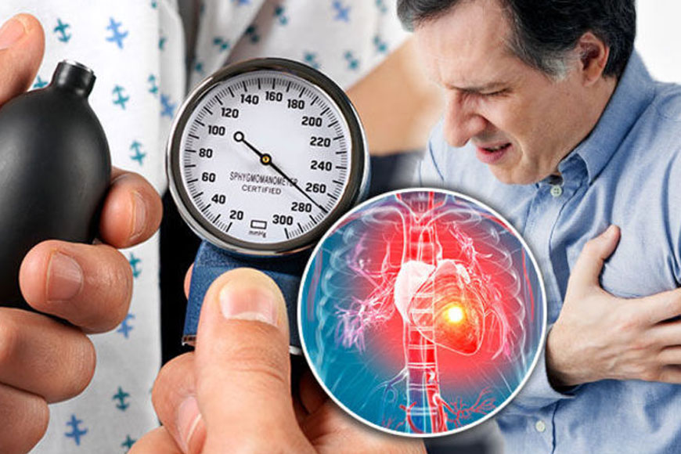

Acknowledgment

I confirm that I have not used any AI tools in the research and creation of this assignment. I confirm that I have not presented any AI-generated materials as my own work. I confirm I have copies of my drafts, notes, and other resources I used, which I may be asked to provide in evidence

Table of contents:
Pages

Introduction: 3
Definition: 3
Burden and Prevalence of Hypertension 4
Key statistics: 5
Risk Factors and Aetiology. 6
Impact of Hypertension: 8
Evidence and Guidelines: 11
Evidence-based Treatments: 12
Theoretical Perspectives and Models: 12
Political HSC Agendas: 13
Recommendations: 14
Conclusion: 15
References: 16

Introduction.

Hypertension is a highly widespread and substantial chronic health problem impacting people globally and continues to pose a serious public health challenge in the United Kingdom (Chaturvedi et al. 2024). Hypertension sometimes manifests without discernible symptoms and can go unnoticed for extended periods, inflicting gradual harm on the cardiovascular system and other organs. Thus, hypertension significantly contributes to cardiovascular disease, stroke, chronic renal disease, heart failure, cognitive decline, disability, and premature mortality (Todd et al. 2023).

Valabhji et al. (2024) stated that long-term conditions (LTCs) account for a substantial proportion of healthcare utilisation within the National Health Service (NHS), with individuals living with chronic diseases often requiring ongoing monitoring, treatment, and support throughout their lives. The NHS Long Term Plan recognises cardiovascular disease prevention and management as a key priority due to the significant burden of hypertension and its associated complications (NHS England, 2019). For health and social care professionals, understanding hypertension involves holistic, person-centred care, acknowledging psychological wellbeing, social circumstances, self-management, family involvement, and health inequalities. This booklet evaluates hypertension as a long-term condition, covering its epidemiology, causes, impacts, management strategies, theoretical frameworks, policy drivers, and future practice recommendations.

Definition.

Hypertension, usually known as high blood pressure (The Royal Buckinghamshire Hospital, 2025), is a condition in which the long-term force of the blood pushing against the artery walls is consistently too high. BP is measured as two values: systolic blood pressure, the pressure during ventricular contraction, and diastolic blood pressure, the pressure during cardiac relaxation (Vidal-Petiot, 2022). According to NICE (2023a), hypertension is diagnosed when clinic blood pressure measurements are consistently 140/90 mmHg or higher and confirmed using ambulatory or home blood pressure monitoring. Primary hypertension accounts for approximately 90–95% of cases and develops through complex interactions between genetic, environmental, behavioural, and socioeconomic factors (Williams et al., 2018). Secondary hypertension, however, arises from identifiable causes such as renal disease, endocrine disorders, or adverse effects of medications.

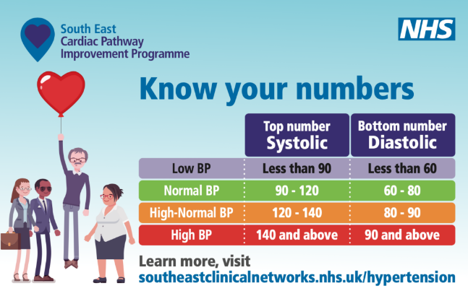
Furthermore, according to Kulkarni et al. 2023, research shows that hypertension may be asymptomatic, yet it induces gradual arterial damage that distinctly elevates the risk of cardiovascular problems. The asymptomatic progression of this ailment poses a significant problem for healthcare workers, as patients frequently underestimate its severity and may exhibit minimal willingness to pursue therapy or lifestyle changes. From a critical standpoint, conventional biological interpretations of hypertension have predominantly concentrated on physiological anomalies and the decrease in blood pressure. Contemporary healthcare increasingly acknowledges that effective management necessitates a biopsychosocial approach, addressing broader determinants of health and individual experiences with chronic illness.

Burden and Prevalence of Hypertension.

Hypertension is one of the most common chronic diseases globally. The World Health Organization (WHO, 2025) estimates that approximately 1.4 billion adults aged between 30 and 79 years live with hypertension worldwide. Alarmingly, nearly half remain unaware of their condition, while only approximately one in five individuals achieve adequate blood pressure control. In addition, worldwide, hypertension contributes to approximately 10.8 million deaths annually and remains the leading modifiable risk factor for cardiovascular disease and premature mortality (WHO, 2023). The increasing prevalence of hypertension is associated with population ageing, urbanisation, obesity, unhealthy diets, physical inactivity, and socioeconomic inequalities. For example, in many rural areas of India, Pakistan, and Bangladesh, awareness of hypertension is low, and access to regular blood pressure screening is limited. As a result, many people remain undiagnosed until they develop serious complications such as stroke or heart disease.

Key statistics.

The latest UK (England) data from the 2024 Health Survey for England shows that men: 32% of adults have hypertension. Women: 27% of adults have hypertension. Overall: 30% of adults aged 16 years and over have hypertension in England (NHS England Digital, 2026). According to the NHS England (2025) report, hypertension remains more common in men than women in England. Hypertension is the second largest risk factor for premature death and disability in England, impacting over 25% of adults (Graham et al., 2025).

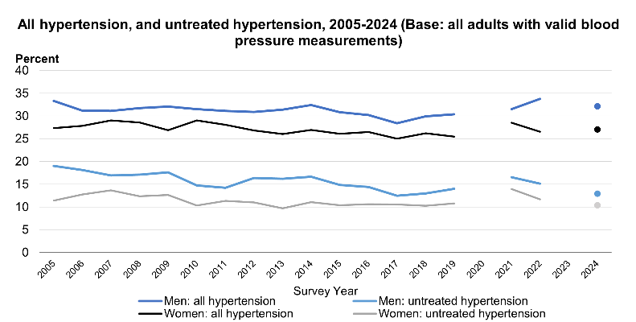

NHS England (2025) reports that hypertension remains more common in men than women in England. The economic burden associated with hypertension is considerable. Cardiovascular disease costs the UK economy approximately £29 billion annually through healthcare expenditure, lost productivity, and informal caregiving responsibilities (British Heart Foundation, 2023). The extreme of this burden is attributable to hypertension-related complications, including stroke, myocardial infarction, and chronic kidney disease.

Risk Factors and Aetiology.

The development of hypertension is influenced by a variety of factors, including biological, behavioural, environmental, and social components such as:

Aging Increases Risk of Hypertension.

As arteries age, their elastin fibres break down and are replaced by collagen, leading to stiffness and increased systolic blood pressure as the heart works harder to pump blood. Aging vascular cells also produce less nitric oxide, leading to sustained vasoconstriction and elevated peripheral vascular resistance. Additionally, low-grade inflammation driven by molecules such as IL-6 and TNF-α damages the endothelial lining of blood vessels, impairing their ability to regulate blood pressure and resulting in chronic hypertension (Fukutomi and Kario, 2010).

Physical Inactivity Causes Hypertension.

Blood flowing through arteries during physical movement generates shear stress on the vessel wall, a key trigger for nitric oxide production. Without regular exercise, shear stress falls, ENOS activity decreases, nitric oxide levels drop, and blood vessels lose their ability to dilate properly, causing peripheral resistance to rise. Inactivity keeps the sympathetic nervous system chronically overactive, sustaining elevated circulating noradrenaline that constricts blood vessels via alpha-1 adrenoceptors and stimulates renin release from the kidneys, feeding into angiotensin II production and aldosterone-driven sodium retention - a cascade that pushes blood pressure up from multiple directions simultaneously (Hayes et al., 2022).

Poor Housing Conditions Cause Hypertension.

Chronic stress from housing instability, overcrowding, and insecurity persistently activates the HPA axis, keeping cortisol levels elevated; sustained cortisol promotes sodium retention in the kidneys and drives structural changes in vascular smooth muscle that increase peripheral resistance - creating a direct hormonal pathway from poor living conditions to high blood pressure. Cold and poorly insulated homes trigger the nervous system to constrict peripheral blood vessels via alpha-adrenergic receptor activation, an acute response that, when experienced chronically over months and years, drives structural remodelling of resistance vessels, leaving them permanently narrowed even when temperatures are normal. Housing instability disrupts sleep patterns, medication adherence, dietary quality, and access to healthcare - each of which independently affects the circadian regulation of blood pressure and sympathetic tone and together creates a compounding physiological environment in which blood pressure progressively rises and is much harder to control (Vijayaraghavan et al., 2012).

Hypertension Causes Stroke.

Sustained high pressure in small cerebral arteries damages their walls through a process called fibrinoid necrosis and lip hyalinosis, where the vessel wall is gradually replaced by fibrous material - this narrows and ultimately occludes the artery, cutting off blood supply to small but critical areas of deep brain tissue and producing what are known as lacunar infarcts. Hypertension accelerates the formation of atherosclerotic plaques in both the large arteries supplying the brain and the smaller intracranial vessels by promoting endothelial damage, lipid infiltration, and inflammatory cell build-up in the vessel wall; these plaques can rupture or shed clots that travel to the brain and block blood flow, causing Ischaemic stroke (Johansson, 2019).

Obesity Causing Hypertension.

Visceral and perirenal adipose tissue constitutively produces angiotensinogen, which is locally converted to angiotensin II - a potent vasoconstrictor that simultaneously signals the adrenal glands to release aldosterone; in obesity, this adipose-based RAAS runs in a chronically activated state, constricting blood vessels and promoting renal sodium retention independent of systemic RAAS controls. Excess leptin secreted by enlarged fat cells acts on hypothalamic and brainstem receptors to drive sustained sympathetic outflow to the kidneys and vasculature - increasing renal renin release, raising tubular sodium reabsorption, and constricting peripheral vessels via alpha-1 adrenoceptors; critically, metabolic leptin resistance develops, but pressor leptin resistance does not, meaning the blood pressure-raising effects of leptin persist even as its appetite-suppressing effects are lost (Kotsis et al., 2010).

Physical Impact of Hypertension.

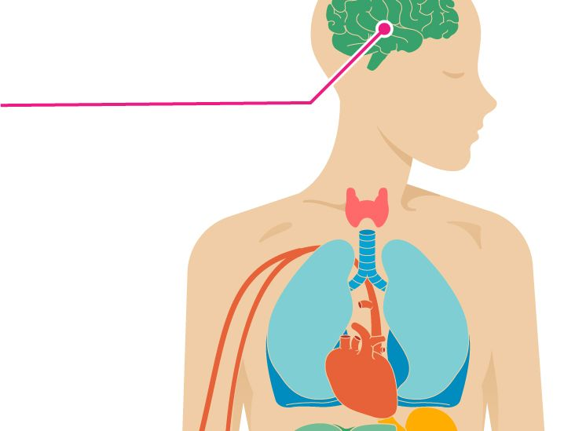

Hypertension exerts profound effects on physical health due to its progressive impact on the cardiovascular system and target organs. Cardiovascular disease represents the most significant consequence of uncontrolled hypertension. Persistent elevated blood pressure accelerates atherosclerosis, increases myocardial workload, and contributes to coronary artery disease, myocardial infarction, and heart failure (British Heart Foundation, 2023). Numerous studies have demonstrated a direct relationship between blood pressure levels and cardiovascular risk. Stroke is another major complication. The Stroke Association (2023) identifies hypertension as the most important modifiable risk factor for both ischaemic and haemorrhagic stroke. Damage to cerebral blood vessels resulting from prolonged hypertension significantly increases the likelihood of cerebrovascular events. Hypertension also contributes substantially to chronic kidney disease. Persistent elevation of blood pressure damages renal blood vessels and impairs kidney function. Kidney Research UK (2023) estimates that hypertension is implicated in approximately one-third of chronic kidney disease issues. Visual impairment may occur through hypertensive retinopathy, while vascular dementia and cognitive decline are increasingly recognised consequences of chronic hypertension. Emerging evidence suggests that effective blood pressure control may reduce dementia risk and support healthy ageing (NHS England, 2023).

The physical burden of hypertension is further complicated by multimorbidity. Many patients experience coexisting conditions such as diabetes, obesity, chronic kidney disease, and heart failure. Multimorbidity increases treatment complexity, healthcare utilisation, and self-management challenges (NICE, 2021).

Psychological Impact of Hypertension.

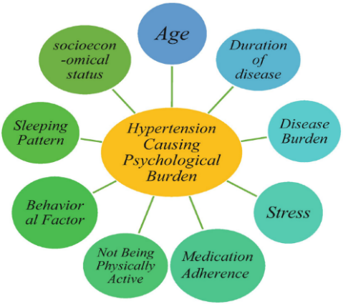

Historically, hypertension management focused primarily on physiological outcomes. However, growing evidence demonstrates substantial psychological impacts associated with chronic disease diagnosis and treatment. Anxiety is commonly observed among individuals diagnosed with hypertension. Patients may experience fears regarding stroke, heart attack, disability, and premature death. These concerns may be exacerbated by information obtained through media sources or personal experiences of family members affected by cardiovascular disease (NHS England, 2026). Research suggests that anxiety can negatively influence blood pressure control through increased sympathetic nervous system activation and reduced adherence to treatment recommendations (Pan et al., 2015).

Depression frequently coexists with hypertension and other long-term conditions. NICE (2022) highlights that individuals with chronic physical illnesses are significantly more likely to experience depression than the general population. Depression may reduce motivation to engage with lifestyle modifications, attend healthcare appointments, or adhere to medication regimens. Hypertension may also affect personal identity and perceptions of health. Leventhal’s Common-Sense Model suggests that individuals develop beliefs regarding the causes, consequences, controllability, and duration of illness. Negative illness perceptions can influence coping strategies and engagement with treatment (Leventhal et al., 2016).

The burden of long-term medication use should not be underestimated. Many patients require lifelong pharmacological treatment, which may generate concerns regarding dependency, side effects, and treatment burden. Polypharmacy is particularly common among older adults with multimorbidity and may contribute to medication fatigue and reduced adherence. Critically, psychological distress associated with hypertension often remains under-recognised within clinical practice. This reflects the persistence of biomedical approaches that prioritise physiological indicators over psychosocial experiences. Greater integration between physical and mental health services may therefore improve outcomes for individuals living with hypertension.

Social Impact on Individuals and Families.

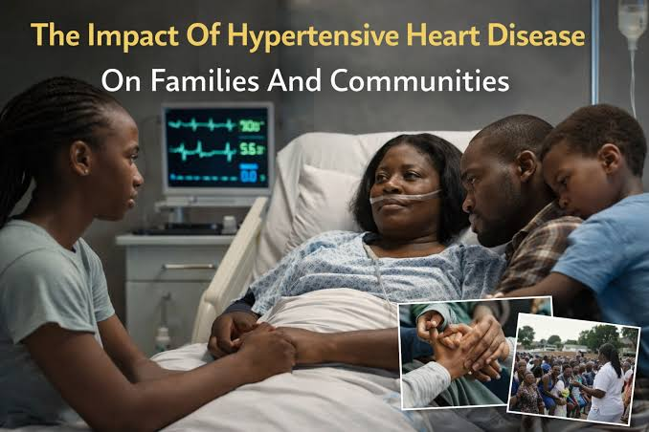

The consequences of hypertension extend beyond individual health outcomes and affect families and society. Social functioning may be impaired by complications such as stroke, heart failure, and chronic kidney disease. Individuals may experience reduced participation in employment, community activities, and social relationships. Such changes can contribute to social isolation and reduced quality of life.
Families frequently assume significant caregiving responsibilities following hypertension-related complications. Carers may provide practical support with medication management, healthcare appointments, mobility assistance, and emotional support. According to Carers UK (2023), unpaid carers contribute billions of pounds worth of support annually within the UK healthcare system. Caregiving responsibilities can have substantial consequences for family members. Research demonstrates increased levels of caregiver stress, anxiety, depression, and financial hardship among individuals supporting relatives with chronic illness (Carers UK, 2023). The impact may be particularly significant following stroke or heart failure when long-term disability develops.

Socioeconomic consequences are also important. Hypertension-related illness may result in reduced employment opportunities, sickness absence, early retirement, and reduced household income. These challenges are often amplified among disadvantaged populations, further contributing to health inequalities. From a public health perspective, the social burden of hypertension highlights the importance of family-centred and community-based approaches to chronic disease management.

Empirical Evidence and Guidelines Supporting Whole-Person Care.

Evidence-based practice requires integration of research evidence, clinical expertise, and patient preferences (Sackett et al., 1996). Hypertension management has been transformed through extensive empirical research demonstrating the benefits of blood pressure reduction. The SPRINT trial demonstrated that intensive blood pressure control significantly reduced cardiovascular events and mortality among high-risk patients (SPRINT Research Group, 2015). Similarly, the Blood Pressure Lowering Treatment Trialists’ Collaboration confirmed that blood pressure reduction substantially decreases the risk of stroke, myocardial infarction, and cardiovascular death (Blood Pressure Lowering Treatment Trialists’ Collaboration, 2021). While these studies provide robust evidence supporting pharmacological intervention, contemporary practice increasingly recognises the importance of whole-person care. Engel’s biopsychosocial model provides a theoretical foundation by acknowledging the interactions between biological, psychological, and social influences on health (Engel, 1977). NICE Guideline NG136 emphasises patient-centred approaches, shared decision-making, and lifestyle interventions alongside pharmacological treatment (NICE, 2023a). NICE Guideline NG197 further promotes collaborative discussions between patients and professionals regarding treatment choices and healthcare goals (NICE, 2021; NICE, 2022). The NHS Long Term Plan advocates personalised care, prevention, integrated care systems, and self-management support. These initiatives recognise that effective hypertension management extends beyond blood pressure reduction and requires attention to individual circumstances and preferences (NHS England, 2019).

Internationally, the World Health Organization’s HEARTS initiative supports integrated cardiovascular disease management through standardised treatment protocols, team-based care, and community engagement (WHO, 2023). Similarly, European Society of Cardiology guidelines emphasise individualised risk assessment and shared decision-making (ESC, 2023). Critically, implementation of whole-person care remains inconsistent. Workforce pressures, limited consultation time, and fragmented services may restrict opportunities for holistic assessment and support. Consequently, ongoing service development is required to recognise the aspirations of person-centred care.

Evidence-Based Treatments Available Through the NHS.

Management of hypertension within the NHS combines lifestyle interventions, pharmacological treatment, monitoring, and ongoing support. Lifestyle modification remains the foundation of treatment. NICE (2023a) recommends weight management, smoking cessation, reduced alcohol consumption, dietary improvement, increased physical activity, and sodium reduction. The Dietary Approaches to Stop Hypertension (DASH) diet has demonstrated significant effectiveness in reducing blood pressure and improving cardiovascular outcomes. Regular physical activity is strongly associated with blood pressure reduction and improved cardiovascular health. Current UK guidance recommends at least 150 minutes of moderate-intensity physical activity per week (Department of Health and Social Care, 2019). Pharmacological treatment is recommended when lifestyle modification alone is insufficient or when cardiovascular risk is elevated. NICE guidelines recommend ACE inhibitors, angiotensin receptor blockers, calcium channel blockers, and thiazide-like diuretics according to patient characteristics and treatment response (NICE, 2023a). Home blood pressure monitoring is increasingly utilised within NHS services. Research demonstrates improved blood pressure control, enhanced patient engagement, and greater self-management capability when patients actively participate in monitoring their condition (NHS England, 2023) and (Lay-Flurrie et al., 2020). Social prescribing has also emerged as an important component of holistic care. Through social prescribing pathways, patients may access community resources that address social isolation, physical inactivity, and wider determinants of health (NHS England, 2019).

Theoretical Perspectives and Models for Improving Outcomes.

Figure 1: Illustration of the LTC Framework (House of Care model)
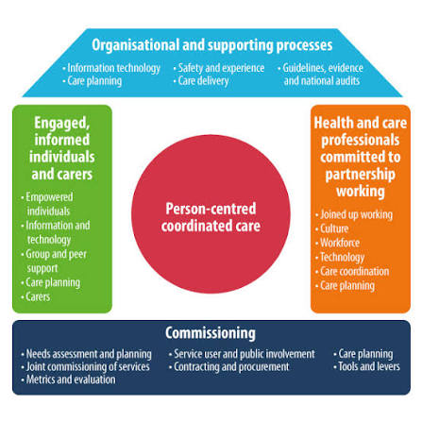
The House of Care Model represents an influential UK framework for managing long-term conditions. Developed through NHS England initiatives, the model emphasises collaborative partnerships between informed patients and prepared healthcare professionals. Effective care planning occurs within a system supported by organisational processes and community resources (The King’s Fund, 2022). The House of Care model aligns closely with principles of personalised care and self-management support. Its strengths include recognition of patient expertise and promotion of collaborative care planning. However, implementation challenges include workforce constraints and variability across healthcare settings (Local Government Association, 2014).

Wagner’s Chronic Care Model.

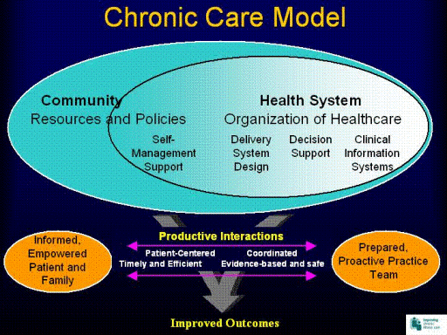

Internationally, Wagner’s Chronic Care Model remains one of the most influential frameworks for chronic disease management. The model emphasises self-management support, clinical information systems, decision support, delivery system redesign, healthcare organisation, and community resources (Wagner et al., 2001). Evidence suggests that implementation of the Chronic Care Model improves clinical outcomes, patient satisfaction, and healthcare efficiency. Nevertheless, critics argue that successful implementation requires substantial organisational investment and may be difficult to achieve within resource-constrained healthcare systems. Both models support a transition away from reactive healthcare towards proactive, coordinated, and person-centred chronic disease management.

Political, Health and Social Care Agendas.

The management of hypertension is affected by national health policies and political agendas. The NHS Long Term Plan designates the prevention of cardiovascular disease as a primary strategic focus. The initiative seeks to avert many heart attacks and strokes by enhancing the identification and management of hypertension and other cardiovascular risk factors (Cheater, 2019). Integrated Care Systems (ICSs) have been established to enhance collaboration across NHS entities, local authorities, social care providers, and volunteer groups. Such integration supports more coordinated management of long-term conditions and aligns with principles of whole-person care (Elizondo et al., 2025). This initiative reflects growing recognition that social determinants significantly influence hypertension prevalence and outcomes.

Public health policies addressing obesity, smoking, alcohol consumption, and physical inactivity contribute to hypertension prevention efforts. However, critics argue that policy approaches often place excessive emphasis on individual responsibility while inadequately addressing structural determinants of health such as poverty and housing quality (Marmot, 2020). Local authorities also play a crucial role through health promotion programmes, community engagement initiatives, and social prescribing services. Effective hypertension management, therefore, requires collaboration across health, social care, and public health sectors.

Recommendations for Improving Person-Centred Care.

Future improvements in hypertension management should include short-term and long-term awareness programs to educate the public (Bilo et al., 2026) and (Manalili et al., 2022). Prioritise enhanced integration between physical and mental health services to address psychological distress associated with chronic disease (LTC Pathways Working Group, 2024) and (NHS England, 2024). Routine screening for anxiety and depression should become standard practice within hypertension reviews; for example, John, a 28-year-old man, was diagnosed with an anxiety disorder after experiencing persistent worry, panic attacks, and difficulty sleeping. Although his blood pressure was initially within the normal range, prolonged anxiety led to chronic activation of his sympathetic nervous system. Over several years, repeated increases in heart rate and blood pressure contributed to the development of hypertension. This example reflects evidence that younger adults diagnosed with anxiety may have a greater risk of developing hypertension over time (Johnson, 2019). Increased focus on self-management through health coaching, digital tools, and patient education is critical for enhancing adherence and health outcomes. Interventions should address health inequalities and be tailored for disadvantaged communities. Community-based strategies can improve engagement, while family involvement and caregiver support are essential. Healthcare professionals must assess caregiver needs and provide resources. Advance care planning is crucial for those with severe cardiovascular issues or multimorbidity. Finally, healthcare systems should prioritize personalized care planning and collaborative partnerships that empower patients as active participants in their care (Slater et al. 2026).

Conclusion.

Hypertension is a significant long-term health problem impacting the UK population and continues to be a primary source of avoidable morbidity and mortality. Its impact extends far beyond elevated blood pressure measurements, affecting physical health, psychological well-being, social participation, family functioning, and healthcare resources. Evidence demonstrates that successful management requires a comprehensive approach combining lifestyle interventions, pharmacological treatment, self-management support, and person-centred care. National and international guidelines, together with theoretical frameworks such as the House of Care Model and Chronic Care Model, provide valuable foundations for improving outcomes.

Future developments should focus on reducing health inequalities, strengthening integrated care, supporting self-management, addressing psychological needs, and recognising the wider social context in which individuals live with hypertension. By employing comprehensive, evidence-based, and compassionate treatment, health and social care workers can markedly enhance the quality of life and long-term results for individuals with hypertension.

References:

Bilo, G., Stergiou, G.S., Parati, G., et al. (2026) “Bridging the gap between hypertension guidelines and real-life practice: strategies and technological tools for improving long-term population blood pressure control”, European Journal of Preventive Cardiology, 33(7), pp. 1045–1057. Available at: https://doi.org/10.1093/eurjpc/zwaf733. Accessed: 09 July 2026.
Blood Pressure Lowering Treatment Trialists’ Collaboration (2021) ‘Pharmacological blood pressure lowering for primary and secondary prevention of cardiovascular disease across different levels of blood pressure: an individual participant-level data meta-analysis’, The Lancet, 397(10285), pp. 1625–1636. doi:10.1016/S0140-6736(21)00560-7. (Accessed: 5 July 2026).
Brennan, A. (2024) “Applying the CORE20PLUS5 to Address Health Inequalities for Patients Under the Rehabilitation and Recovery Service in the London Borough of Hackney,” BJPsych open., 10(S1), pp. S223–S223. Available at: https://doi.org/10.1192/bjo.2024.548. (Accessed: 02 July 2026).
British Heart Foundation (2023) “UK factsheet: cardiovascular disease statistics.” London: British Heart Foundation. Available at: https://www.bhf.org.uk (Accessed: 24 June 2026).
Carers UK (2023) State of caring 2023: the impact of caring on health. Available at: https://www.carersuk.org/reports/state-of-caring-2023-the-impact-of-caring-on-health/ (Accessed: 5 July 2026).
Chaturvedi, A. et al. (2024) “Social Determinants of Health and Disparities in Hypertension and Cardiovascular Diseases,” Hypertension, 81(3), pp. 387–399. Available at: https://doi.org/10.1161/HYPERTENSIONAHA.123.21354. (Accessed: 05 July 2026).
Cheater, S. (2019) “The NHS Long-Term Plan,” International journal of health promotion and education., 57(3), pp. 174–175. Available at: https://doi.org/10.1080/14635240.2019.1595526. Accessed: 02 July 2026.
Department of Health and Social Care (DHSC) (2022) “Living well with long-term conditions.” London: Department of Health and Social Care. Available at: https://www.gov.uk/government/publications/living-well-with-long-term-conditions (Accessed: 5 July 2026).
Elizondo, A. et al. (2025) “Implementing integrated care infrastructure: A longitudinal study on the interplay of policies, interorganizational arrangements and interoperability in NHS England,” Health policy., 160. Available at: https://doi.org/10.1016/j.healthpol.2024.105237. (Accessed: 02 July 2026).
Fukutomi, M. and Kario, K. (2010) “Aging and hypertension,” Expert review of cardiovascular therapy., 8(11), pp. 1531–1539. Available at: https://doi.org/10.1586/erc.10.78. (Accessed: 05 July 2026).
Graham, C., Petersen, J., Mindell, J.S. and colleagues (2025) “Trends in hypertension prevalence, control, and antihypertensive use in England from 2003 to 2021: insights from annual, nationwide Health Surveys for England”, BMJ Medicine, 4(1), e001556. Available: Physical disability and risk of incident hypertension: a prospective cohort analysis | Journal of Human Hypertension. Accessed: 01 July 2026.
Hayes, P., Ferrara, A., Keating, A., McKnight, K. and O’Regan, A. (2022). “Physical Activity and Hypertension.” Reviews in Cardiovascular Medicine. Available at: https://doi.org/10.31083/j.rcm2309302. Accessed: 01 July 2026.
Hypertension (2017) “American College of Cardiology/American Heart Association (ACC/AHA) Guideline,” Journal of the American Heart Association, 7(11). Available at: https://doi.org/10.1161/JAHA.118.008888.30. (Accessed: June 2026).
Johansson, B.B. (2019). “Hypertension mechanisms causing stroke.” Clinical and Experimental Pharmacology & Physiology, pp.563–565. Available at: https://doi.org/10.1046/j.1440-1681.1999.03081.x. Accessed: 01 July 2026.
Johnson, H.M. (2019) “Anxiety and hypertension: Is there a link? A literature review of the comorbidity relationship between anxiety and hypertension”, Current Hypertension Reports, 21(9), p. 66. Available at: https://doi.org/10.1007/s11906-019-0972-5. Accessed: 09 July 2026.
Kidney Research UK (2023) “High blood pressure and kidney disease.” Peterborough: Kidney Research UK. Available at: https://www.kidneyresearchuk.org (Accessed: 24 June 2026).
Kotsis, V., Stabouli, S., Papakatsika, S., Rizos, Z. and Parati, G. (2010) “Mechanisms of obesity-induced hypertension.” Hypertension Research, pp.386–393. Available at: https://doi.org/10.1038/hr.2010.9. (Accessed: 01 July 2026).
Kulkarni, S. et al. (2023) “Management of hypertensive crisis: British and Irish Hypertension Society Position document”, Journal of human hypertension, 37(10), pp. 863–879. Available at: https://doi.org/10.1038/s41371-022-00776-9. Accessed: 26 June 2026.
Lay-Flurrie, S.L. et al. (2020) “Impact of Changes to National Hypertension Guidelines on Hypertension Management and Outcomes in the United Kingdom,” Hypertension, 75(2), pp. 356–364. Available at: https://doi.org/10.1161/HYPERTENSIONAHA.119.13926. (Accessed: 5 July 2026).
Leventhal, H., Phillips, L.A. and Burns, E. (2016) “The common-sense model of self-regulation (CSM): a dynamic framework for understanding illness self-management”, Journal of Behavioral Medicine, 39(6), pp. 935–946. doi:10.1007/s10865-016-9782-2. (Accessed: 24 June 2026).
Local Government Association (2014) “The value case for co-ordinated health and social care.” London: Local Government Association. Available at: https://www.local.gov.uk/sites/default/files/documents/overarching-value-case-pd-f5e.pdf. Accessed: 01 July 2026.
LTC Pathways Working Group (2024) “NHS Talking Therapies Integrated Long-term Physical Health Conditions (LTC) Pathways – London Regional Referral Guidance”. London: NHS England (London Region). Available at: https://primarycare.northeastlondon.icb.nhs.uk/wp-content/uploads/2024/07/London-talking-therapies-LTC-pathways-April-2024.pdf (Accessed: 9 July 2026).
Manalili, K. et al. (2022) “The effectiveness of person‐centred quality improvement strategies on the management and control of hypertension in primary care: A systematic review and meta‐analysis,” Journal of evaluation in clinical practice., 28(2), pp. 260–277. Available at: https://doi.org/10.1111/jep.13618. Accessed: 08 July 2026.
Marmot, M. (2020) “Health equity in England: the Marmot review 10 years on.,” BMJ : British medical journal., 368. Available at: https://doi.org/10.1136/bmj.m693. (Accessed: 03 July 2026).
National Institute for Health and Care Excellence (NICE) (2021) “Multimorbidity: clinical assessment and management (NG56).” Available at: https://www.nice.org.uk/guidance/ng56 (Accessed: 5 July 2026).
National Institute for Health and Care Excellence (NICE) (2021) “Shared decision making (NG197)”, NICE. Available at: https://www.nice.org.uk/guidance/ng197. (Accessed: 5 July 2026).
National Institute for Health and Care Excellence (NICE) (2022) “Depression in adults with a chronic physical health problem: assessment and management (NG222)”, NICE. Available at: https://www.nice.org.uk/guidance/ng222 (Accessed: 5 July 2026).
National Institute for Health and Care Excellence (NICE) (2022) Depression in adults: treatment and management (NG222). Available at: https://www.nice.org.uk/guidance/ng222 (Accessed: 5 July 2026).
National Institute for Health and Care Excellence (NICE) (2023a) Hypertension in adults: diagnosis and management (NG136). Available at: https://www.nice.org.uk/guidance/ng136. (Accessed: 5 July 2026).
NHS England (2019) Social prescribing and community-based support: Summary guide. Available at: https://www.england.nhs.uk/publication/social-prescribing-and-community-based-support-summary-guide/ (Accessed: 5 July 2026)
NHS England (2019) The NHS Long Term Plan. Available at: https://www.longtermplan.nhs.uk/wp-content/uploads/2019/08/nhs-long-term-plan-version-1.2.pdf. (Accessed: 5 July 2026).
NHS England (2023) Home blood pressure monitoring. Available at: https://www.england.nhs.uk/ourwork/clinical-policy/cvd/home-blood-pressure-monitoring/ (Accessed: 5 July 2026).
NHS England (2024) Improving the physical health of people living with severe mental illness. Available at: https://www.england.nhs.uk/long-read/improving-the-physical-health-of-people-living-with-severe-mental-illness/ (Accessed: 9 July 2026).
NHS England (2025) “Health Survey for England 2024: Adults' health,” NHS England. Available at: https://digital.nhs.uk/data-and-information/publications/statistical/health-survey-for-england/2024/adults-health. (Accessed: 05 July 2026).
NHS England (2026) Health Survey for England 2024: Adults’ health. Available at: https://digital.nhs.uk/data-and-information/publications/statistical/health-survey-for-england/2024/adults-health (Accessed: 5 July 2026).
NHS England. (2026) “Health Survey for England, 2024: Adults' health”, NHS England Digital. Available at: https://digital.nhs.uk/data-and-information/publications/statistical/health-survey-for-england/2024/adults-health. Accessed: 1 July 2026.
Pan, Y., Cai, W., Cheng, Q., Dong, W., An, T. and Yan, J. (2015) “Association between anxiety and hypertension: a systematic review and meta-analysis of epidemiological studies”, Neuropsychiatric Disease and Treatment, 11, pp. 1121–1130. (Accessed: 05 July 2026).
Slater, K. et al. (2026) “Patient personas exemplifying behavioural barriers and enablers to patient education across the hypertension journey: A qualitative framework analysis,” Patient education and counseling., 149. Available at: https://doi.org/10.1016/j.pec.2026.109707. Accessed: 08 July 2026.
SPRINT Research Group (2015) “A randomized trial of intensive versus standard blood-pressure control”, New England Journal of Medicine, 373(22), pp. 2103–2116. doi:10.1056/NEJMoa1511939. (Accessed: 5 July 2026).
Stroke Association (2023) “State of the nation: stroke statistics,” London: Stroke Association. Available at: https://www.stroke.org.uk (Accessed: 24 June 2026).
The Royal Buckinghamshire Hospital (2025) “Hypertension Management”, Royal Buckinghamshire Hospital. Available at: https://www.royalbucks.co.uk/conditions-and-symptoms/hypertension/. Accessed: 02 July 2026.
Todd, O. et al. (2023) “Attainment of NICE blood pressure targets among older people with newly diagnosed hypertension: nationwide linked electronic health records cohort study,” Age and Ageing, 52(5). Available at: https://doi.org/10.1093/ageing/afad077. Accessed: 05 July 2026.
Valabhji, J. et al. (2024) “Prevalence of multiple long-term conditions (multimorbidity) in England: a whole population study of over 60 million people,” Journal of the Royal Society of Medicine, 117(3), pp. 104–117. Available at: https://doi.org/10.1177/01410768231206033. (Accessed: 26 June 2026).
Vidal-Petiot, E. (2022) “Thresholds for Hypertension Definition, Treatment Initiation, and Treatment Targets: Recent Guidelines at a Glance,” Circulation, 146(11), pp. 805–807. Available at: https://doi.org/10.1161/CIRCULATIONAHA.121.055177. (Accessed: 02 July 2026).
Vijayaraghavan, M., Kushel, M.B., Vittinghoff, E., Kertesz, S., Jacobs, D., Lewis, C.E., Sidney, S. and Bibbins-Domingo, K. (2012) “Housing Instability and Incident Hypertension in the CARDIA Cohort.” Journal of Urban Health, pp.427–441. Available at: https://doi.org/10.1007/s11524-012-9729-z. Accessed: 01 July 2026.
Wagner, E.H., Austin, B.T., Davis, C., Hindmarsh, M., Schaefer, J. and Bonomi, A. (2001) “Improving chronic illness care: translating evidence into action”, Health Affairs, 20(6), pp. 64–78. Available at: https://doi.org/10.1377/hlthaff.20.6.64. Accessed: 24 June 2026
Williams, B., Mancia, G., Spiering, W., Agabiti Rosei, E., Azizi, M., Burnier, M., Clement, D.L., Coca, A., de Simone, G., Dominiczak, A. et al. (2018) “2018 ESC/ESH Guidelines for the management of arterial hypertension”, European Heart Journal, 39(33), pp. 3021–3104. doi:10.1093/eurheartj/ehy339. (Accessed: 05 July 2026).
World Health Organization (2023). “Hypertension”, World Health Organization. Available at: https://www.who.int/news-room/fact-sheets/detail/hypertension. (Accessed: 26 June 2026).
World Health Organization (WHO) (2023) “Global report on hypertension: the race against a silent killer.” Geneva: World Health Organization. Available at: https://www.who.int/publications/i/item/9789240081062 (Accessed: 5 July 2026).
World Health Organization (WHO) (2025) Hypertension. Available at: https://www.who.int/news-room/fact-sheets/detail/hypertension (Accessed: 5 July 2026).

