Fix the webservice so that it will “use” CORS if needs be.
- First, place a new const variable near the top of the file.
- Insert an object called corsOptions as below.
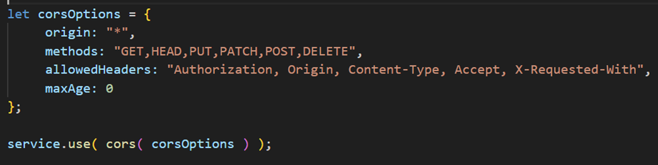

- Next, build a webservice that allows student details to added, read and deleted (CRUD operations).
- Include student details of:
  - Id (Provided by the database)
  - Name
  - Age
  - Course
- Use the URI http://localhost:1339/students
  - For add, method is POST. It will return 201 on success.
  - Also return the new student data from the “database”, although it is possible to return nothing (res.status(201).end())

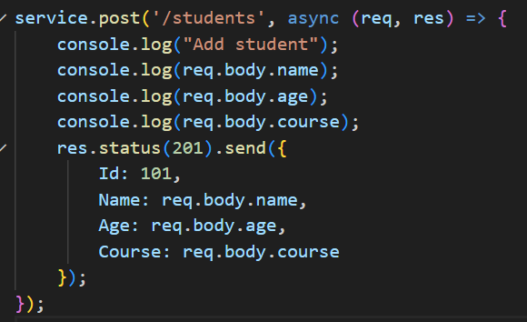
For this we will pretend we added it and return a fake primary key “Id” value of 101.
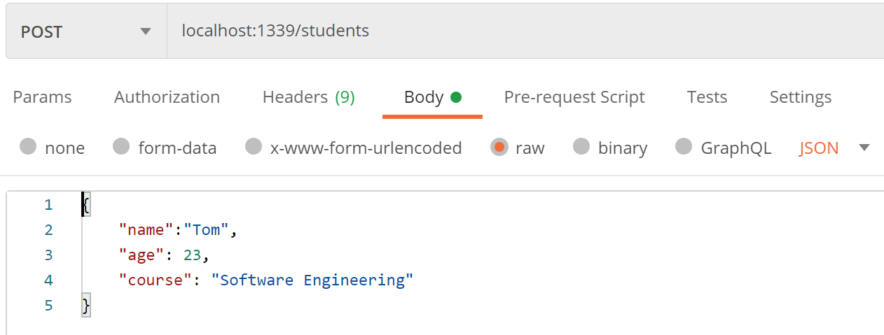

  - For read, method is GET. It will return 200 on success.
  - To read all student’s details, use the same URI http://localhost:1339/students
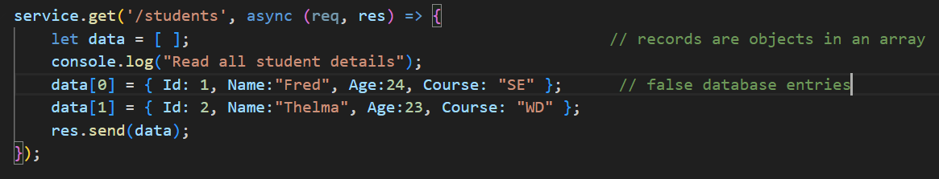


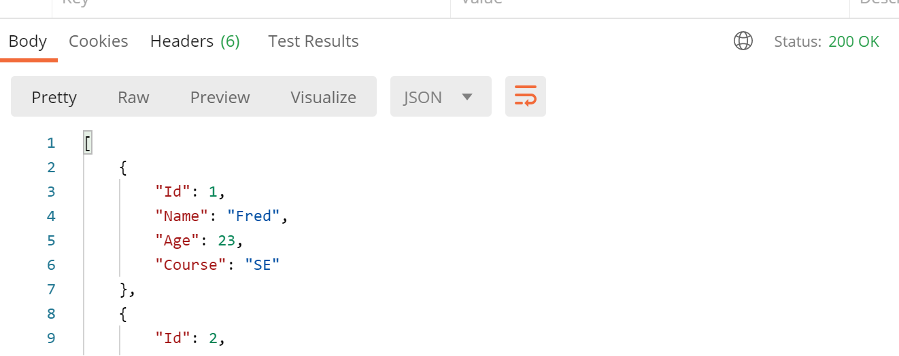

  - To read a specific student’s details provide the id, use http://localhost:1339/students/:id
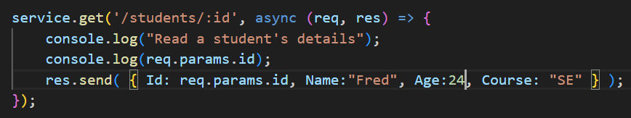


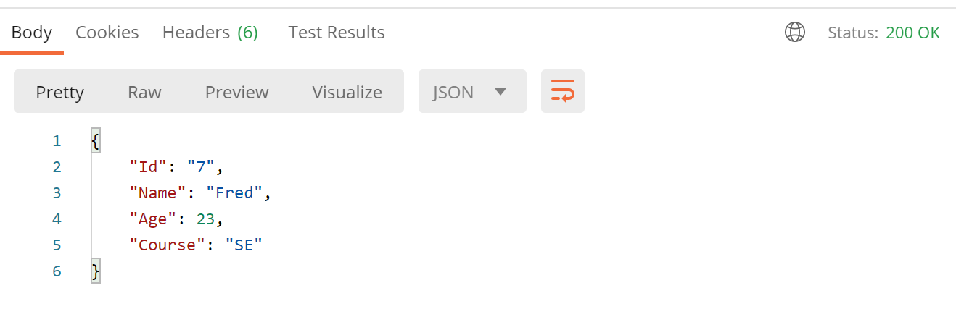
  - We can extract parameters from the URI add as query string parameters following the ? symbol. The name of the student, use http:/localhost:1339/students?name=:name
The expressjs framework automatically extracts the query string parameters for us.
We can get these parameters from the request object using the query array e.g. to read the above “name” value:
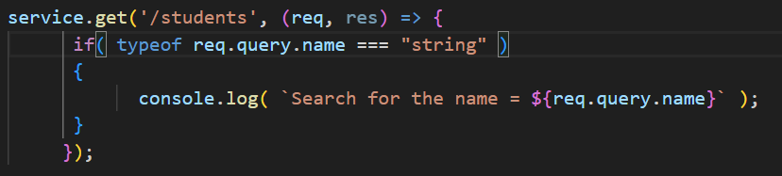
URI is http://localhost:1339/students?name=:name and method is GET is the routing parameter expected for the student Name.
On successful read, return status code 200 and JSON in Response Body.
Modify the previous “/students” route that read all the students details
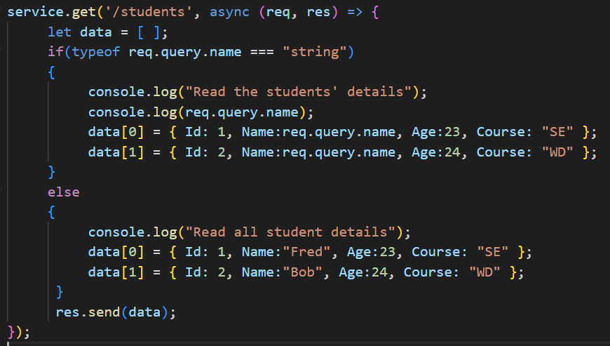

- To delete a record, method is DELETE and the student id must be specified like so: http://localhost:1339/students/:id this will return 200 on success.





