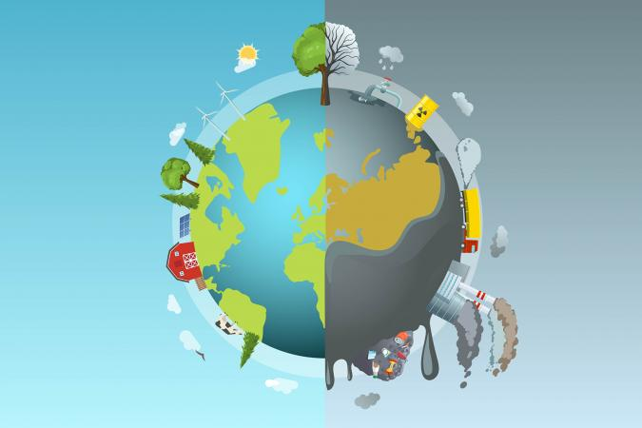
Analysing environmental impact

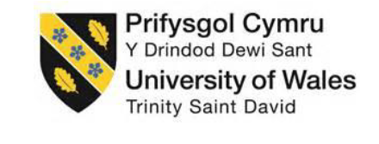
Executive Summary
September 14, 2023
University of Wales Trinity Saint David
STUDENT: James Clemett-Davies
Student ID: 2114360

The purpose of this report is to analyse……..
DO THIS SECTION LAST!!!!!!
NOT INCLUDED IN WORD COUNT – this section should be around ¾ of a page in length for a 2500 word report.

DO NOT cite any sources in this section.

Table of Contents
Executive Summary 0
Introduction 3
Main Findings 4
Recommendations 13
Bibliography 15

Figure 1 – Three Phase induction motor design (Technology, 2023) 4
Figure 2 - Display of material fractions increased from the base IE2 model to the IE4 model (Auer and Meincke, 2018) 5
Figure 3 - Framework for different stages of LCA 6
Figure 4 - Different product life cycle models of LCA (Zazala Quist, 2023) 6
Figure 5 - The four stages of product lifecycle 7
Figure 6 - CO2 annual emissions by sector (Ritchie, Roser and Rosado, 2020) 8
Figure 7 - Environmental impact made by motors at different lifecycle stages 9
Figure 8 - ABB bill of materials product declaration for 90Kw pump (Mark Laatu, 2023) 10

Table 1 - ABB data for environmental impacts (Mark Laatu, 2023) 11

Introduction

“Jerry Greenfield quotes, ‘Look at your business and the activities that you undertake, Then, start to think about not just your economic concerns, but about social and environmental impacts that businesses have’”. This philosophy can be applied to a product, part(s) or services produced in the manufacturing sector by using tools enabling analysis of industries such as environmental impact assessments. The report aims to provide readers with an understanding of the current state of affairs, including key trends, challenges and opportunities to improve the efficiency of motors. By reviewing relevant literature and case studies, I hope to offer valuable insights and recommendations for improvements that could be considered by companies and stakeholders alike.
One tool for doing such an assessment is a Life cycle assessment or (LCA). Life cycle assessment will be analysed through the report, identifying environmental impacts associated with manufacturing a motor, delivery, the use of the motor and end-of-life scenarios. Datasheets sourced from a motor manufacturer, ABB, will be used alongside the analysis.
Life cycle assessments are a crucial tool for manufacturers and customers to quantify the environmental impact of their products. This tool allows companies to make better-informed decisions and take proactive steps towards improving sustainability. It is essential to prioritise sustainability not just for the sake of companies but also for the environment.
What if this analysis showed that a company could be more energy efficient, reduce waste and be kinder to the environment that we live in? Maybe these improvements would make the company more attractive to customers who are increasingly conscious of their environmental impact, this could lead to increased sales, market share and ultimately the company's bottom line, where do I sign up.

Main Findings

A three-phase induction motor has been selected for the analysis of the report. Three-phase induction motors play a vital part in the manufacturing sector and are the most widely used electric motors in industrial applications. They are widely used in such applications as pumps, compressors, fans, conveyors, hoists and agitators (Torrent, Martinez and Andrada, 2012). It is easy to see why this type of electric motor is favoured by many companies across the world. Its simplicity of design, high reliability, and affordability make it a perfect selection for many different applications (Csanyi, 2011).
A typical design of a three phase induction motor is illustrated in Figure 1 (Technology, 2023). The design of an induction motor has several advantages: being highly reliable and affordable compared to other types of motors, having High motor efficiency, and the life span of the motor is high. Due to the simplicity of the design, the Fluke company (Fluke, 2023) confirm that minimal non-contact parts mean that bearings on both the drive and non-drive end of the motor shaft or insulation breakdown that occurs on the stator windings are the most common failures of an induction motor allowing for planned preventative maintenance to prevent premature failures from occurring. Implementing planned maintenance strategies on known failure points of motors (which could be determined by Failure modes and effects analysis (FMEA)) could extend the life span of the motor and, therefore, reduce the need for a replacement and reduce some environmental impacts on production, transportation and waste and cost less than reactive unplanned maintenance (Weidner, 2023).
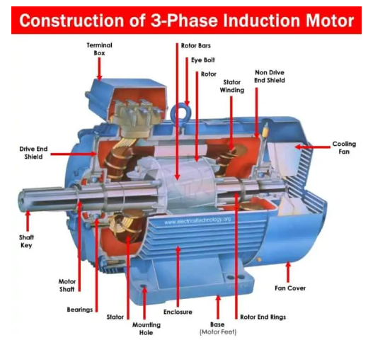
Figure 1 – Three Phase induction motor design (Technology, 2023)
Environmental Impacts
Both (Torrent, Martinez and Andrada, 2012; Emma Westberg, 2021) state that electric motors consume approximately 45% of electricity globally. This can contribute to yearly emissions of around 6040 Mt CO_{2.} As the world seeks to reduce electricity consumption and reduce harmful emissions, Regulations such as IEC 60034-30-1:2014 have been implemented across many countries internationally to help combat and ensure conformity to standards that the implementation of high-efficiency motors (Rotating electrical machines, 2010), Directive 2005/32/EC of the European Parliament and of the council confirm that, there is a total potential for cost-effective improvement of the energy efficiency of these motor systems by about 20% to 30% if energy efficient motors were used within industry (Commission regulation, 2009).
According to (Rassõlkin et al., 2020) show that there are currently four energy classes used to describe the energy efficiency of motors - standard efficiency (IE1), high efficiency (IE2), premium efficiency (IE3), and super premium efficiency (IE4). As energy efficiency requirements continue to rise, researchers have been exploring alternative technologies for electrical machines. Among these possibilities, using rare-earth permanent magnets (PMs) in rotating electrical machines to achieve IE3 and IE4 efficiency classes has emerged as a promising solution. However, it is essential to consider that this may lead to a higher environmental footprint compared to IE2 efficiency class machines. Figure 2 shows a visual representation of the bill of materials of a motor that increases in material fraction as the efficiency of the motors increase (Auer and Meincke, 2018).
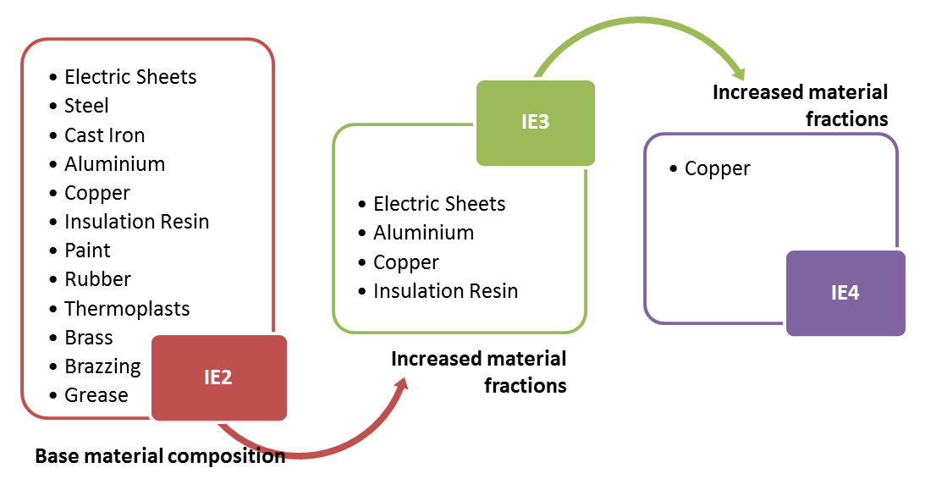
Figure 2 - Display of material fractions increased from the base IE2 model to the IE4 model (Auer and Meincke, 2018)

Lifecycle Assessment
Lifecycle assessment, also known as LCA, is a valuable tool for analysing the environmental impact of a product or process throughout its entire lifespan, from production to end of life. LCA can help identify areas where improvements can be made to reduce the product's overall environmental impact. ISO 14040 and ISO 14044 are the international standards developed as a framework for life cycle assessment standards, principles and guidelines for life cycle assessments (Finkbeiner et al., 2006).
There are different stages of a whole life cycle assessment; both (Ayyappan et al., 2019; Emma Westberg, 2021) agree with the following workflow, as shown in Figure 3, which sets out the framework for a life cycle analysis. The double arrows indicate that the process is iterative to the interpretation stage showing the process is repeated back and forth with data analysis and the data is not all analysed during the end of the analysis.
Figure 3 - Framework for different stages of LCA
When assessing the impact of a motor on the environment, it is essential to consider the entire lifecycle of the product, commonly called cradle-to-grave assessment which has been shown in the Figure 4 (Zazala Quist, 2023); other models can be studied as part of life cycle assessment, cradle-to-gate, cradle-to-cradle or gate-to-gate (Zazala Quist, 2023) but will not be analysed in detail for this analysis.
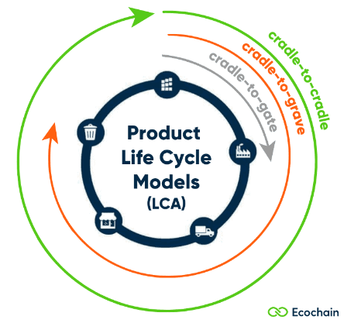
Figure 4 - Different product life cycle models of LCA (Zazala Quist, 2023)
The cradle-to-grave approach includes everything from acquiring materials to manufacturing, transportation, marketing, use, and eventual recycling or disposal (Orlova et al., 2016). By conducting a thorough lifecycle assessment, we can identify critical areas where we can reduce the environmental impact of these products and make more informed decisions about their production and use. According to (Jolliet et al., 2016) LCA is a critical tool for businesses and people looking to minimise their environmental impact and promote sustainable practices worldwide. LCA is applied to products or services. When it comes to motors (Orlova et al., 2016; Rassõlkin et al., 2020) agree that there are four distinct stages in Life cycle analysis that must be considered: production, distribution, use, and end-of-life which can be shown in Figure 5.

Figure 5 - The four stages of product lifecycle

Each stage determines a motor's overall sustainability and environmental impact. During the production stage, it's essential to consider the materials and manufacturing processes used to create the motor and any potential environmental impacts associated with these processes. During distribution, factors like transportation and logistics come into play, and it's essential to consider the most efficient and sustainable ways to move the motor from the factory to the end user. Once the motor is in use, its energy efficiency and maintenance needs will determine its overall environmental impact. Operating energy losses are also considered during this stage of the LCA (Ayyappan et al., 2019). Finally, when the motor reaches the end of its life, it's essential to consider how it can be recycled or disposed of in the most environmentally responsible way possible. By taking a holistic approach to the motor life cycle, manufacturers and users can work towards creating a more sustainable and environmentally friendly future.
It is essential to recognize that pollution of the environment starts with the extraction of natural resources required to make motor products. This means the production process involves extracting these resources and the energy sources needed. Additionally, transportation of the basic materials before processing also falls under this stage. After this, the raw material is processed, and the final product is obtained (Rassõlkin et al., 2020).
It is crucial to consider the environmental impact of extracting raw materials, such as those used to produce the different components in the motor, The process can harm ecosystems, pollute water, and air, and contribute to climate change. Therefore, we must find sustainable methods to meet our needs. The extraction process of the raw materials does not end here for the environmental impacts, further processing of the raw materials to make them suitable for manufacturing and processing can often involve milling, metalworking, and sheet rolling of steel and iron along with wire drawing of copper and injection moulding for the polypropylene components used in the manufacture of the motor. The processing and manufacturing can cause environmental emissions to the atmosphere and produce waste for landfill or incineration, along with water usage and discharge which can further impact the environment. The processing stages use a lot of heat and electricity. Statistics show (Ritchie, Roser and Rosado, 2020) that electricity and heat usage and CO2 emissions has been ever rising over the last 30 years. This needs to change to make a positive environmental impact.
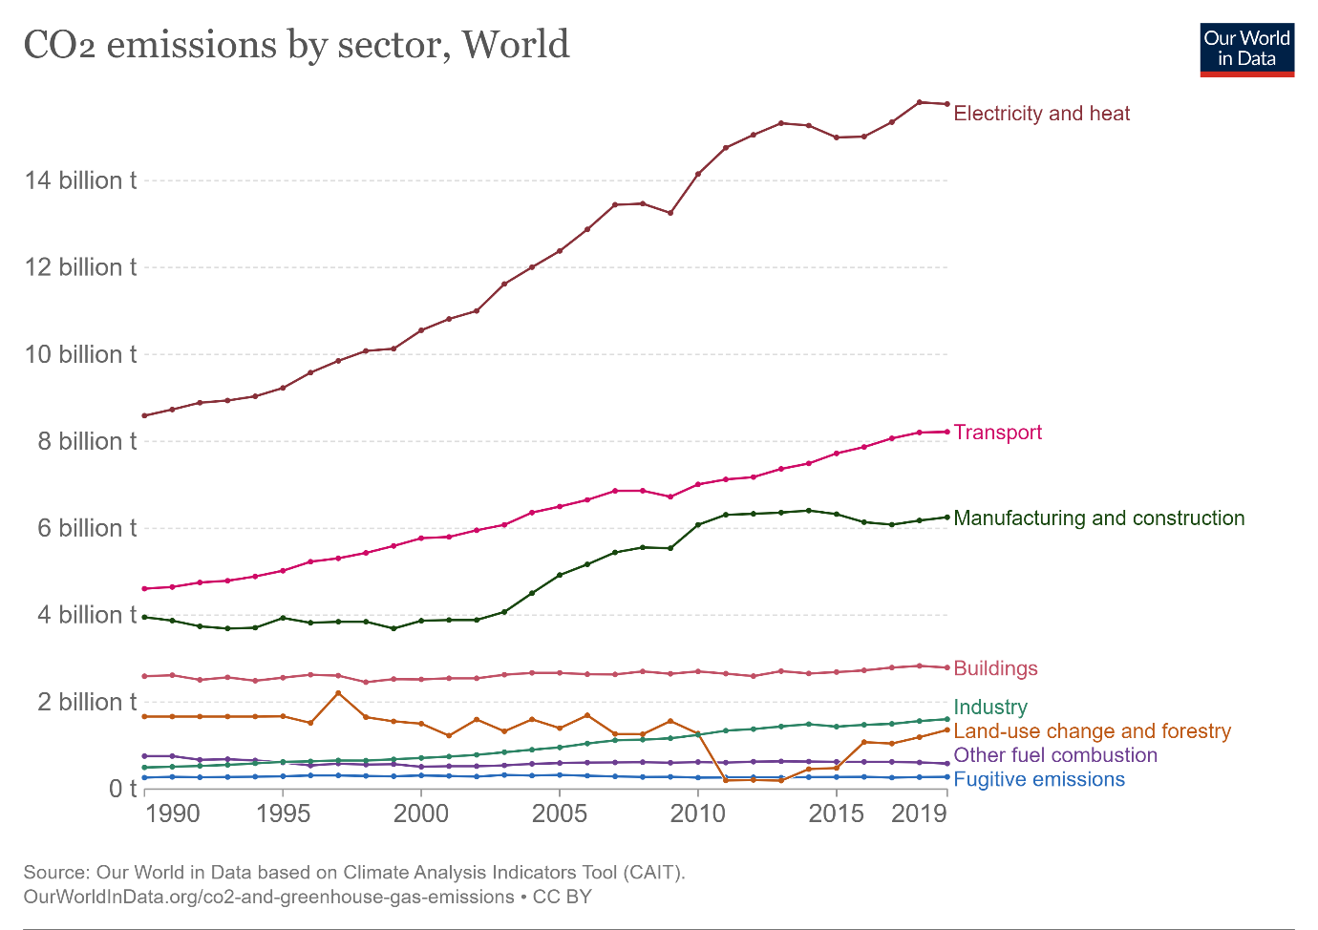
Figure 6 - CO2 annual emissions by sector (Ritchie, Roser and Rosado, 2020)
The distribution phase of the life cycle product although a smaller portion of the product's life cycle, is still a contributing factor towards environmental impacts. The use of fossil fuels in the form of petrol and diesel fuel will contribute towards CO2 emissions by nature of the emissions. Packaging is also considered at this stage, the use of non-recyclable materials that need to be incinerated in the form of plastics, or even the recycling of materials for re-use can also form part of the CO2 emissions issue.
The use stage of a motor can be stated as being the most dominant phase of the four stages of the motor life cycle which is shown in Figure 7 (Orlova et al., 2016).
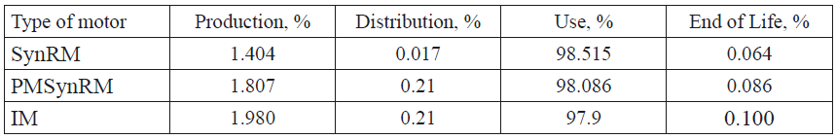
Figure 7 - Environmental impact made by motors at different lifecycle stages

Figure 7 shows data populated as an example for three different motor types (Orlova et al., 2016). For this analysis, the study of an IM or Induction motor is being carried out. The use stage for the three different types of motor is significantly the dominant portion of the four-stage life cycle assessment. As the motor is an energy converter for another application, only losses are calculated in the life cycle assessment use phase. The considered efficiency for the ABB pump in analysis has been stated as being 95.2%; this means that the losses are then calculated to be 4.8% which has been assumed to be running at 6500 hours/year at 100% load over a 30-year life cycle of the motor (Mark Laatu, 2023).
When analysing life cycle assessments, a helpful tool that can be applied is the MEEuP/MEErP methodology (Methodology study for Ecodesign of energy using or related products). It is a system used to evaluate the energy efficiency of items such as electric motors. The MEErP methodology is used to classify electric motors based on their energy efficiency. The classification is based on the motor's efficiency rating, which is expressed as a percentage. The higher the percentage, the more energy-efficient the motor is. The MEErP methodology provides a set of standards that electric motor manufacturers must follow to ensure that their products meet minimum energy efficiency levels. These standards are based on the size and type of the motor, and they are designed to ensure that electric motors are as energy-efficient as possible. By using the MEErP methodology, manufacturers can produce more energy-efficient electric motors, which in turn can help reduce energy consumption and greenhouse gas emissions and reduce their and customers' energy usage and costs in the process.
For the ABB 90 Kw pump studied, ABB manufacturers have declared a summary of the bill of materials, as shown in Figure 8 (Mark Laatu, 2023), which is required for a Life cycle assessment study. Unfortunately, the exact quantities measured in kg of each material are unknown, probably due to ABB's intellectual property rights, but the following materials are listed in the ABB environmental product declaration (Mark Laatu, 2023) and are as follows; carbon steel, stainless steel, cast iron, synthetic rubber, aluminium, sawn wood, board carton, copper, resistor, cable, polypropylene, Primer and finish paint coat for motor product and epoxy resin for stator coatings. These are the standard bill of materials for the ABB induction motor 90Kw being analysed.

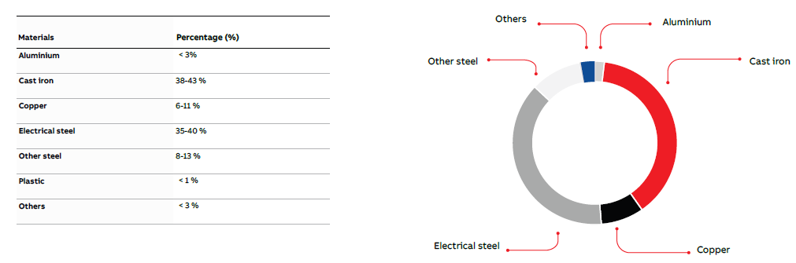
Figure 8 - ABB bill of materials product declaration for 90Kw pump (Mark Laatu, 2023)

Table 1 has been populated from data that ABB has published for the motor (Mark Laatu, 2023) in Microsoft Excel. The data shows the environmental impact based on a 1Kw rating basis. The data would therefore need to be multiplied by 90 to show the accurate representation of the 90Kw motor impact study. The data is presented this way to allow easier comparisons between other motors at 1Kw.
Table 1 - ABB data for environmental impacts (Mark Laatu, 2023)

As shown in Table 1, the collected results should be interpreted during the LCA assessment and not necessarily at the end of the evaluation as discussed earlier and shown in Figure 3. This allows for more reliable data which can be used to process the results and provide recommendations for improvement.
Analysing the results in Table 1 shows that a portion of the LCA from the cradle-to-grave utilises renewable energy sources alongside that of non-renewable resources. This equates to approximately 16.5% of Renewable energy used in the life cycle assessment, as this analysis was conducted in Finland where renewable sources as of 2019 at 36% of the total energy sources supplying Finnish electricity (KPMG, 2023). Further analysis of the data in Table 1, which confirms the earlier study in Figure 7, shows that the use phase of a motor is by far the most significant contributor to environmental impact. This is shown in the data in which fossil resources show up as substantial contributors from global warming potential and Abiotic depletion potential (a measure of the use of non-renewable sources for energy production); this could be down to the country of motor operation where fossil fuels like Oil, Natural gas or coal are used as energy sources to produce electricity that would run the motor and the results would therefore vary by country.
There are several ways in which environmental impact can be decreased. One way would be to introduce what is known as a circular business model. A circular business model as researched by (Callorda Fossati and Bauler, 2022) is a way of operating a business that aims to reduce waste and create a more sustainable economy by the principles of Reduce, Reuse, and Recycle. This is achieved by designing products and services with a focus on longevity, repairability, and reuse. In a circular business model, products are not seen as disposable but as resources that can be used repeatedly. This helps reduce the amount of waste generated and conserve natural resources. Additionally, circular business models often involve using renewable energy sources and implementing closed-loop systems, where waste is recycled or repurposed into new products or materials. By adopting a circular business model, companies can reduce their environmental impact, create new revenue streams, and improve their reputation as a socially responsible organization. Analysing the ABB datasheets and information provided, it assumes that 95% of the products are recycled at the end-of-life scenario, with only 5% ending up in landfill as waste disposal (Mark Laatu, 2023).
Further improvements can also be made by increasing the motor efficiency rating , By companies adopting and improving strategies that allow change of application after the use phase, or by Improving or designing refurbishment programs that could extend the life span of the motor itself, would also have a positive impact on the environment and waste to landfill or incineration reduction (Emma Westberg, 2021).

Recommendations

Companies can implement several solutions and improvements that will positively impact the environment. Increasing the rating of the efficiency of the motors, from IE1- standard efficiency to IE4 – premium efficiency, will undoubtedly have a positive impact during the use phase of the motor, which, is, the most dominant factor in environmental impact. Manufacturers must complete thorough assessments to ensure that by increasing efficiency, the reverse of increasing environmental impact does not occur, as discussed by (Rassõlkin et al., 2020).
Another good recommendation could be for companies to ensure that their suppliers and customers have values that are seeking to be a sustainable company. They source materials responsibly and sustainably and lead in reducing environmental impacts.
The bill of materials listed should be analysed to see if any material selection could be improved, for example, by increasing robustness, it could increase life span on parts if this improvement does not increase environmental impact at the same time. This material list should be analysed to ensure that when it comes to the end-of-life part of the LCA cycle, Ensure companies have a robust design for refurbishment and recycling programs to allow components to be replaced and go back into service and less reliance on the extraction of raw materials to be processed to enable the products to be made. Use of the recycled products gets processed and starts the life cycle journey once again.
As the use phase is the most significant part of the life cycle that impacts the environment, companies should look at motors on a case-by-case basis. Things that should be taken into consideration for improvement are motor loadings. Are the motors oversized for the duty, Do the motors need to run at full load all the time? If the answer is no, then upgrading to variable speed motor drives or VSDs could considerably reduce electricity usage and CO2 emissions impact over the life cycle of the motor.
Transportation of motors and spare parts could be decreased by having better links with customers and closer facilities to reduce distances, fuel usage, and less CO2 emissions. Manufacturers should look to minimise the amount of unique spare parts they produce and hold; a system of universal parts for different motor types which can limit the need for mass production of other parts and require less manufacturing, which would positively impact CO2 emissions.
Ensure Planned maintenance programs are adopted and in place to allow servicing before failures occur, this way the motor life should last much longer and enable less reliance on replacement products which will add environmental impacts throughout the four stage cycle.

Bibliography

Auer, J. and Meincke, A. (2018) ‘Comparative life cycle assessment of electric motors with different efficiency classes: a deep dive into the trade-offs between the life cycle stages in ecodesign context’, The International Journal of Life Cycle Assessment, 23(8), pp. 1590–1608. Available at: https://doi.org/10.1007/s11367-017-1378-8.
Ayyappan, G.S. et al. (2019) ‘Electrical Motor Maintenance Techniques and Life Cycle Assessment- A Review with Case Studies’, in 2019 2nd International Conference on Power and Embedded Drive Control (ICPEDC). 2019 2nd International Conference on Power and Embedded Drive Control (ICPEDC), Chennai, India: IEEE, pp. 167–172. Available at: https://doi.org/10.1109/ICPEDC47771.2019.9036543.
Commission regulation (2009) Commission Regulation (EC) No 640/2009 of 22 July 2009 implementing Directive 2005/32/EC of the European Parliament and of the Council with regard to ecodesign requirements for electric motors (Text with EEA relevance), Legislation.gov.uk. Available at: https://www.legislation.gov.uk/eur/2009/640 (Accessed: 28 August 2023).
Csanyi, E. (2011) Basic construction of 3-phase AC induction motors you should know | EEP. Available at: https://electrical-engineering-portal.com/construction-of-3-phase-ac-induction-motors (Accessed: 16 August 2023).
Emma Westberg (2021) Environmental impact of an electric motor and drive. LinKoping University.
Finkbeiner, M. et al. (2006) ‘The New International Standards for Life Cycle Assessment: ISO 14040 and ISO 14044’, The International Journal of Life Cycle Assessment, 11(2), pp. 80–85. Available at: https://doi.org/10.1065/lca2006.02.002.
Fluke (2023) 13 Common Causes of Motor Failure | Fluke, FLUKE. Available at: https://www.fluke.com/en-gb/learn/blog/motors-drives-pumps-compressors/13-causes-of-motor-failure (Accessed: 17 August 2023).
G.S.Ayyappan et al. (2019) Electrical motor maintenance techniques and life cycle assessment - A review with case studies. Piscataway, NJ: IEEE. Available at: 10.1109/ICPEDC47771.2019.9036543. (Accessed: 31 August 2023).
IEEE Xplore Full-Text PDF: (no date). Available at: https://ieeexplore-ieee-org.ezproxy.uwtsd.ac.uk/stamp/stamp.jsp?tp=&arnumber=9036543 (Accessed: 31 August 2023).
Jolliet, O. et al. (2016) Environmental life cycle assessment. London: Taylor & Francis.
Larsson, M. (2018a) ‘Development as a Process of Organization’, in Larsson, M., Circular Business Models. Cham: Springer International Publishing, pp. 9–18. Available at: https://doi.org/10.1007/978-3-319-71791-3_2.
Larsson, M. (2018b) ‘The Circular Economy and Business Challenges’, in Larsson, M., Circular Business Models. Cham: Springer International Publishing, pp. 27–39. Available at: https://doi.org/10.1007/978-3-319-71791-3_4.
Mark Laatu (2023) ‘Environmental product declaration for cast iron process performance induction motor (90kW)’. ABB. Available at: https://library.e.abb.com/public/7d0893bcbe6e4d238acfe108d2a265c9/9AAU00000000030_EPD_M3BP_3GBP282230-ADK_EN_02-2023.pdf (Accessed: 28 August 2023).
Orlova, S. et al. (2016) ‘Lifecycle Analysis of Different Motors from the Standpoint of Environmental Impact’, Latvian Journal of Physics and Technical Sciences, 53(6), pp. 37–46. Available at: https://doi.org/10.1515/lpts-2016-0042.
Product Life-cycle Environmental Impact Assessment Technology (no date). Available at: https://www.ricoh.com/technology/tech/063_lca (Accessed: 15 August 2023).
Rassõlkin, A. et al. (2020) ‘Life cycle analysis of electrical motor-drive system based on electrical machine type’, Proceedings of the Estonian Academy of Sciences, 69(2), p. 162. Available at: https://doi.org/10.3176/proc.2020.2.07.
Rimbawati et al. (2017) ‘Design of motor induction 3-Phase from waste industry to generator for microhydro at isolated village’, IOP Conference Series: Materials Science and Engineering, 237, p. 012021. Available at: https://doi.org/10.1088/1757-899X/237/1/012021.
Ritchie, H., Roser, M. and Rosado, P. (2020) ‘CO₂ and Greenhouse Gas Emissions’, Our World in Data [Preprint]. Available at: https://ourworldindata.org/emissions-by-sector (Accessed: 30 August 2023).
Rotating electrical machines (2010). Geneva: IEC.
Technology, E. (2023) Three-Phase Induction Motor – Construction, Working, Types & Applications, Electrical technology. Available at: https://www.electricaltechnology.org/2020/05/three-phase-induction-motor.html (Accessed: 16 August 2023).
Torrent, M., Martinez, E. and Andrada, P. (2012) ‘Assessing the environmental impact of induction motors using manufacturer’s data and life cycle analysis’, IET Electric Power Applications, 6(8), p. 473. Available at: https://doi.org/10.1049/iet-epa.2012.0021.
Zazala Quist (2023) Life Cycle Assessment (LCA) - Complete Beginner’s Guide, Ecochain. Available at: https://ecochain.com/blog/life-cycle-assessment-lca-guide/#four-phase-lca (Accessed: 3 September 2023).

