The Impact of MyPEEPS Mobile in Promoting Sexual Health Among Adolescents

Introduction
Sexual health is a key public-health concern, especially for adolescents and young adults.
- More than one million STIs are acquired every day worldwide (WHO, 2023).
- The highest prevalence occurs in people aged 15–24 years.
- Barriers such as stigma, embarrassment, and limited access to confidential services often prevent young people from getting accurate information (UNFPA, 2022; Montgomery et al., 2021).
Digital health apps now offer private, accessible ways to promote knowledge and safer sexual behaviour (Guse et al., 2012; Wadham et al., 2019).

Figure 1: Key global sexual-health indicators highlighting the need for youth-focused digital interventions.

What Is MyPEEPS Mobile?

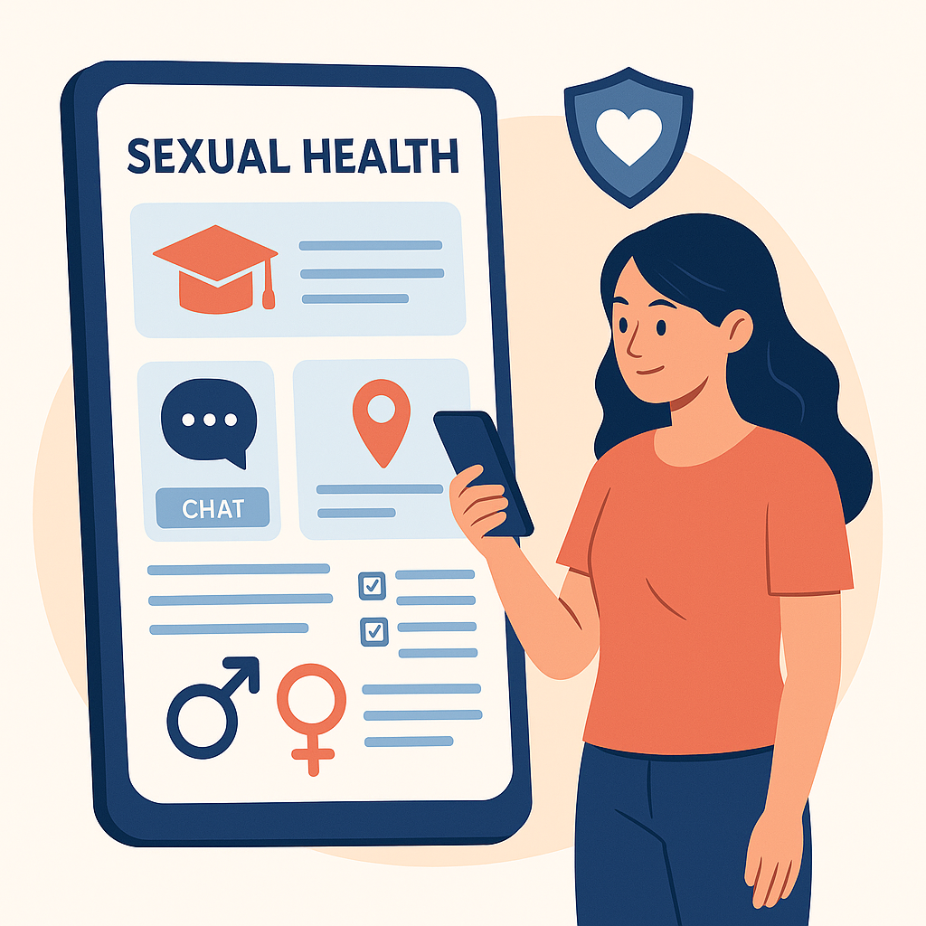
Figure 2: Example of a youth-friendly mobile sexual-health education interface, like MyPEEPS Mobile.

- Full name: Male Youth Personal Education and Engagement for Sexual Health.
- Target group: Boys and young men who have sex with men (ages 13–18).
- Purpose: Reduce HIV/STI risk and promote healthy relationships.

Key features
- Gamified learning: Quizzes, stories, and mini-games teach safer-sex decision-making.
- Interactive modules: Cover condom use, communication, consent, and STI prevention.
- Real-life simulations: Users practise handling social and sexual situations.
- Anonymity: Encourages open learning without fear of judgment (Gabarron & Wynn, 2016).
The app reflects health-promotion values of empowerment, participation, and equity (WHO, 1986).

Evidence of Impact
Research consistently shows that MyPEEPS Mobile improves young people’s sexual-health knowledge and confidence:
- A randomised controlled trial found participants using MyPEEPS Mobile reported higher condom use and fewer condomless anal-sex acts than controls (Brown et al., 2022).
- Studies also show increases in self-efficacy and motivation for safer behaviours (Mustanski et al., 2019; Gilliam et al., 2020).
- The app provides a scalable and cost-effective approach to youth sexual-health education (Guse et al., 2012).

Critical Discussion
Advantages
- Accessible anytime via smartphone.
- Confidential and inclusive environment.
- Engages youth through interactive learning.
- Based on strong scientific evidence (Brown et al., 2022).

Limitations
- Focused mainly on male adolescents in the U.S., limiting generalisability (Mustanski et al., 2019).
- Requires internet access—may exclude some low-income users (Montgomery et al., 2021).
- Ongoing updates are needed to maintain medical accuracy.

Improvements
- Add multilingual content and offline access.
- Tailor content for diverse cultural and gender groups.
- Strengthen data-privacy protection and link to verified health services (Wadham et al., 2019).

Conclusion
MyPEEPS Mobile illustrates how digital technology can make sexual-health education engaging, confidential, and effective. By blending scientific evidence with youth-friendly design, it empowers adolescents to make safer decisions. With ongoing evaluation, inclusive design, and ethical safeguards, MyPEEPS can continue contributing to global sexual-health promotion.

Reference list
Brown, J.D. et al. (2022) ‘Efficacy of the MyPEEPS mobile intervention to reduce sexual risk among adolescent men who have sex with men: Results of a randomized controlled trial’, AIDS and Behavior, 26(7), pp. 2365–2377.
Gabarron, E. and Wynn, R. (2016) ‘Use of social media for sexual health promotion: A scoping review’, Global Health Action, 9(1), p. 32193.
Gilliam, M.L. et al. (2020) ‘Enhancing digital sexual health education for adolescents: Findings from a randomized trial’, Journal of Adolescent Health, 66(2), pp. 135–143.
Guse, K. et al. (2012) ‘Interventions using new digital media to improve adolescent sexual health: A systematic review’, Journal of Adolescent Health, 51(6), pp. 535–543.
Montgomery, P., Knerr, W. and Weatherford, R.D. (2021) ‘The effectiveness of digital sexual health interventions for young people: A systematic review and meta-analysis’, Sexual Health, 18(6), pp. 495–506.
Mustanski, B. et al. (2019) ‘Effects of an online HIV prevention program for young men who have sex with men: A randomized controlled trial’, Journal of Adolescent Health, 65(1), pp. 87–95.
UNFPA (2022) Sexual and reproductive health and rights: The foundation for sustainable development. Available at: https://www.unfpa.org/ (Accessed: 25 November 2024).
Wadham, E., Green, C., Debattista, J., Somerset, S. and Sav, A. (2019) ‘New digital media interventions for sexual health promotion: A systematic review’, Sexual Health, 16(2), pp. 101–123.
World Health Organization (1986) Ottawa Charter for Health Promotion. Geneva: World Health Organization.
World Health Organization (2023) Sexually transmitted infections (STIs): Key facts. Available at: https://www.who.int/news-room/fact-sheets/detail/sexually-transmitted-infections-(stis) (Accessed: 25 November 2024).

SafeConnect – A New Digital Innovation for Sexual Health Promotion

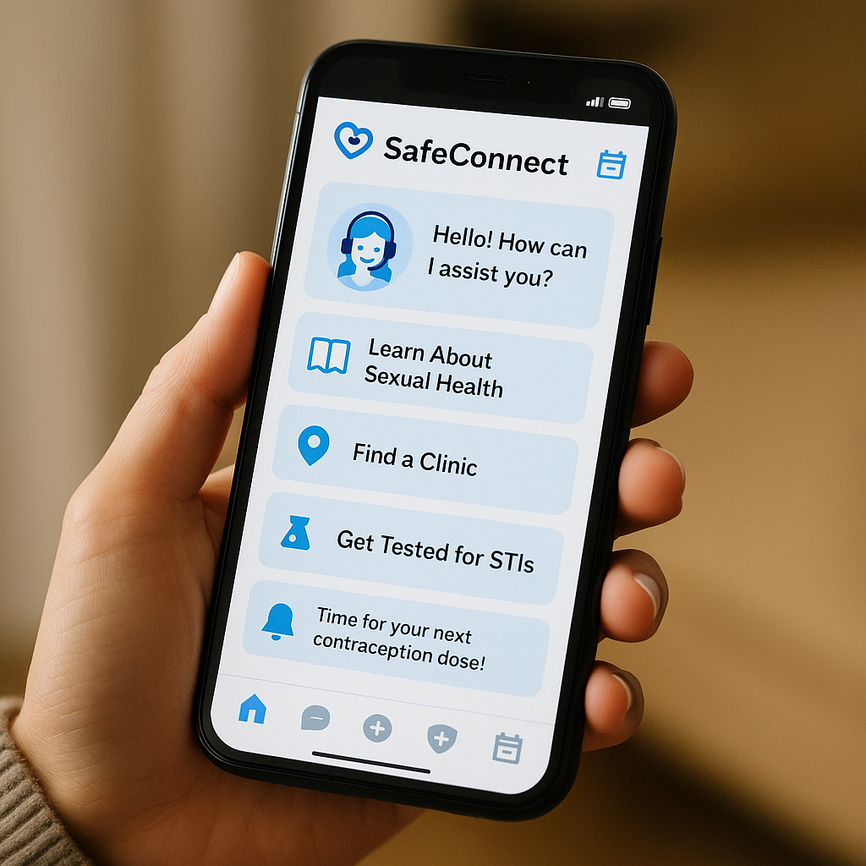
Figure 3: Concept illustration of the SafeConnect app, featuring an AI chatbot and youth-friendly sexual-health tools.

Introduction
Many young people still struggle to access accurate sexual-health information.
Key barriers include:
- Stigma
- Misinformation
- Privacy concerns
- Limited access to youth-friendly services
(UNFPA, 2022; Montgomery et al., 2021)
SafeConnect is a newly designed mobile app created to address these challenges. The app provides a confidential, evidence-based, and interactive digital platform for sexual-health education.
Aim: Empower young people with accessible tools to improve their sexual-health knowledge and behaviours.

Figure 4: Major barriers impacting adolescents’ access to sexual-health information

Description of SafeConnect
SafeConnect offers a range of digital features designed to improve sexual-health access and engagement among young people. The app brings together education, AI support, and personalised digital tools to create a more inclusive and youth-friendly learning experience (Gabarron & Wynn, 2016; Tark et al., 2019).
- It provides educational resources that strengthen sexual-health knowledge (Gabarron & Wynn, 2016).
- An AI-powered chatbot allows users to ask questions anonymously and receive instant, reliable guidance (Alghonaim et al., 2023).
- The clinic locator helps young people find nearby services and book appointments through the app (Wadham et al., 2019).
- The app adapts its content according to user age, gender identity, and cultural background, making it more inclusive for diverse youth populations (Montgomery et al., 2021).
By combining these evidence-based features, SafeConnect has the potential to support safer sexual-health decision-making and reduce common access barriers for young people.

How It Promotes Health
SafeConnect helps overcome the key barriers young people face in accessing sexual-health support by offering a private, judgment-free environment that encourages open learning and safer behaviours (Hollmann et al., 2022).
- The app boosts users’ self-efficacy by providing clear, supportive guidance on sexual-health decisions (Feroz et al., 2021).
- Its approach aligns with the Health Belief Model (HBM), emphasising perceived risk, perceived benefits, and cues to action that motivate behaviour change (Rosenstock, 1974).
- SafeConnect also follows the Theory of Planned Behaviour (TPB), focusing on attitudes, intentions, and perceived behavioural control as drivers of safer sexual practices (Ajzen, 1991).
By combining behavioural-theory principles with personalised digital support, SafeConnect promotes sustained, safer sexual-health behaviours among adolescents.
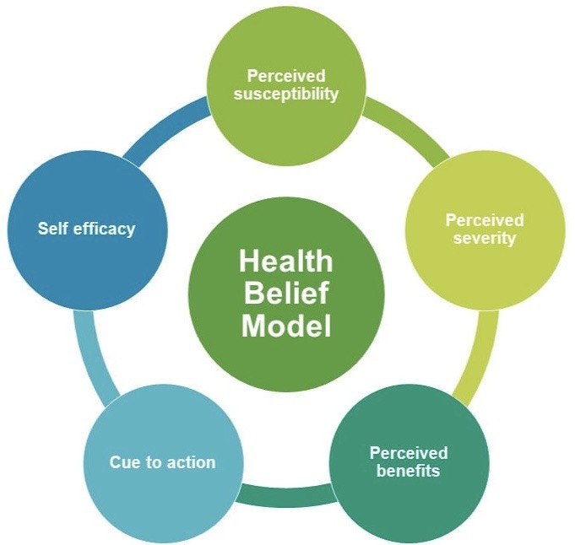
Figure 5: Health Belief Model in our application
Critical Discussion
SafeConnect offers several strengths that make it a promising tool for youth sexual-health promotion, particularly through its accessibility, anonymity, and AI-driven personalisation (Alghonaim et al., 2023). However, a number of challenges must be addressed to ensure safe and equitable use of the app.
- Algorithmic bias within the AI chatbot may influence the accuracy or fairness of responses (Bailey et al., 2015).
- Overreliance on digital tools may reduce in-person engagement when professional intervention is necessary (Montgomery et al., 2021).
- Partnerships with schools, youth groups, and public health agencies could further promote inclusivity and expand access to under-served populations (Wadham et al., 2019).
Together, these considerations highlight the importance of combining digital innovation with ethical safeguards and community engagement to maximise SafeConnect’s impact.

Conclusion
By integrating artificial intelligence, gamification, and real-time support, SafeConnect represents a forward-thinking approach to sexual-health promotion. It enhances accessibility, strengthens health literacy, and encourages sustainable behaviour change. With ongoing evaluation, ethical oversight, and inclusive design, SafeConnect has the potential to contribute significantly to global sexual-health goals (WHO, 2023; WHO, 1986).

Reference list
Ajzen, I. (1991) ‘The theory of planned behavior’, Organizational Behavior and Human Decision Processes, 50(2), pp. 179–211.
Alghonaim, A., Alsubaie, A., Alsalman, D. and Almugren, N. (2023) ‘Effectiveness of digital health interventions for improving sexual and reproductive health outcomes: A systematic review’, BMC Public Health, 23(1), p. 125.
Bailey, J.V. et al. (2015) ‘Sexual health promotion for young people delivered via digital media: A scoping review’, Public Health Research, 3(13), pp. 1–120.
Feroz, A., Ali, N.A., Saleem, S. and Tikmani, S.S. (2021) ‘Role of mHealth applications for improving adolescent sexual and reproductive health: A review’, Reproductive Health, 18(1), p. 205.
Gabarron, E. and Wynn, R. (2016) ‘Use of social media for sexual health promotion: A scoping review’, Global Health Action, 9(1), p. 32193.
Hollmann, A., Lameijer, J.R. and de Groot, C. (2022) ‘Digital interventions for sexual health promotion among adolescents: An integrative review’, JMIR Public Health and Surveillance, 8(7), p. e37210.
Montgomery, P., Knerr, W. and Weatherford, R.D. (2021) ‘The effectiveness of digital sexual health interventions for young people: A systematic review and meta-analysis’, Sexual Health, 18(6), pp. 495–506.
Rosenstock, I.M. (1974) ‘The Health Belief Model and preventive health behavior’, Health Education Monographs, 2(4), pp. 354–386.
Tark, R., Metcalf, M. and McKay, K. (2019) ‘Gamification in sexual health education: A review of digital learning interventions’, Journal of Medical Internet Research, 21(5), p. e12329.
UNFPA (2022) Sexual and reproductive health and rights: The foundation for sustainable development. Available at: https://www.unfpa.org/ (Accessed: 25 November 2024).
Wadham, E., Green, C., Debattista, J., Somerset, S. and Sav, A. (2019) ‘New digital media interventions for sexual health promotion: A systematic review’, Sexual Health, 16(2), pp. 101–123.
World Health Organization (1986) Ottawa Charter for Health Promotion. Geneva: World Health Organization.
World Health Organization (2023) Sexually transmitted infections (STIs): Key facts. Available at: https://www.who.int/news-room/fact-sheets/detail/sexually-transmitted-infections-(stis) (Accessed: 25 November 2024).

