Marketing Plan

Introduction: I would like to share with you my plan that I organized for the wedding packages that will be organized at the Thomas Dylan Centre, which is in the city of Swansea. A plan that consists of certain components that we should have when planning ceremony venues.

SMART OBJECTIVES:
S- Our wedding package has been designed for all that you could need to celebrate your big day. Including the ceremony room hire, in our luxurious Vivien Hall, including food and drinks in the Thomas Dylan Centre. The offer is a variety of wedding packages to suit your needs. Our chefs have created a specific menu which we can share with you.
M- Create a comprehensive checklist that includes everything, this article will be practical while the order of the service provided is perfect. Ideal for easily guiding guests around a day. Let us dive into wedding photographer, packages and what usually include. Wedding photographer packages provides, photographers with straight forward method pricing their service and giving couple of options. We will learn more about wedding favors and how we can package them in a way that will make your celebration last a long time.
A- Celebrate your day, with our affordable and luxurious wedding packages, that includes wedding ceremony, wedding reception and entertainments easy to calculate in your budget, but in our offers wedding packages is a possible to get them affordable if you are book a weekdays ceremony instead of Saturday or Sunday.
R- It is no secret that wedding budget planning can feel dauting, particularly because weddings are expensive. The knot of wedding study found that the average cost of wedding in 2023 was different than the cost in 2024. Typically, the most expensive aspects of weddings are ceremonies and reception venues, which depend on whether the venue comes with or its location.
T- To create a package, head to set up a package, you can give it a name and description. From the calendar, add new appointments and add first service. Recourse, time duration and price list. Before we choose subscription, during the trial, we have unlimited access to all timely features, so we can work out which features give us the most value.

Marketing KPI’s:
Conversion rate: If 6% of our website visitors join your mailing list, or make a purchase, our website is 6% effective. That is exceptionally good. In fact, a reliable website conversion rate falls between 2% and 5% across all industries. Conversion rate is calculated by total number of visitors for booking.
Customer Acquisition cost: A good acquisition per customer we can calculate (CAC) by dividing total expenses by the number of new customers acquired in a specific period. A (CAC) is significantly lower than customer lifetime value (LTV). Around 3:1 or 4:1 LTV: CAC ratio. The average (CAC) varies across the industries. (CAC) shows how much you spend to win a single new customer. Marketing (ROI) measures the revenue generated by our marketing activities.
Return and investment: (ROI) refers to return and investments, or simply how much you are getting out from what you invested. Calculating (ROI) is important for wedding pros to conduct profitable decision making. The ratio of what you have gained or lost against what you invested into the relationship.
Website traffic: It is article, detail strategies and design elements that propelled a 50% increase in traffic for wedding venue websites. By optimizing your website for relevant keywords, you can increase your website search engine ranking and attract more organic traffic.
Lead generation: Lead generation is typically utilized in the initial stage of the sales. Aims to cast a wide net, reaching out to a larger audience and capturing contact information or interest in the production services. Sales prospecting comes after lead generation. Google ads lead from extension are lead-generation. Ads designed to help business drive leads directly from the mobile search result page.
Customer lifetime value: Our customer lifetime value should be at least three times greater than our customer acquisition cost (CAC), and deal (LVT): (CAC) ratio should be 3;1 the value of customer should be three times more than the cost of acquiring them. If the ratio is close, you are spending too much. If it is 5;1, you are spending too little.
Engagement rate: Depend on how many guests are invited, but the realistic and average amount for their wedding is around 20,775£ or 25,952£ including engagement ring and honeymoon. But in 2023 the average cost of wedding was 20,700£ and in 2022 the average cost of wedding packages was 18,400£ so in a year the percentage comes up / up to 12,5% higher.
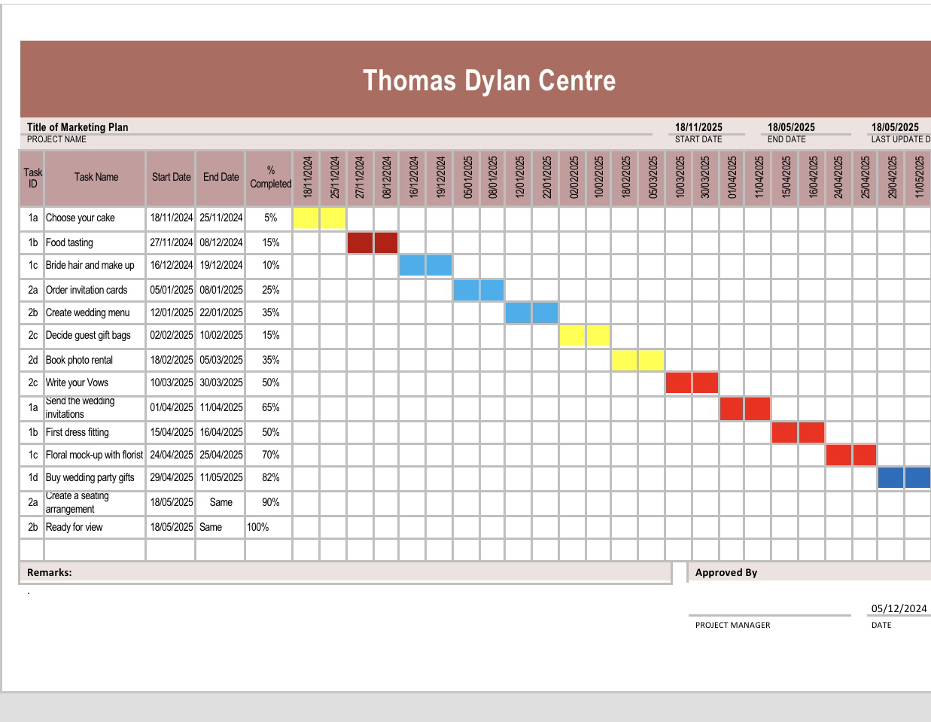

Market research: The competitive landscape refers to the list of options a customer could choose rather than your service or product. Market research helps find customers for your business. Competitive analysis helps to make your business unique. Conducting survey to learn more about their target audience preferences and buying. Any sets of techniques used to gather information and better understanding a target market. The type of data you need and how much you are willing to spend will determine the technique that you choose.

Monitoring: Revenue per booking is critical, Eding venues, that measures average income generated for each booking. Choosing the theme of your weddings is an effective way to start the process, it helps your big day establish a budget. Create a checklist, set a date, book venue, and make your guest list.

Target market and customer profile: Target market in the wedding industry is engaged couples looking to plan a wedding. Suppliers and venous may also be a target, as a partnership in the wedding industry. Engaged couples are our potential clients as they are most likely to hire wedding planners to help them plan their perfect wedding. That is the group of consumers that you need to focus on when advertising your business. A customer segment consists of couples who envision a timeless and traditional wedding with elegant decor, formal attire, and focus on tradition and heritage. The value expertise of a wedding planner to create a dreamy, fairy-tale wedding experience. Identifying our target audience is recommended by reviewing the client information you have gathered over 12 months.

SWOT ANALYSIS:
STRENGHT: Dylan Thomas Centre can accommodate an event from 2-200 guests. The facilities include outside seating favoring the SA1 sail bridge.
WEAKNESSES: Dylan Thomas Centre can improve a wide range of venues approval for marriages and civil partnerships.
OPPORTUNITIES: For Dylan Thomas Centre as offerings rooms with a different capacity for venues. In the 2 different rooms. Vivien hall – Theare.
THREADS: Celebrating the momentous event in Thomas Dylan Centre are offer a range of services and ceremony venues.

UNIQUE VALUE THOMAS DYLAN CENTRE:
The Thomas Dylan Centre is a beautiful building in the Maritime quarter near to Swansea Museum, who is known as the greatest poet of the 20th century at Thomas Dylan Centre, a unique and fascinating destination, in Swansea. Thomas Dylan had a unique style of writing he was a Welsh poet and writer.
MARKETING ACTIVITIES: The strategy of SEO is a process of organizing a website content by topic to improve the like hood of preparing in search results. Seo for research engine is about helping search engines understand your content and help users find your site and decide whether they should visit it through a search engine. Seo strategy is a plan to create, optimize and promote content to improve its visibility in search engine results, attracting more organic traffic to websites. It involves a variety of techniques. Such as keywords research, page optimization or technical Seo and building link. Example of Seo optimizing a piece of content to a specific keyword. For example, if you are publishing a blog post. Keywords in your post include title, and description marketing strategy in Seo involves components life advertising, content market, social media. Campaigns and other promotional tactics.

CONCLUSION: I was the first to start looking on social networks for ways to create smart objectives, so that my plan could be specified, measured and achievable realistic and time focused. Each paragraph that I received consists of certain activities that i focused on wedding packages. Marketing activities connected with the wedding package's preparation contain important things that should inform us about all the options important when purchasing. I searched on social media how and what i should focus on first to reach a conclusion and successful process, which I stated in my document.

REFERENCIES LIST:

In a letter to Rayner Heppenstall, dated 27 November 1939, he said he was born "about 11 p.m." (Ferris (1985), p. 432).

See, for example, his radio broadcasts Reminiscences of Childhood, Memories of Childhood and Holiday Memory collected in Maud (1991).

The main cluster of Williams farms included Waunfwlchan, Llwyngwyn, Maesgwyn, Pentowyn, Pencelli-uchaf and Penycoed. For more on both Thomas's farmyard and Swansea aunts, see Dylan and his aunties
"Did hard-living or medical neglect kill Dylan Thomas?". BBC. 8 November 2013. Archived from the original on 27 April 2014. Retrieved 20 April 2014.

Morton, Richard (1 January 1962). "Notes on the imagery of Dylan Thomas". English Studies. 43 (1–6): 155–164. doi:10.1080/00138386208597117.

Moynihan, William T. (1964). "Dylan Thomas and the "Biblical Rhythm"". PMLA. 79 (5): 631–647. doi:10.2307/461150. JSTOR 461150. S2CID 164050426.
Ferris, Paul (2004). "Thomas, Dylan Marlais (1914–1953) (subscription needed)". Oxford Dictionary of National Biography, online edition. Oxford University Press. Retrieved 29 August 2017.
"About Dylan Thomas: Academy of American Poets". poets.org. Retrieved 10 May 2020.
FitzGibbon (1965) lists 39 venues visited in the first US trip, compiled with the help of John Brinnin, but accepts that some locations may have been missed.
Davenport was, for many years, literary editor of The Observer newspaper. "From July to November 1940 Dylan Thomas and his family stayed at 'The Malting House' 78 High Street, Marshfield, near Chippenham in Gloucestershire, with the critic John Davenport and his American painter wife, Clement, who kept an open house for musicians and writers.
On her translations, see Thomas (2004), pp.
154–172. According to Ferris (1989), p. 190, the footage was taken from Riefenstahl's 1935 propaganda film Triumph des Willens.
Jones (1968), pp. 179–80, notes that in Thomas's early work, such as Eighteen Poems, the iambic foot was the rhythmic basis of his line, while in his later work a count of syllables replaced a count of accents.
"Welcome to Dylan Thomas Birthplace". Thomas (2003), pp. 33–53.

Thomas, David N. "A True Childhood: Dylan's Peninsularity" in Ellis (2014), pp. 7–29, and online at Dylan and his aunties.
Florence's father, George Williams, was also Anne's father. For more on this, see pp. 42, 182–185 and 290, in Thomas, D. N. (2003), Dylan Remembered 1914–1934, Seren, and Note (ii) at Dylan and his Ferryside aunts and uncles Both
Thomas's mother and father had relatives in Pontardulais. See Deric M. John and David N. Thomas (2010), From Fountain to River: Dylan Thomas and Pontardulais, in Cambria, Autumn, and online at Dylan Thomas and Pontardulais

