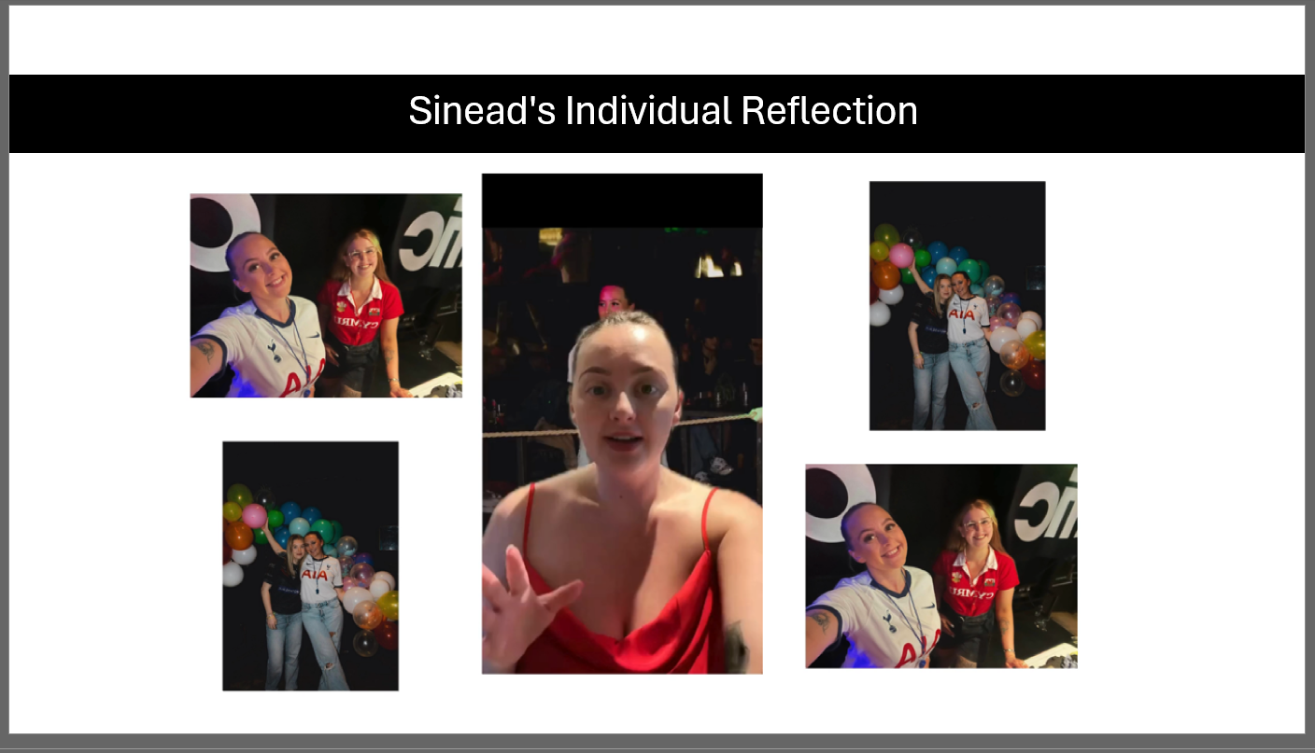This is a screen grab on my section of the presentation. Along side this I also provided all the video edits that went along side the presentation on the day.

