Evaluation of Blended Learning and Classroom Learning on Student Attainment (report)

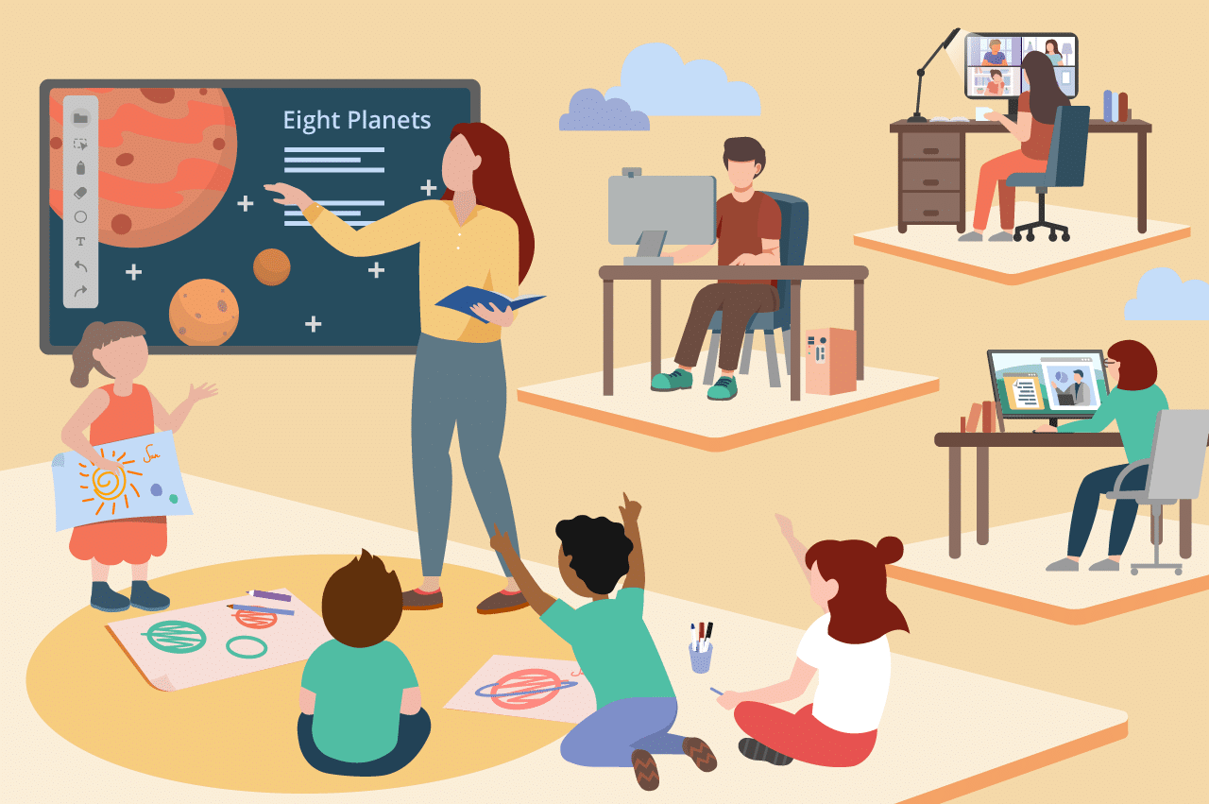

Student Name | Farhana Musharrath Tahura
Student ID | 2109147
Module Code | BMSW4001
Assignment Section | Task 1
Lecturer | Alex Worth

Table of Content

Abstract..........................................................................................................................3
Introduction....................................................................................................................4
Blended Learning..........................................................................................................5
Advantages of Blended Learning……………………….........…………….......……….......5
Disadvantages of Blended Learning………….………………...……………………….......5
Traditional Classroom Learning........................................….......................................6
Advantages of Traditional Classroom Learning...............................................................6
Disadvantages of Traditional Classroom Learning..........................................................6
Compare..........................................................................................................................7
Recommendation...........................................................................................................7
Conclusion ….................................................................................................................7
References…..................................................................................................................8
References.......................................................................................................................9

Abstract
The purpose of this study is to investigate if blended learning would be suitable for students studying the Certificate in Higher Education. The aim is to find out the advantages and disadvantages of blended learning in higher education as well as the advantages and disadvantages of traditional classroom learning. After analysing the positives of blended learning, it resulted in finding that students had higher motivation and more confidence through blended learning than in traditional classroom learning but the negatives were that students would need suitable tech to do their online learning and work on also good internet connection. An advantage of traditional classroom learning was that communication skills that will be needed later on in life can be learnt through physical classroom learning but a disadvantage was that costs to and from the classroom could be too much for some students. After digging into the issues that were faced with blended learning recommending suitable solutions to help with them came next so students might not struggle as much. One recommendation that would help improve blended learning would be to support students who don’t have much IT skills by offering classes so that they can access their classes and do their work. Overall, it was shown that blended learning could be improved but for where it is right now it could still be used as a great learning method.

Introduction
Is blended learning the future of study? Or should we stick to our roots with traditional classroom learning? In this essay blended learning and traditional classroom learning will be discussed to see which is the better option for students today by comparing the advantages and disadvantages of each. Blended learning is classroom learning but the classroom can be anywhere. The goal of blended learning is to take the benefits of classroom learning and add them to the benefits of online learning thus creating blended learning. (Holden and Westfall, 2010, p. 36) In an article written on the BML Munjal University’s website by Bhanu Kaushik she explained that classroom learning is the traditional way of learning as the name hints the classes will be inside the physical walls of the classroom with both the students and teachers attending physically. (Kaushik, 2020) After discussing the positives and negatives of the two learning methods, comparing them comes next to see which is better or worse before recommending solutions to improve both.

Blended Learning

Advantages of Blended Learning
In a study provided by the University of Granada it has been proven that blended learning has its benefits “The study shows that the use of blended learning has a positive effect in reducing dropout rates and in improving exam marks.” (López-Pérez and Pérez-López and Rodríguez-Ariza, 2010a, p. 1) and that “Students’ motivation increased during certain experiments in which blended learning was implemented.” (López-Pérez and Pérez-López and Rodríguez-Ariza, 2010b, p. 2) In an article by Farahiza Zaihan Azizan on blended learning in the Open University of Malaysia it was said that blended learning has given students who are usually unengaging in class the confidence to speak up and engage with the rest of the class and teachers (Zaihan Azizan, 2010, p. 9) Blended learning grants more flexibility for learners to take their time and work at their own pace. In a conference paper produced by Mihai, Mihaela and Irina it was stated that blended learners had to a certain degree more flexibility on how they went about their studies, they could decide when to learn and instead of rushing take their time which would allow them to go over topics which they might not understand fully. (Mihai and Mihaela and Irina, 2017, p. 2)

Disadvantages of Blended Learning
It may have its advantages but there is also a downside to blended learning such as if you have no internet connection you won’t be able to join your classes a disadvantage mentioned by the authors Celestino Eduardo Henrique and Noronha Adriana Backx “Disadvantages include the need for responsibility and time management from students, in addition to the inevitability of a good quality internet connection.” (Celestino and Noronha, 2021, p1) Dorman Woodall has brought up that students will need suitable technology and a good internet connection for blended learning “In most cases, the participants need advanced workstations and a high-speed connection.” (Woodall, 2004, p. 6) Due to the pandemic, some universities have had to go completely online for everyone’s safety it was not just difficult for the students but also the teachers “This was a hard transition for many traditional instructors not familiar with teaching online.” (Lewis and Price-Howard, 2021, p. 1)
Traditional Classroom Learning

Advantages of Traditional Classroom Learning
Some people may view classroom learning as something of the past but there are those who still prefer it to the modern ways. One of the reasons as to why people still prefer attending classes physically is because they like socialising with their classmates and or teachers to get to know the people who they will most likely be in class with for the next few months or years. By communicating with each other in person it gives students the communication skills they will need in life. When learning is supported by beneficial conversations and healthy competition, it activates critical thinking skills amongst students. This develops social skills and public speaking skills that will be very useful later on in their lives. (Agarwal, 2020, p. 1). Communicating will also be much easier as some people may not be the savviest with tech to communicate efficiently on there. Other reasons could be because it is much easier to not get distracted by something like technology such as phones or televisions when the teacher is in front of you and can see when you aren’t paying attention, so paying attention will be much easier.

Disadvantages of Traditional Classroom Learning
The disadvantages for traditional classroom learning for one is commuting to and from classes which will require money if you don’t live within walking distance, fuel for your car or transport in a taxi, bus and train will cost money. An article by Classgap stated that “Higher costs not only of money but also of time: as previously mentioned, commuting demands an economic expense. And if the classroom is far, time is also a factor to take into account.” (classgap, n.d.) Students will also need to make sure they leave earlier so that they arrive on time and depending on how far the students live some may have to travel extremely far which could be inconvenient for them. If students have people whom they look after such as children, leaving their home may not always be convenient such as if they can’t find a babysitter, they will miss class. In addition, students may be too focused on notetaking to focus on the lesson because the class won’t be recorded for them to watch back later, or they may feel self-conscious about themselves which could be distracting too. “Some school environments may be filled with distractions, such as too much socialising, a loud room, or an uncomfortable atmosphere for your child.” (Bee, n.d.)

Compare
It wasn’t until recently that more and more educational institutions started adding blended learning and other online learning methods as a way to learn this was because of COVID-19. Before COVID-19 only some educational institutions had online learning methods but after the COVID-19 pandemic hit the safest way to learn was at home so as to stop the spread of COVID. (EdTick, n.d.a) “When the pandemic hit, everyone had to switch from offline to online classes; in fact, according to UNESCO, 191 countries in the world (98% of the global student population) switched to online lessons.” (EdTick, n.d.b) In the past traditional classroom learning was like a game of Simon says the teacher would tell the students what they had to do, and they would do it this was done by recitation and memorisation techniques but now things have changed. (The Stephen Perse Foundation, 2017a) In present times classroom learning has changed drastically, now it requires collaboration and communication between students and teachers and is a more active way of learning. (The Stephen Perse Foundation, 2017b) Blended learning gives students confidence and traditional classroom learning gives people communication skills both are great at different things “As with most things, it’s all about balance. We need to understand when a traditional method works best and when it’s right to try new and innovative approaches.” (Sarah Wright, 2016)

Recommend
Based on this evaluation of blended learning and traditional classroom learning each has its positives and negatives. Some ways to improve blended learning for all involved could be to provide classes that can be saved so students can view them later because not all students might always have access to the internet to join lessons at specific times so when they do go to the library or a café, they can use the Wi-Fi there to catch up on what they missed. Another improvement could be to support students who do not have the IT knowledge that is required by giving them short courses or in-depth tutorials that could let them know what they are meant to do in an easier to understand way. A few recommendations to improve classroom learning could be to help students who cannot afford their transport with their expenses. Additionally, teachers and staff should be aware of students who may struggle socially and try to help them as much as they can, so they feel comfortable in classroom settings.

Conclusion
Although times are changing, and some people see online learning as the future there are still people who prefer the traditional style of learning which is to be expected as not everyone has the same opinions. Blended learning is still quite new and has many improvements which need to be made so students and teachers can all do their work stress-free online. Blended learning gives more motivation to students to attend their lessons and confidence to students who are usually quiet in class to speak up whereas traditional classroom learning provides healthy competition between students and better communication skills. Which method of study will be effective will be different for each person. Having both methods at hand would be the ideal situation. We need to know when to use both learning methods because for some people blended learning would be more efficient and for others traditional classroom learning would be. (Sarah Wright, 2016) Even though it is still in need of improvement blended learning is a suitable learning method for university students if the students and teachers know how to use it.

References
Agarwal, P. (2020) Pros & Cons Of Classroom Learning V/s Online Learning. Business World (India) Available at: https://www.proquest.com/docview/2424898228/B5E83E2B6484C06PQ/1?accountid=130472 (Accessed: 23 November 2021)

Azizan, F.Z. (2010) Blended Learning In Higher Education Institution In Malaysia. Available at: http://library.oum.edu.my/oumlib/content/e-learning-resources/farahiza-zaihan-azizan/4334

Bee, A. (n.d.) The advantages & disadvantages of traditional education. Available at: https://www.ehow.co.uk/info_8385009_advantages-disadvantages-peer-tutoring.html
(Accessed: 24 November 2021)

classgap (n.d.) Online education vs Traditional Education: Which one is better for you? [blog]. Available at: https://www.classgap.com/en-gb/blog/online-education-traditional-education-which-one-better-for (Accessed: 23 November 2021)

EdTick (n.d.a) The Position Of Online Education Before And After The COVID-19 Pandemic. Available at: https://www.edtick.com/en/news/the-position-of-online-education-before-and-after-the-covid-19-pandemic (Accessed: 23 November 2021)

EdTick (n.d.b) The Position Of Online Education Before And After The COVID-19 Pandemic. Available at: https://www.edtick.com/en/news/the-position-of-online-education-before-and-after-the-covid-19-pandemic (Accessed: 23 November 2021)

Eduardo, H.C. & Adriana, B.N. (2021) ‘Blended learning: a systematic review of advantages and disadvantages in students’ perceptions and impacts on higher education institutes.’ Available at: https://www.proquest.com/docview/2542463863/abstract/432F7279CFC44E07PQ/1?accountid=130472 (Accessed: 23 November 2021)

Holden, J.T. and Westfall, P.J. (2010) An Instructional Media Selection Guide for Distance Learning- Implications for Blended Learning Featuring an Introduction to Virtual Worlds. Second edition. United States Distance Learning Association. Available at: https://lincs.ed.gov/professional-development/resource-collections/profile-810

Kaushik, B. (2020) Online Learning vs Classroom Learning – The Pros and Cons. Available at: https://www.bmu.edu.in/social/online-learning-vs-classroom-learning-the-pros-and-cons/ (Accessed: 20 November 2021)

Lewis, H. and Price-Howard, K. (2021) Worlds collide: Traditional Classroom Meets Online Learning. Journal of Hospitality & Tourism Research. Available at: https://journals.sagepub.com/doi/full/10.1177/10963480211011542 (Accessed: 23 November 2021)

López-Pérez, M.V. and Pérez-López, M.C. and Rodríguez-Ariza, L. (2010a) Blended learning in higher education: Students’ perceptions and their relation to outcomes. Available at: https://www.sciencedirect.com/science/article/pii/S0360131510003088?casa_token=1e1XaayGqWcAAAAA:PUnjXJyY2N0jV80o8wQRQWZm-jebe5z9WxTq2Grrq05qmMXwNoFFzLNKVlP-rMi9EmO6jAY

López-Pérez, M.V. and Pérez-López, M.C. and Rodríguez-Ariza, L. (2010b) Blended learning in higher education: Students’ perceptions and their relation to outcomes. Available at: https://www.sciencedirect.com/science/article/pii/S0360131510003088?casa_token=1e1XaayGqWcAAAAA:PUnjXJyY2N0jV80o8wQRQWZm-jebe5z9WxTq2Grrq05qmMXwNoFFzLNKVlP-rMi9EmO6jAY

Mihai, F. and Mihaela, D. and Irina, A. (2017) BLENDED LEARNING IN HIGHER EDUCATION - A ROMANIAN STUDENTS PERSPECTIVE. The International Scientific Conference eLearning and Software for Education; Bucharest, Vol. 1 Available at: https://www.proquest.com/docview/1901648176/fulltext/BC9DAD1F97F4579PQ/1?accountid=130472 (Accessed: 24 November 2021)

Sarah Wright (2016) The 30-second briefing: What is the traditional versus progressive education debate? Available at: https://www.tes.com/news/30-second-briefing-what-traditional-versus-progressive-education-debate (Accessed: 23 November 2021)

The Stephen Perse Foundation (2017a) Teaching Methods: Traditional Vs Modern. Available at: https://sixthform.stephenperse.com/blog/?pid=458&nid=45&storyid=4728 (Accessed: 23 November 2021)

The Stephen Perse Foundation (2017b) Teaching Methods: Traditional Vs Modern. Available at: https://sixthform.stephenperse.com/blog/?pid=458&nid=45&storyid=4728 (Accessed: 23 November 2021)

Woodall, D. (2004) Blended learning strategies. Skillsoft Corporation White Paper. Available at: http://classtap.pbworks.com/f/SkillSoft+-+Blended+Elearning.pdf (Accessed: 23 November 2021)

